**Computer Vision-Based Method for Quantifying Iron-Related Defects in Silicon Solar Cell**

Oleg Olikh, Oleksii Zavhorodnii, Yulia Perets

*Taras Shevchenko National University of Kyiv, 64/13, Volodymyrska Street, Kyiv, 01601, Ukraine*

olegolikh@knu.ua

**SUPPLEMENTARY MATERIAL**

I. *Initial hyperparameter search space*

Abbreviations to denote visual models and their feature extraction outputs:

ENB7:CL - EfficientNetB7, classifier layer output (1000-D).

ENB7:FE - EfficientNetB7, feature extractor output (2560-D).

ENB7:FE:P - EfficientNetB7, feature extractor output with PCA reduction (39-D).

MNV2:CL - MobileNetV2, classifier layer output (1000-D).

MNV2:FE - MobileNetV2, feature extractor output (1280-D).

MNV2:FE:P - MobileNetV2, feature extractor output with PCA reduction (124-D).

NAS:CL - NASNetLarge, classifier layer output (1000-D).

NAS:CL:P - NASNetLarge, classifier layer output with PCA reduction (30-D).

NAS:FE - NASNetLarge, feature extractor output (4032-D).

R152:CL - ResNet152V2, classifier layer output (1000-D).

R152:FE - ResNet152V2, feature extractor output (2048-D).

XCP:CL - Xception, classifier layer output (1000-D).

XCP:FE - Xception, feature extractor output (2048-D).

YL:FE1 - YOLOv4 (CSPDarknet53 backbone), raw feature extractor (top layer, 86528-D).

YL:FE1:P - YOLOv4 (CSPDarknet53 backbone), raw feature extractor with PCA (137-D).

YL:FE2 - CSPDarknet53 backbone, raw feature extractor (top & penultimate layers, 433640-D).

YL:FE2:P - CSPDarknet53 backbone, raw feature extractor with PCA (142-D).

YL:FP1 - YOLOv4, global average pooled features from the top layer (512-D).

YL:FP2 - YOLOv4, concatenated pooled features from the top & penultimate layers (1024-D)

Table S1. Search space of hyperparameters for RF

|  |  |
| --- | --- |
| Hyperparameter | Values |
| # estimators | [100; 1200] |
| max depth | [10; 95] |
| min samples leaf | [1; 15] |
| min samples split | [2; 16] |
| bootstrap | True, False |
| max features | 'log2', 'sqrt', [0.05; 1.0] |

Table S2. Search space of hyperparameters for GB

|  |  |
| --- | --- |
| Hyperparameter | Values |
| # estimators | [100; 1200] |
| max depth | [15; 90] |
| min samples leaf | [1; 15] |
| min samples split | [2, 16] |
| learning rate | [10-3, 10-1] |
| max features | 'log2', 'sqrt', [0.05; 1.0] |

Table S3. Search space of hyperparameters for SVR

|  |  |
| --- | --- |
| Hyperparameter | Values |
| kernel | linear, poly, rbf, sigmoid |
| Degree* | [2; 6] |
| C0 | [0; 15] |
| Tolerance | [10-6; 10-2] |
| C | [10-2; 15] |
| Epsilon | [10-3; 1] |
| * for poly kernel only | |

Table S4. Search space of hyperparameters for XGB

|  |  |
| --- | --- |
| Hyperparameter | Values |
| booster | gbtree, gblinear, dart |
| max depth* | [2, 10] |
| min split loss* | [0; 5] |
| min child weight* | [0; 5] |
| subsample* | [0.1; 1.0] |
| сolsample by tree* | [0.1; 1.0] |
| # estimators | [200; 1700] |
| learning rate | [10-5; 1] |
| L1 | [10-9; 1] |
| L2 | [10-8; 1] |
| * for all boosters except gblinear | |

Table S5. Search space of hyperparameters for DNN

|  |  |
| --- | --- |
| Hyperparameter | Values |
| hidden layers configuration | [512, 256, 128, 64] |
| # nodes for first hidden layer | 10 |
| # hidden layers | 5 |
| activation function* | ReLu, sigmoid, tanh, SELU, ELU |
| Optimizer* | SGD, RMSprop, Adam, Adadelta, Adagrad, Adamax, Nadam, Ftrl |
| learning rate | [10-5; 10-2] |
| # epochs | 1000 |
| weight initializer* | Xavier Normal, Xavier Uniform, He Normal, He Uniform, Random Normal, Random Uniform |
| Regularizer | None, L1, L2 |
| RegRate** | [10-5; 10-1] |
| DropoutNeeded | True, False |
| DropRate*** | [0.2; 0.5] |
| LayerNormalization | True, False |
| * all activation functions, optimizers, and weight initializations used in this work correspond to standard implementations available in the Keras deep learning framework  **for Regularizer ≠ None  ***for DropoutNeeded = True | |

II. *Selected hyperparameter combinations*

Table S6. Rational hyperparameter combinations for RF models

|  |  |  |  |  |  |  |
| --- | --- | --- | --- | --- | --- | --- |
| Visual Model | Hyperparameter | | | | | |
| # estimators | max depth | min sample split | min sample leaf | max features | bootstrap |
| ENB7:CL | 750 | 35 | 3 | 2 | 0.2 | False |
| ENB7:FE | 900 | 40 | 4 | 2 | 0.2 | False |
| ENB7:FE:P | 460 | 54 | 4 | 1 | 1 | True |
| MNV2:CL | 450 | 20 | 4 | 1 | 0.1 | False |
| MNV2:FE | 460 | 50 | 3 | 1 | 0.05 | False |
| MNV2:FE:P | 500 | 85 | 5 | 3 | 0.5 | False |
| NAS:CL | 395 | 59 | 2 | 1 | 0.2 | False |
| NAS:CL:P | 1175 | 70 | 2 | 1 | 0.4 | False |
| NAS:FE | 750 | 10 | 2 | 1 | 0.1 | False |
| R152:CL | 640 | 40 | 4 | 2 | 0.4 | False |
| R152:FE | 367 | 38 | 2 | 1 | sqrt | False |
| XCP:CL | 640 | 90 | 2 | 1 | 0.2 | False |
| XCP:FE | 820 | 48 | 4 | 1 | 0.1 | False |
| YL:FP1 | 960 | 75 | 4 | 1 | 0.4 | False |
| YL:FP2 | 650 | 70 | 2 | 1 | 0.2 | False |
| YL:FE2:P | 475 | 45 | 3 | 1 | 0.5 | False |
| YL:FE1:P | 425 | 45 | 10 | 1 | 0.5 | False |

Table S7. Rational hyperparameter combinations for GB models

|  |  |  |  |  |  |  |
| --- | --- | --- | --- | --- | --- | --- |
| Visual Model | Hyperparameter | | | | | |
| # estimators | max depth | min sample split | min sample leaf | max features | LR |
| ENB7:CL | 750 | 20 | 7 | 11 | 0.1 | 3.4e-02 |
| ENB7:FE | 750 | 50 | 6 | 9 | 0.3 | 4.2e-02 |
| ENB7:FE:P | 680 | 25 | 4 | 15 | 1 | 3.9e-02 |
| MNV2:CL | 1100 | 40 | 10 | 3 | sqrt | 1.0e-02 |
| MNV2:FE | 890 | 50 | 12 | 2 | sqrt | 1.4e-02 |
| MNV2:FE:P | 575 | 60 | 4 | 12 | 0.6 | 2.8e-02 |
| NAS:CL | 850 | 70 | 13 | 15 | 0.3 | 4.8e-02 |
| NAS:CL:P | 675 | 80 | 11 | 13 | 0.4 | 3.8e-02 |
| NAS:FE | 650 | 67 | 5 | 3 | 0.1 | 1.3e-02 |
| R152:CL | 700 | 55 | 8 | 1 | 0.4 | 1.1e-01 |
| R152:FE | 640 | 85 | 3 | 7 | sqrt | 2.3e-02 |
| XCP:CL | 470 | 25 | 2 | 6 | sqrt | 5.2e-02 |
| XCP:FE | 760 | 75 | 10 | 4 | 0.1 | 2.9e-02 |
| YL:FP1 | 1160 | 75 | 2 | 8 | 0.1 | 3.9e-02 |
| YL:FP2 | 900 | 54 | 3 | 6 | 0.2 | 2.3e-02 |
| YL:FE2:P | 750 | 55 | 4 | 7 | 0.4 | 1.9e-02 |
| YL:FE1:P | 850 | 55 | 2 | 10 | 0.7 | 1.2e-02 |

Table S8. Rational hyperparameter combinations for XGB models

|  |  |  |  |  |  |  |  |  |  |  |
| --- | --- | --- | --- | --- | --- | --- | --- | --- | --- | --- |
| Visual Model | Hyperparameter | | | | | | | | | |
| booster | max depth | min split loss | min child weight | sub  sample | сolsample bytree | # estimators | LR | L1 | L2 |
| ENB7:CL | gblinear | 3 | -- | -- | -- | -- | 1080 | 1.1e-1 | 1.8e-7 | 8.4e-4 |
| ENB7:FE | gblinear | 3 | -- | -- | -- | -- | 1150 | 3.2e-1 | 3.8e-8 | 2.6e-3 |
| ENB7:FE:P | gblinear | 3 | -- | -- | -- | -- | 1640 | 1.6e-1 | 5.9e-9 | 1.4e-2 |
| MNV2:CL | gblinear | 3 | -- | -- | -- | -- | 1040 | 7.0e-2 | 5.7e-7 | 3.1e-3 |
| MNV2:FE | gblinear | 3 | -- | -- | -- | -- | 600 | 1.4e-1 | 6.1e-8 | 1.9e-2 |
| MNV2:FE:P | gblinear | 3 | -- | -- | -- | -- | 1150 | 7.4e-2 | 1.0e-8 | 1.0e-1 |
| NAS:CL | gblinear | 3 | -- | -- | -- | -- | 1050 | 2.6e-1 | 9.9e-9 | 2.3e-3 |
| NAS:CL:P | gblinear | 3 | -- | -- | -- | -- | 800 | 3.8e-2 | 5.0e-9 | 1.4e-2 |
| NAS:FE | gblinear | 3 | -- | -- | -- | -- | 700 | 6.9e-2 | 8.5e-9 | 6.1e-2 |
| R152:CL | gbtree | 8 | 7.9e-3 | 5.7e-1 | 0.4 | 0.9 | 825 | 2.2e-2 | 1.9e-8 | 3.3e-3 |
| R152:FE | gblinear | 6 | -- | -- | -- | -- | 500 | 4.4e-1 | 1.1e-8 | 1.5e-2 |
| XCP:CL | gblinear | 3 | -- | -- | -- | -- | 550 | 2.0e-1 | 1.4e-6 | 1.7e-4 |
| XCP:FE | gblinear | 3 | -- | -- | -- | -- | 390 | 2.2e-1 | 3.7e-6 | 9.9e-2 |
| YL:FP1 | gblinear | 3 | -- | -- | -- | -- | 520 | 9.4e-2 | 4.7e-5 | 2.0e-2 |
| YL:FP2 | gblinear | 3 | -- | -- | -- | -- | 650 | 1.7e-1 | 8.1e-9 | 1.9e-2 |
| YL:FE2:P | gbtree | 5 | 6.4e-2 | 3.6 | 0.9 | 0.5 | 1275 | 8.1e-3 | 1.9e-8 | 4.9e-3 |
| YL:FE1:P | gbtree | 2 | 3.2e-1 | 2.5 | 0.8 | 0.9 | 525 | 3.5e-2 | 2.1e-8 | 6.7e-3 |

Table S9. Rational hyperparameter combinations for SVR models

|  |  |  |  |  |  |
| --- | --- | --- | --- | --- | --- |
| Visual Model | Hyperparameter | | | | |
| kernel | C0 | Tolerance | C | Epsilon |
| ENB7:CL | linear | 7.79 | 6.9e-06 | 2.5 | 2.2e-05 |
| ENB7:FE | linear | 8.29 | 3.0e-05 | 2.6 | 3.5e-05 |
| ENB7:FE:P | linear | 10.57 | 8.4e-04 | 13.7 | 2.9e-04 |
| MNV2:CL | rbf | 6.80 | 3.9e-04 | 10.9 | 9.6e-05 |
| MNV2:FE | linear | 6.54 | 4.9e-04 | 6.7 | 7.1e-05 |
| MNV2:FE:P | linear | 7.31 | 5.2e-04 | 4.6e-03 | 8.7e-04 |
| NAS:CL | linear | 6.60 | 4.9e-04 | 4.6 | 1.5e-04 |
| NAS:CL:P | rbf | 7.17 | 5.5e-03 | 11.7 | 1.5e-04 |
| NAS:FE | linear | 5.31 | 6.5e-04 | 5.9 | 2.6e-05 |
| R152:CL | linear | 6.66 | 4.2e-03 | 2.3 | 5.4e-05 |
| R152:FE | linear | 6.65 | 1.3e-04 | 5.2 | 1.4e-04 |
| XCP:CL | rbf | 8.27 | 7.2e-03 | 13.8 | 3.5e-04 |
| XCP:FE | linear | 11.24 | 2.5e-03 | 9.1 | 3.8e-04 |
| YL:FP1 | rbf | 12.61 | 2.4e-03 | 6.9 | 5.6e-05 |
| YL:FP2 | rbf | 8.30 | 1.9e-04 | 9.2 | 1.4e-05 |
| YL:FE1 | linear | 8.62 | 5.3e-04 | 7.9 | 1.6e-05 |
| YL:FE2 | rbf | 11.5 | 2.3e-05 | 4.6 | 6.3e-06 |
| YL:FE2:P | linear | 9.18 | 3.9e-03 | 2.2 | 2.4e-04 |
| YL:FE1:P | rbf | 7.04 | 2.7e-03 | 2.6 | 2.5e-04 |

Table S10. Rational hyperparameter combinations for DNN models

|  |  |  |  |  |  |  |  |  |  |
| --- | --- | --- | --- | --- | --- | --- | --- | --- | --- |
| Visual Model | Hyperparameter | | | | | | | | |
| LR | optimizer | activ. func. | w.  init. | Regul. | RegRate | Drop.  Need. | Drop.  Rate | LayerNorm. |
| ENB7:CL | 3.0e-03 | Adam | ELU | HN | None | -- | False | -- | True |
| ENB7:FE | 1.4e-03 | Adamax | SELU | RN | L2 | 1.0e-03 | False | -- | True |
| ENB7:FE:P | 1.4e-04 | Nadam | SELU | RU | L2 | 1.0e-03 | False | -- | True |
| MNV2:CL | 2.4e-03 | Nadam | SELU | RN | L2 | 1.7e-03 | True | 0.5 | True |
| MNV2:FE | 2.8e-03 | Nadam | ELU | RN | None | -- | False | -- | False |
| MNV2:FE:P | 1.3e-04 | Adam | tanh | RU | L2 | 6.4e-04 | True | 0.4 | False |
| NAS:CL | 1.4e-04 | Adamax | sigmoid | XU | None | -- | False | -- | False |
| NAS:CL:P | 3.9e-04 | Nadam | tanh | RU | None | -- | False | -- | True |
| NAS:FE | 4.4e-04 | Nadam | SELU | RU | None | -- | False | -- | True |
| R152:CL | 3.3e-04 | Adamax | ELU | RN | L2 | 2.2e-03 | False | -- | True |
| R152:FE | 1.1e-03 | Nadam | ReLu | HN | None | -- | False | -- | True |
| XCP:CL | 1.5e-04 | Adamax | ReLu | HU | L1 | 9.7e-04 | False | -- | True |
| XCP:FE | 2.1e-04 | Nadam | sigmoid | XN | L2 | 8.5e-04 | False | -- | True |
| YL:FP1 | 5.2e-05 | Adam | tanh | RU | None | -- | False | -- | True |
| YL:FP2 | 6.9e-04 | Adam | SELU | RU | None | -- | False | -- | True |
| YL:FE2:P | 4.1e-04 | Adam | sigmoid | XN | L1 | 1.3e-04 | True | 0.2 | True |
| YL:FE1:P | 4.3e-04 | RMSprop | ELU | XU | L1 | 5.4e-05 | False | -- | True |

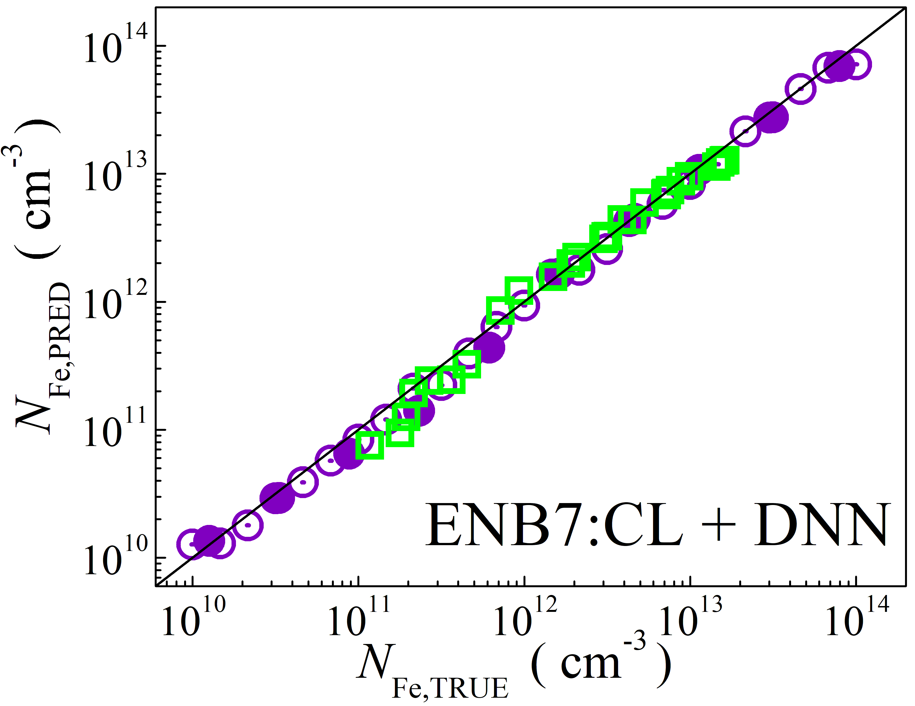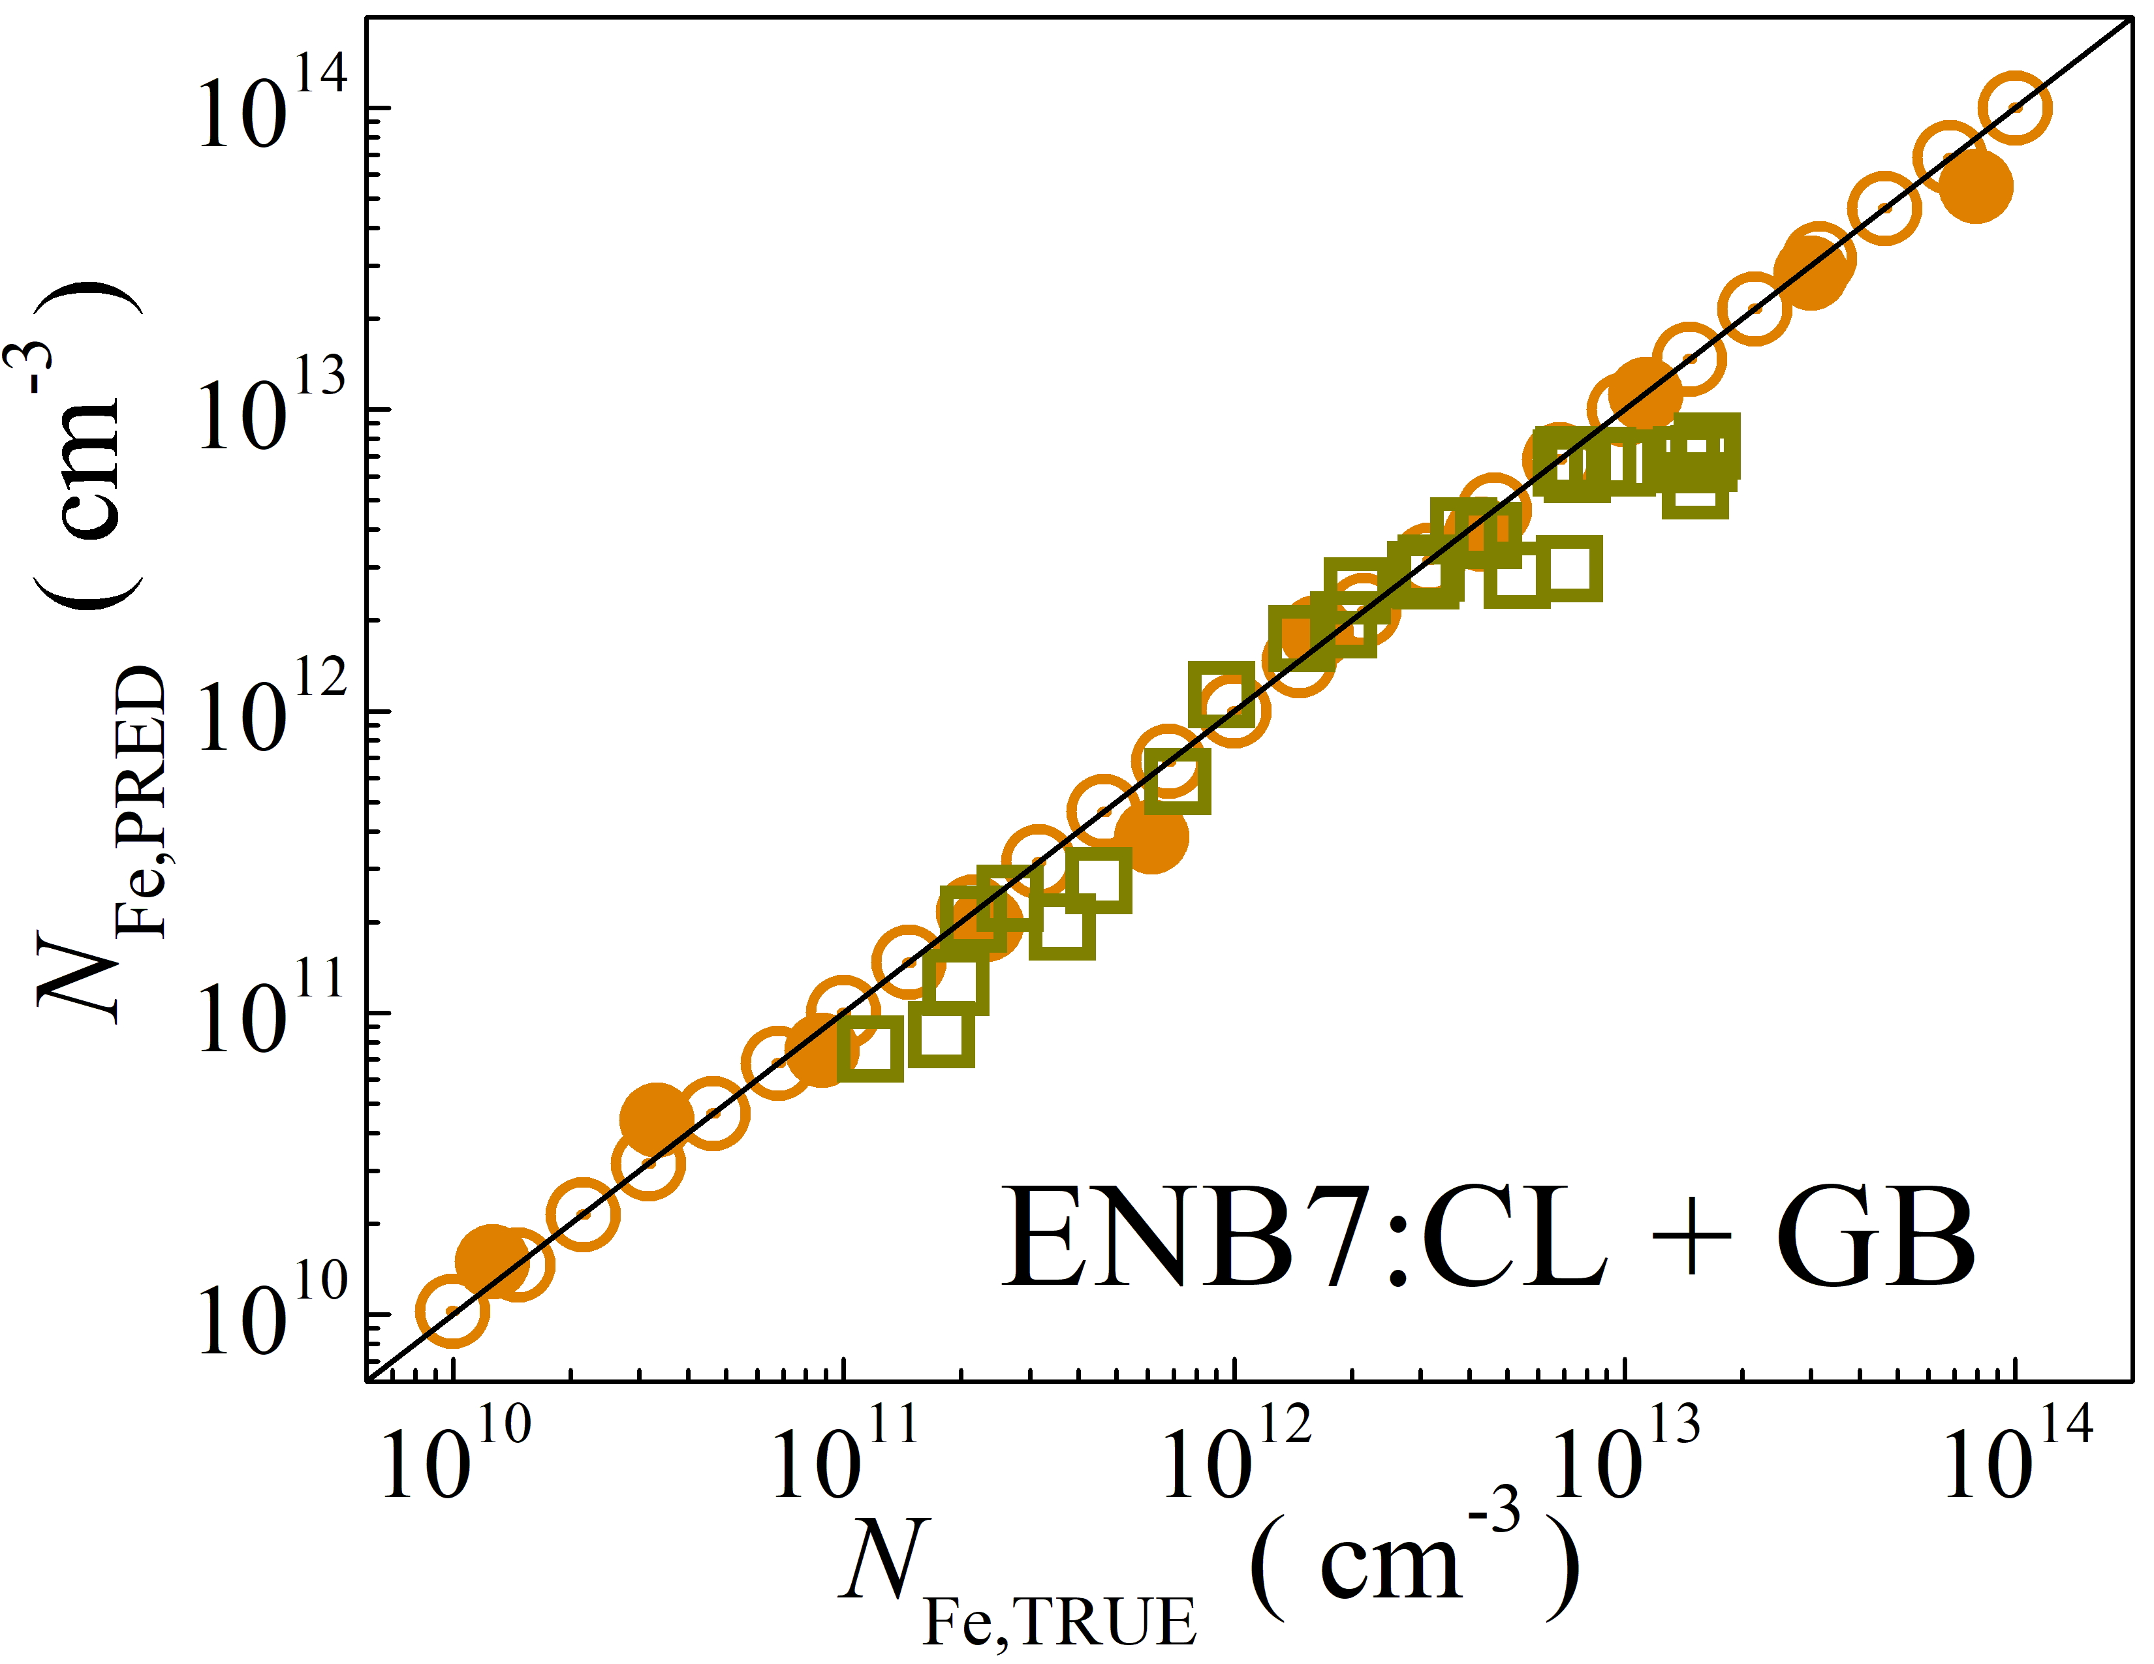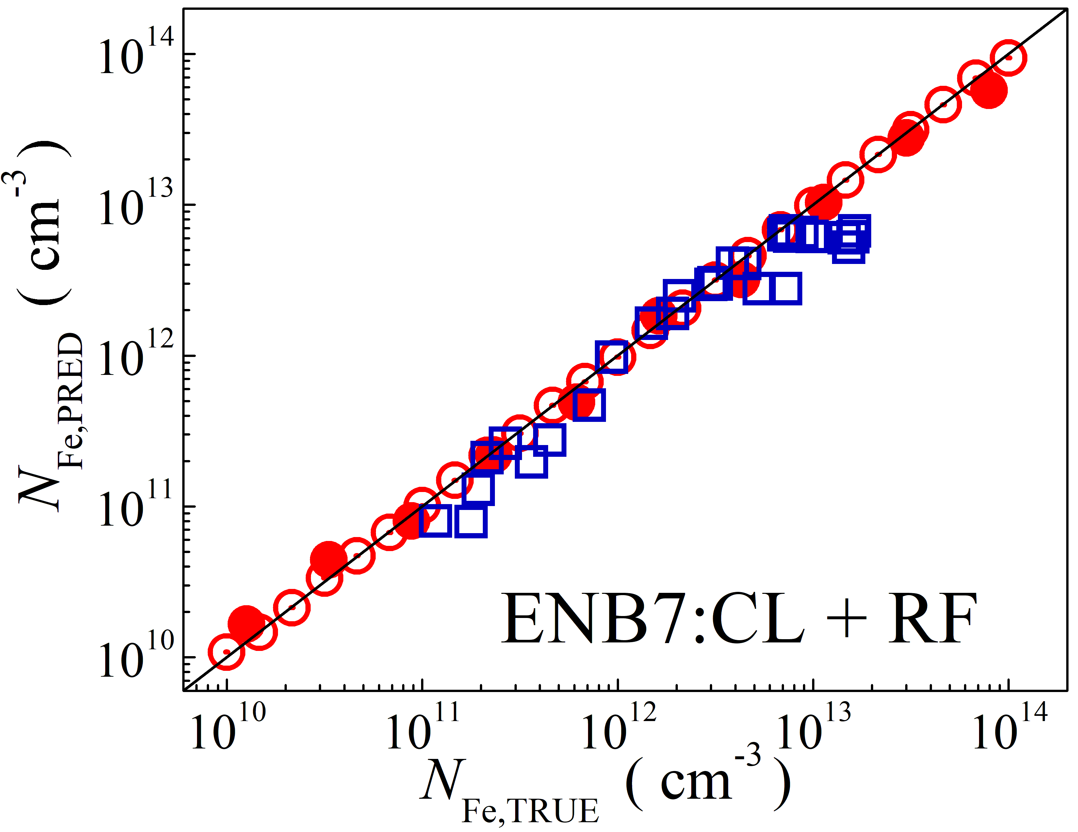

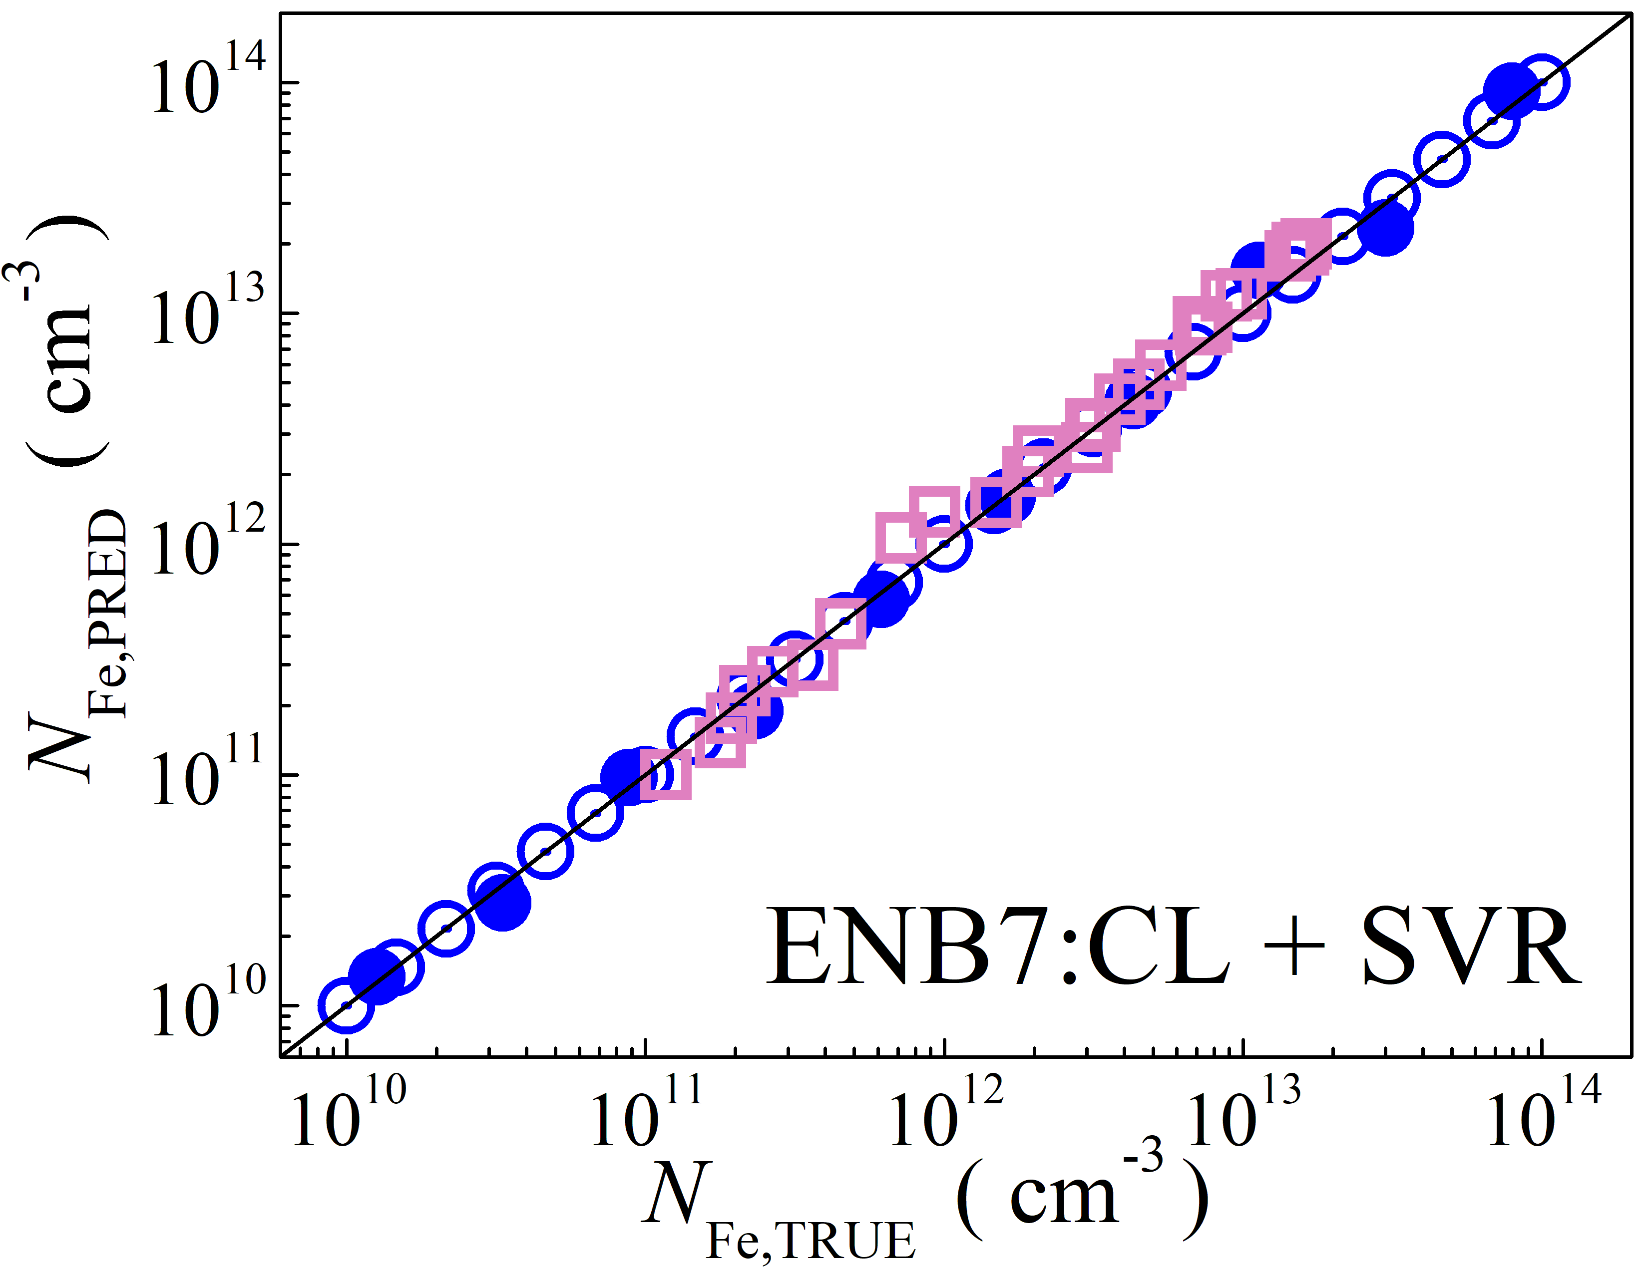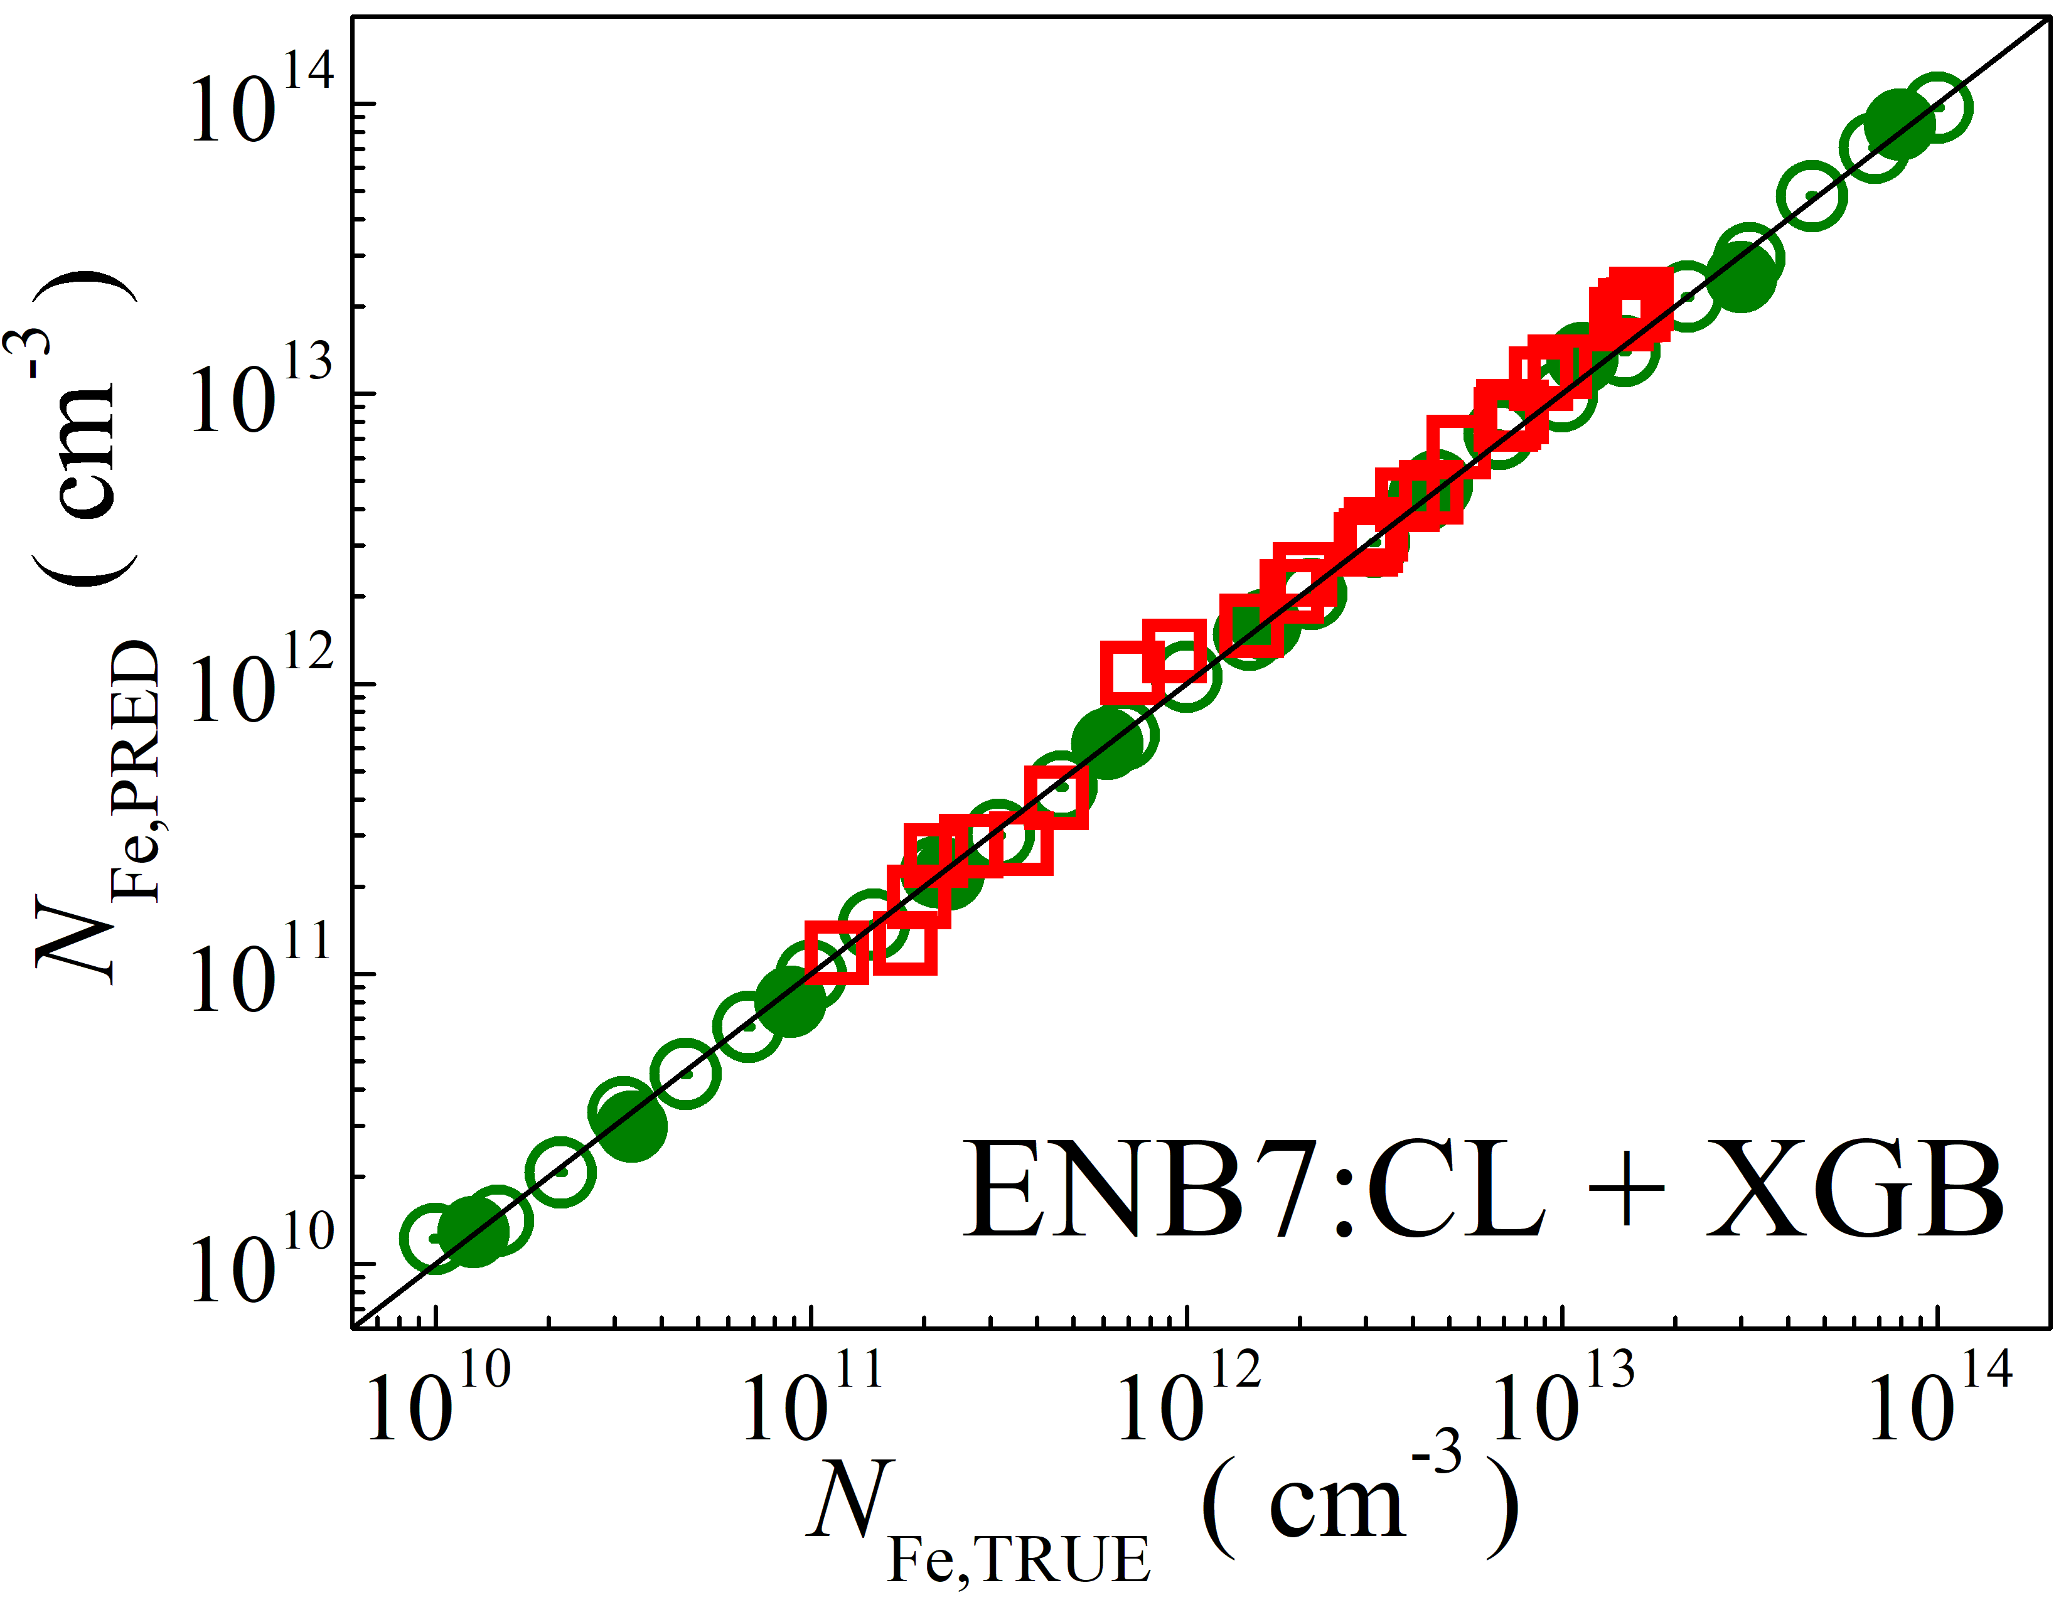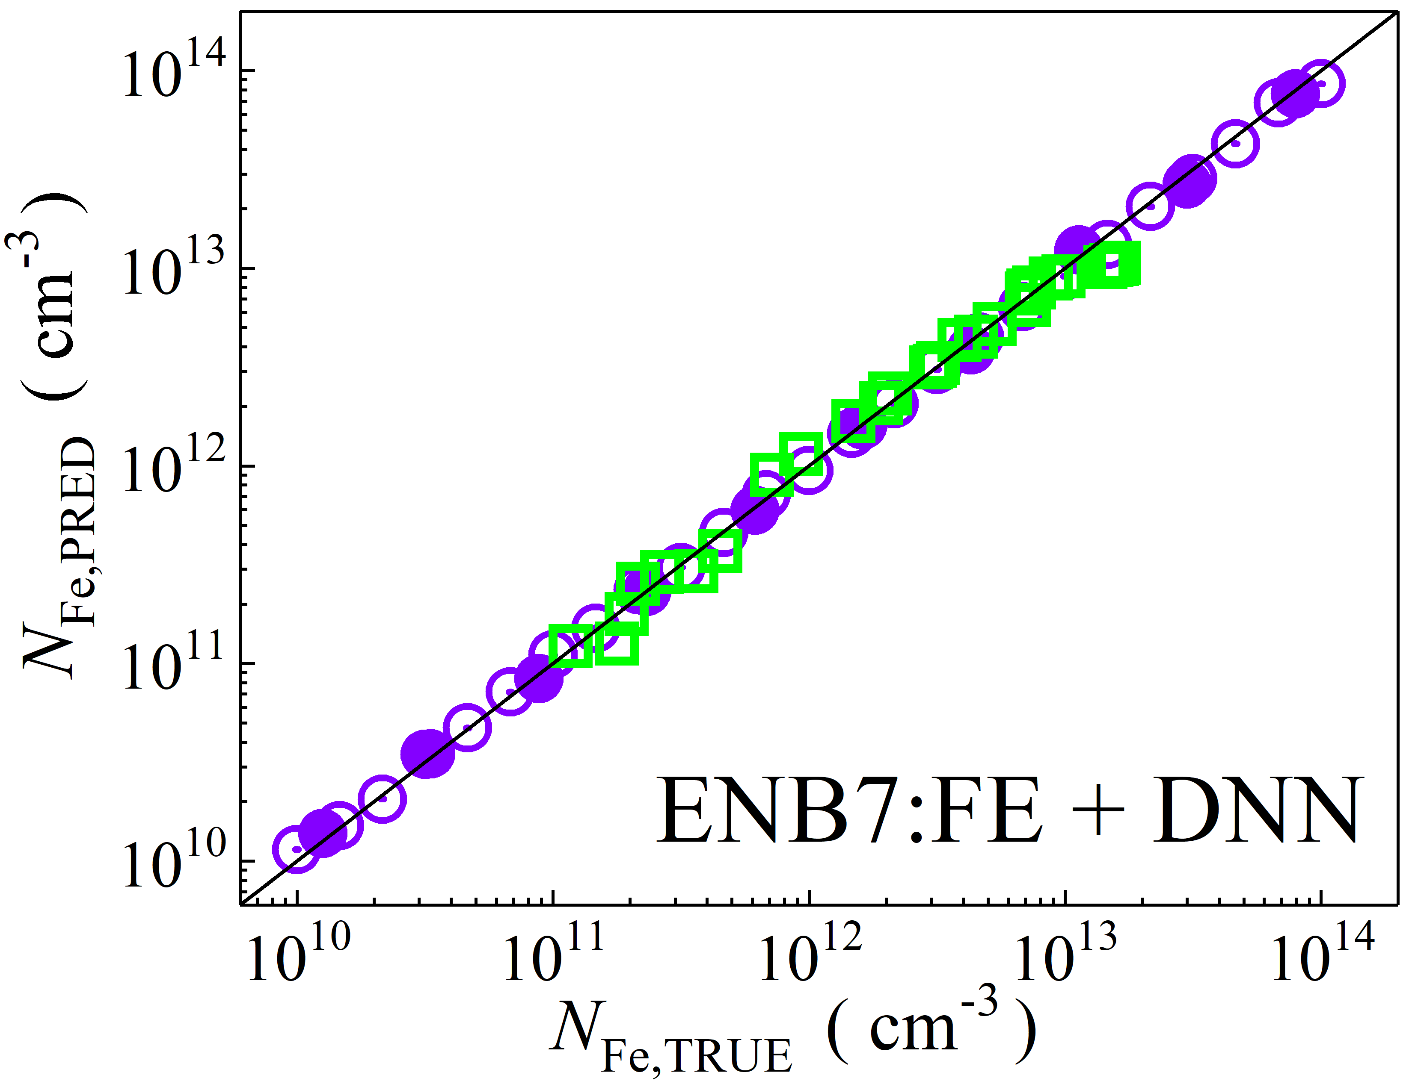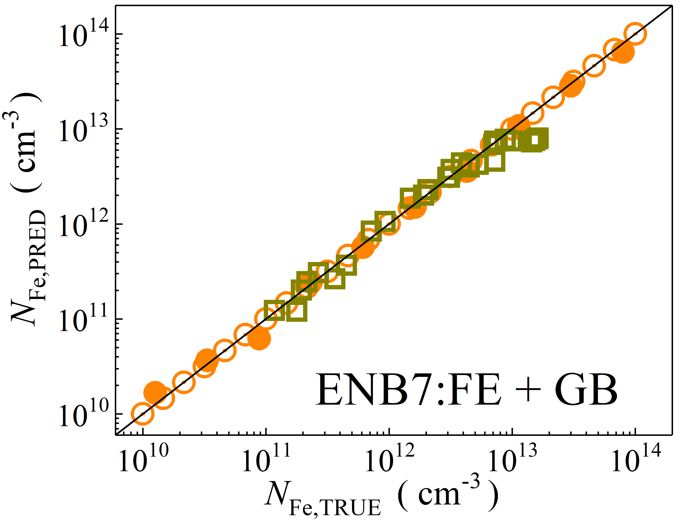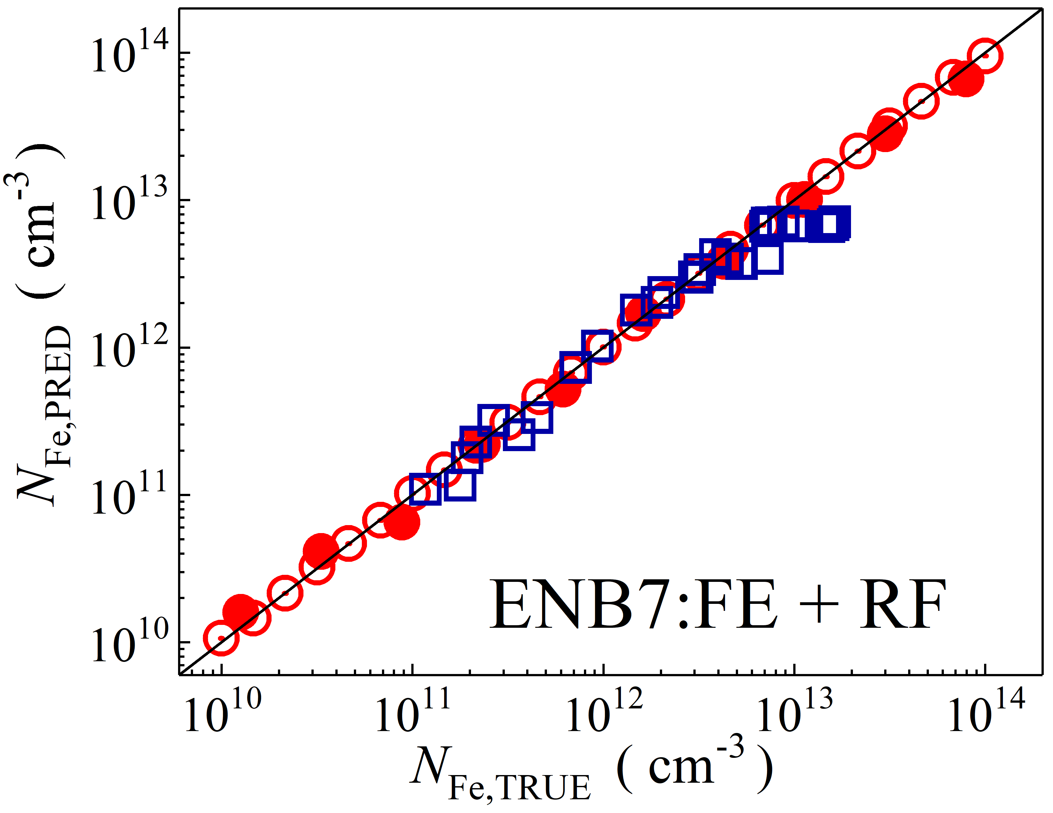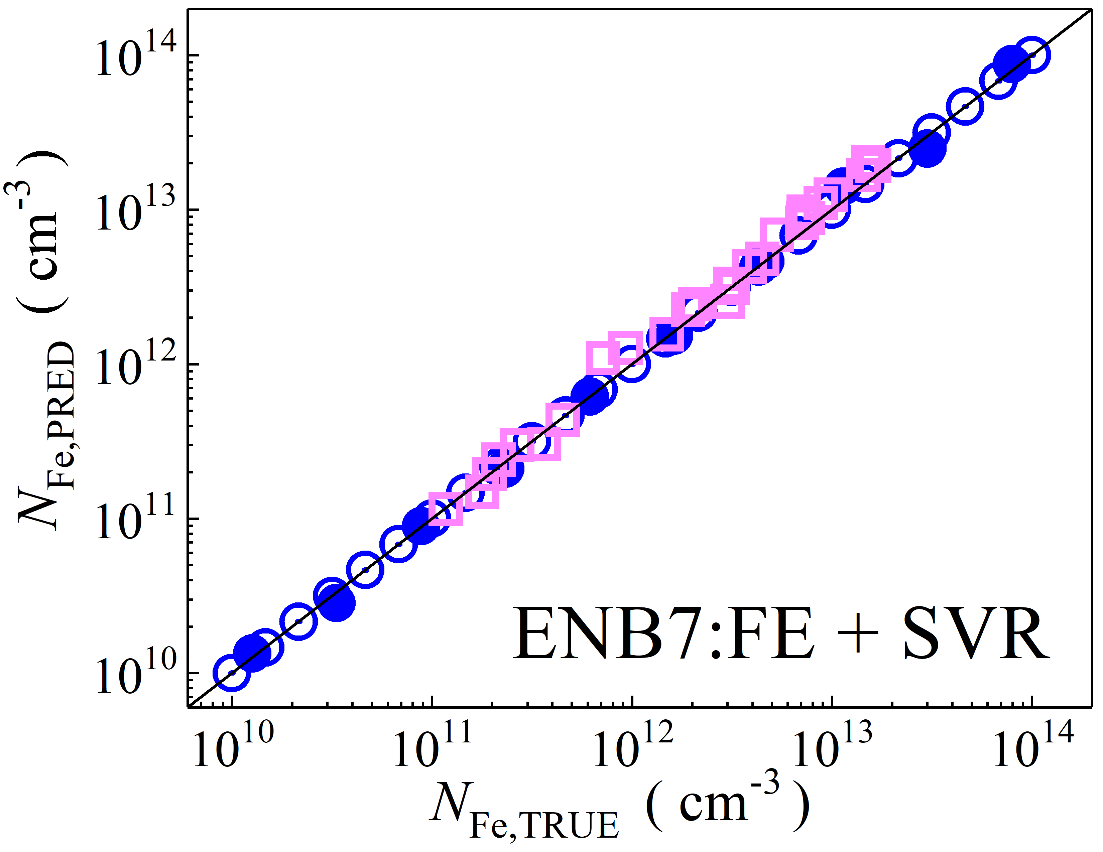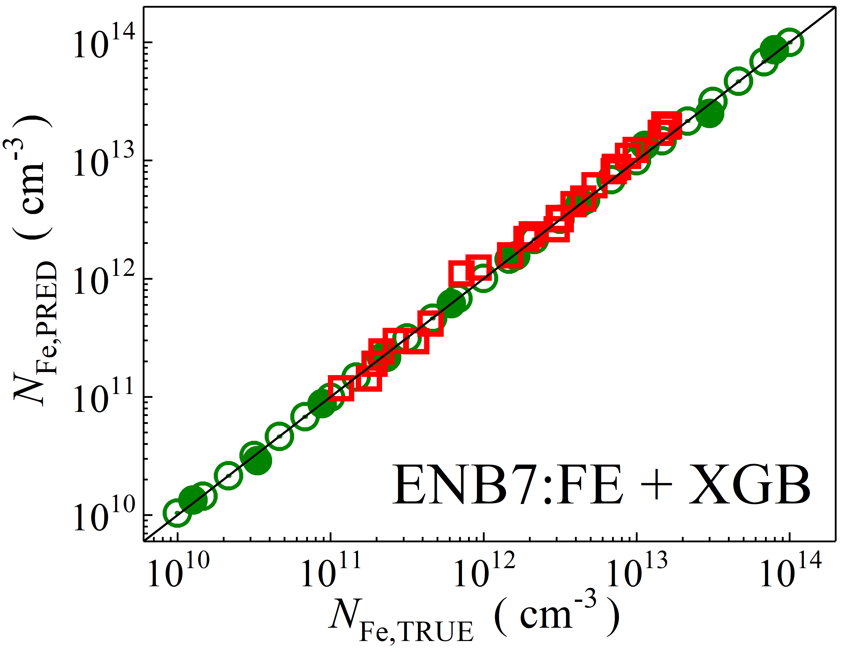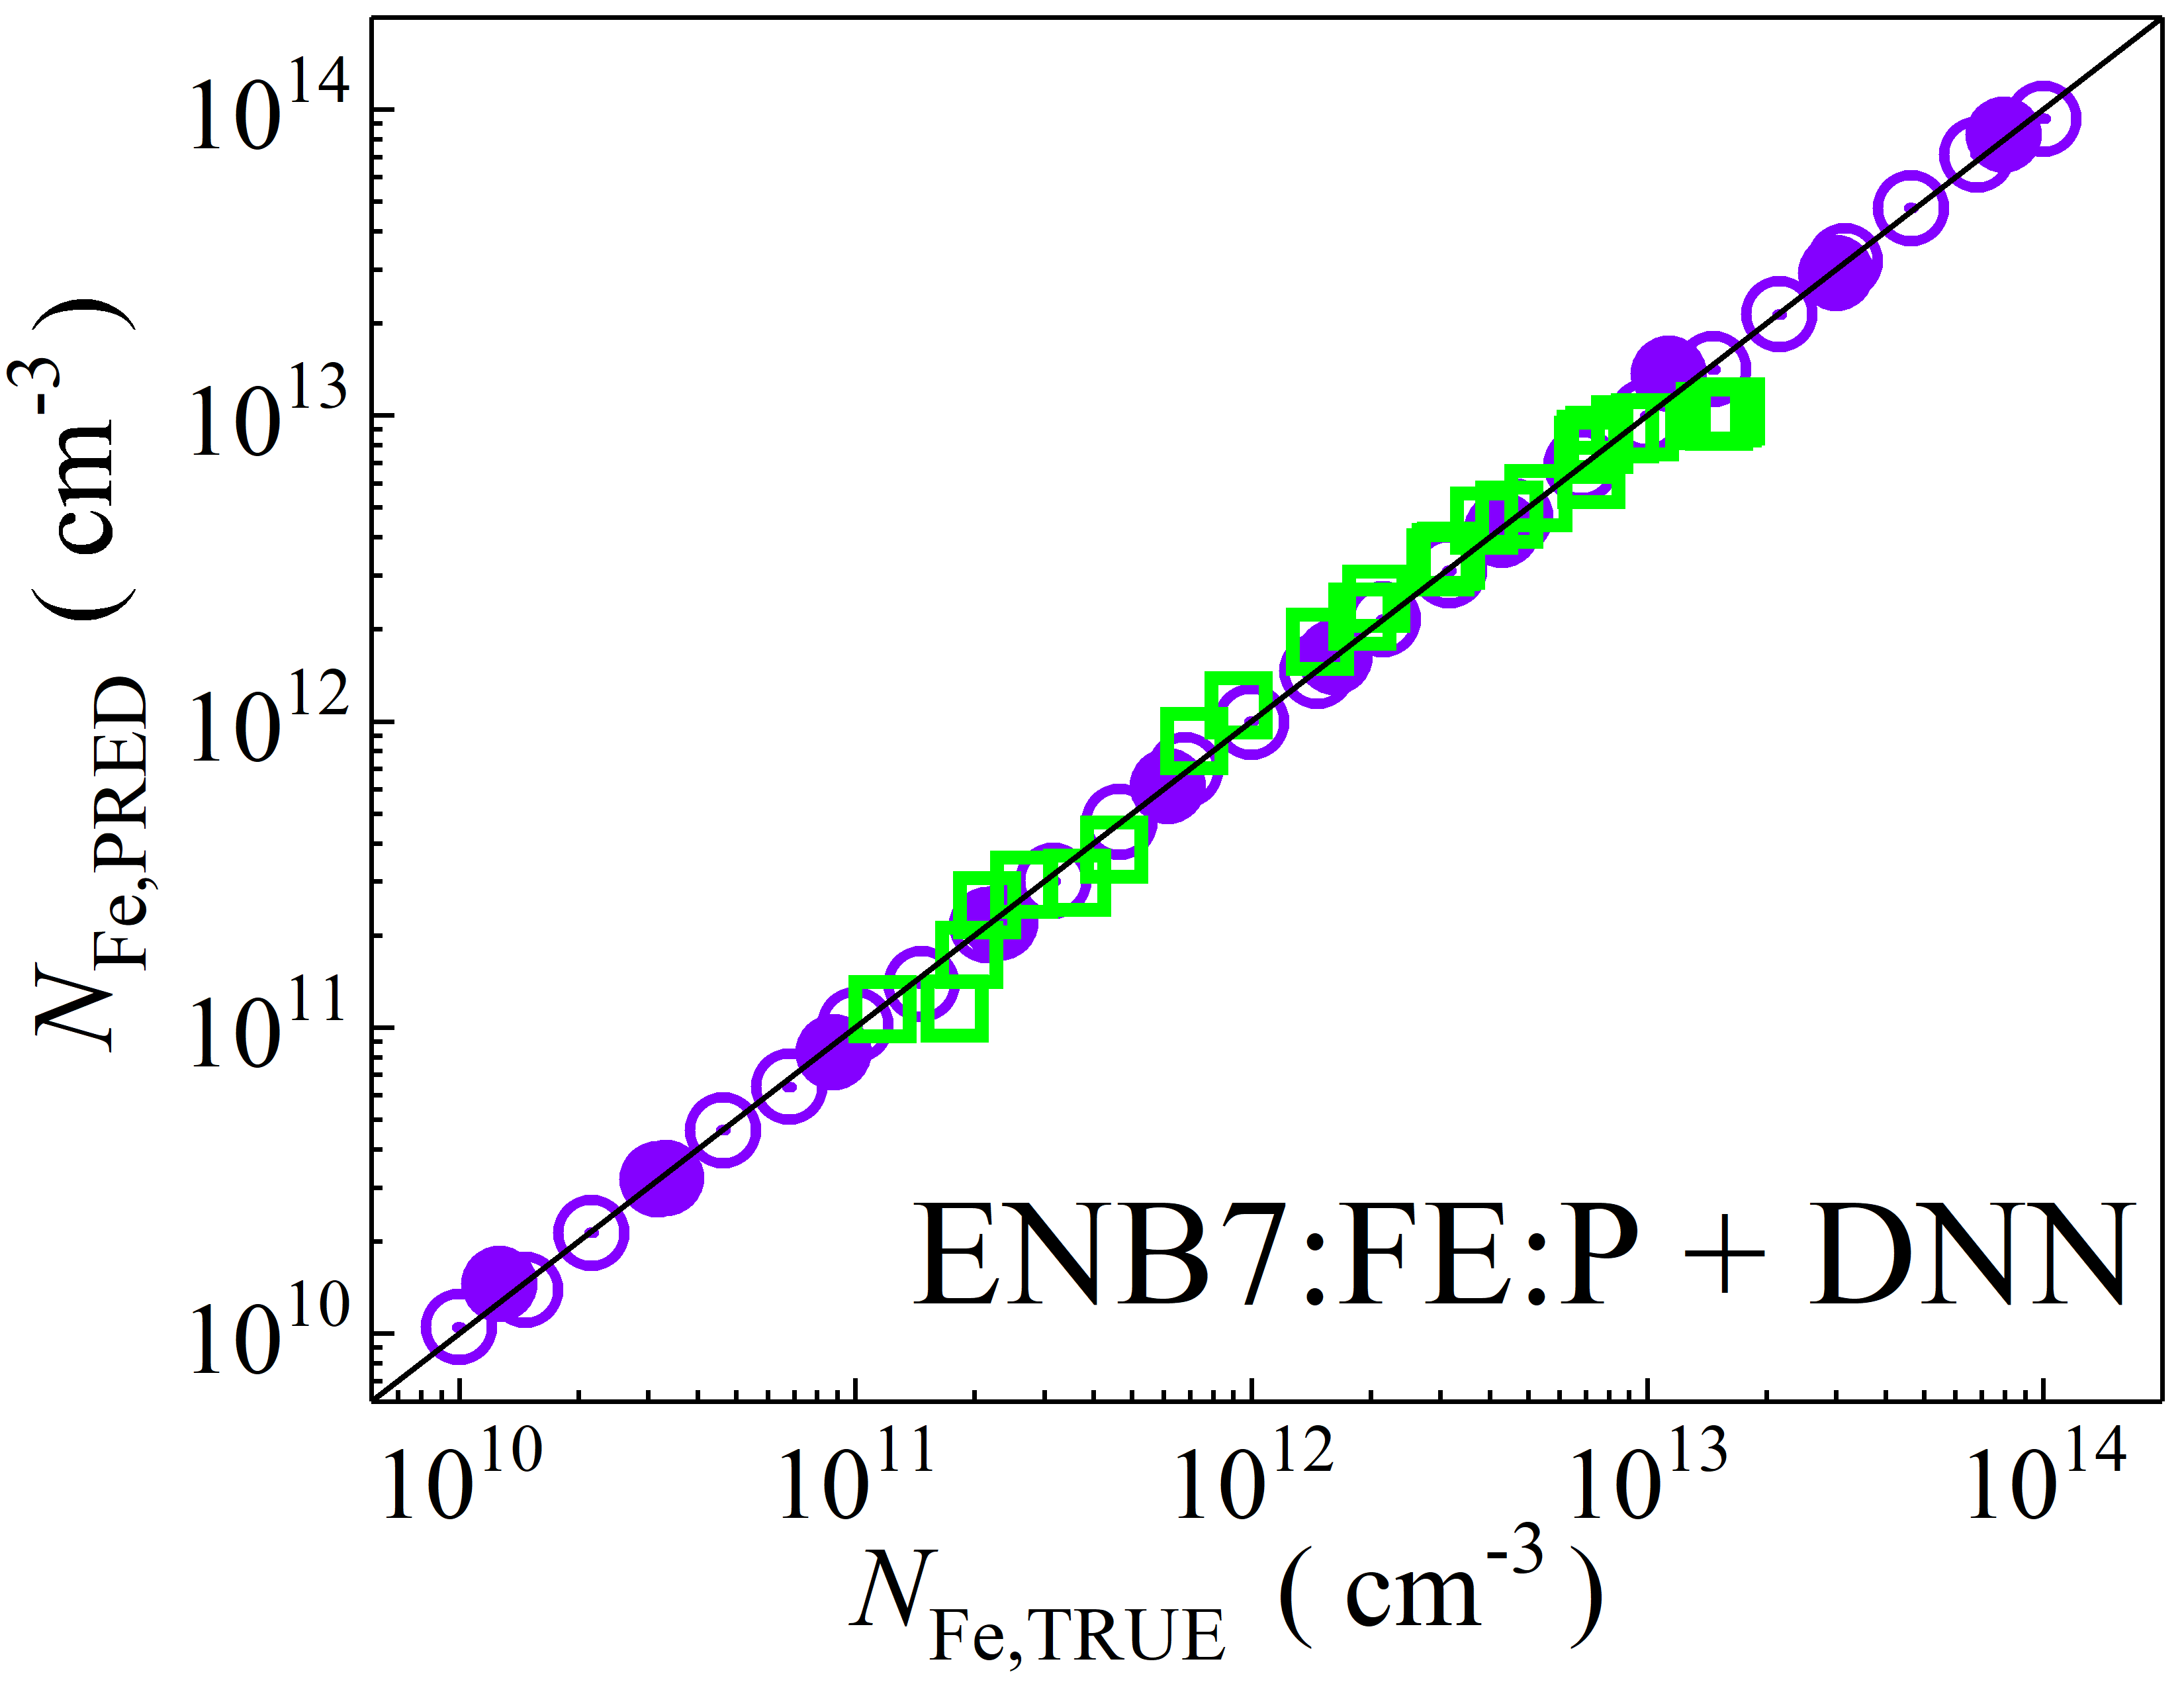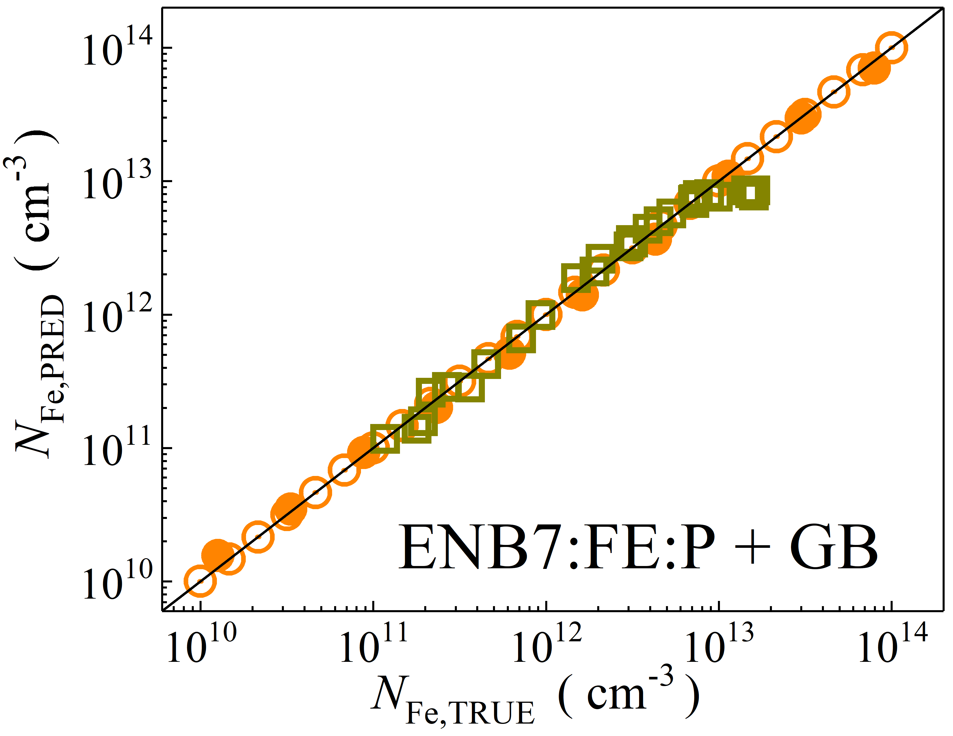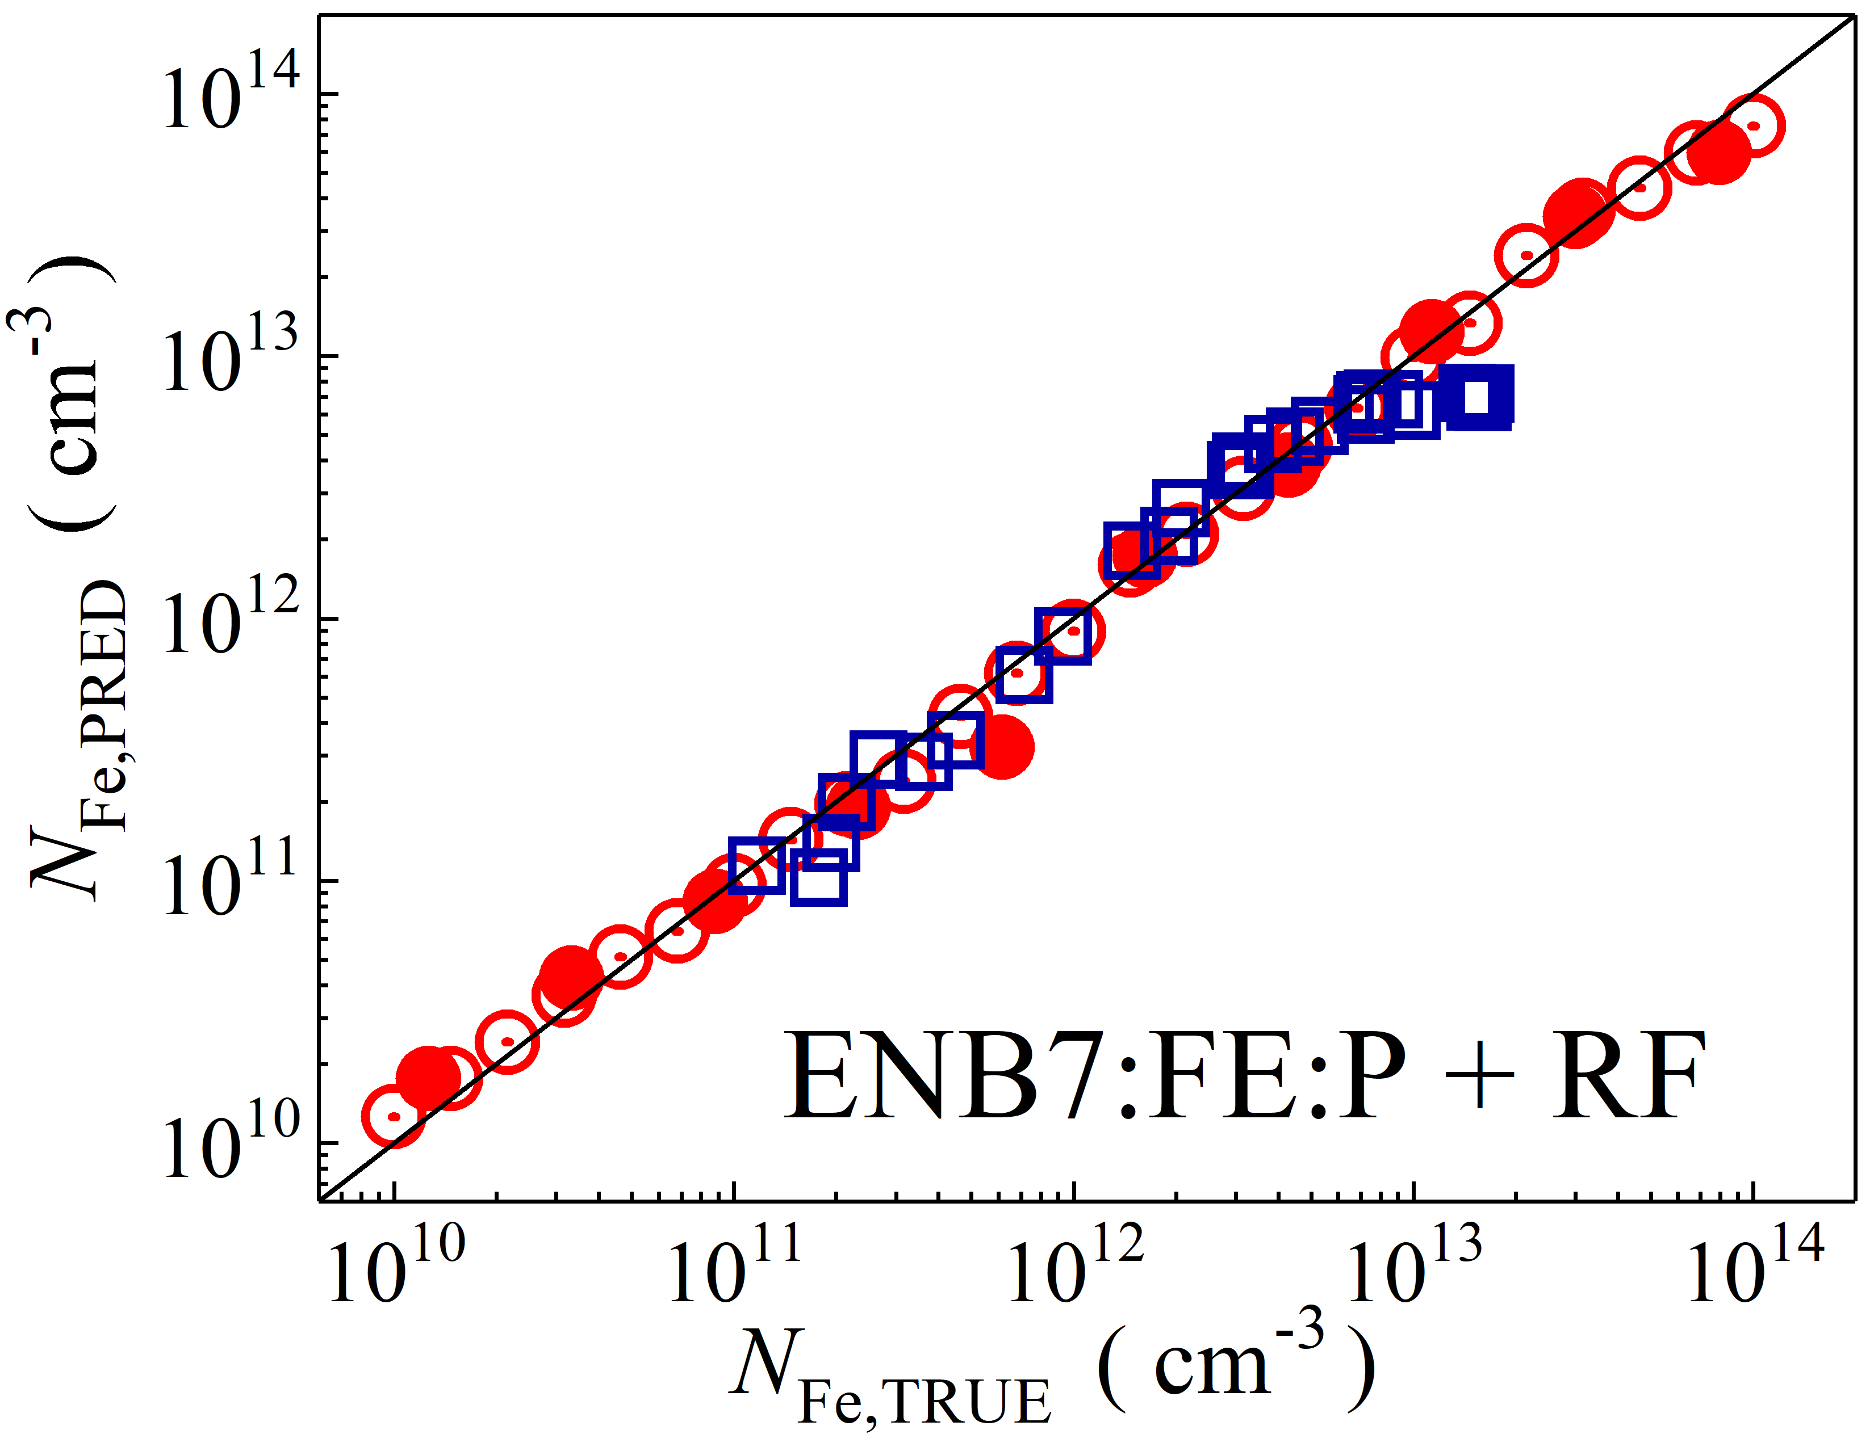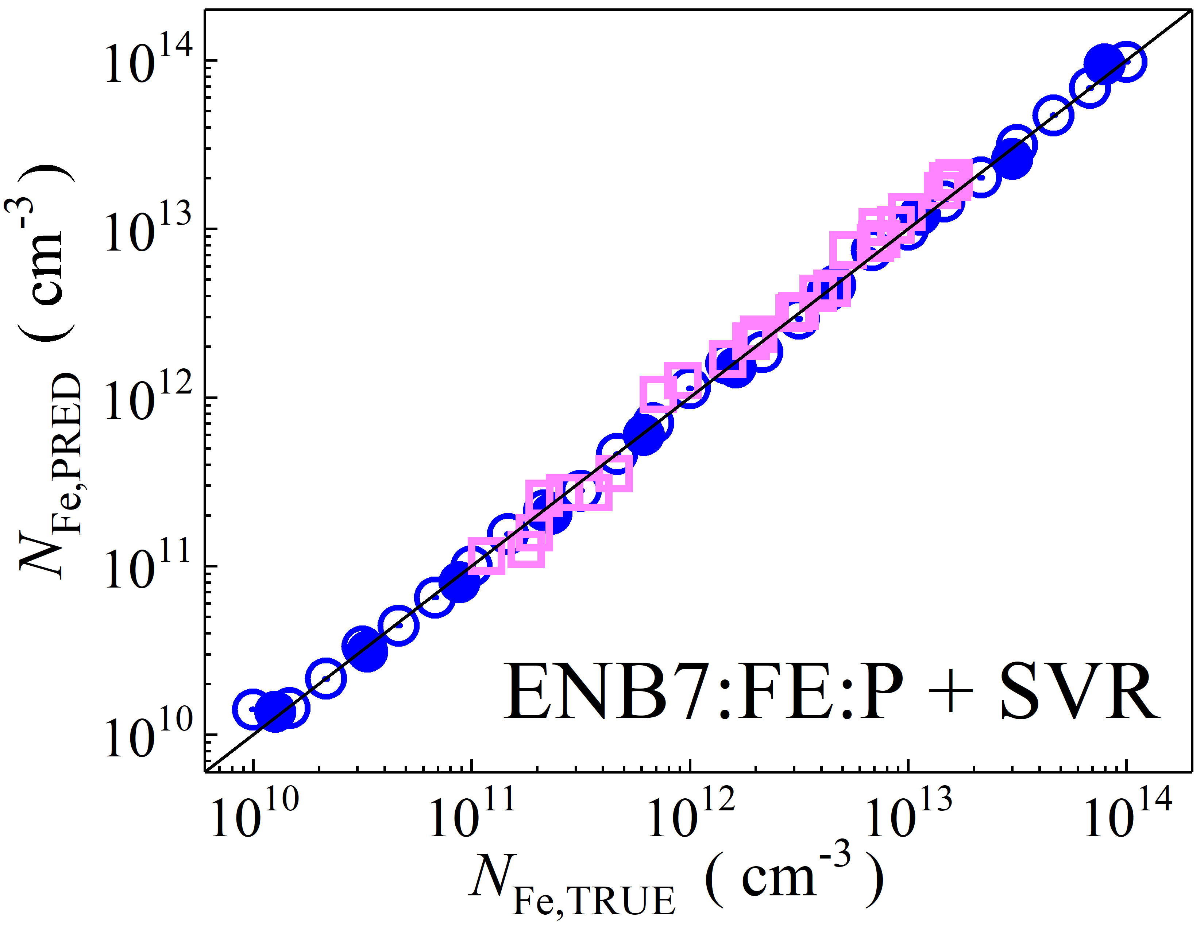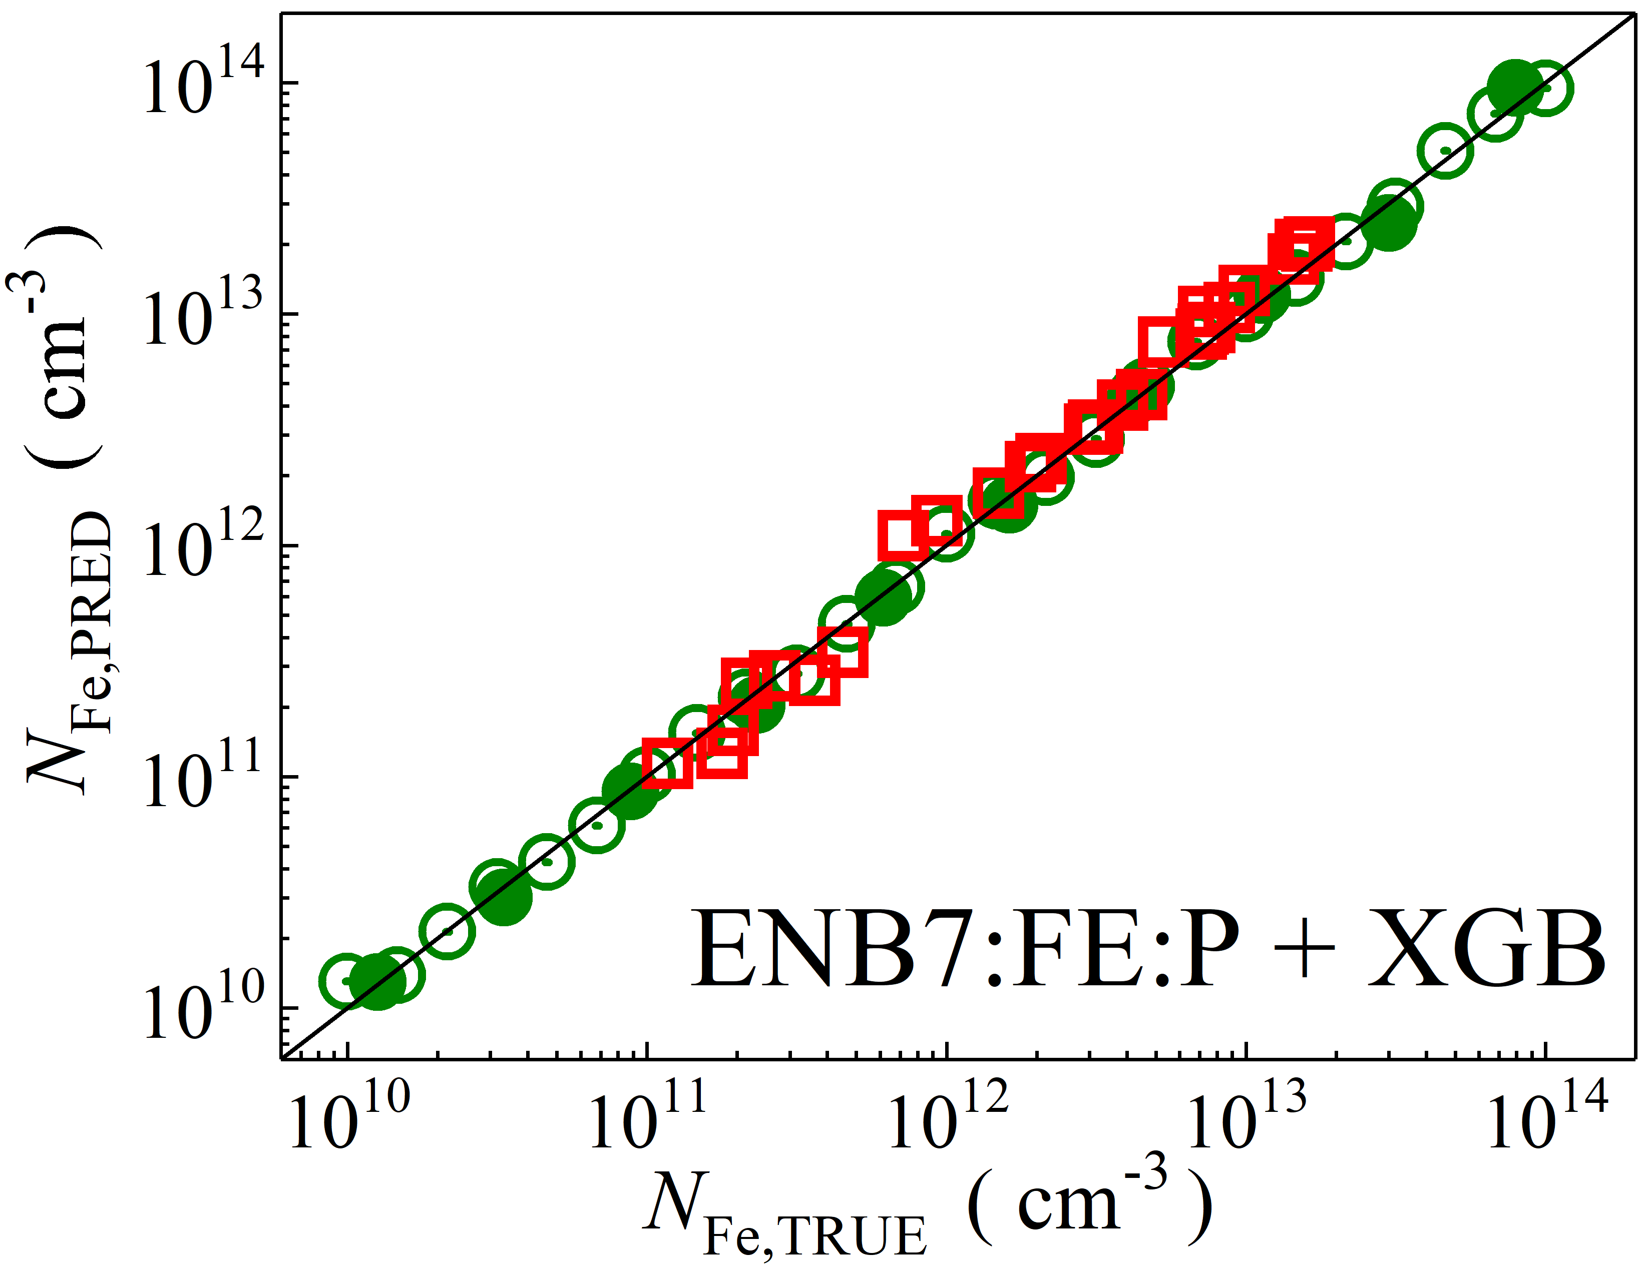

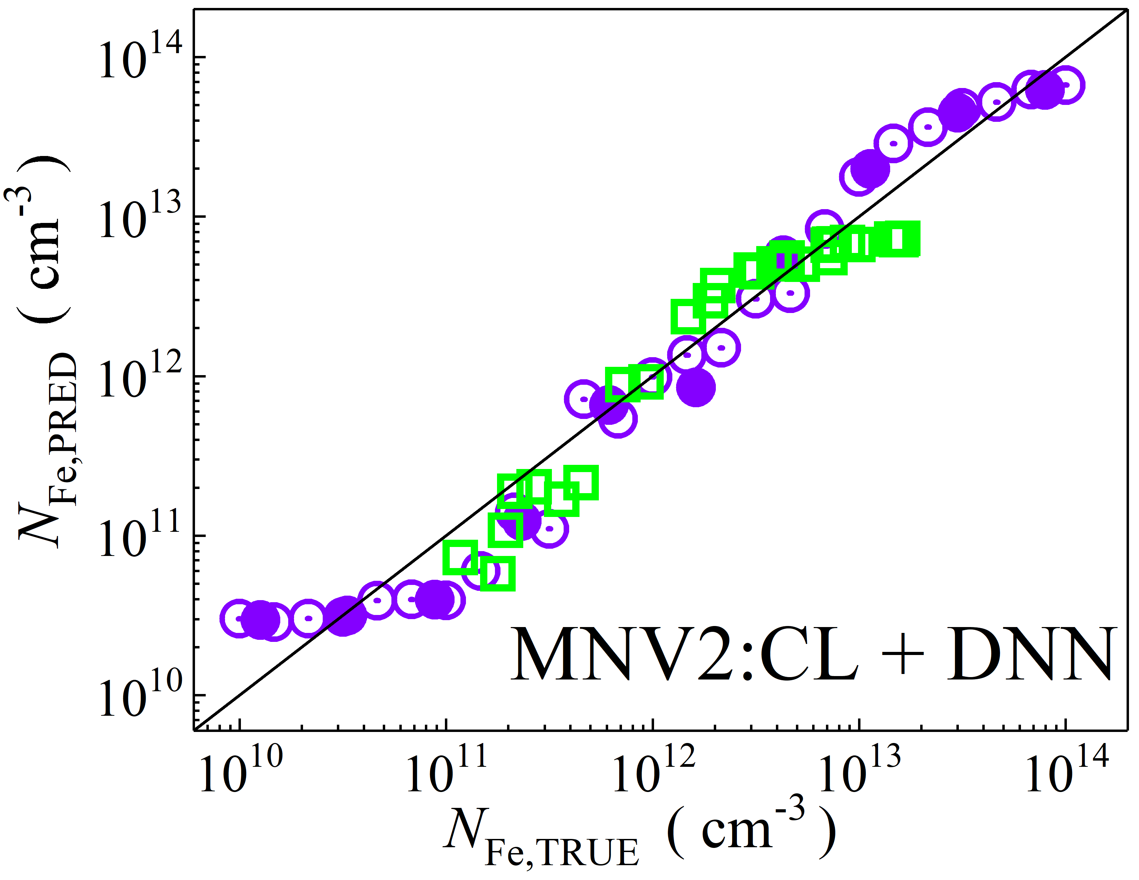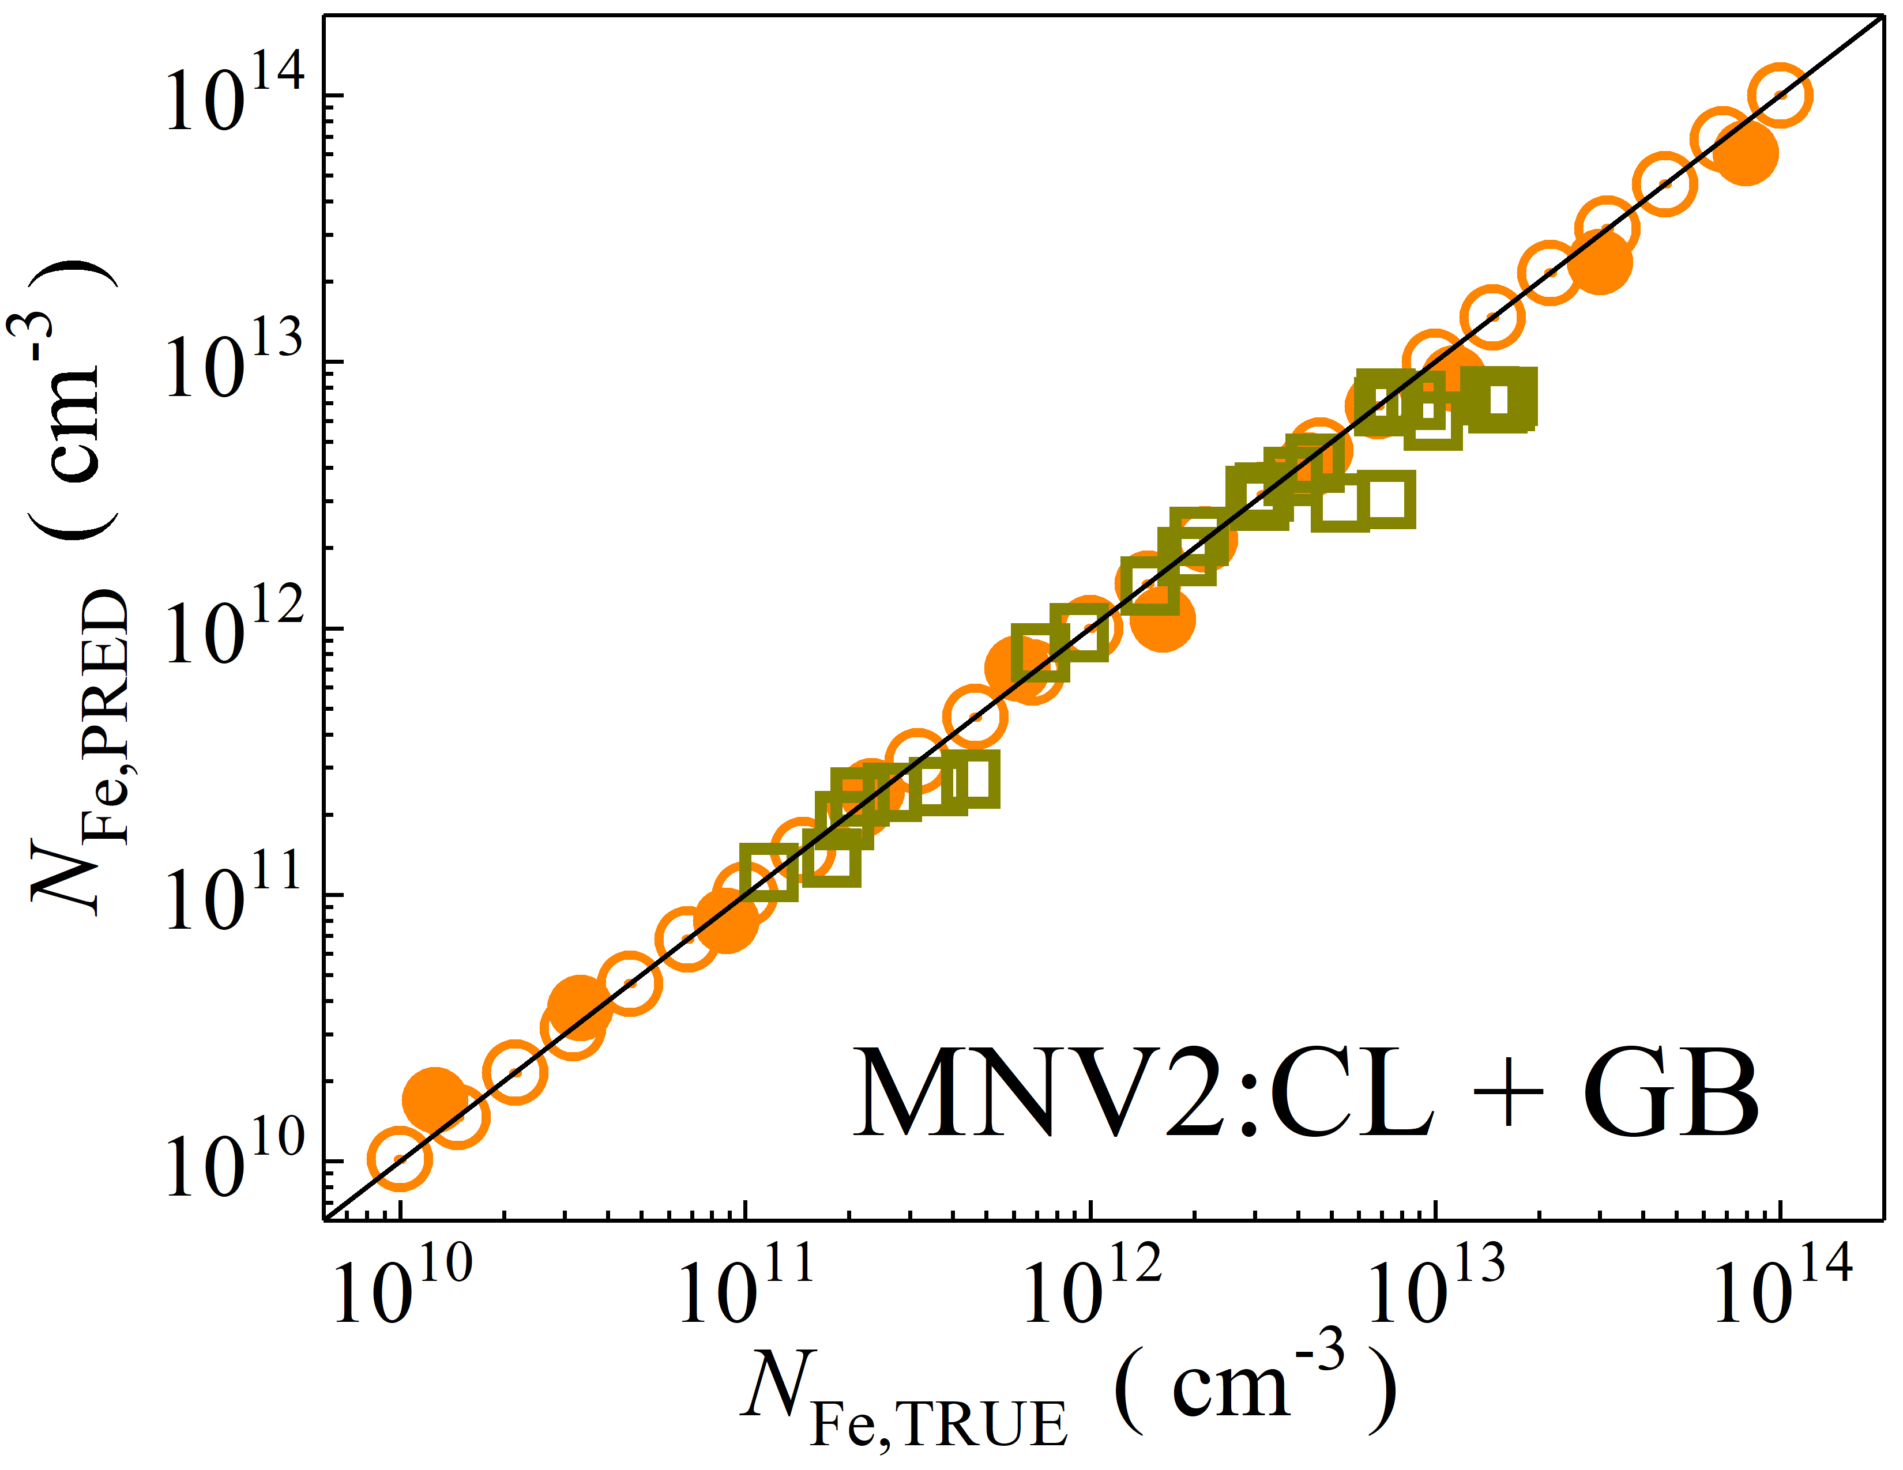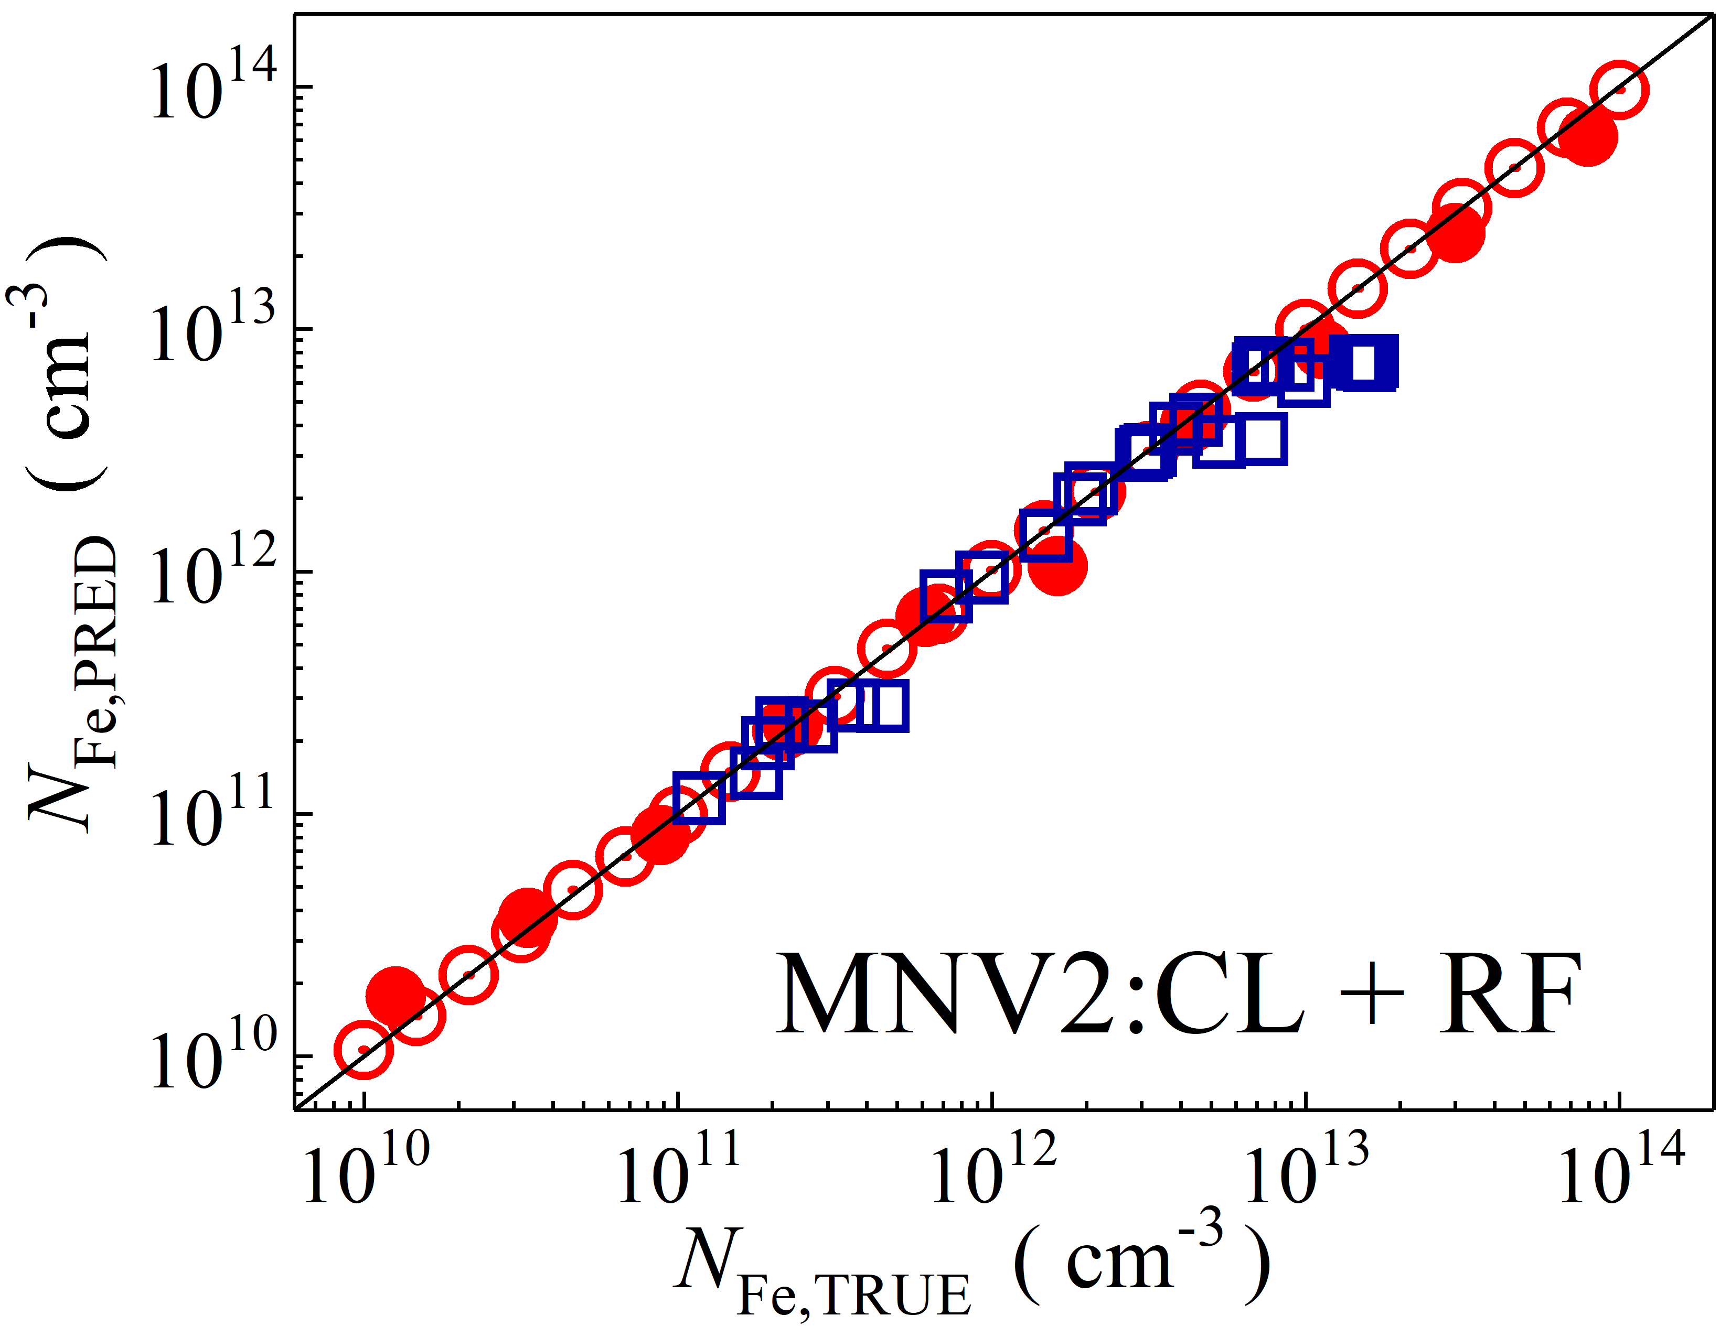

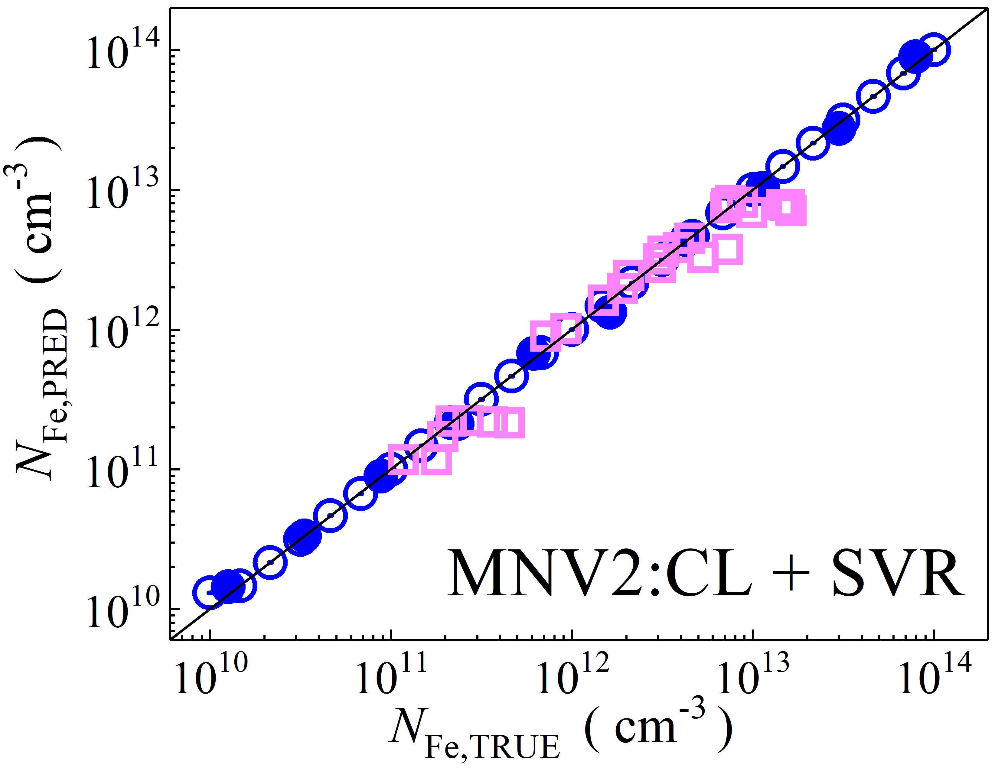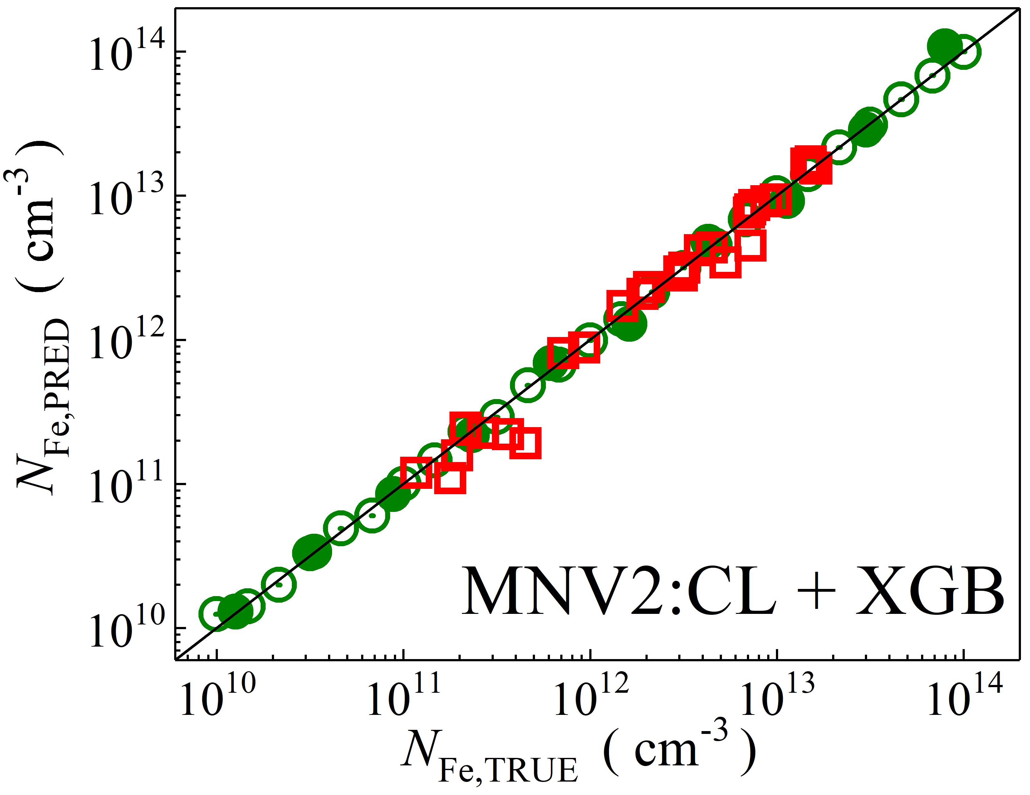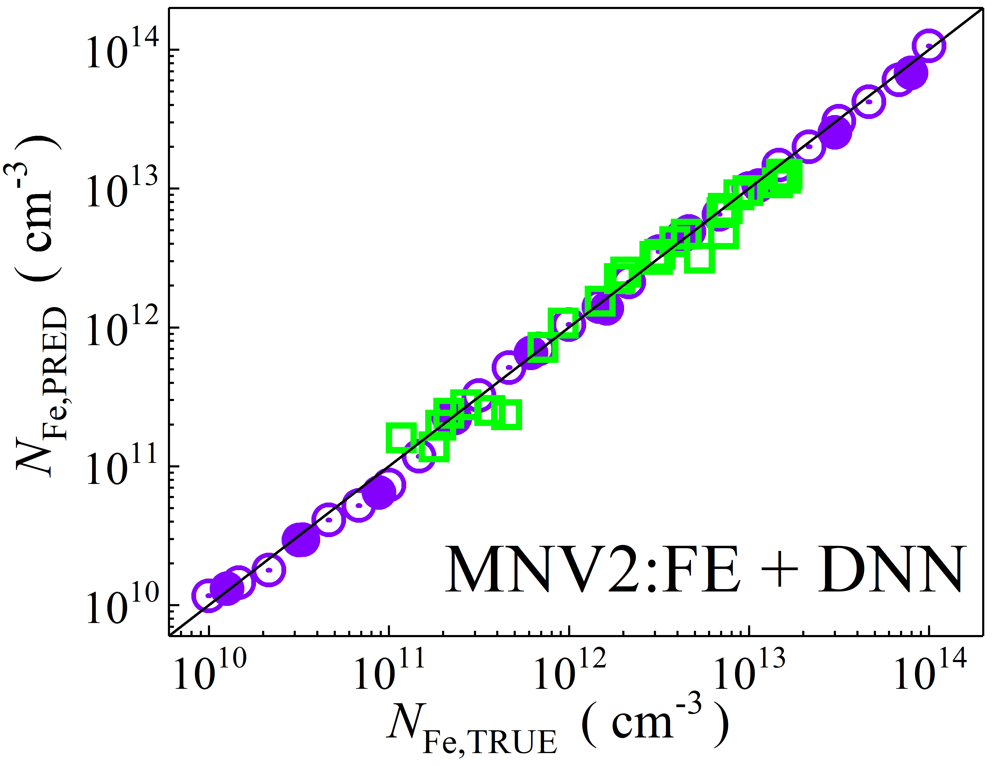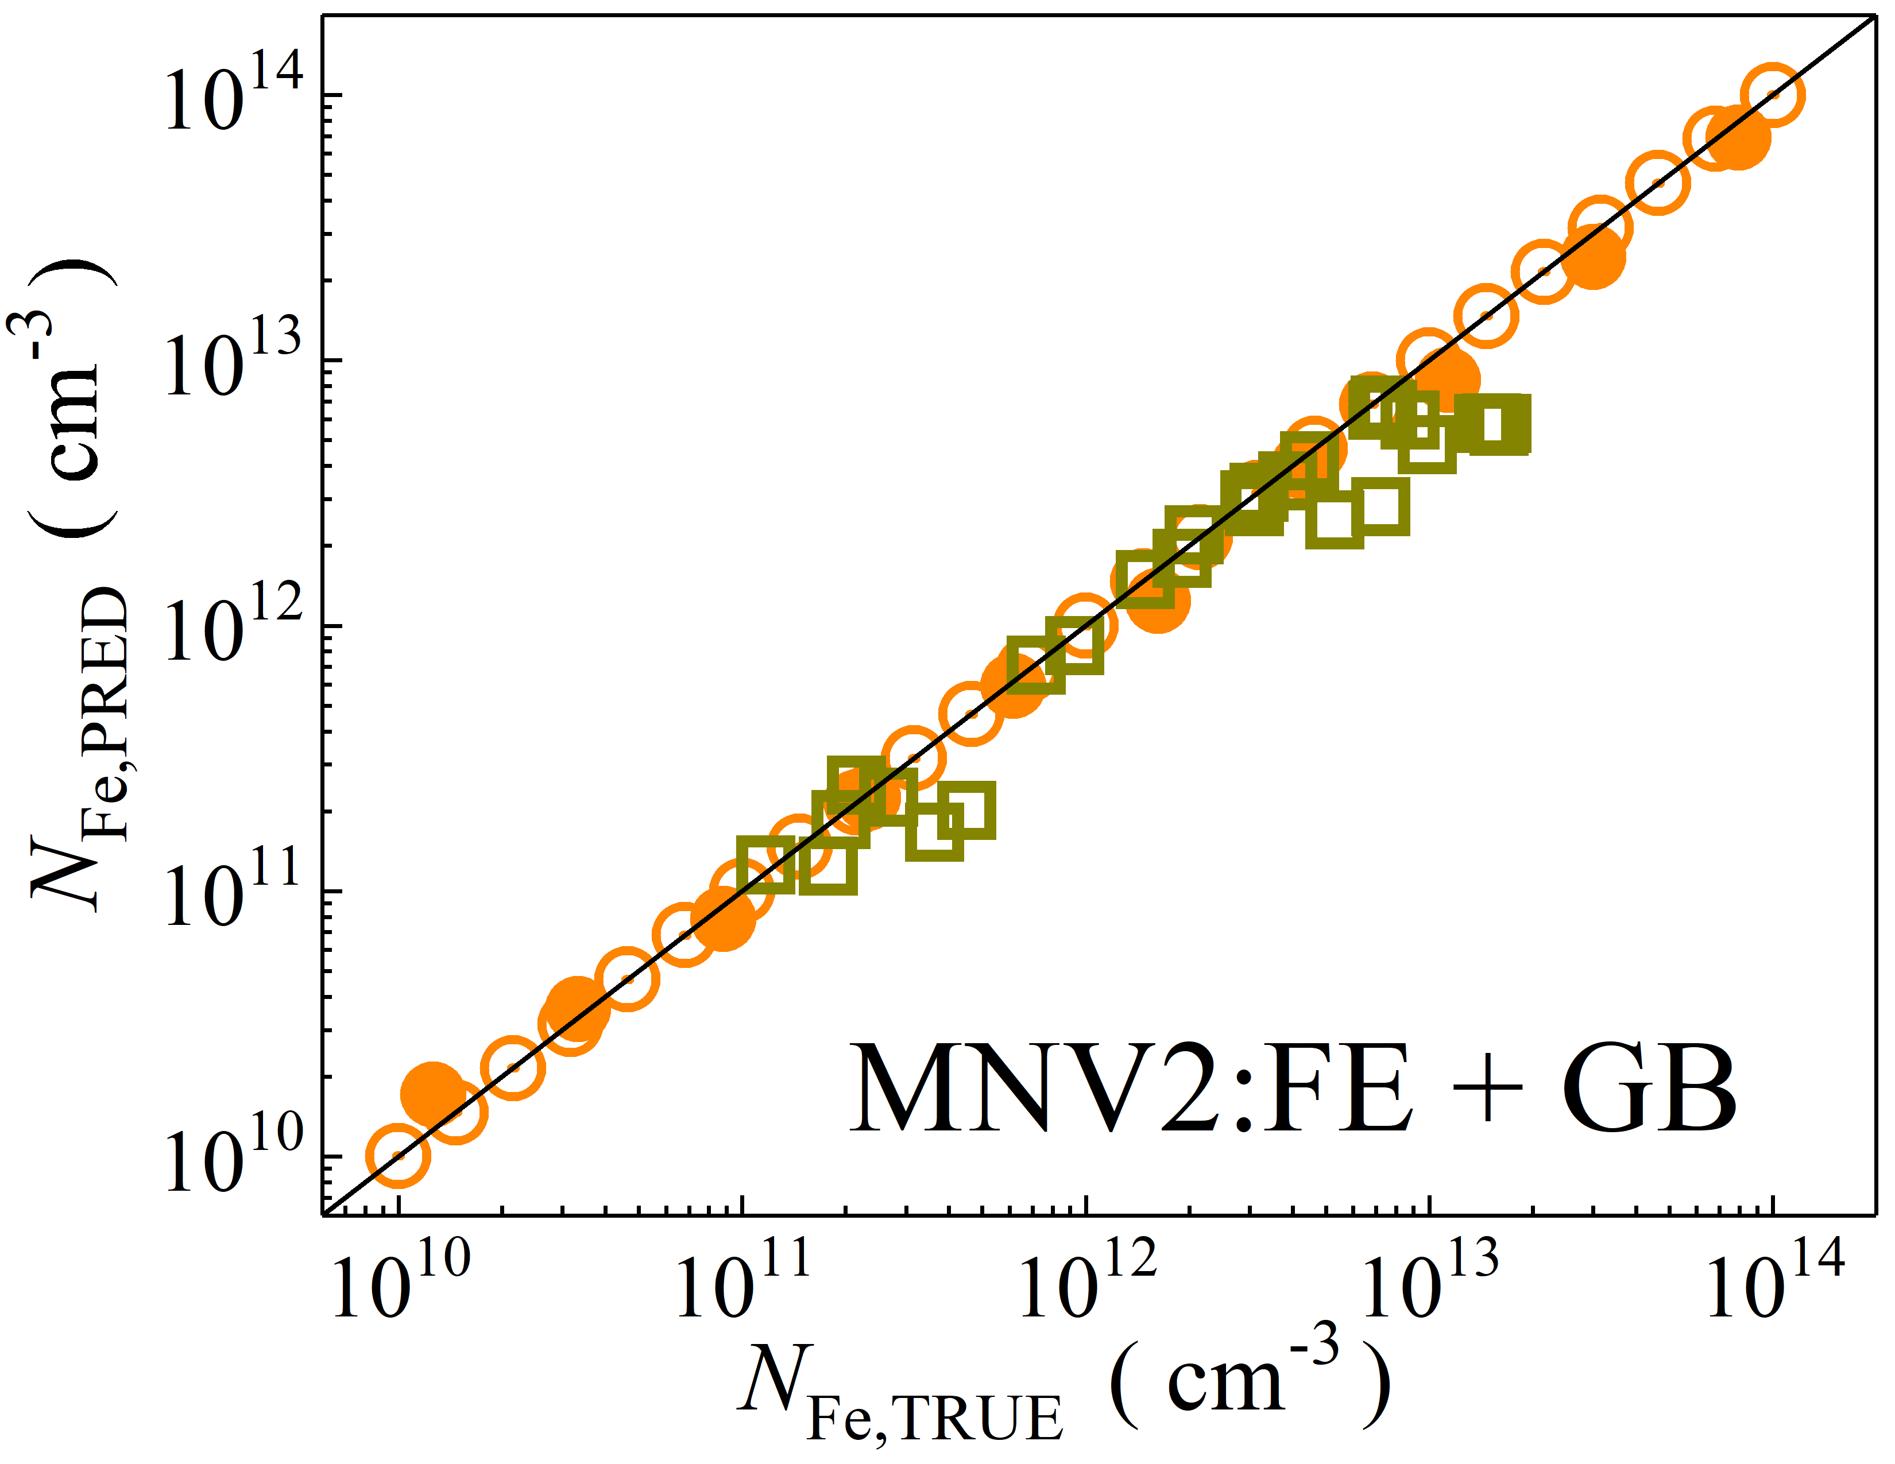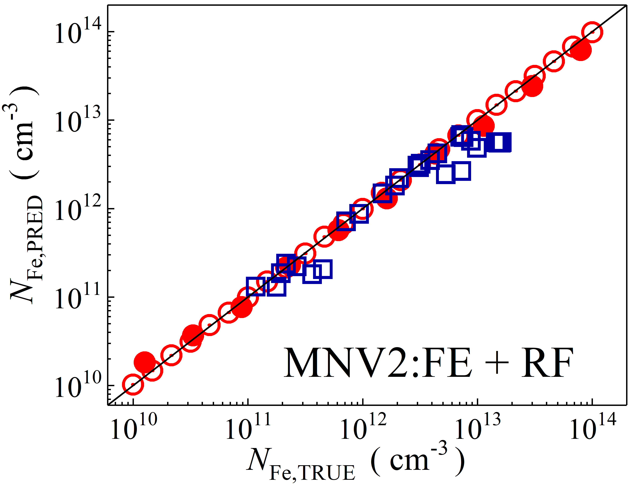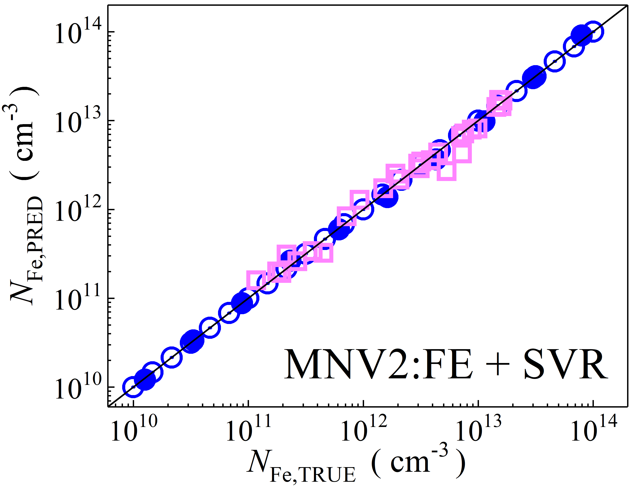

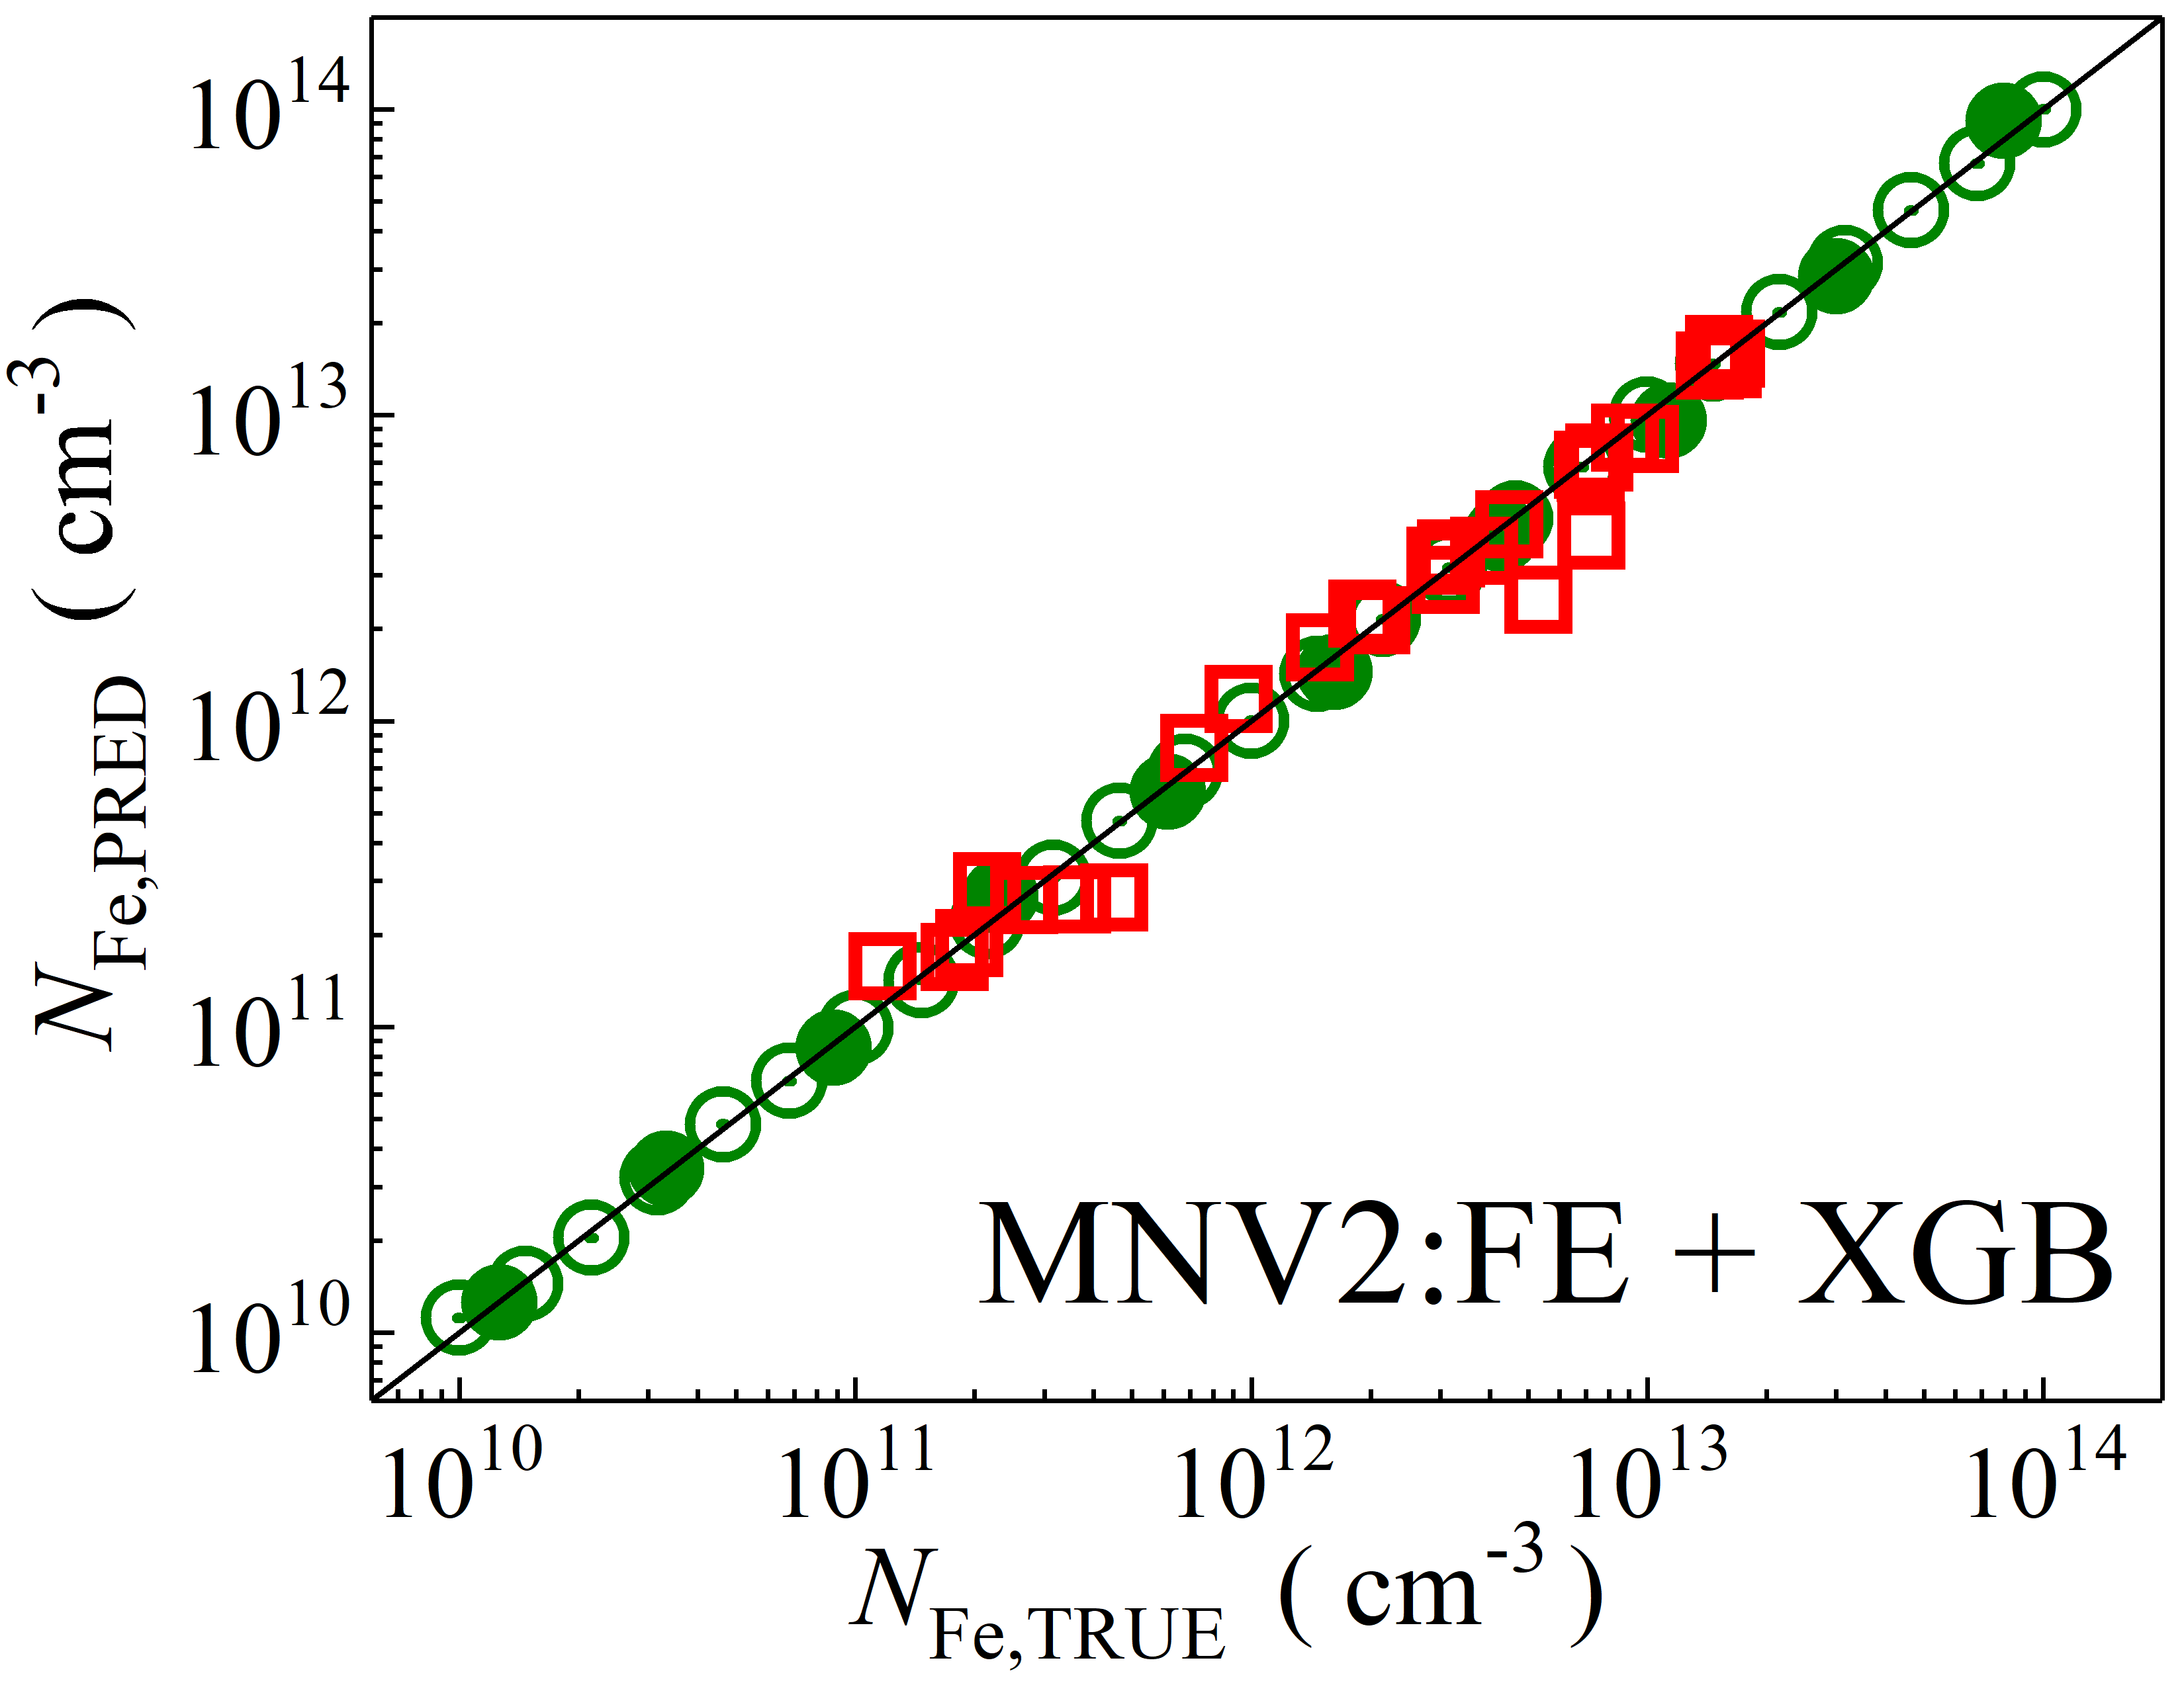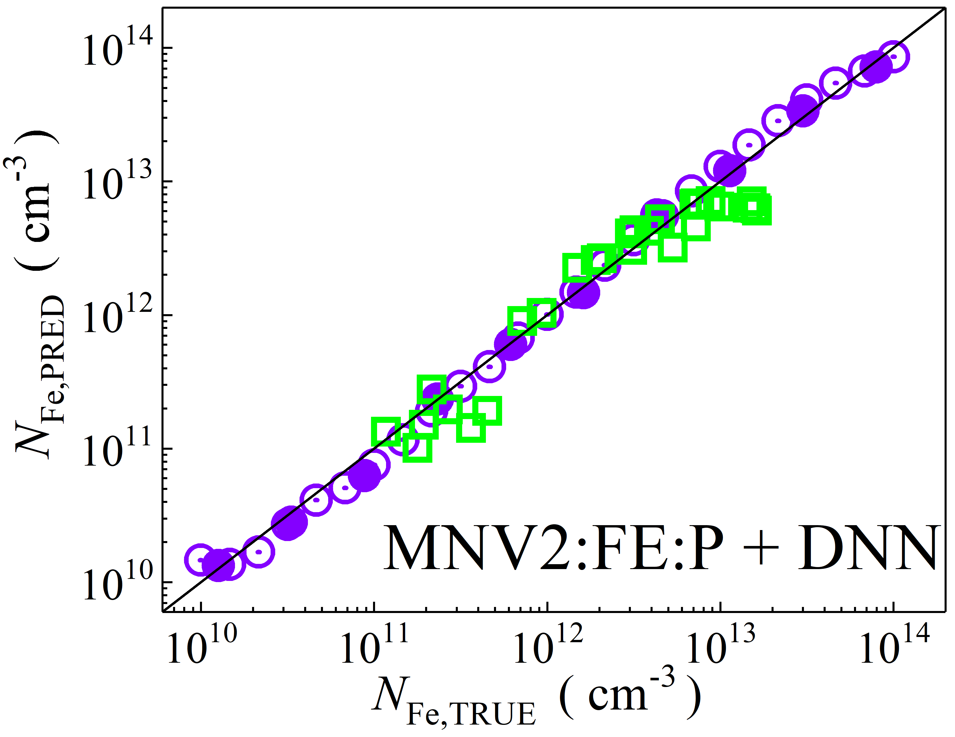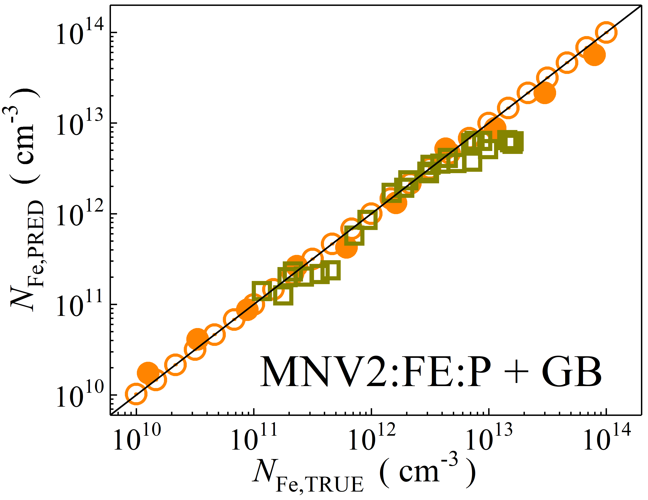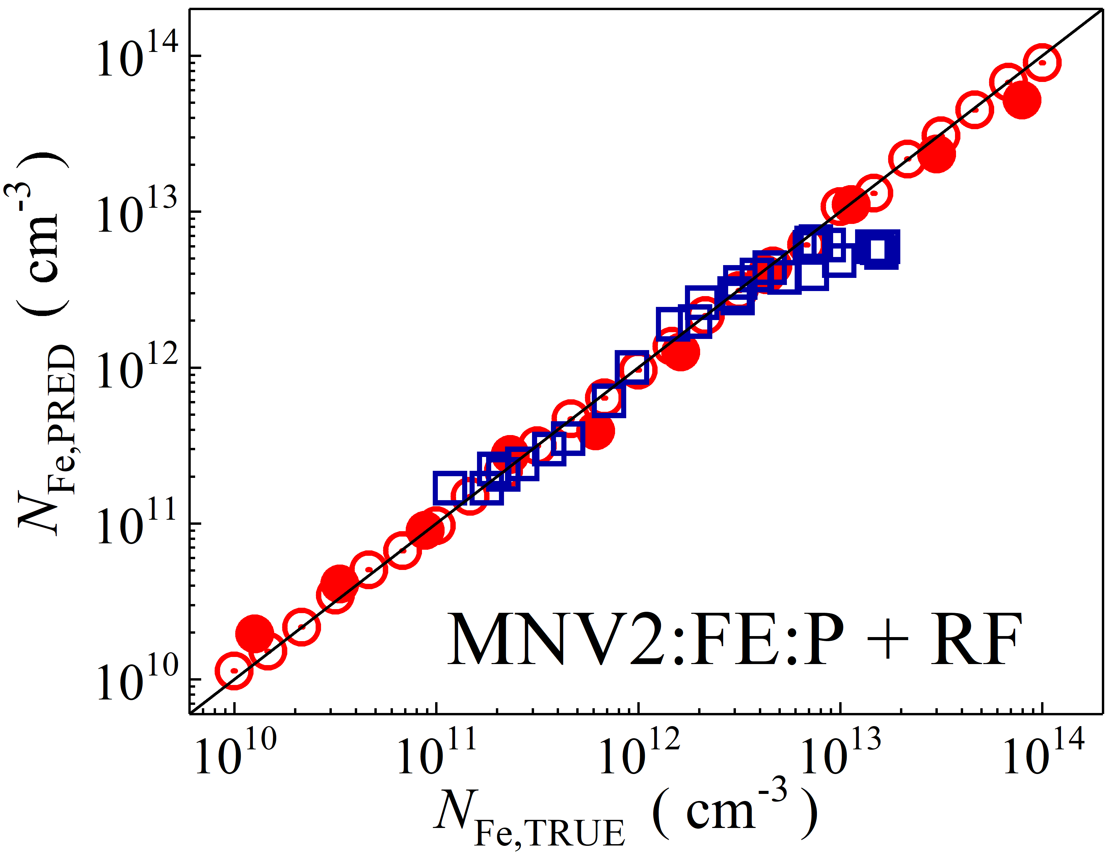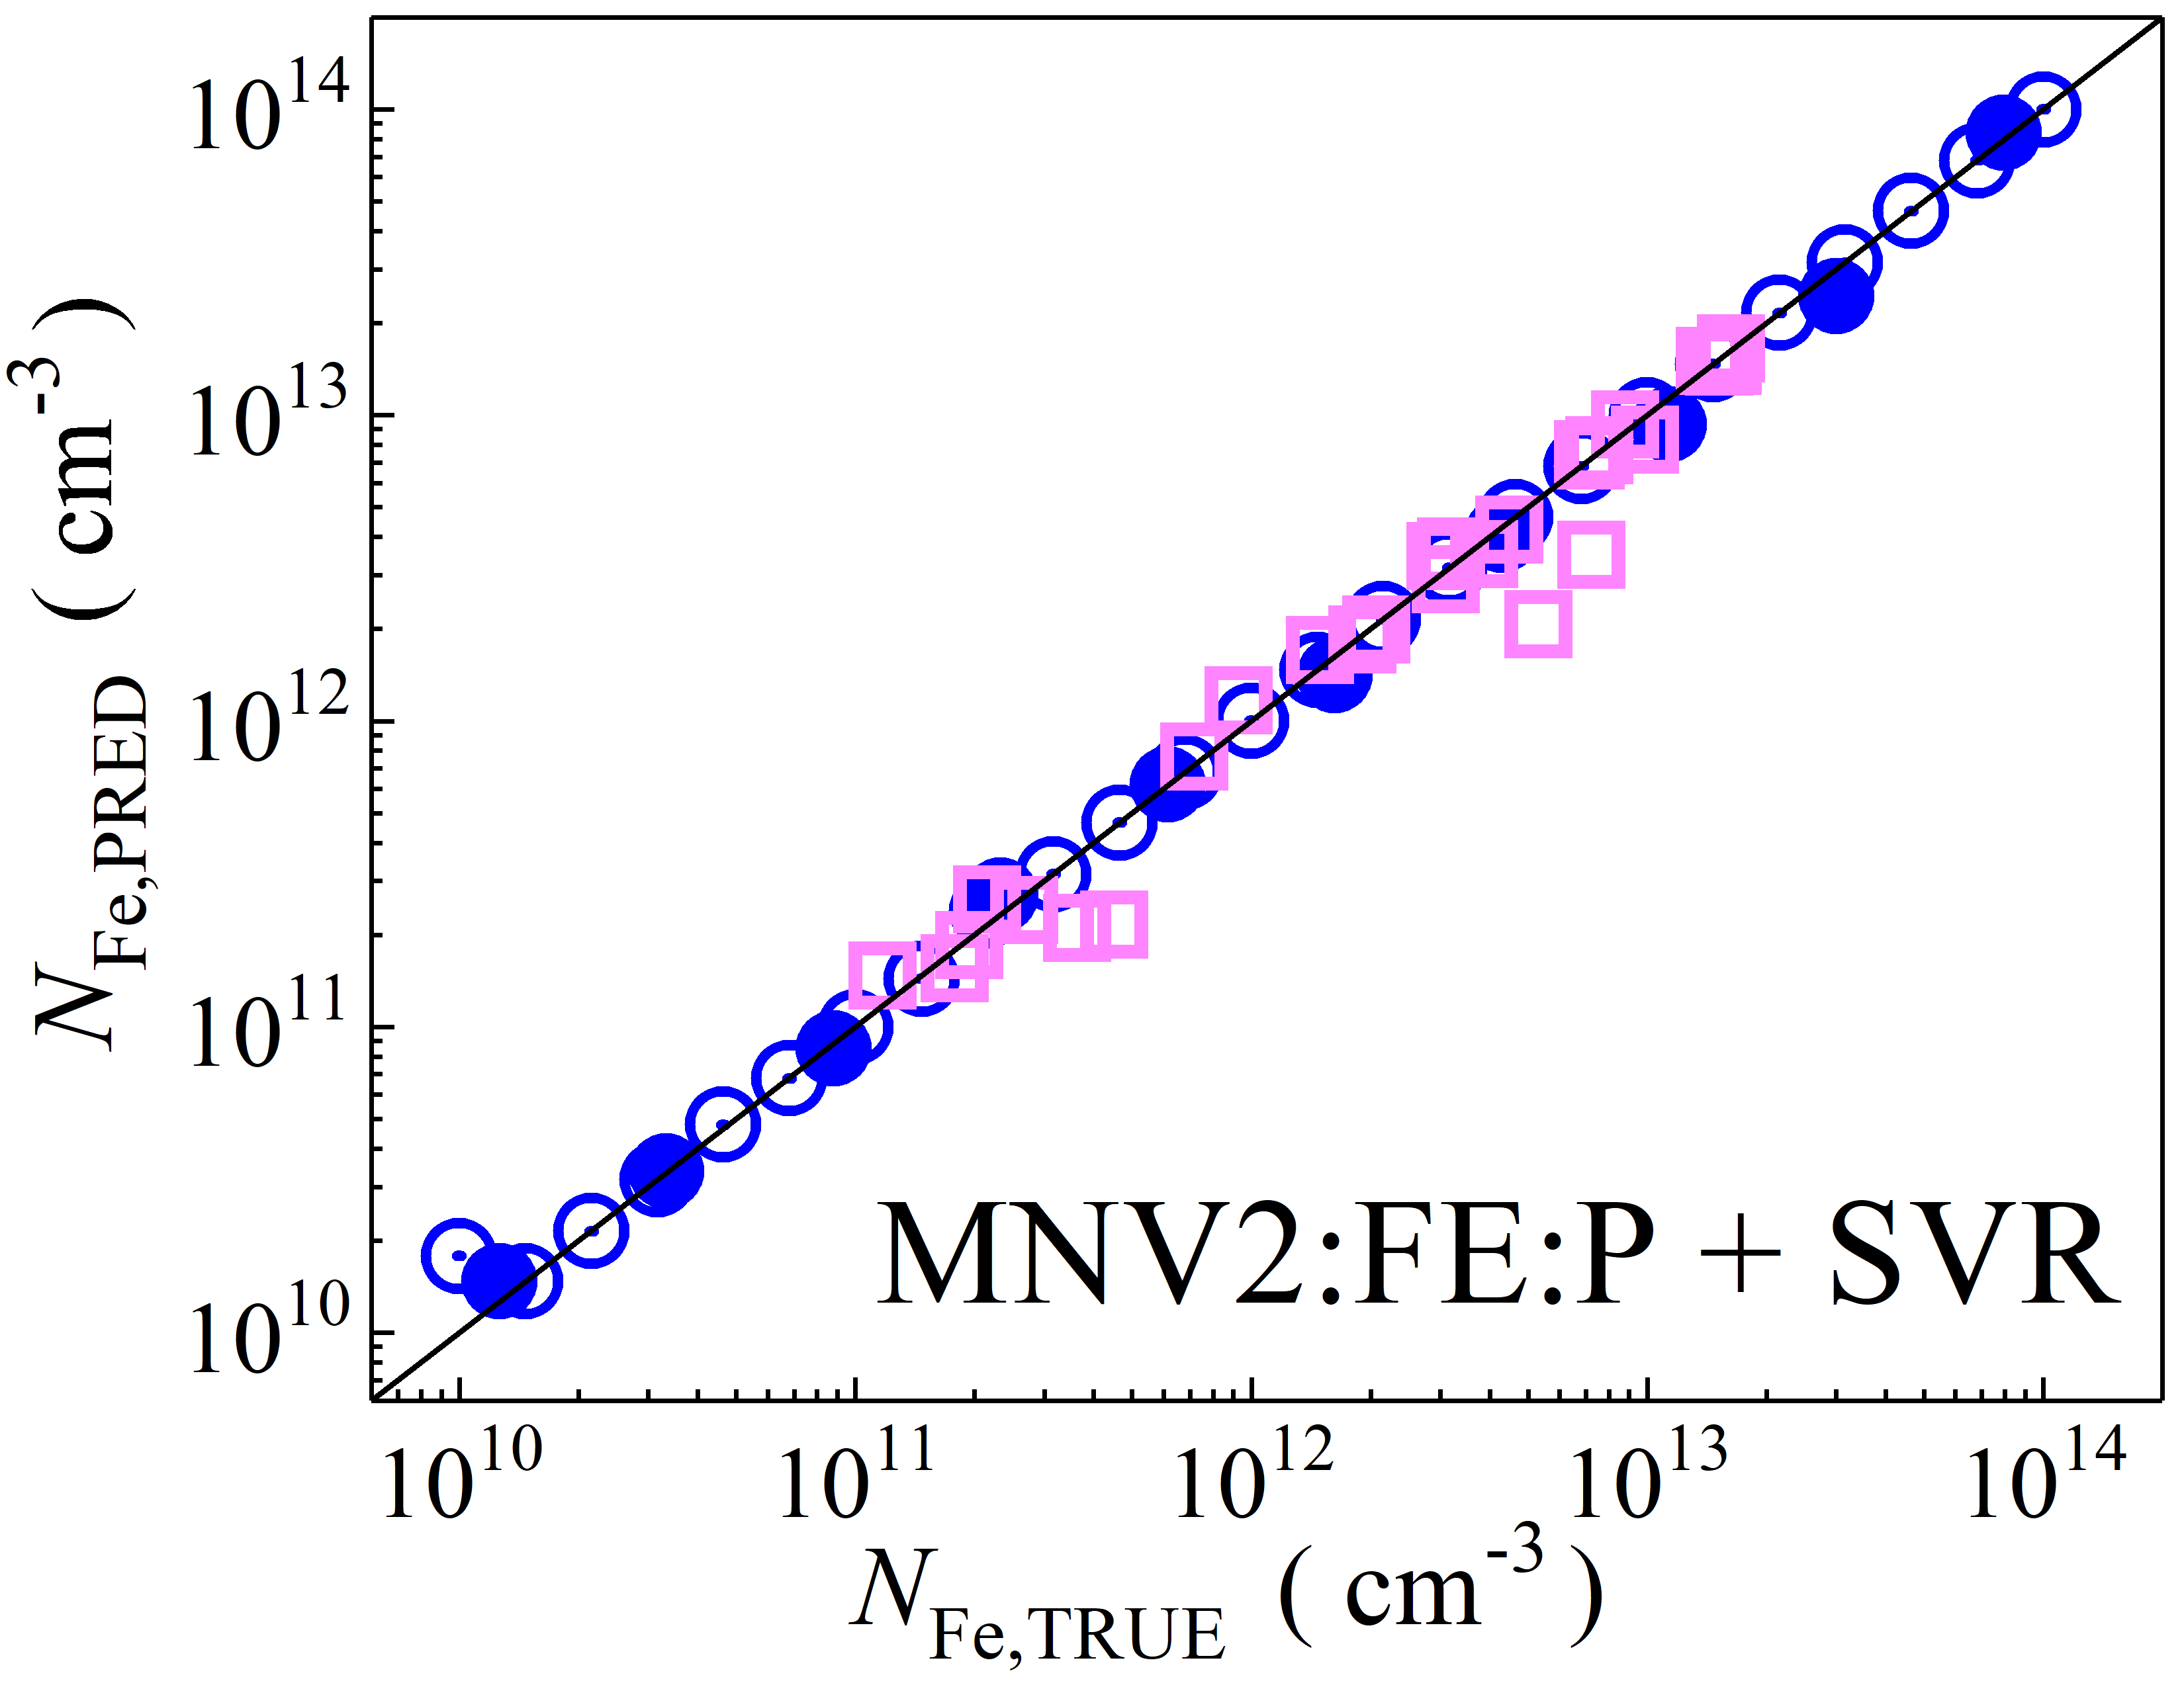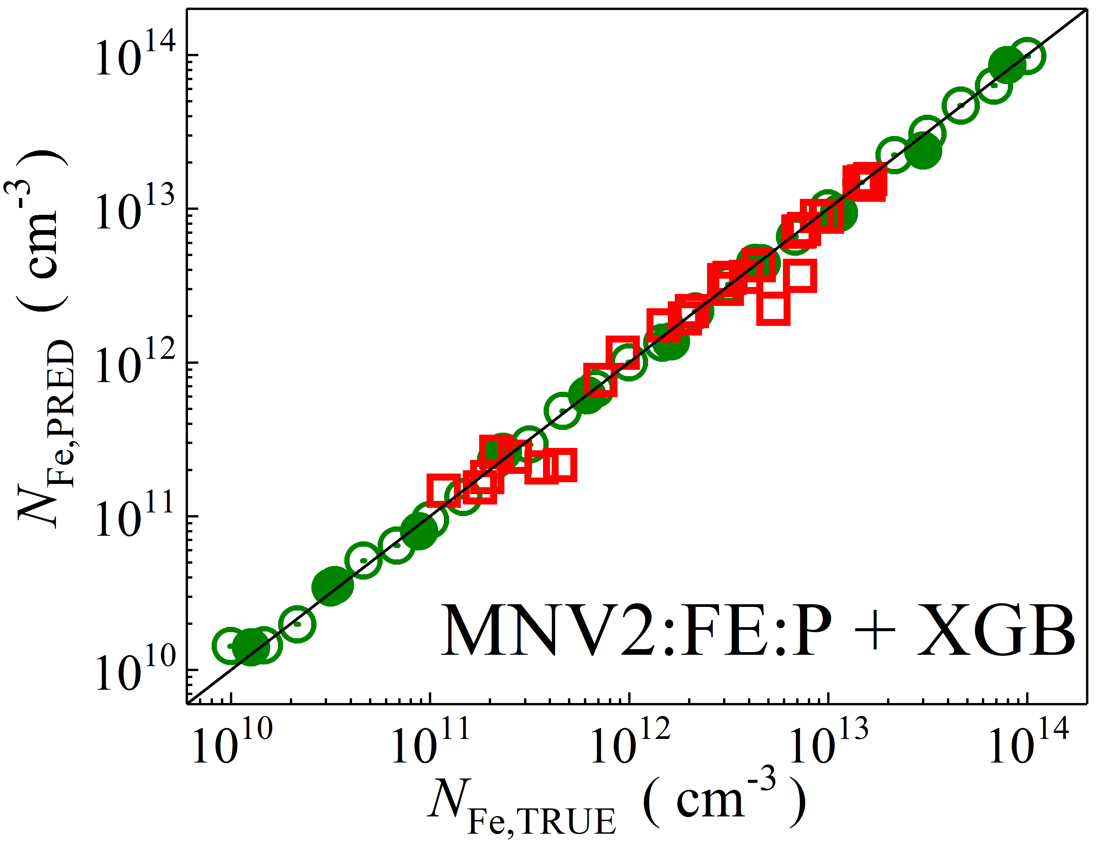

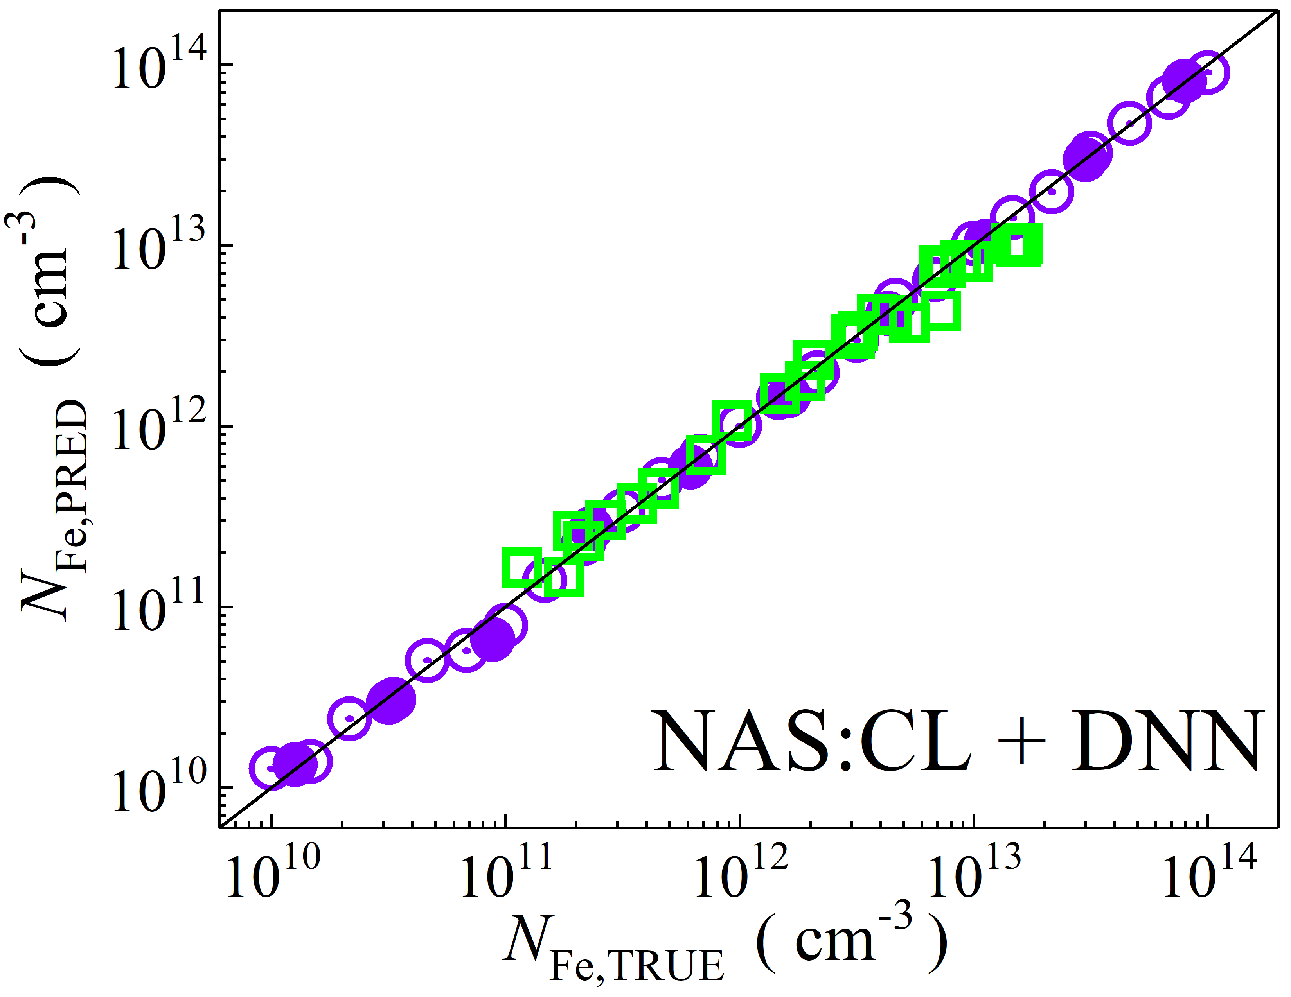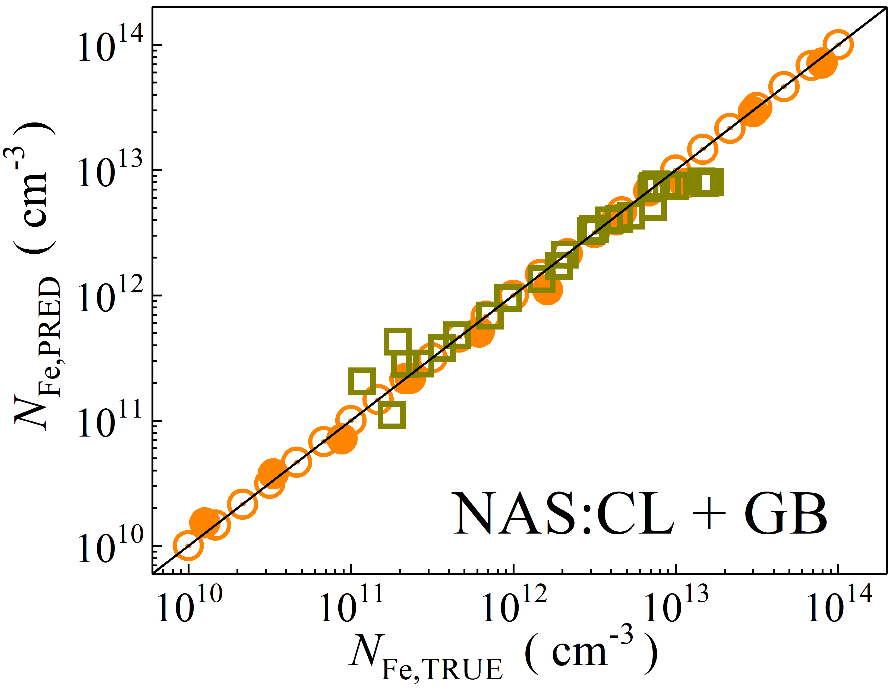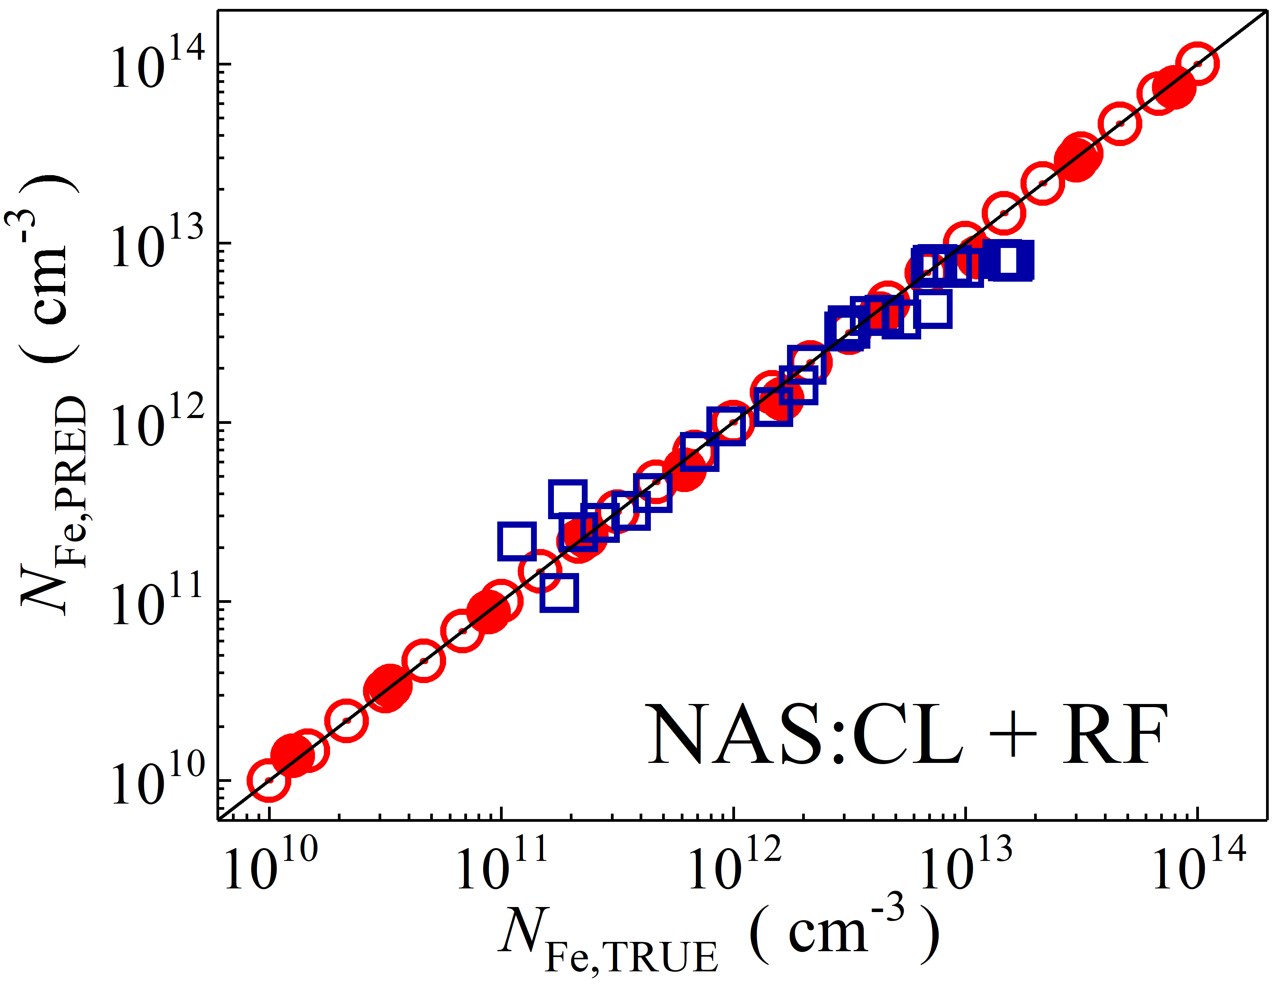

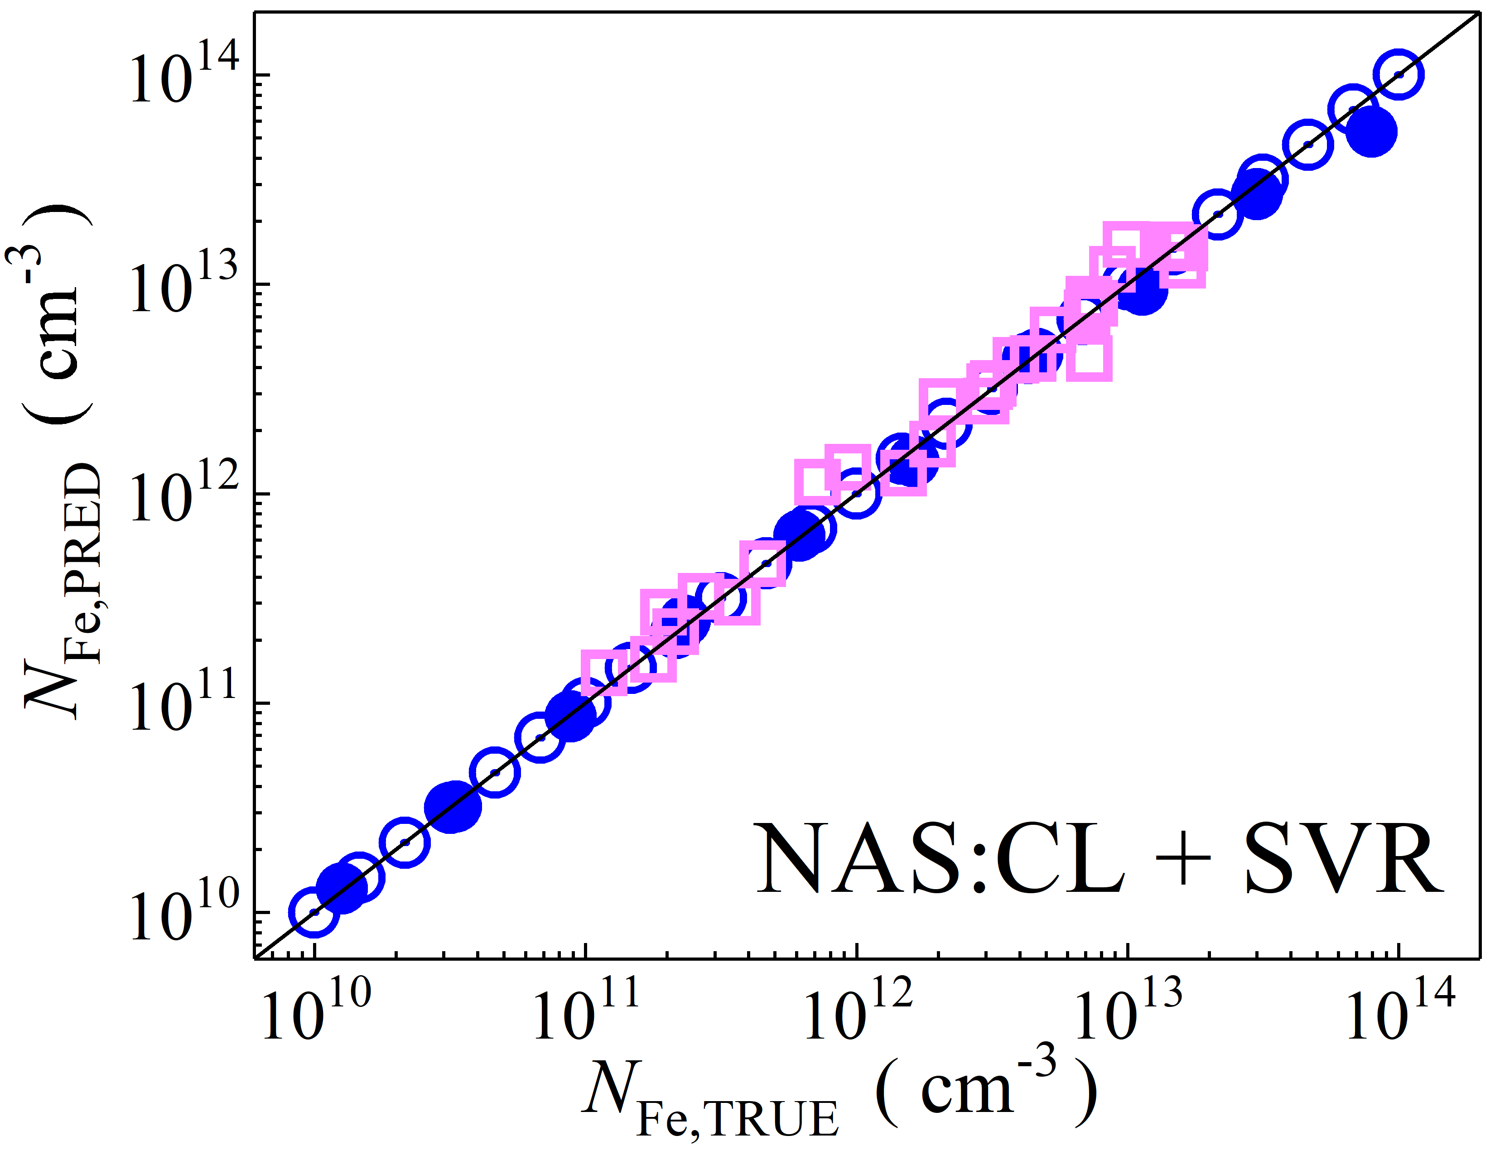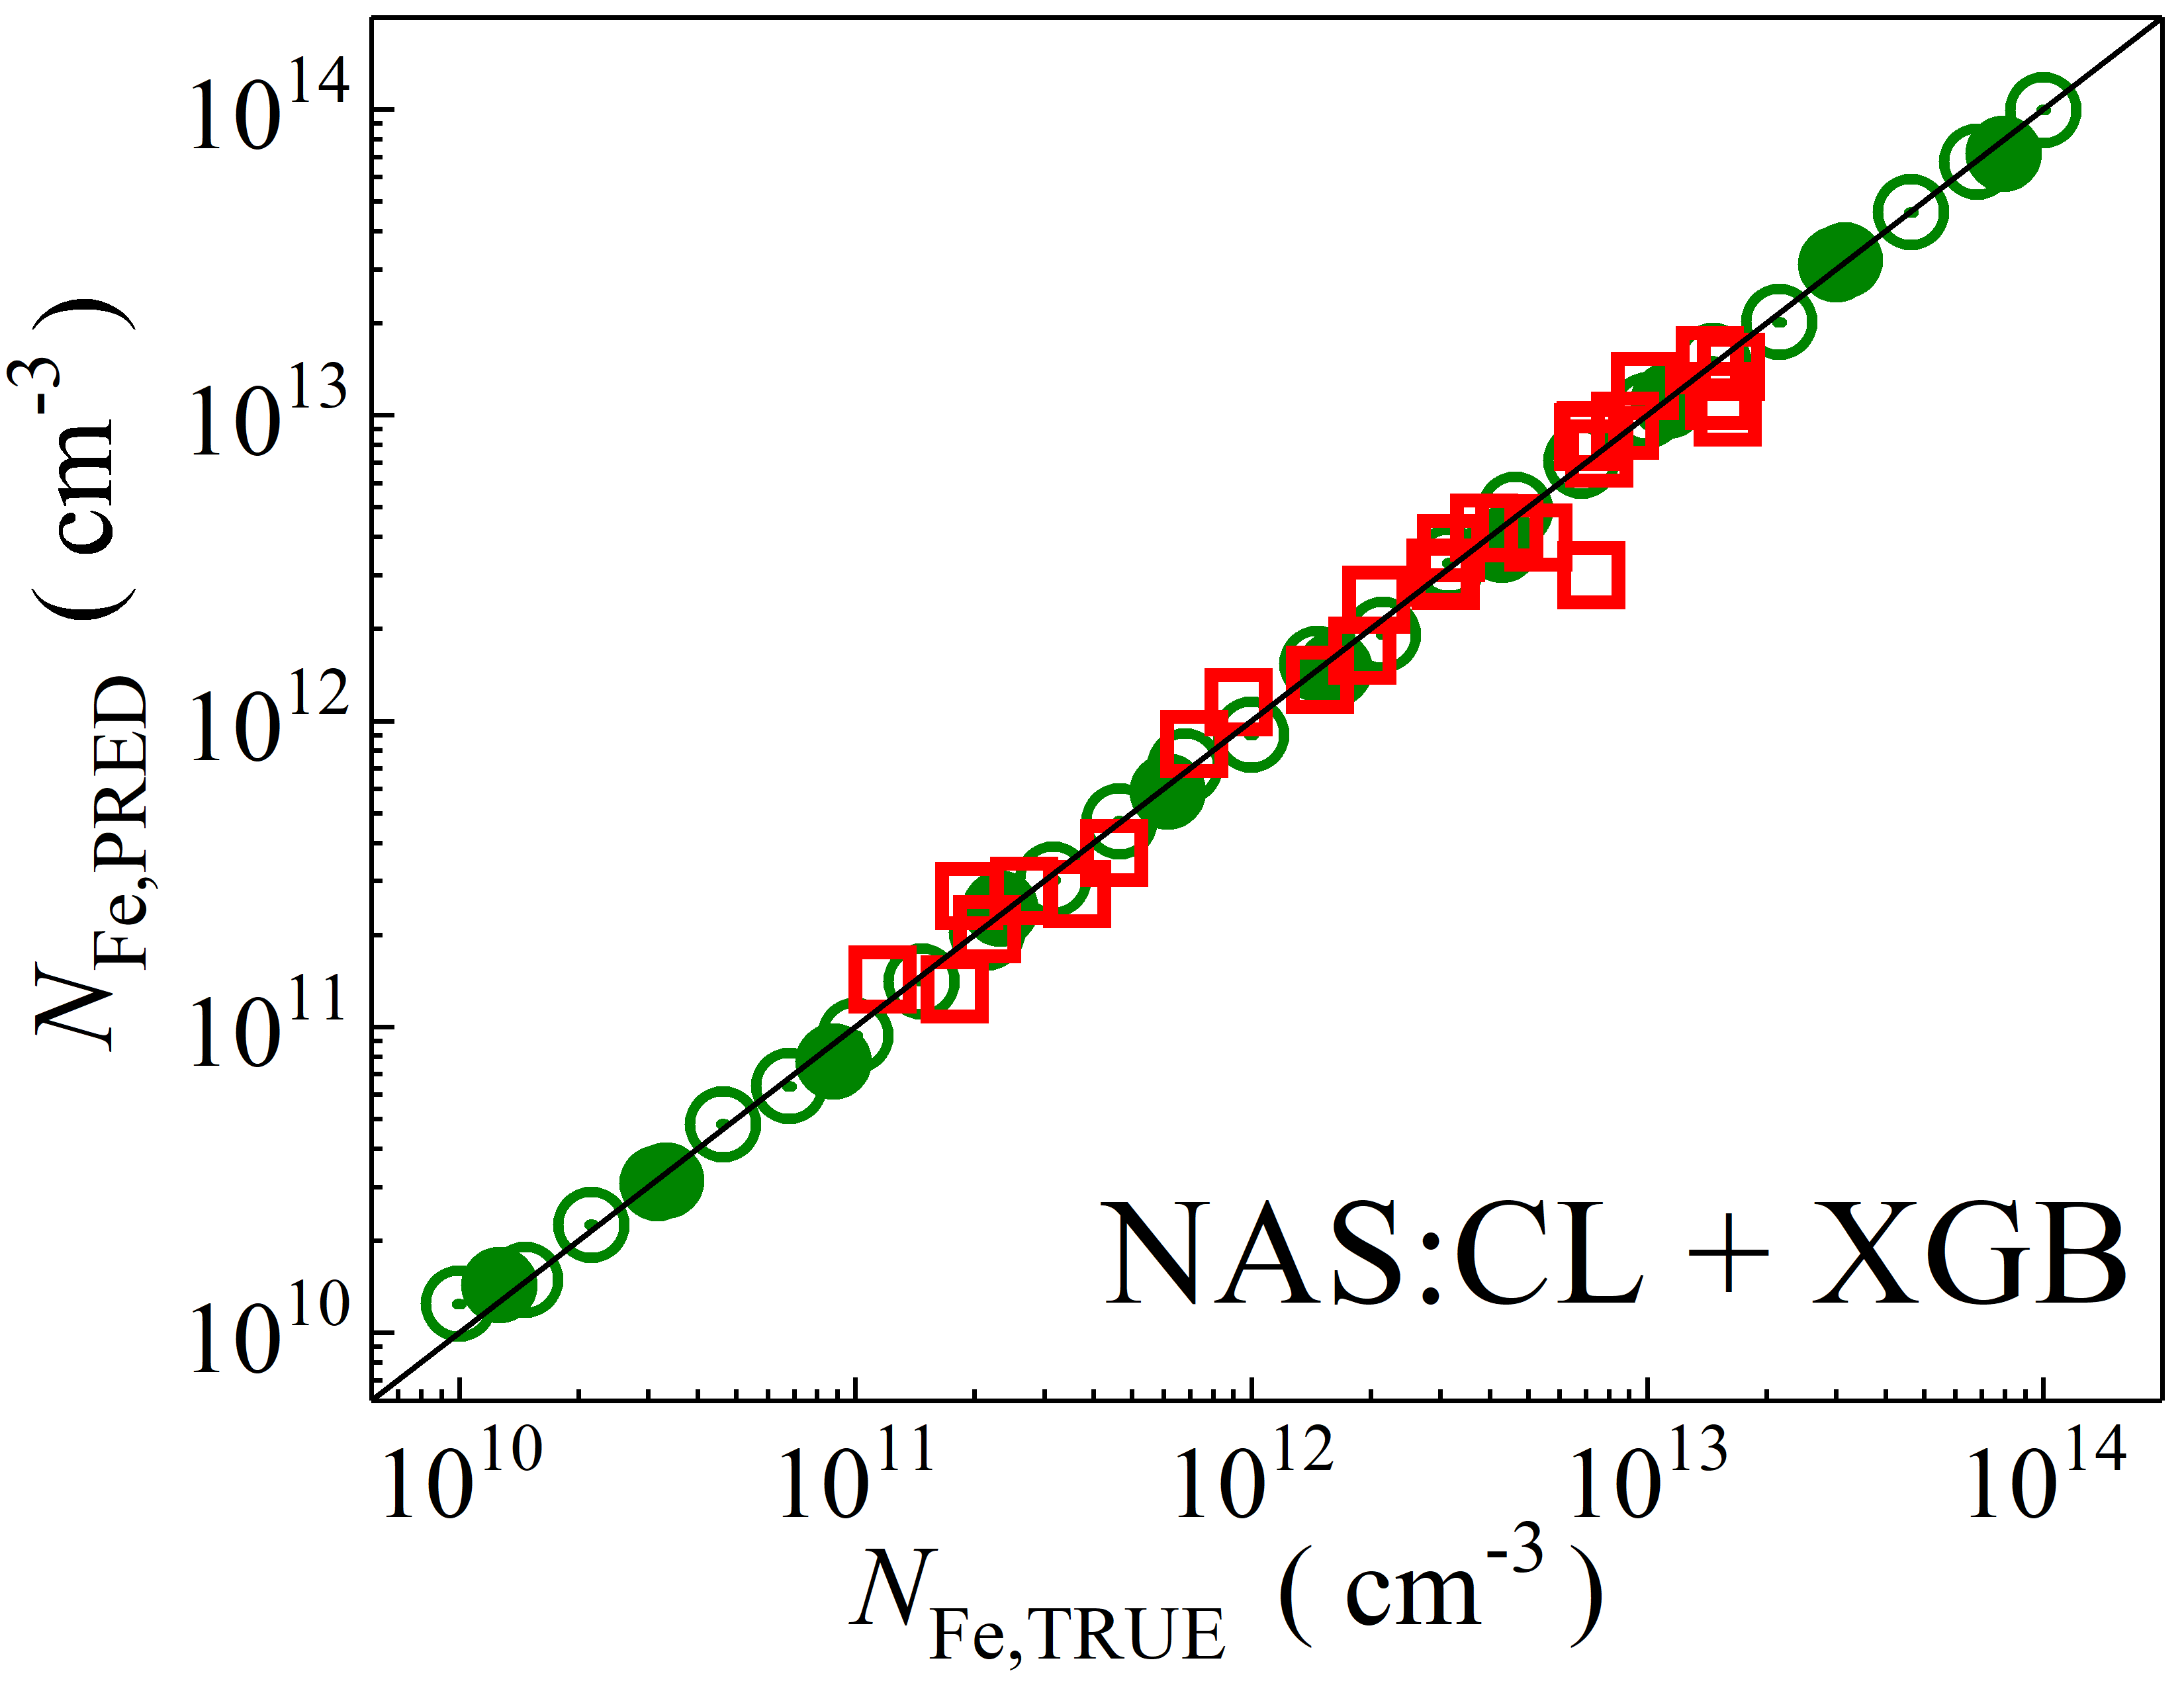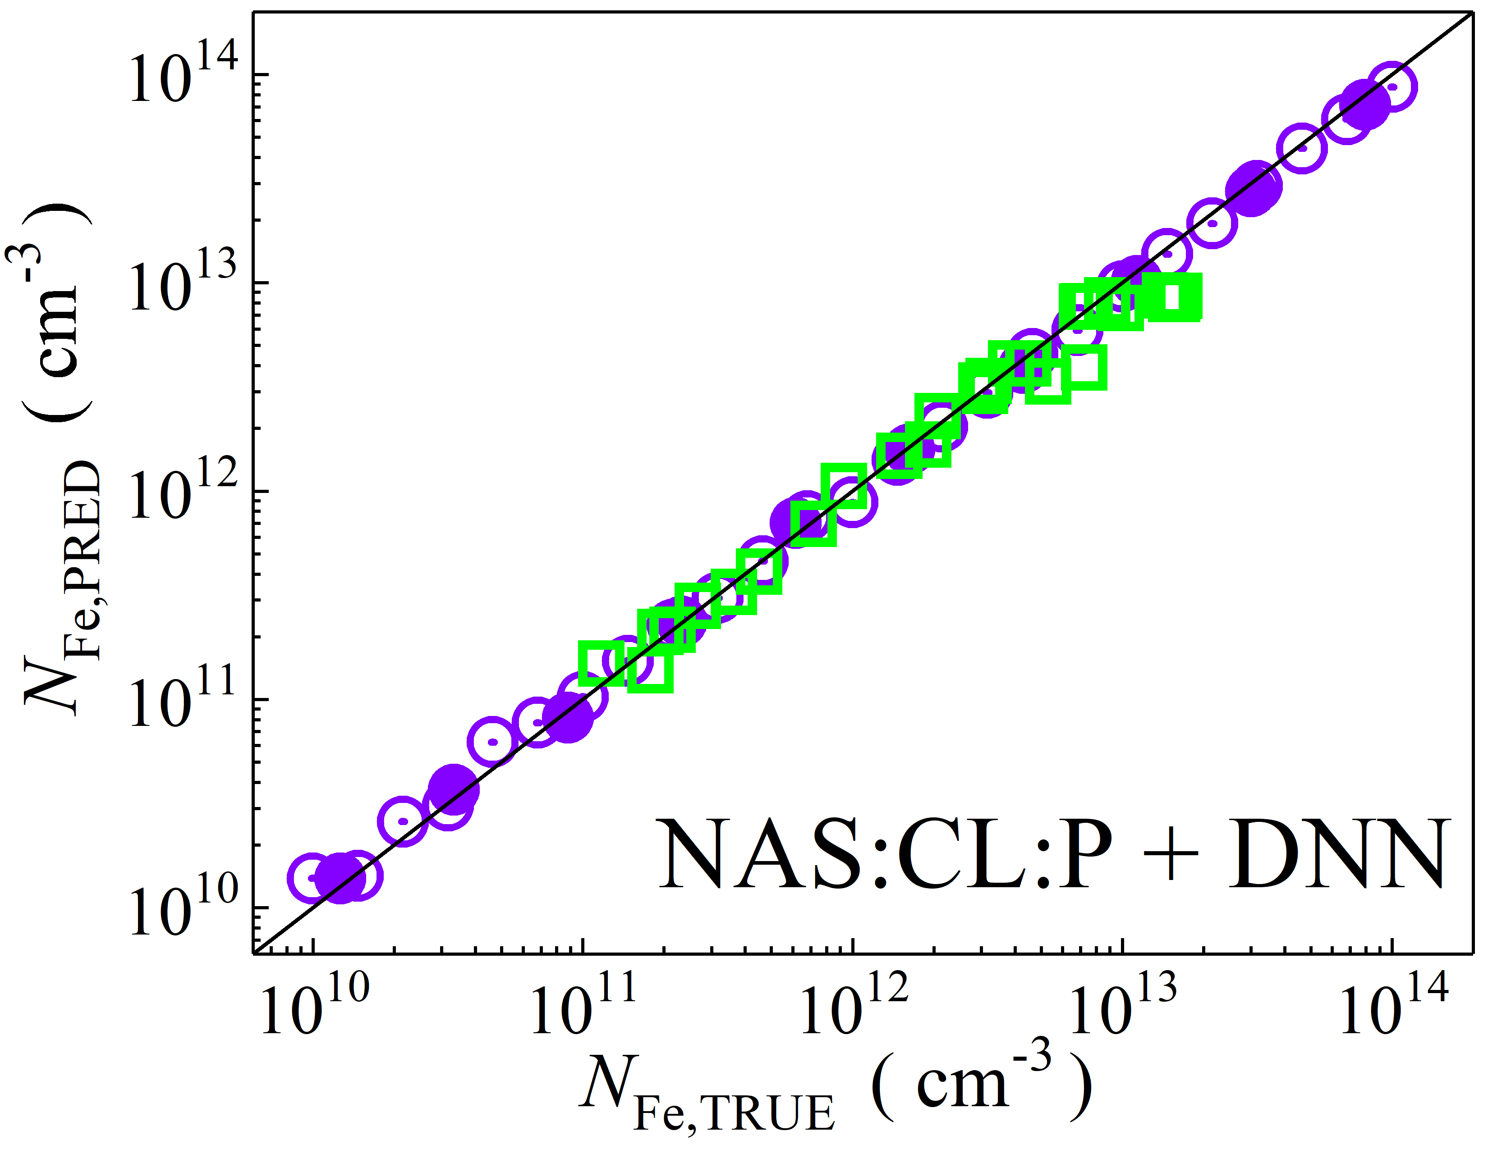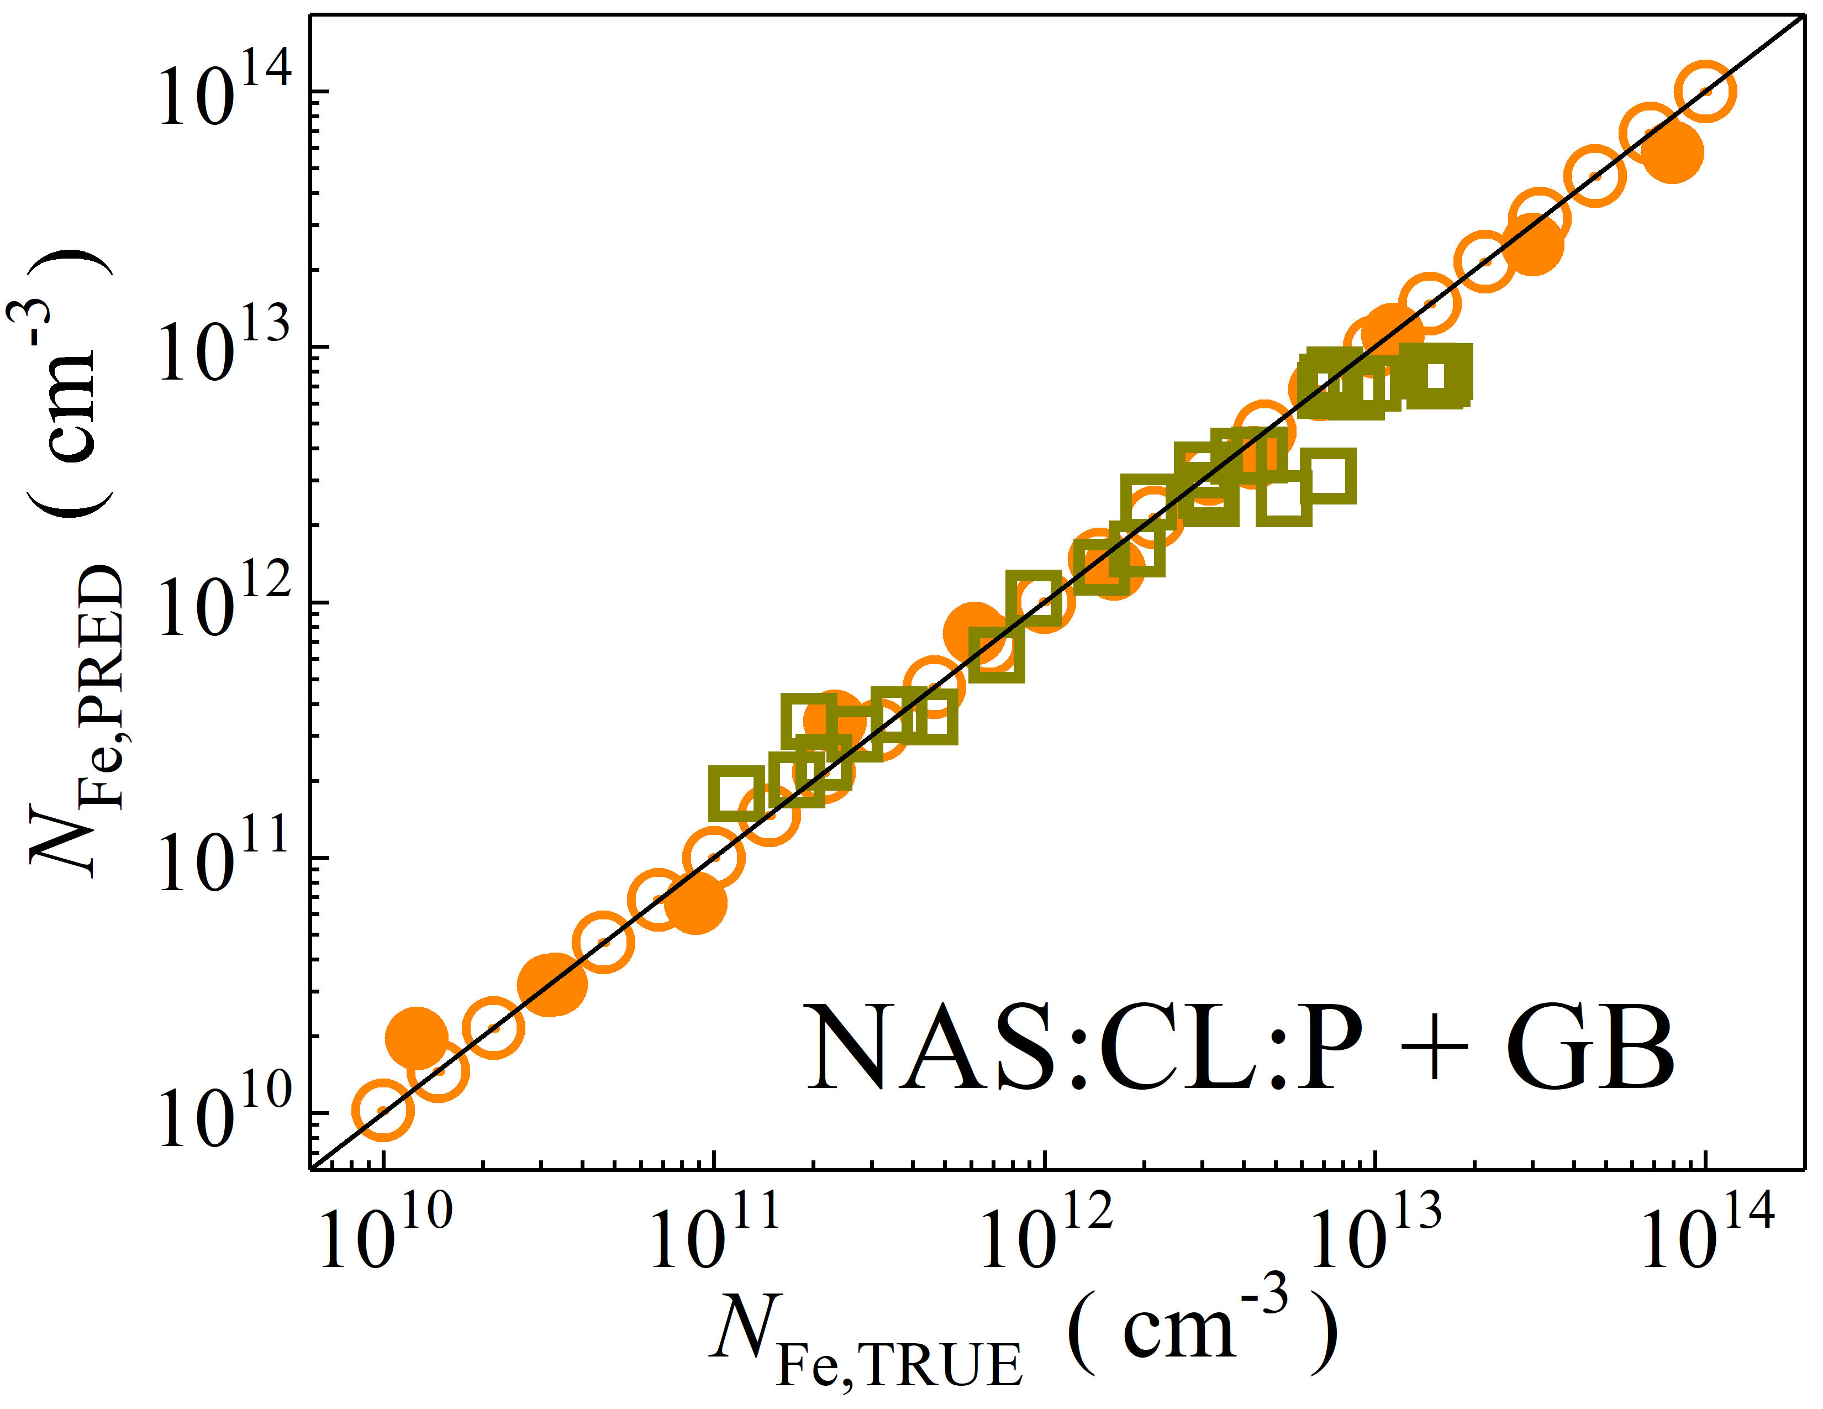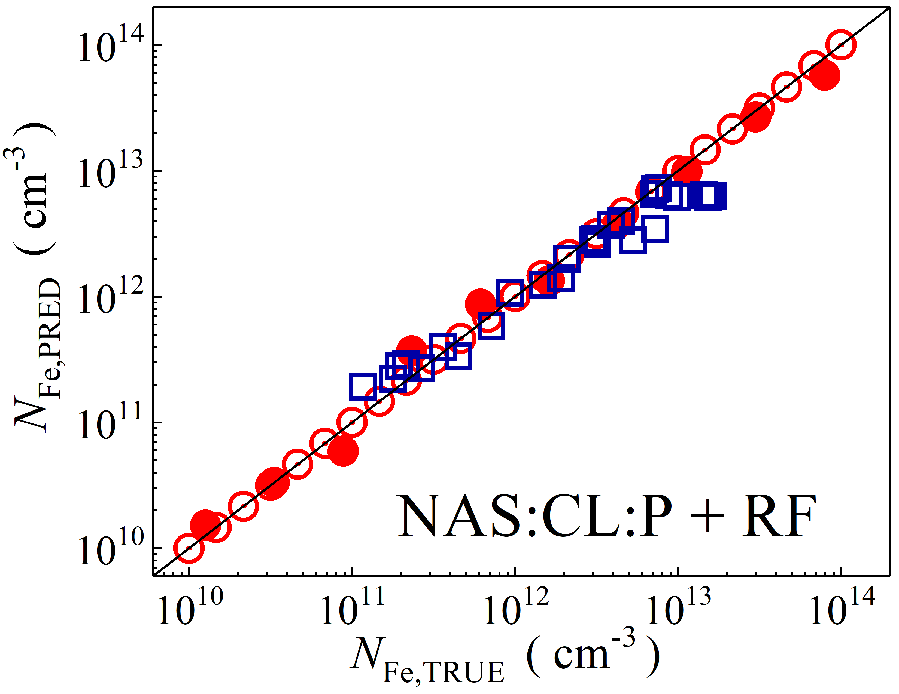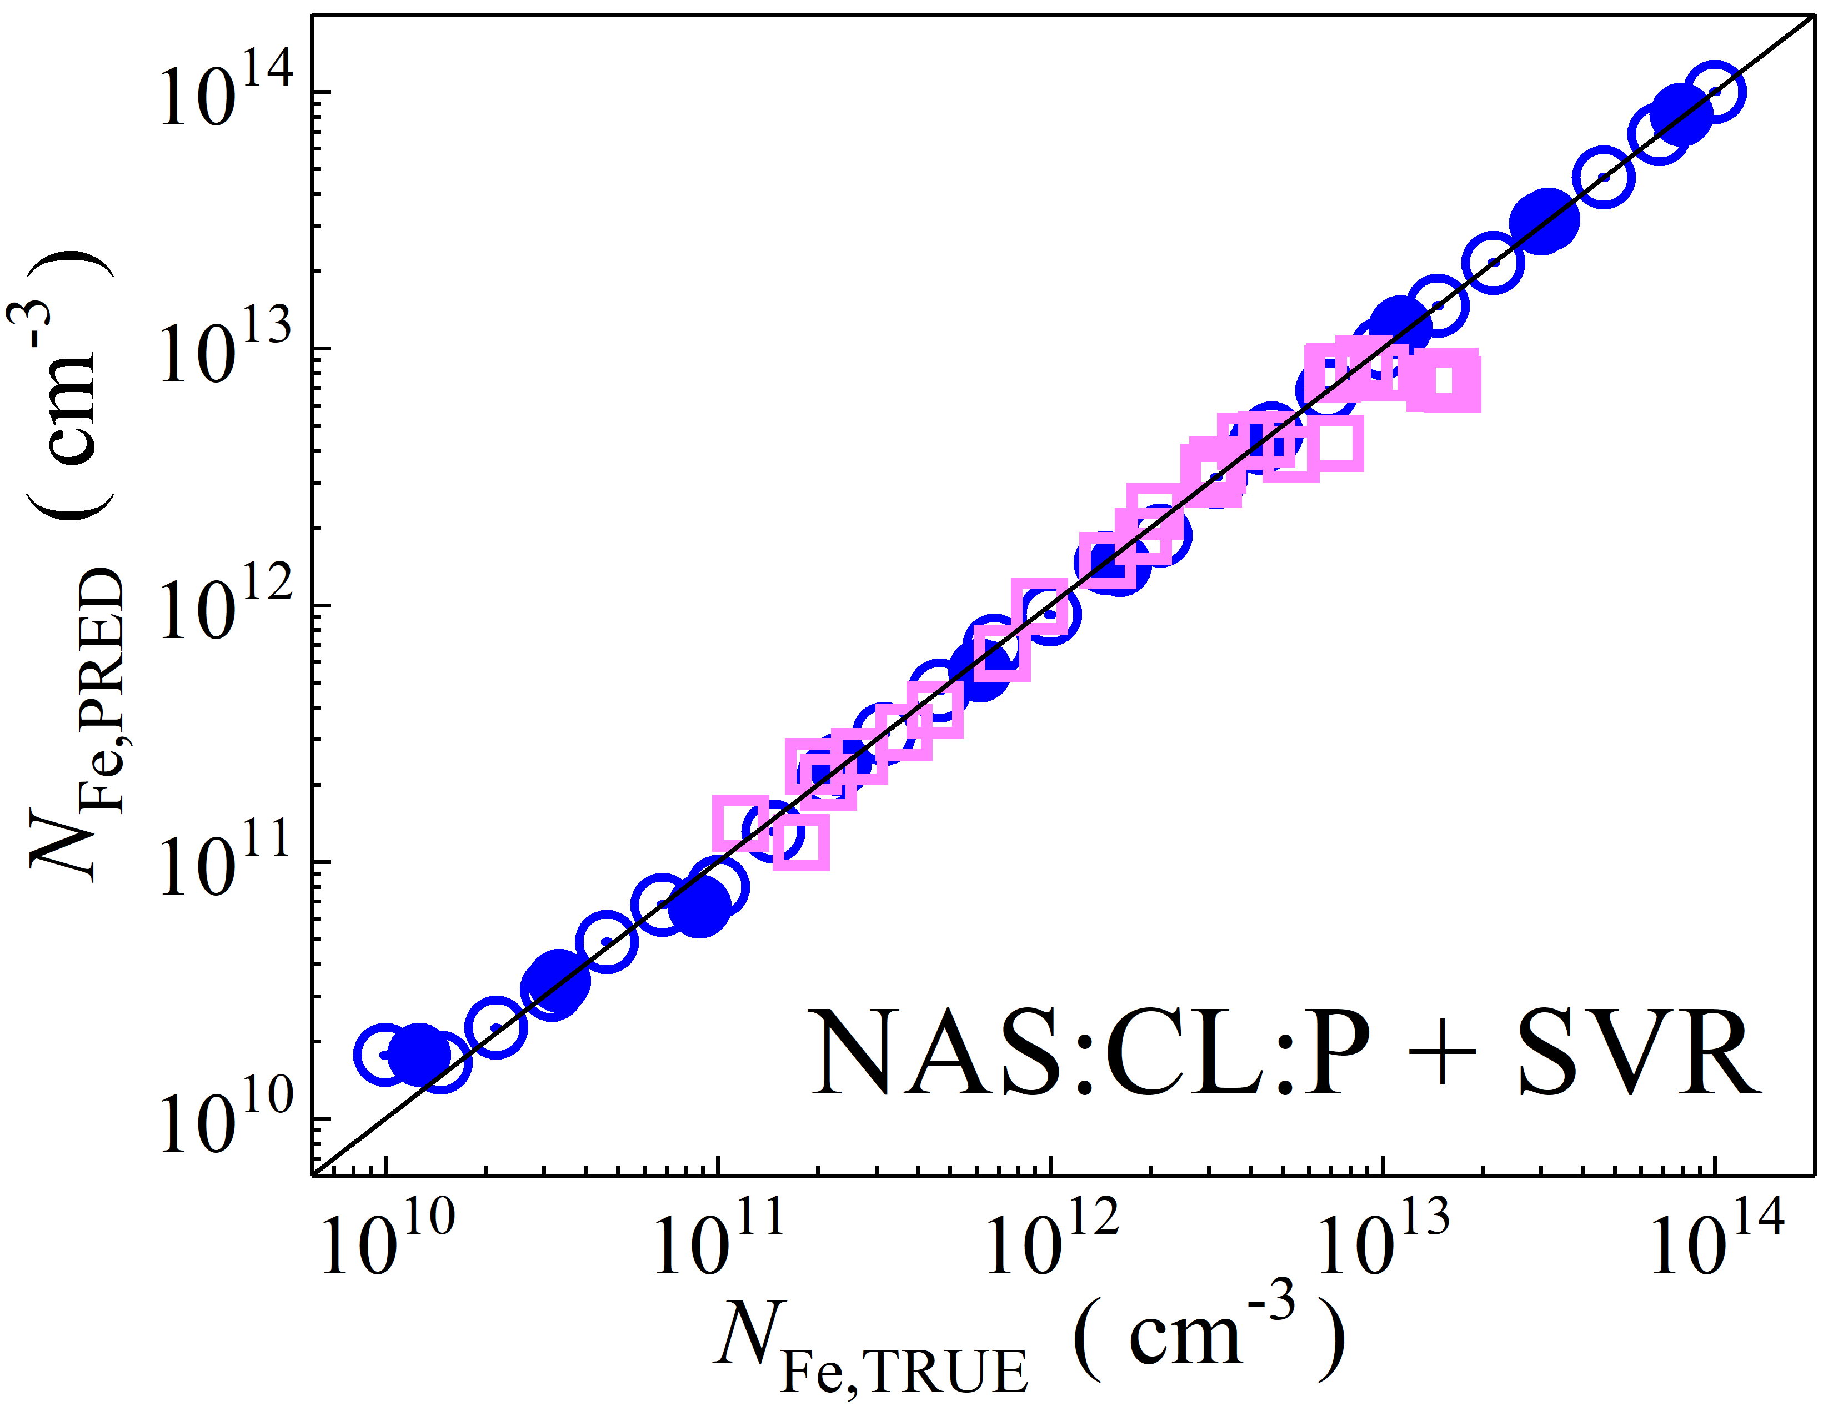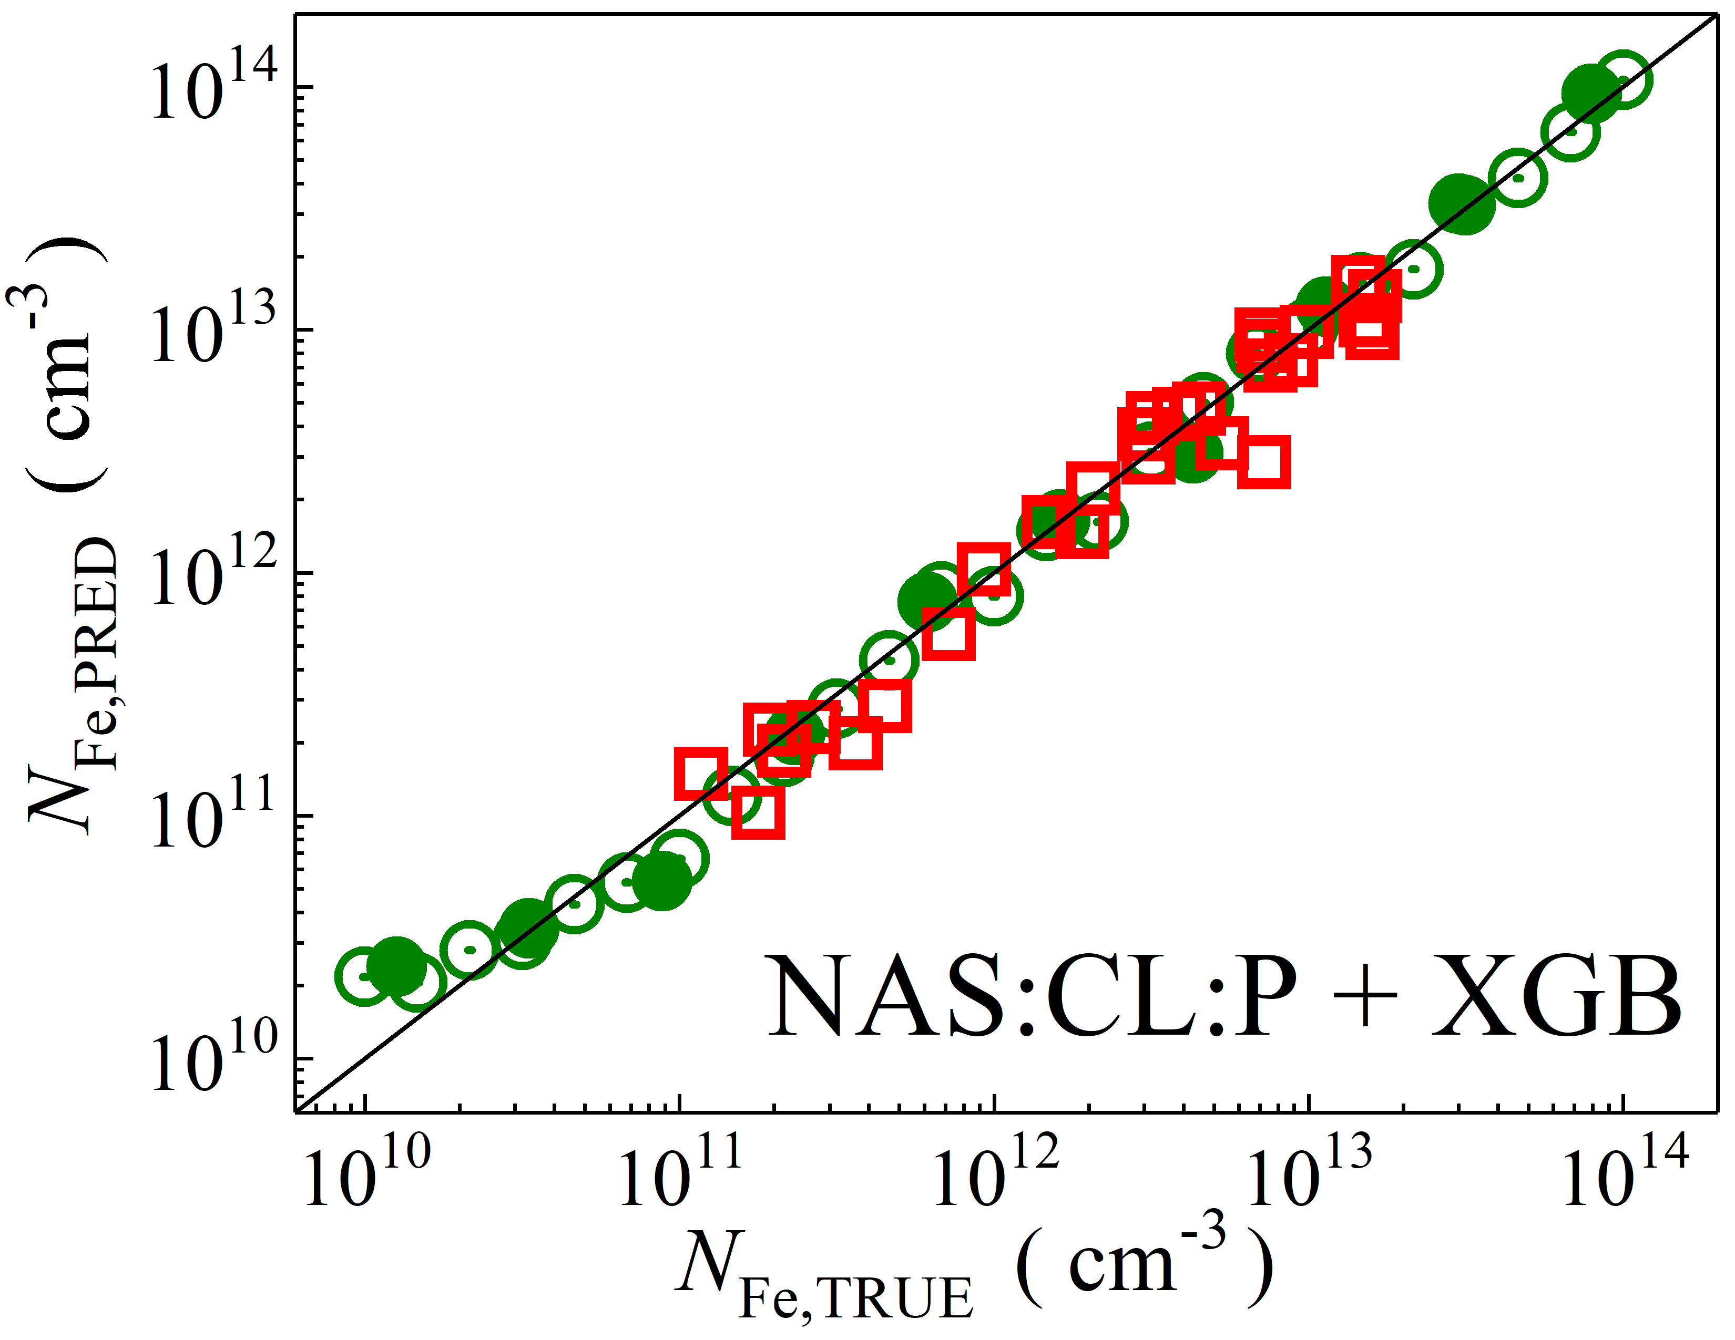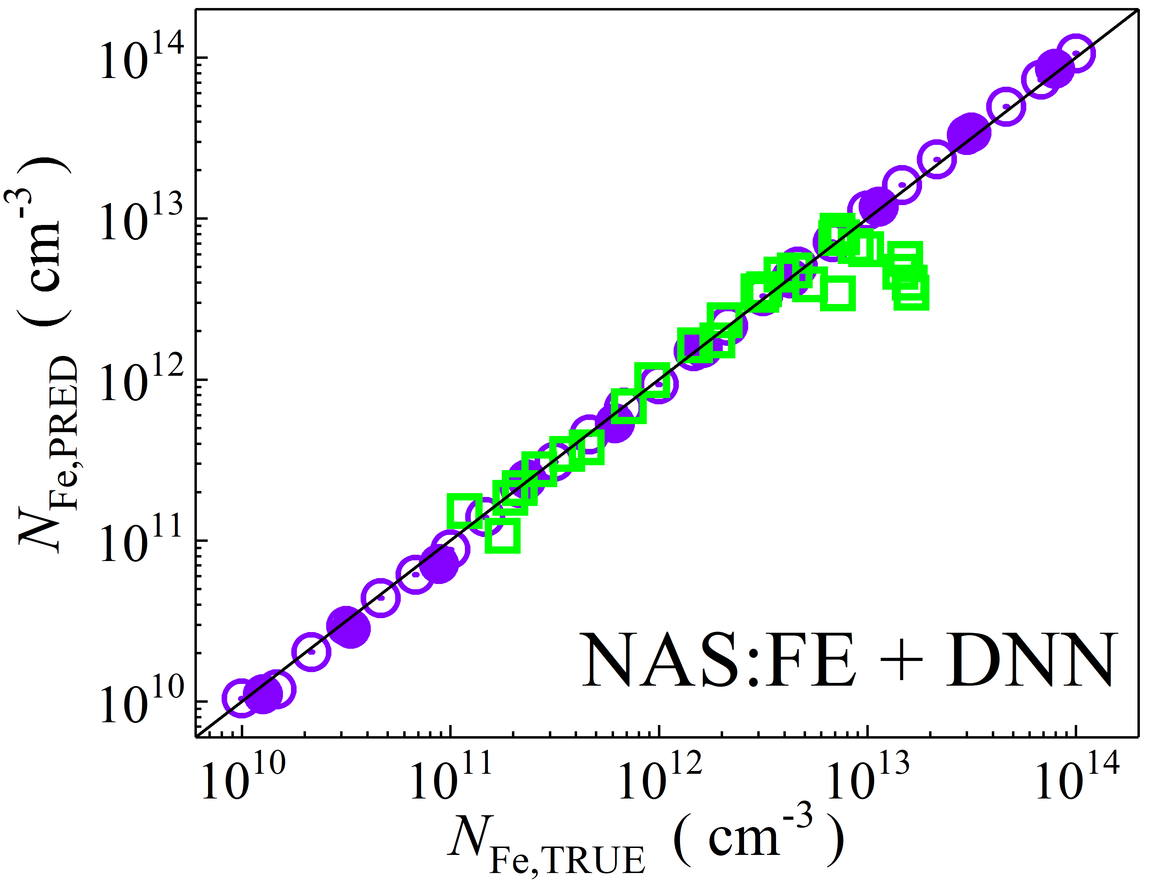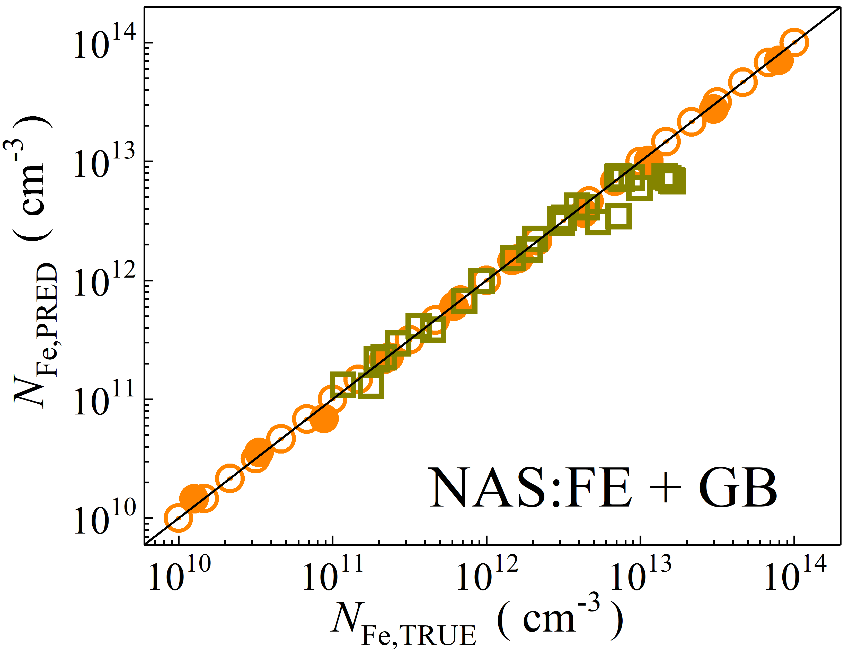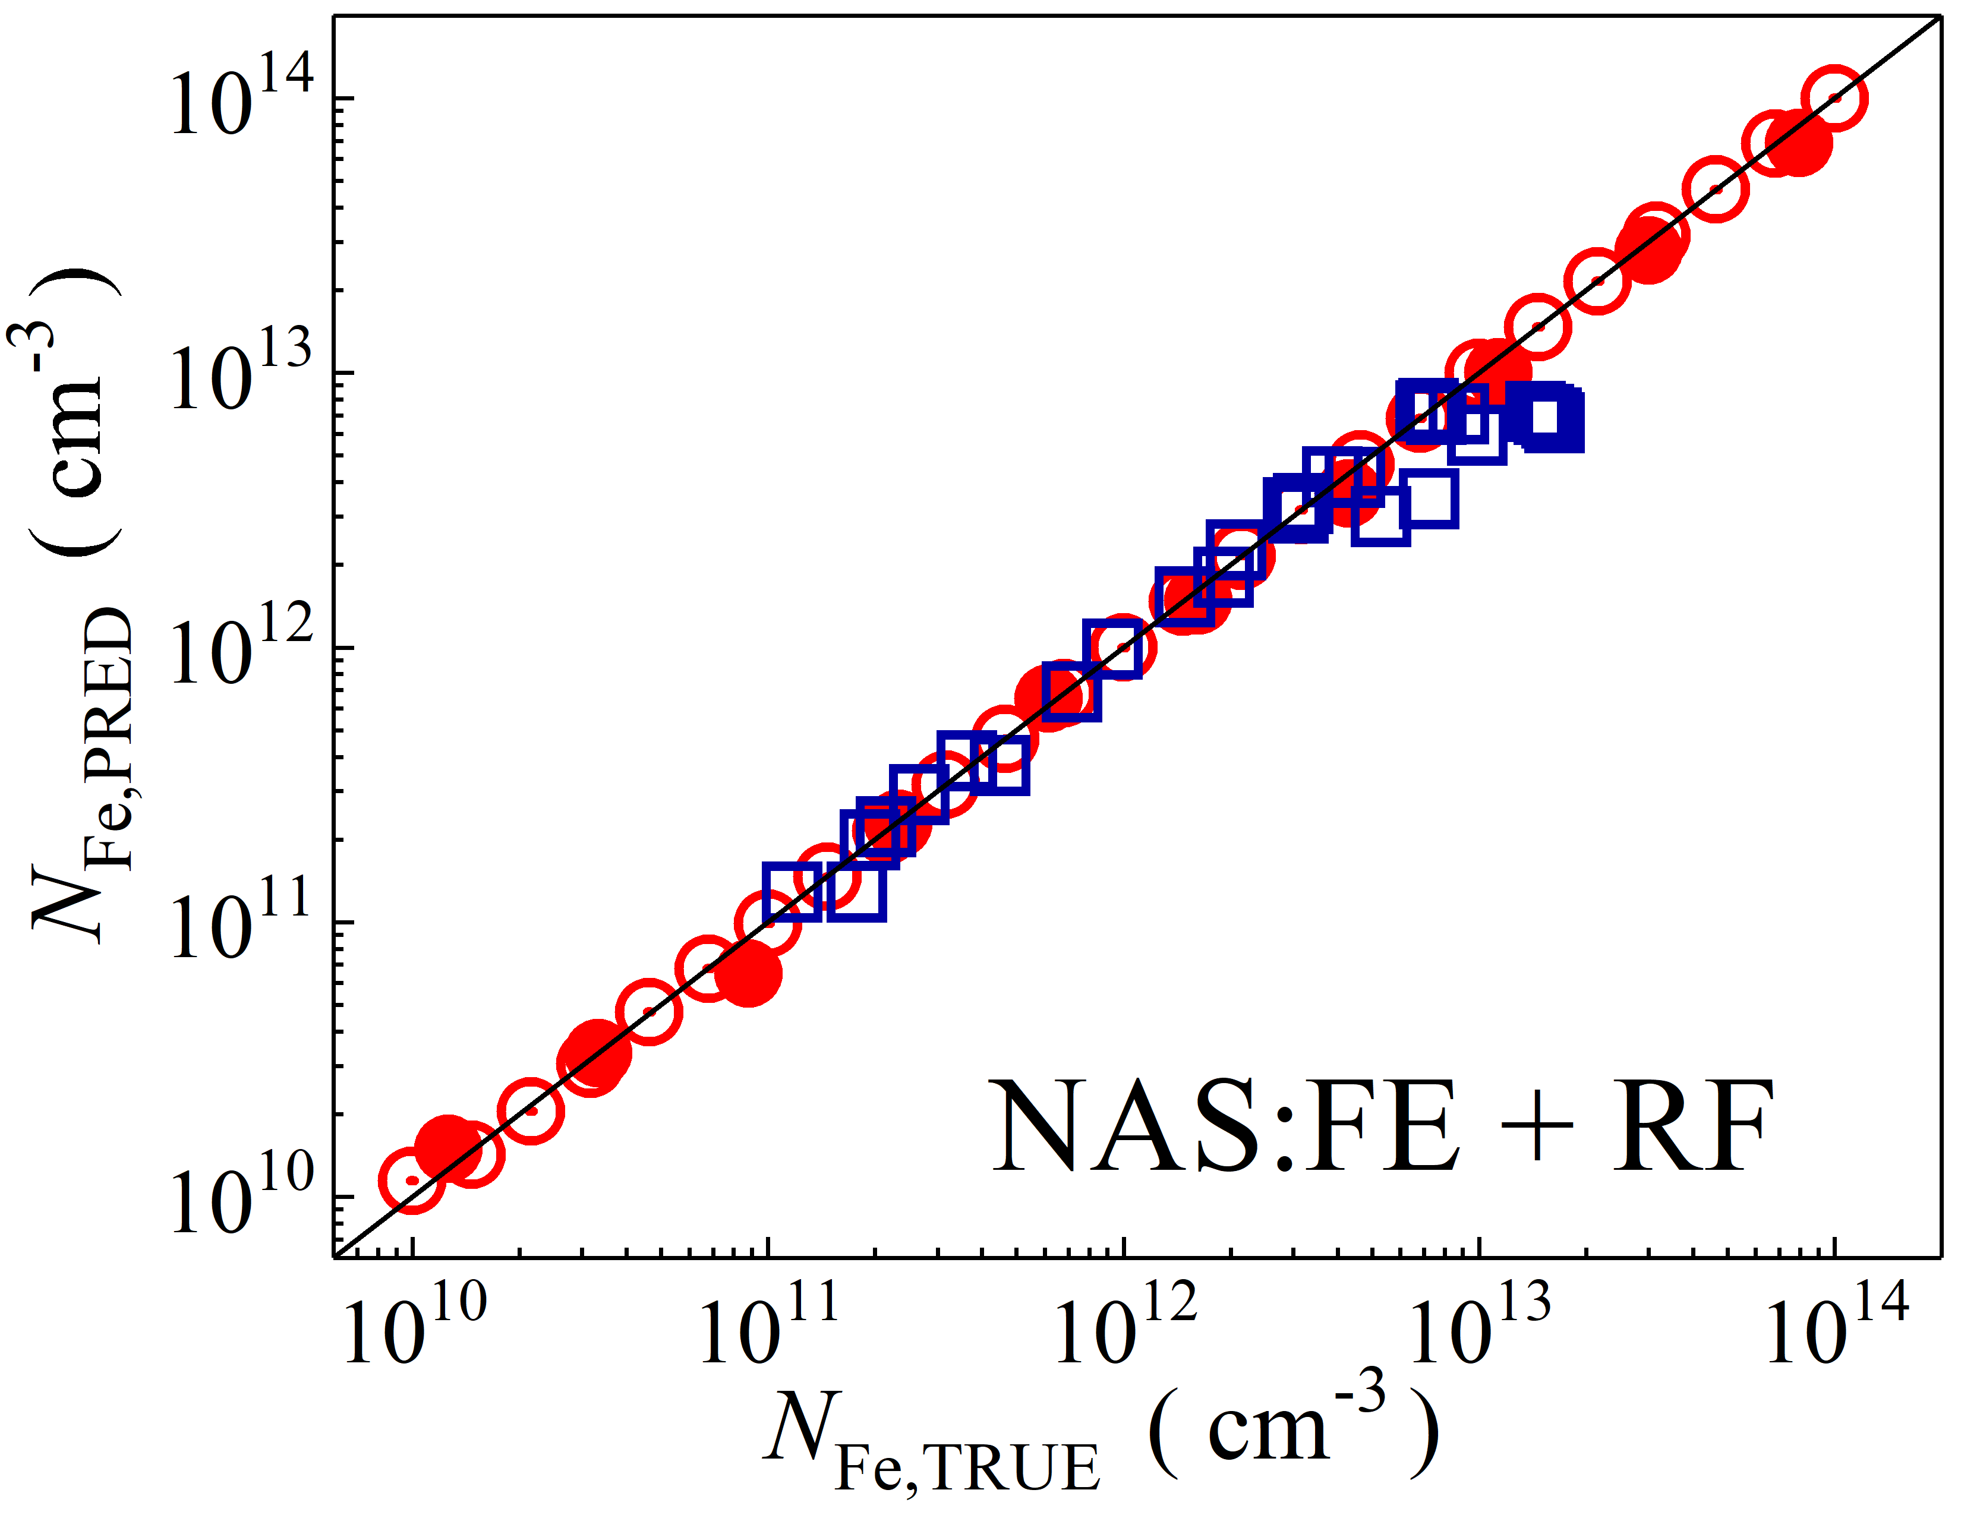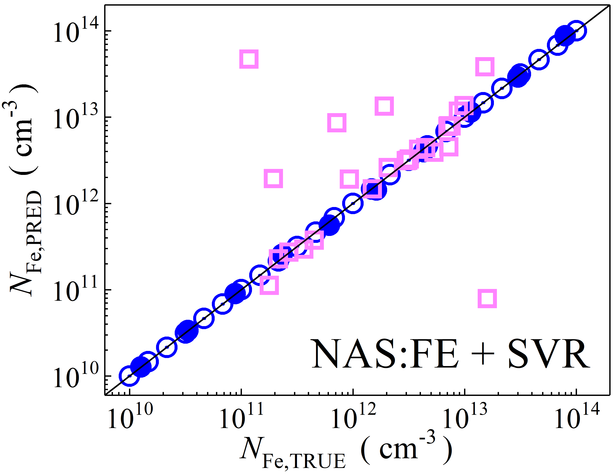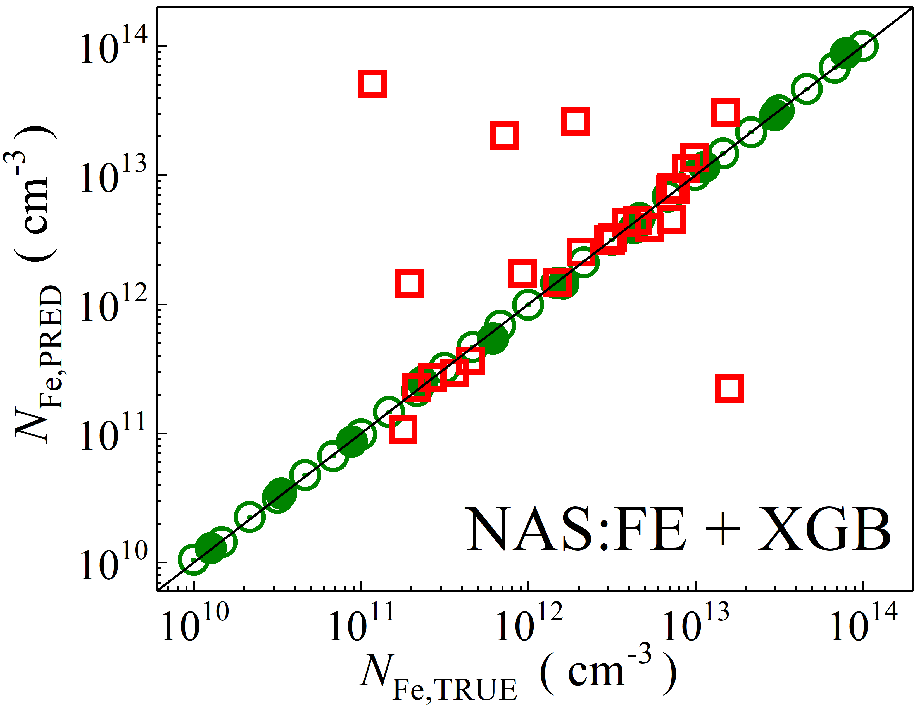

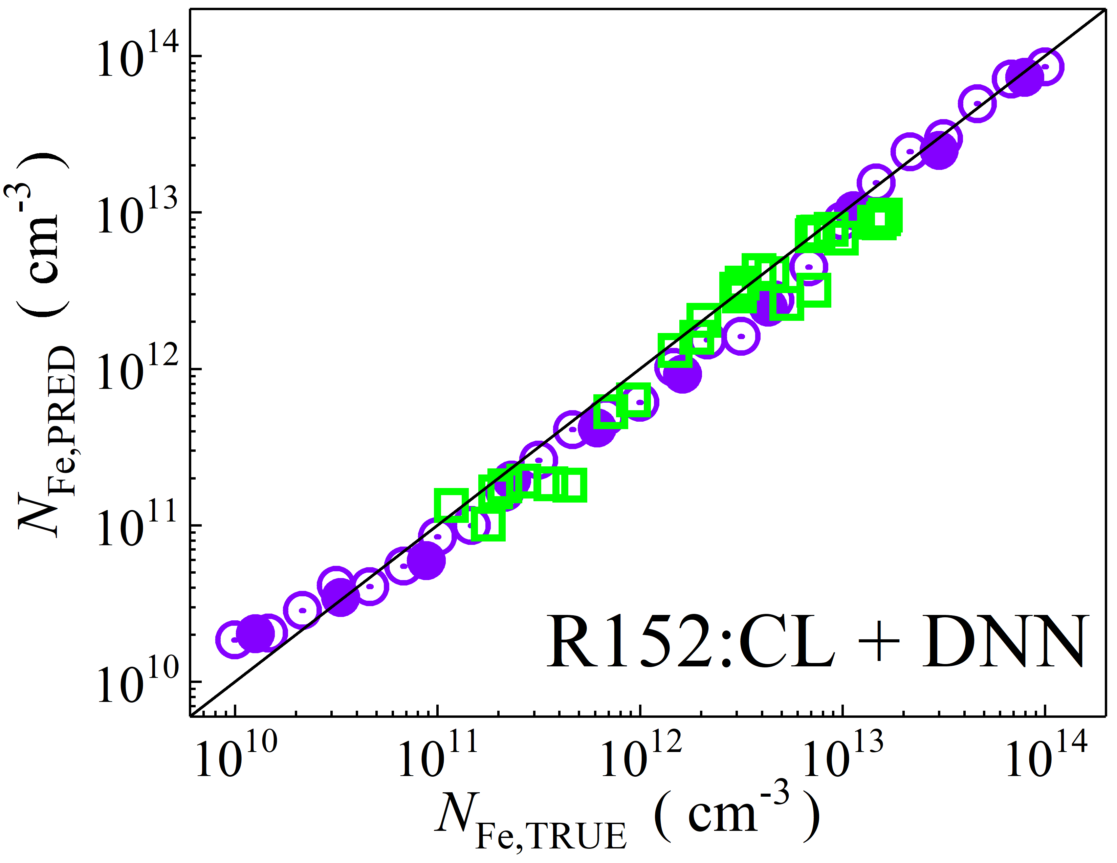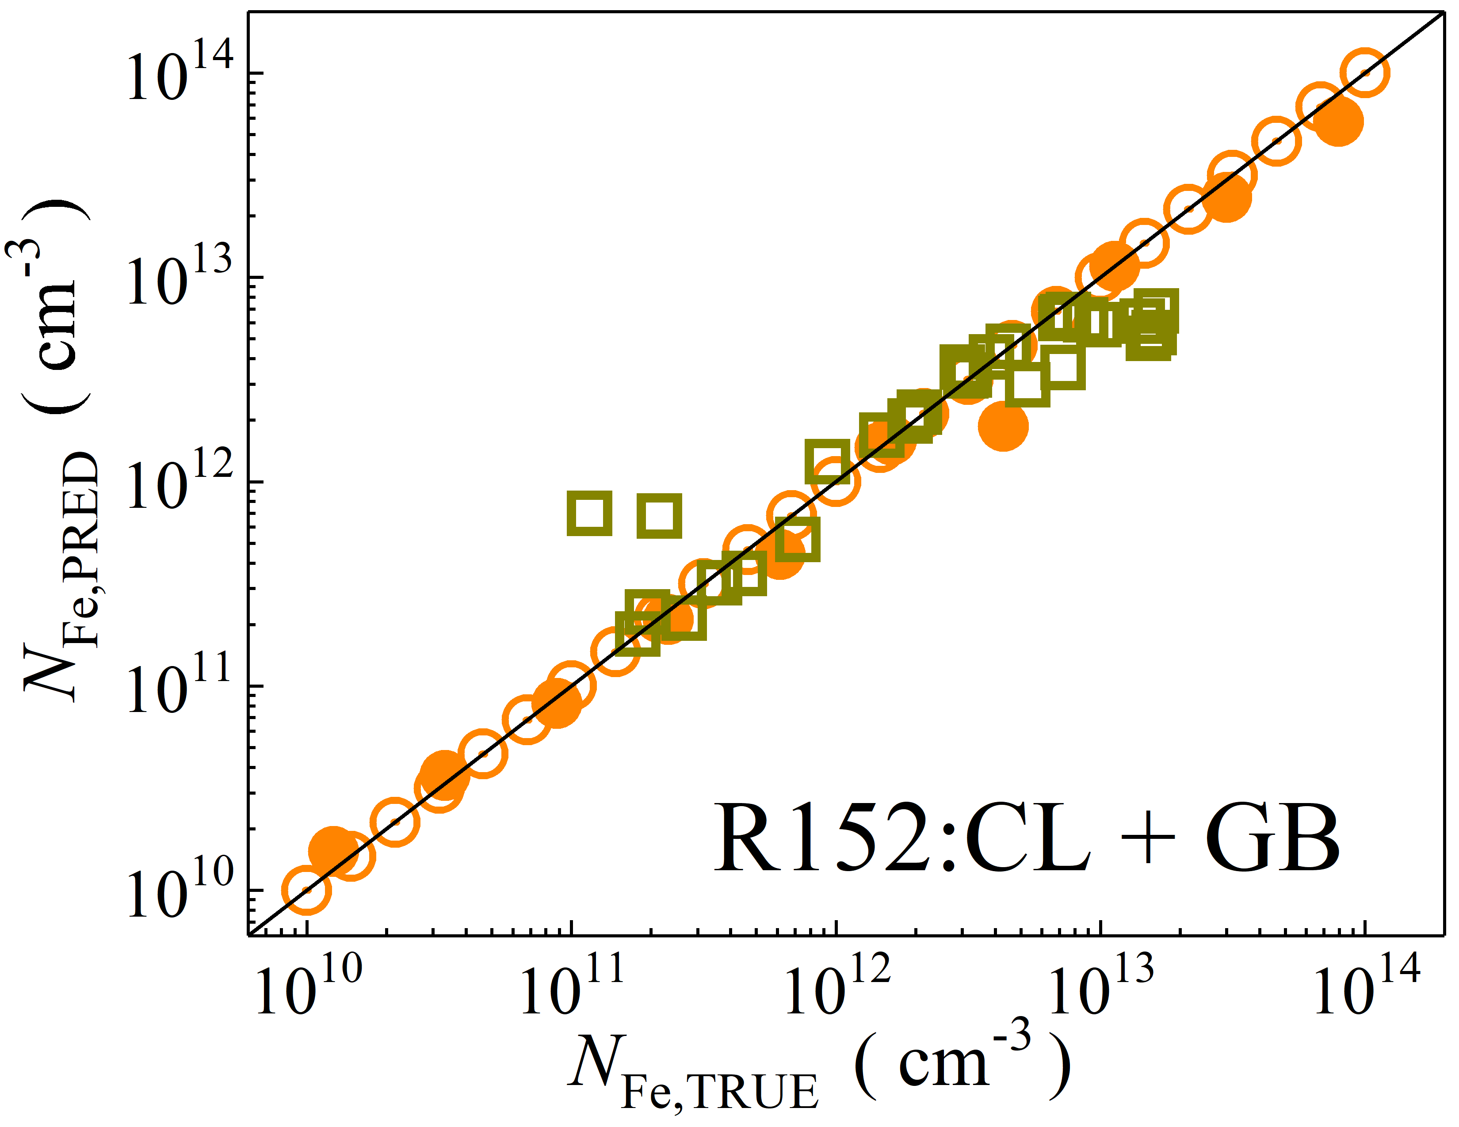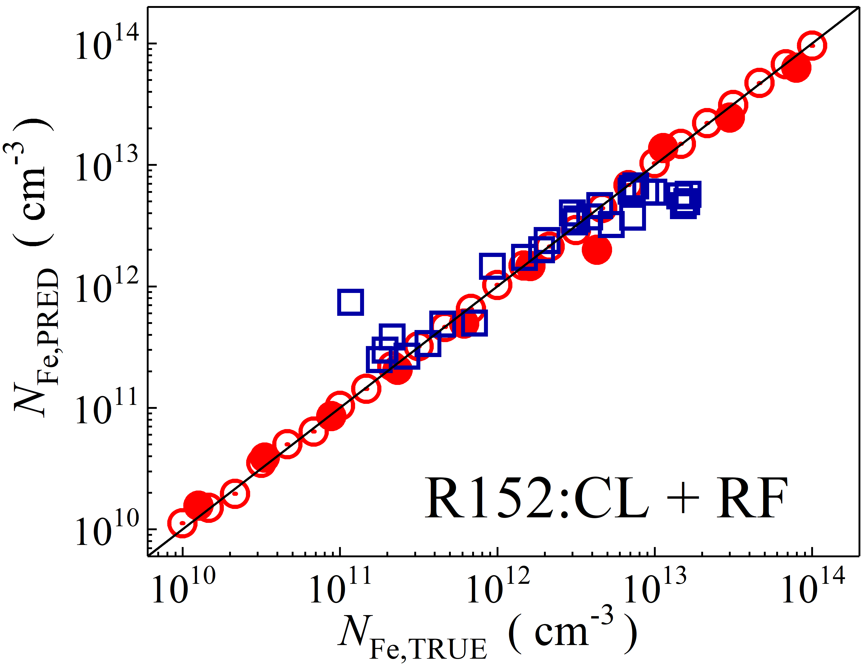

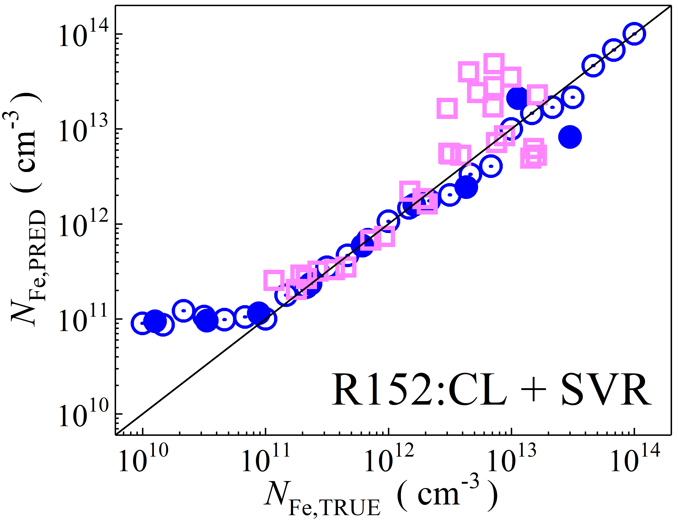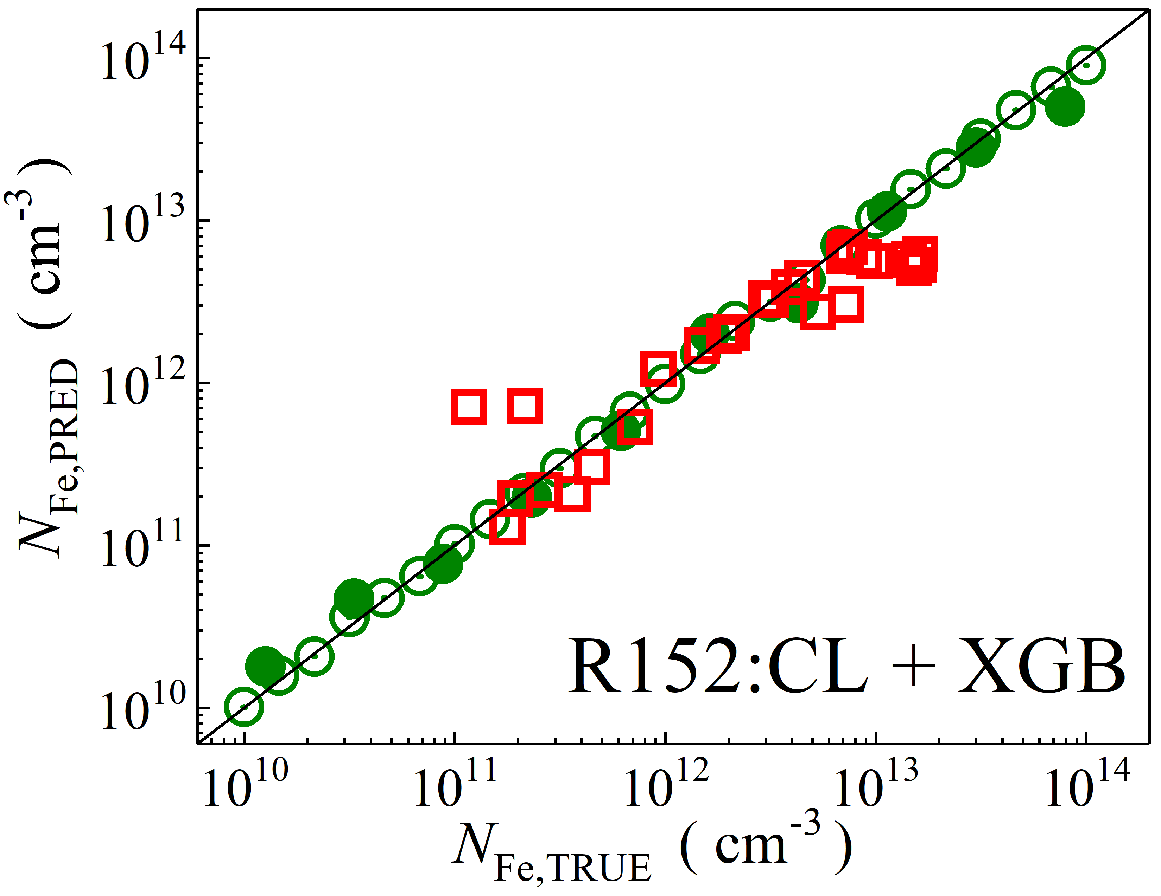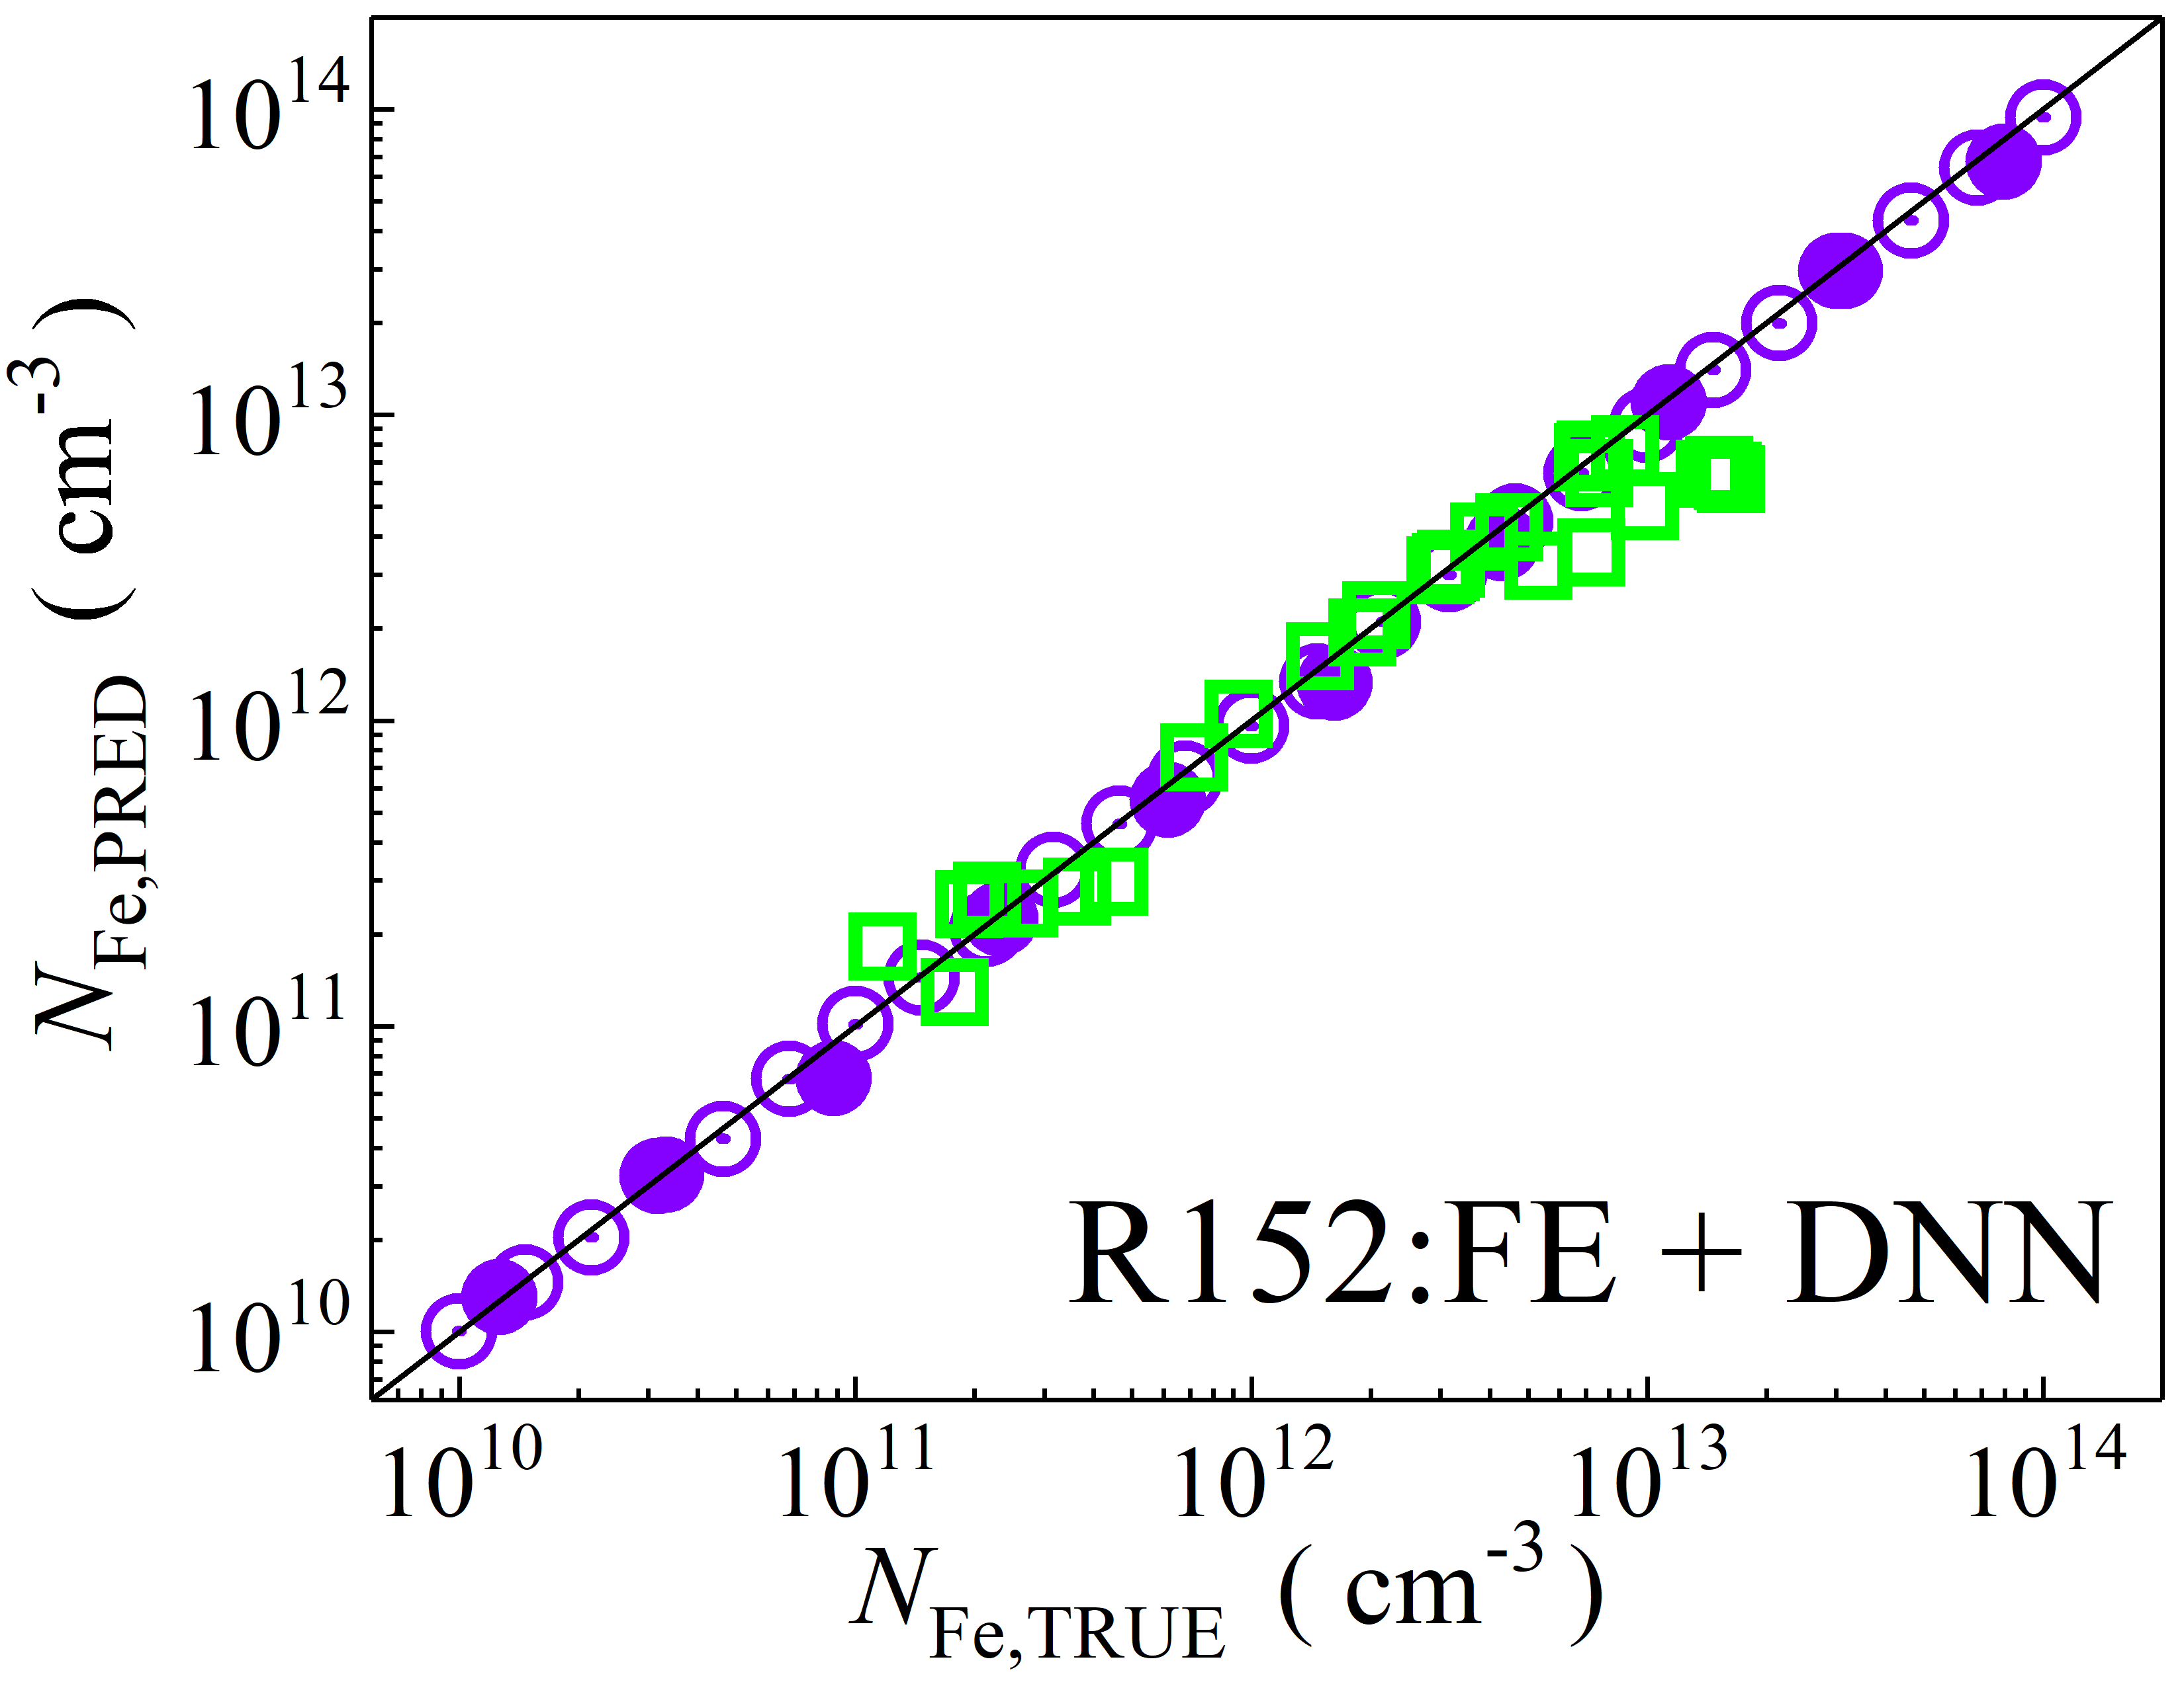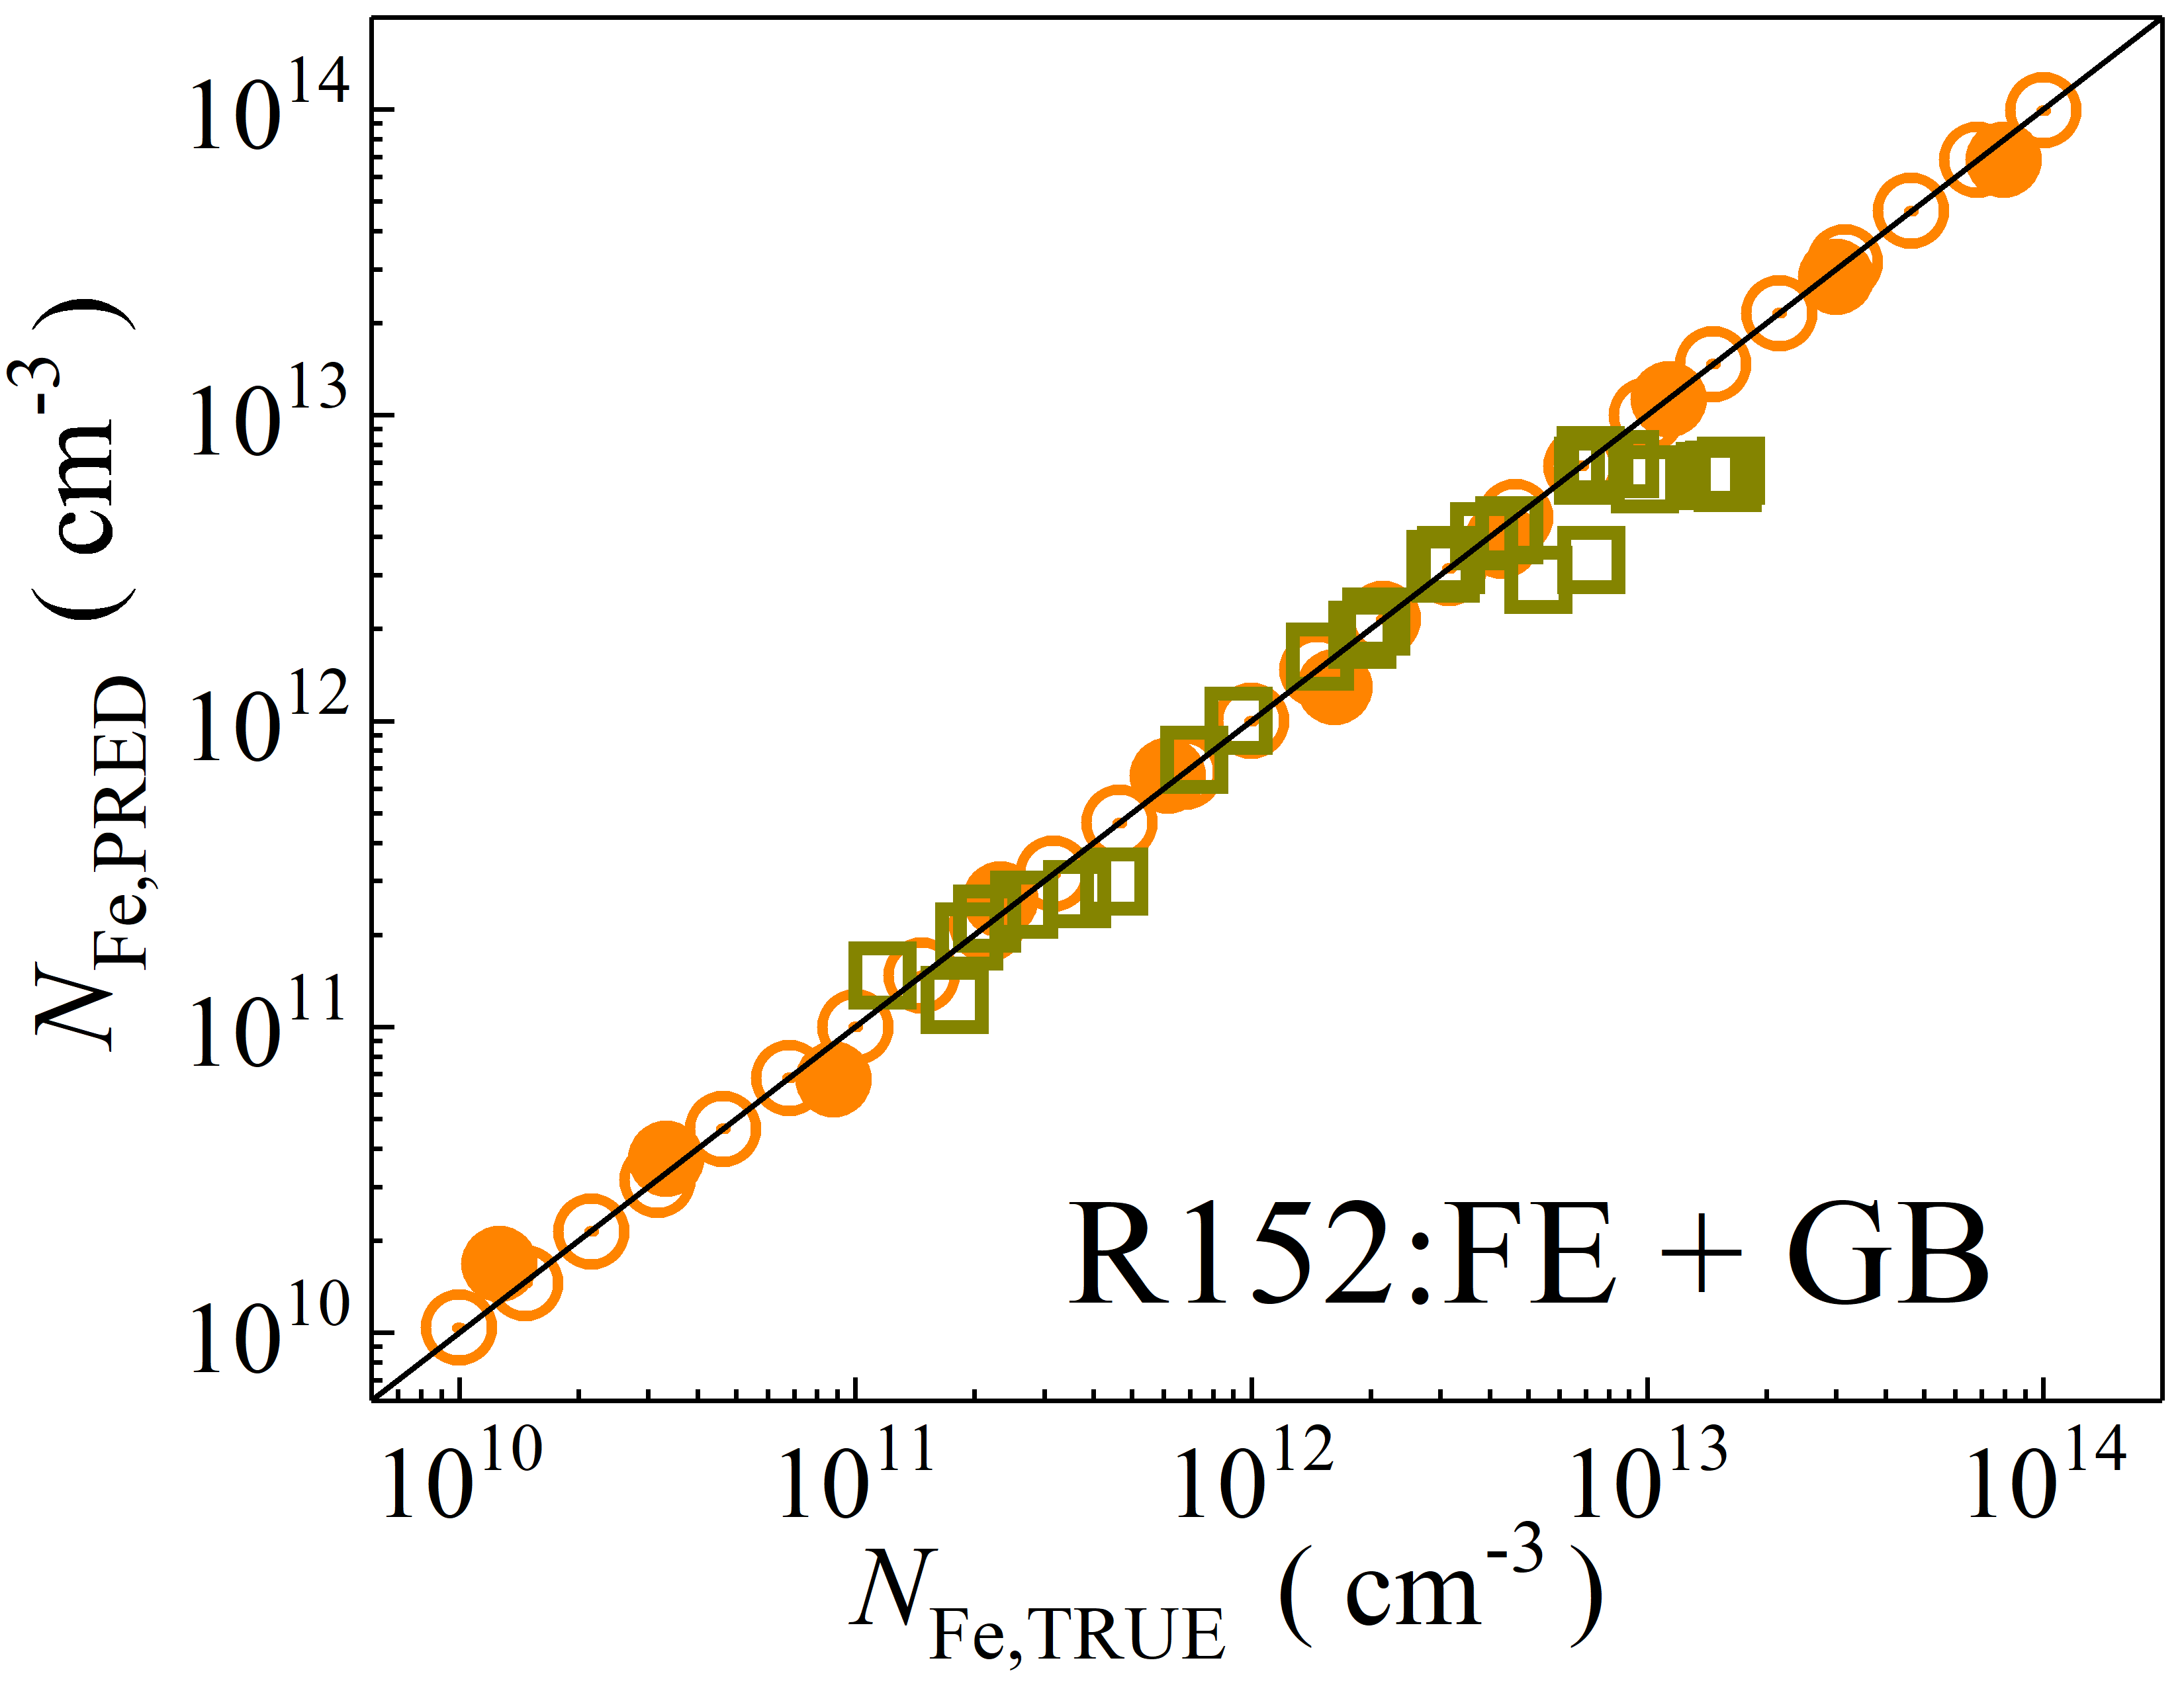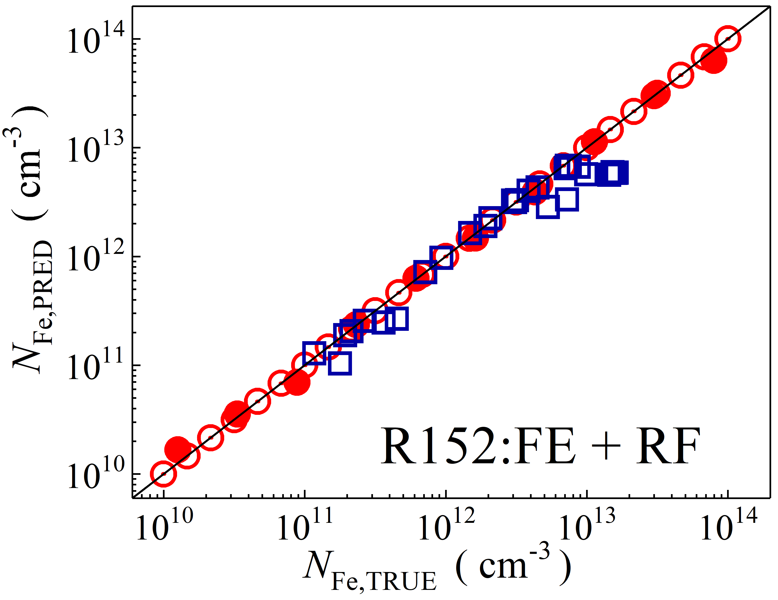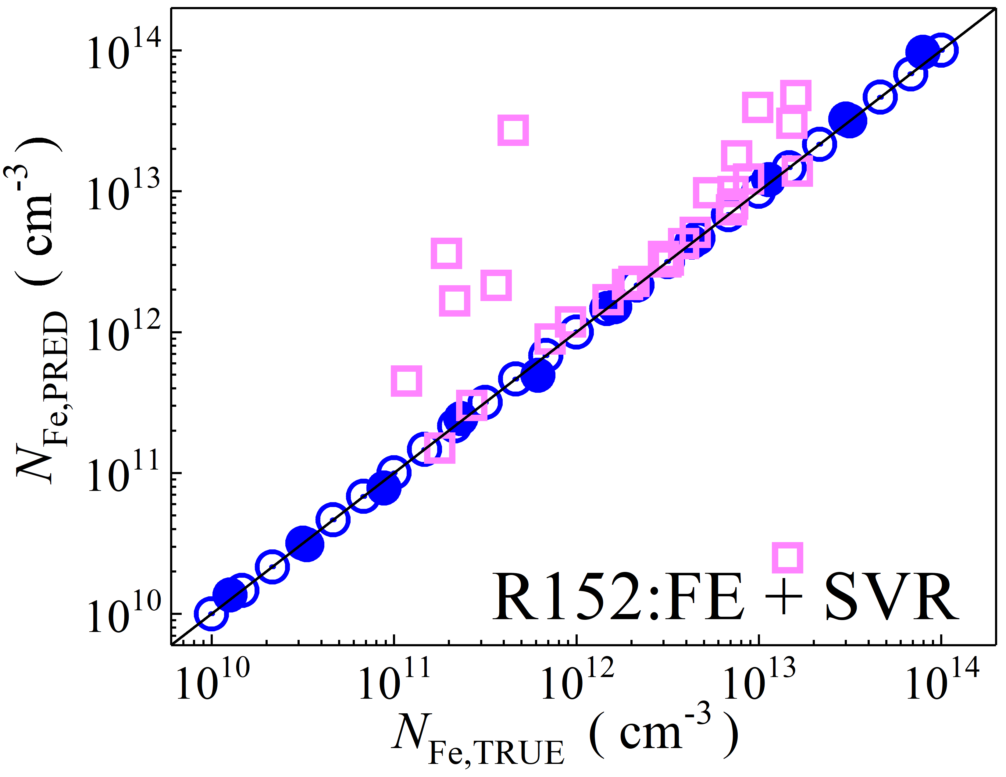

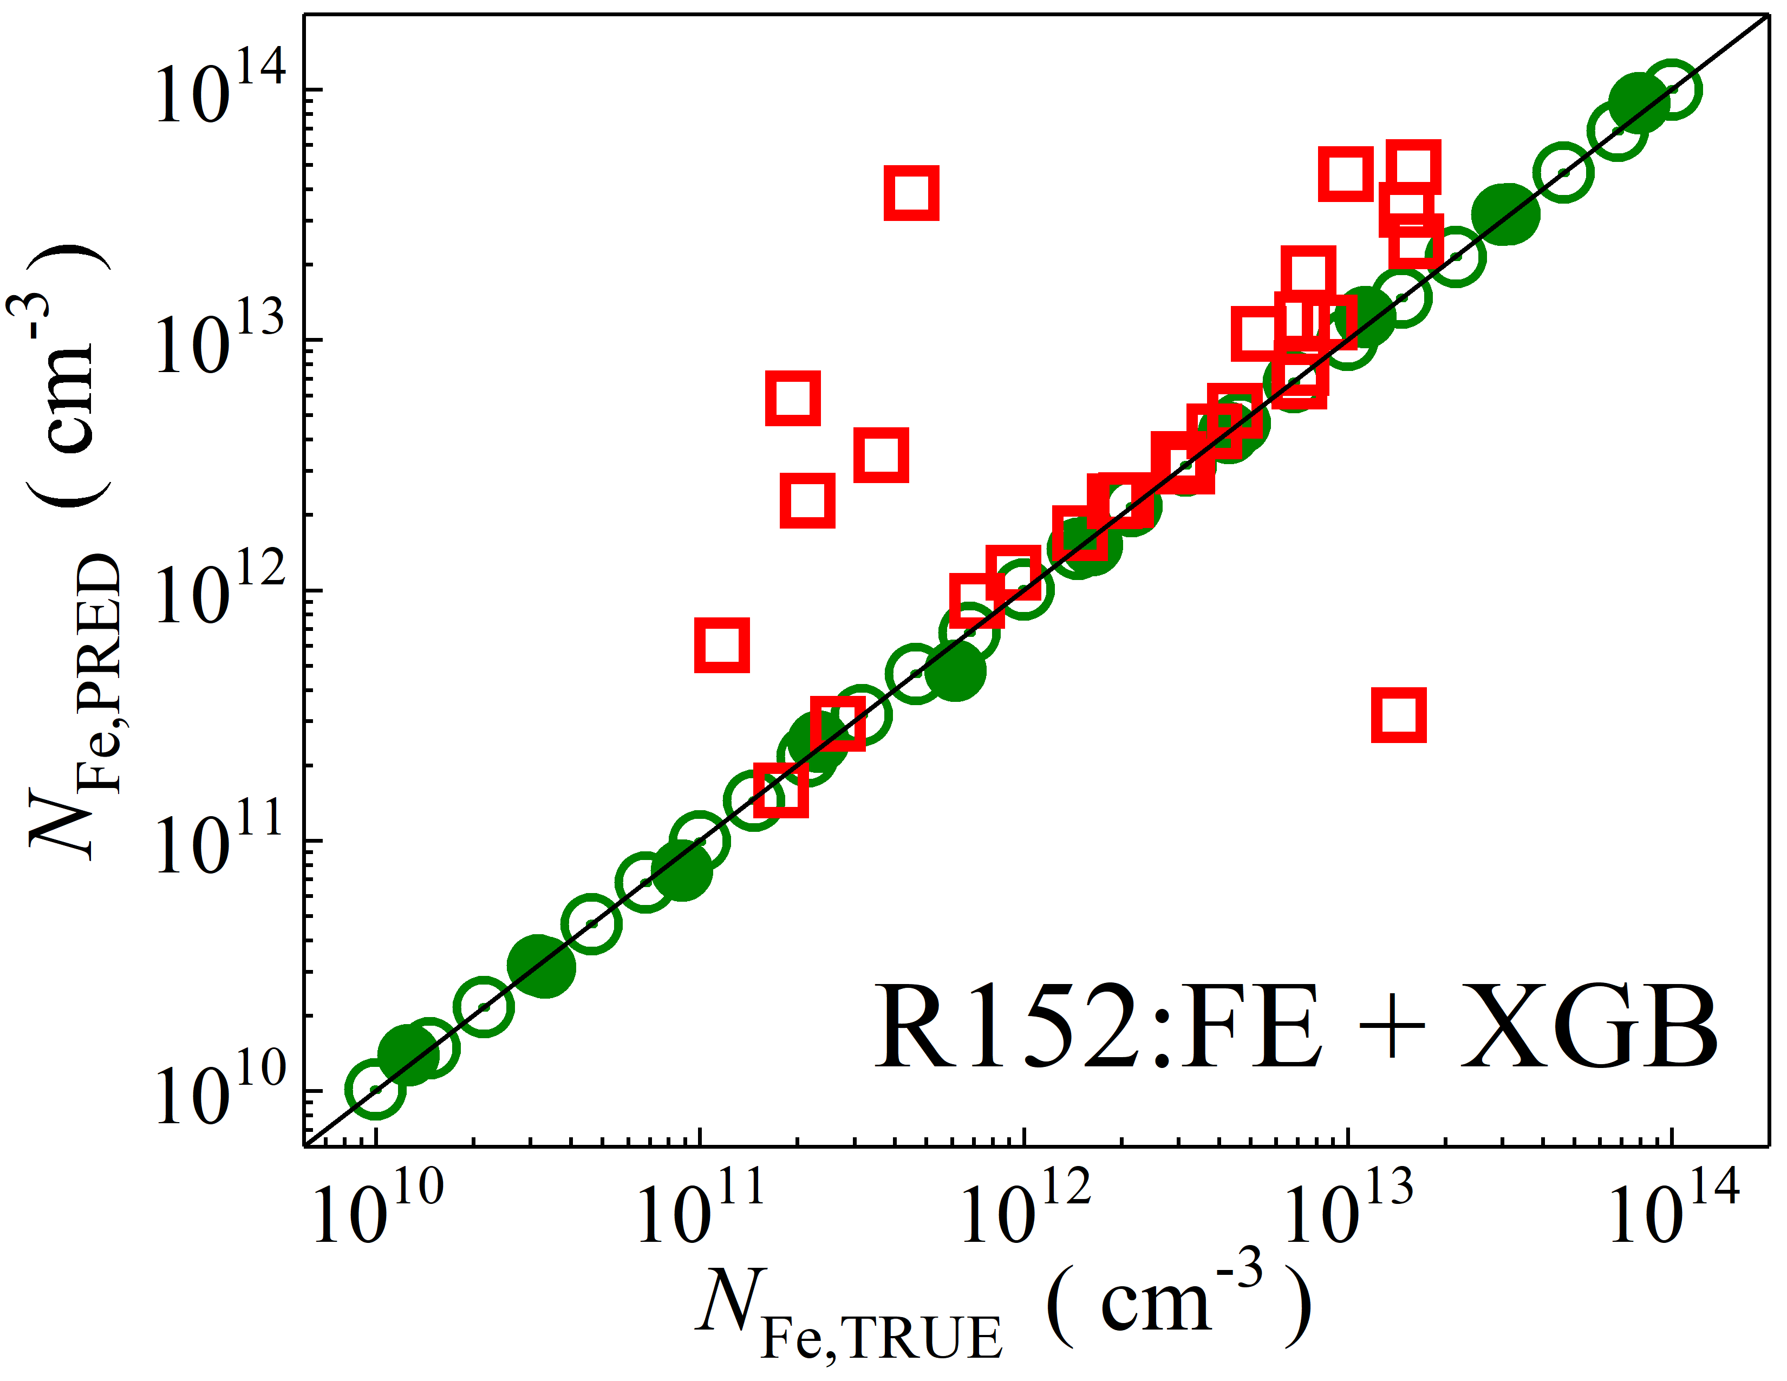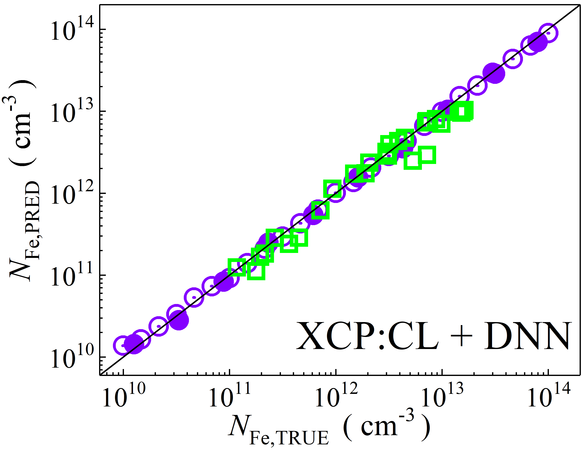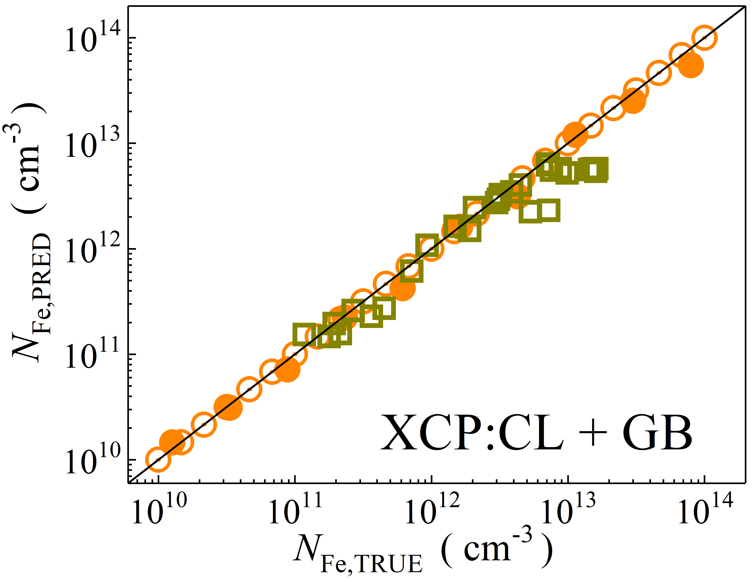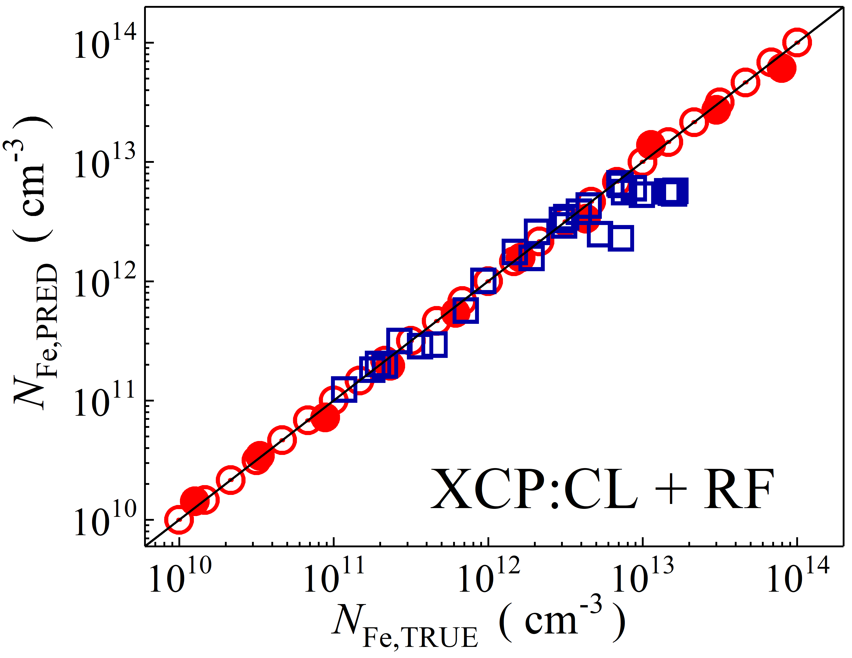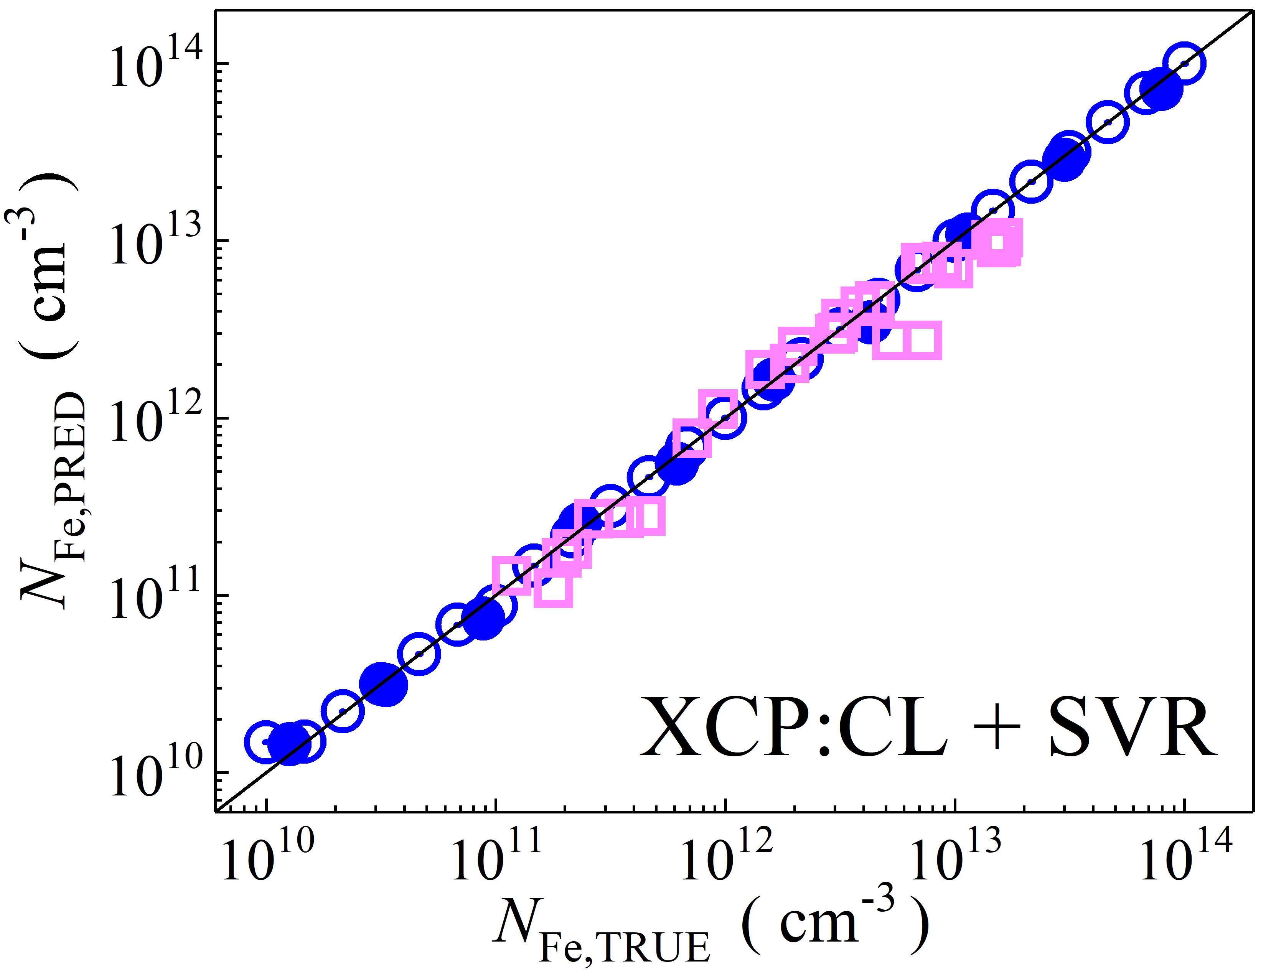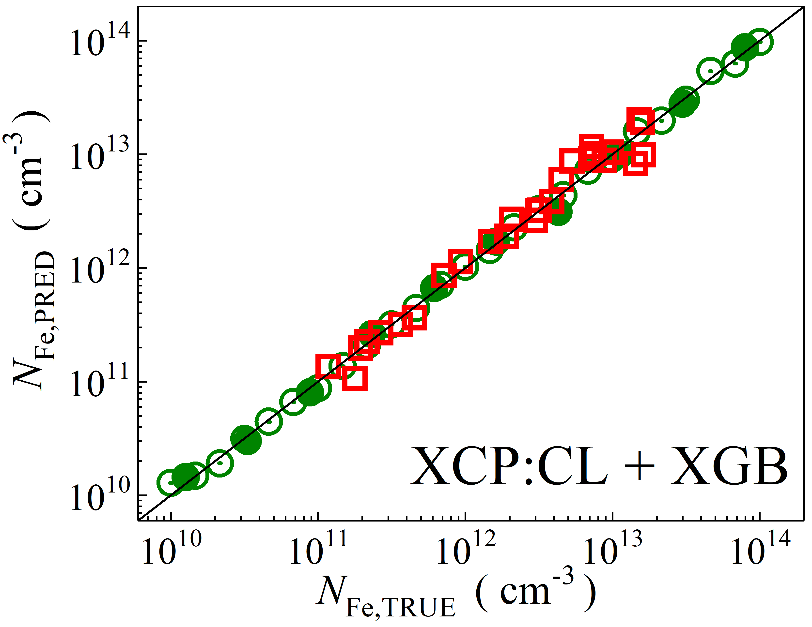

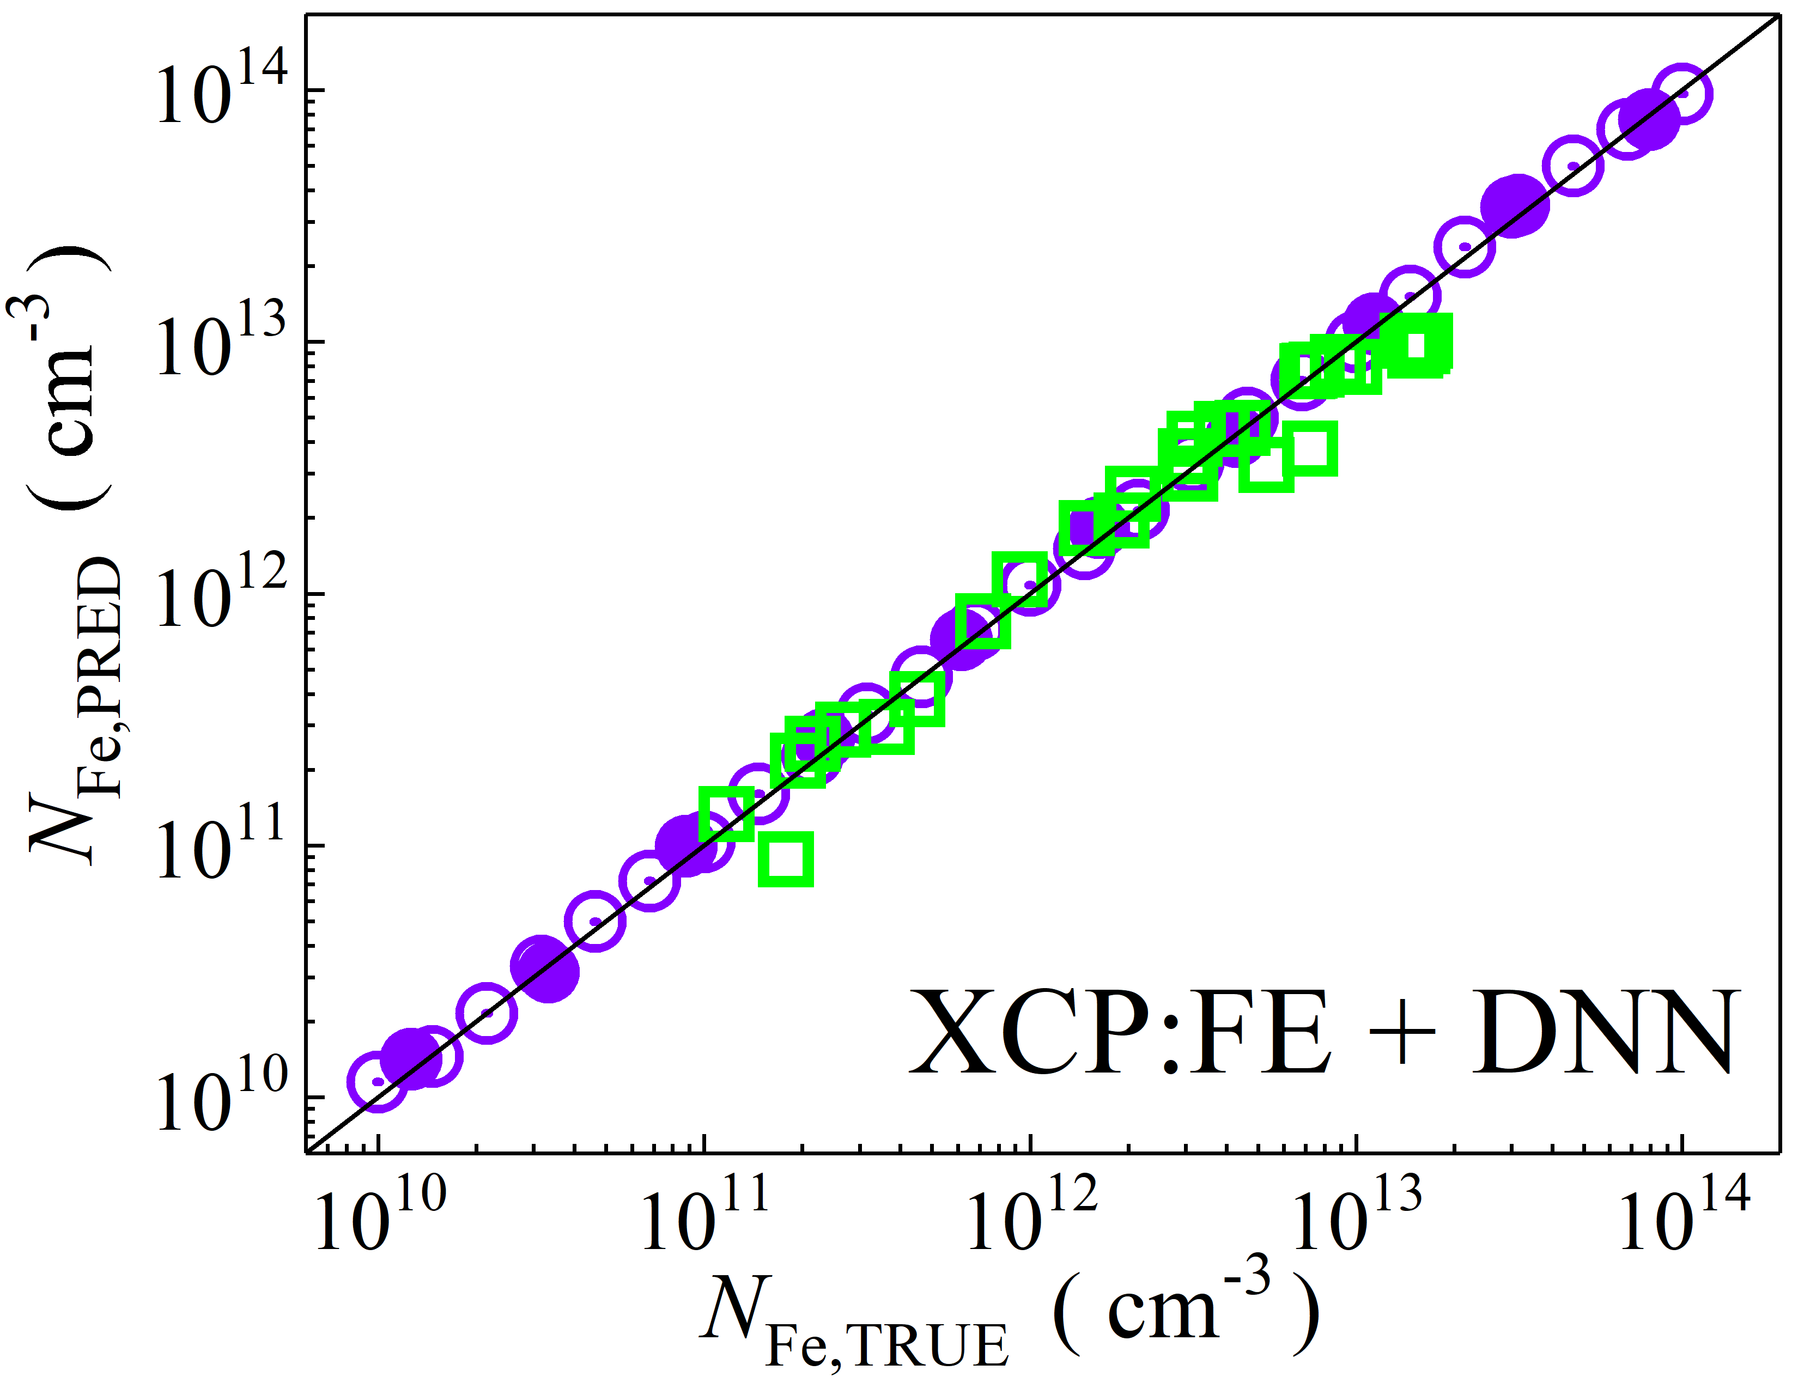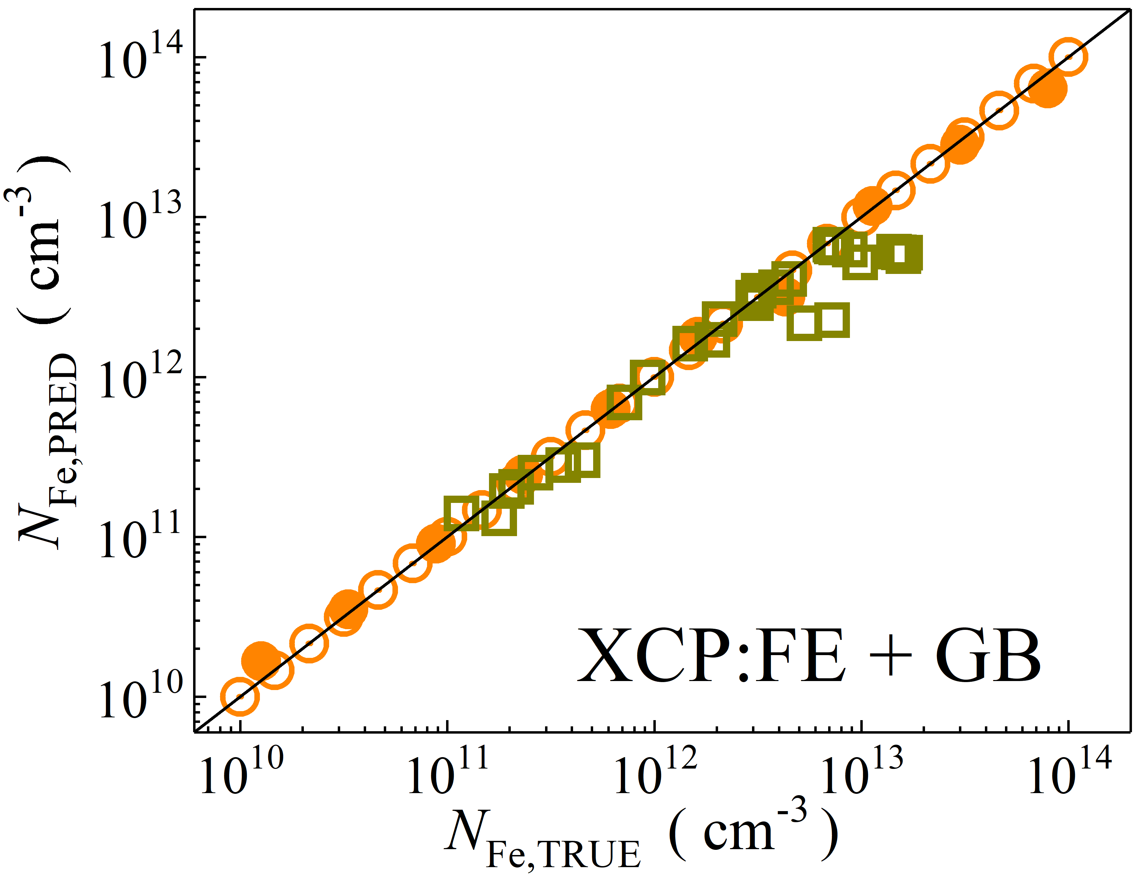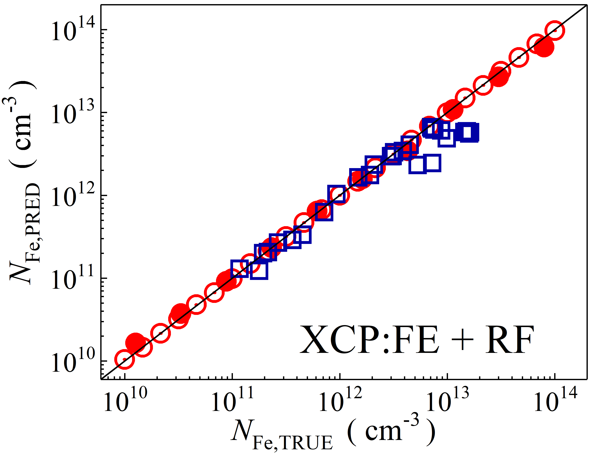

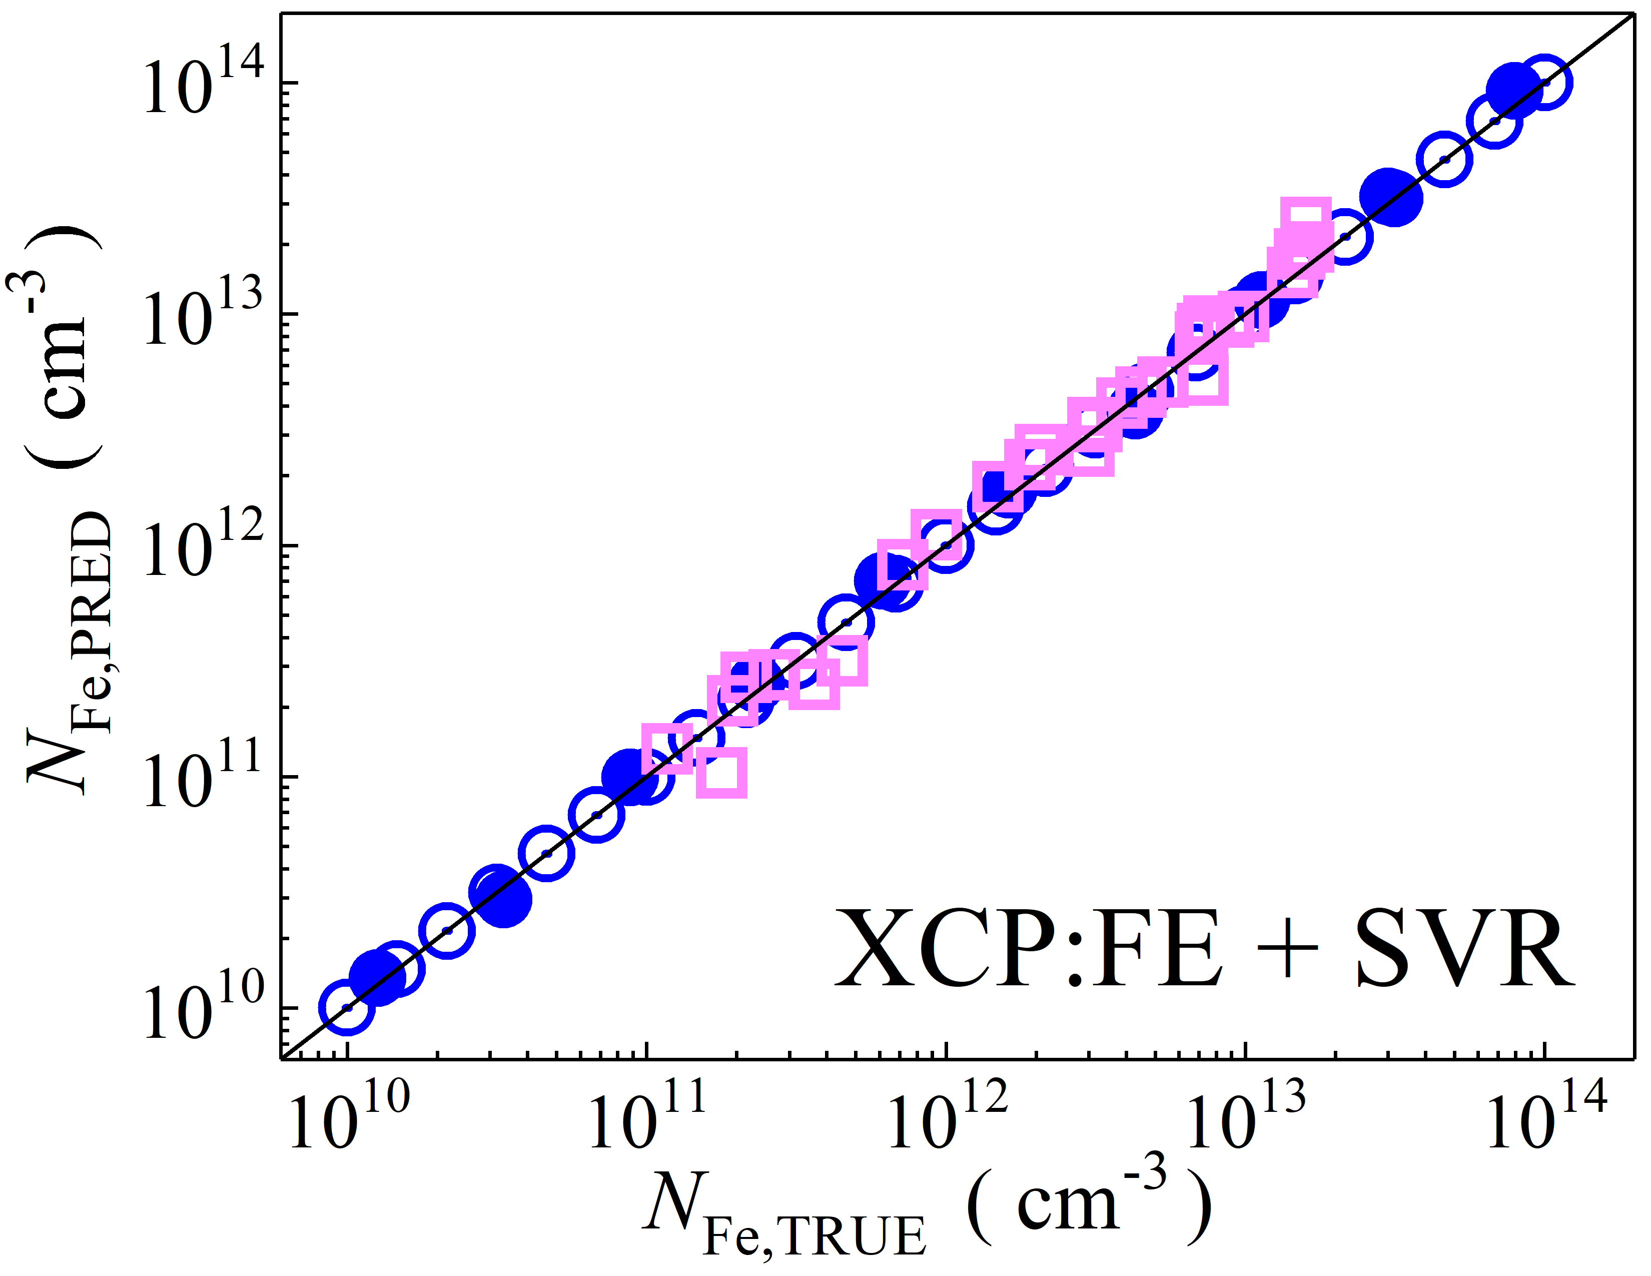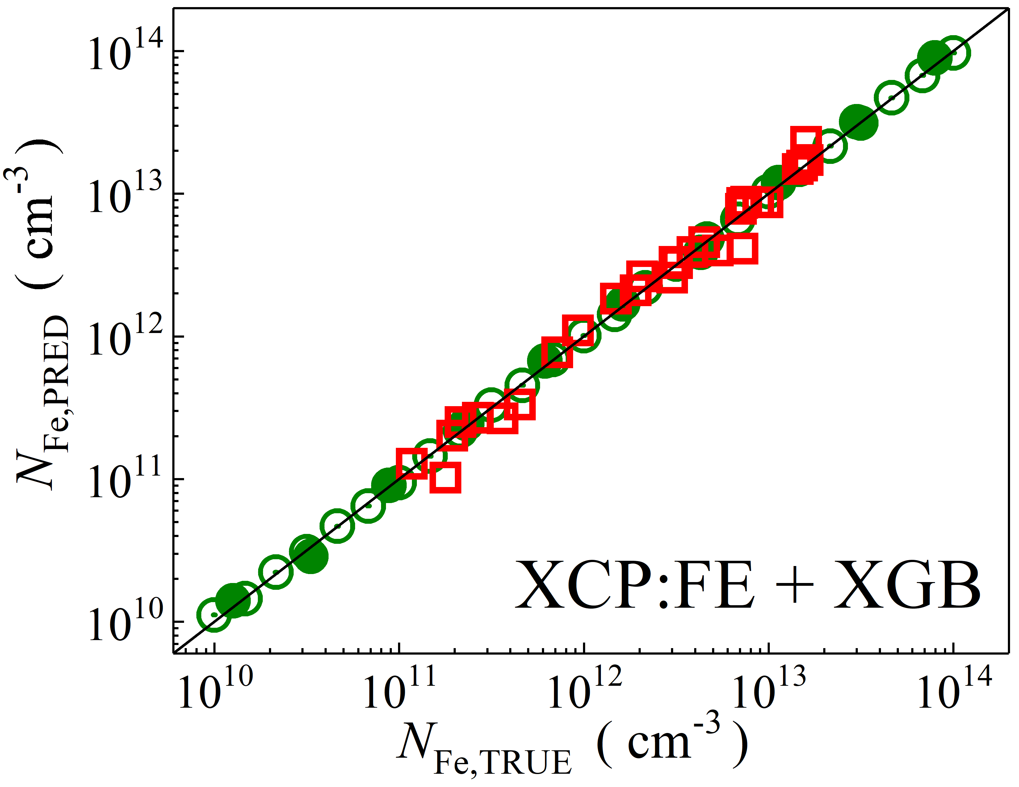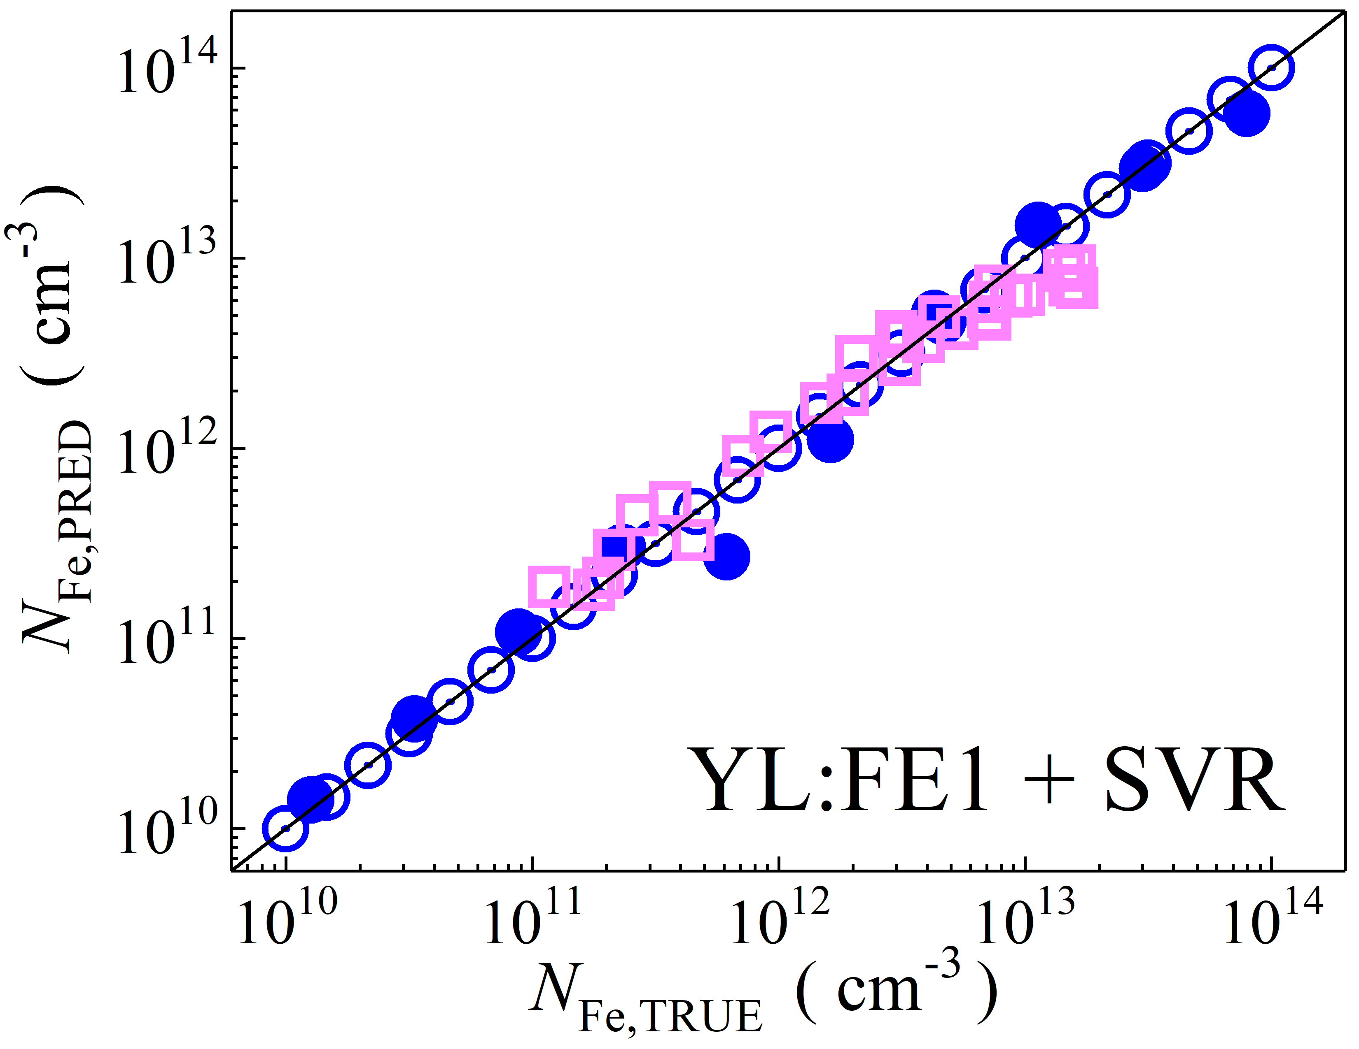

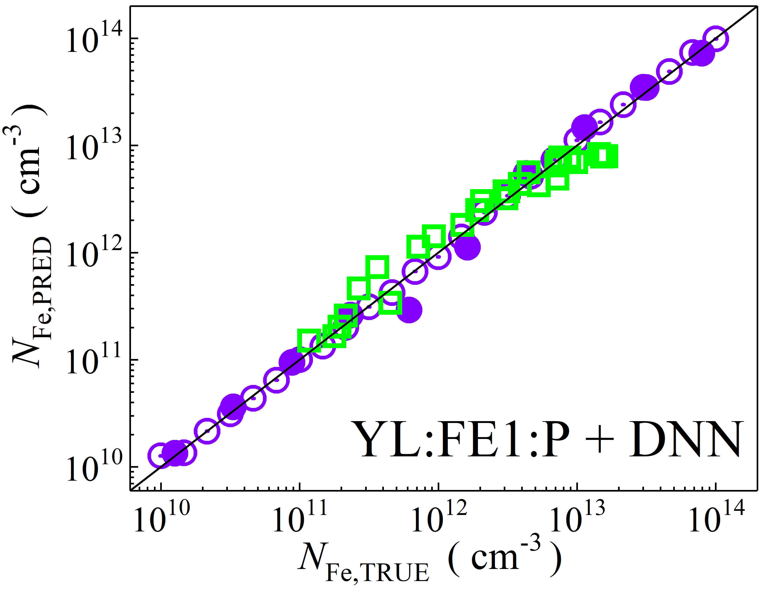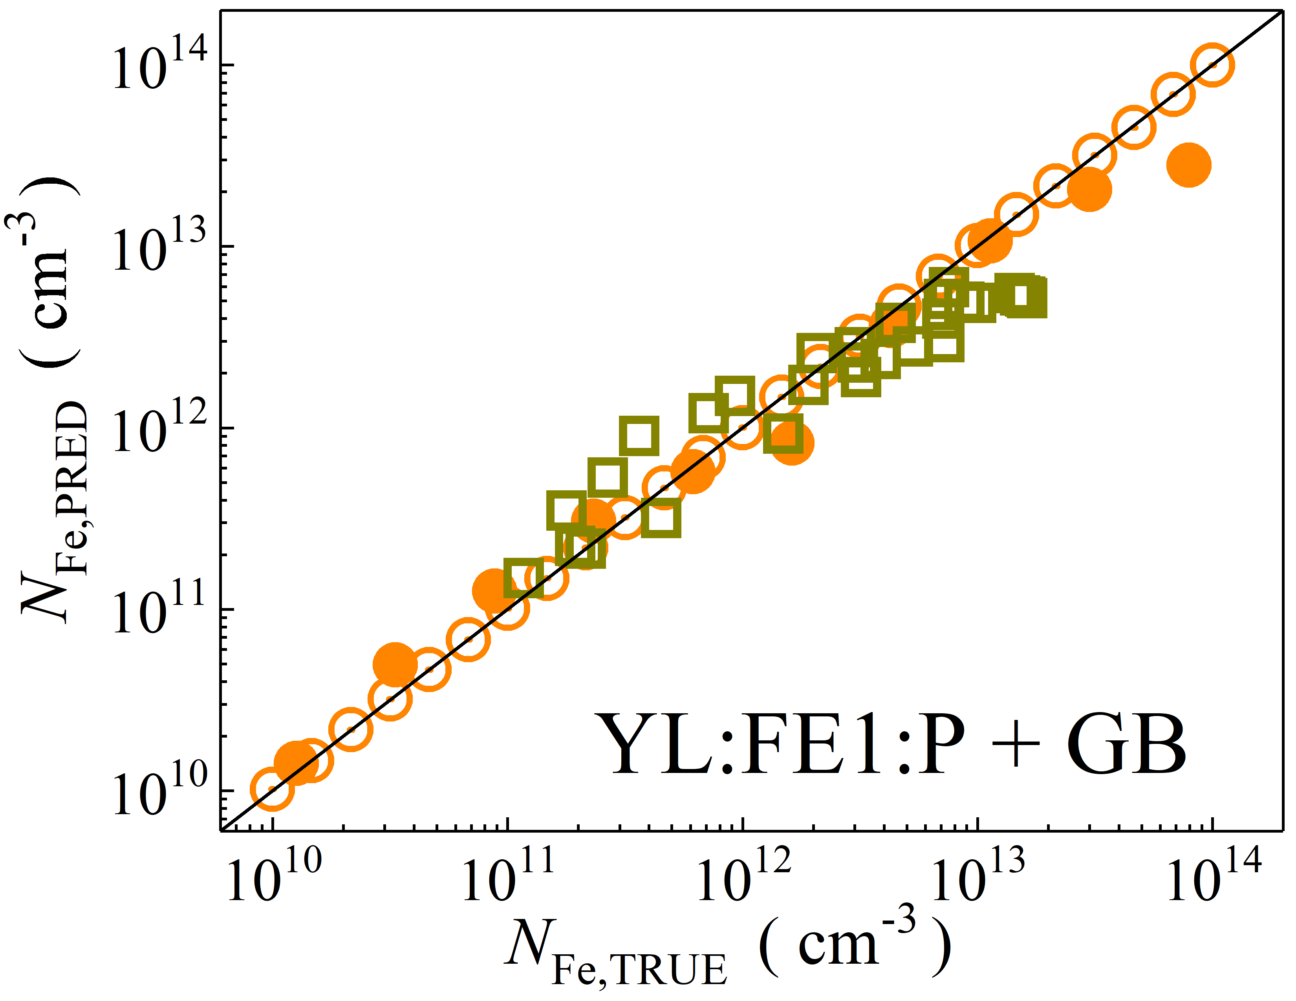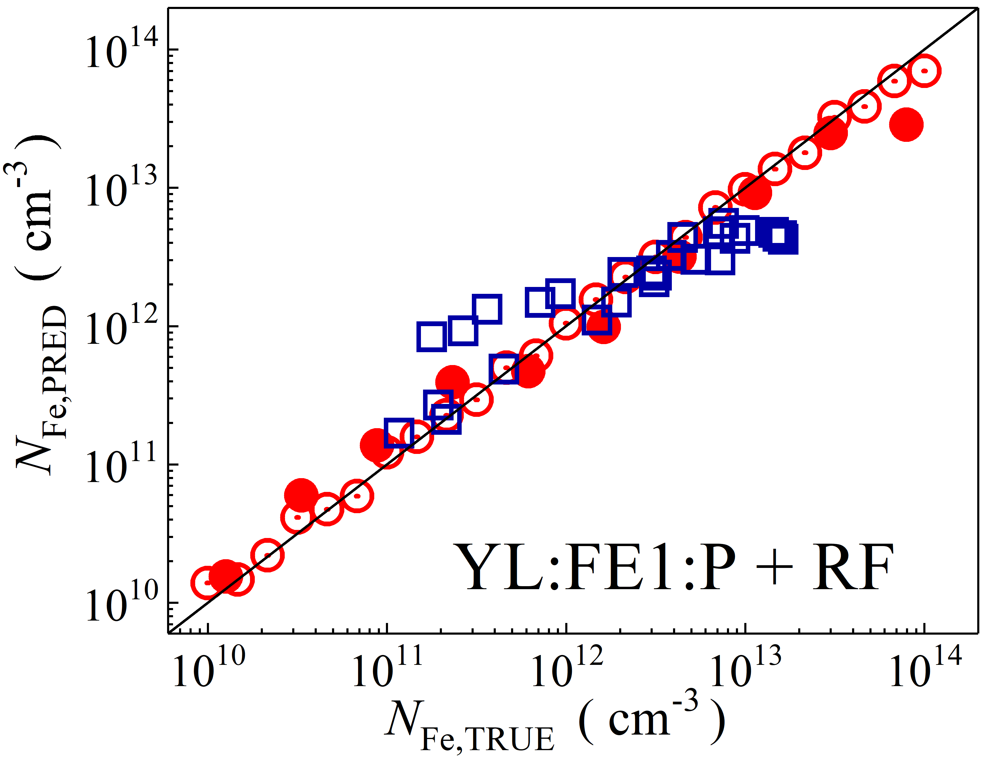

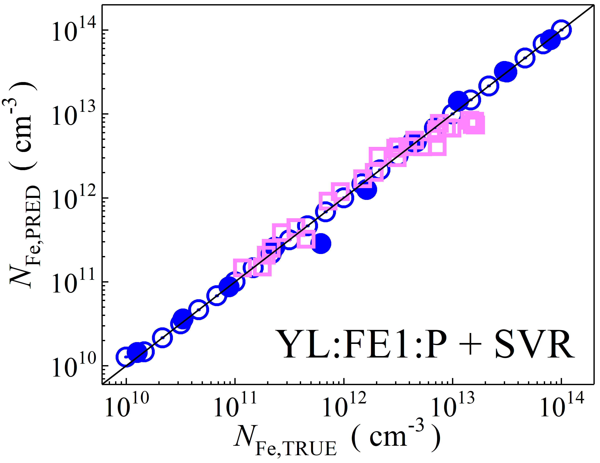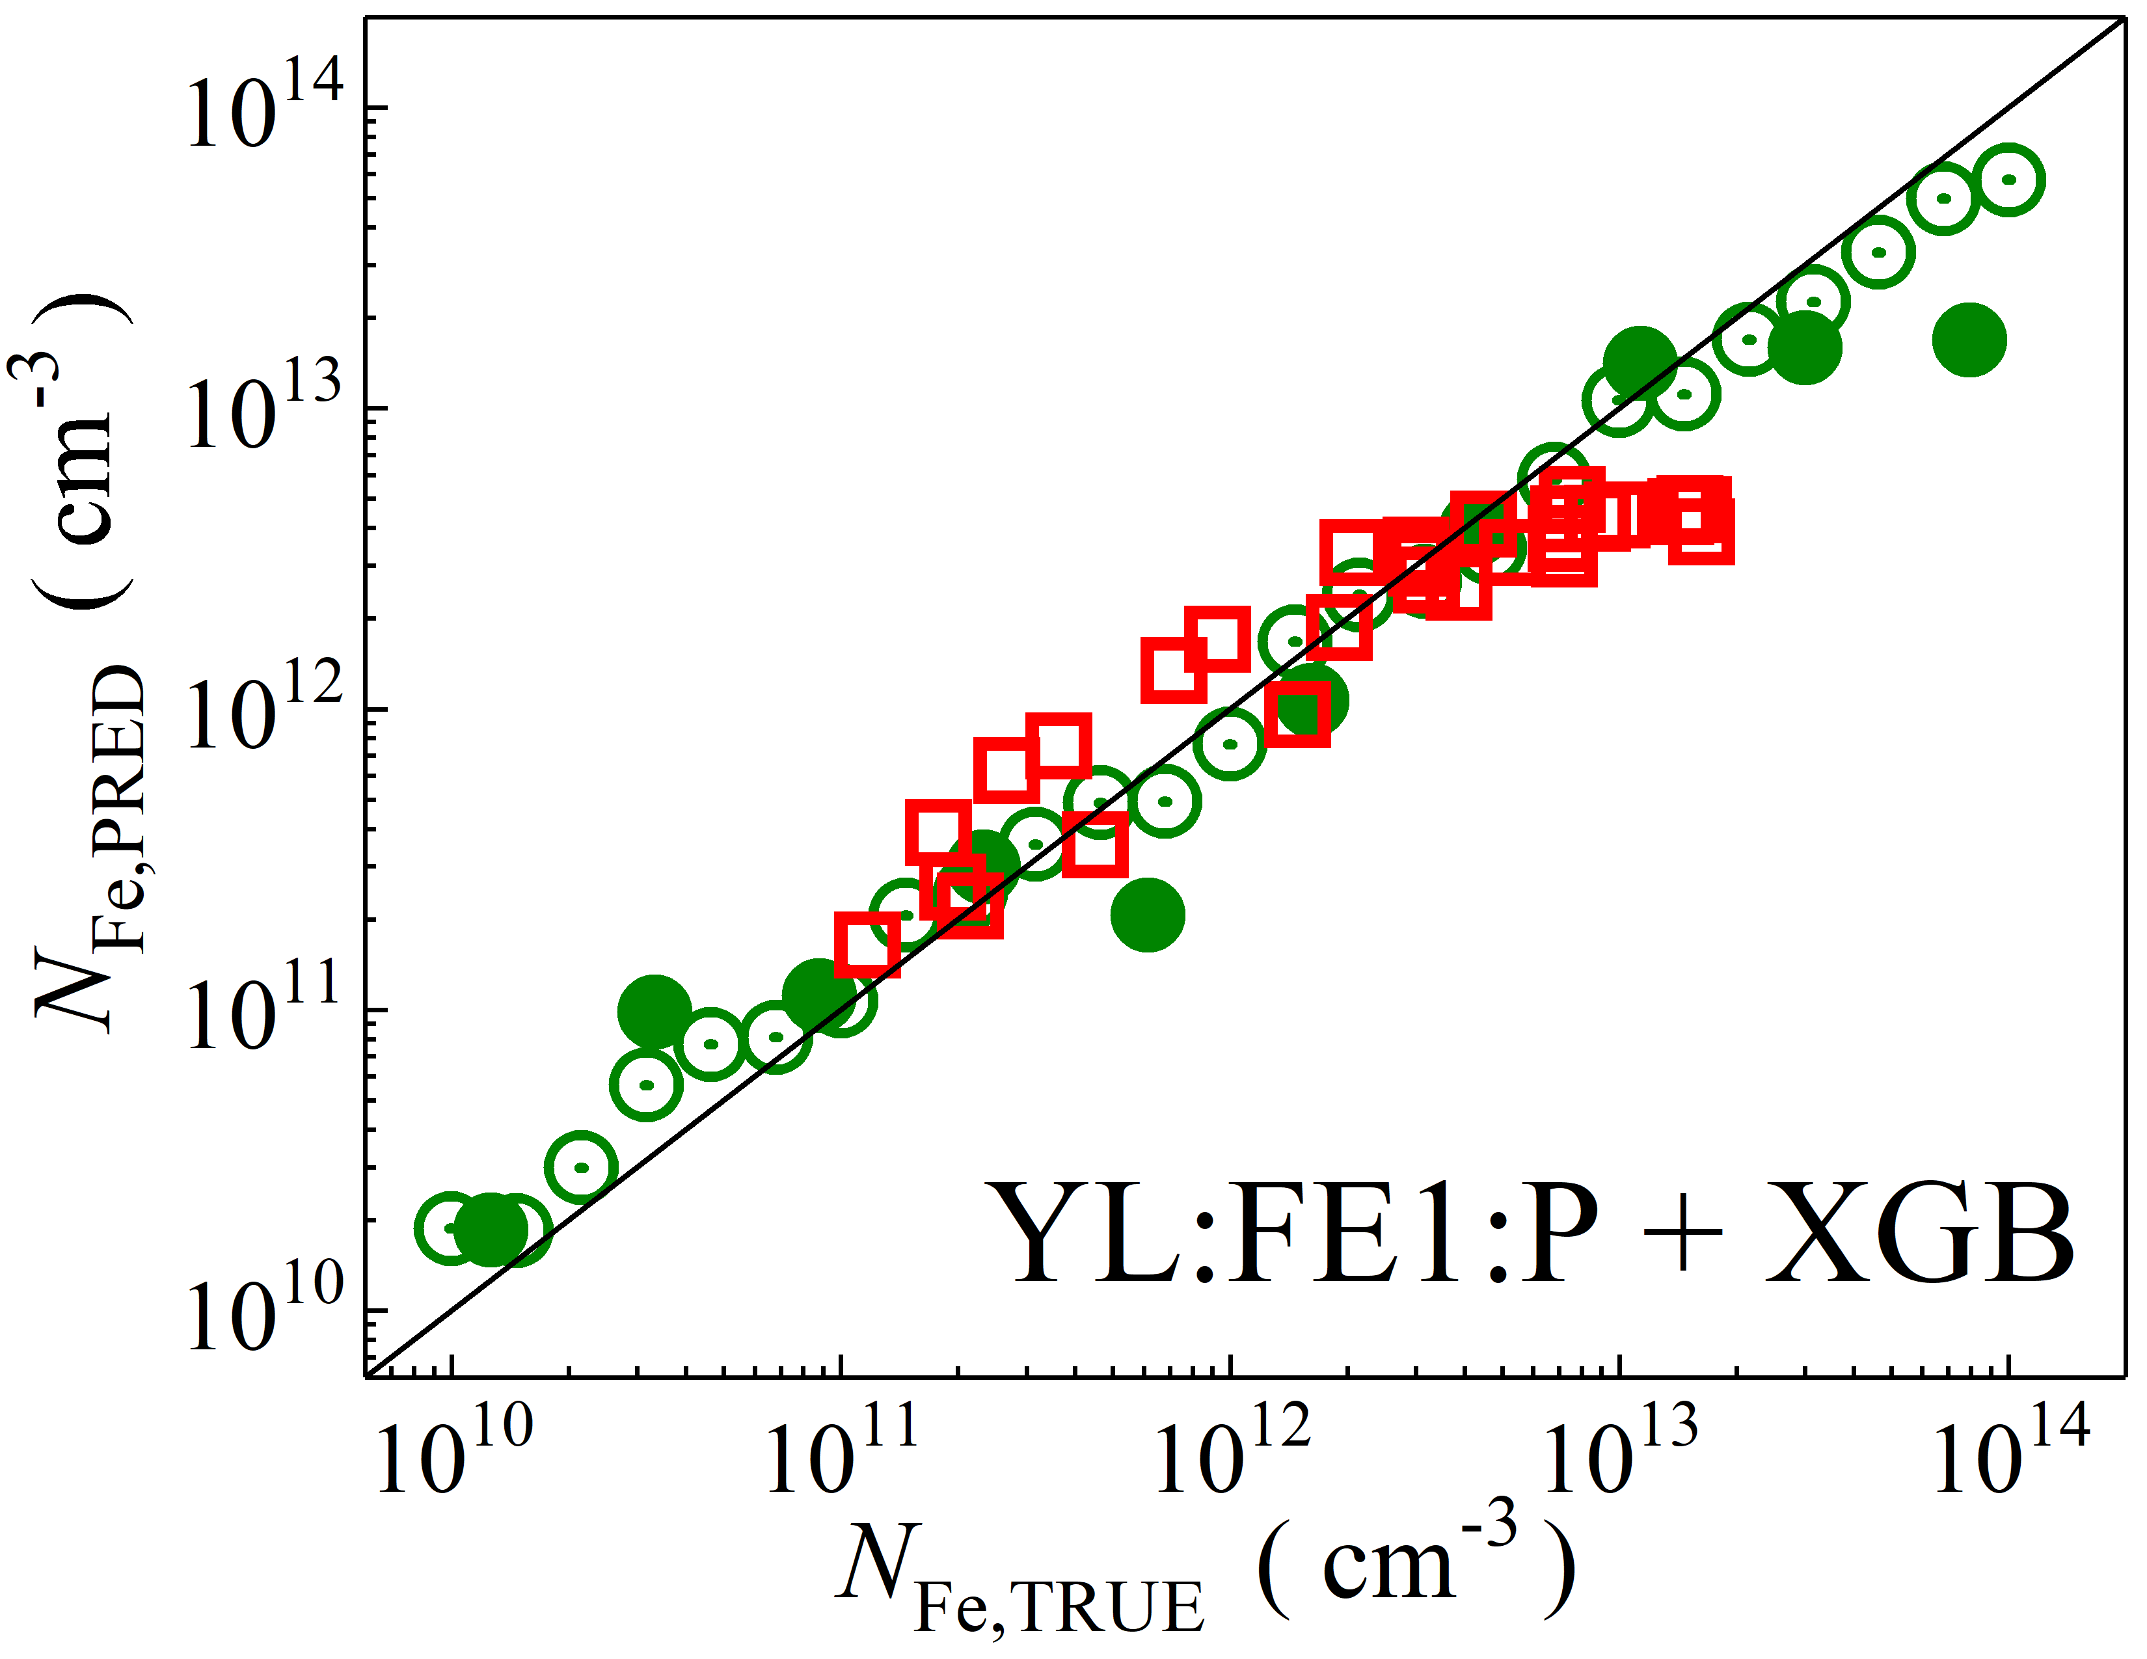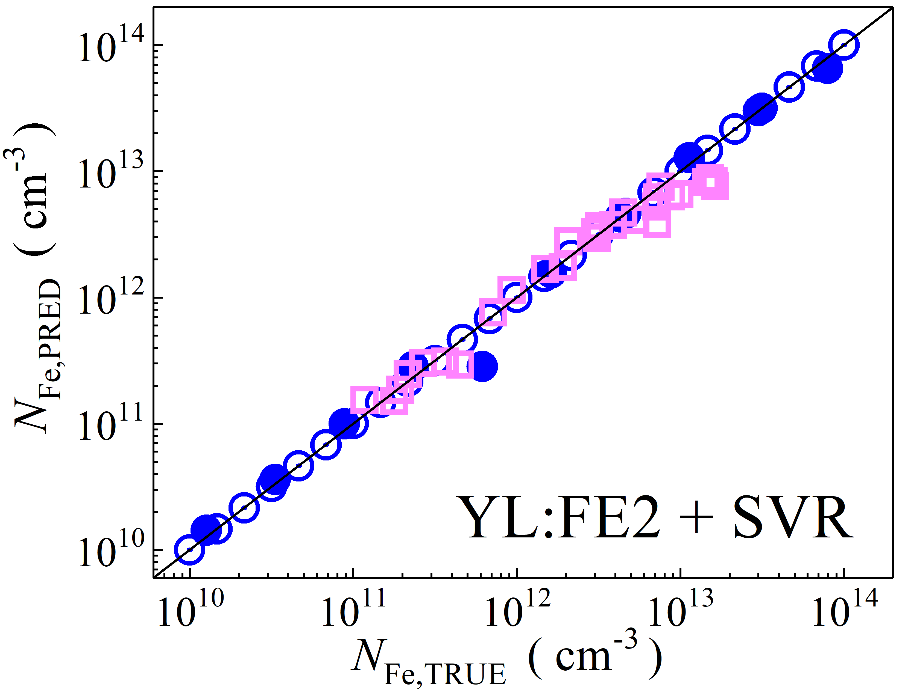

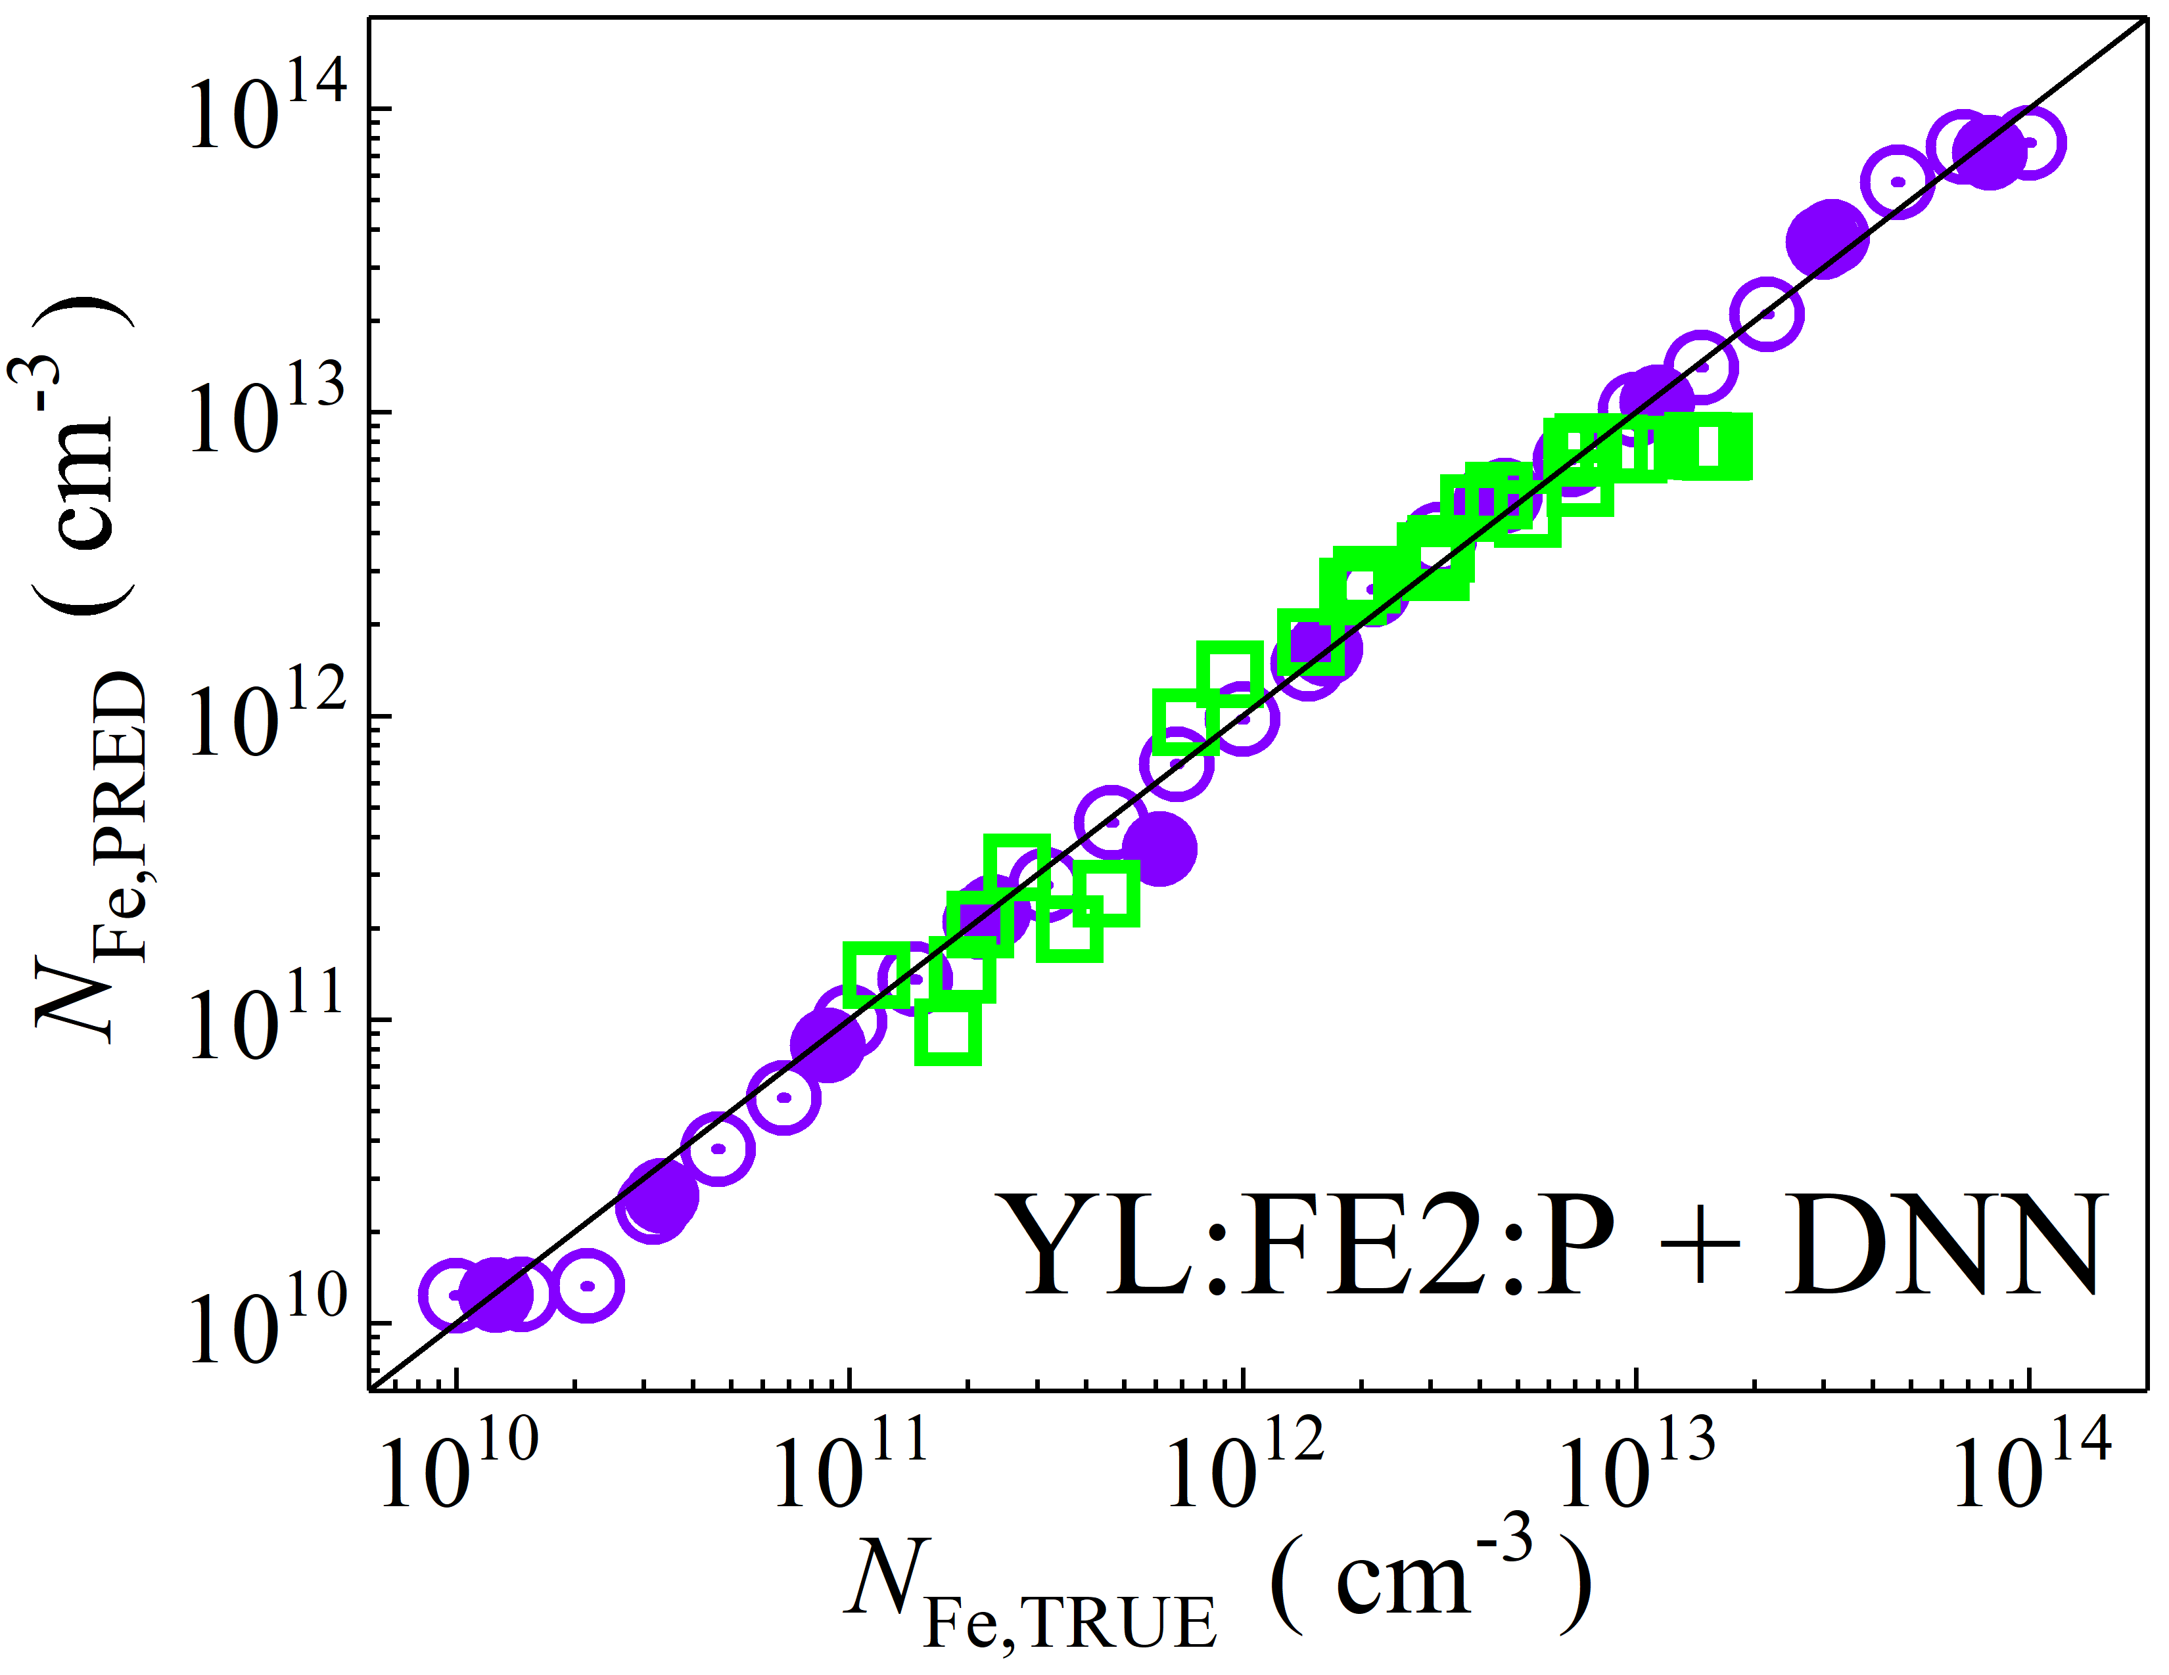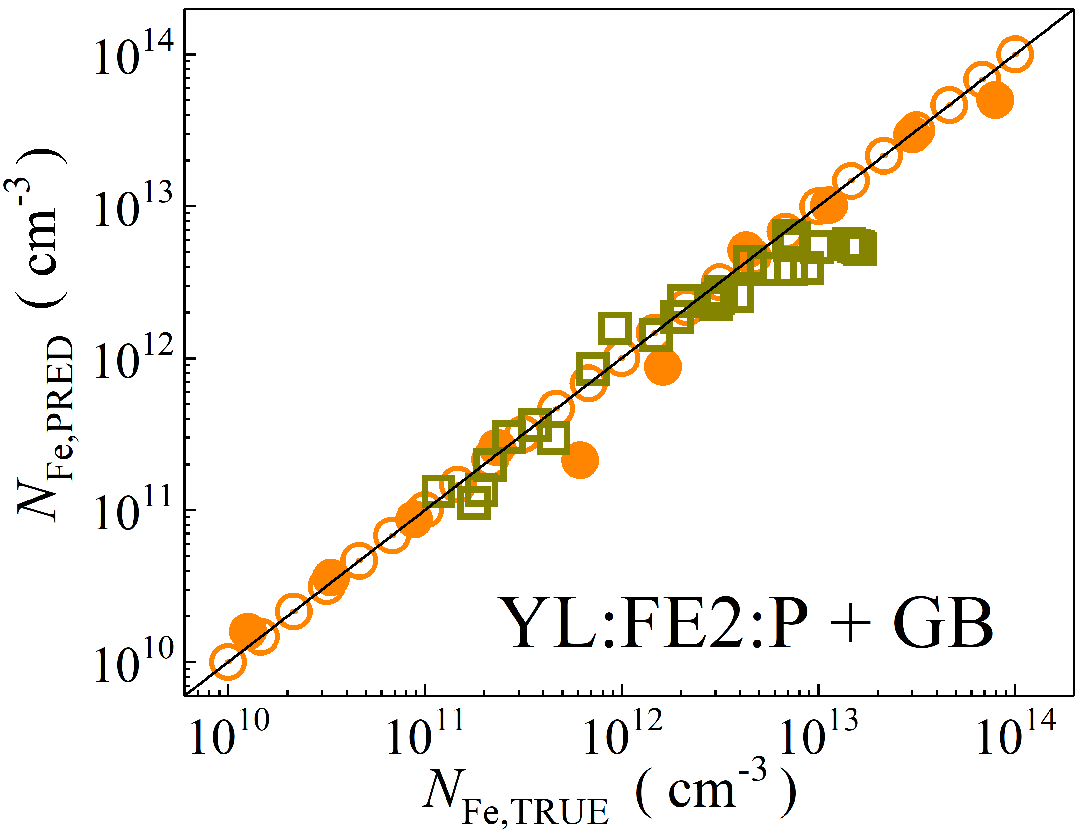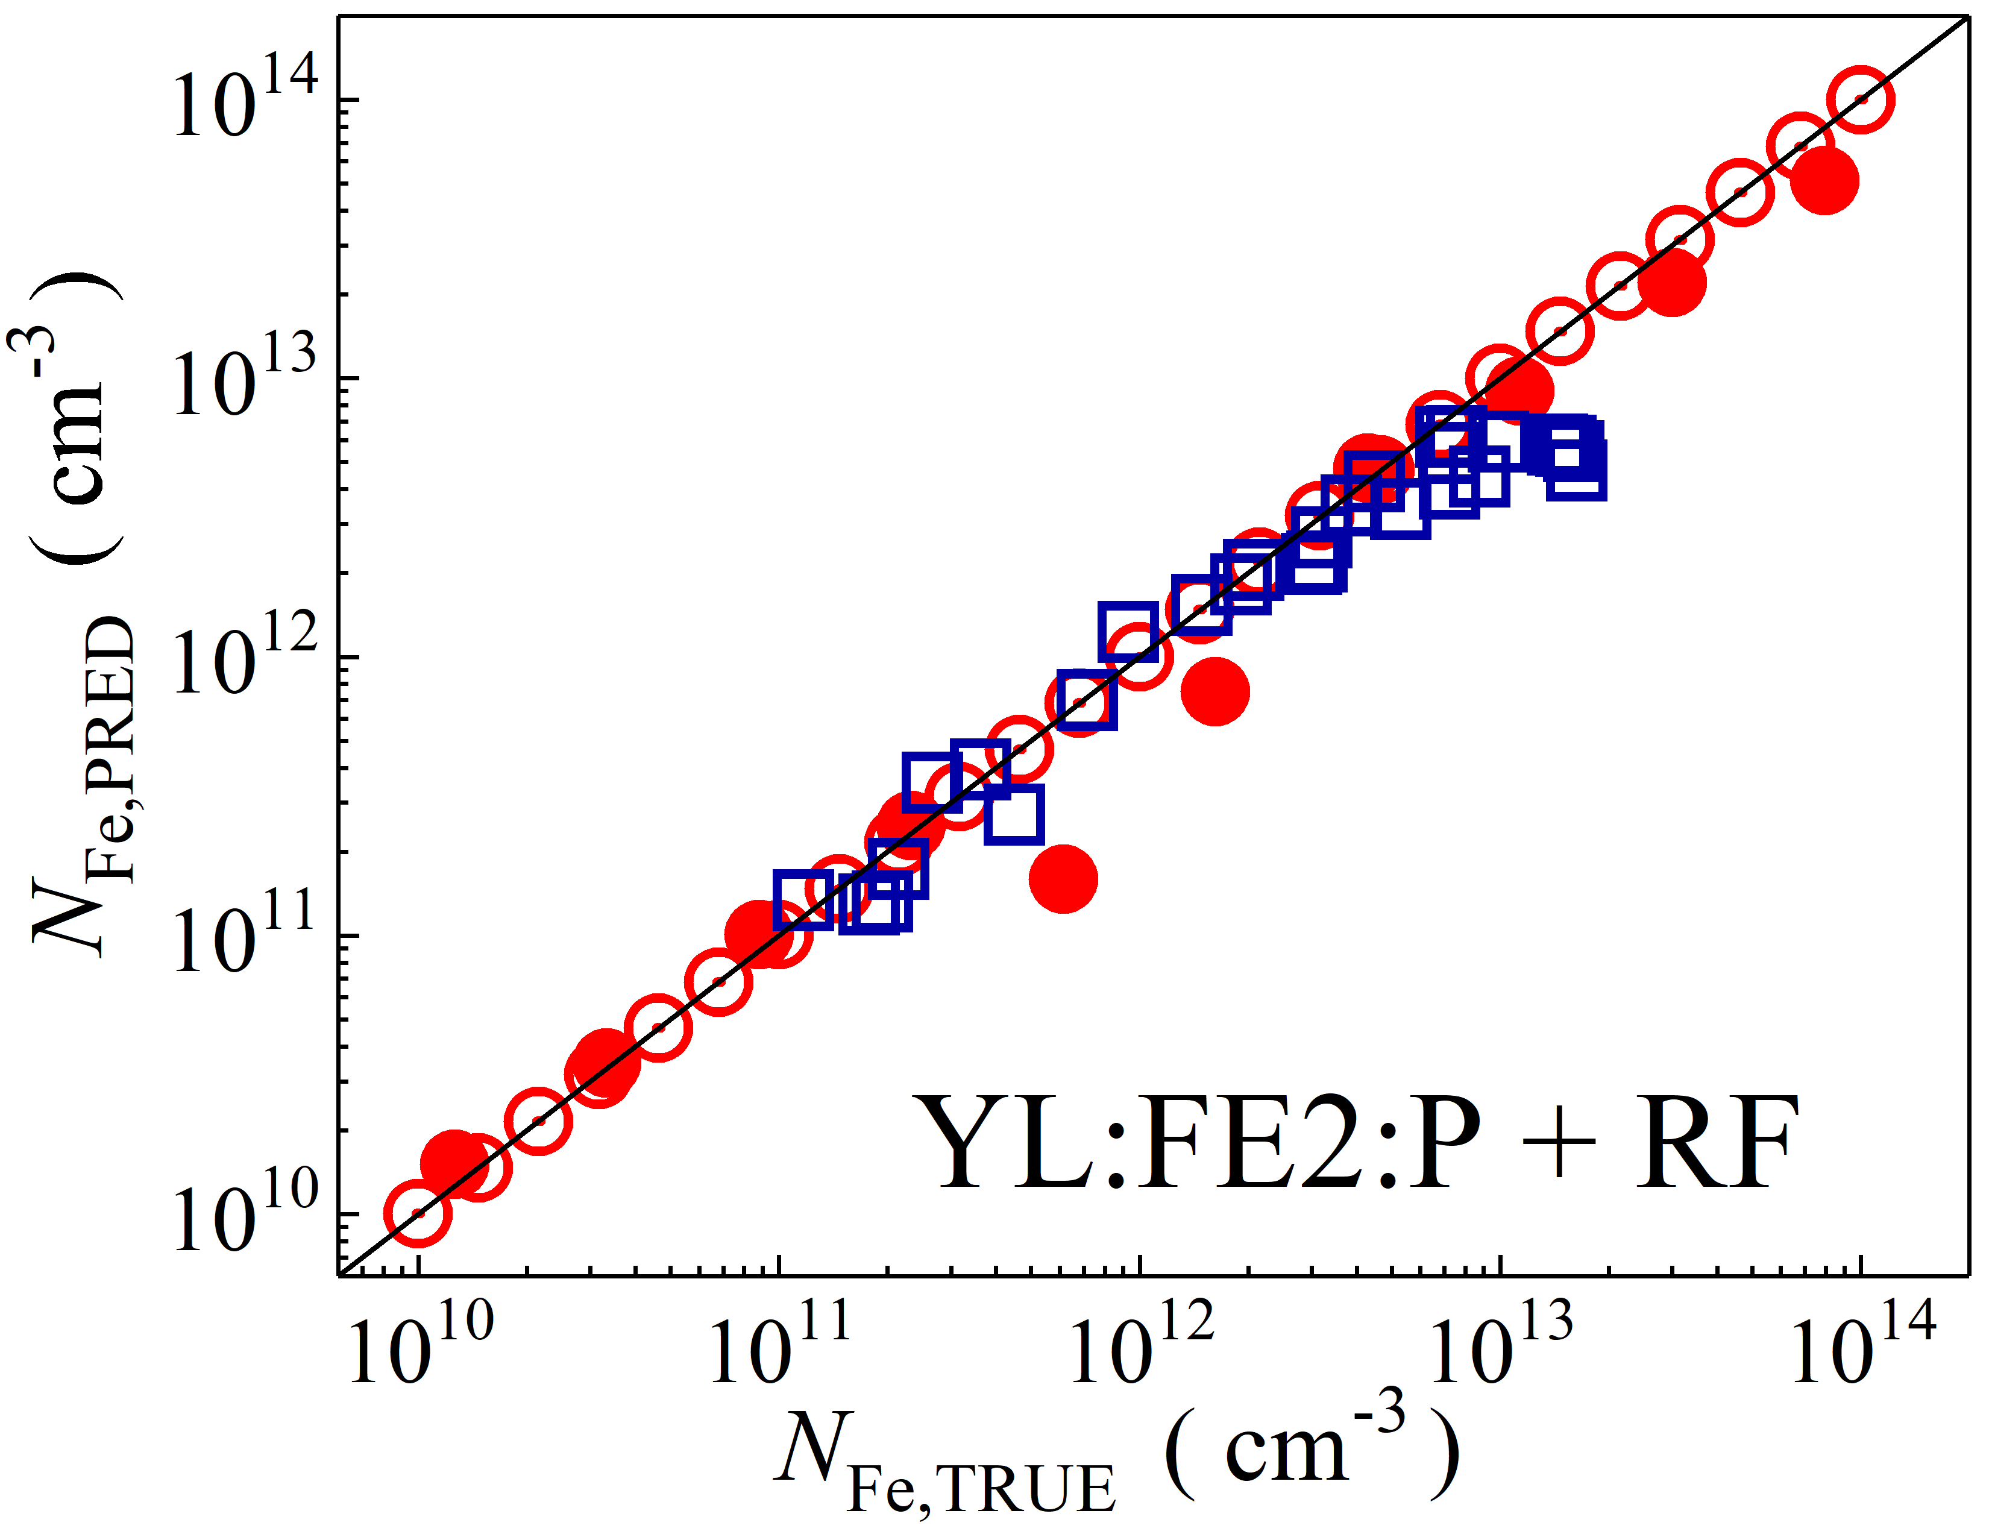

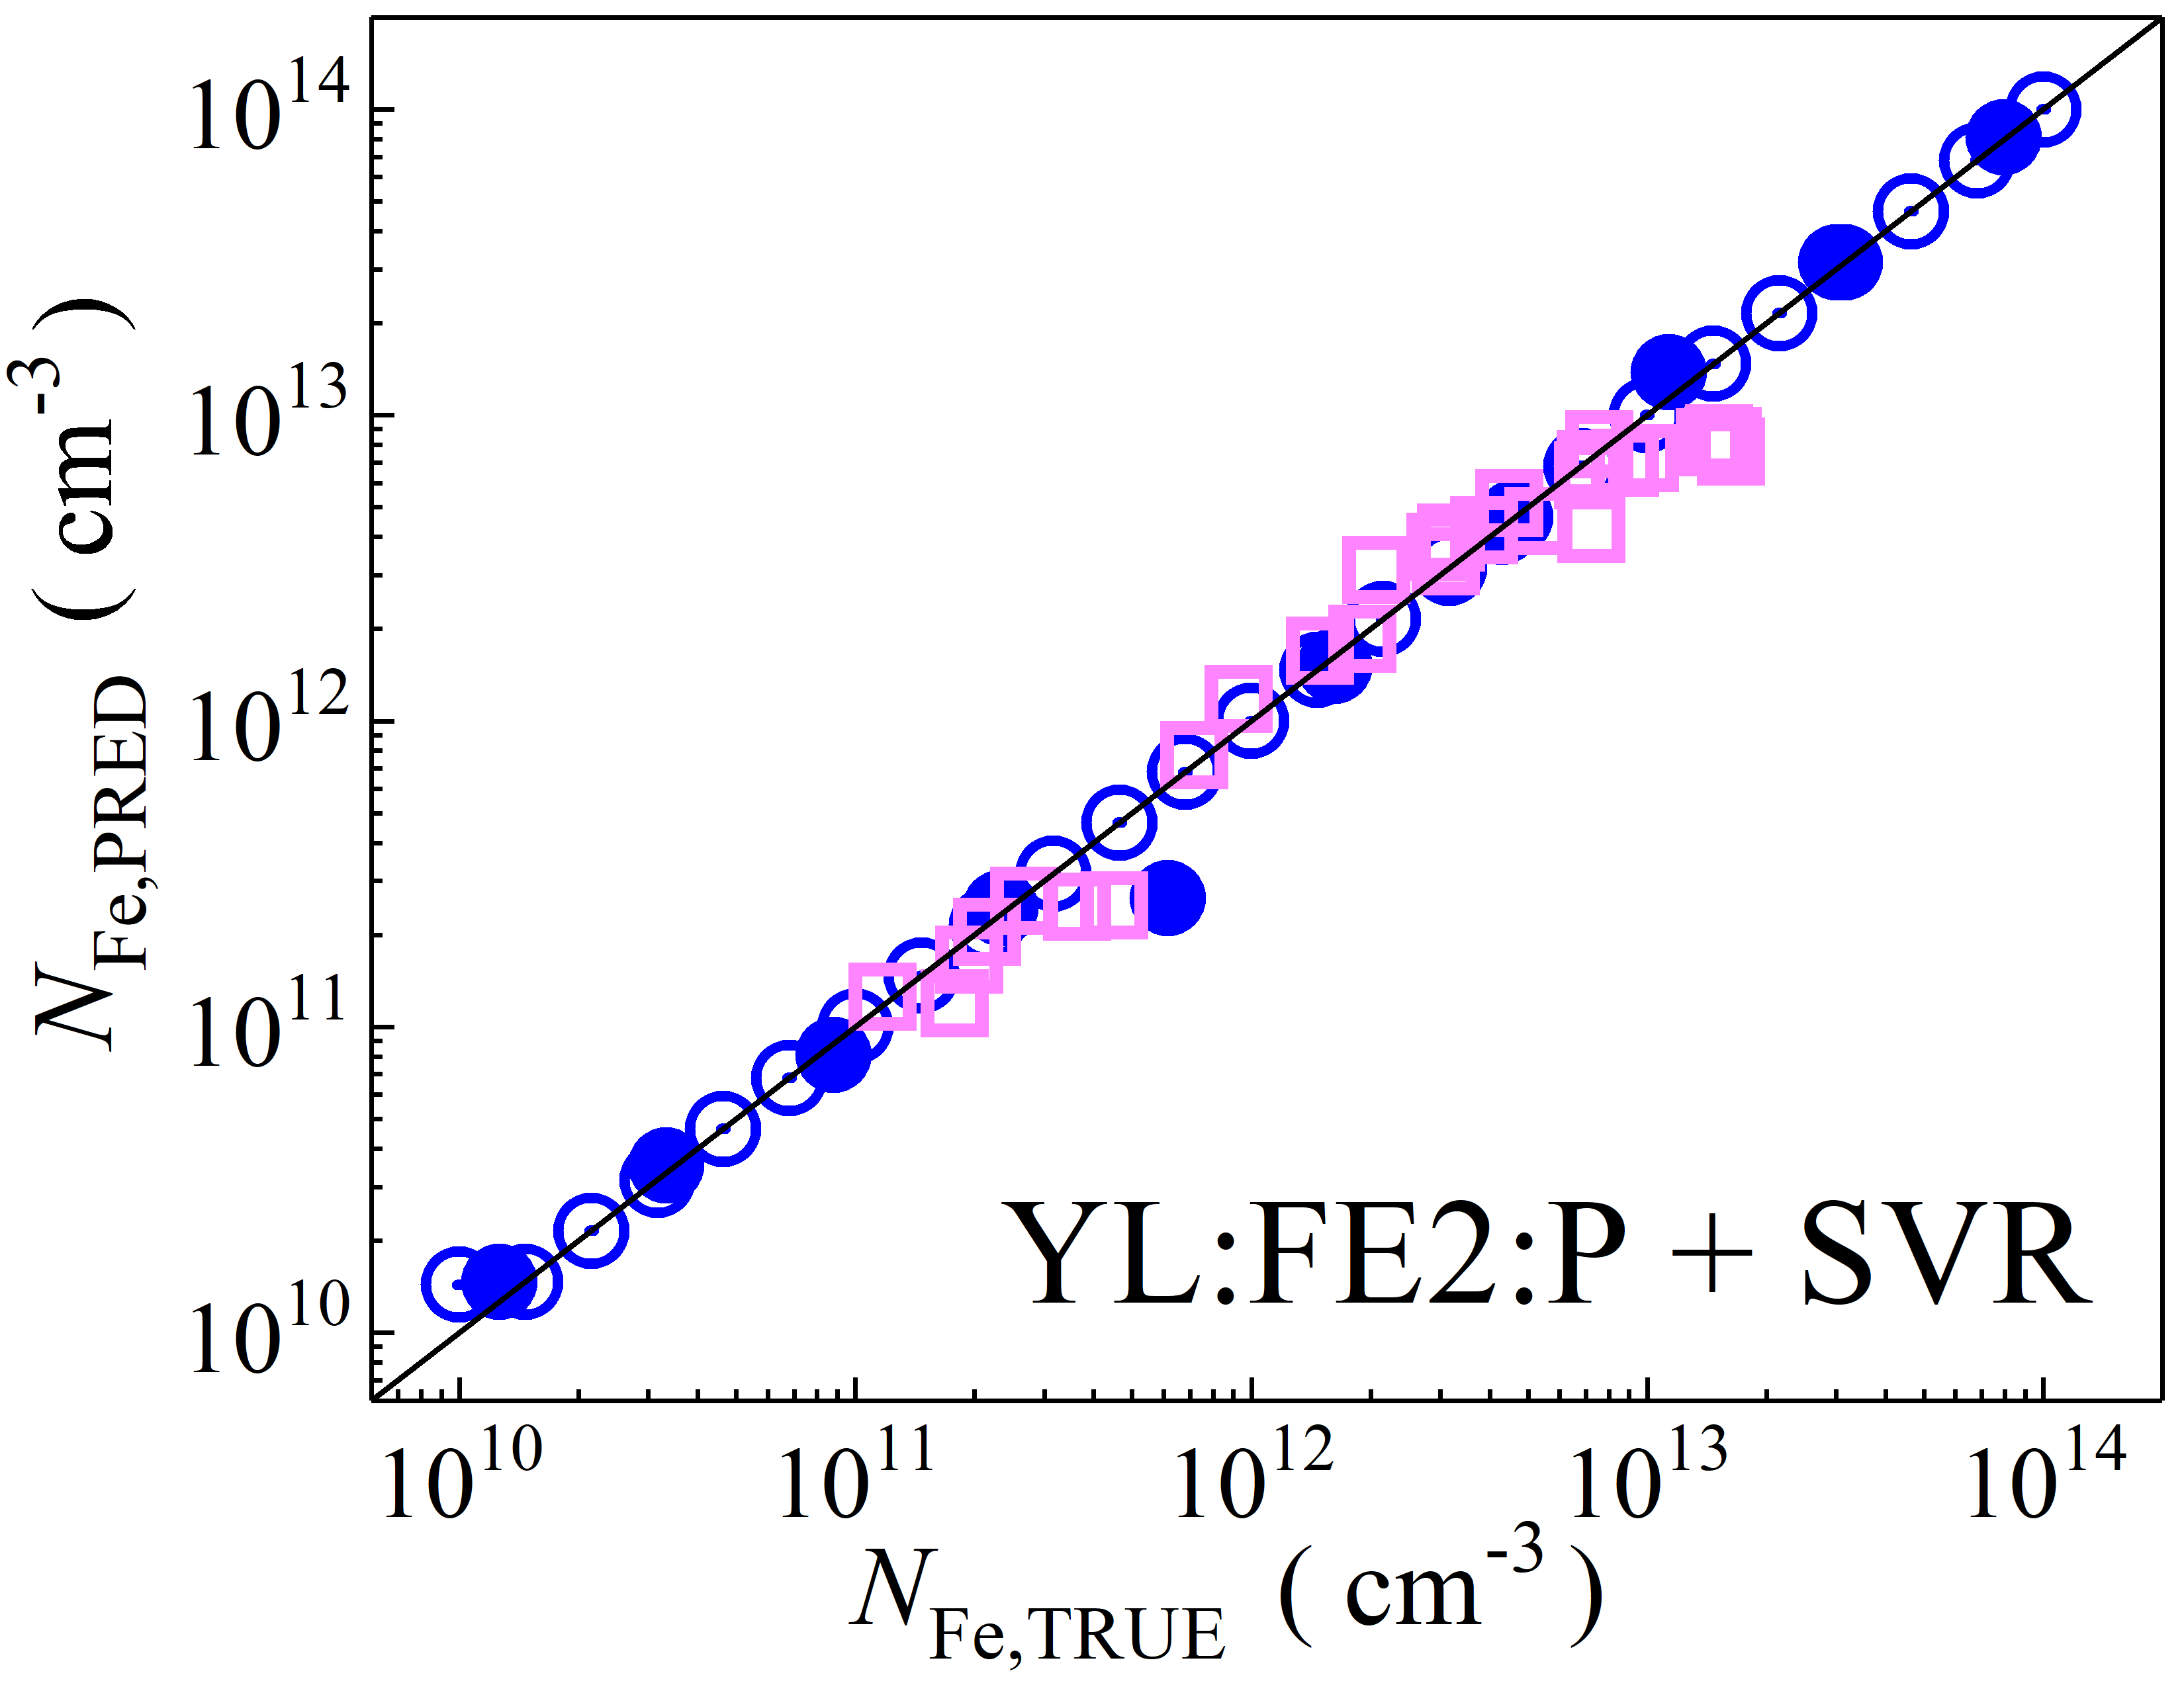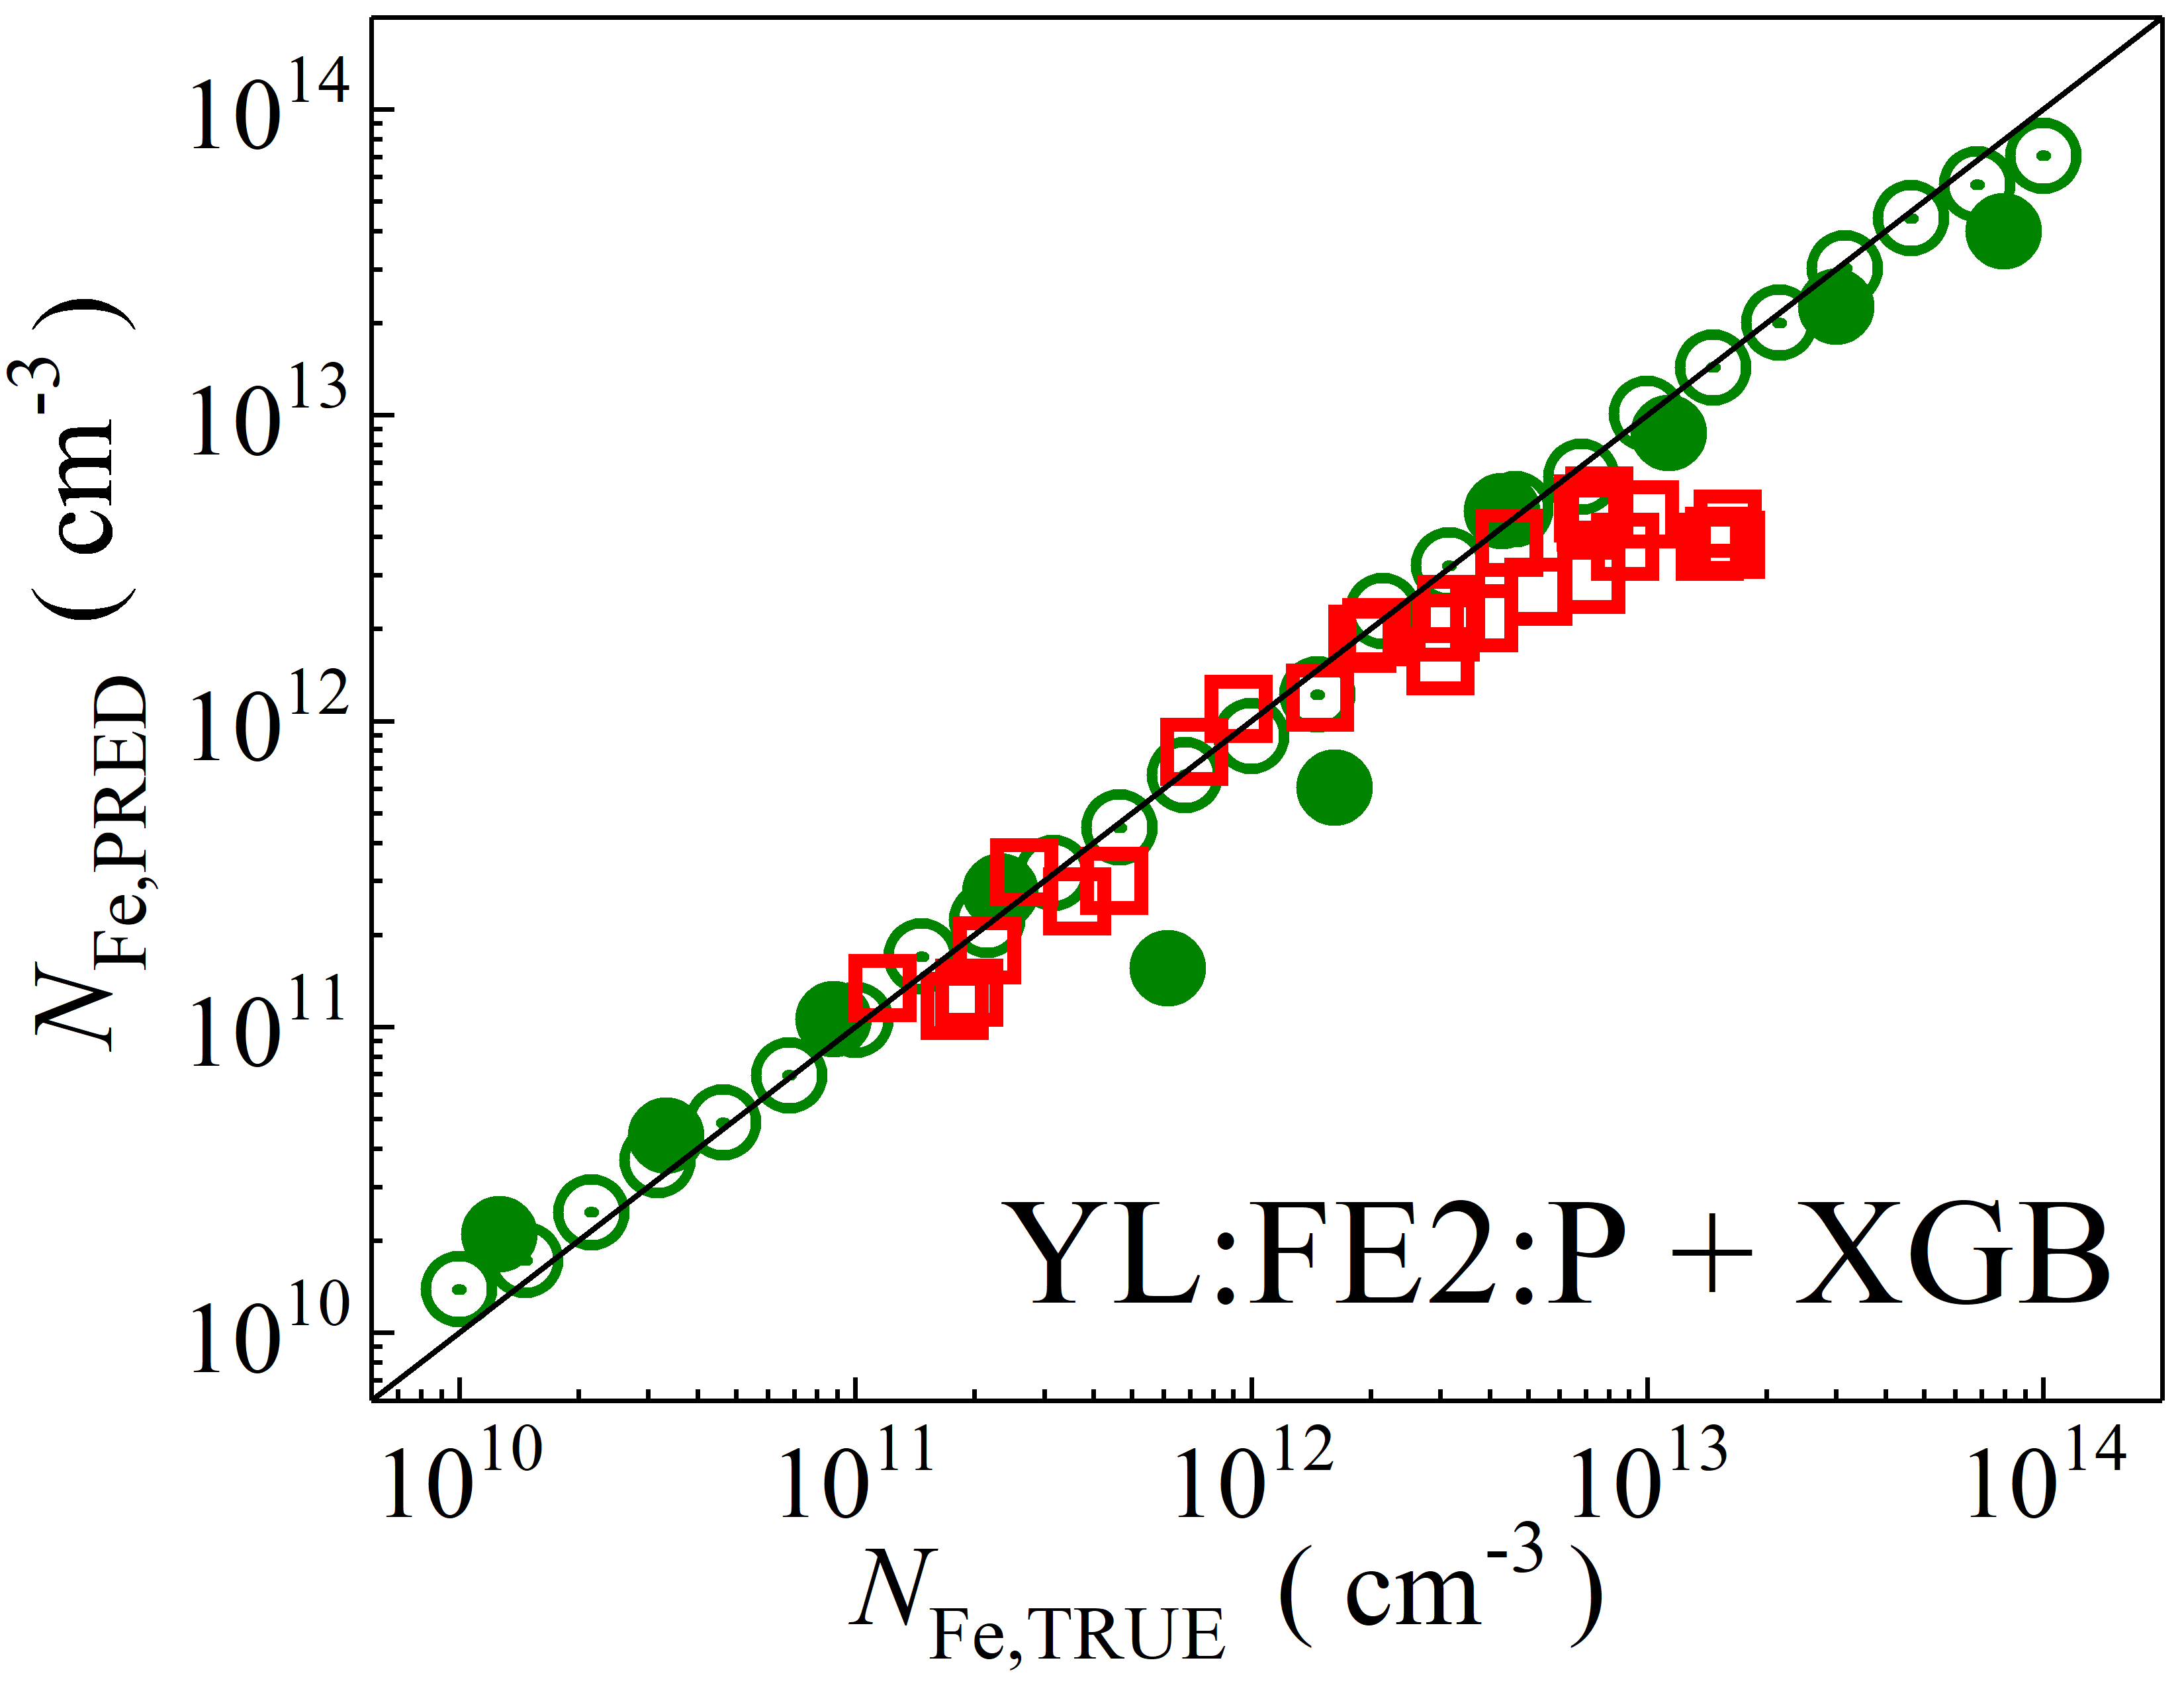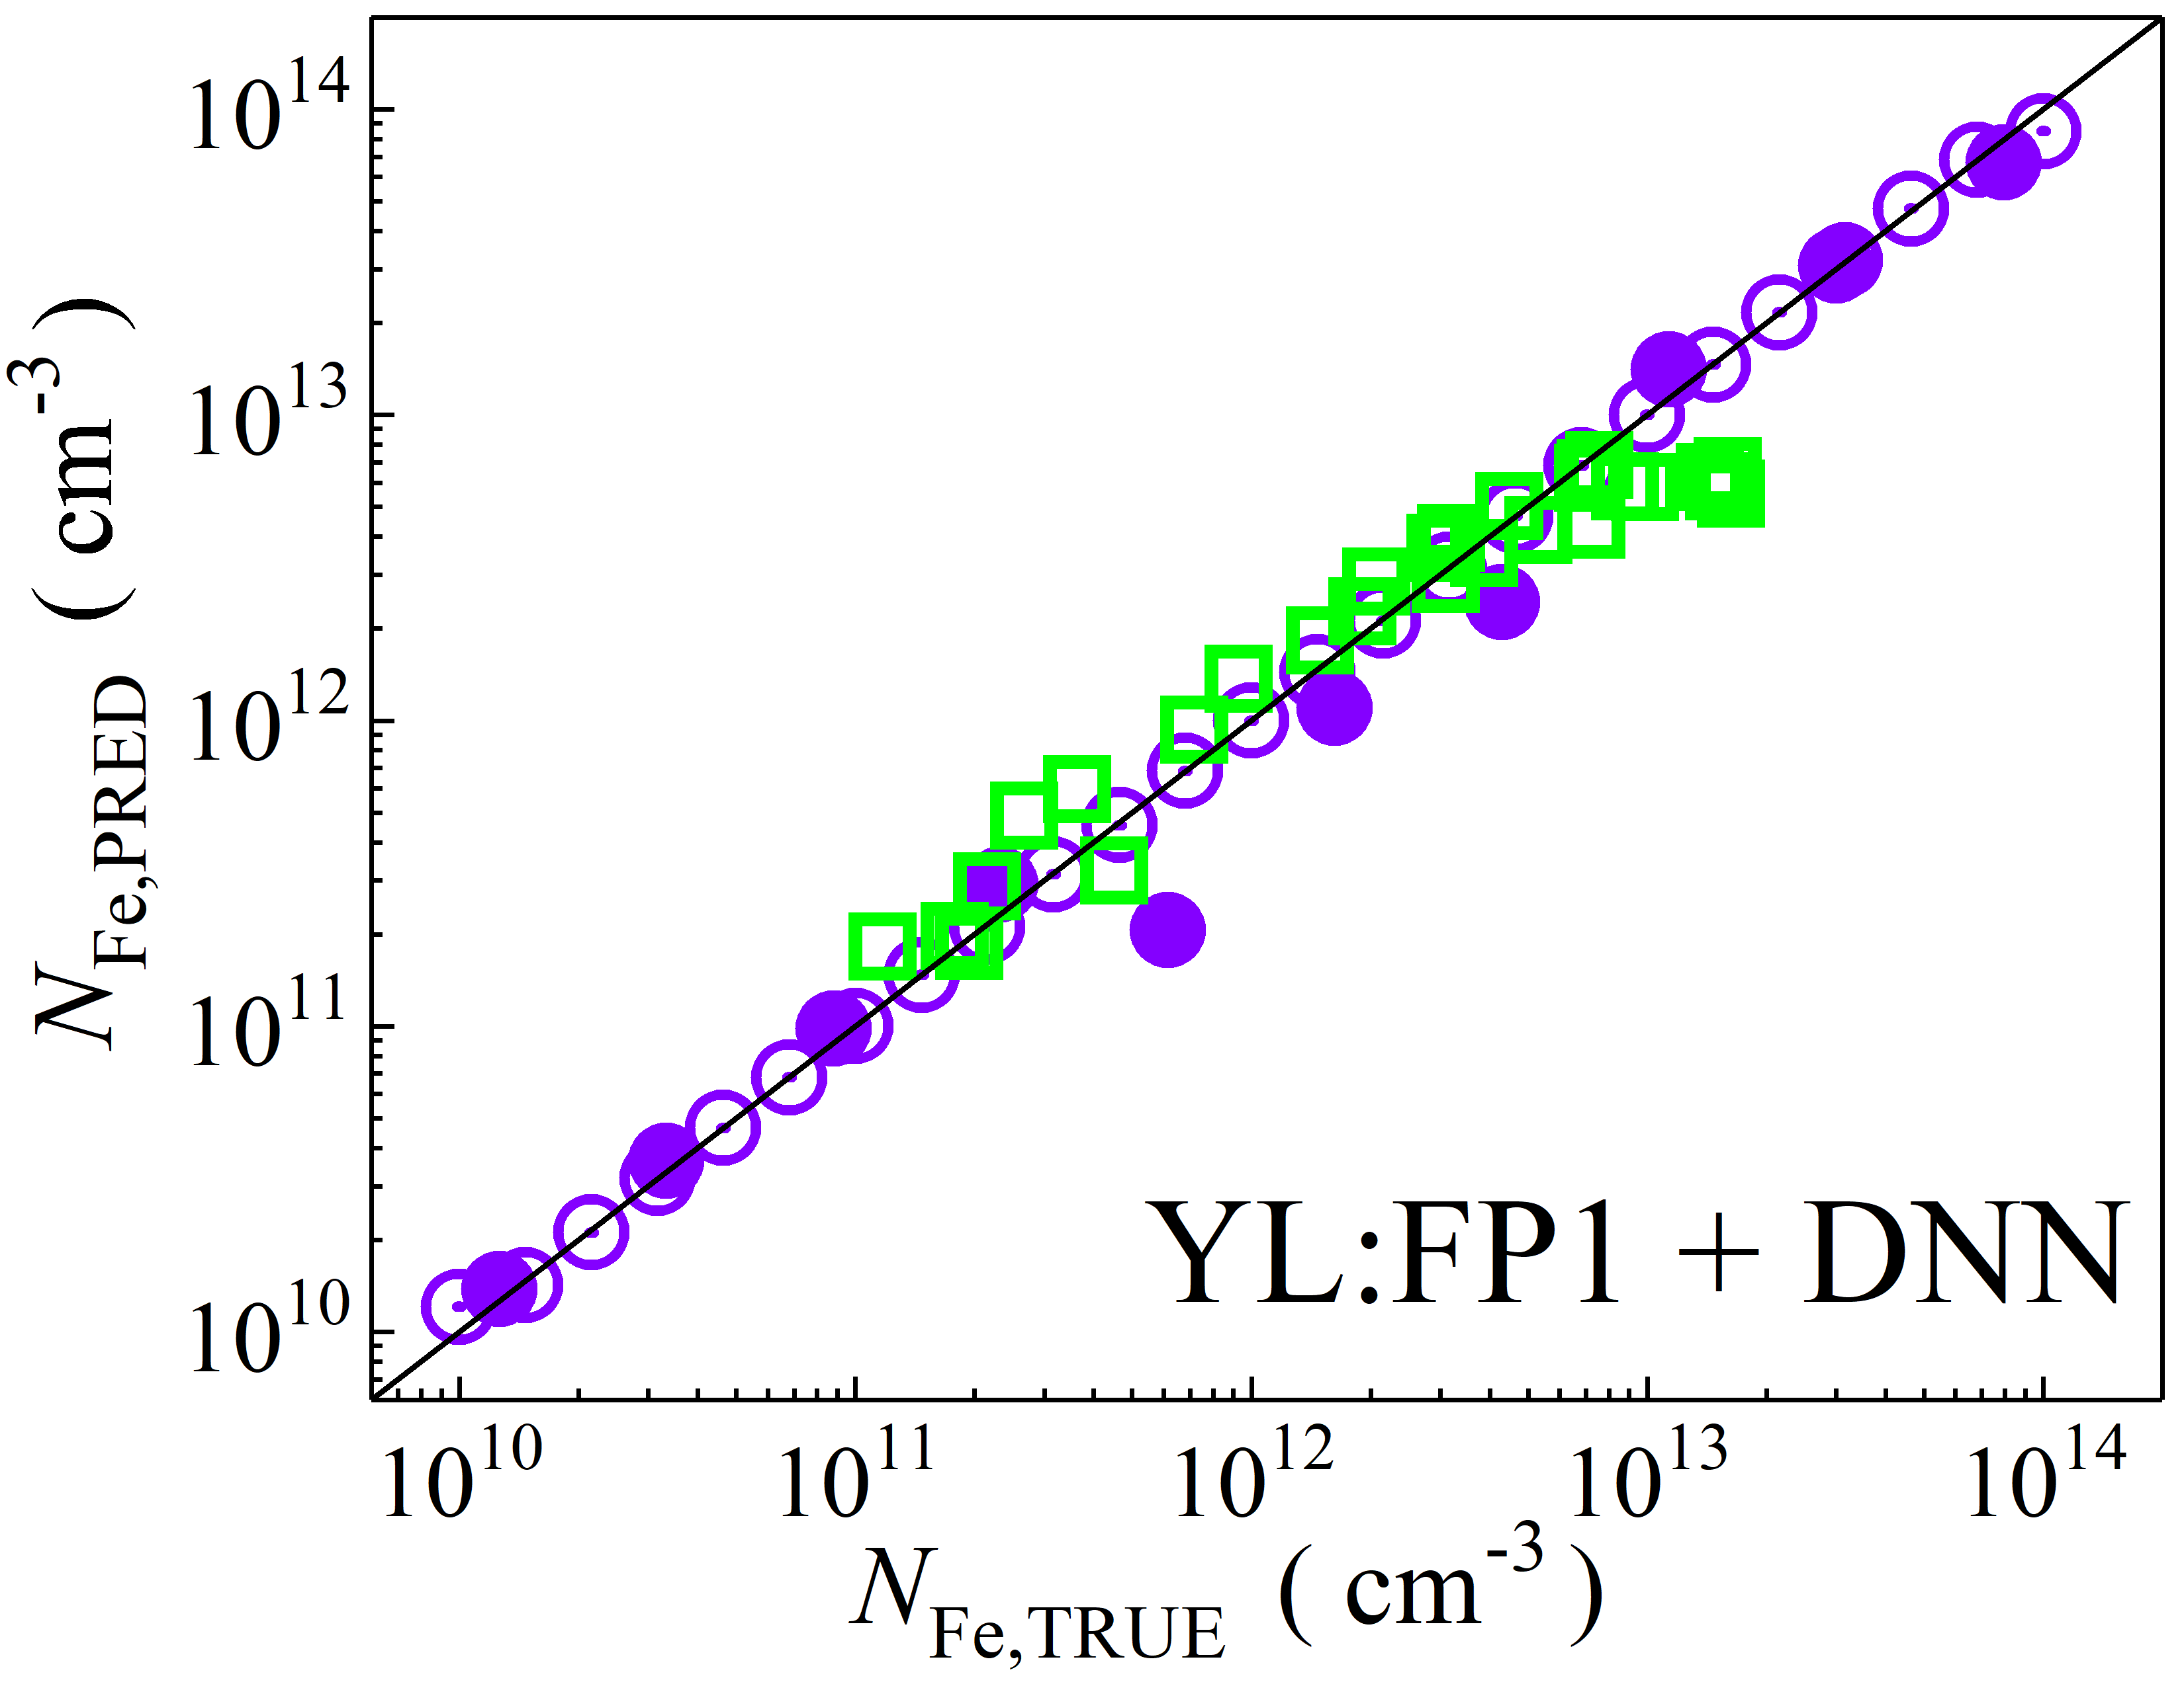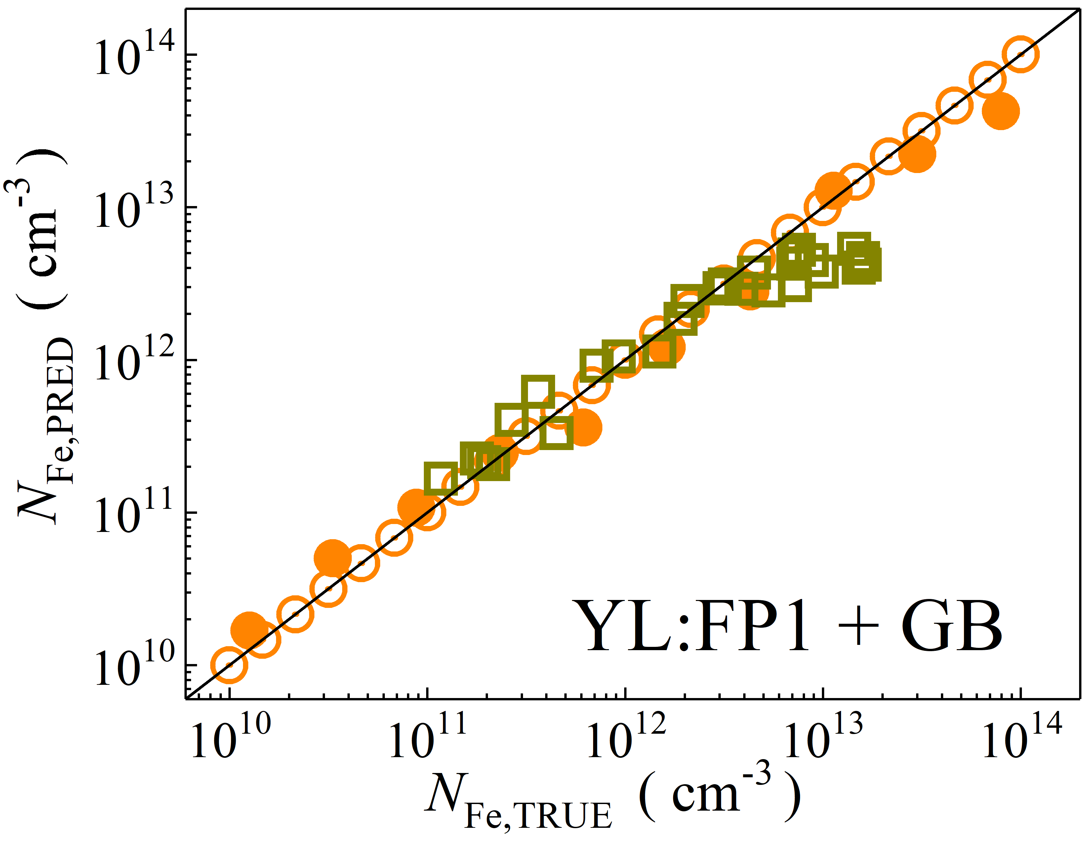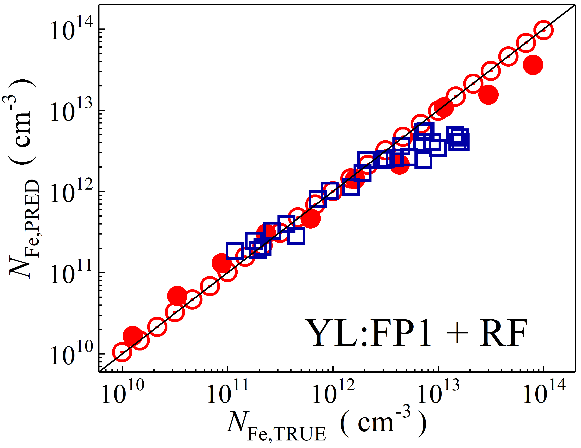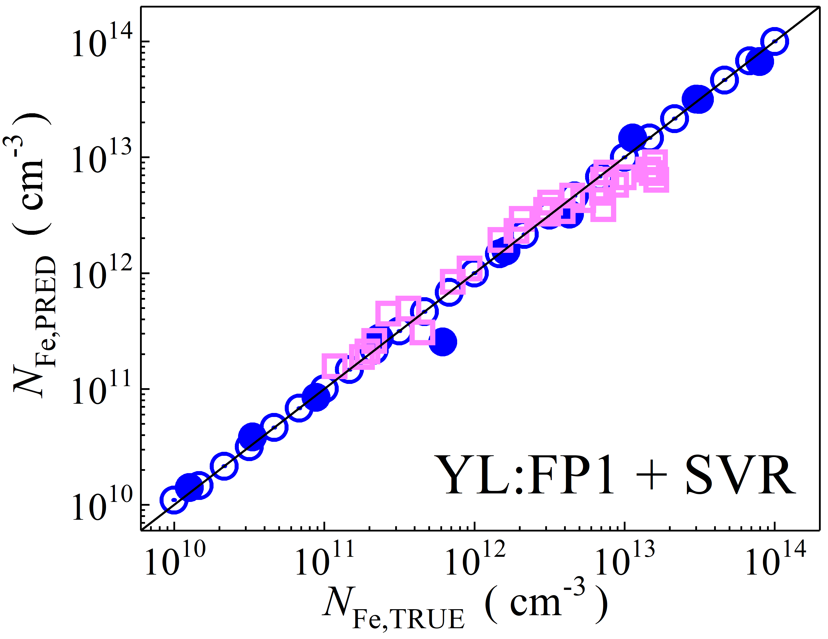

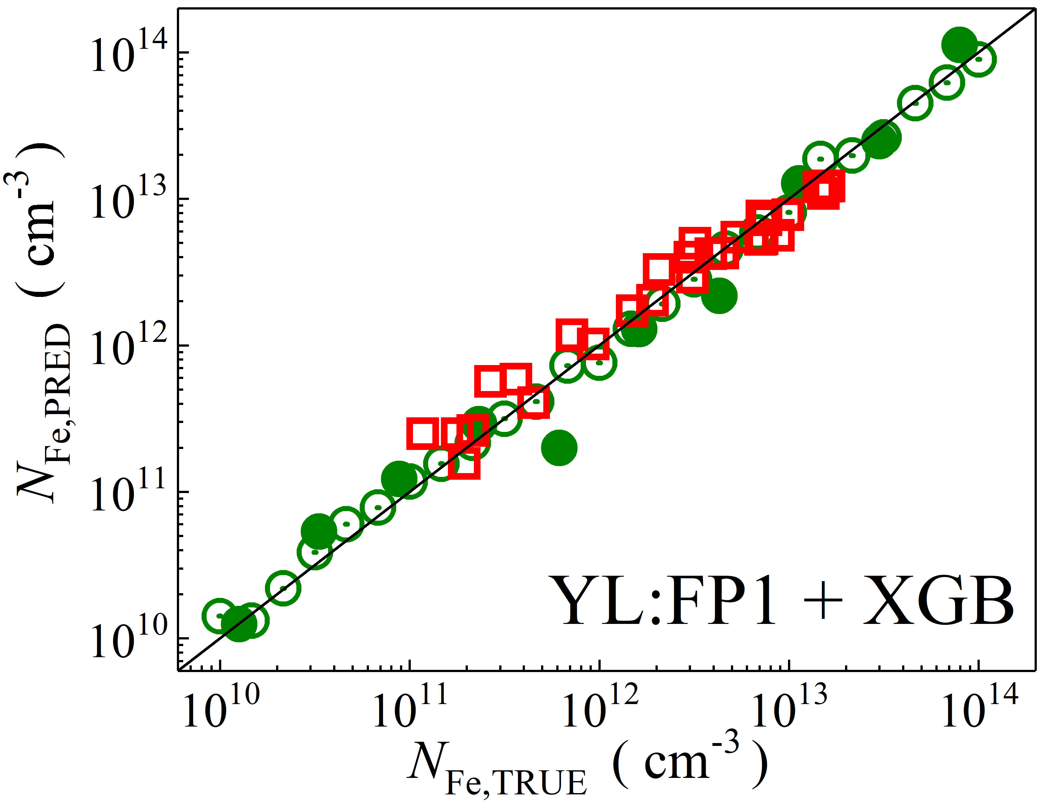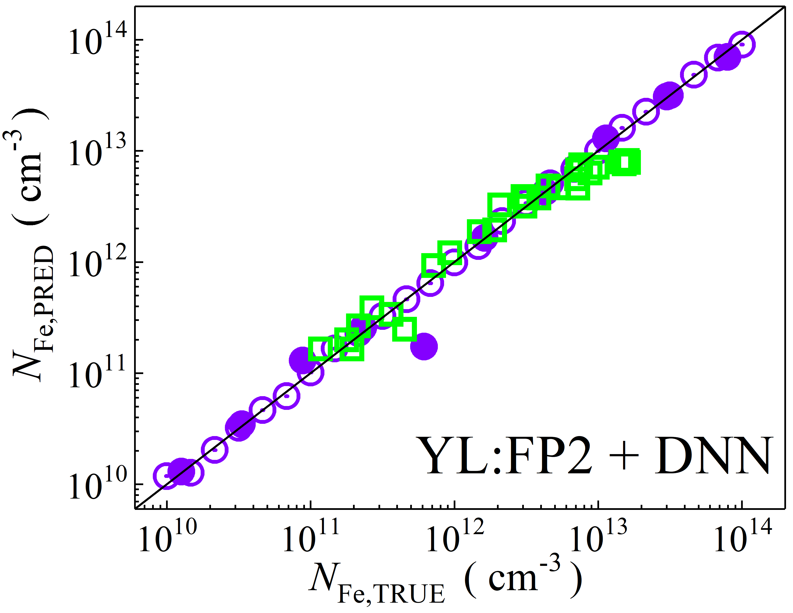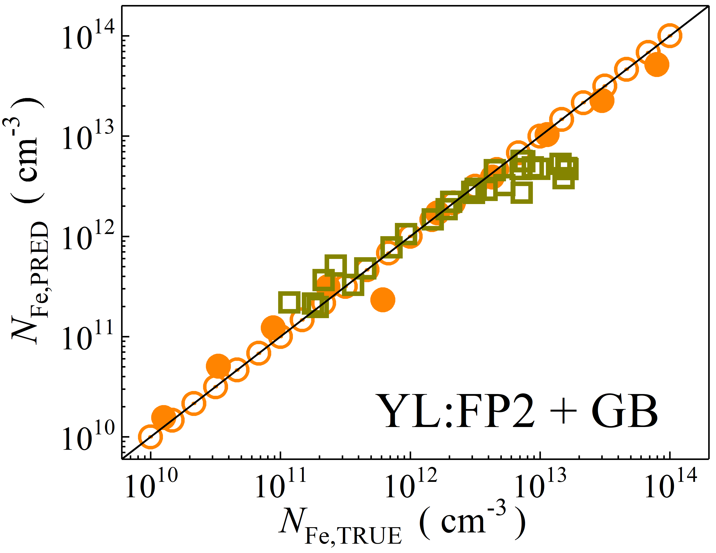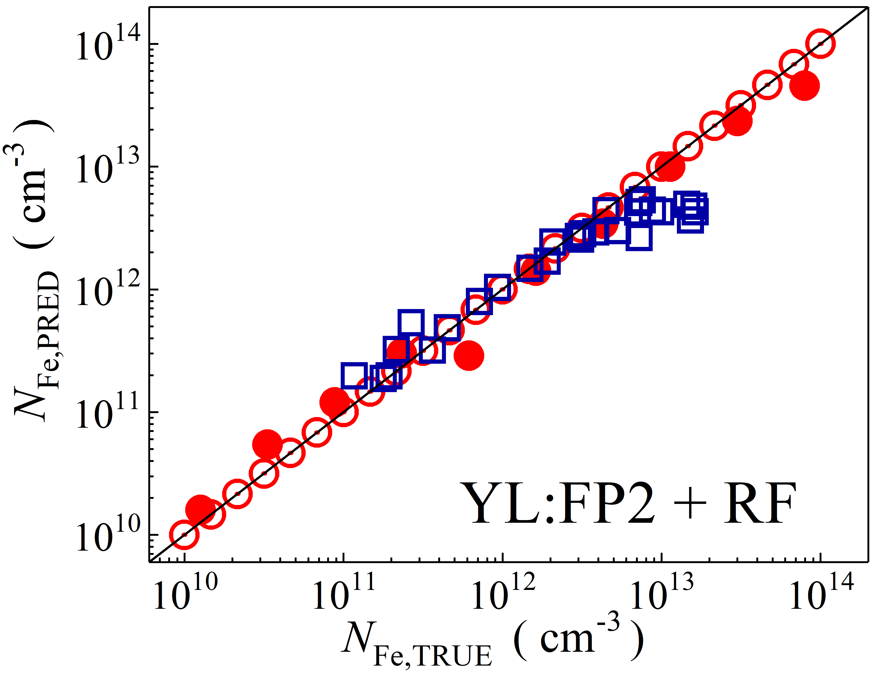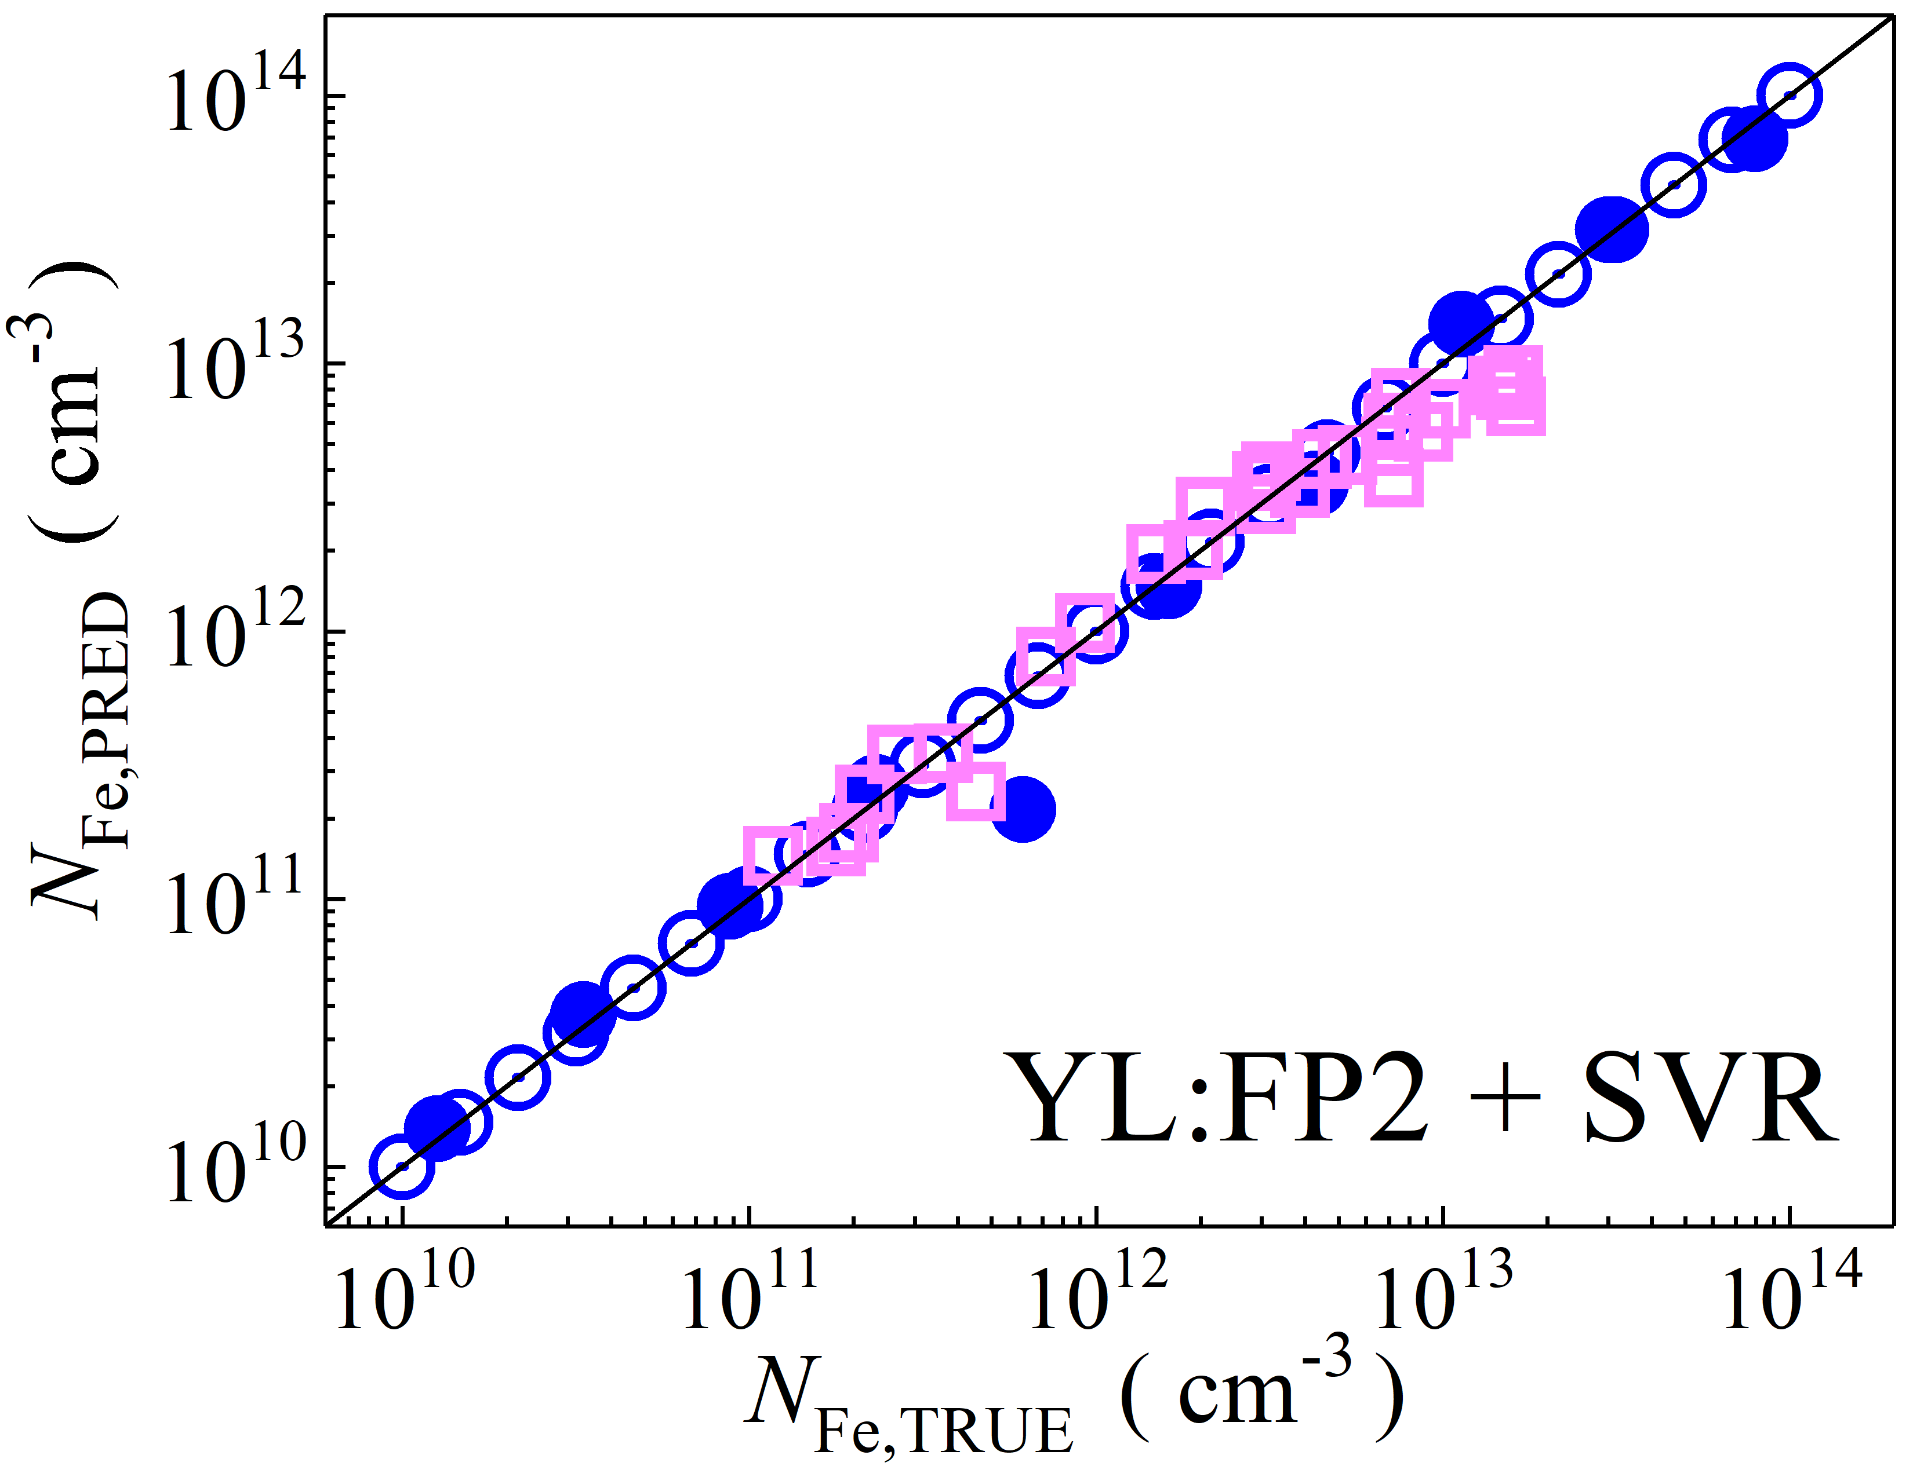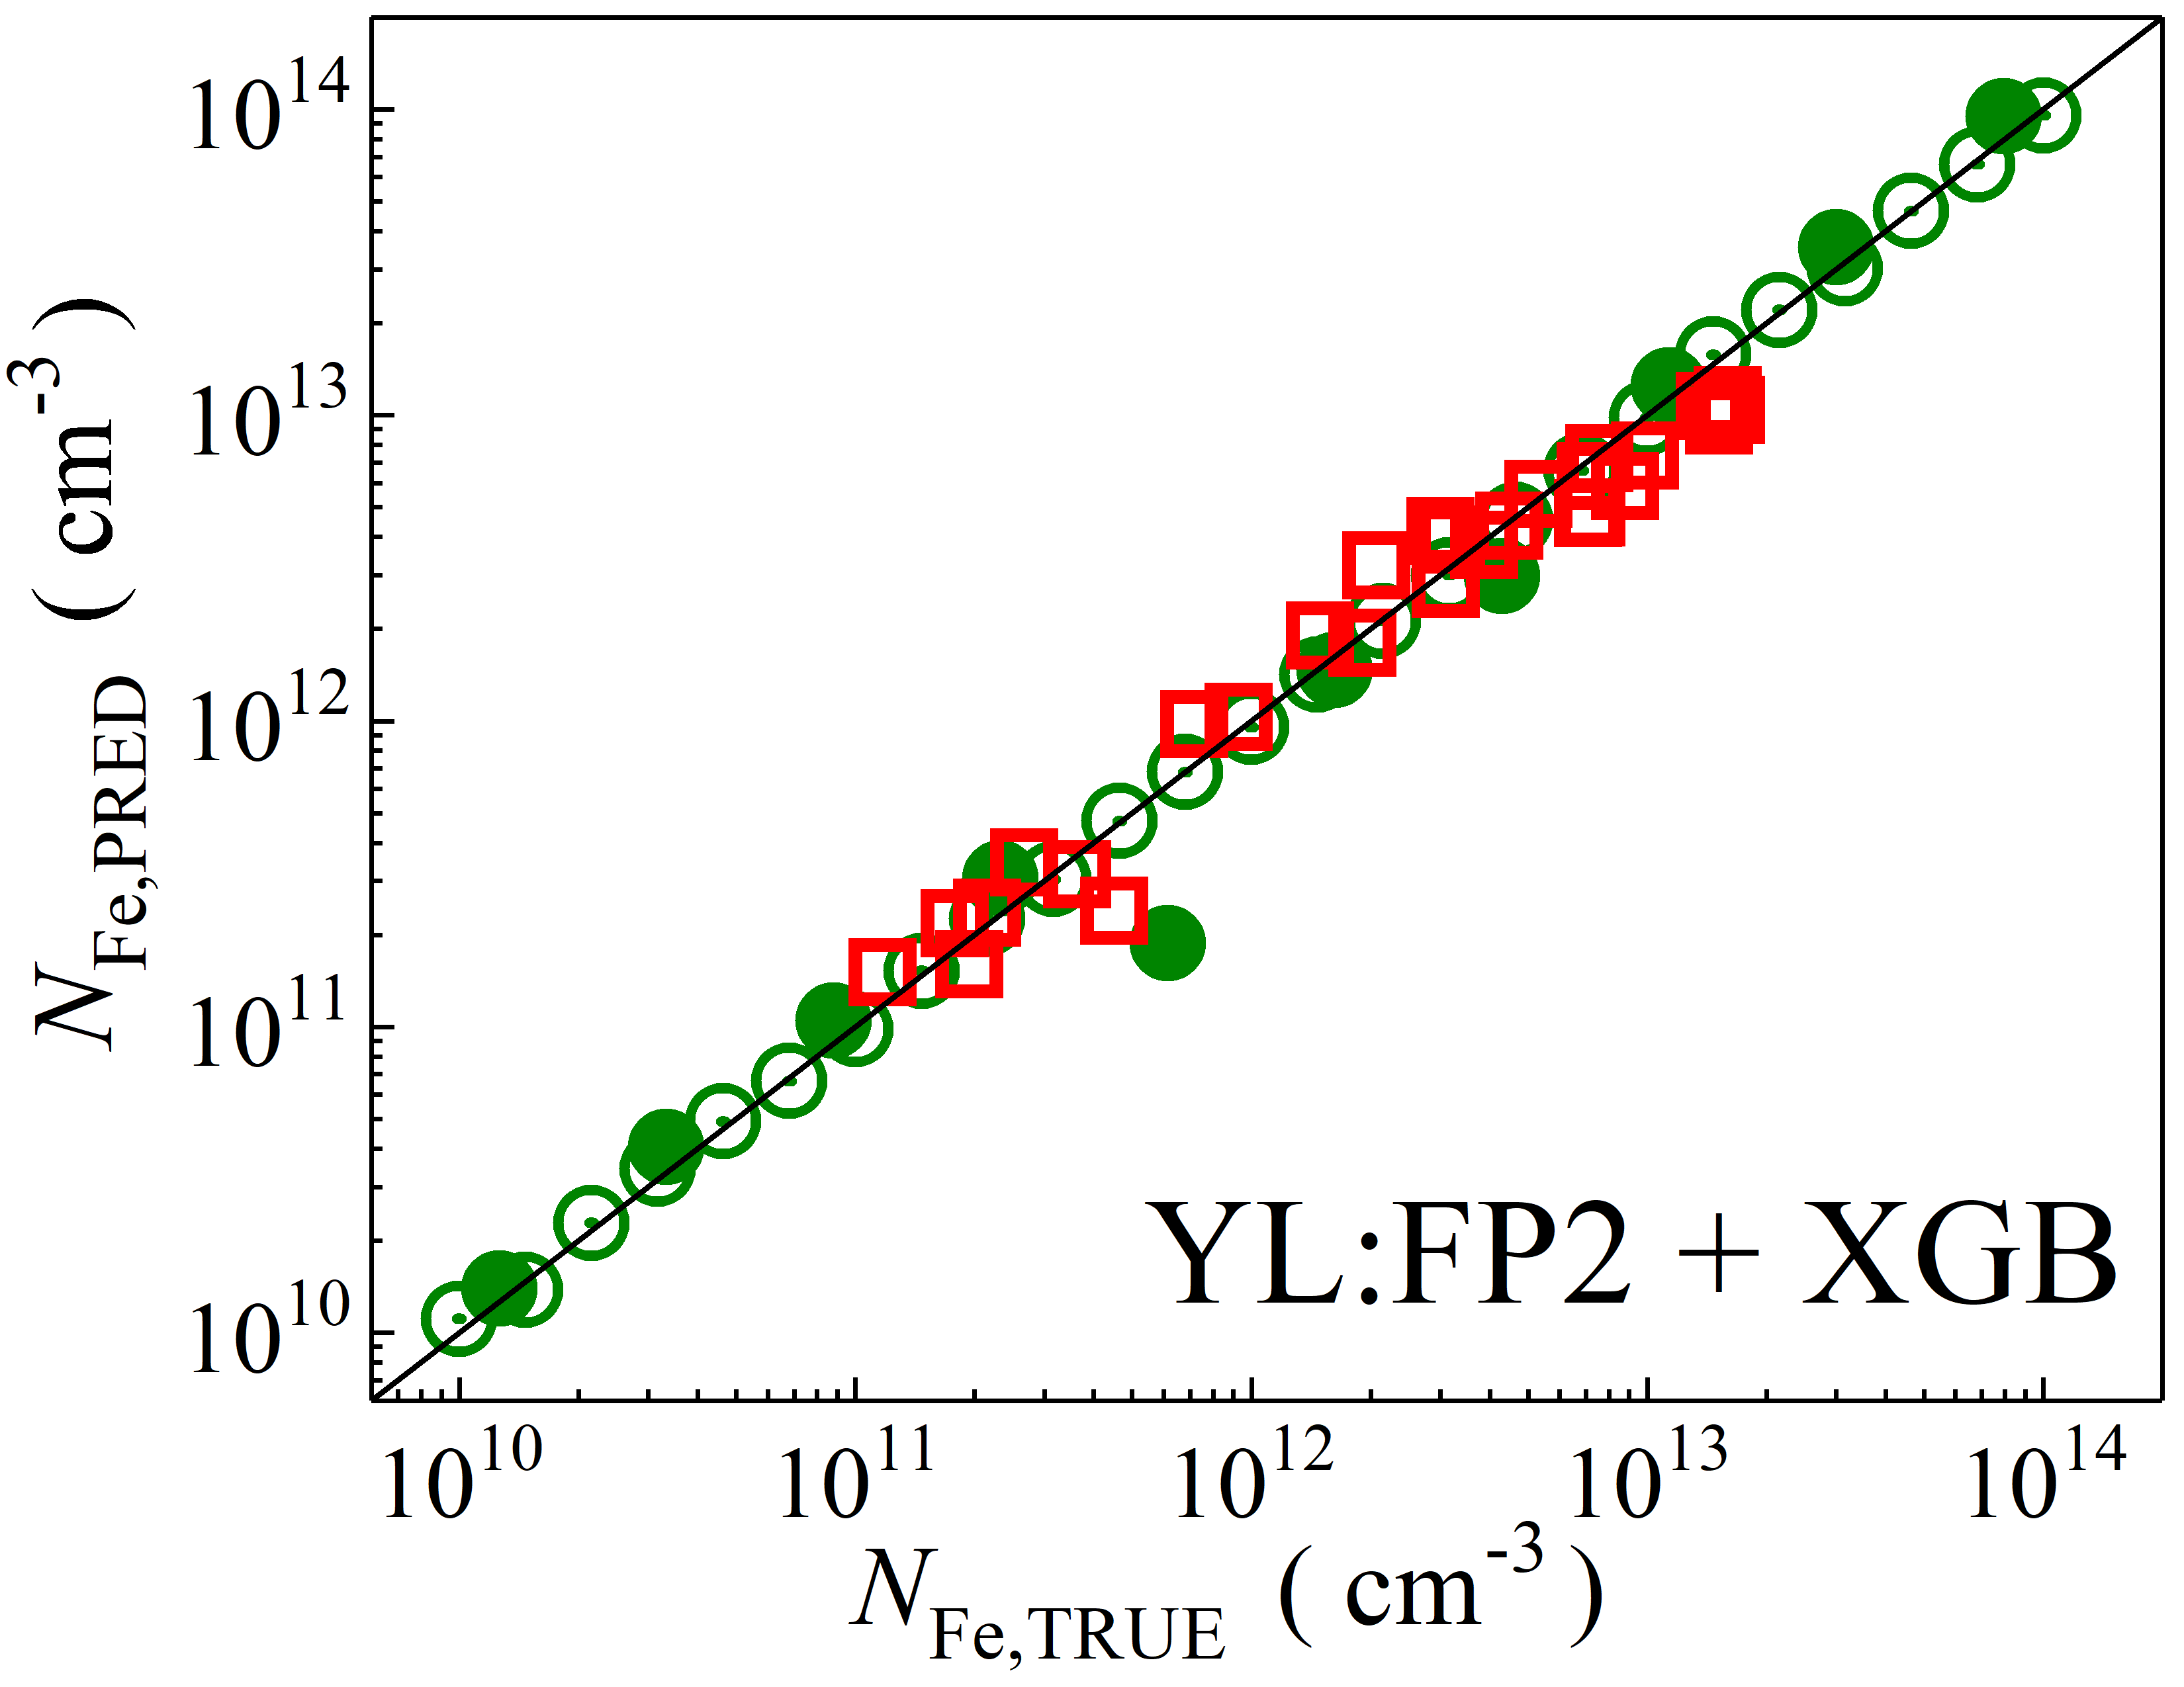

Fig. S1. Scatter plots compare reference iron concentrations $N_{Fe,TRUE}$ with ML-predicted values $N_{Fe,PRED}$ using feature vectors extracted from various computer vision models, including EfficientNetB7, MobileNetV2, NASNet, ResNet152, Xception, and YOLO. The ML algorithms applied are DNN, GB, RF, SVR, and XGB. Symbols represent different datasets: open circles — training data (simulated), filled circles — test data (simulated), and open squares — test data from experimental measurements. The black lines are the identified lines serving as the references.

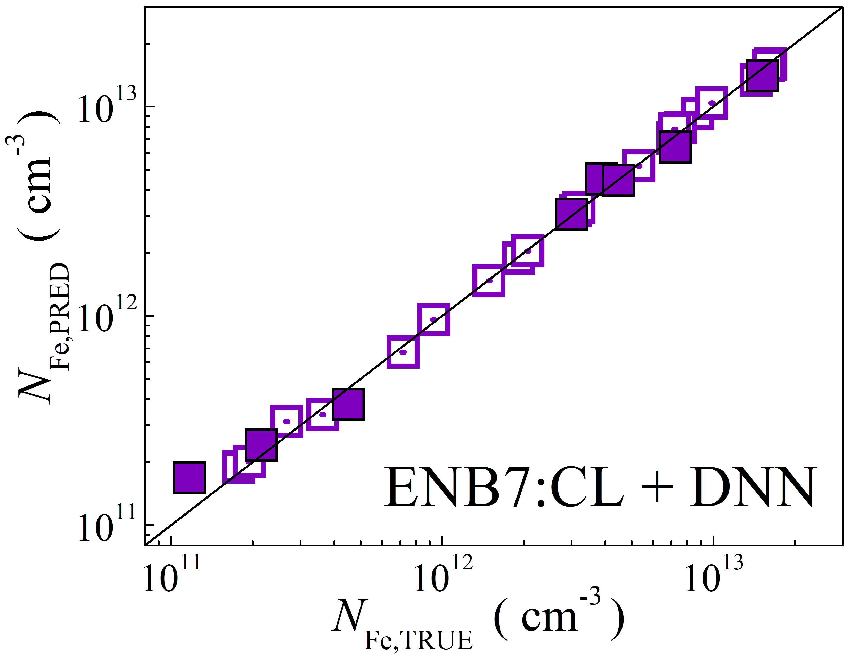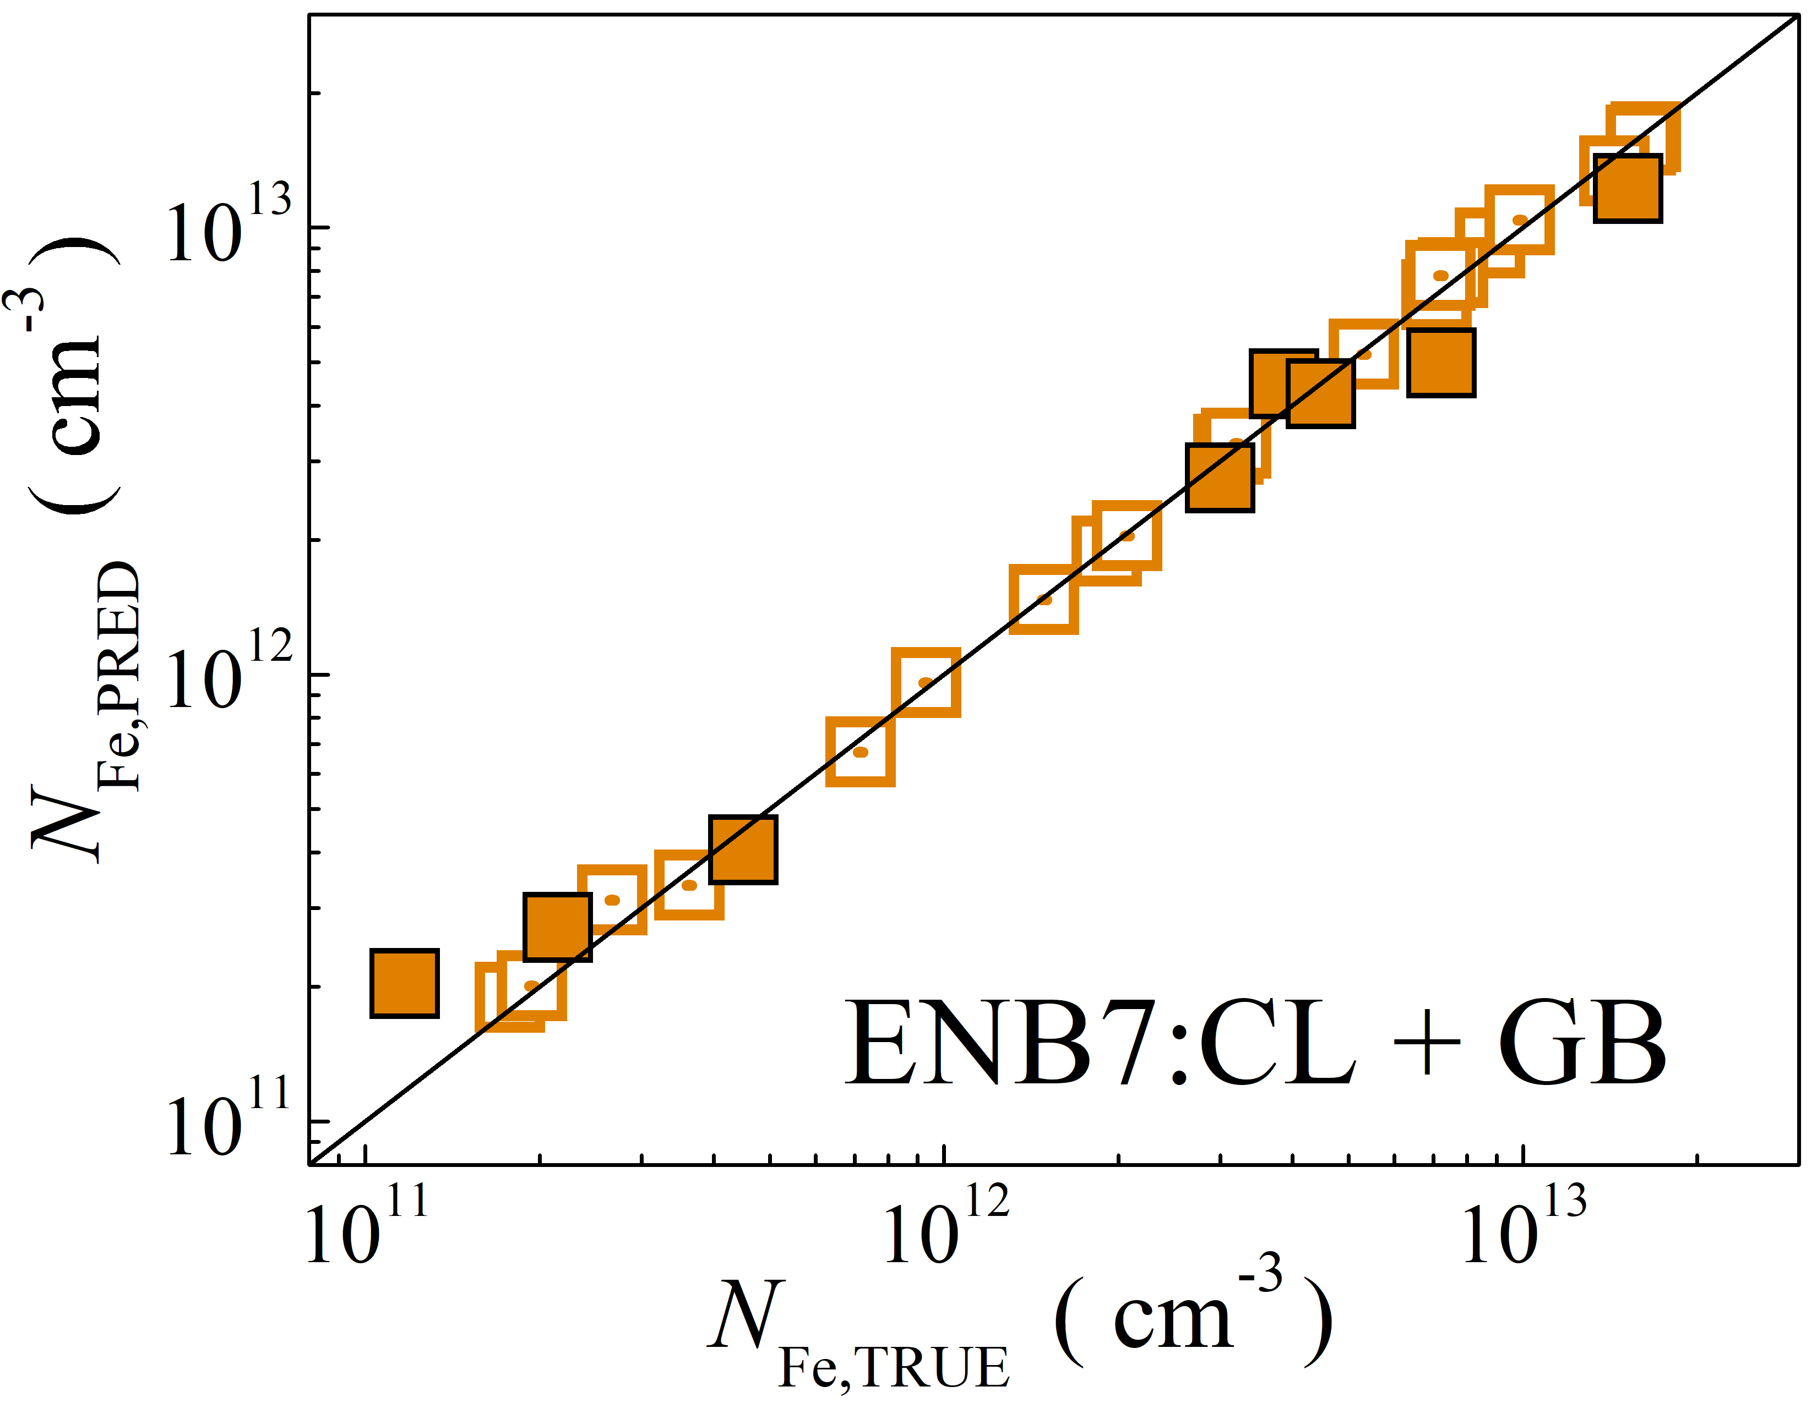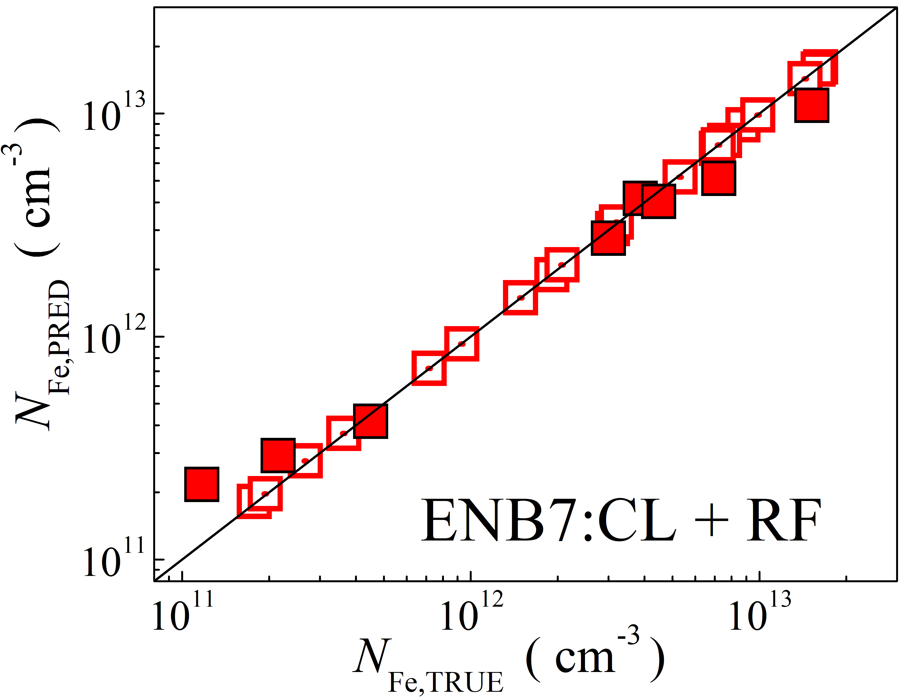

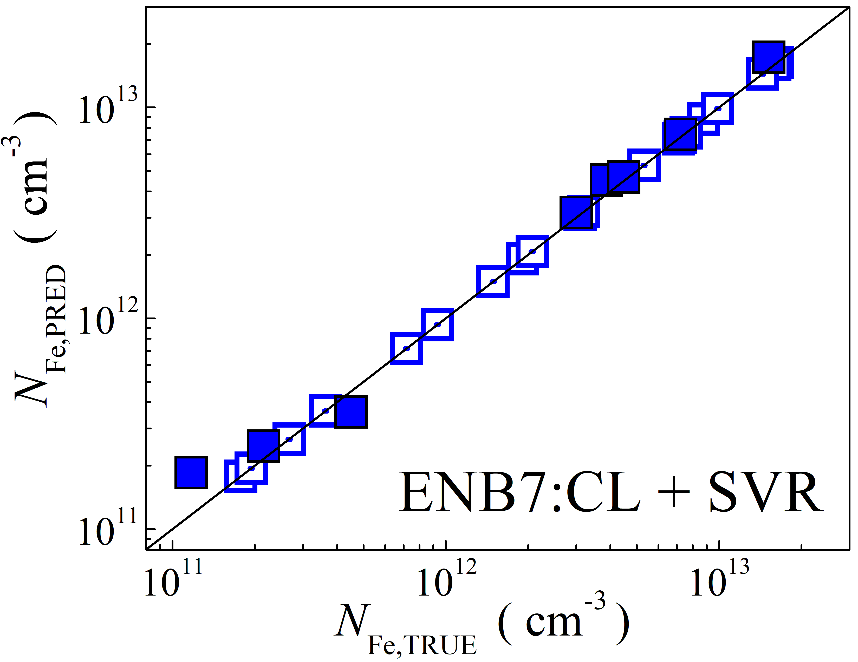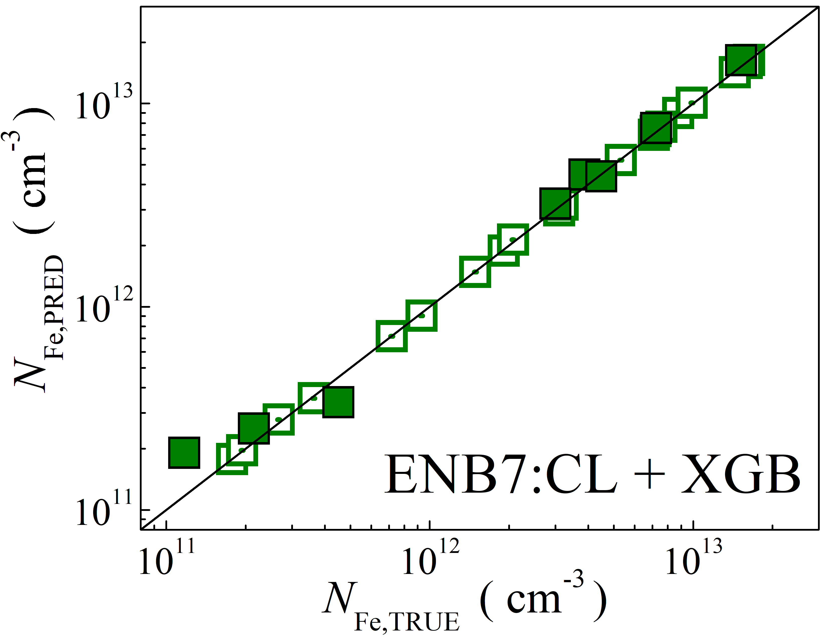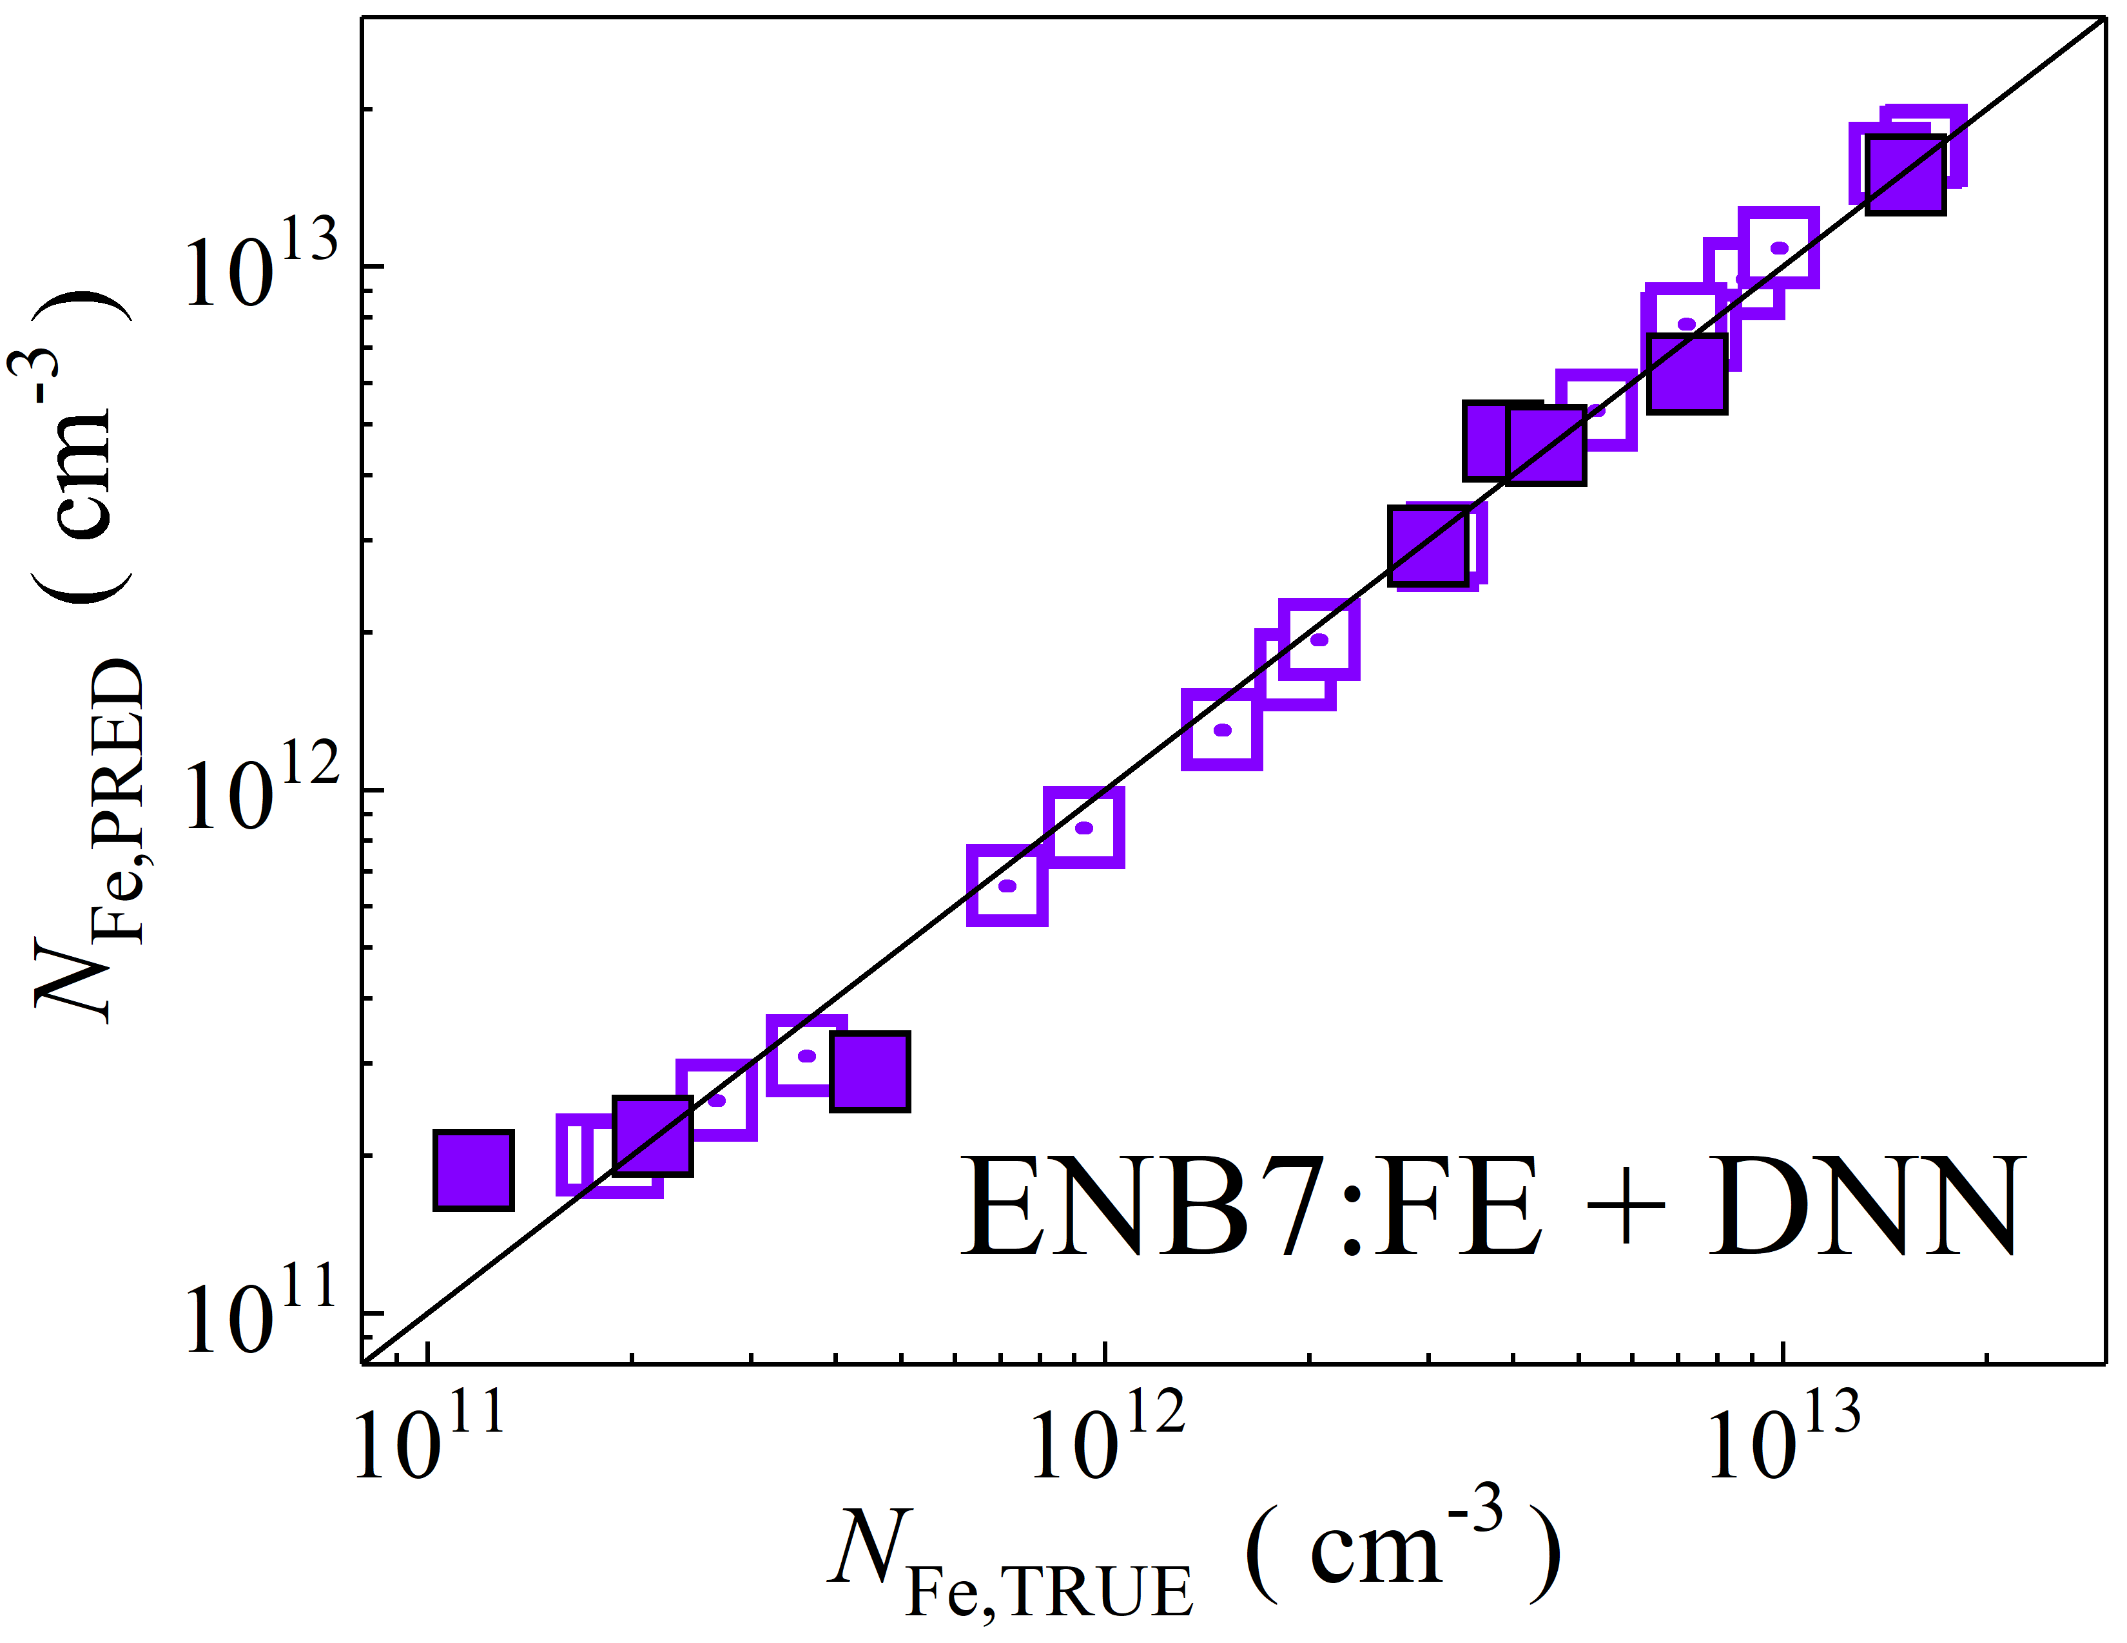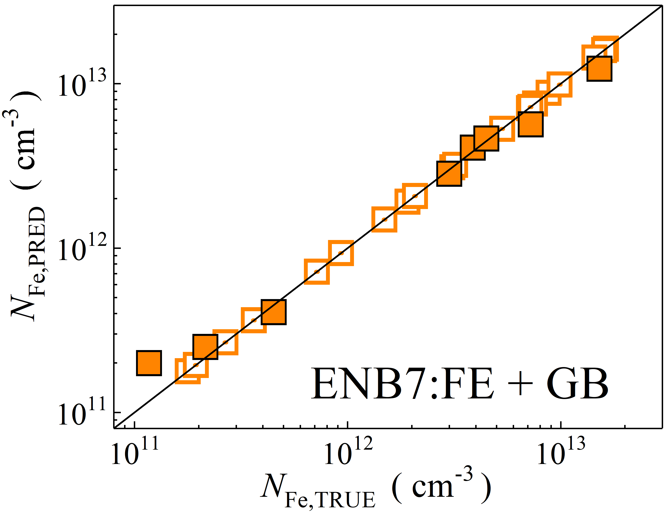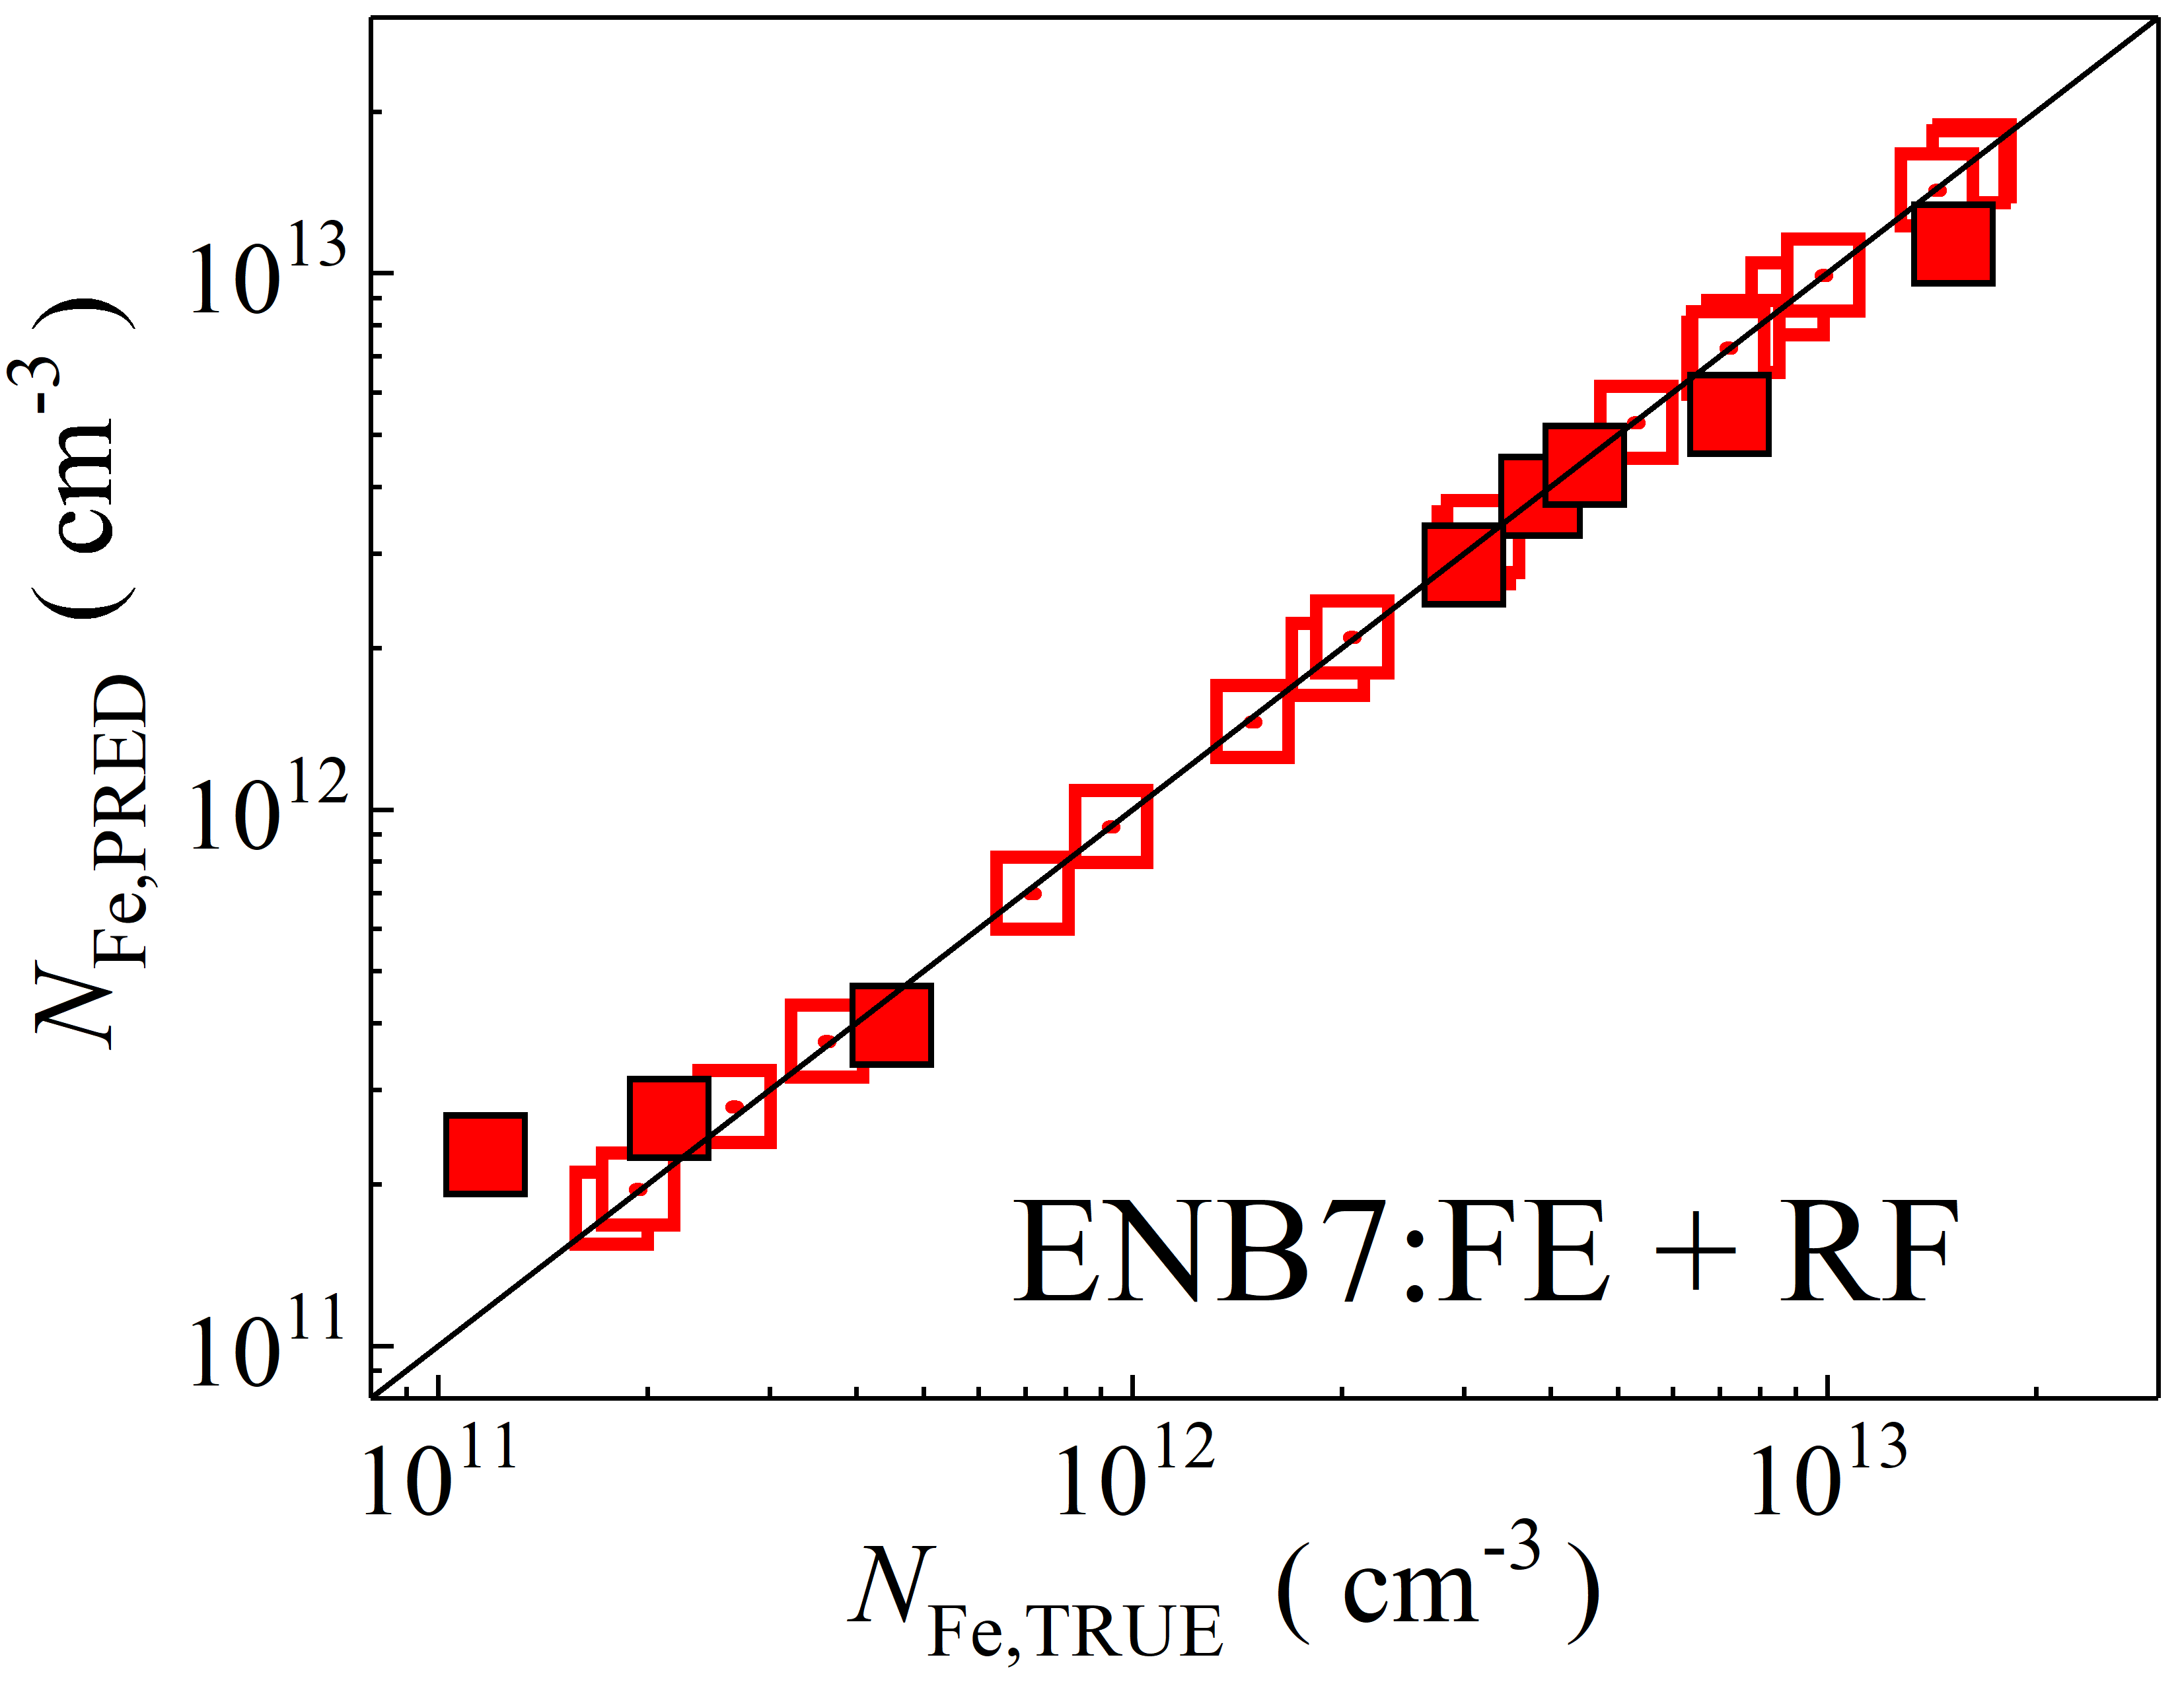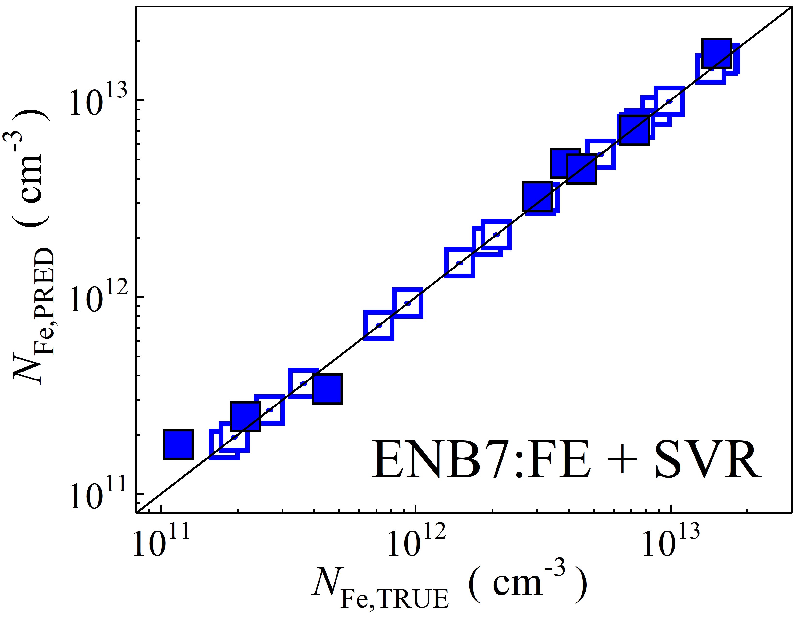

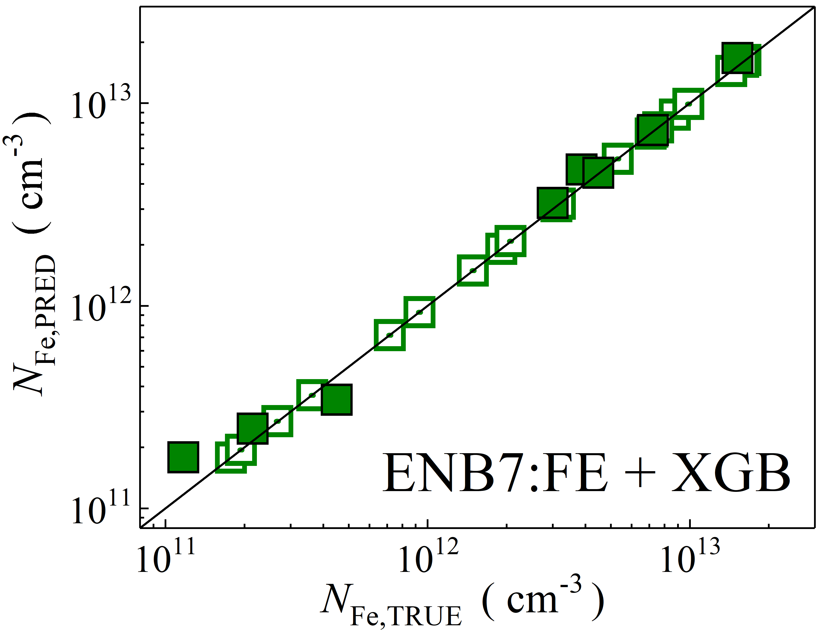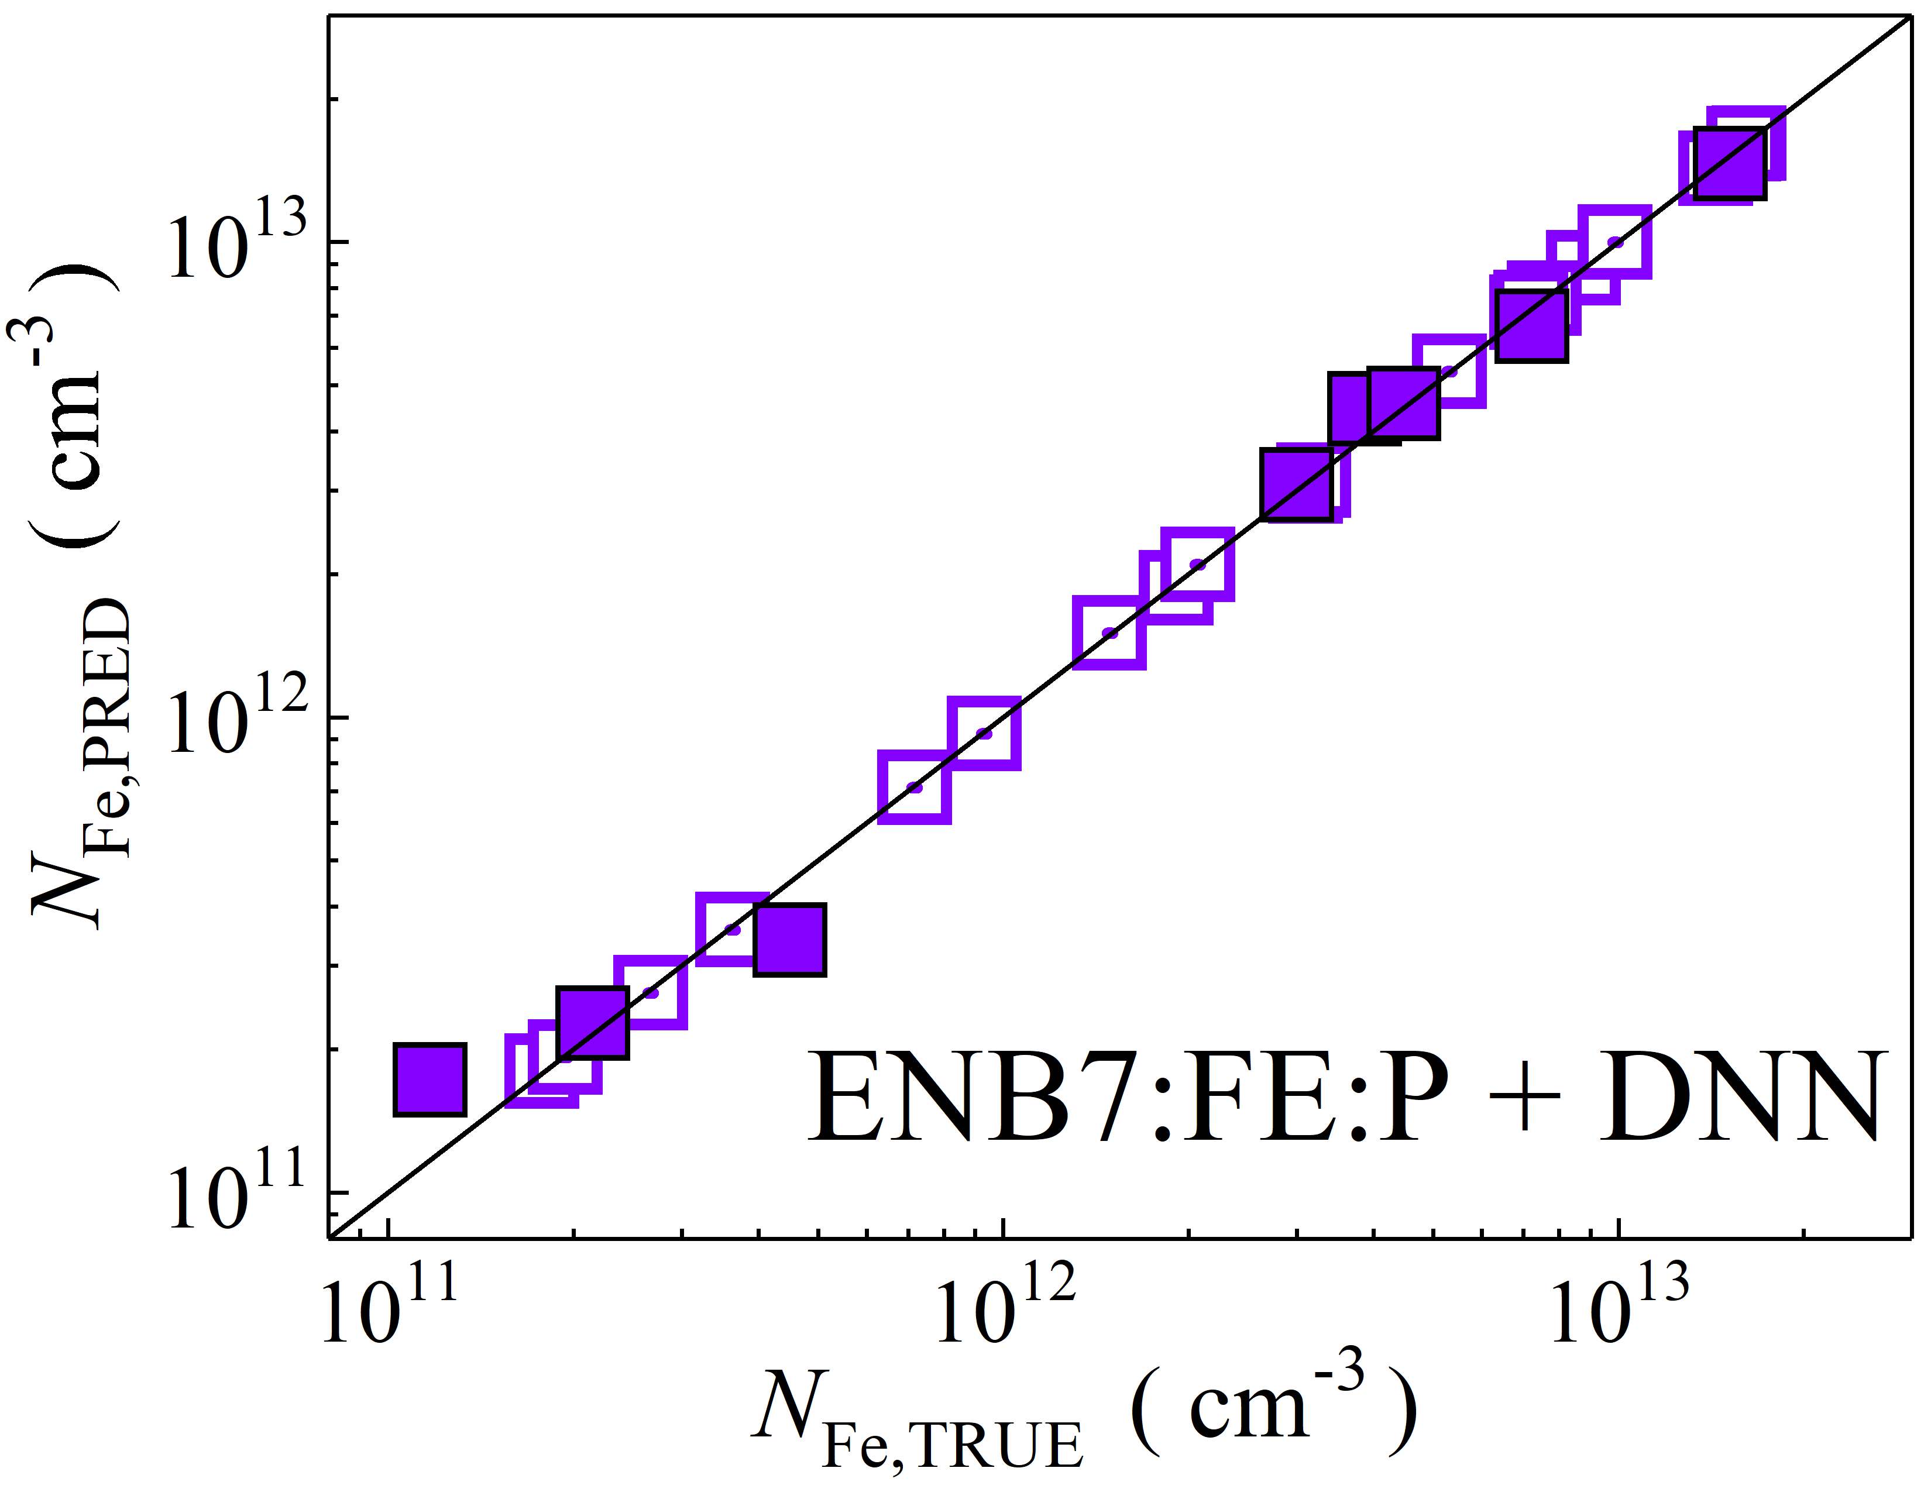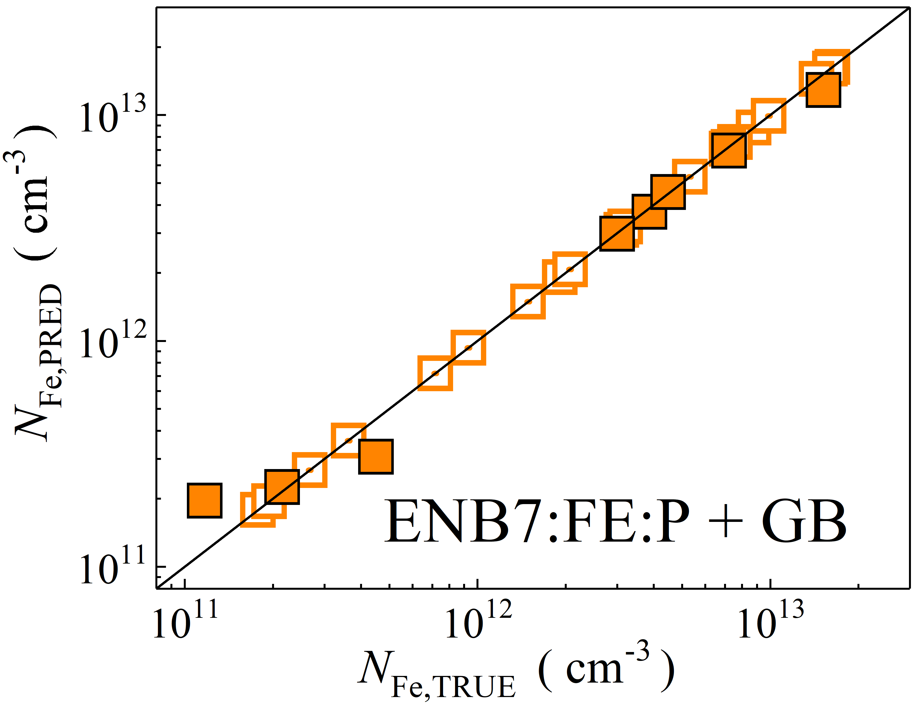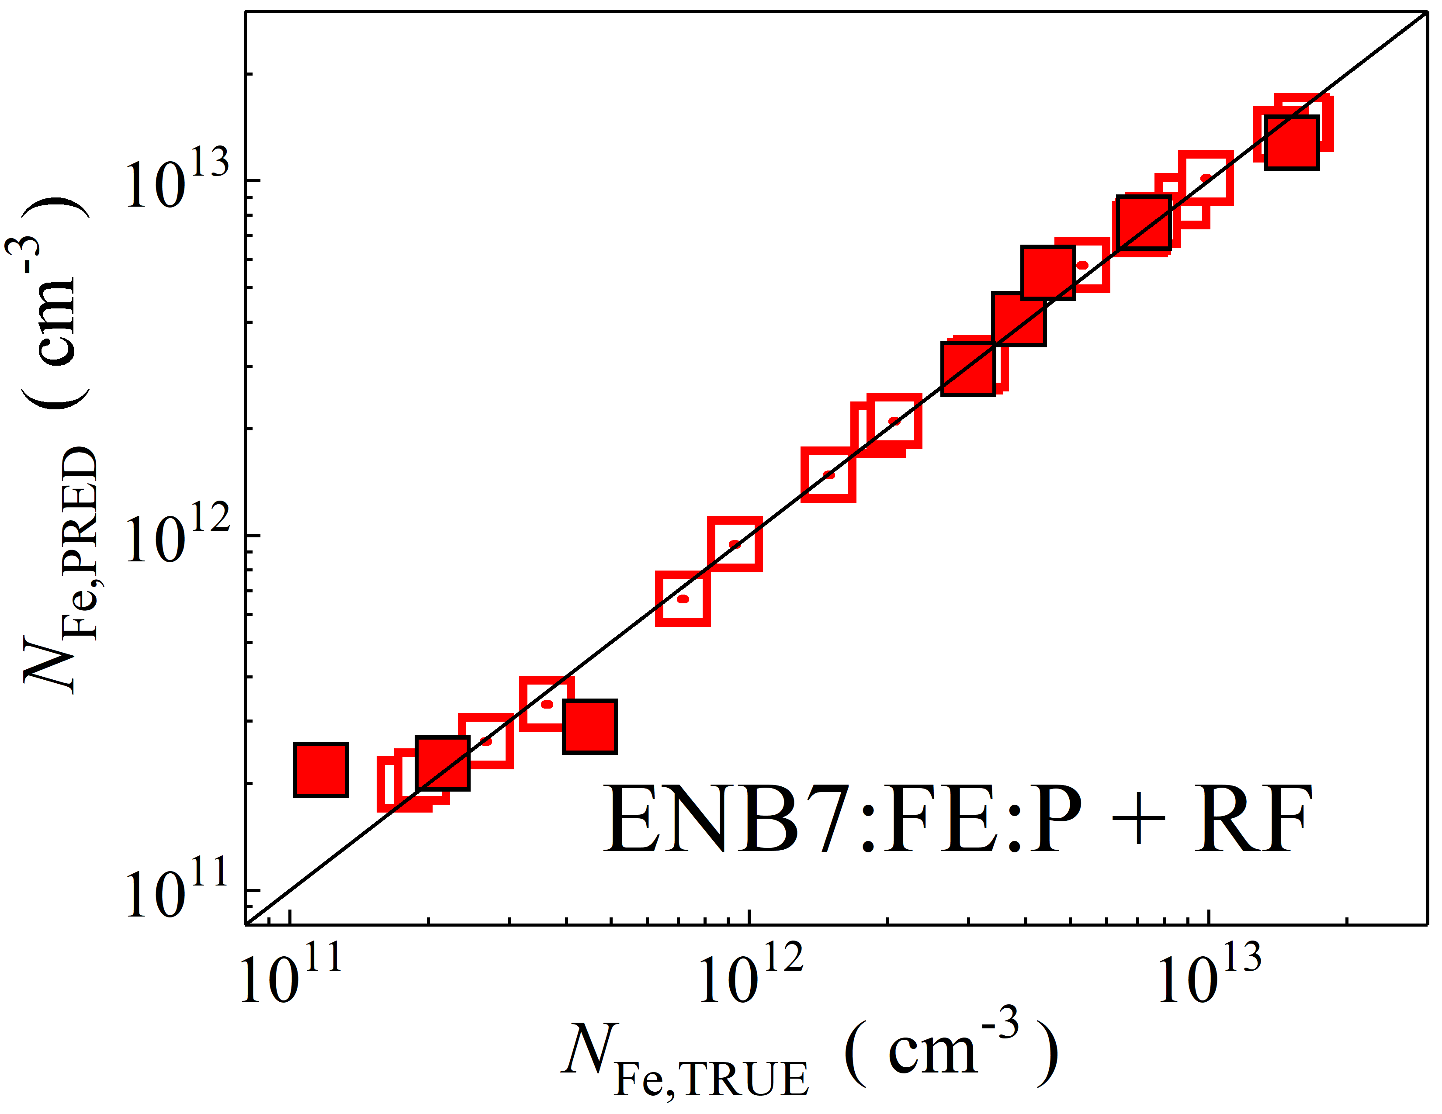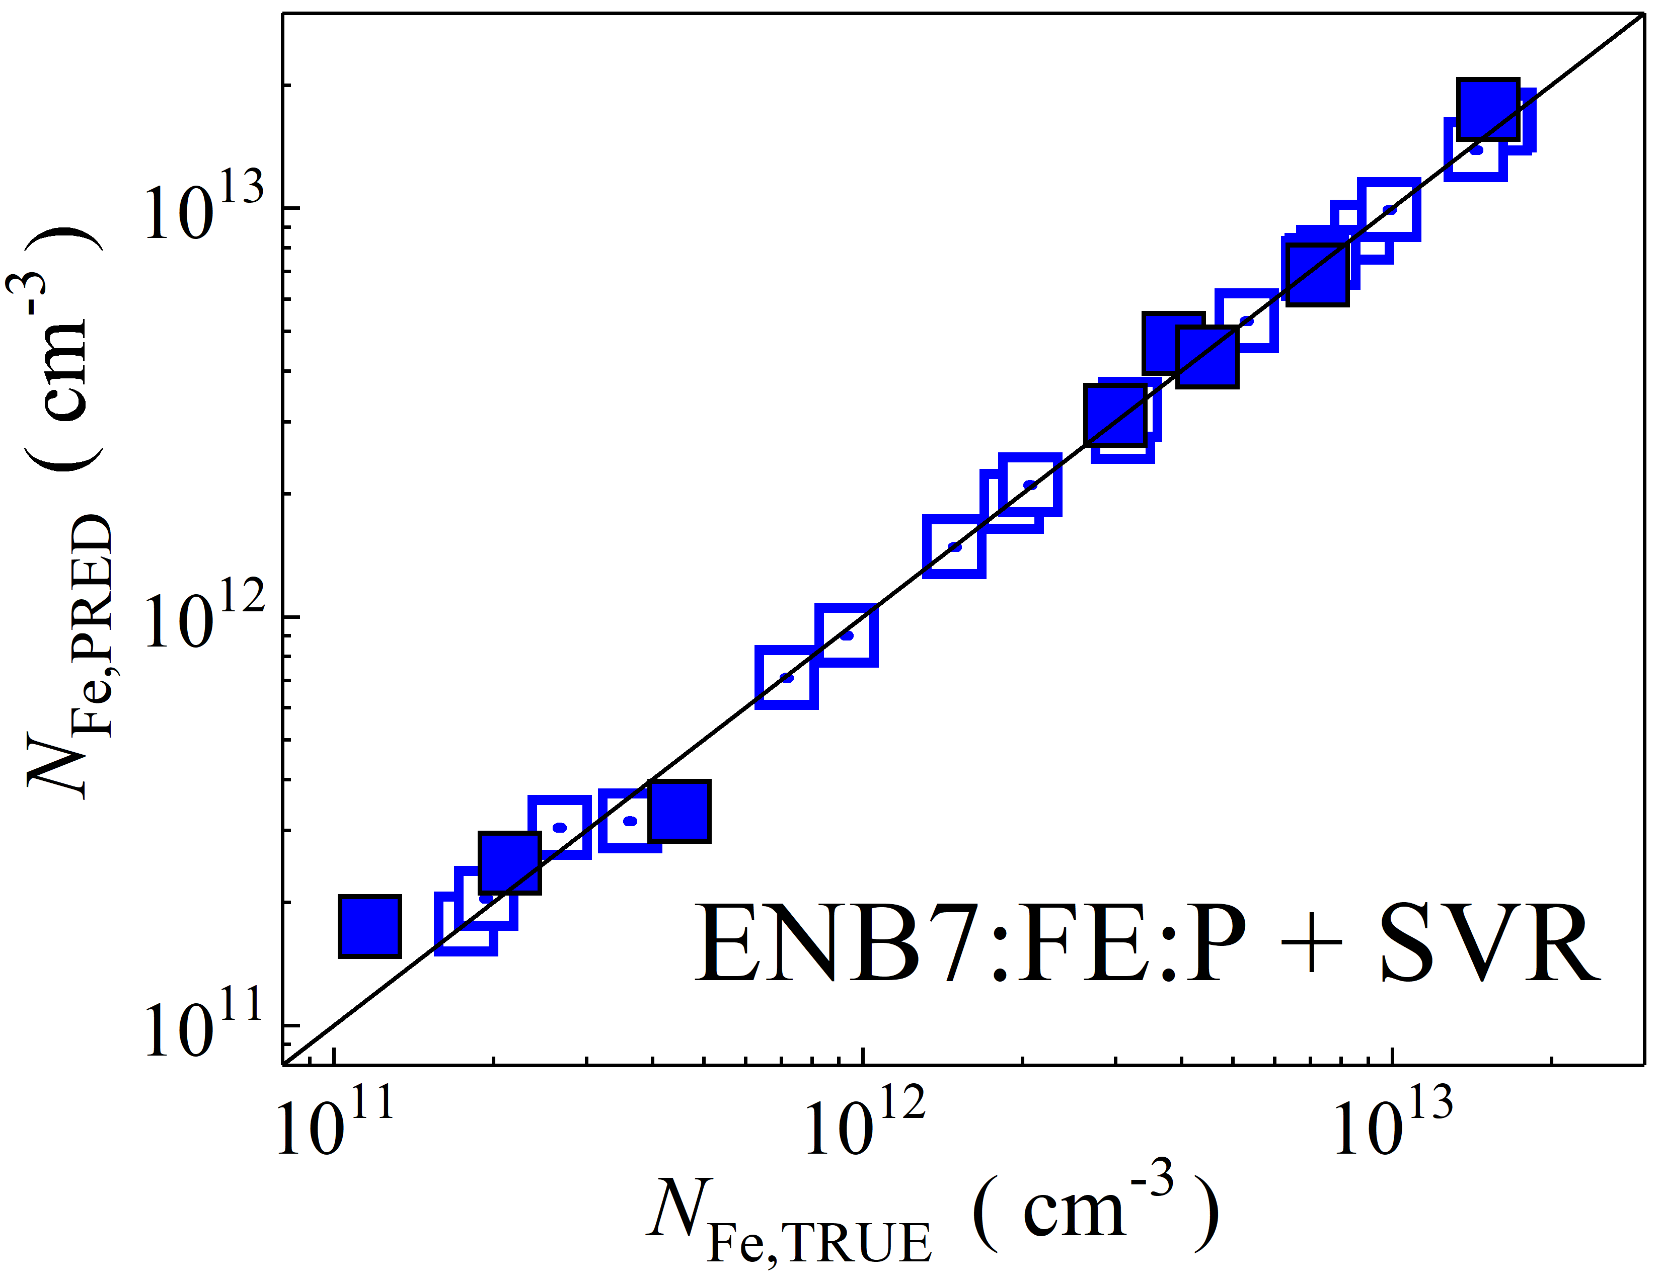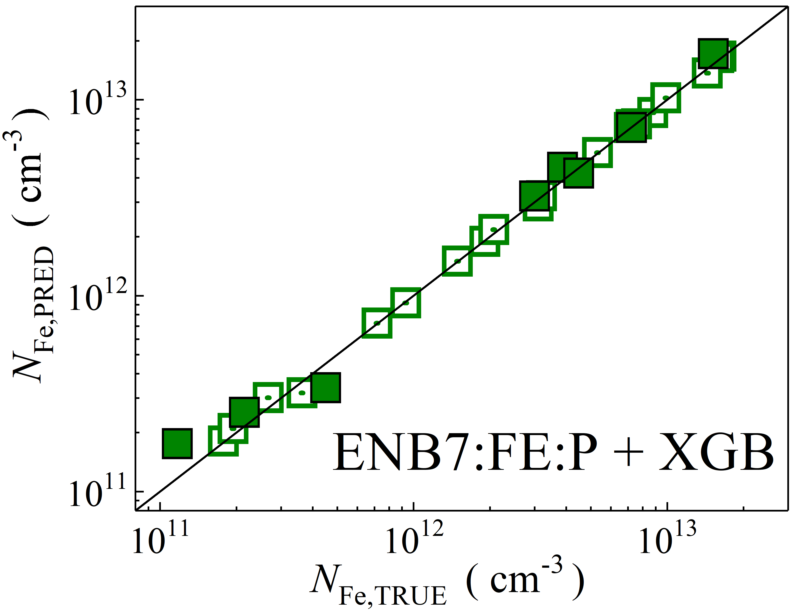

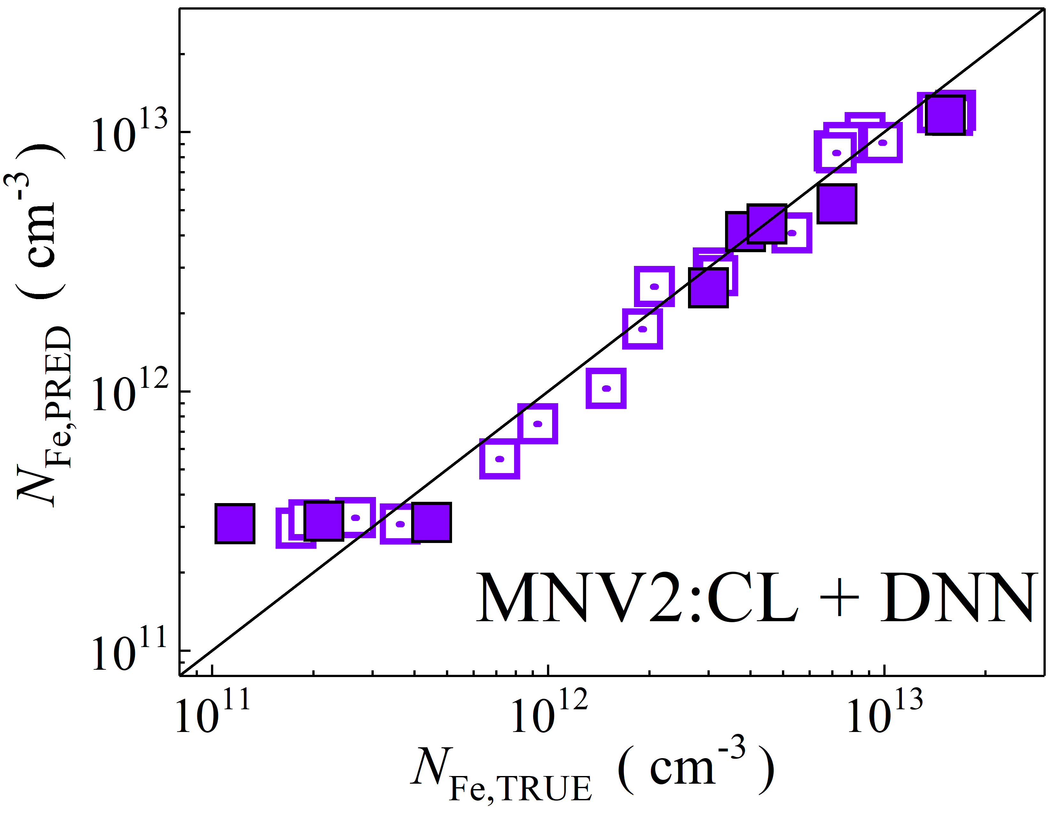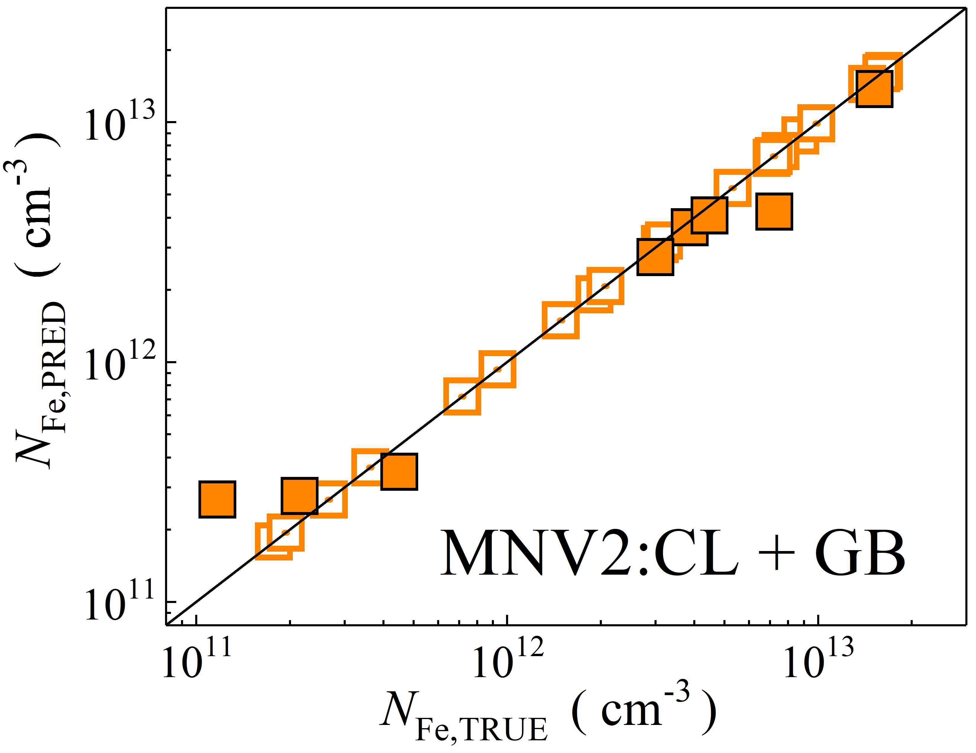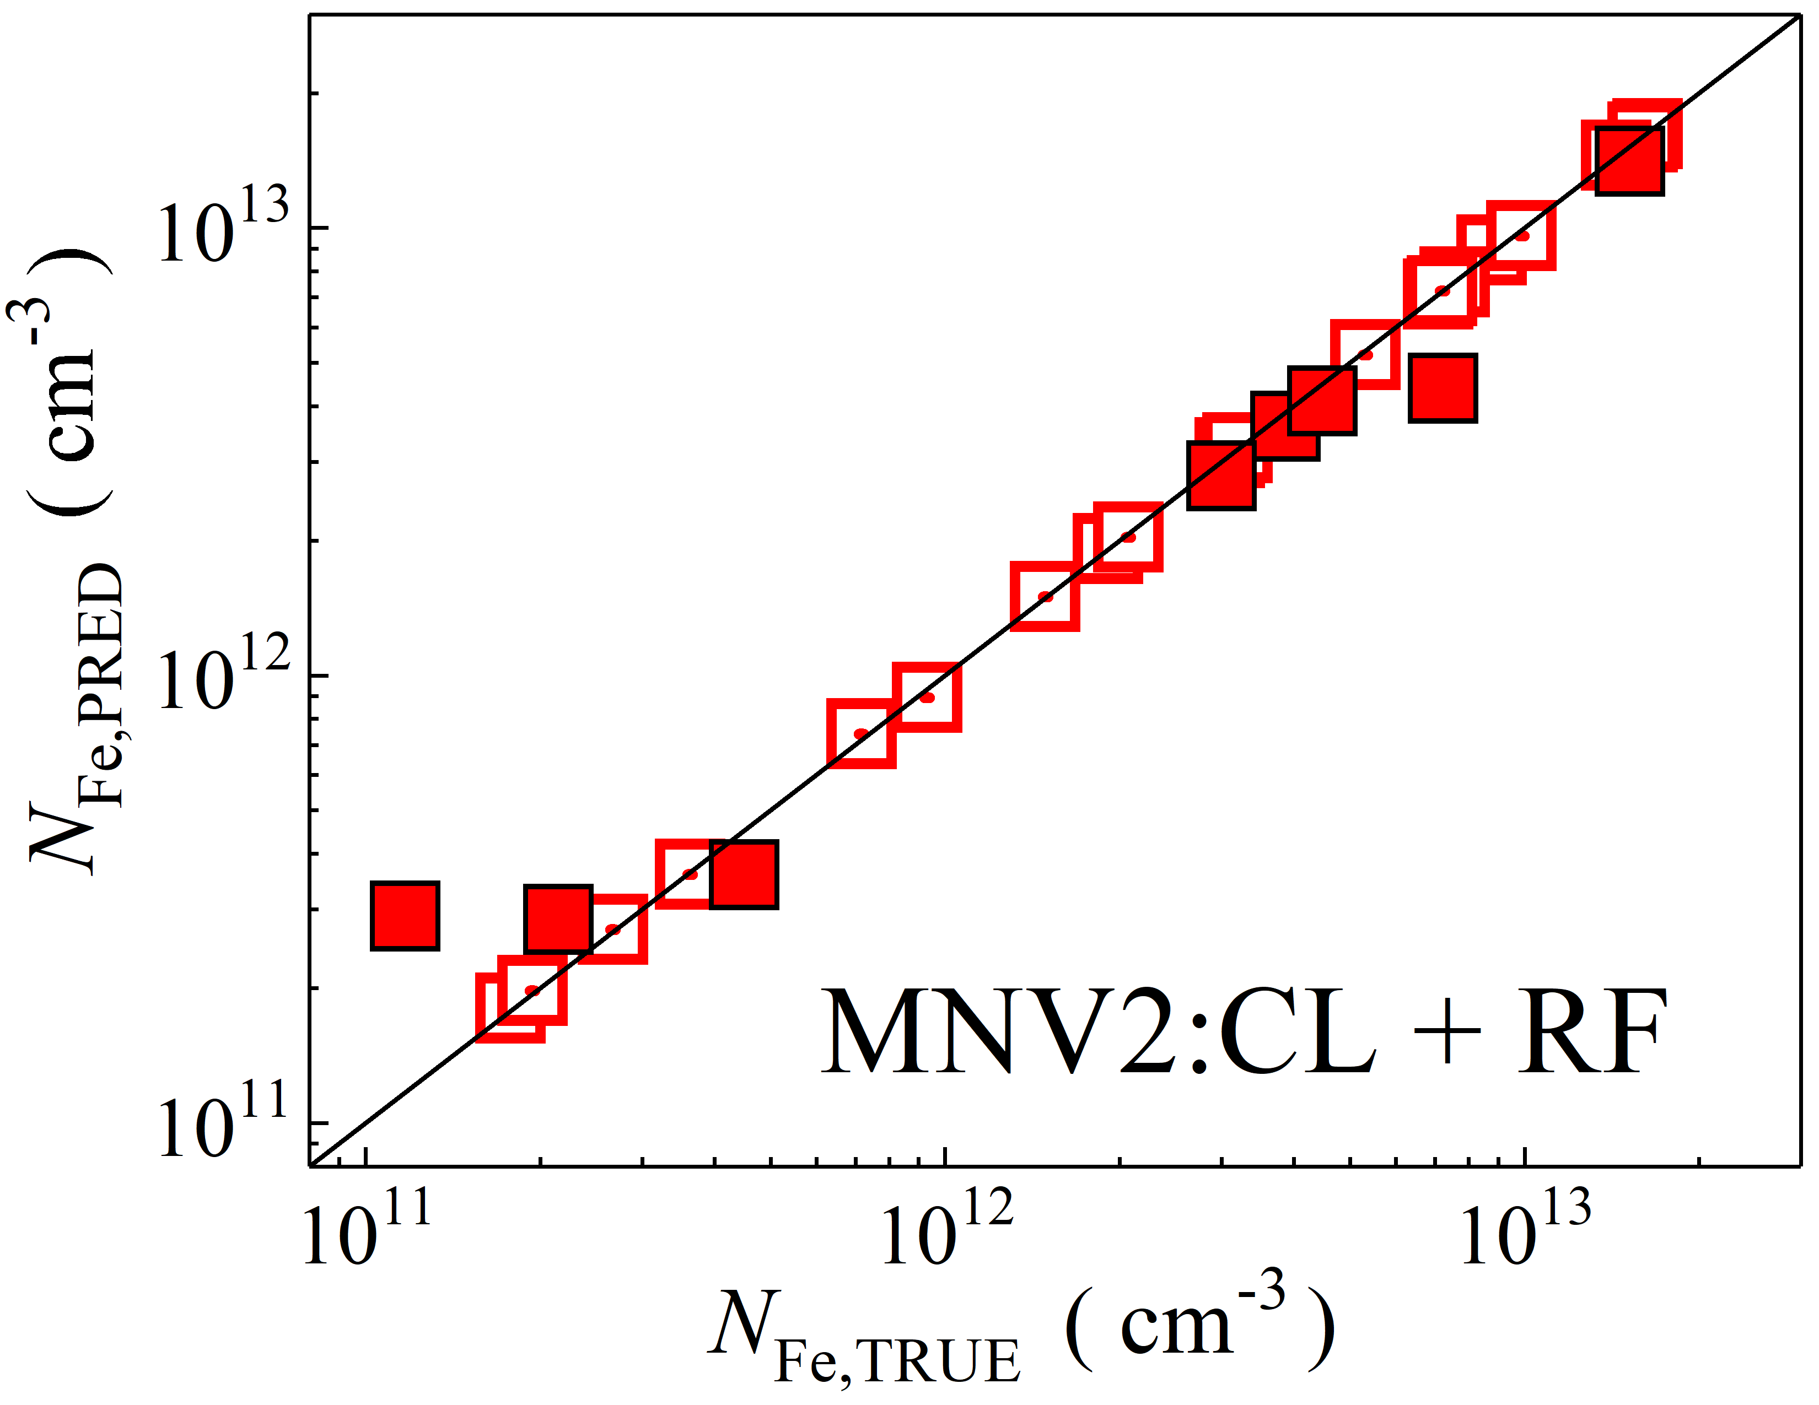

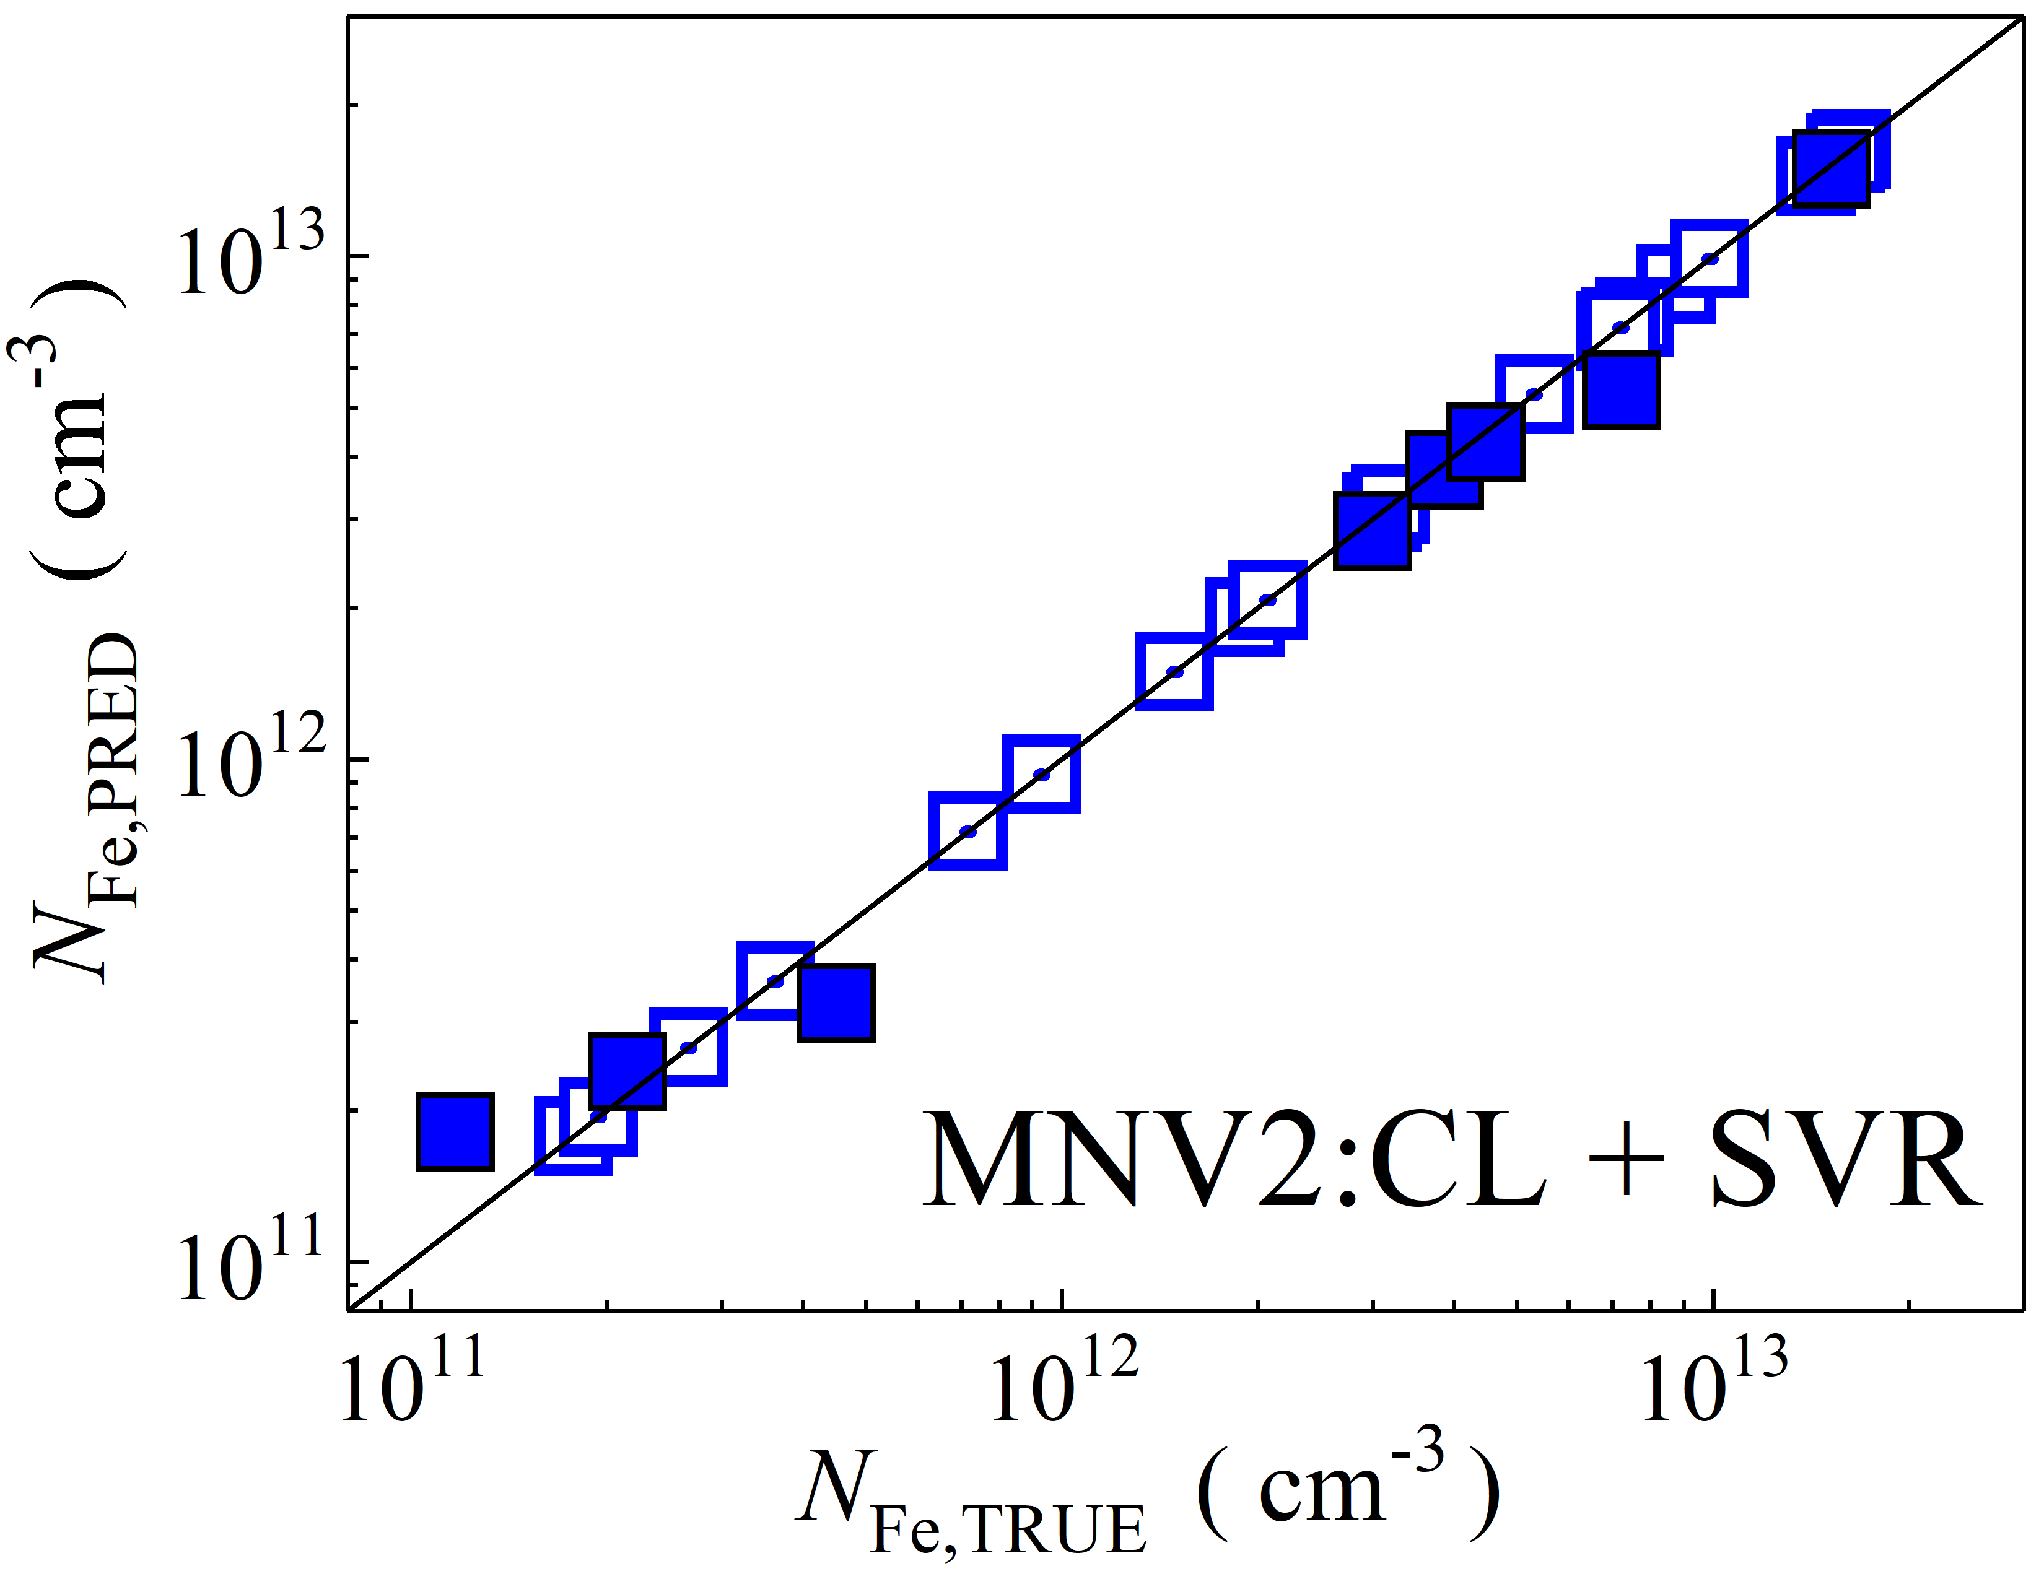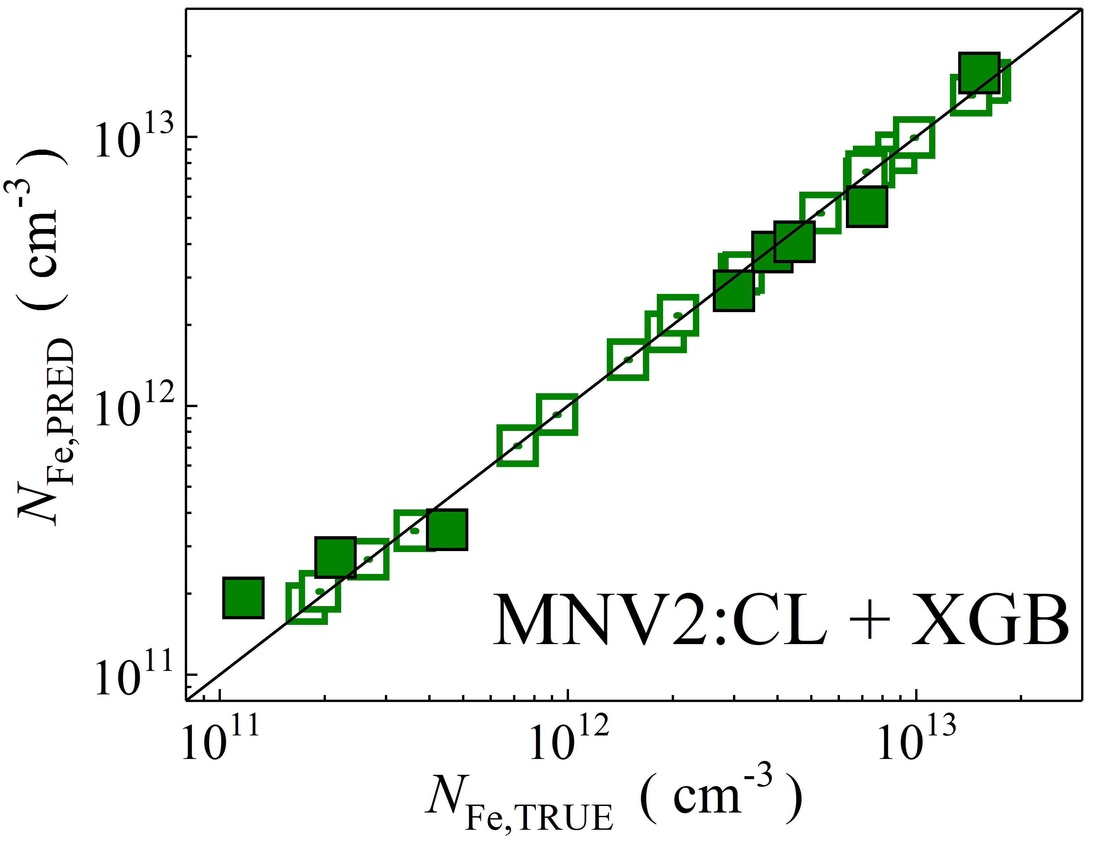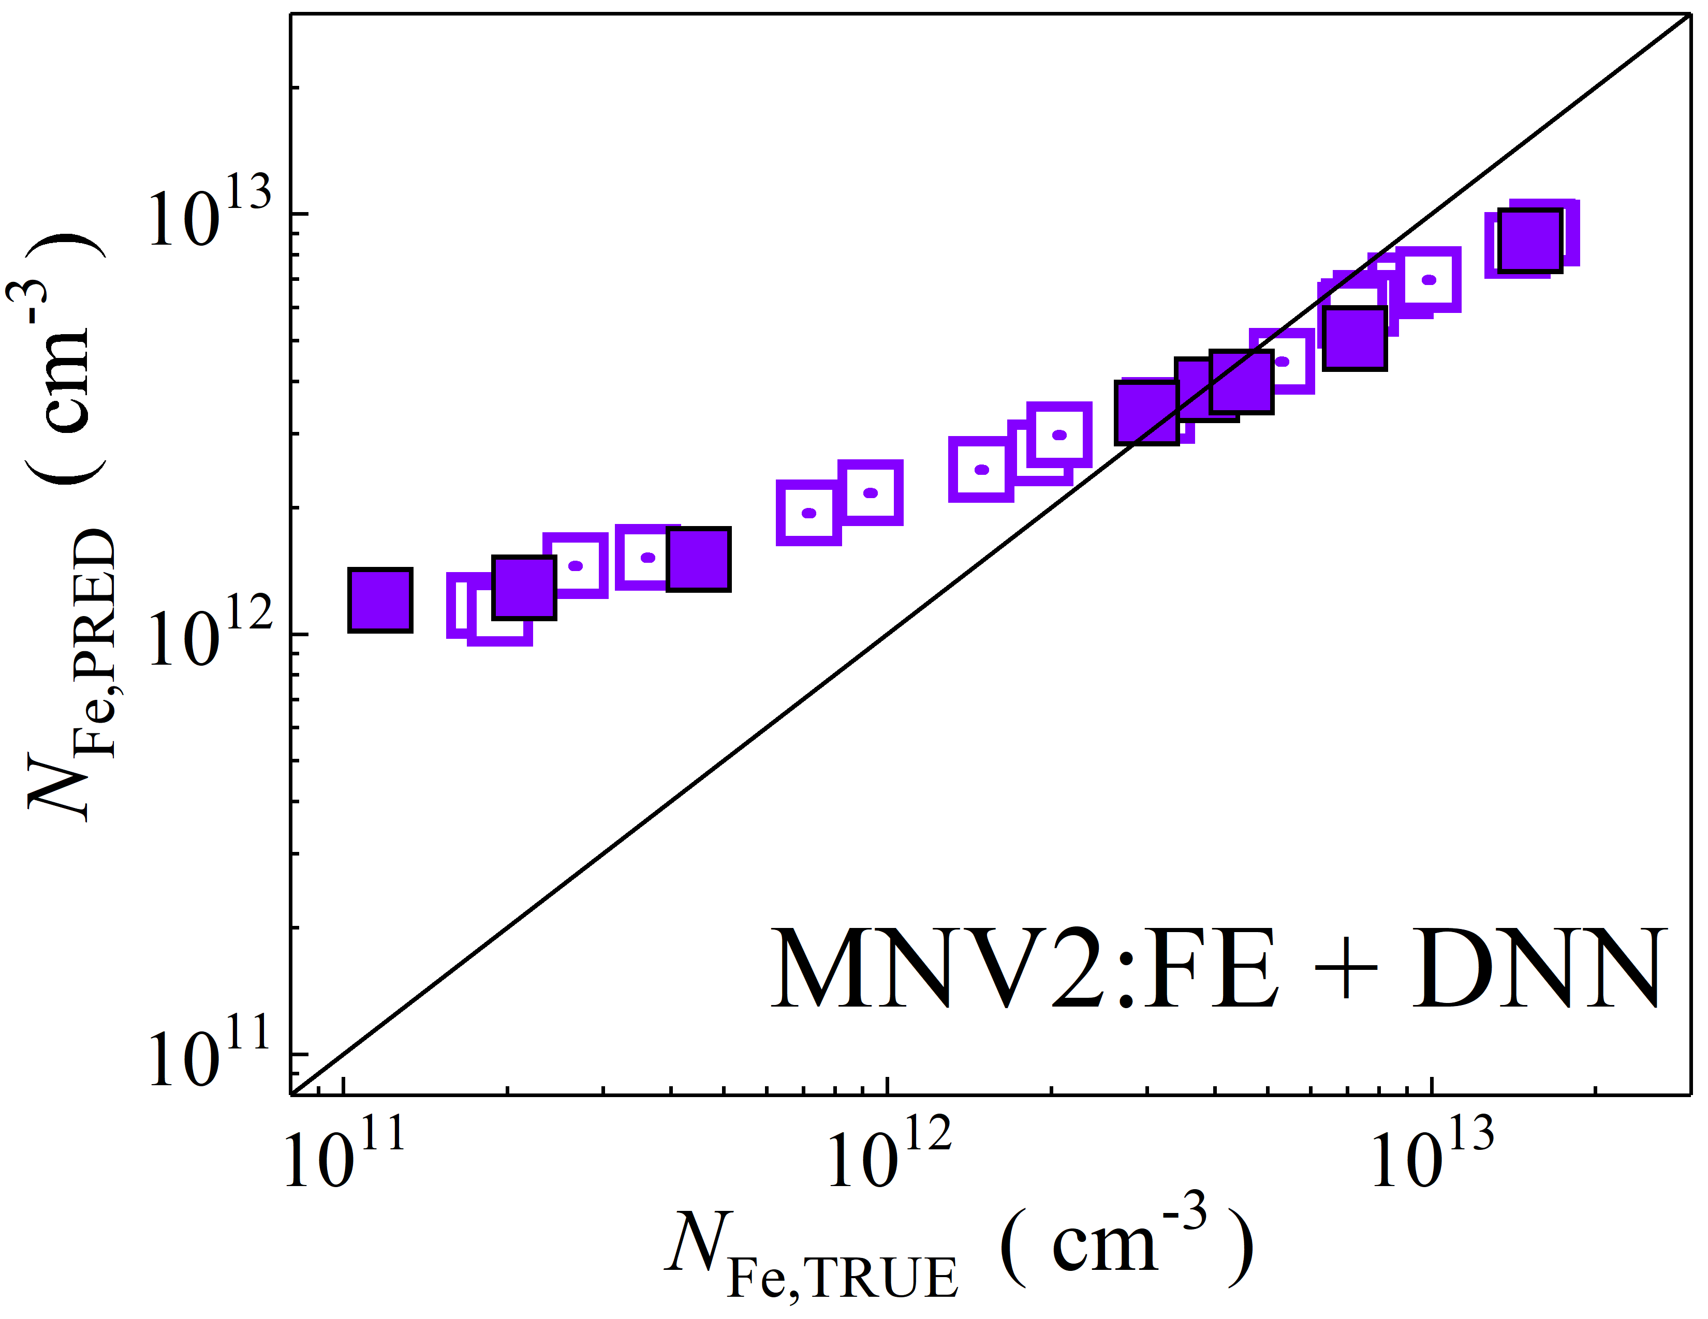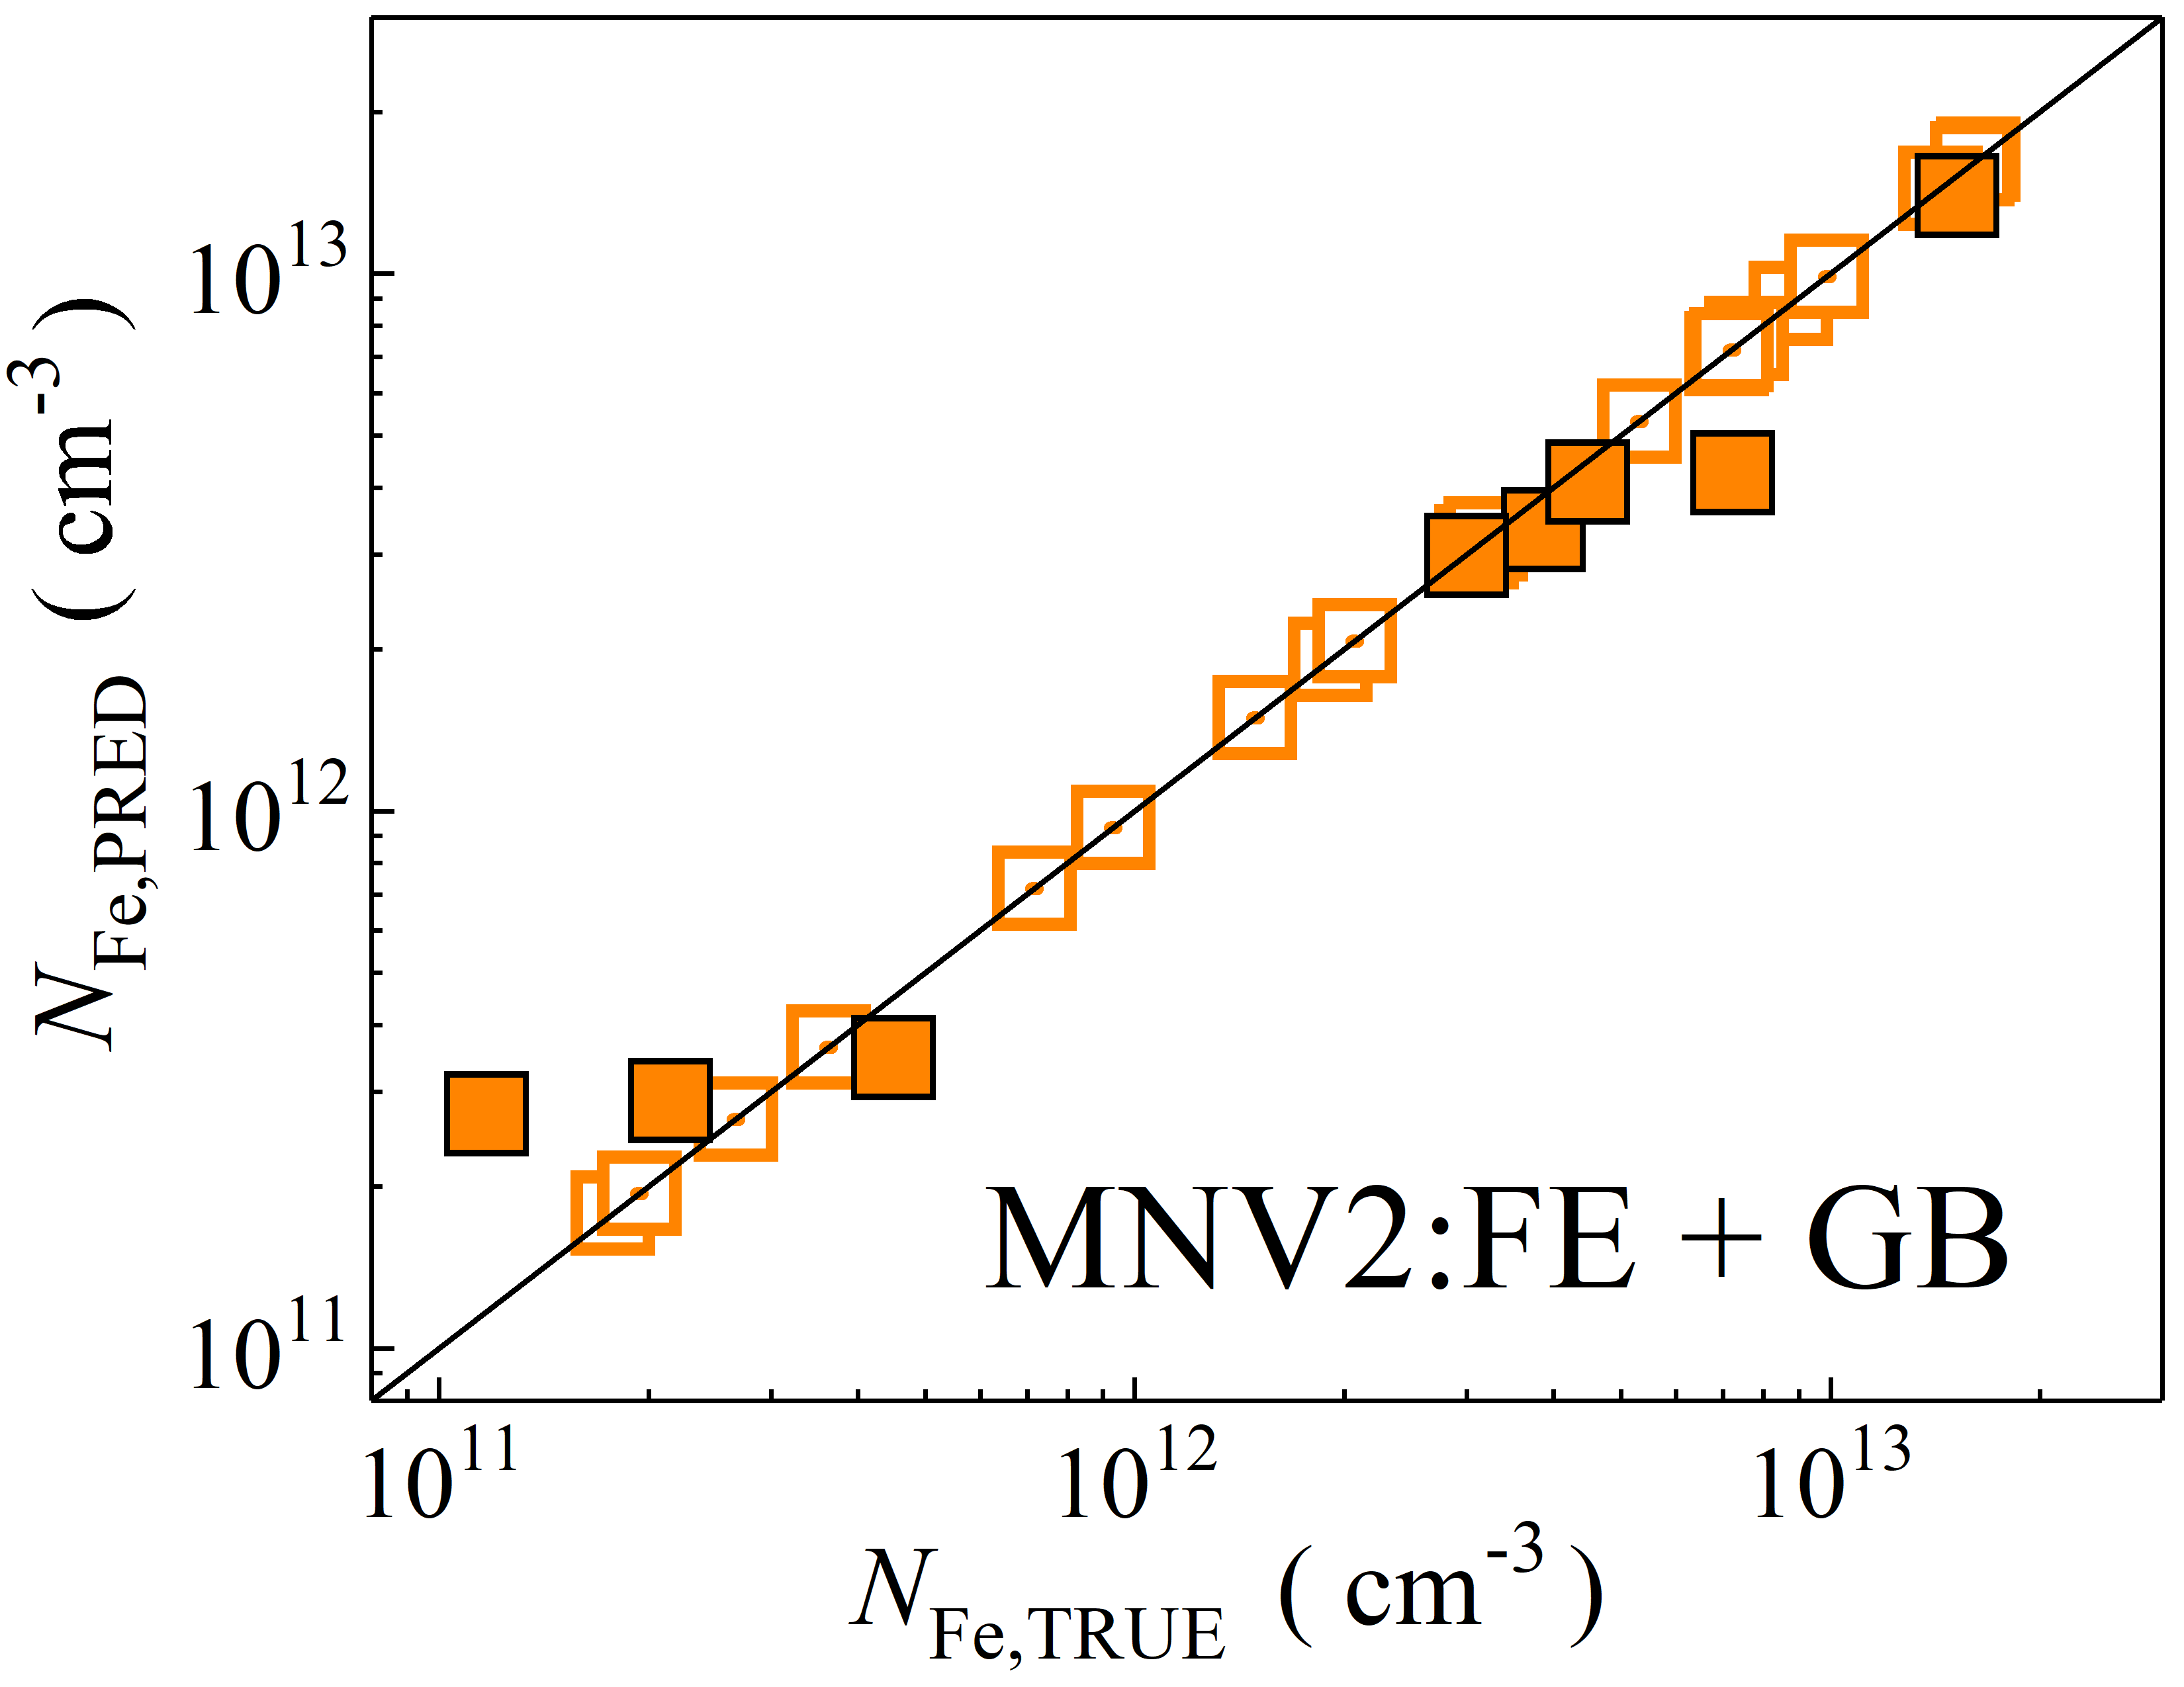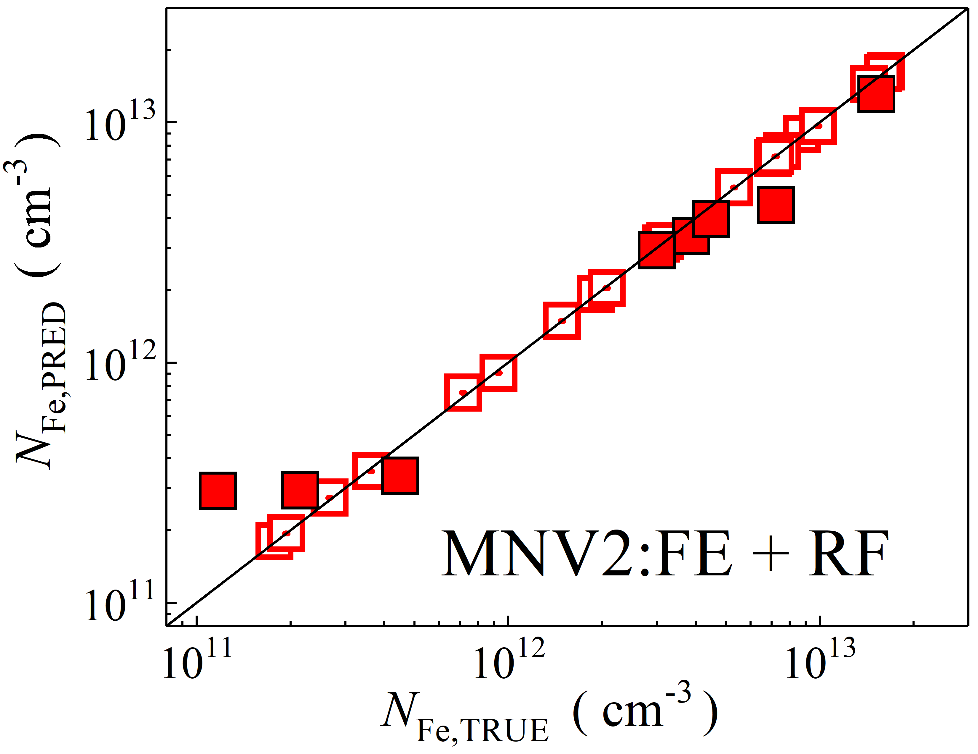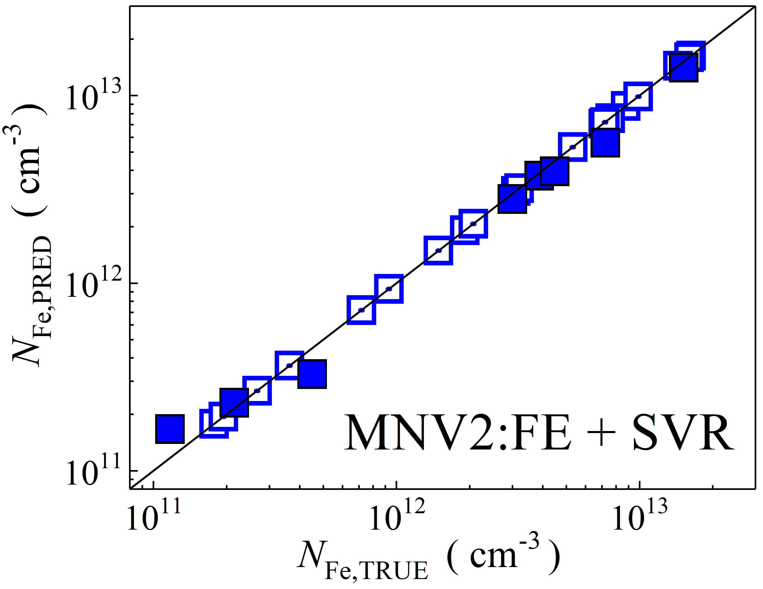

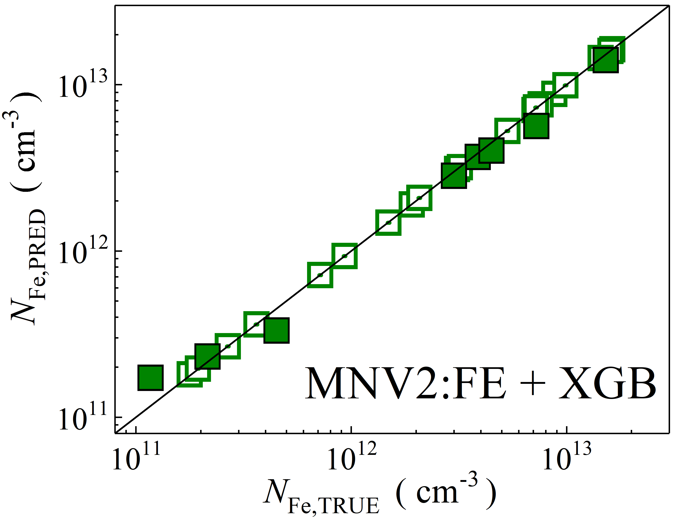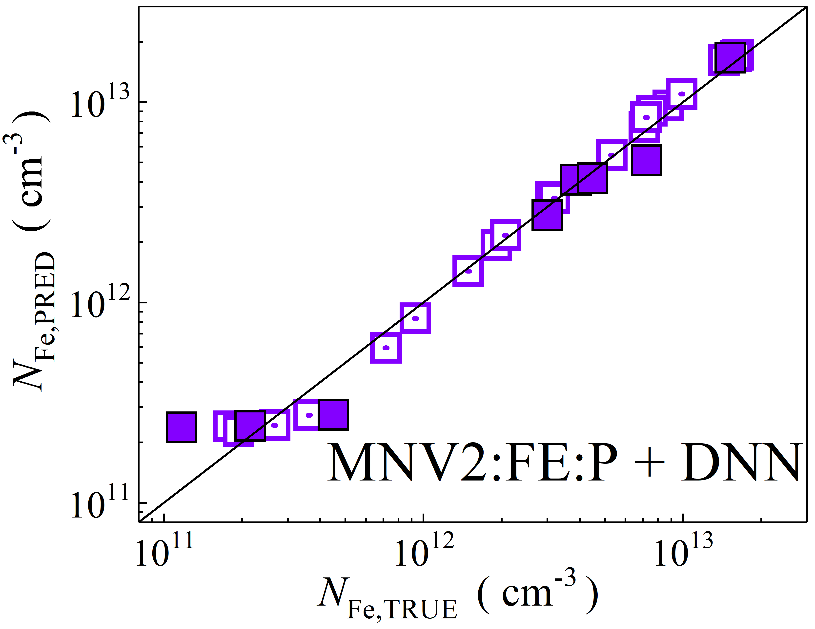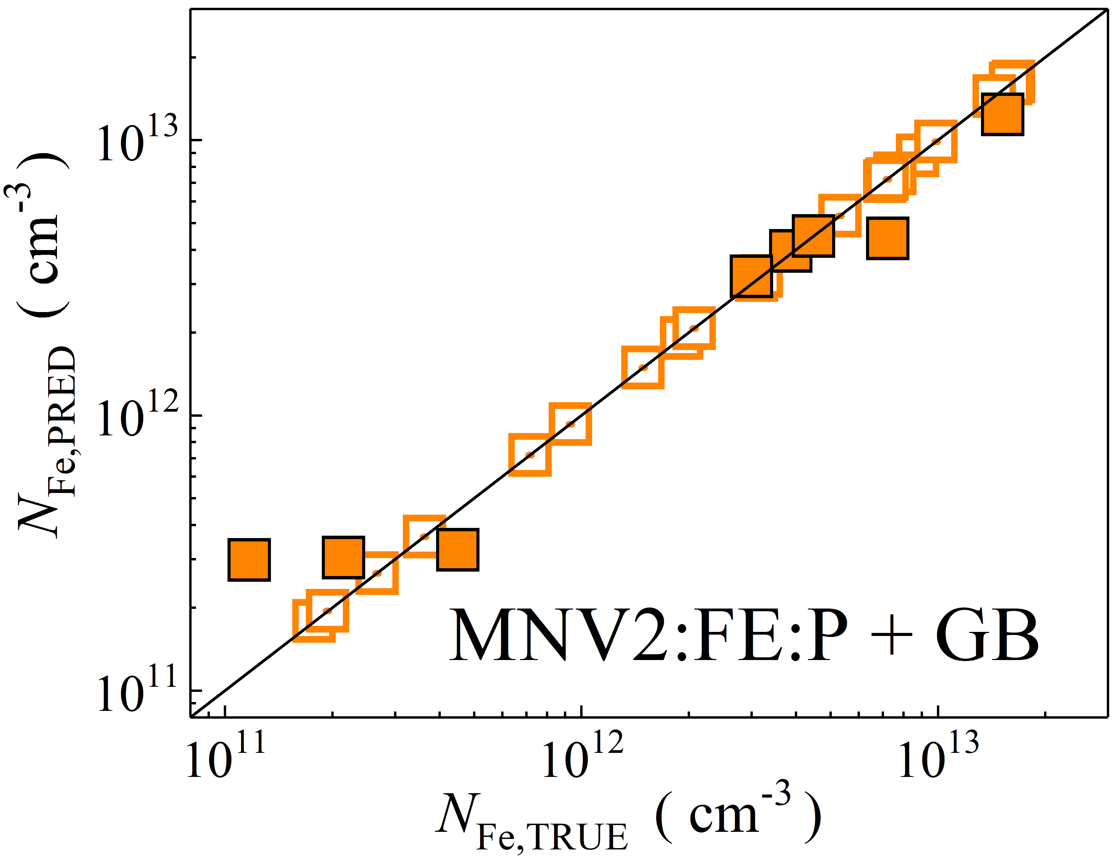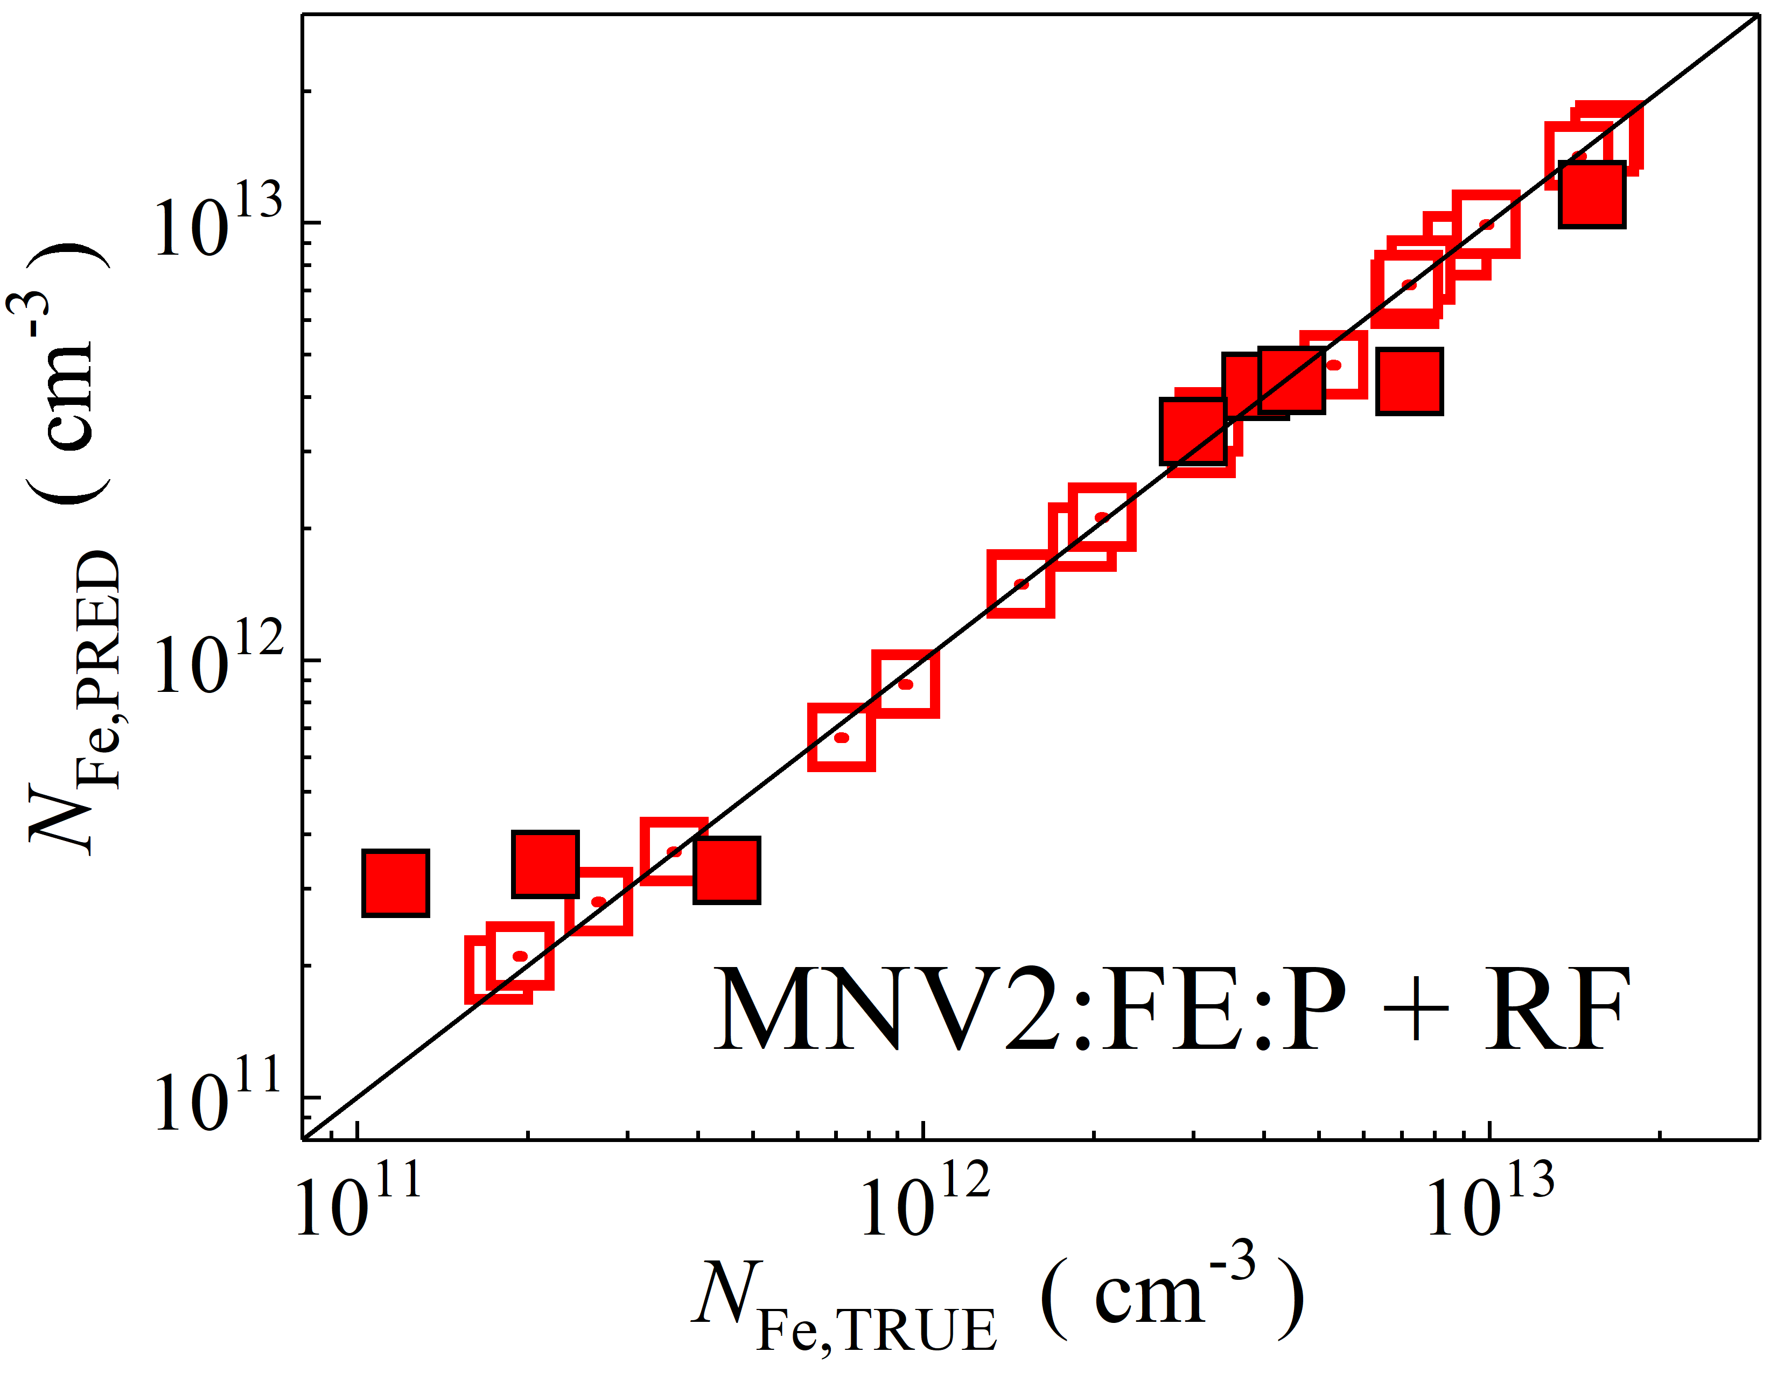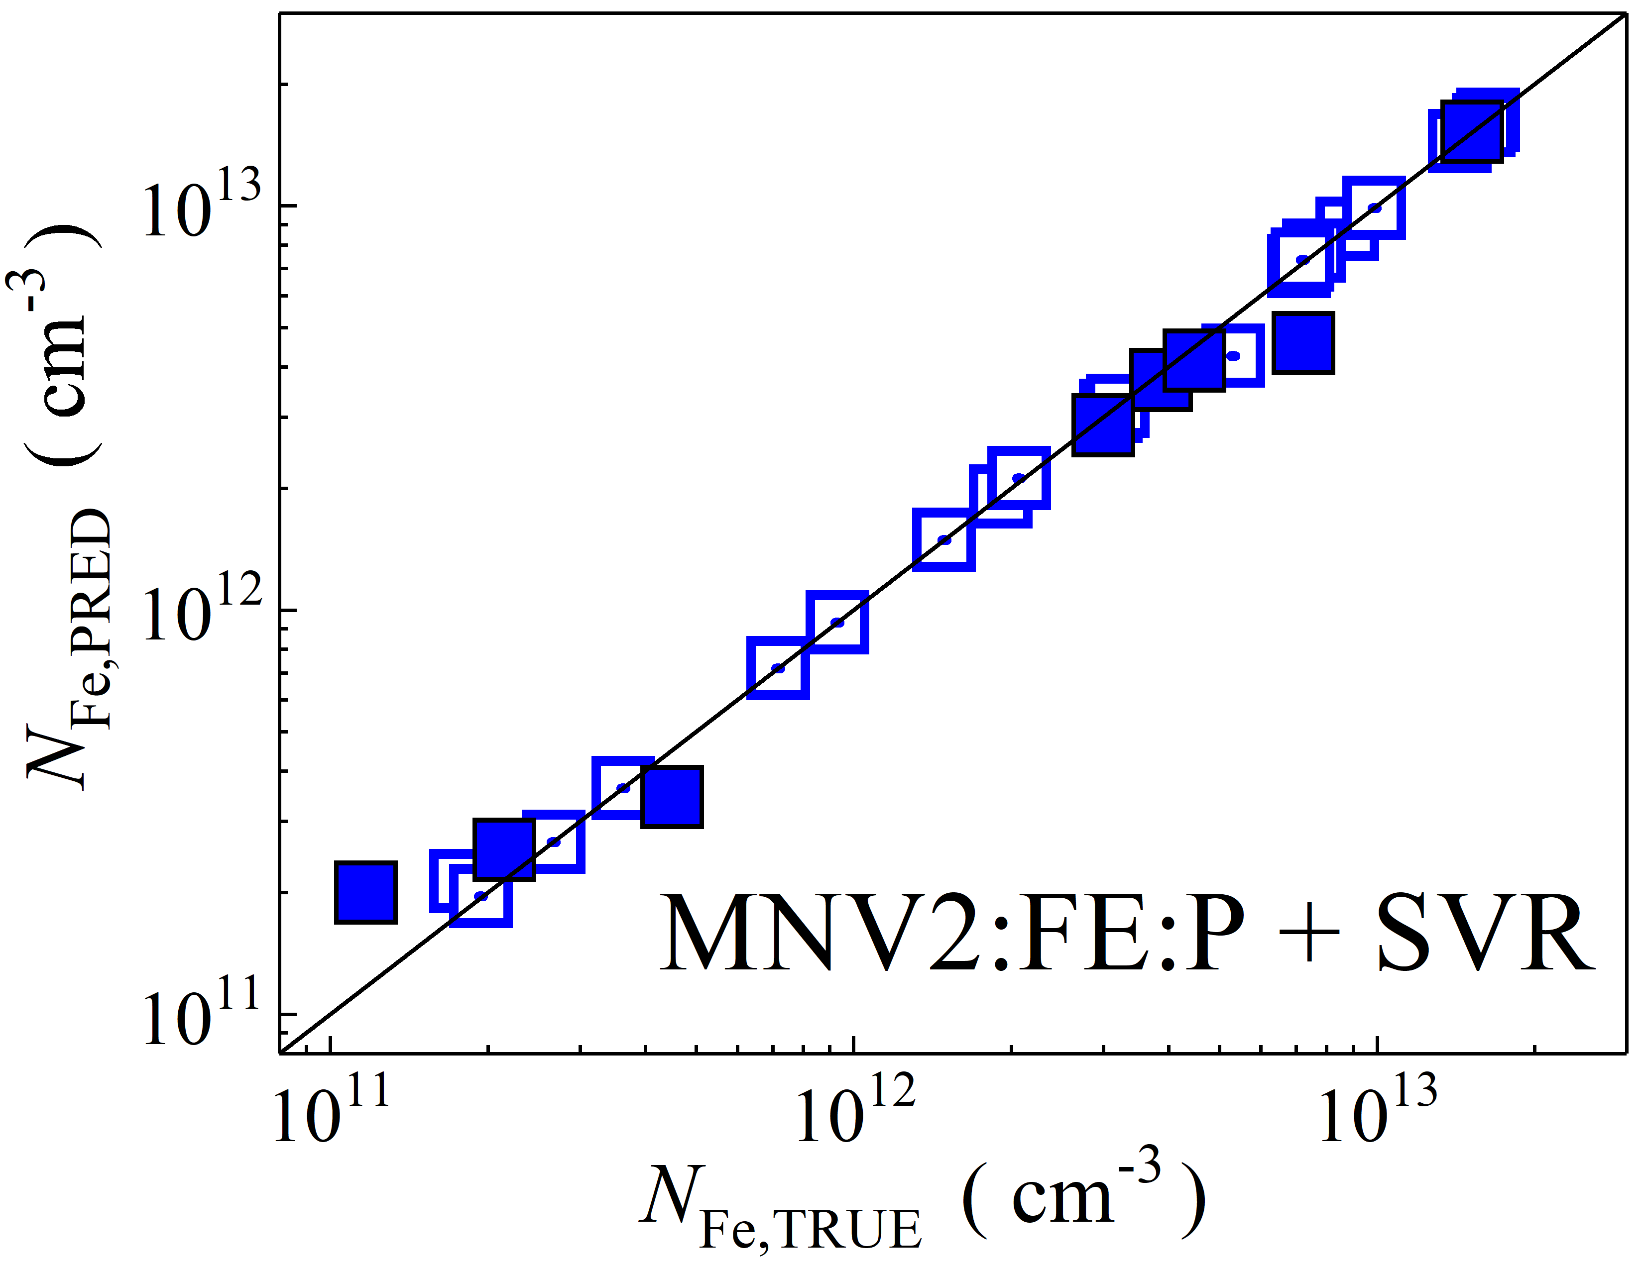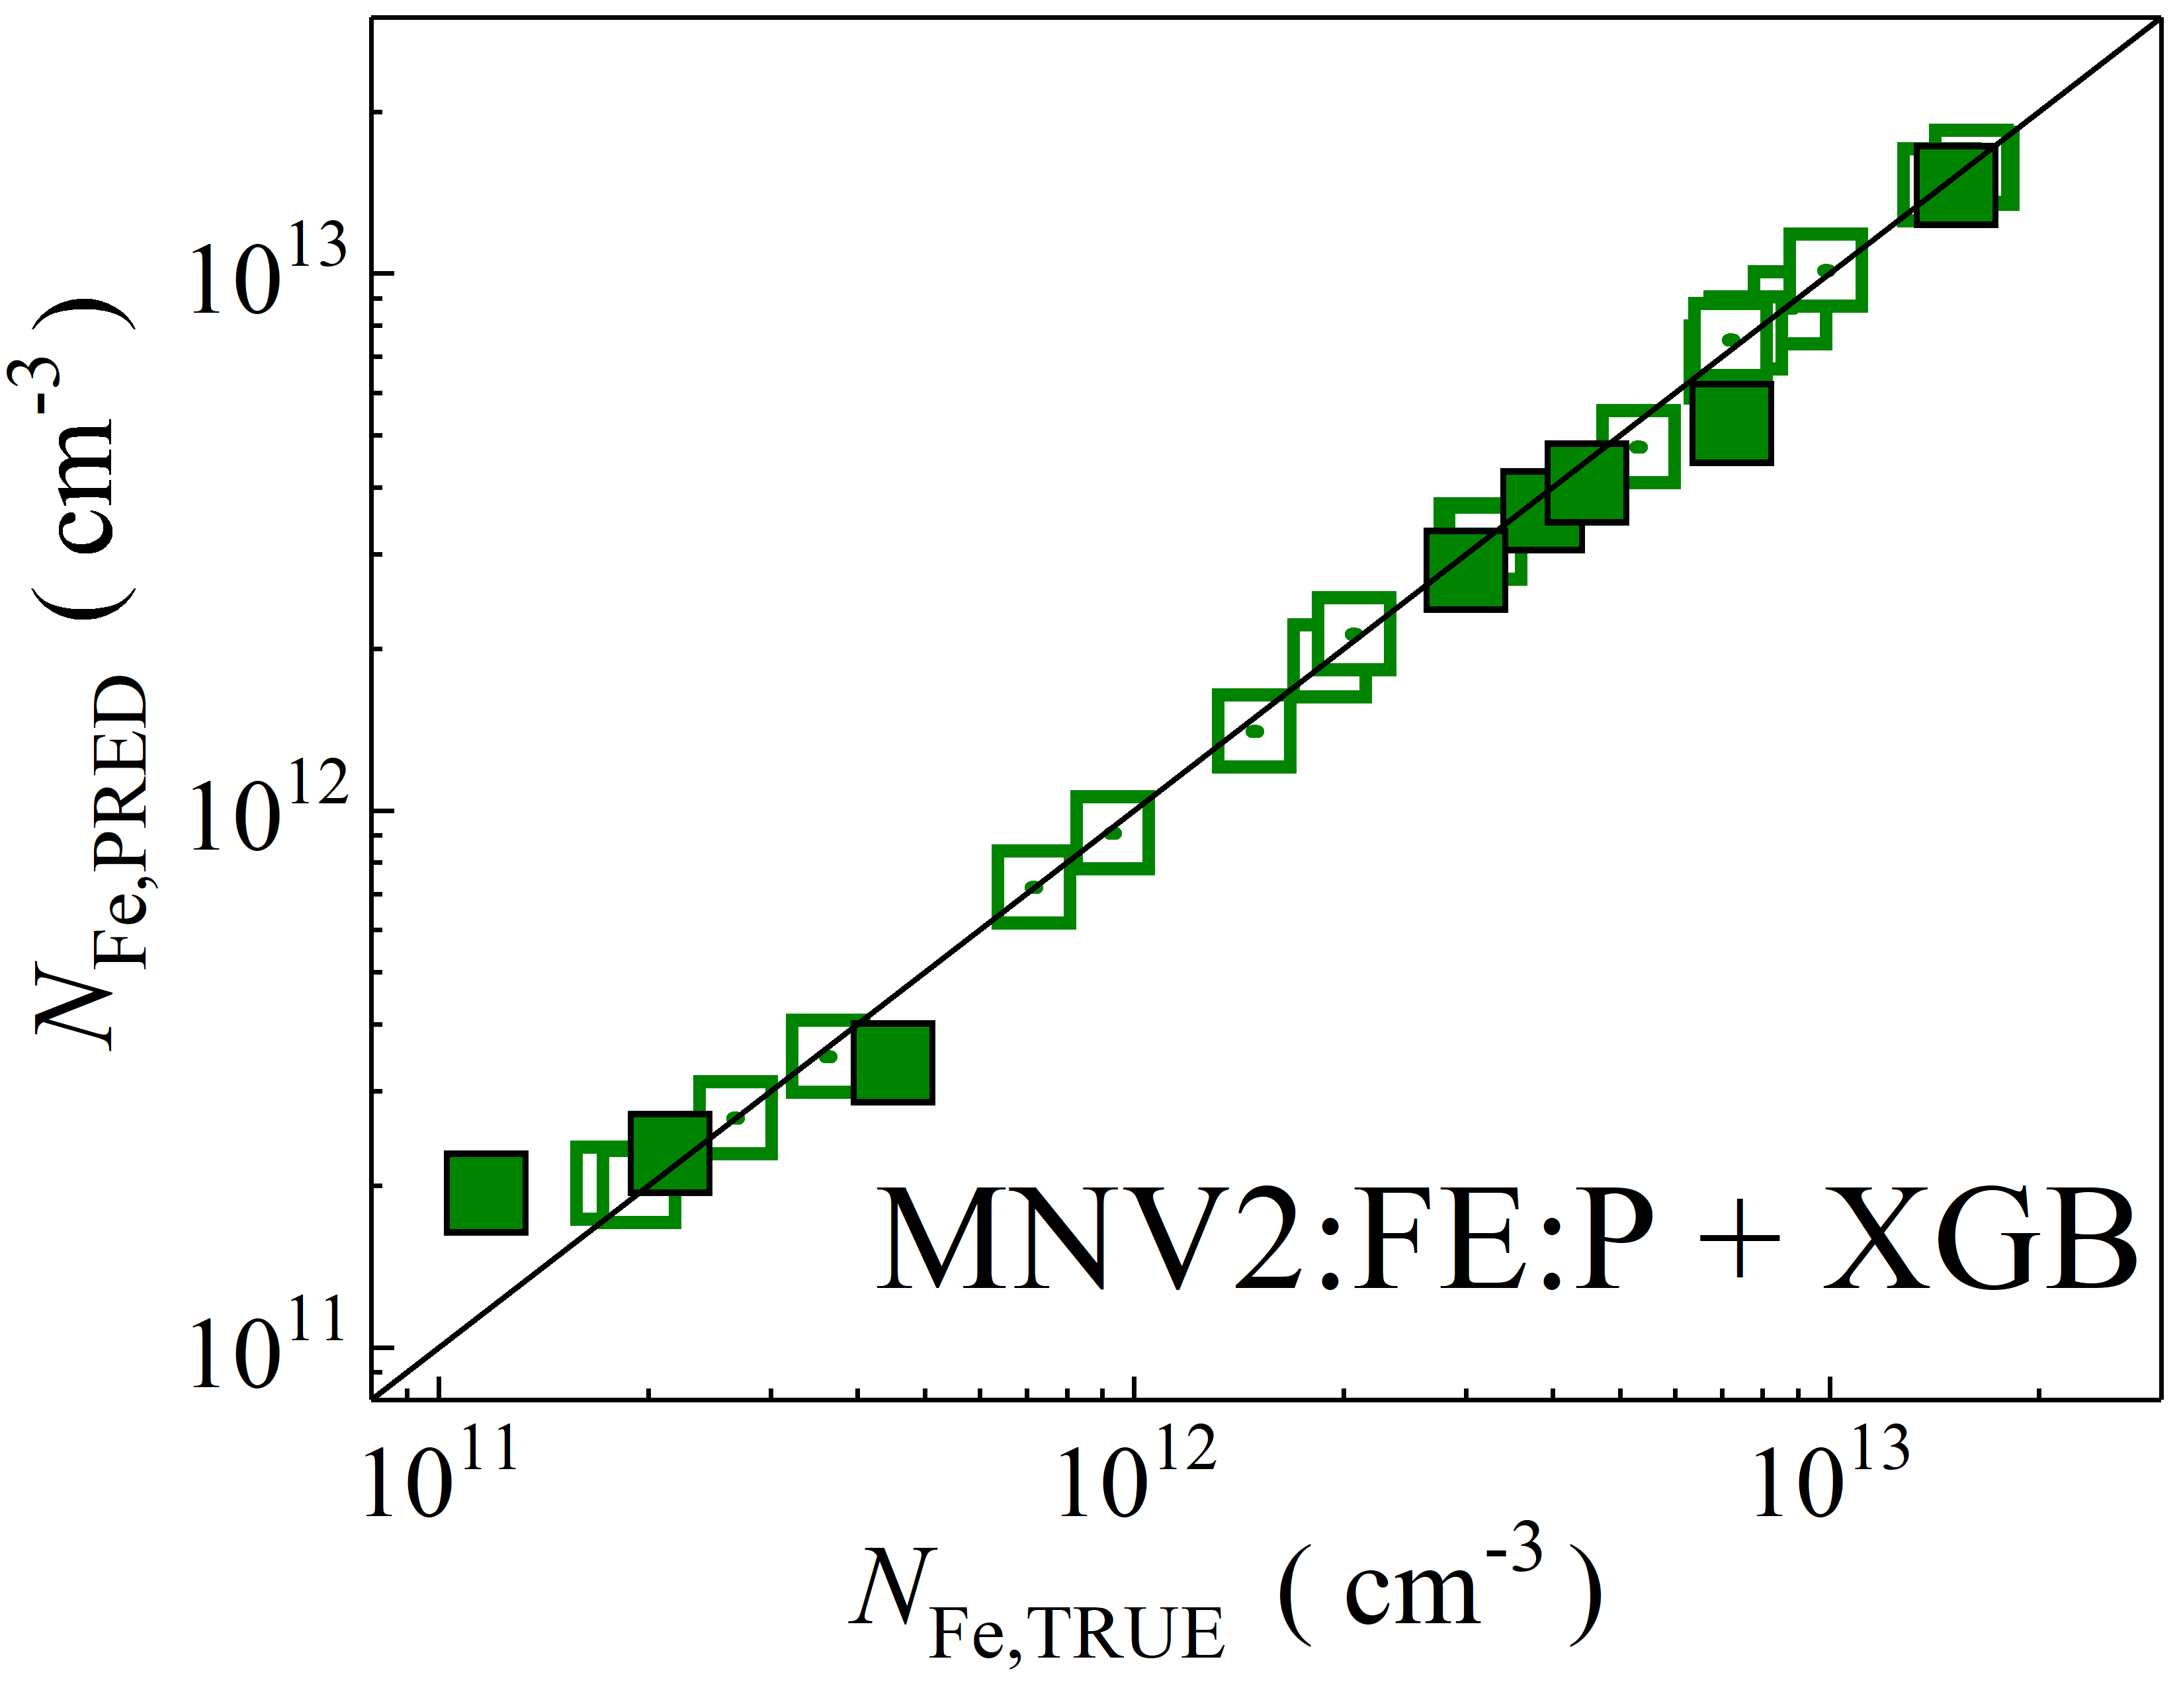

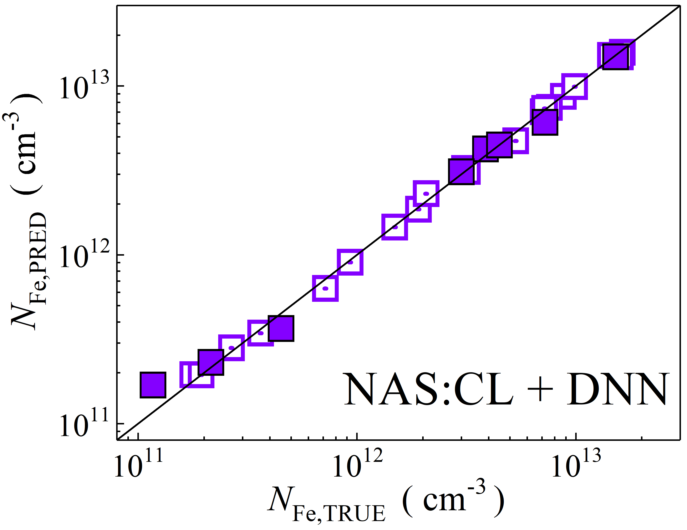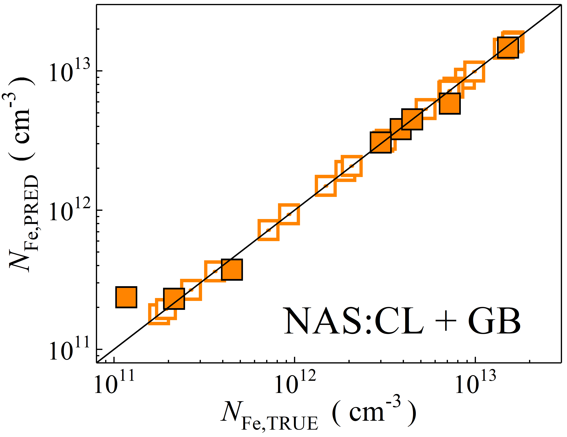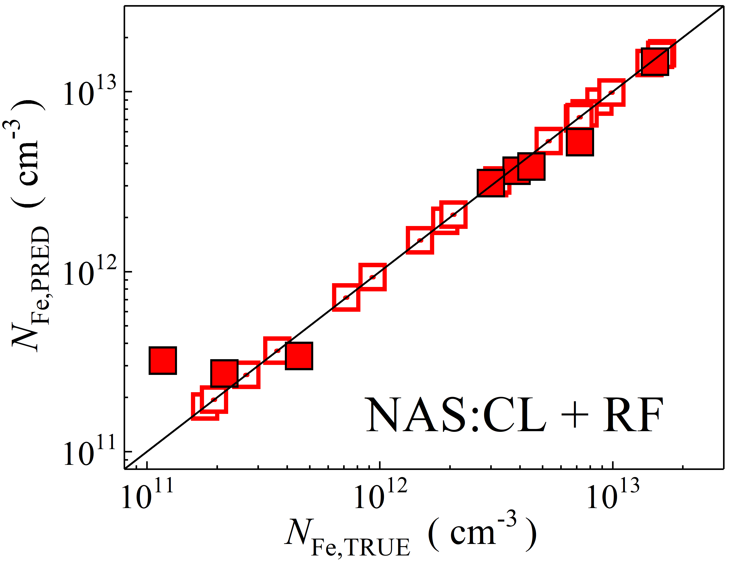

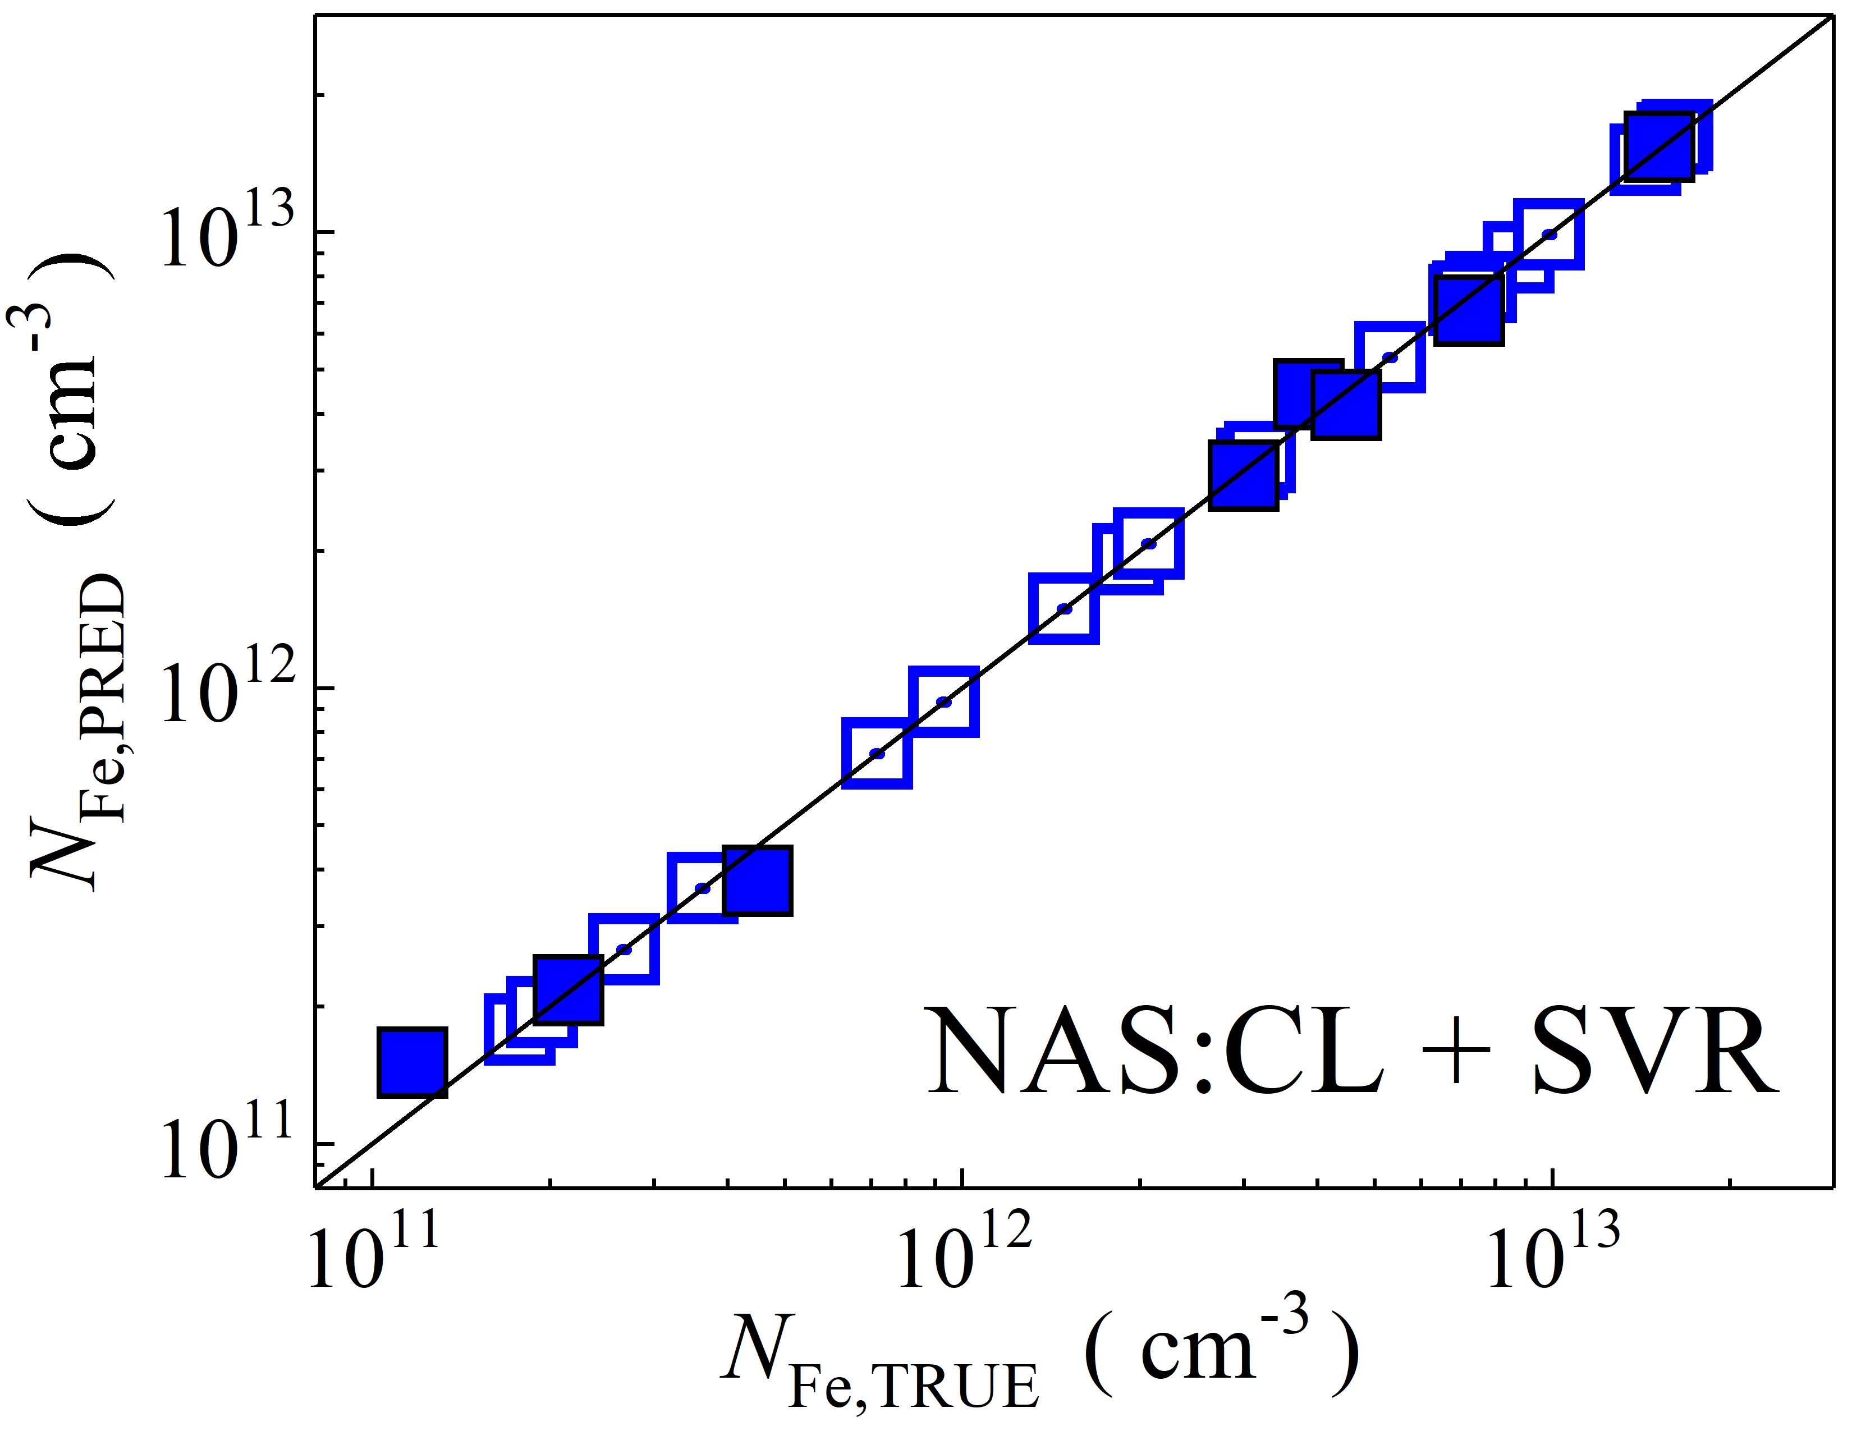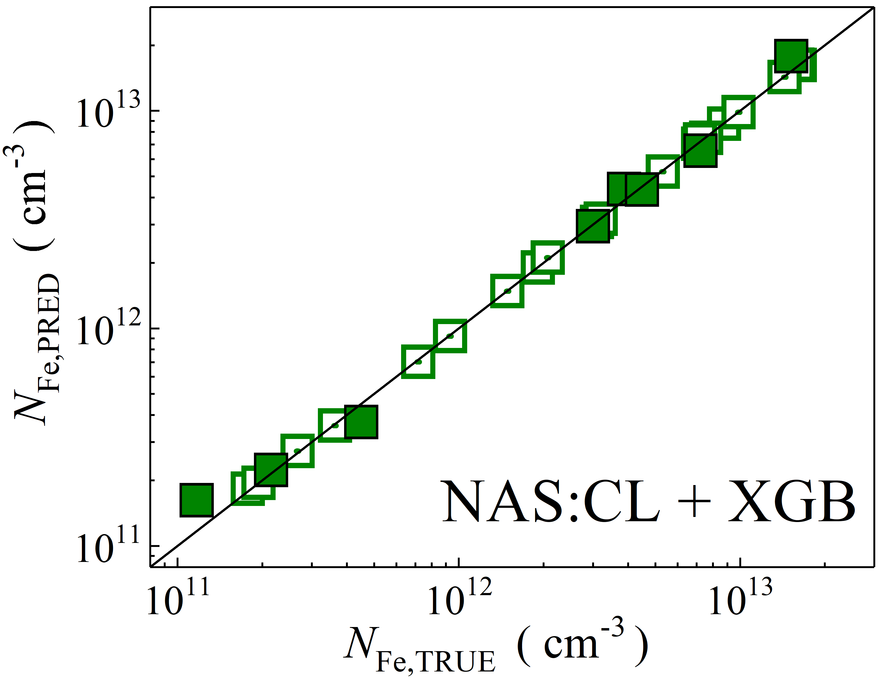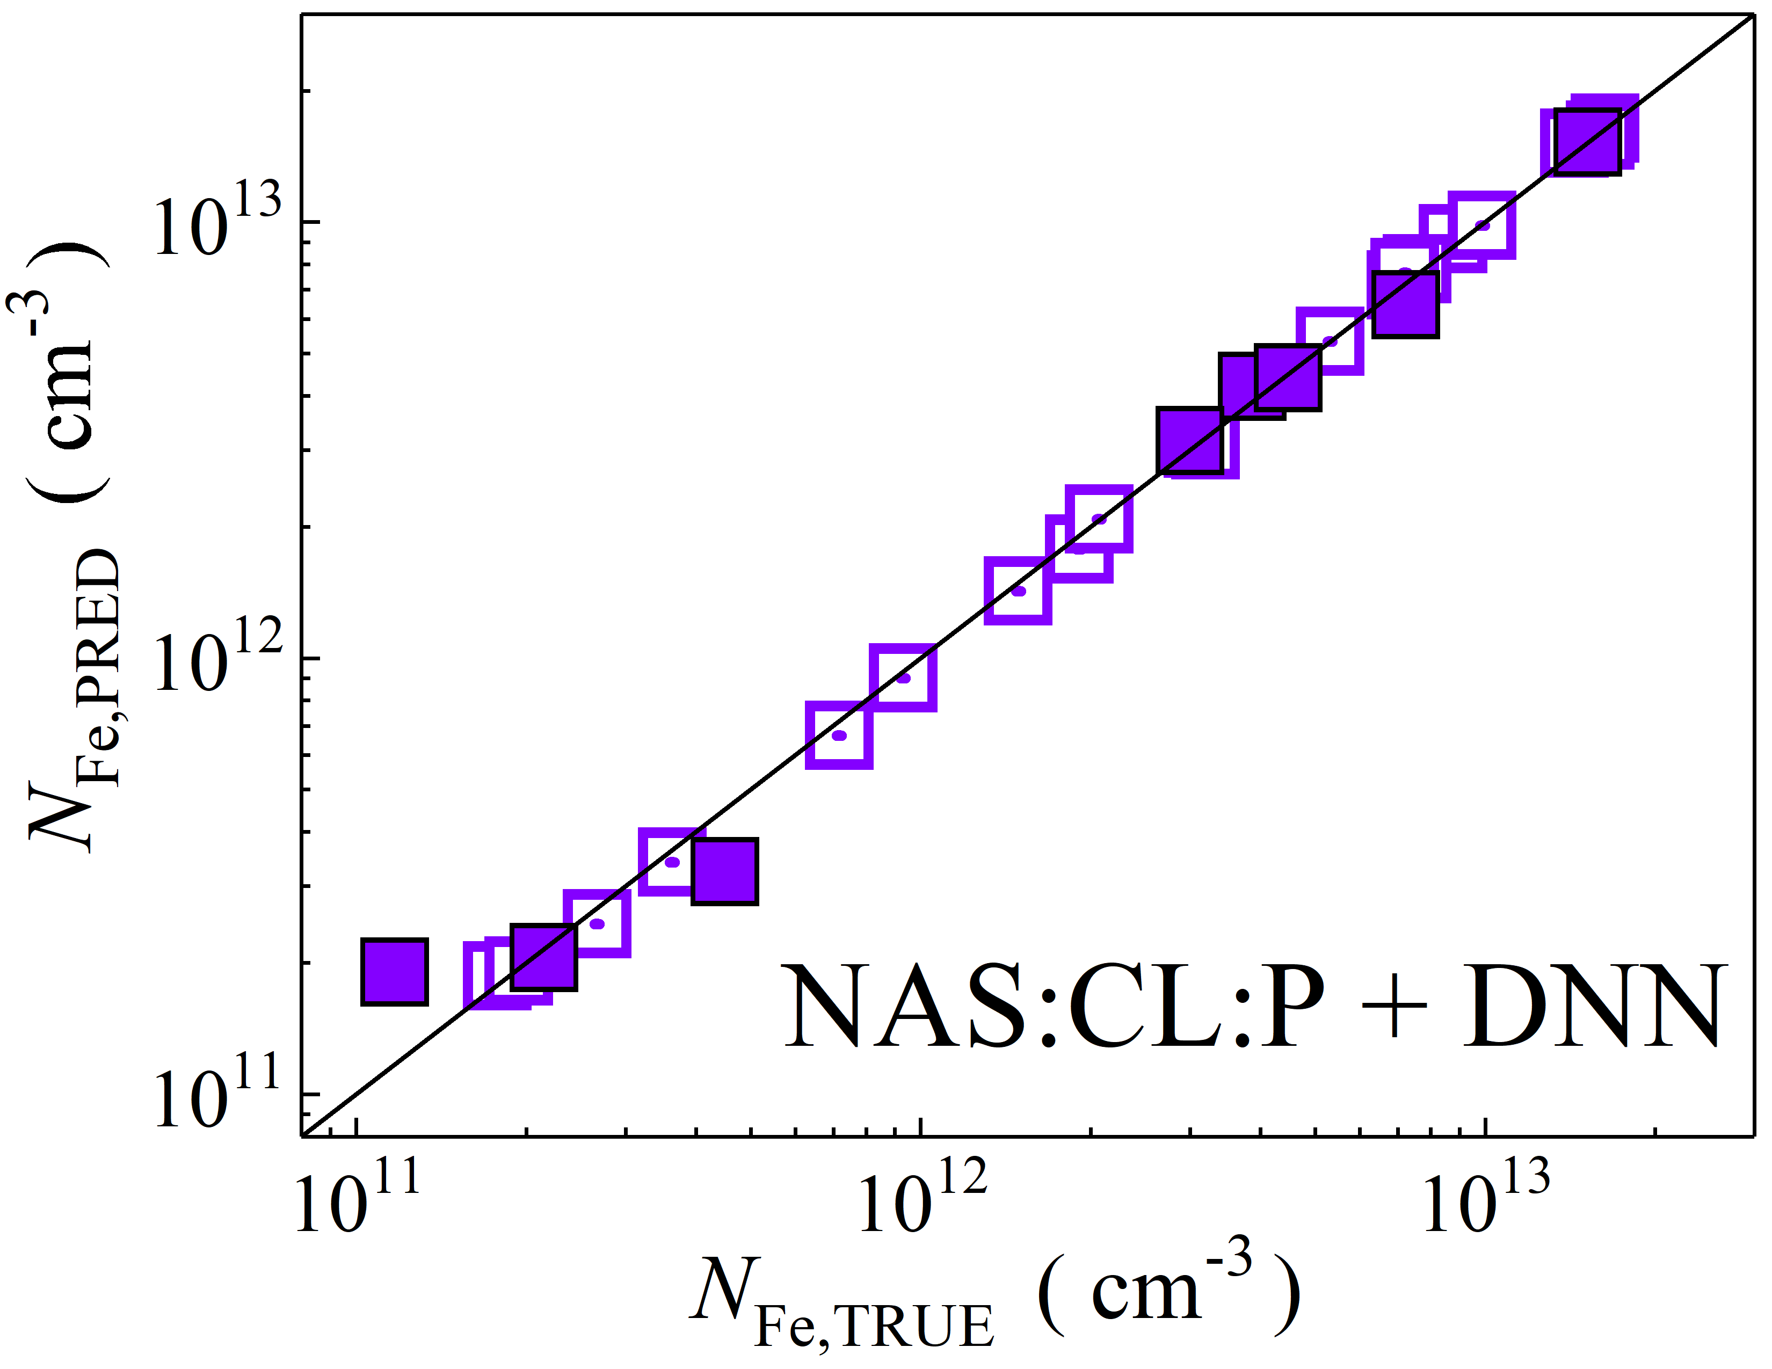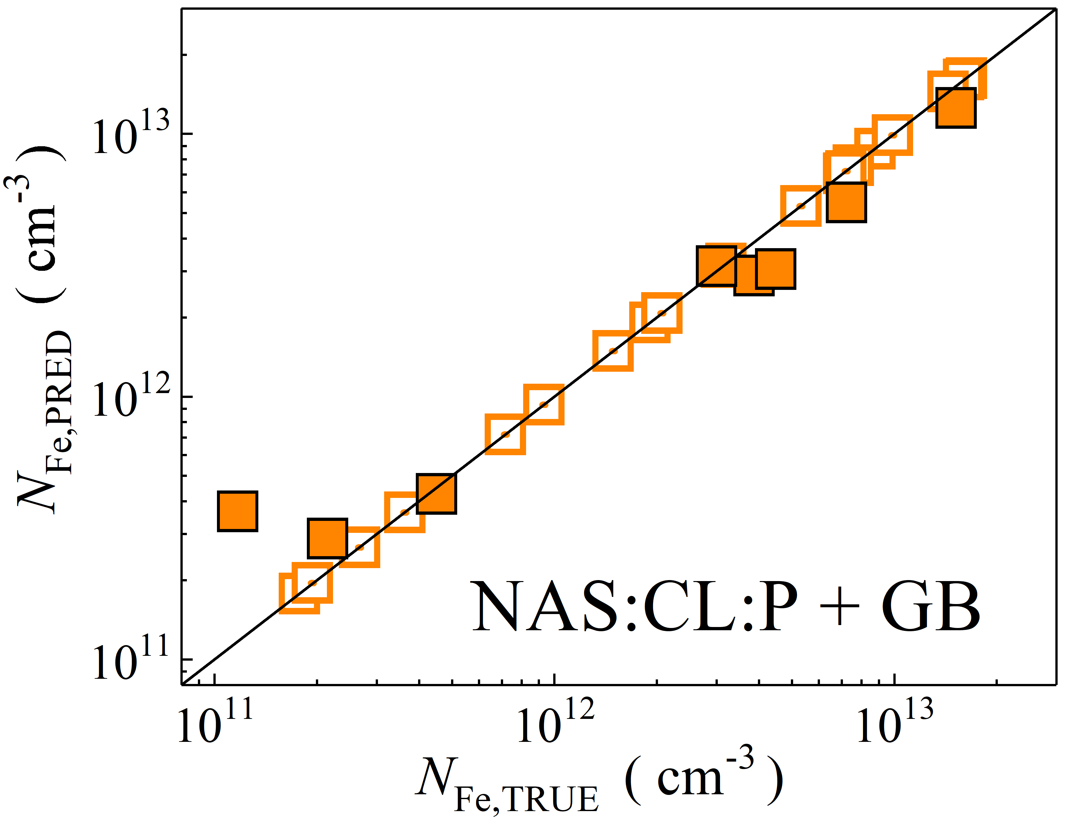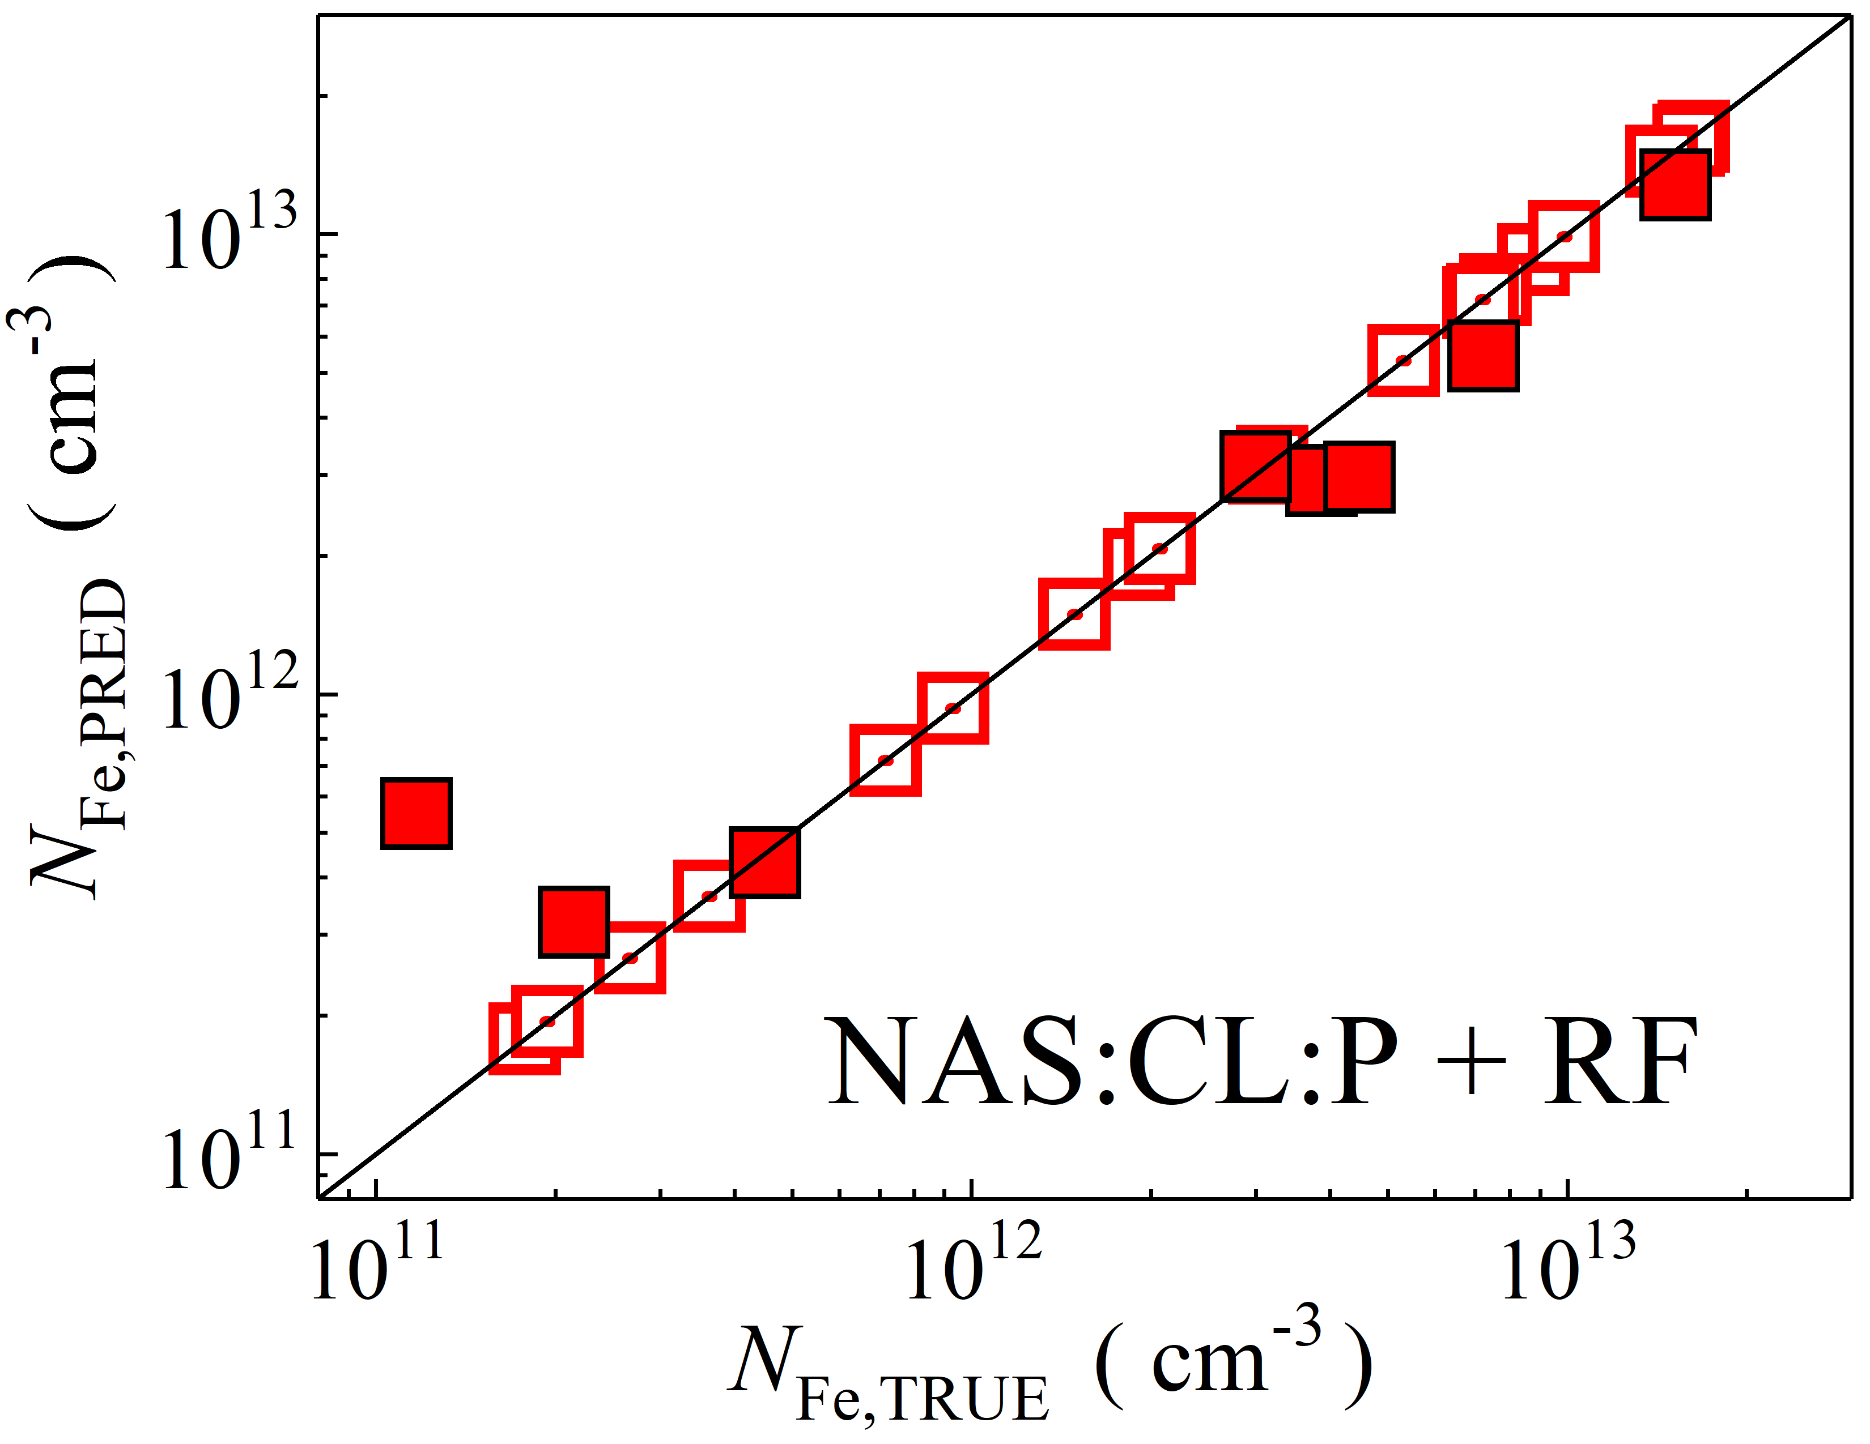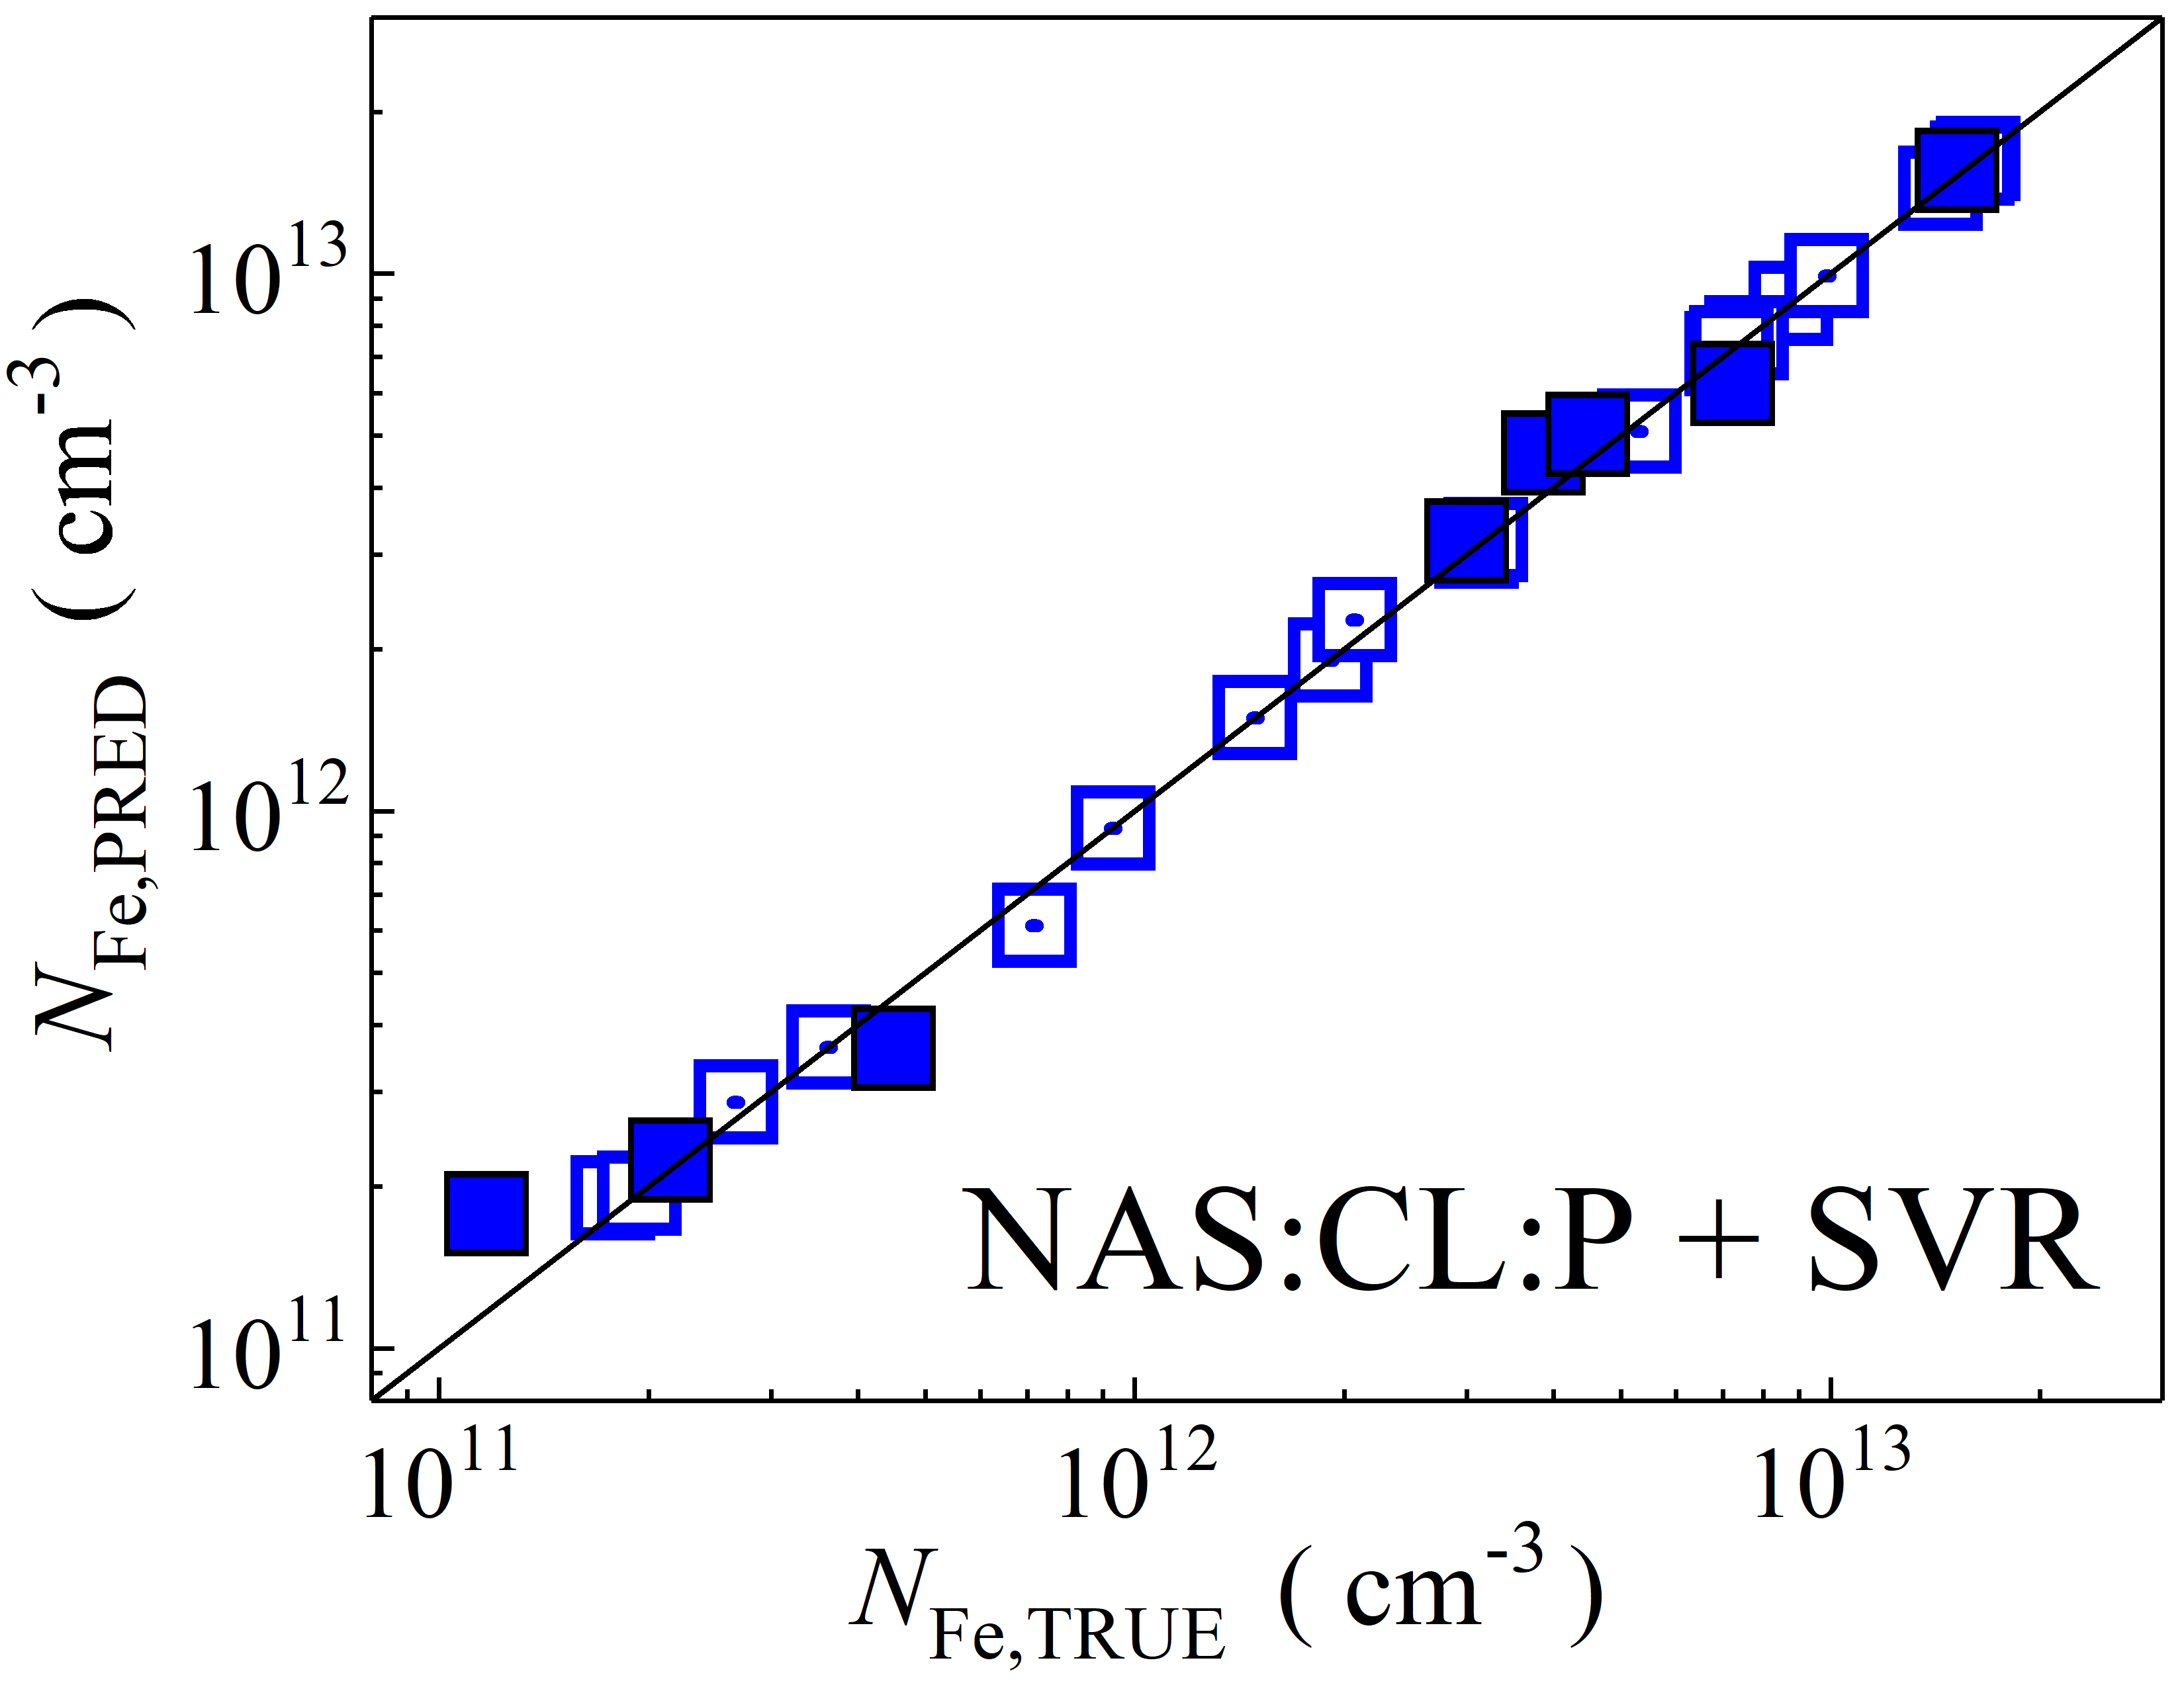

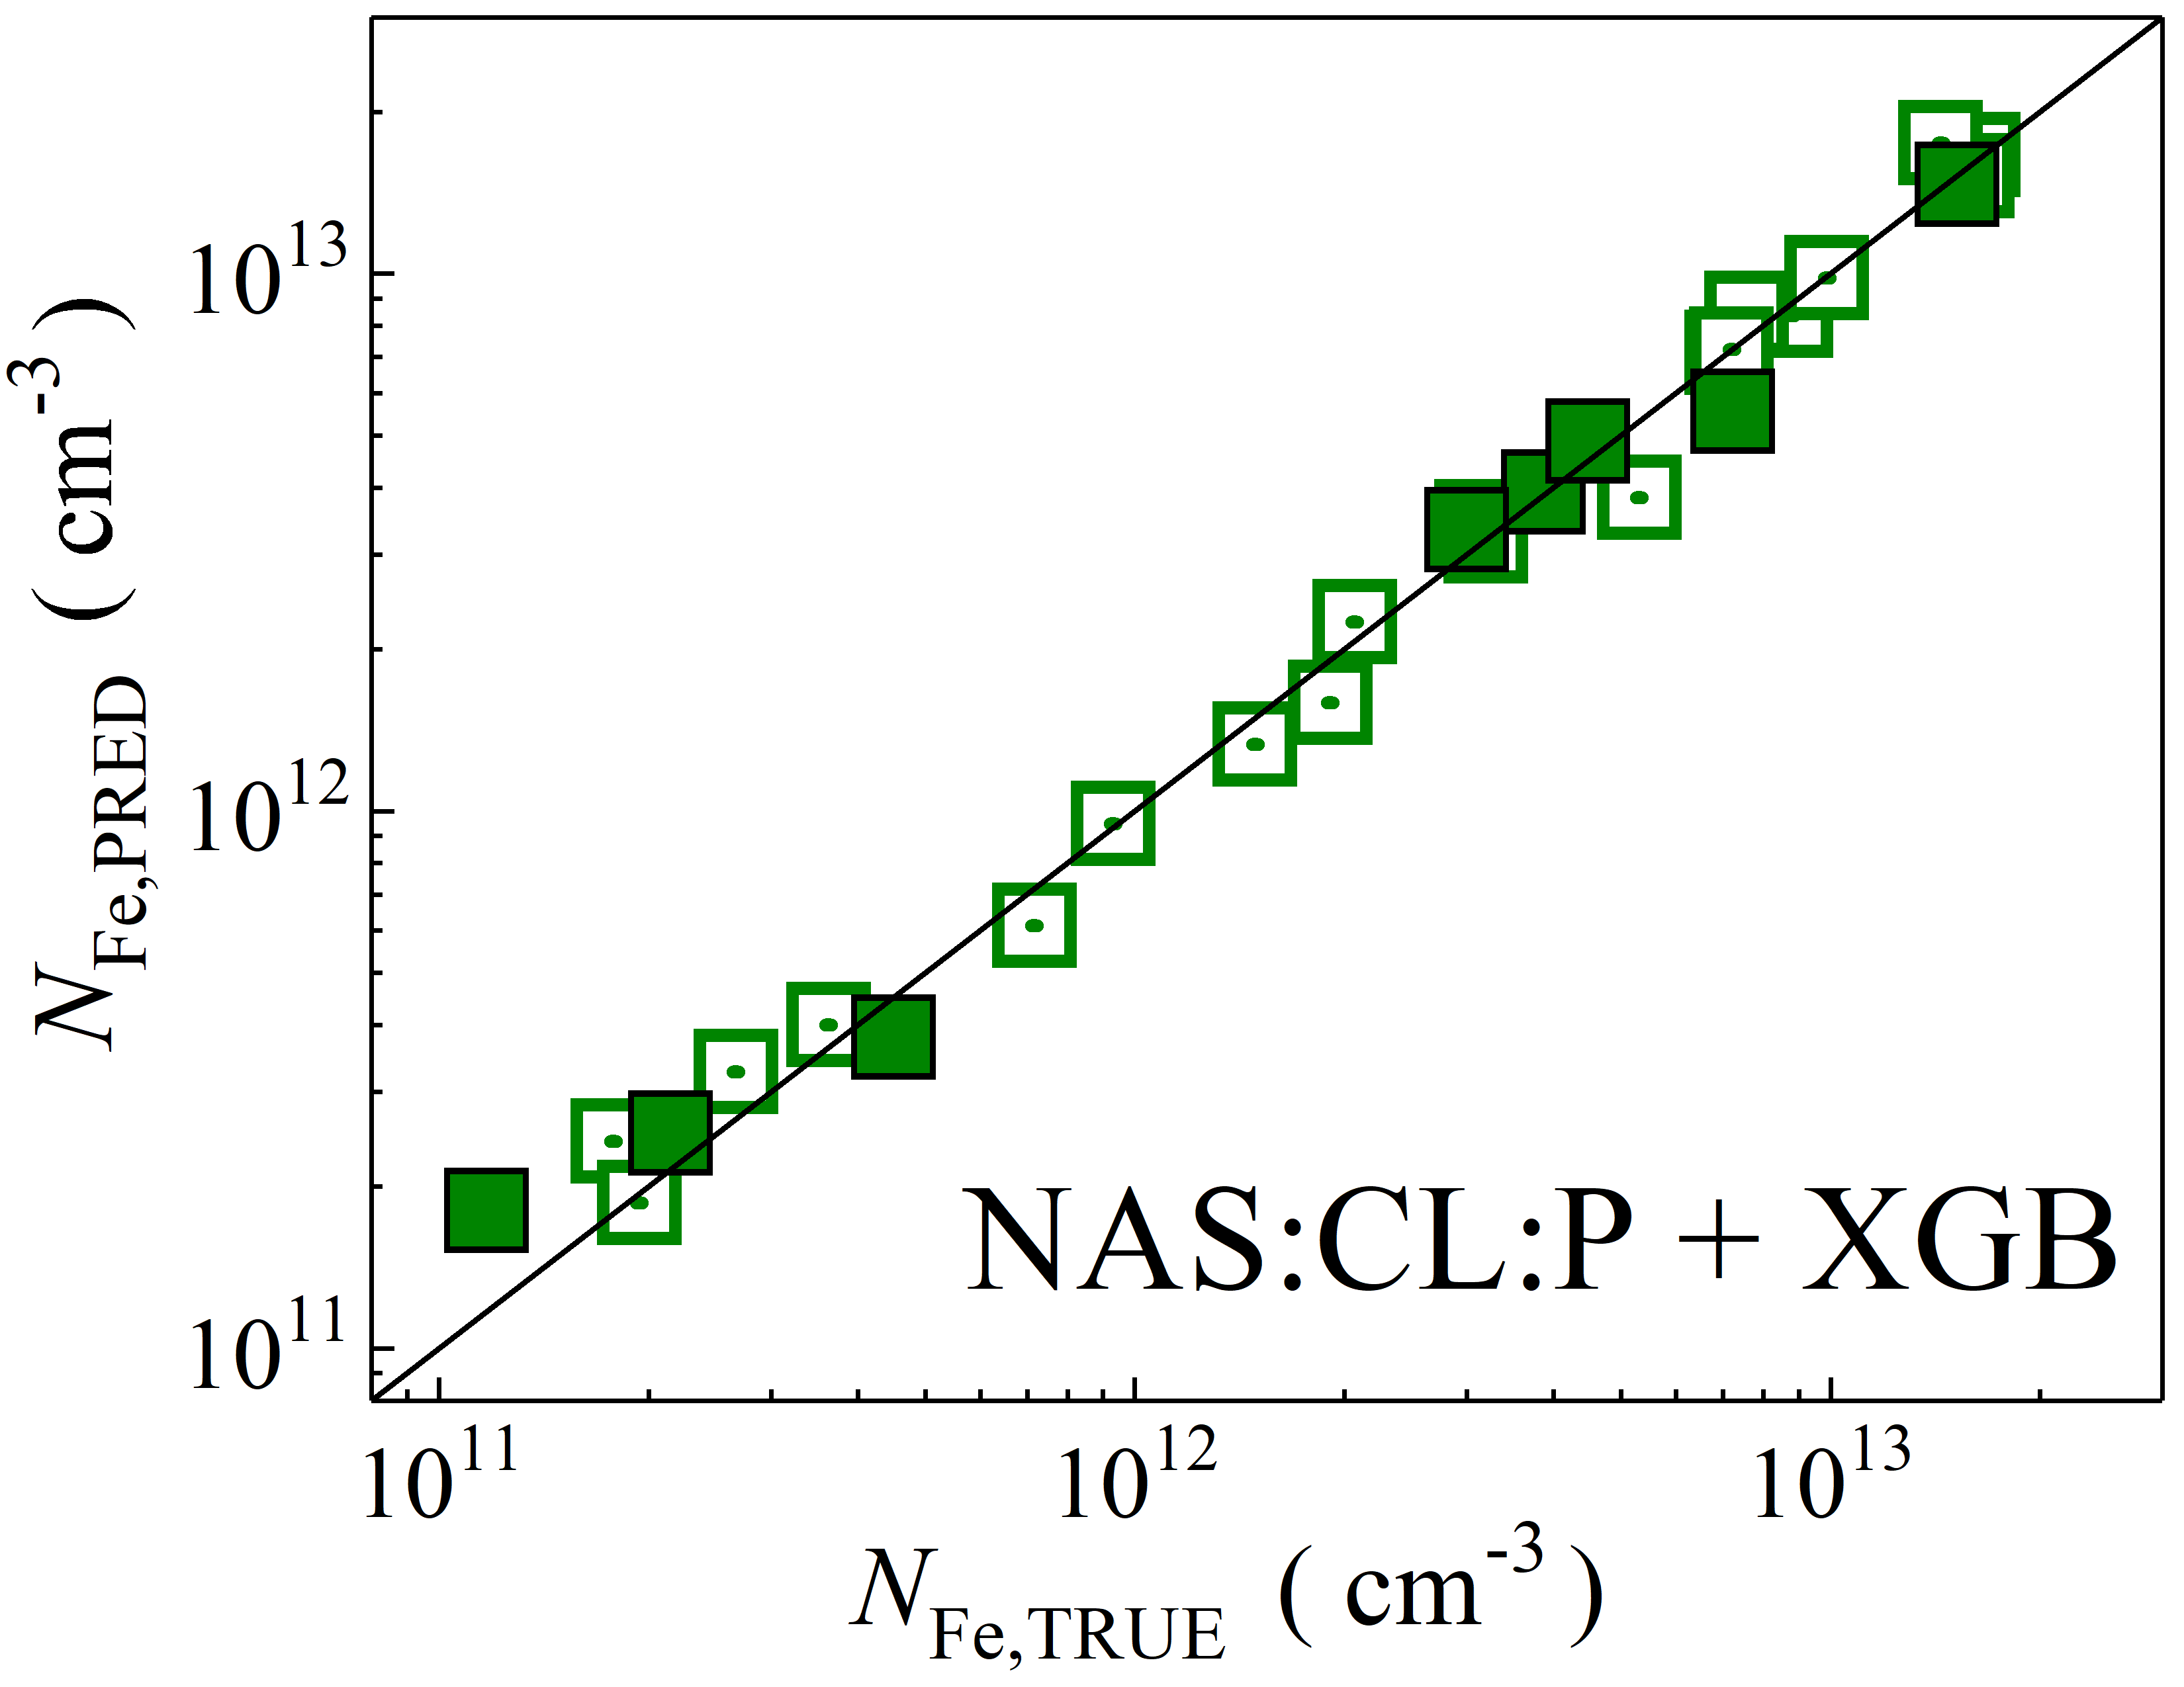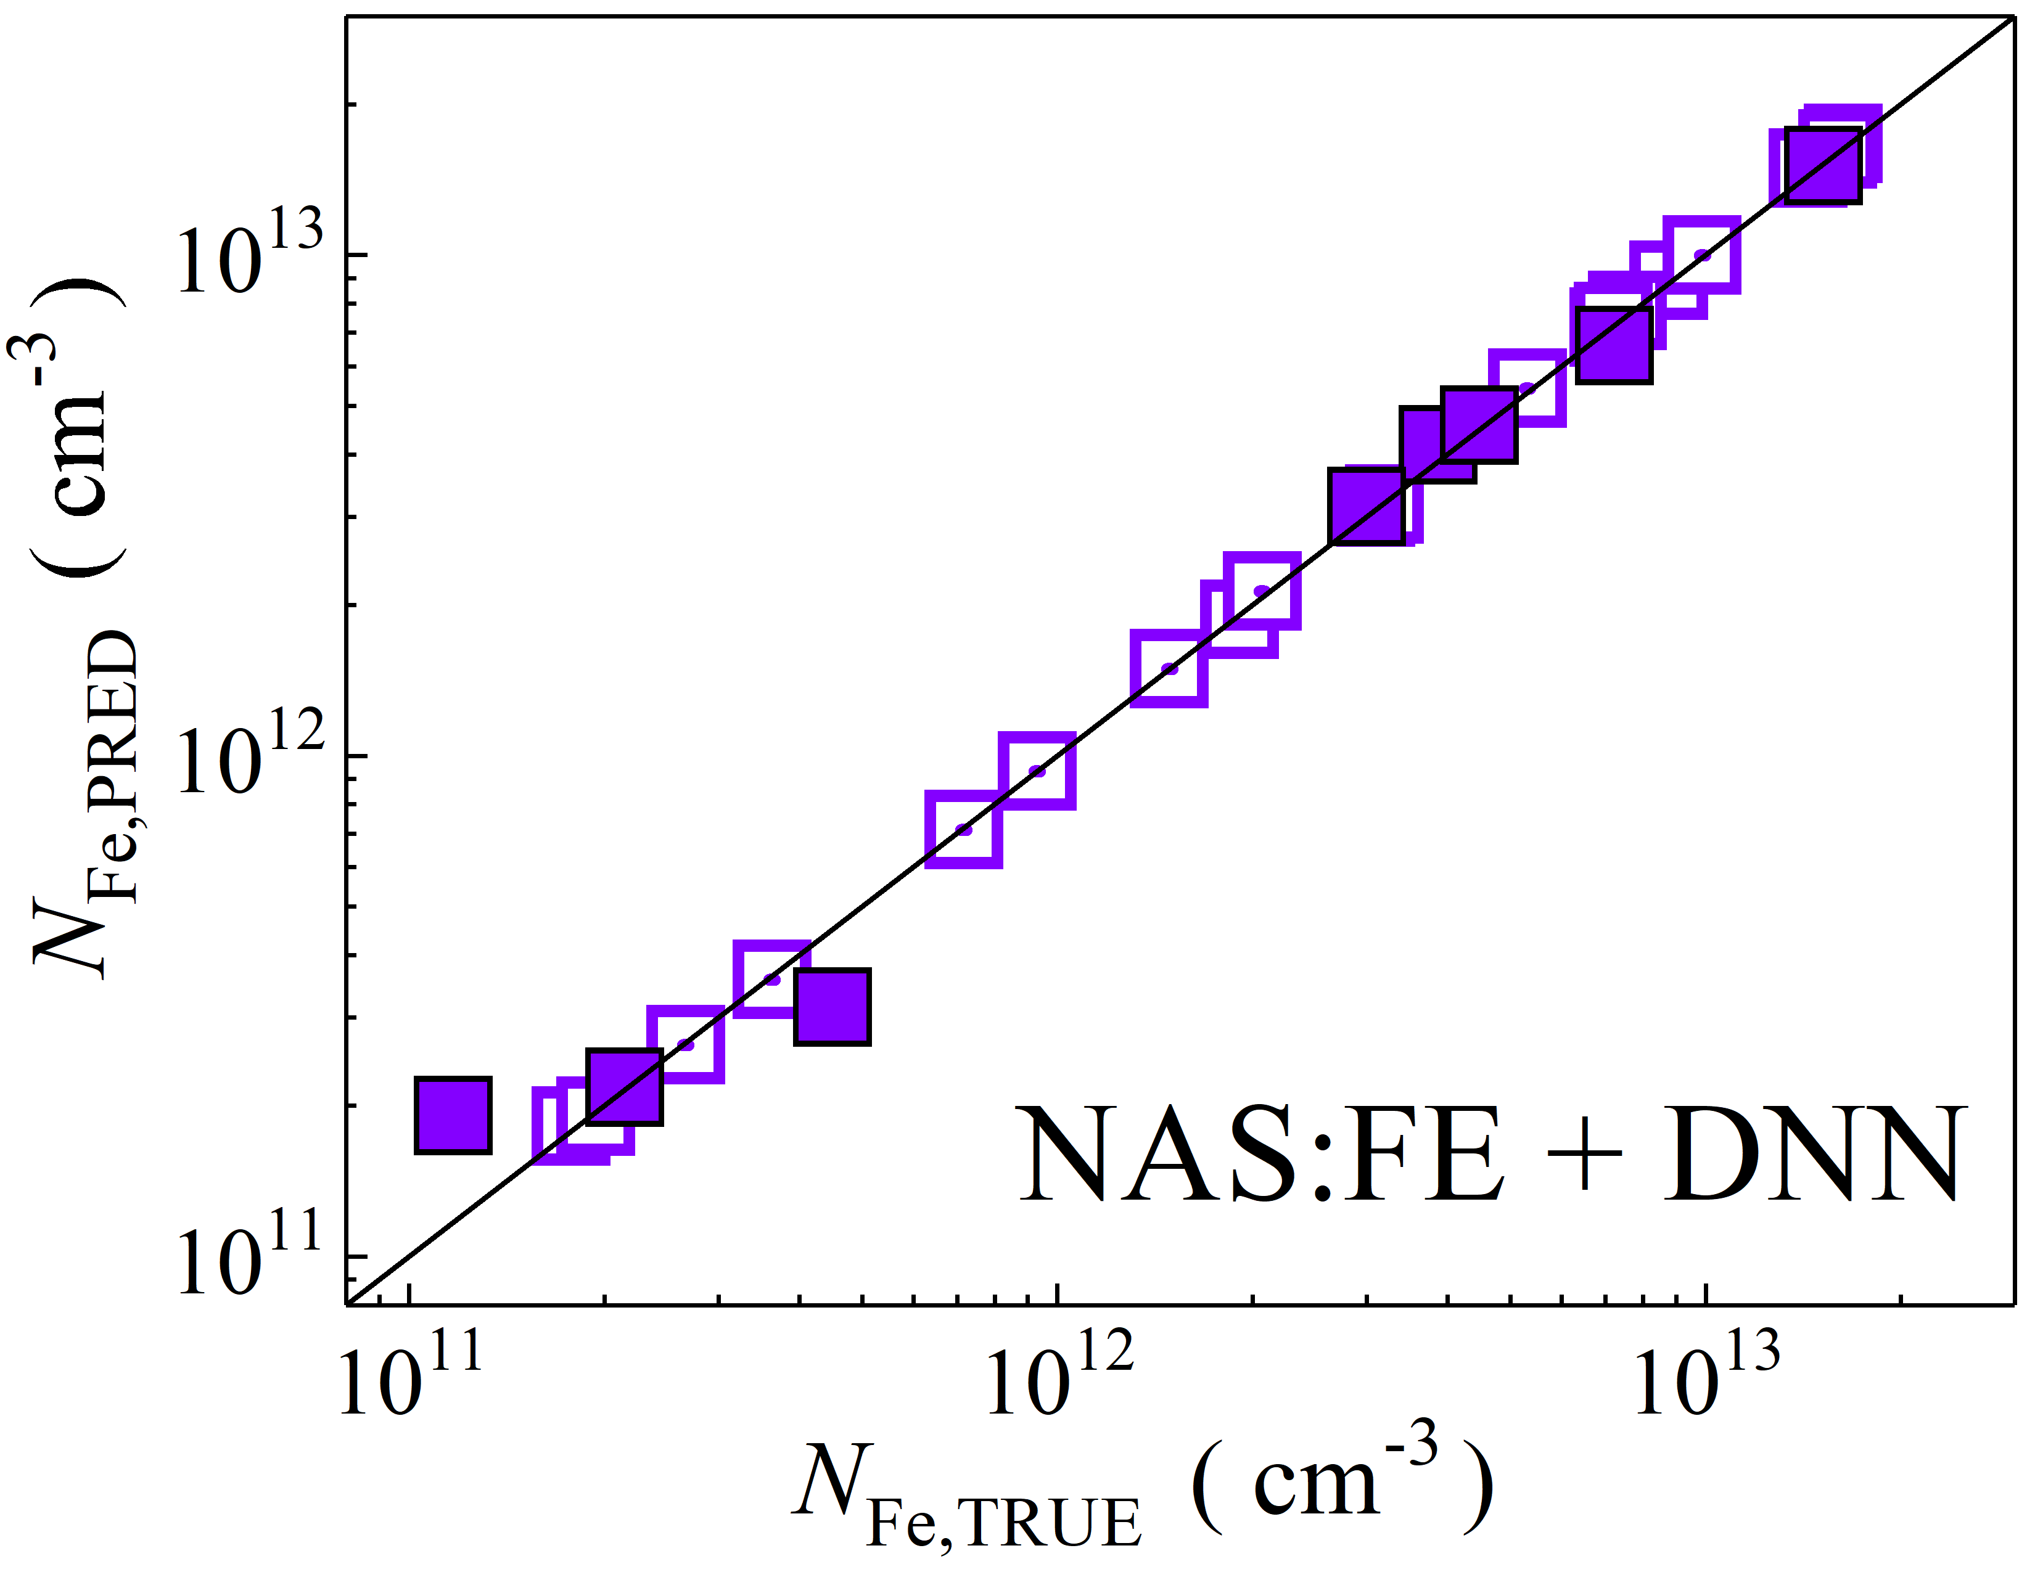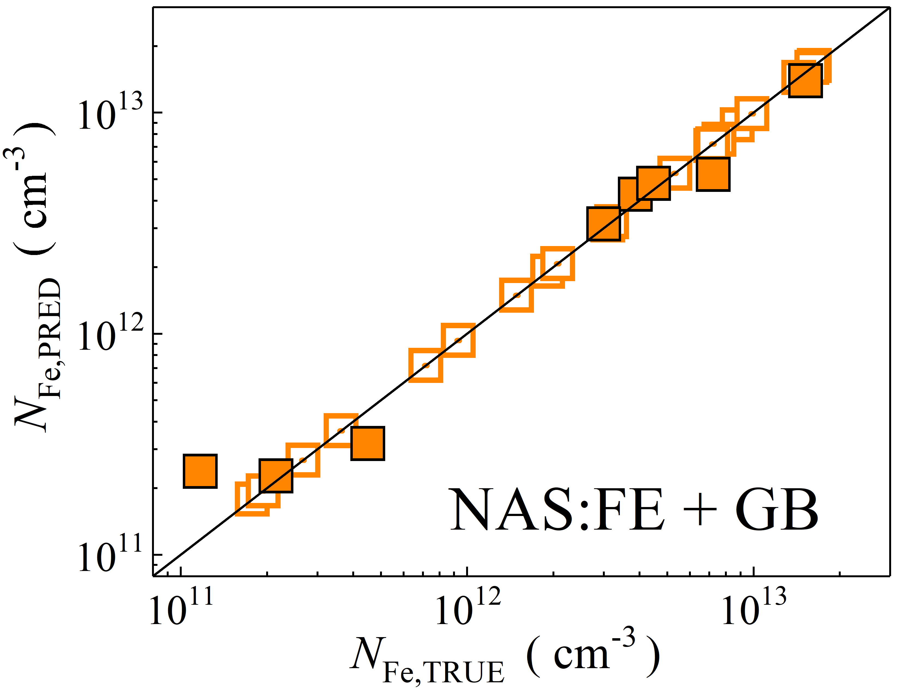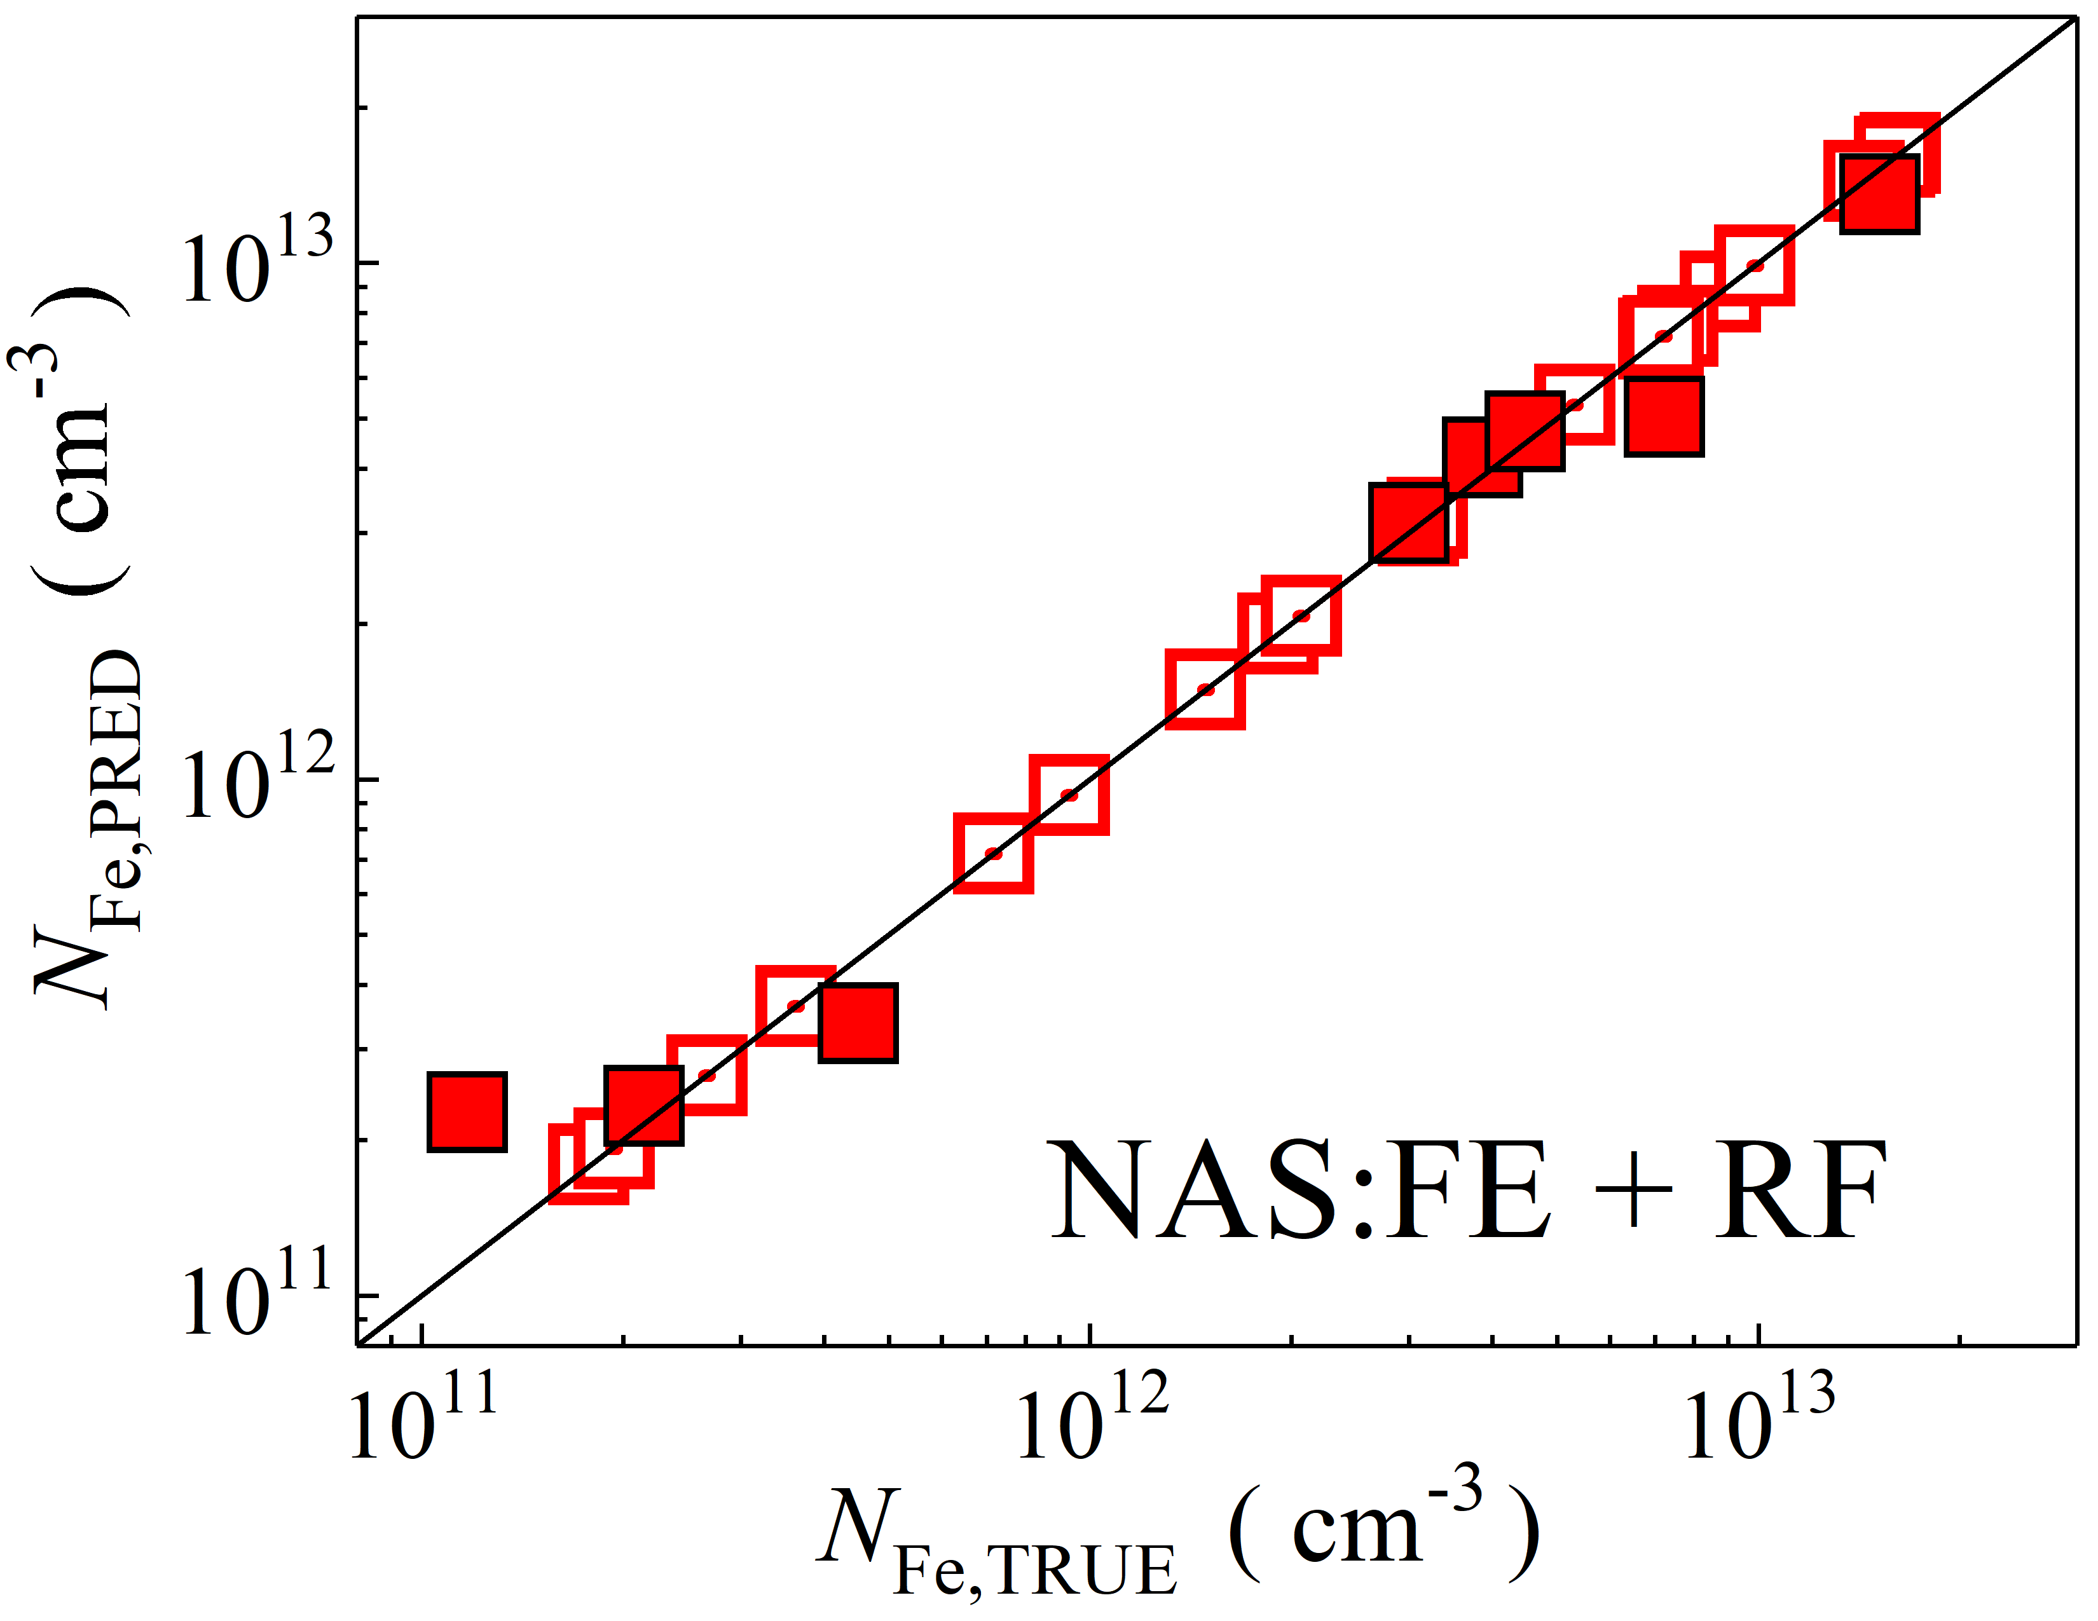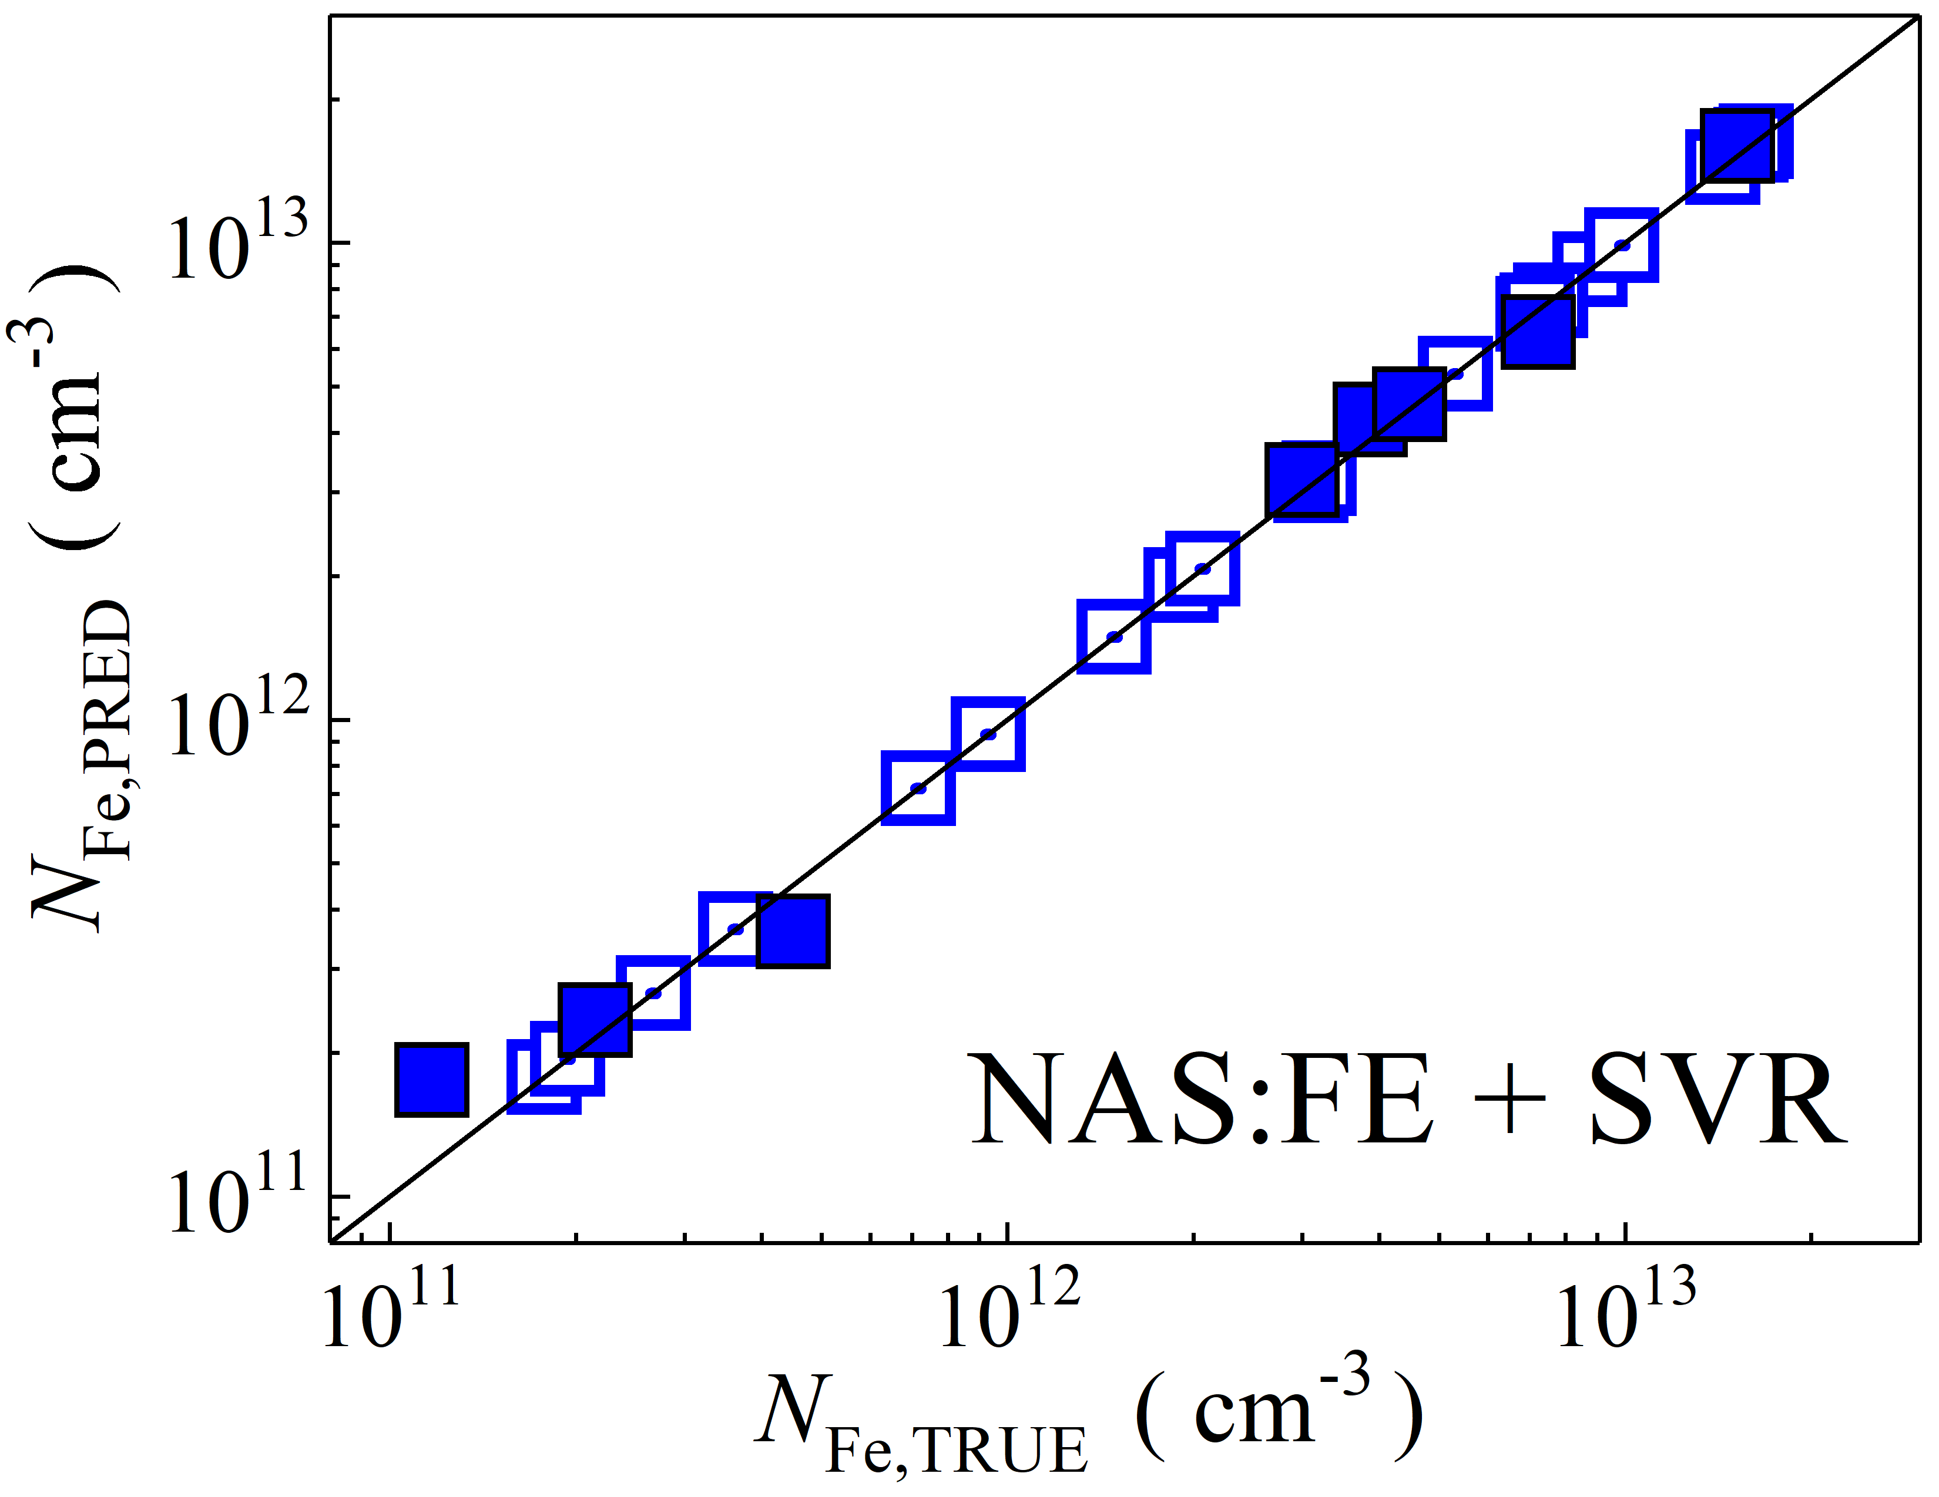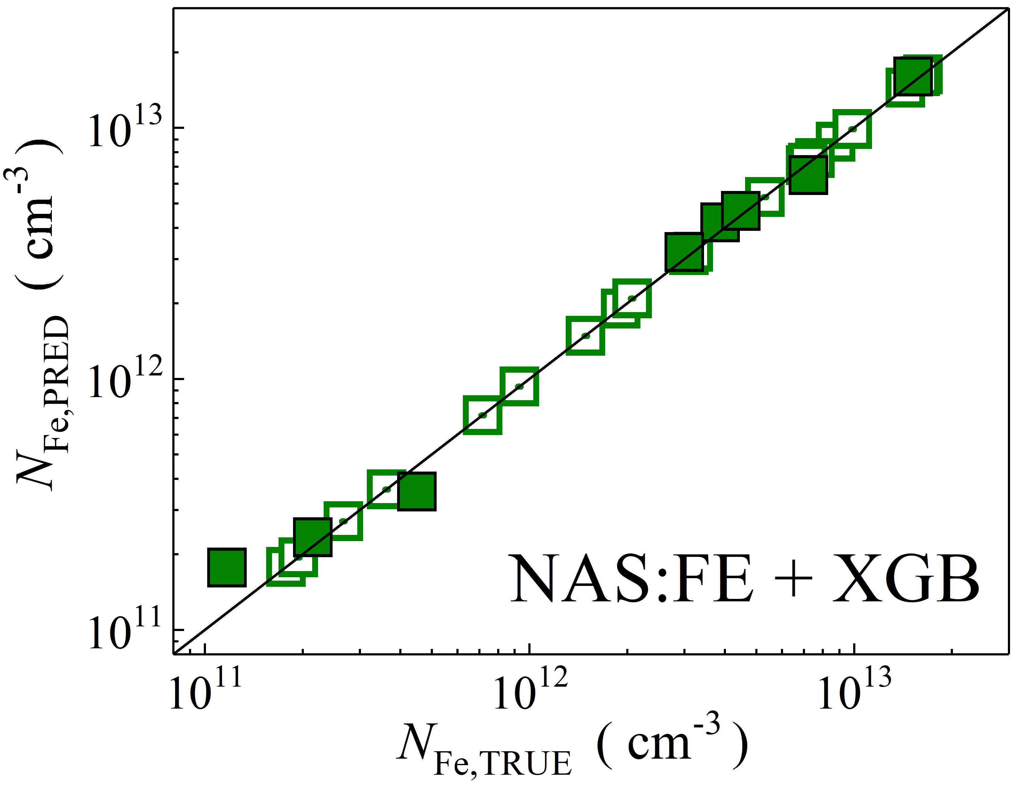

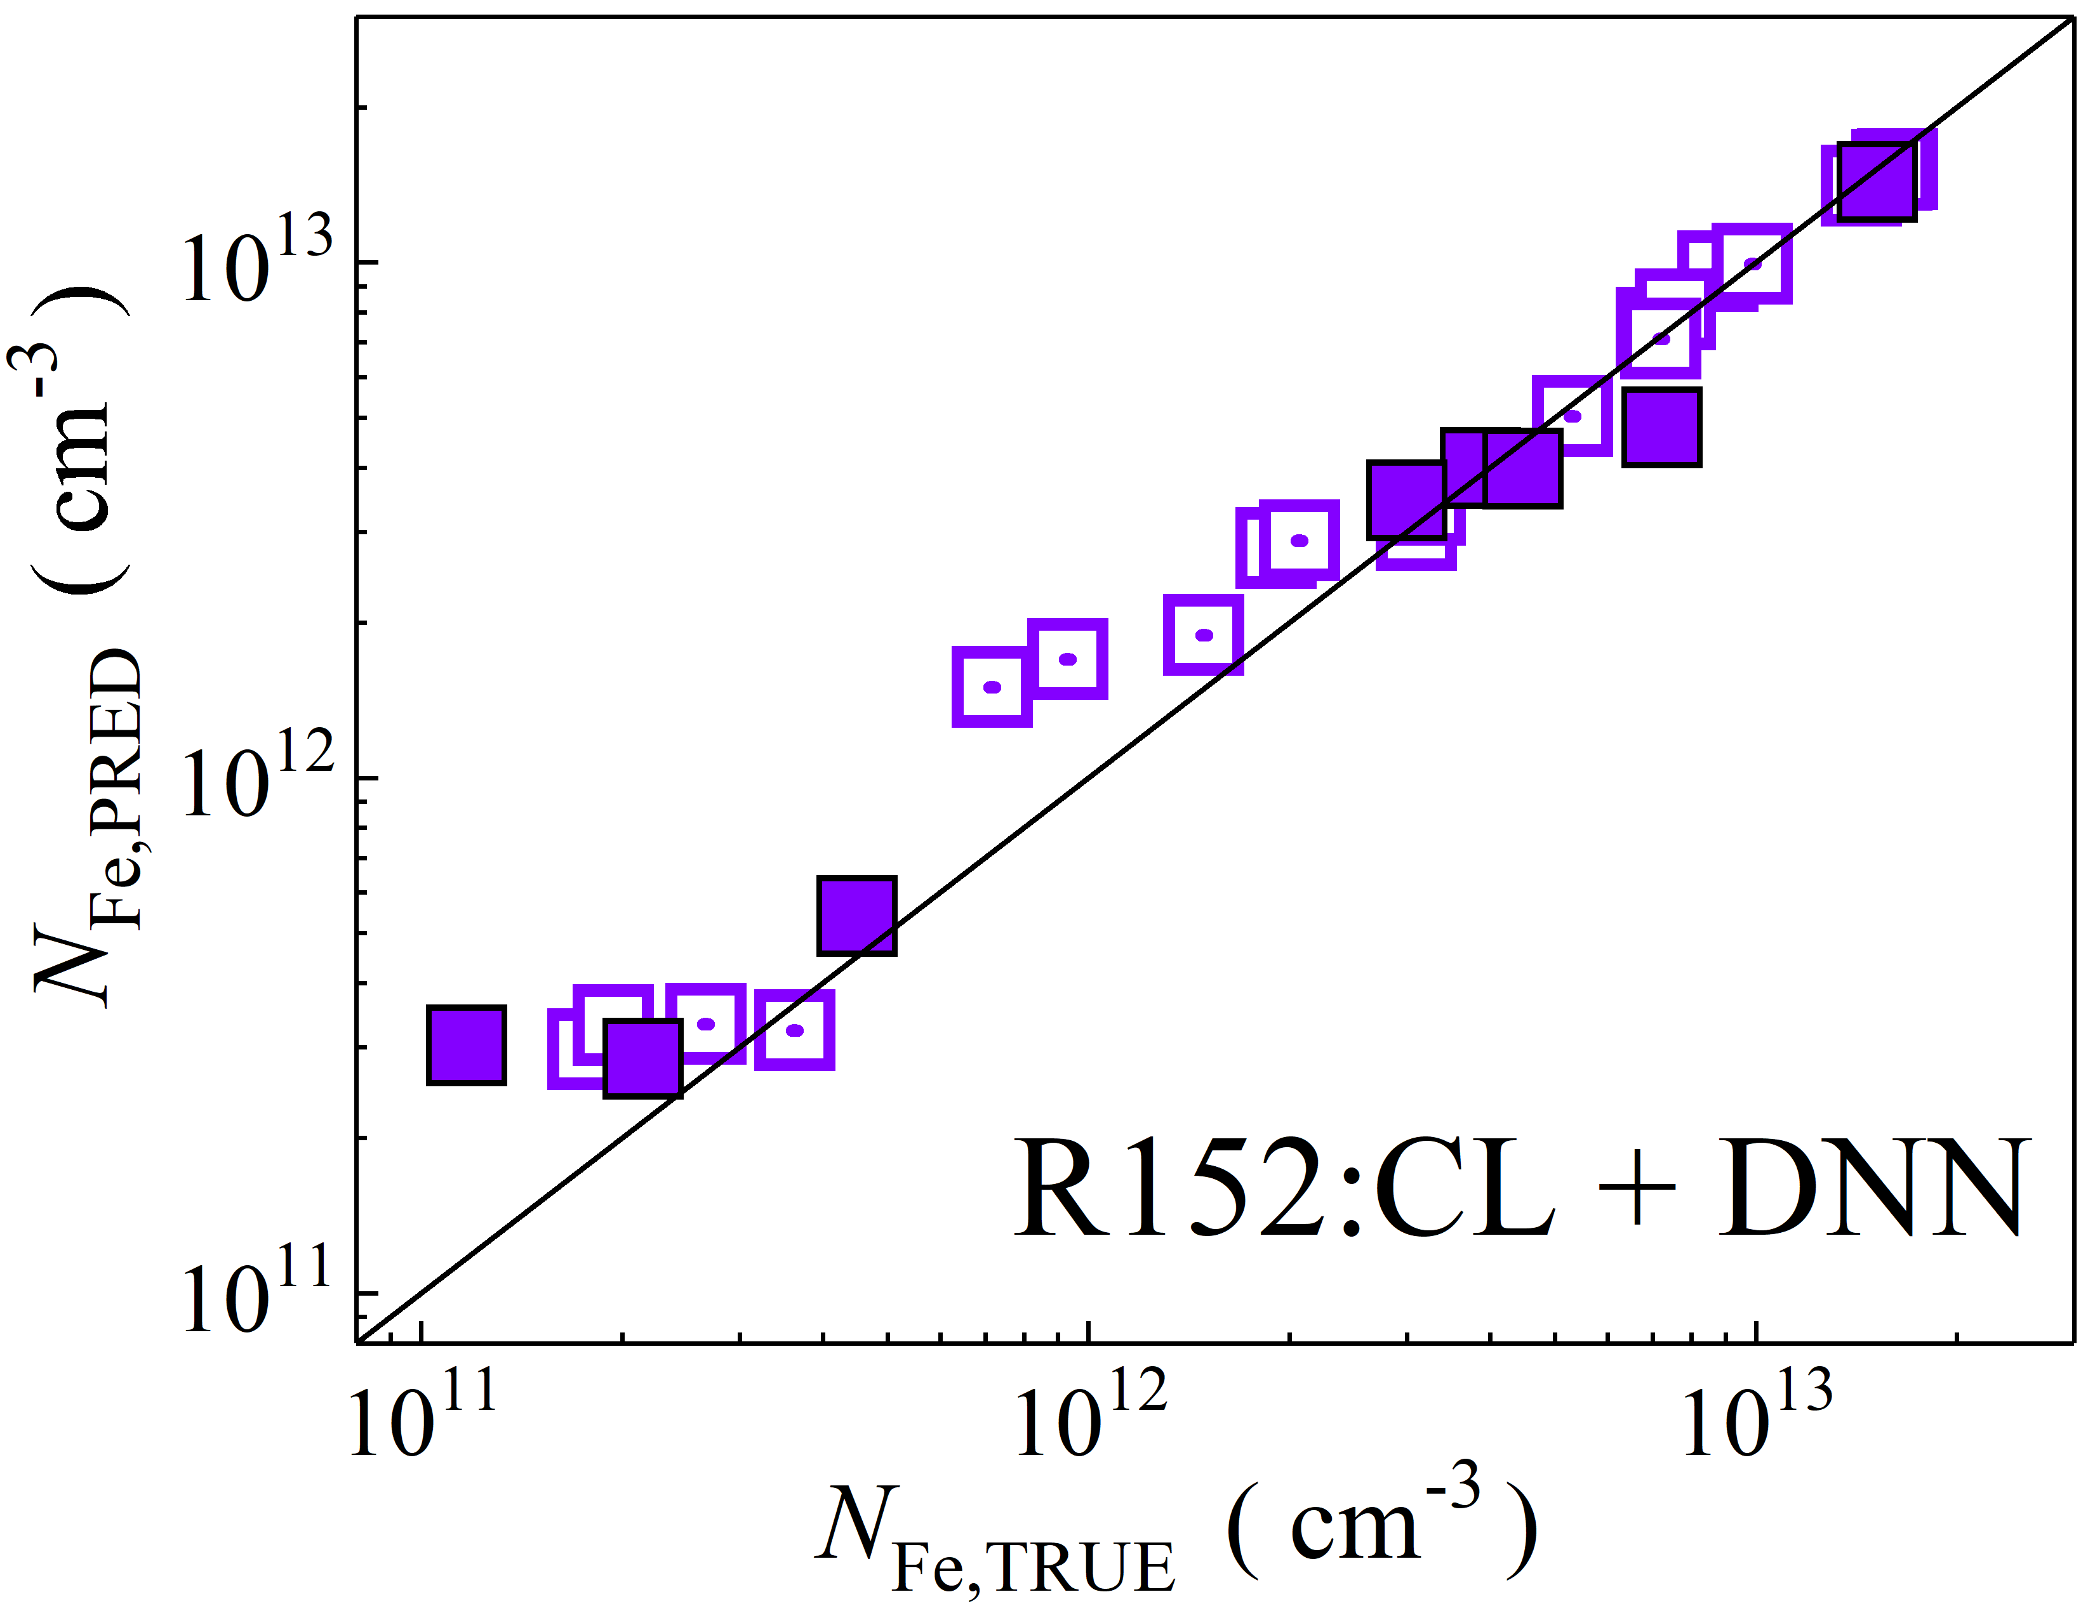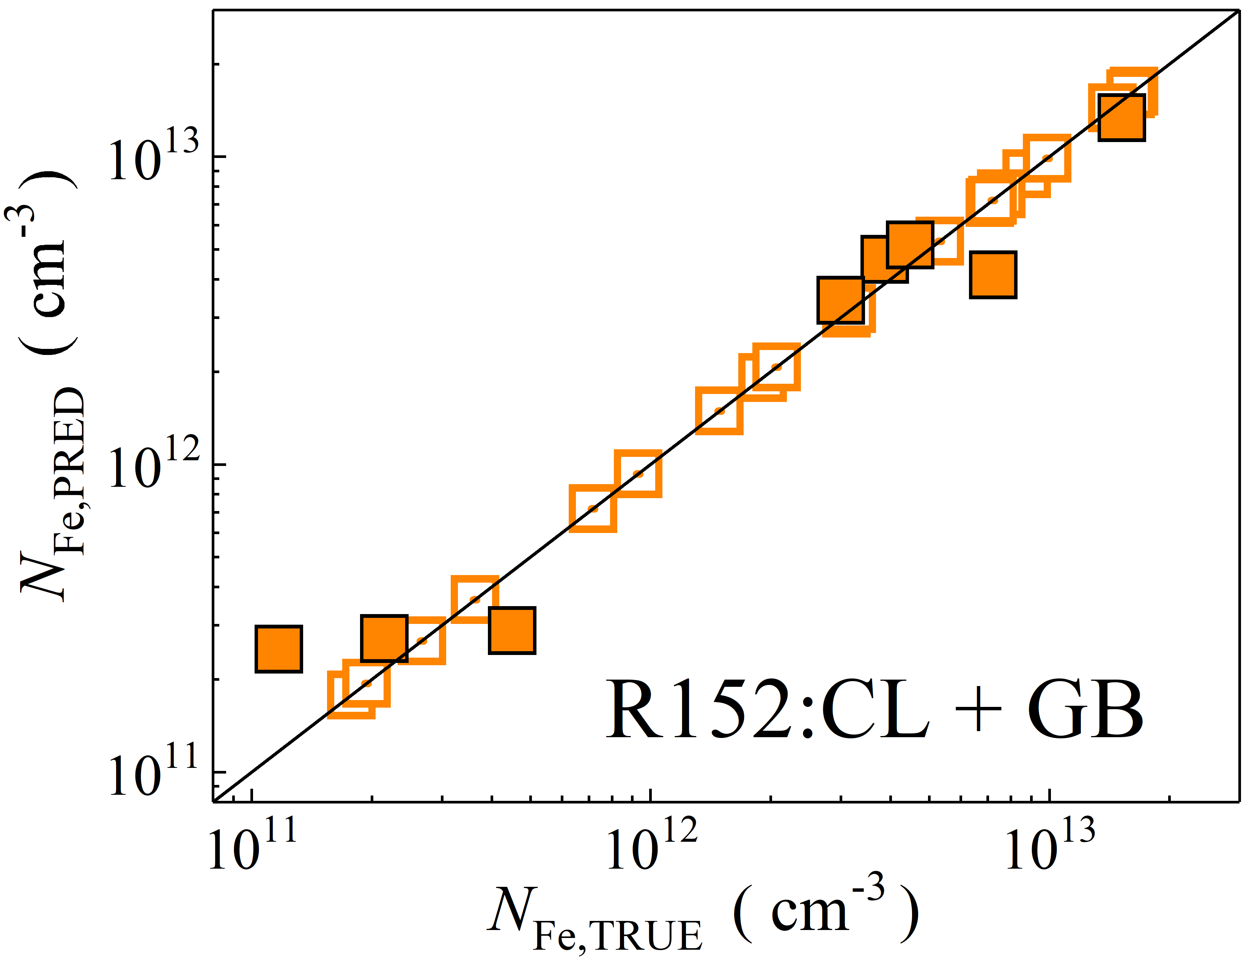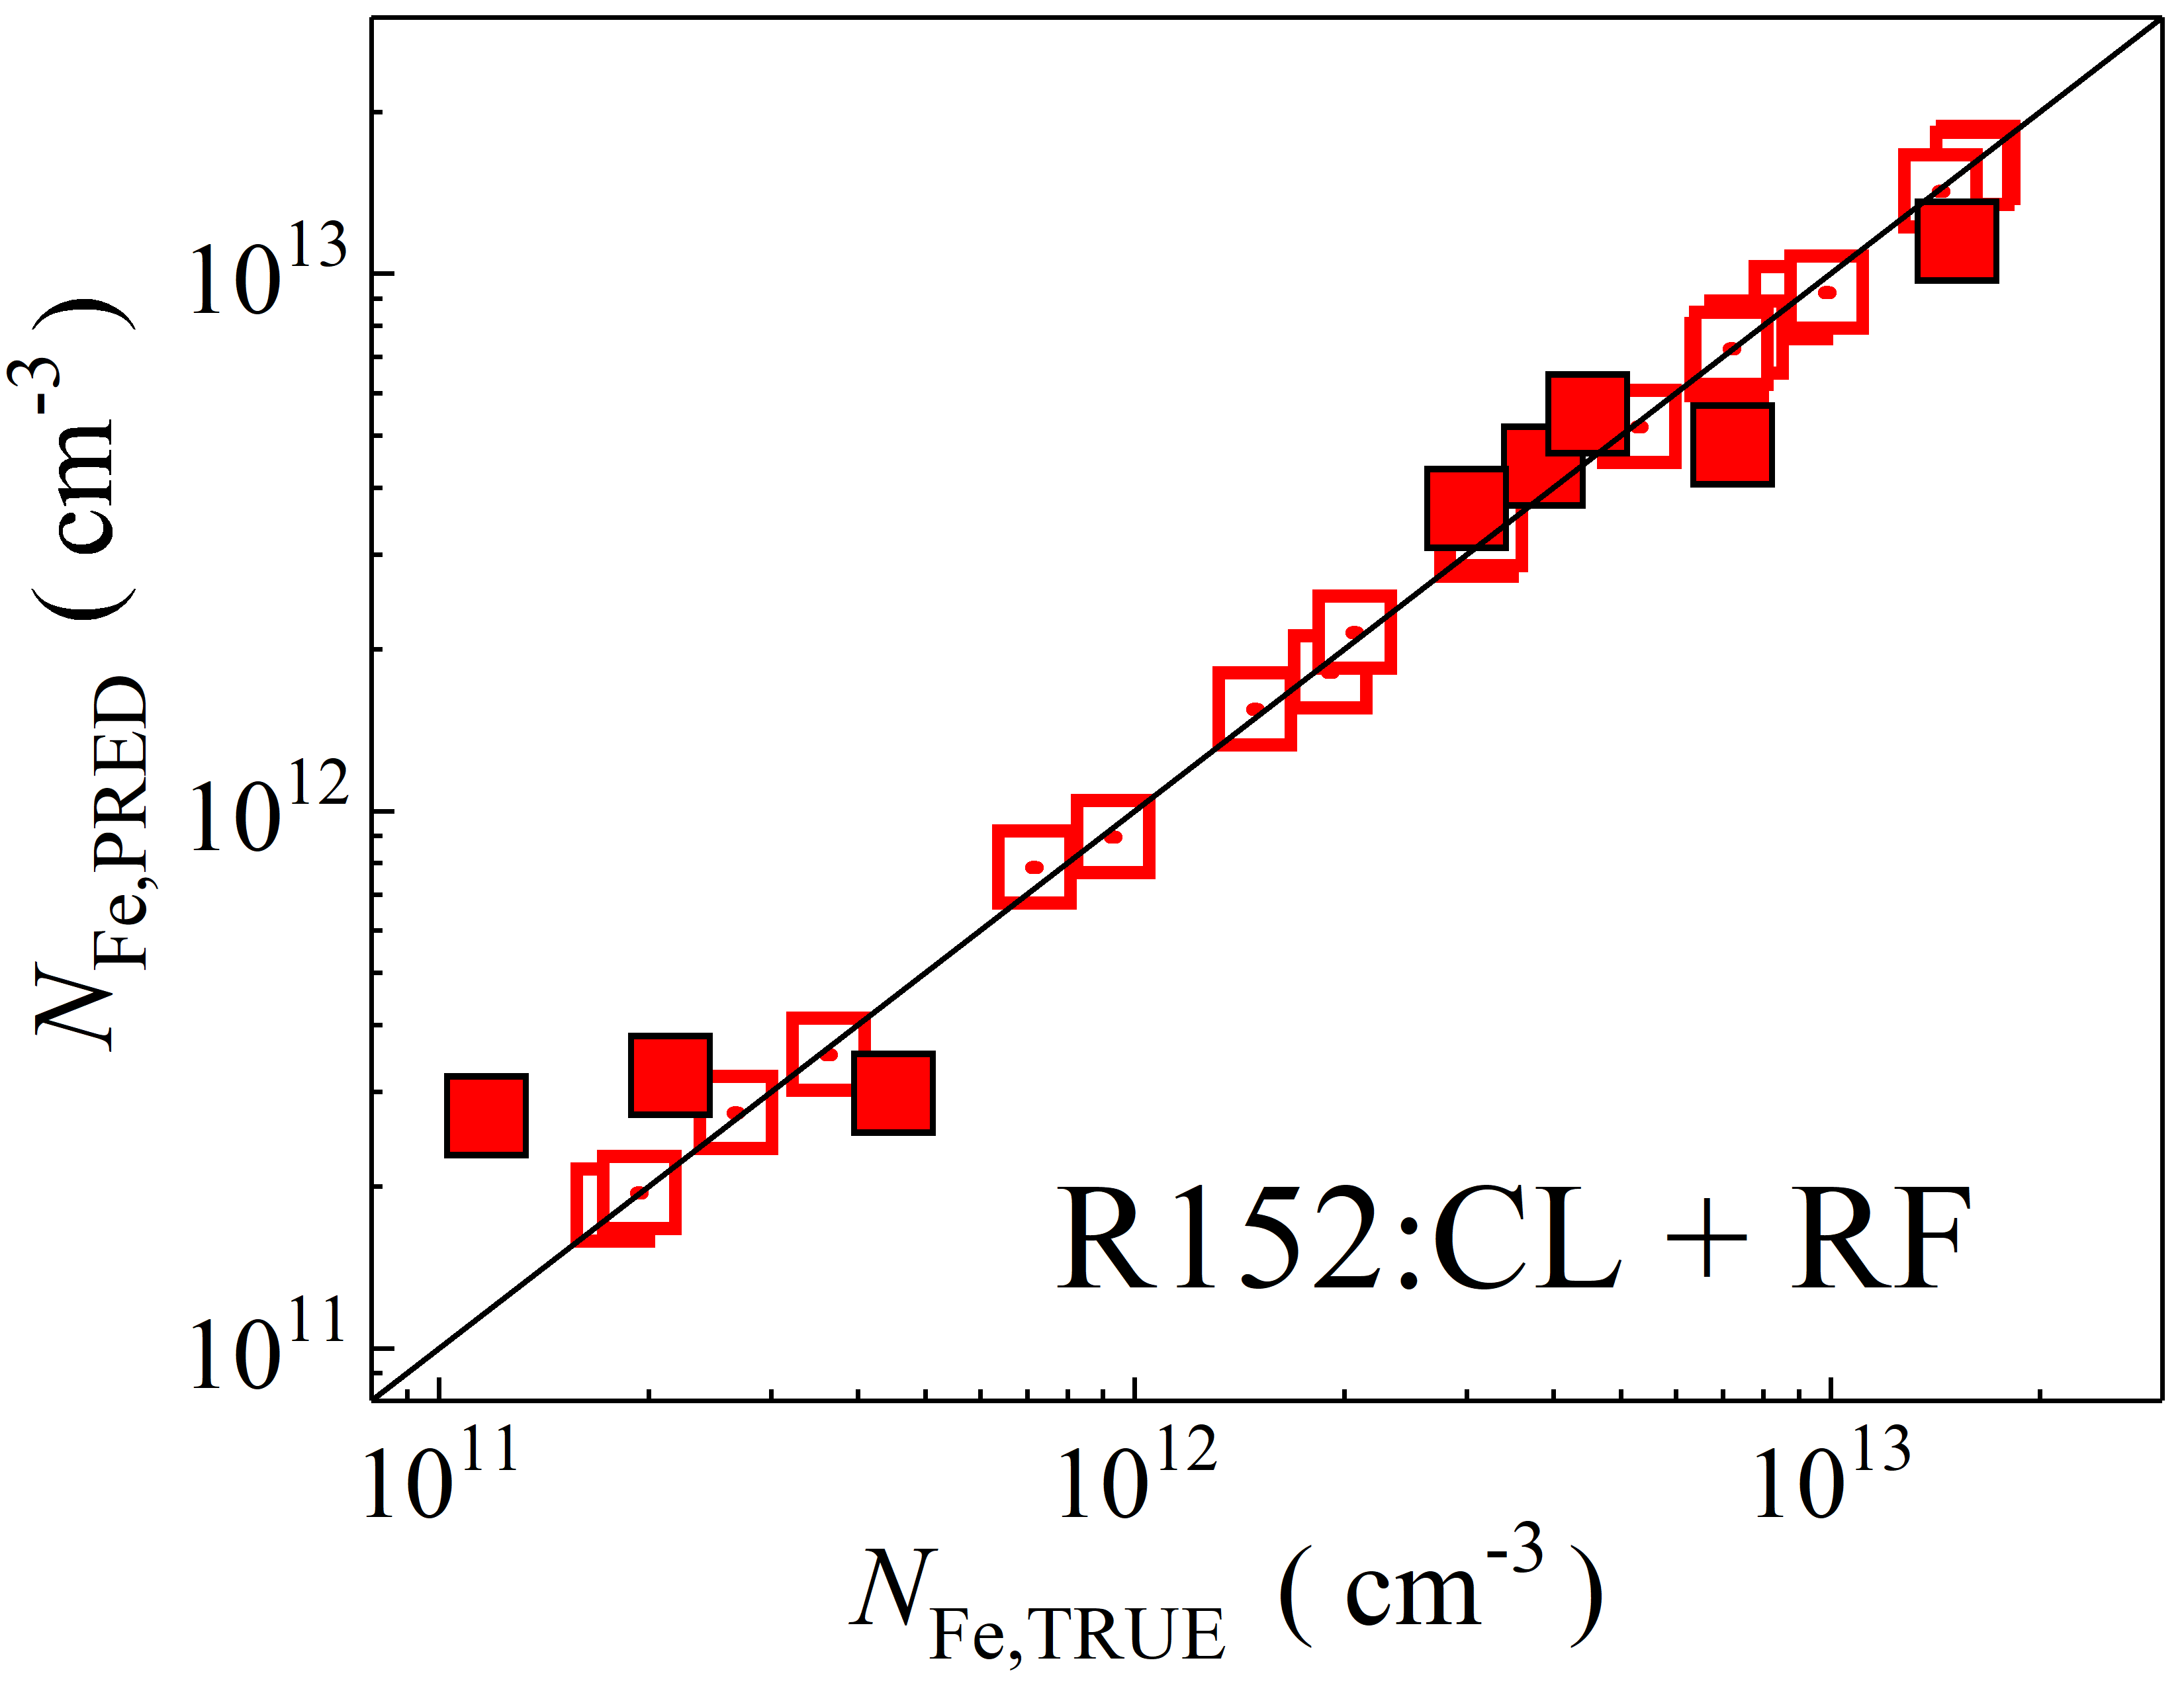

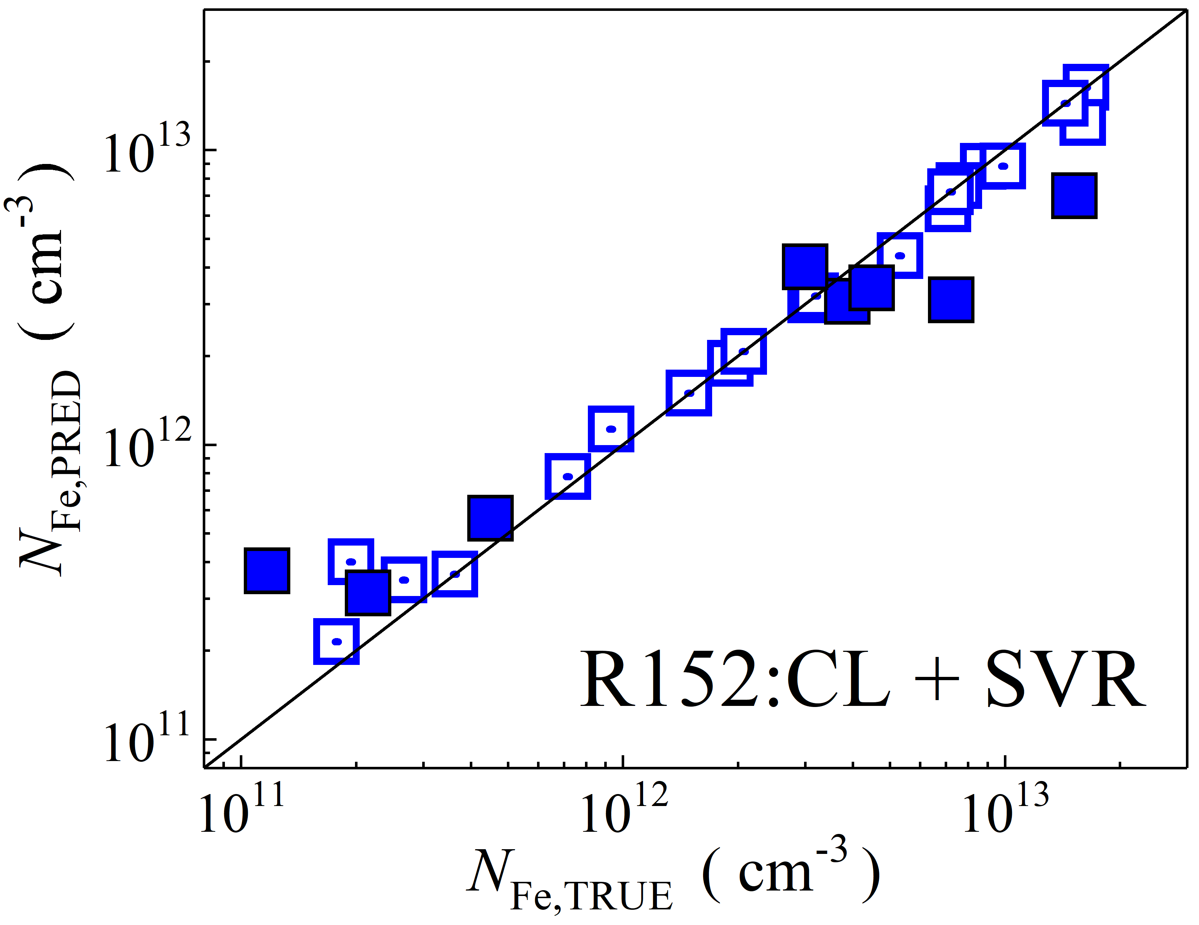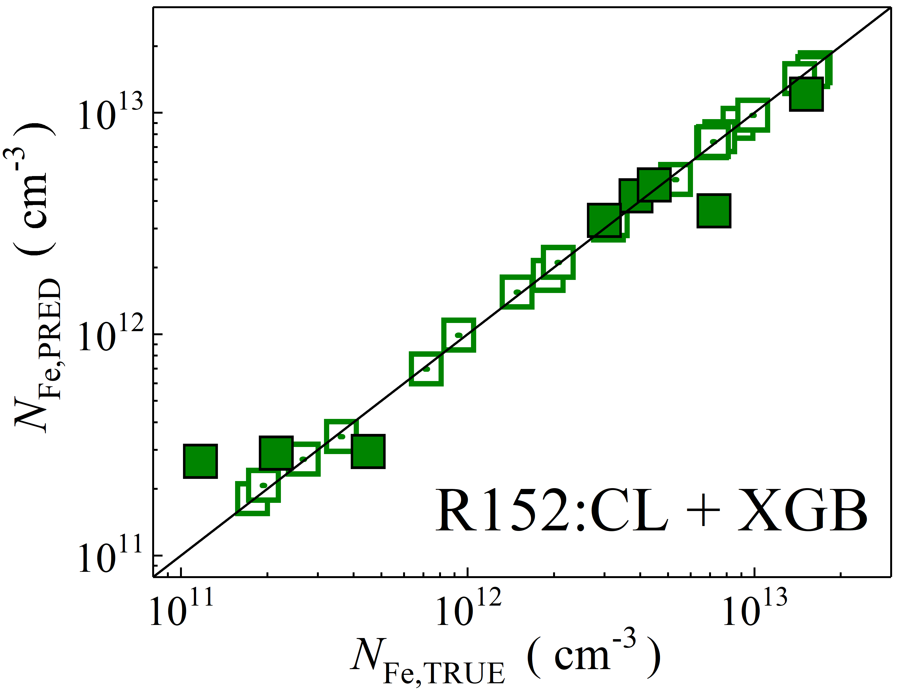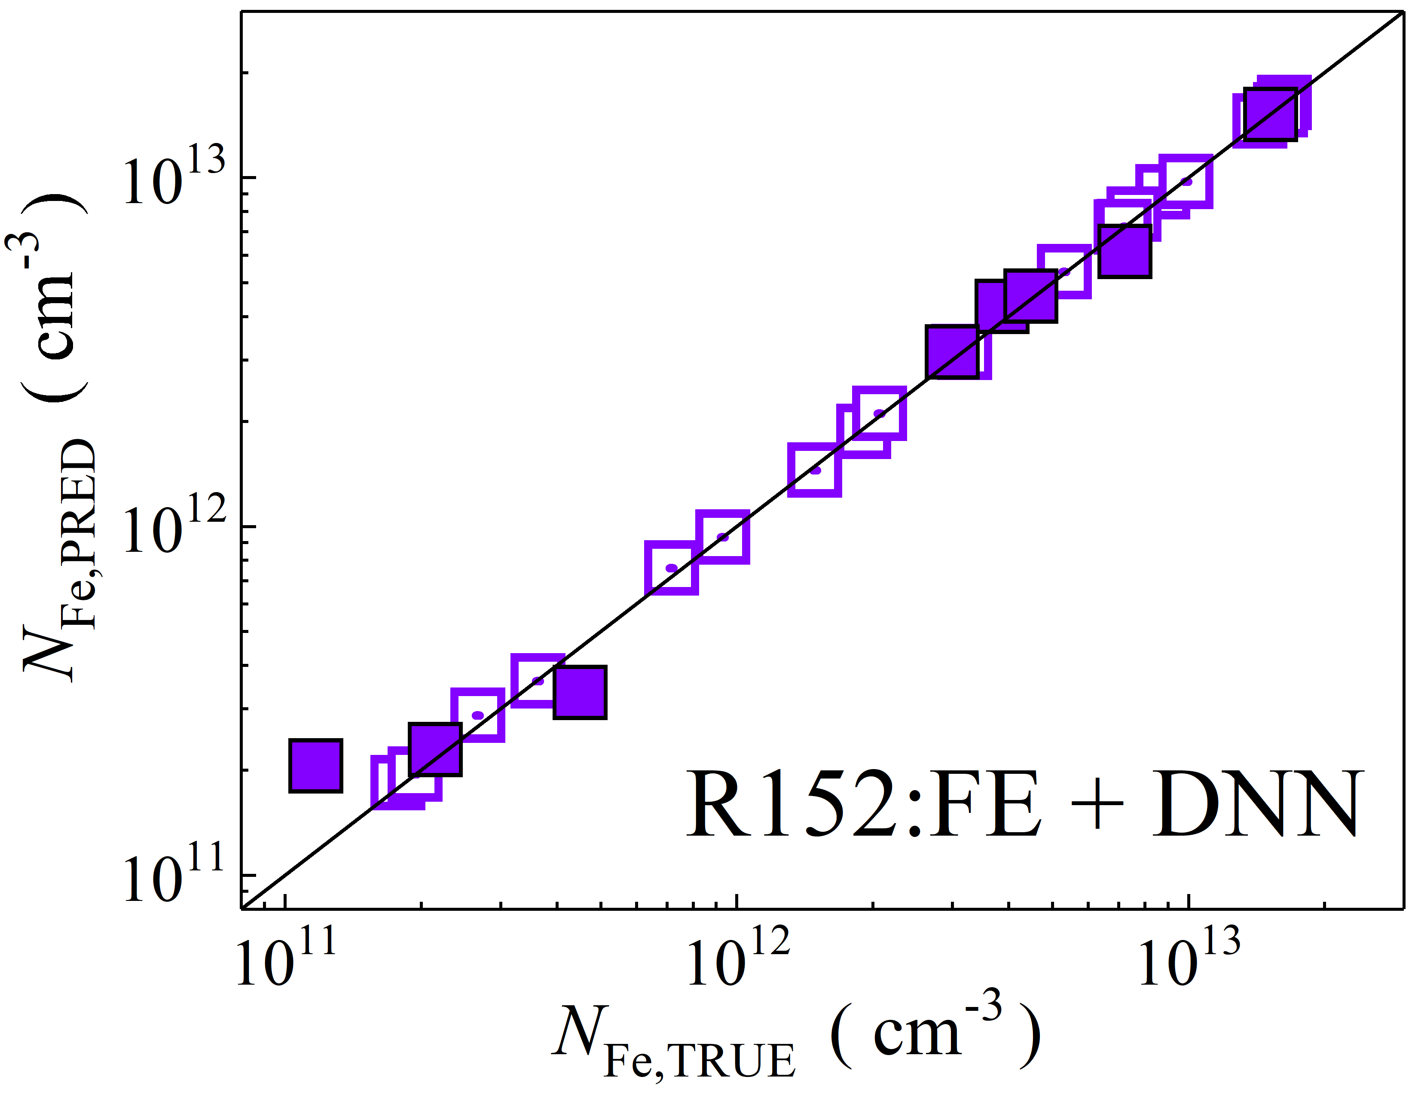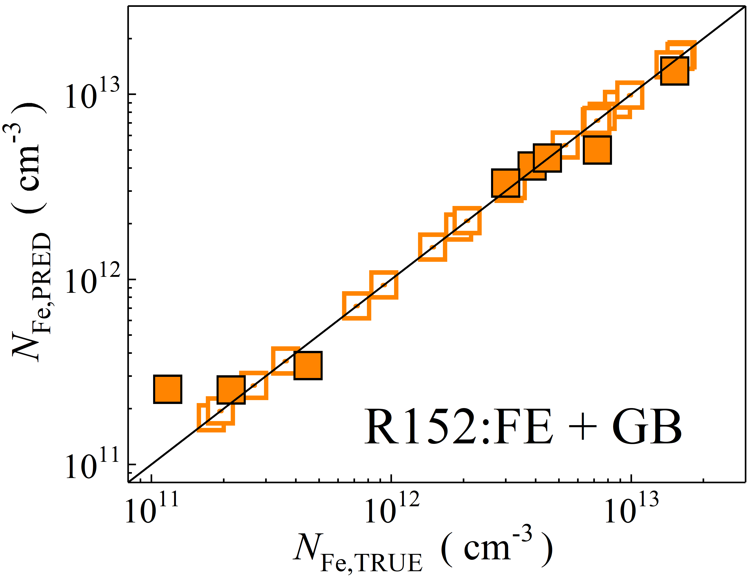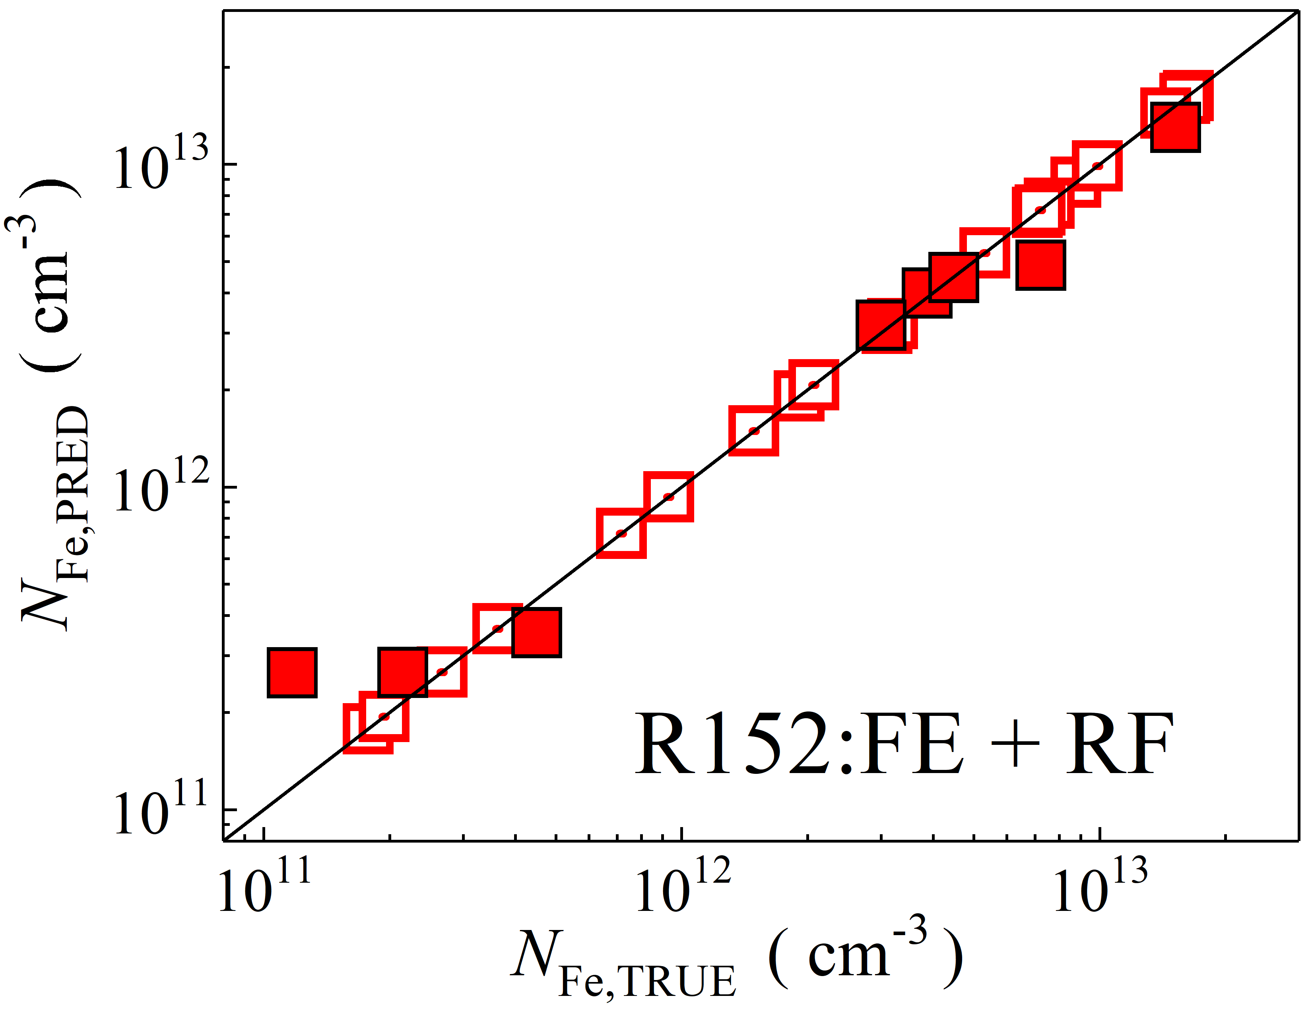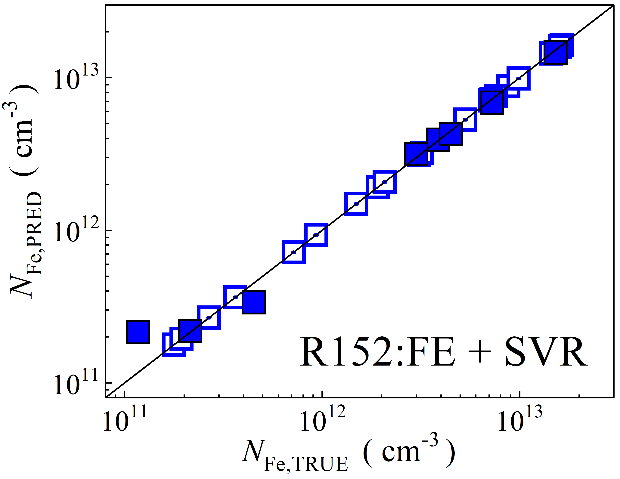

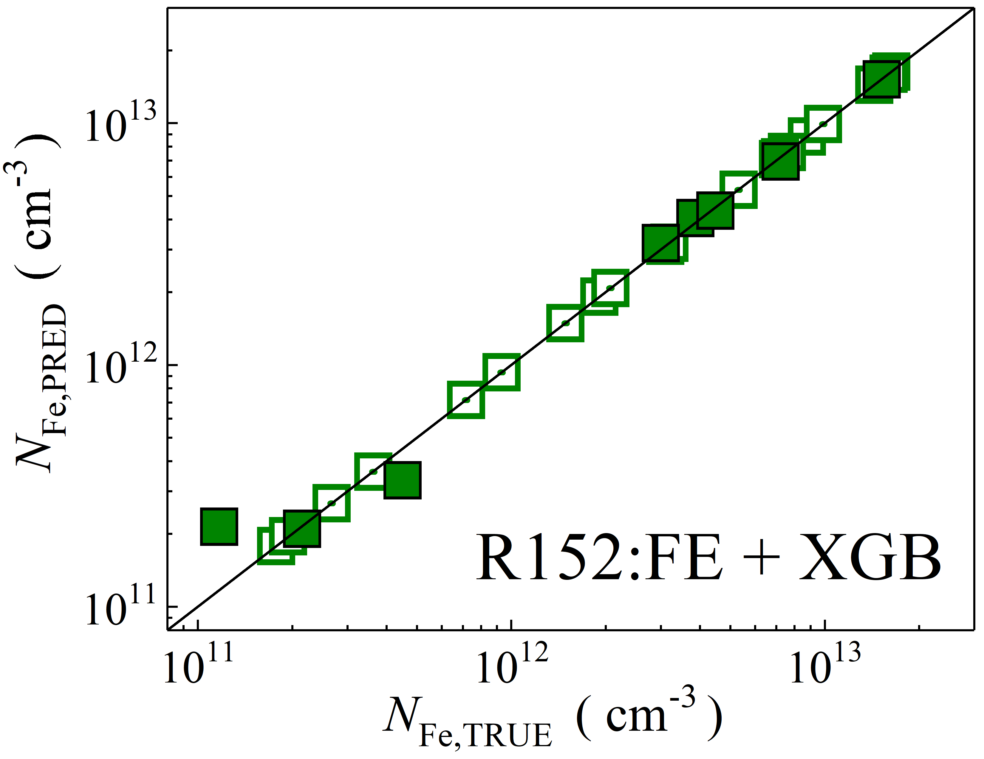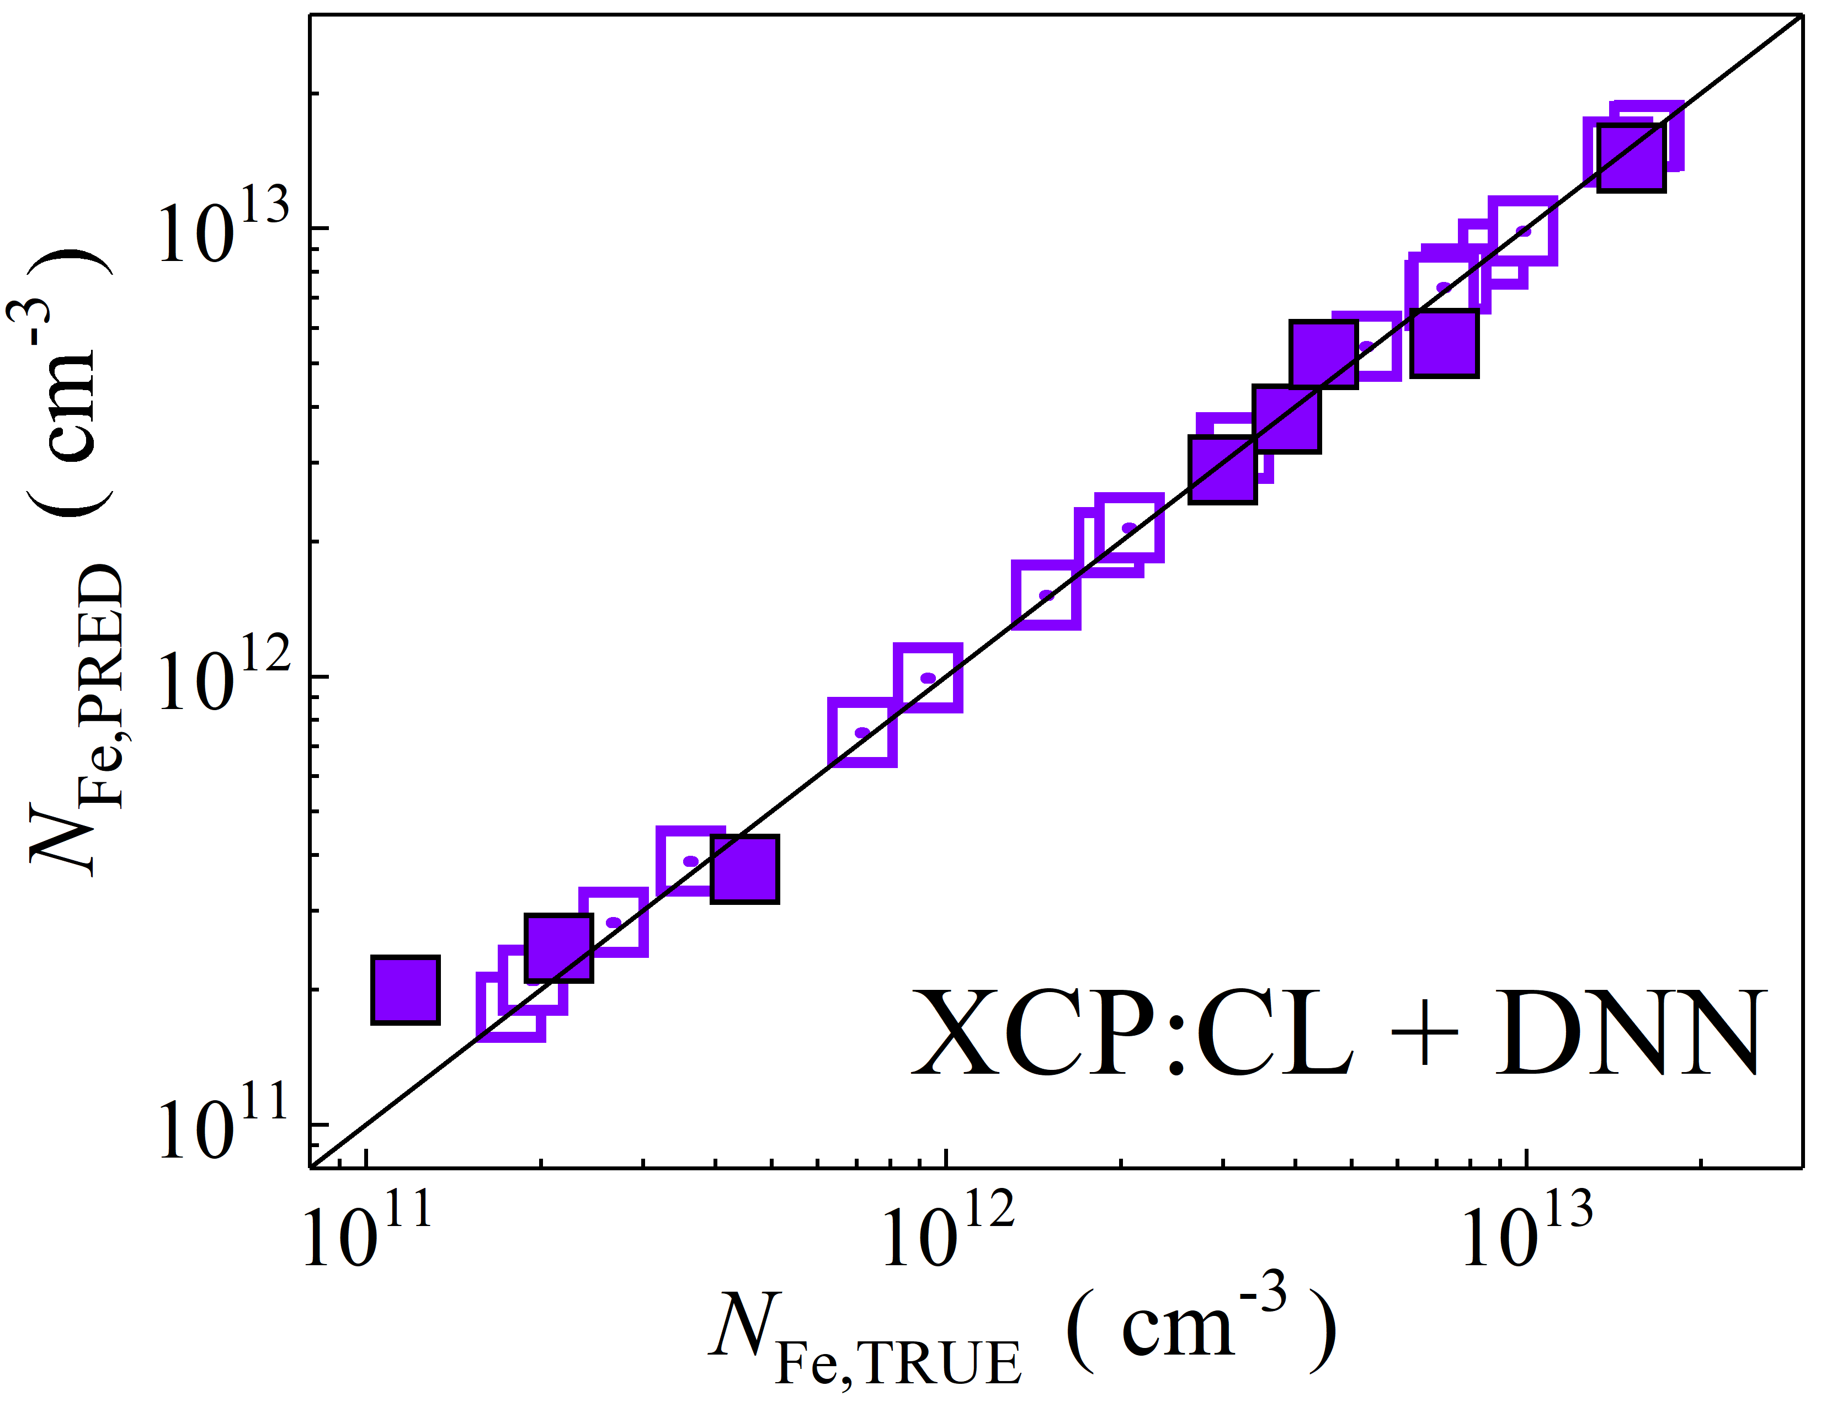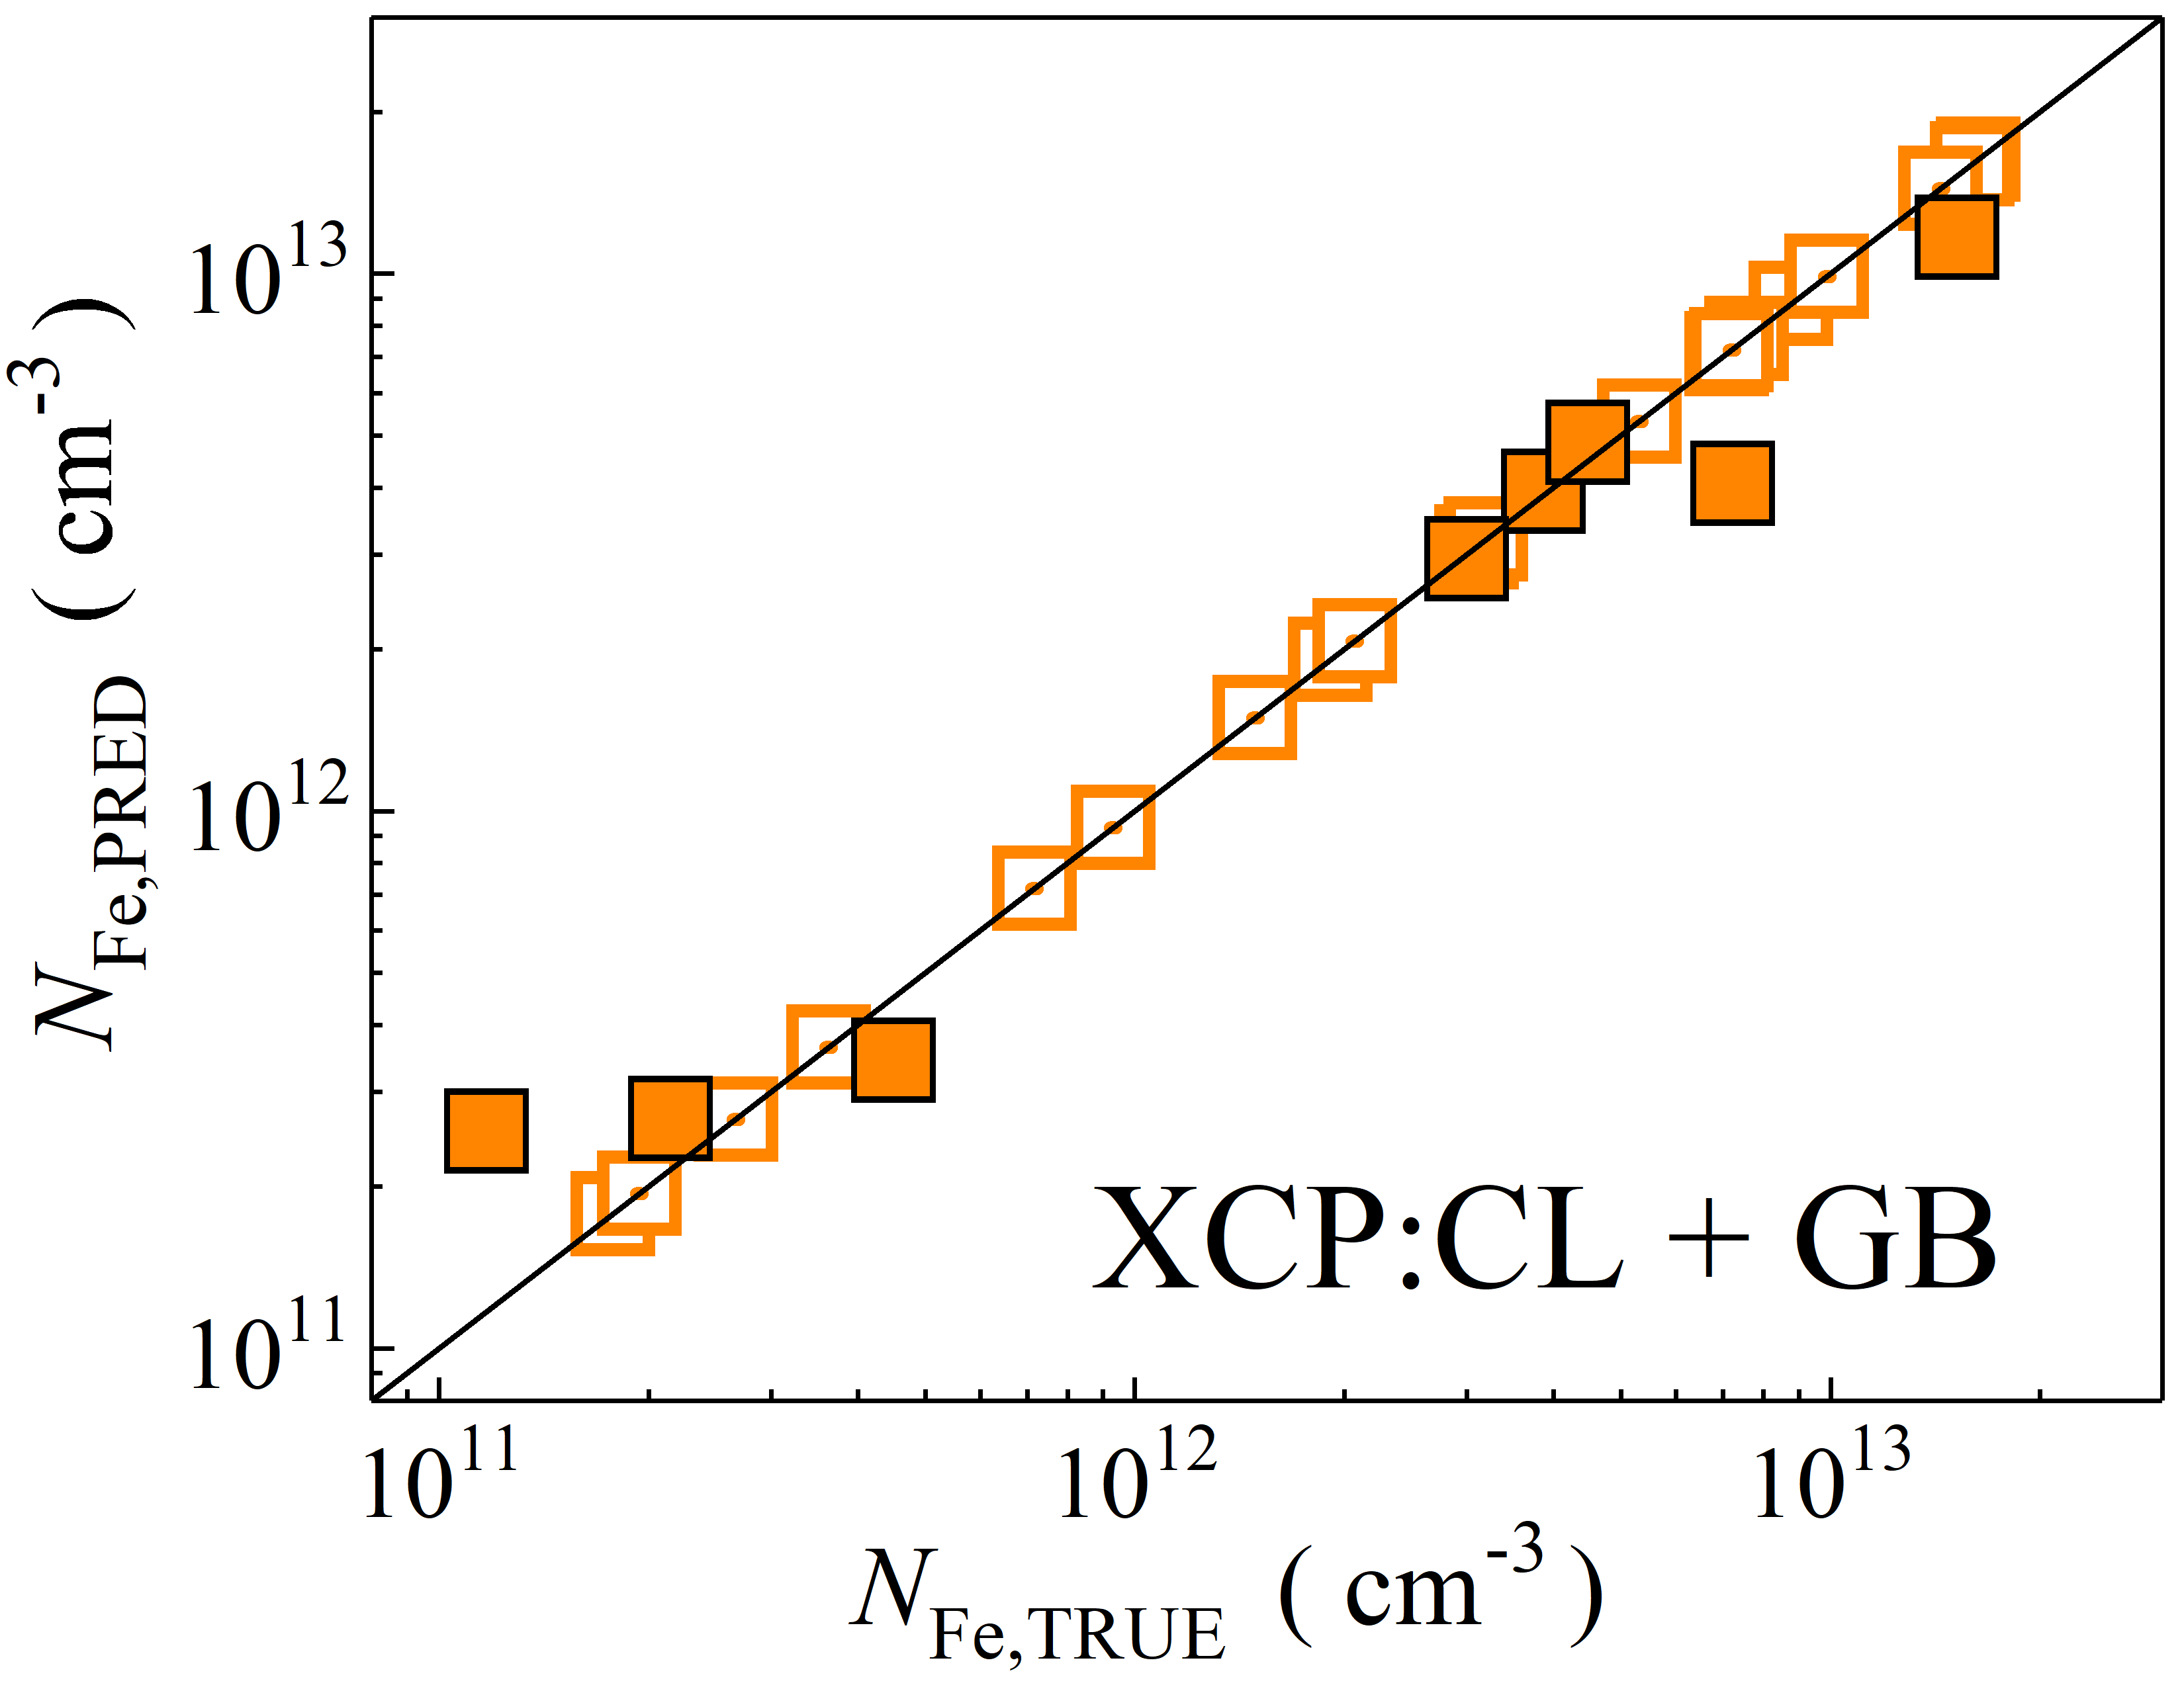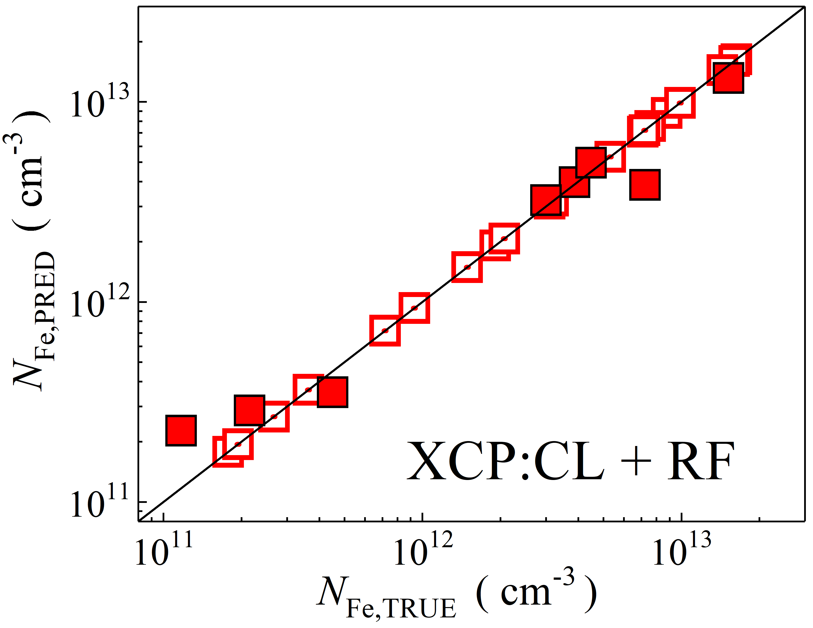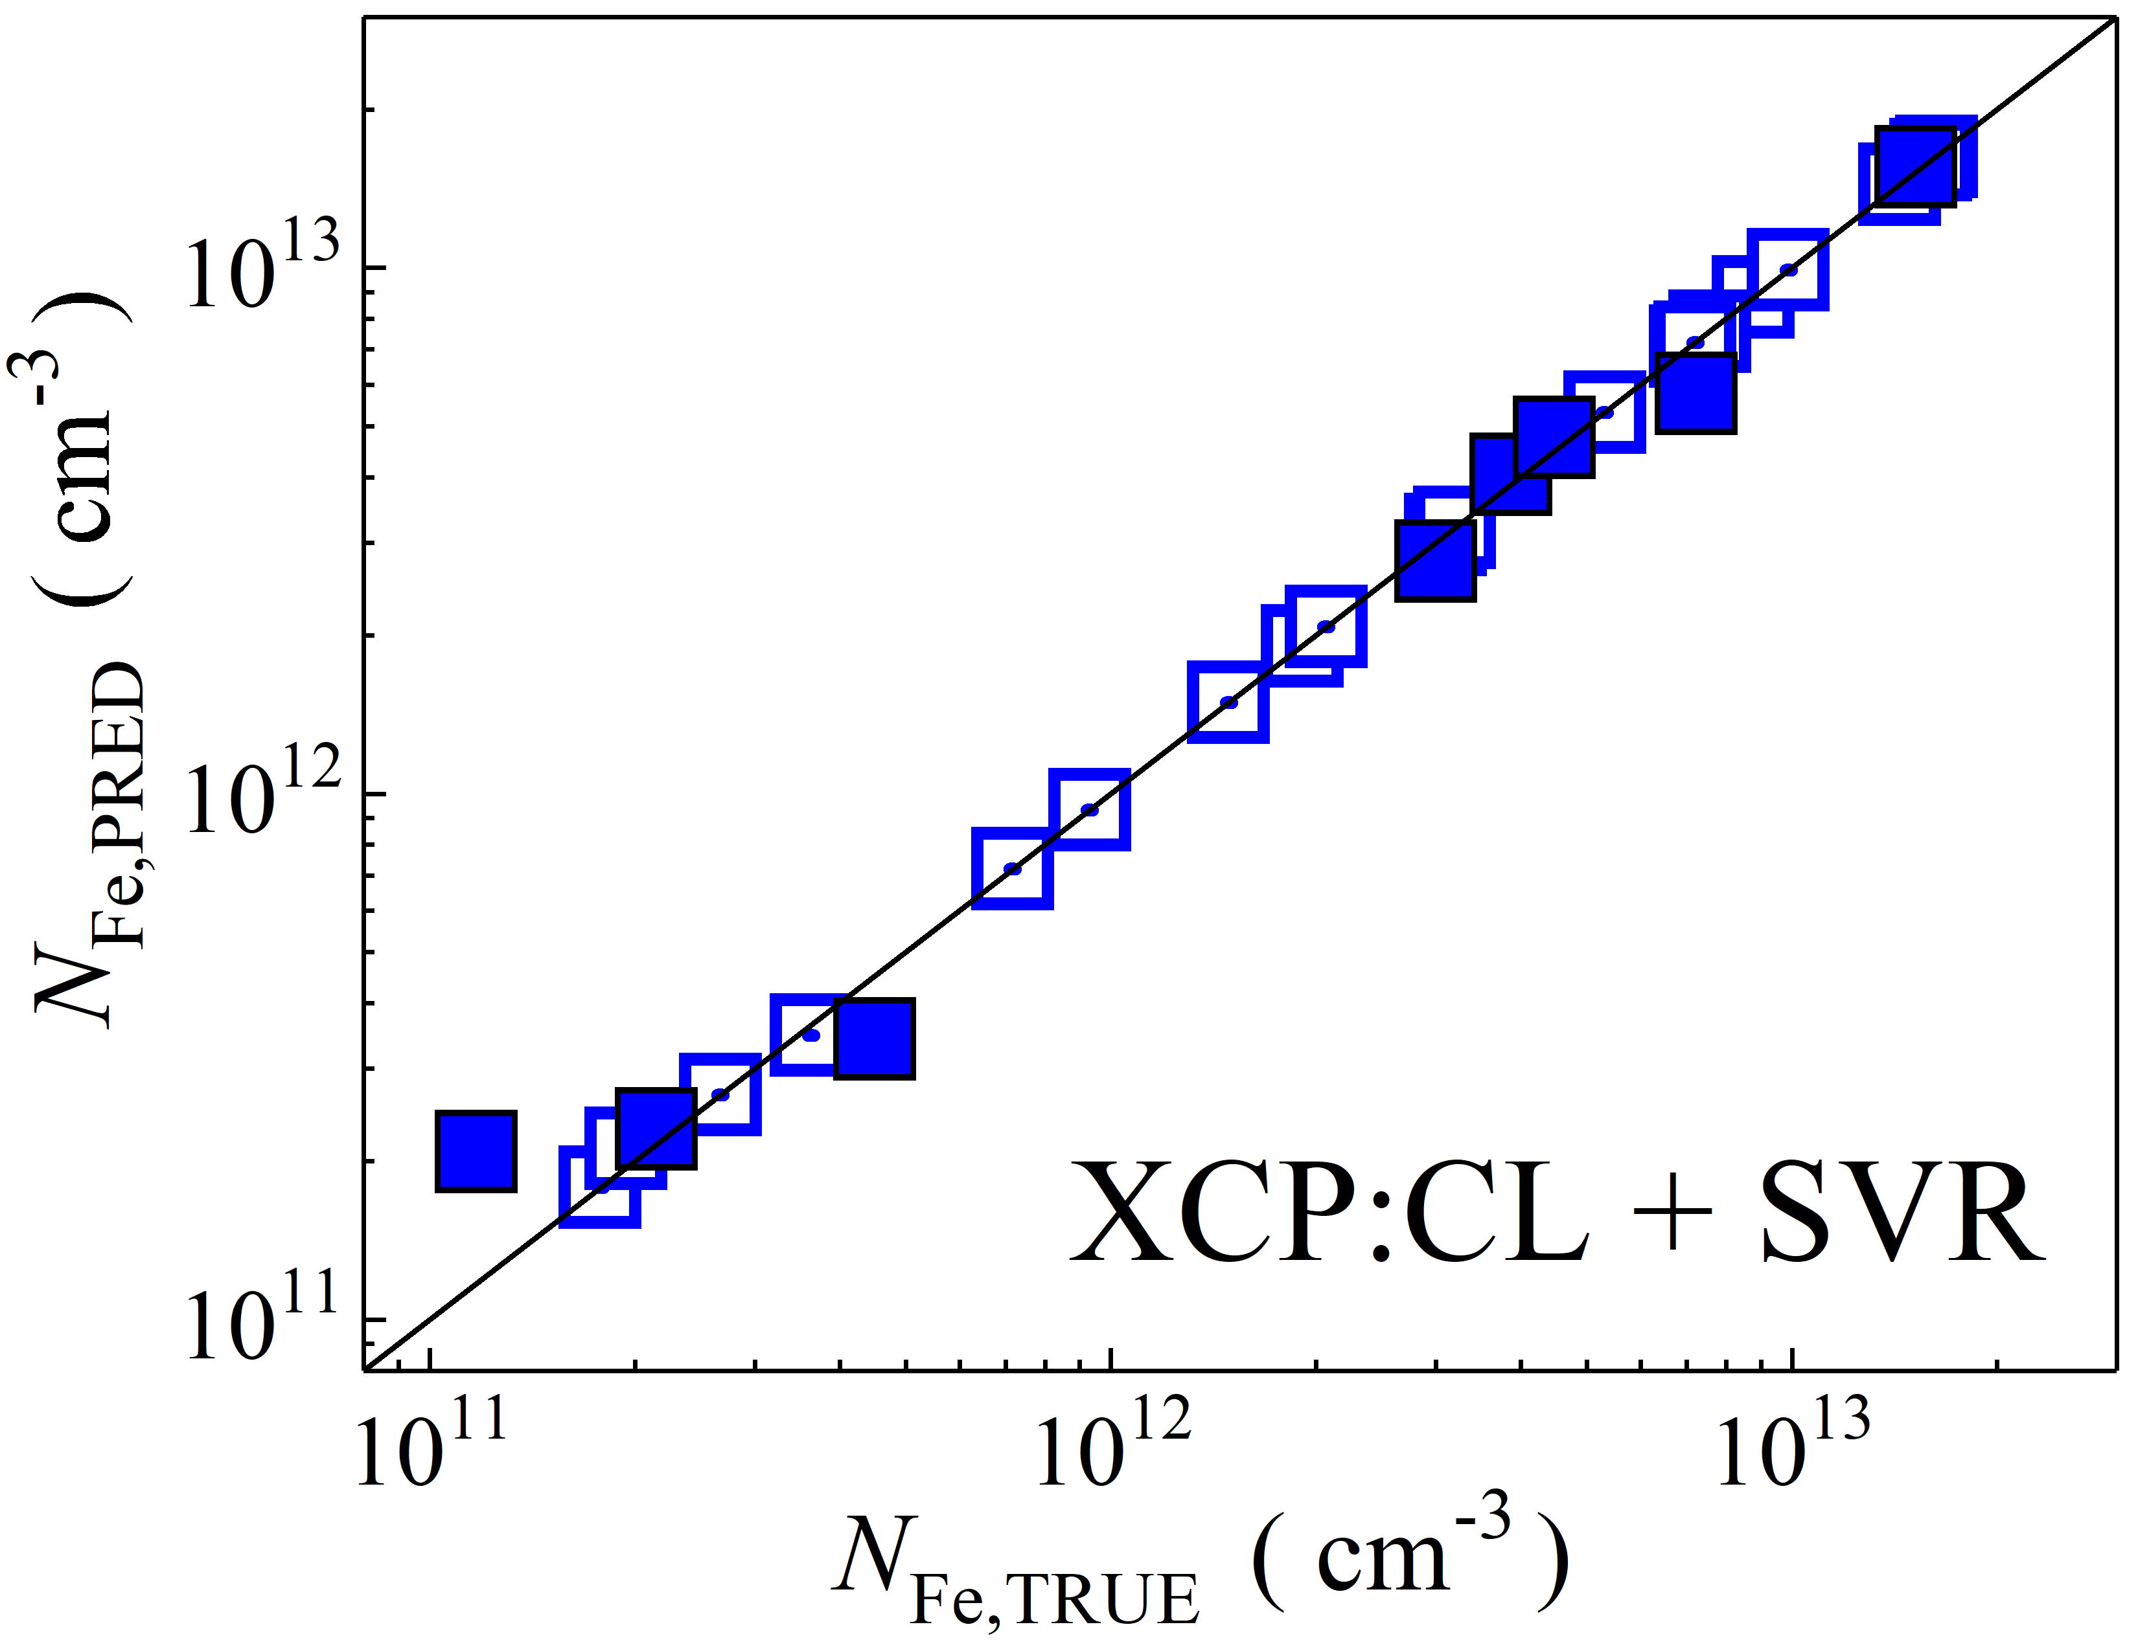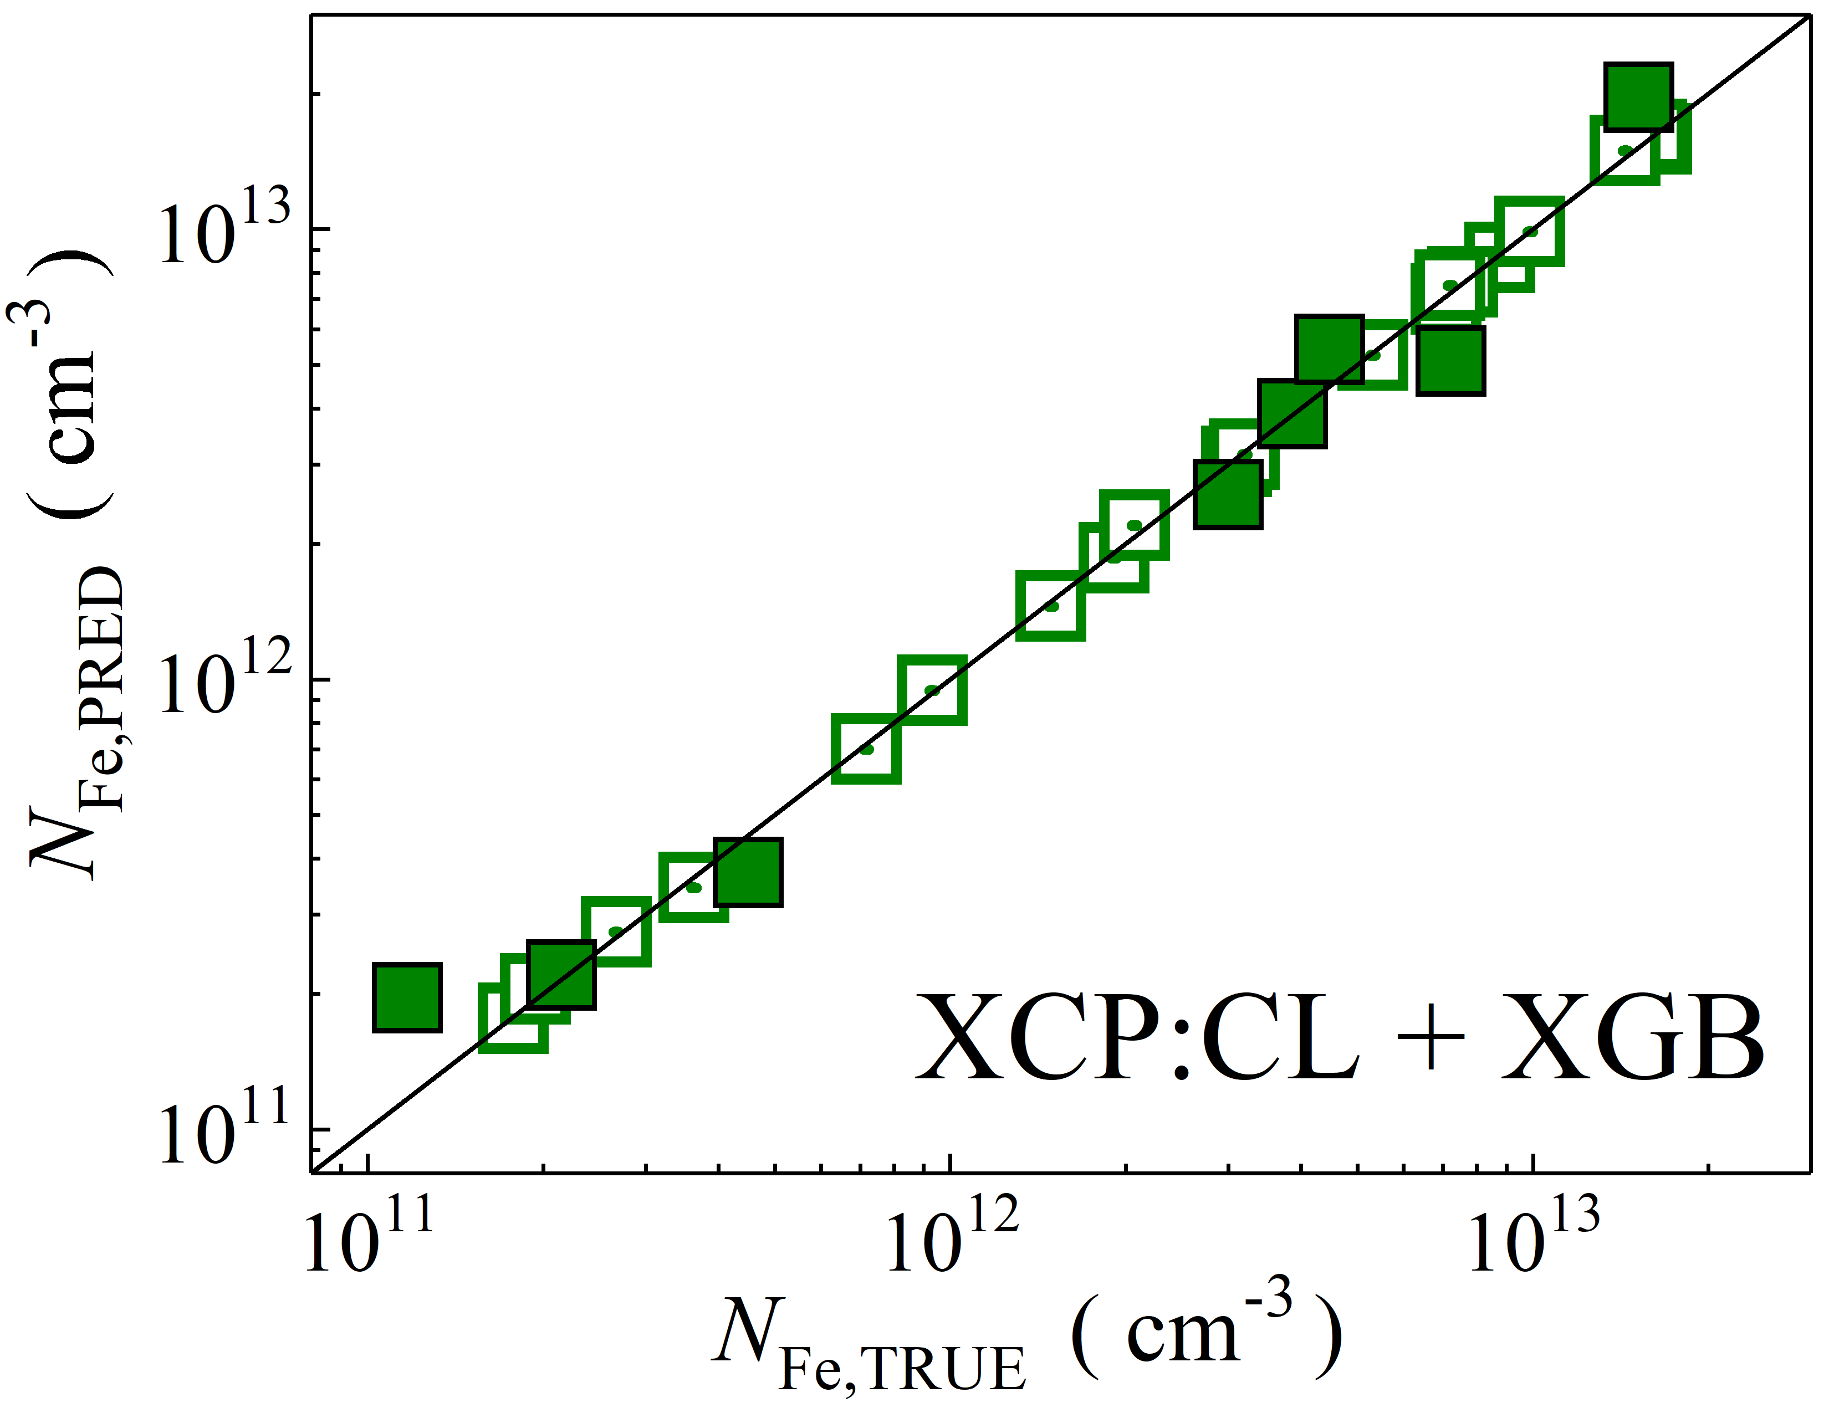

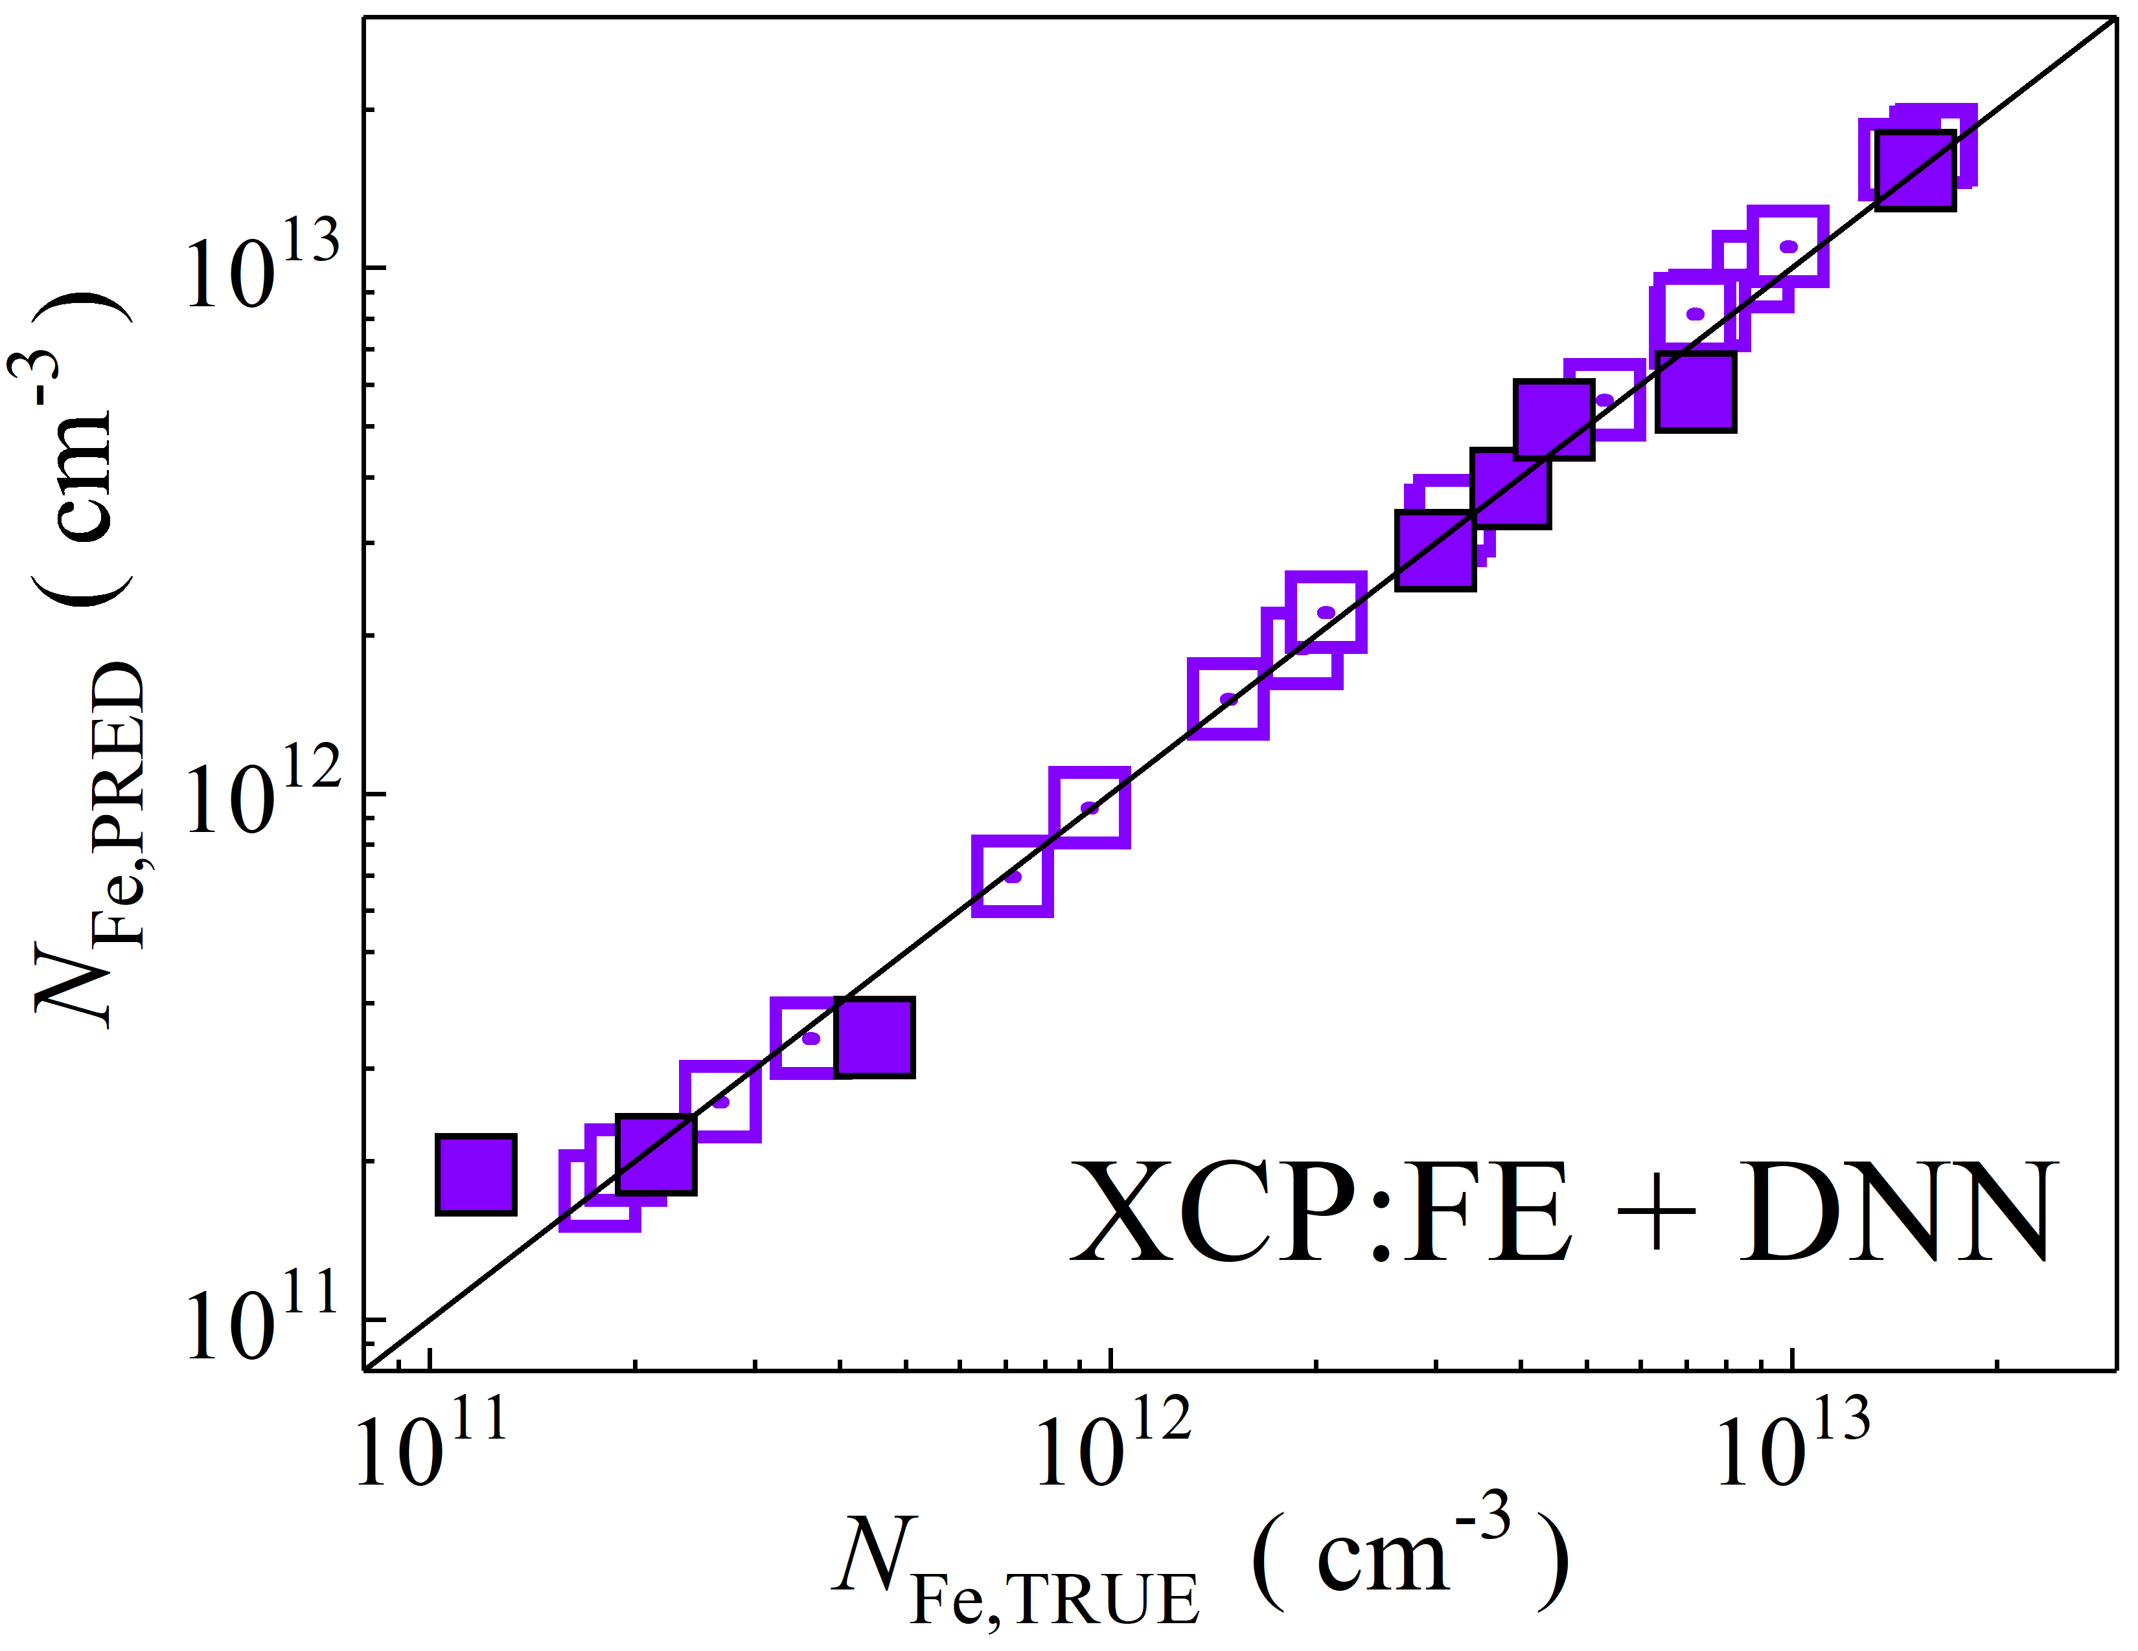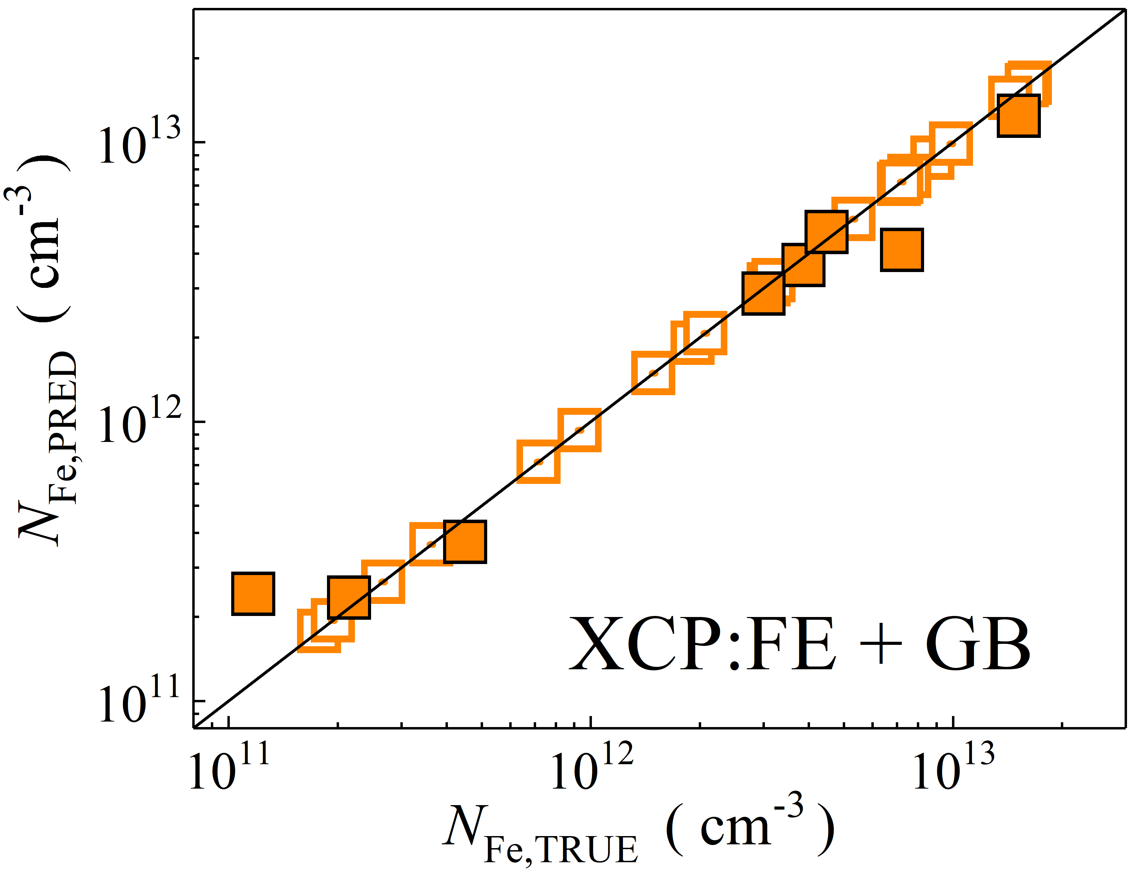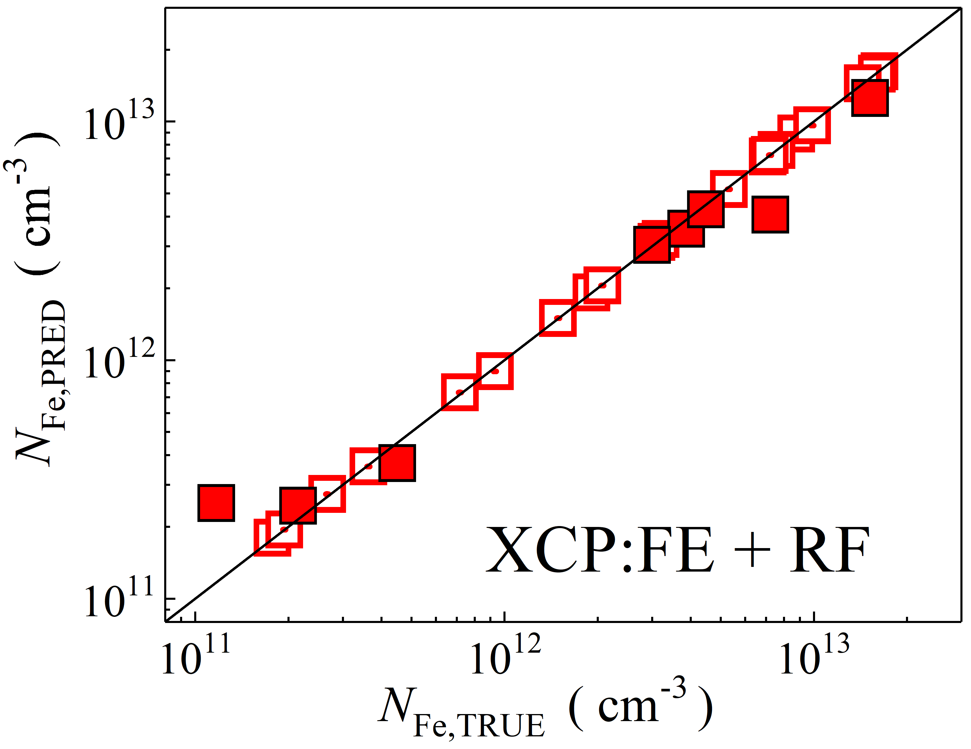

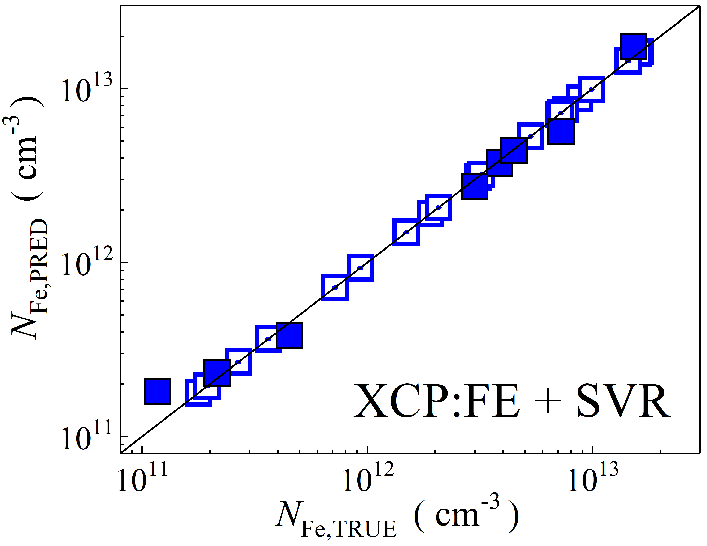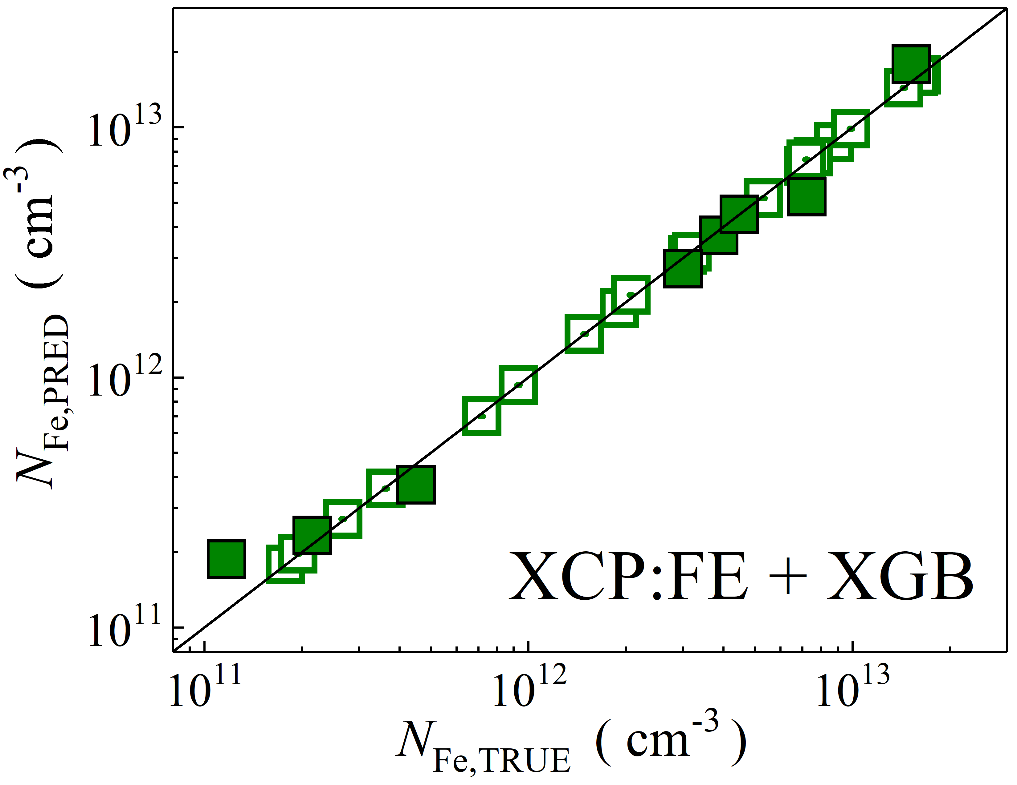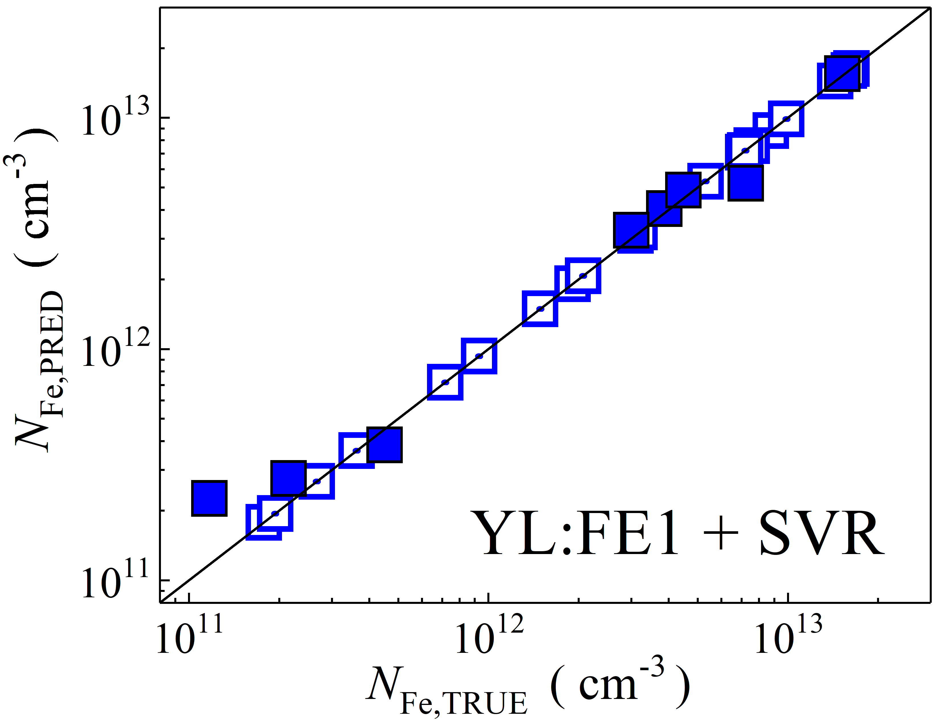

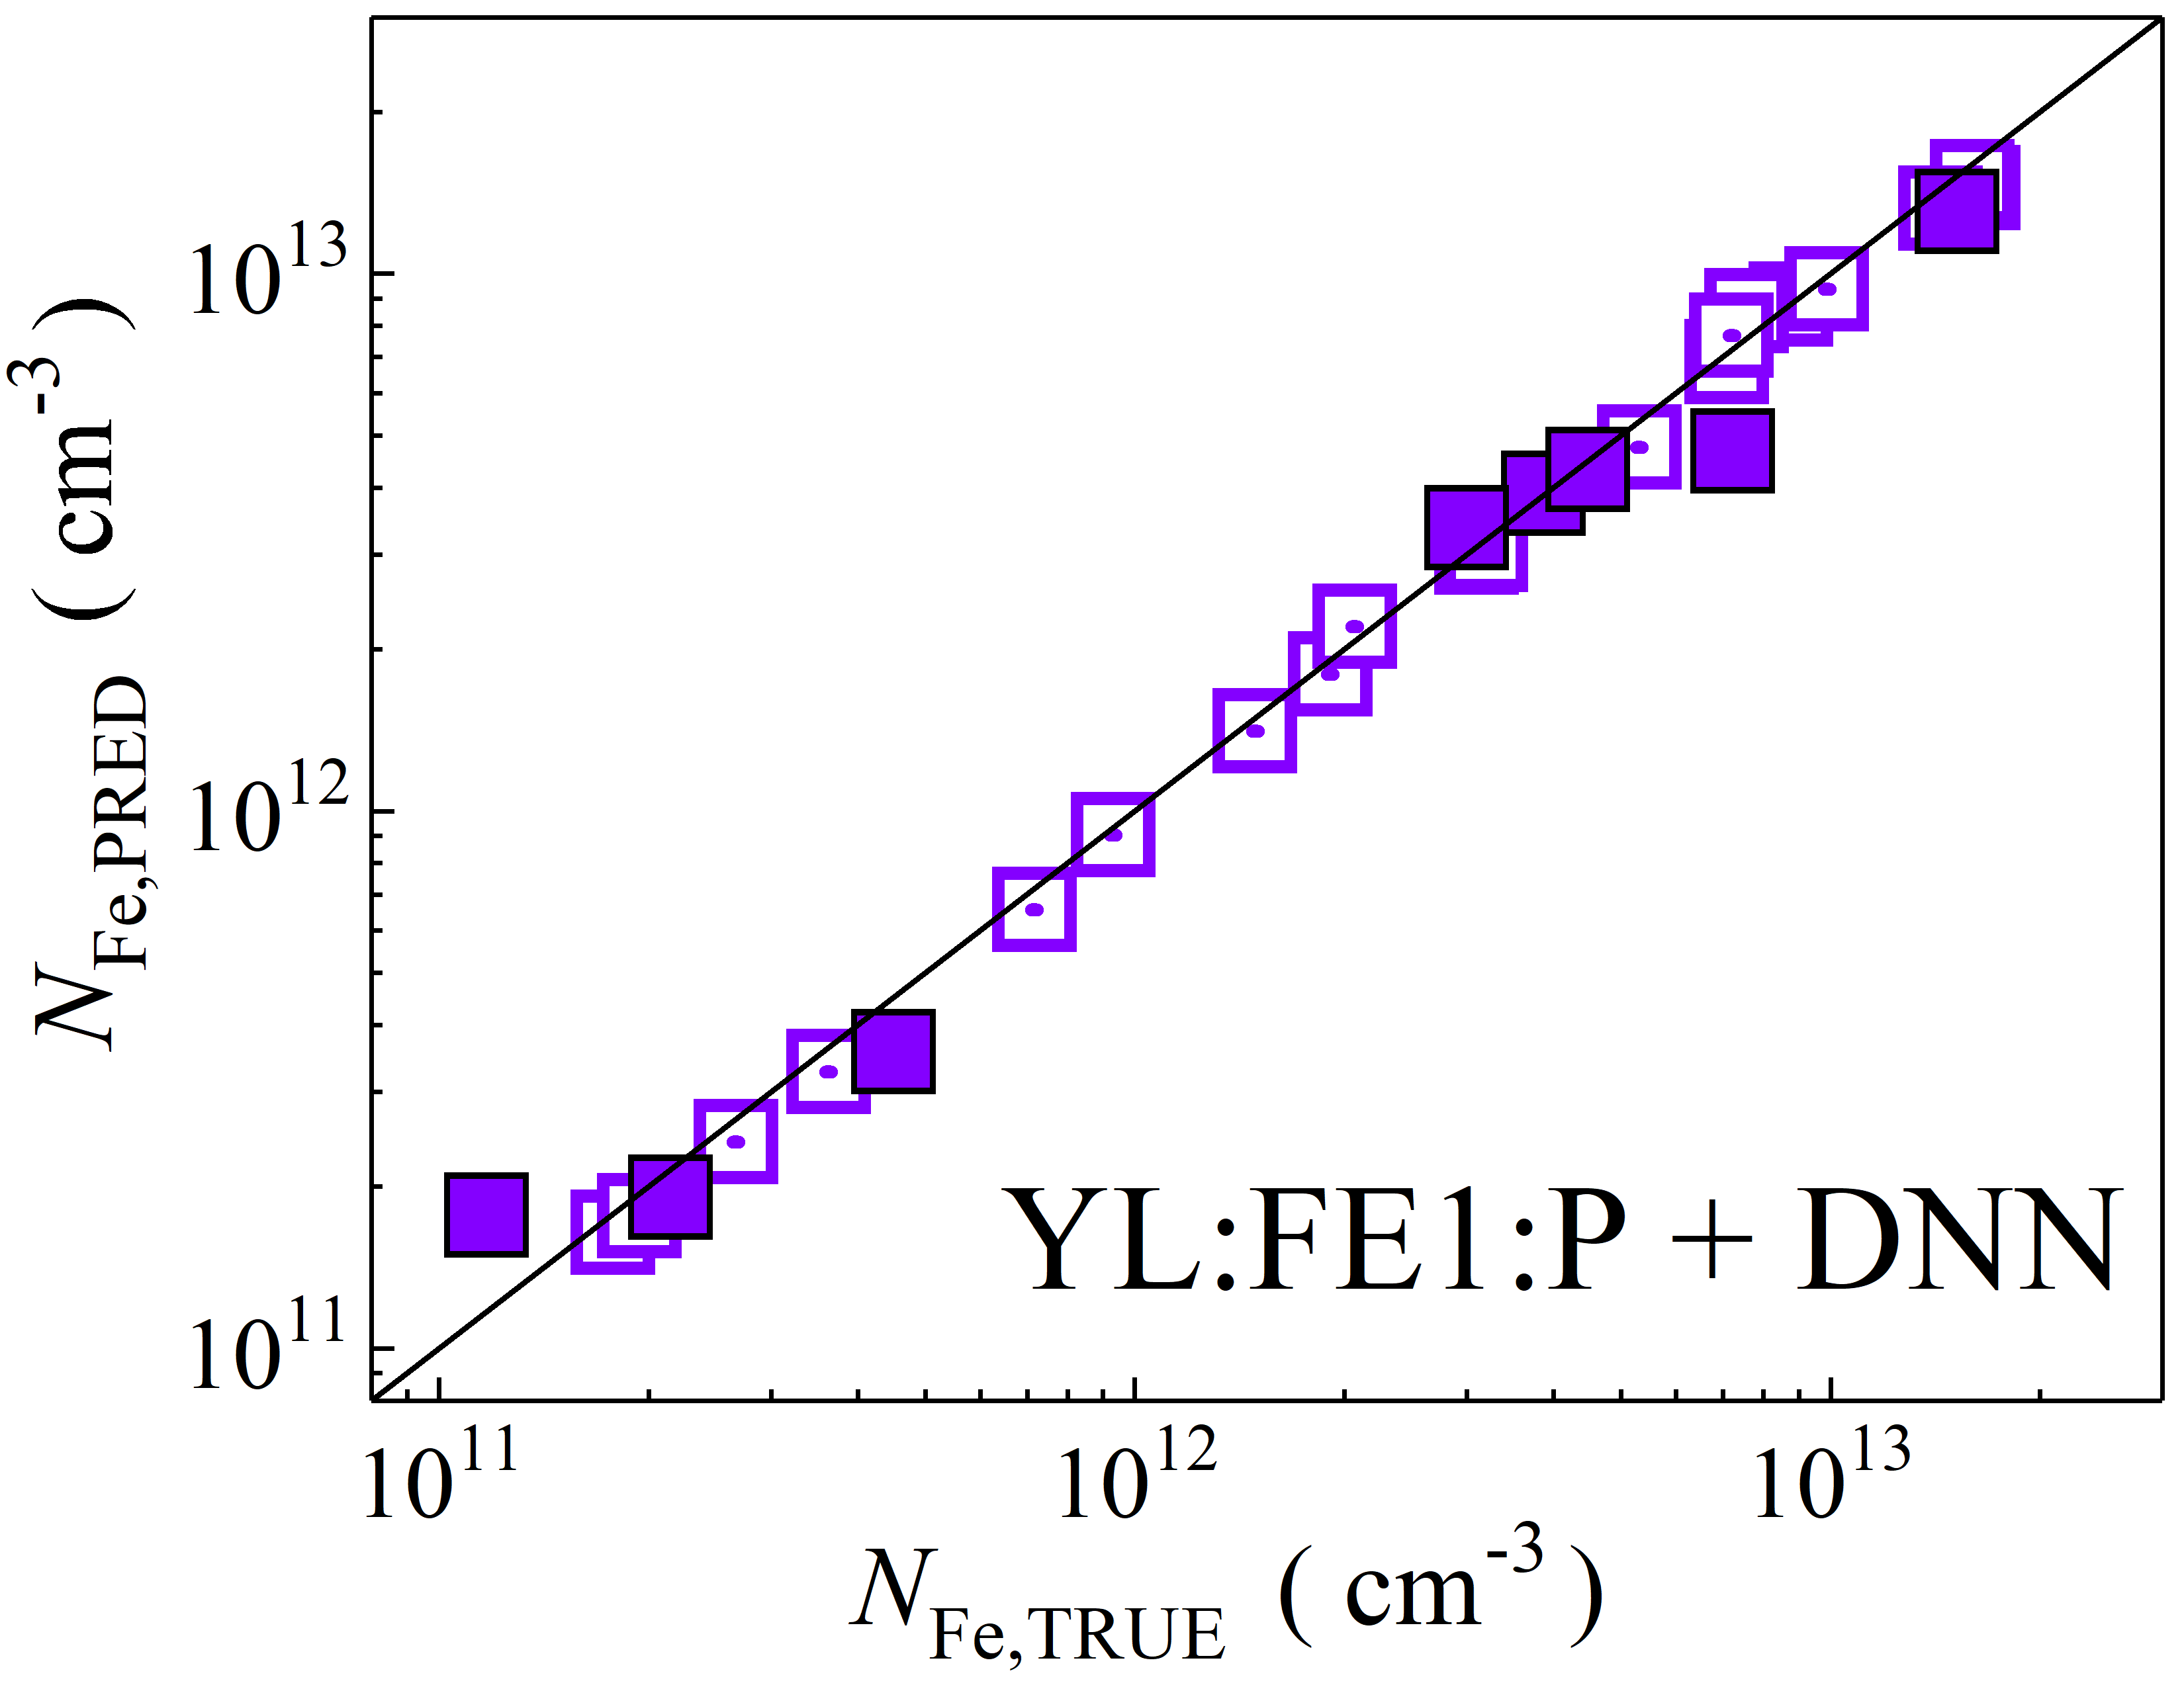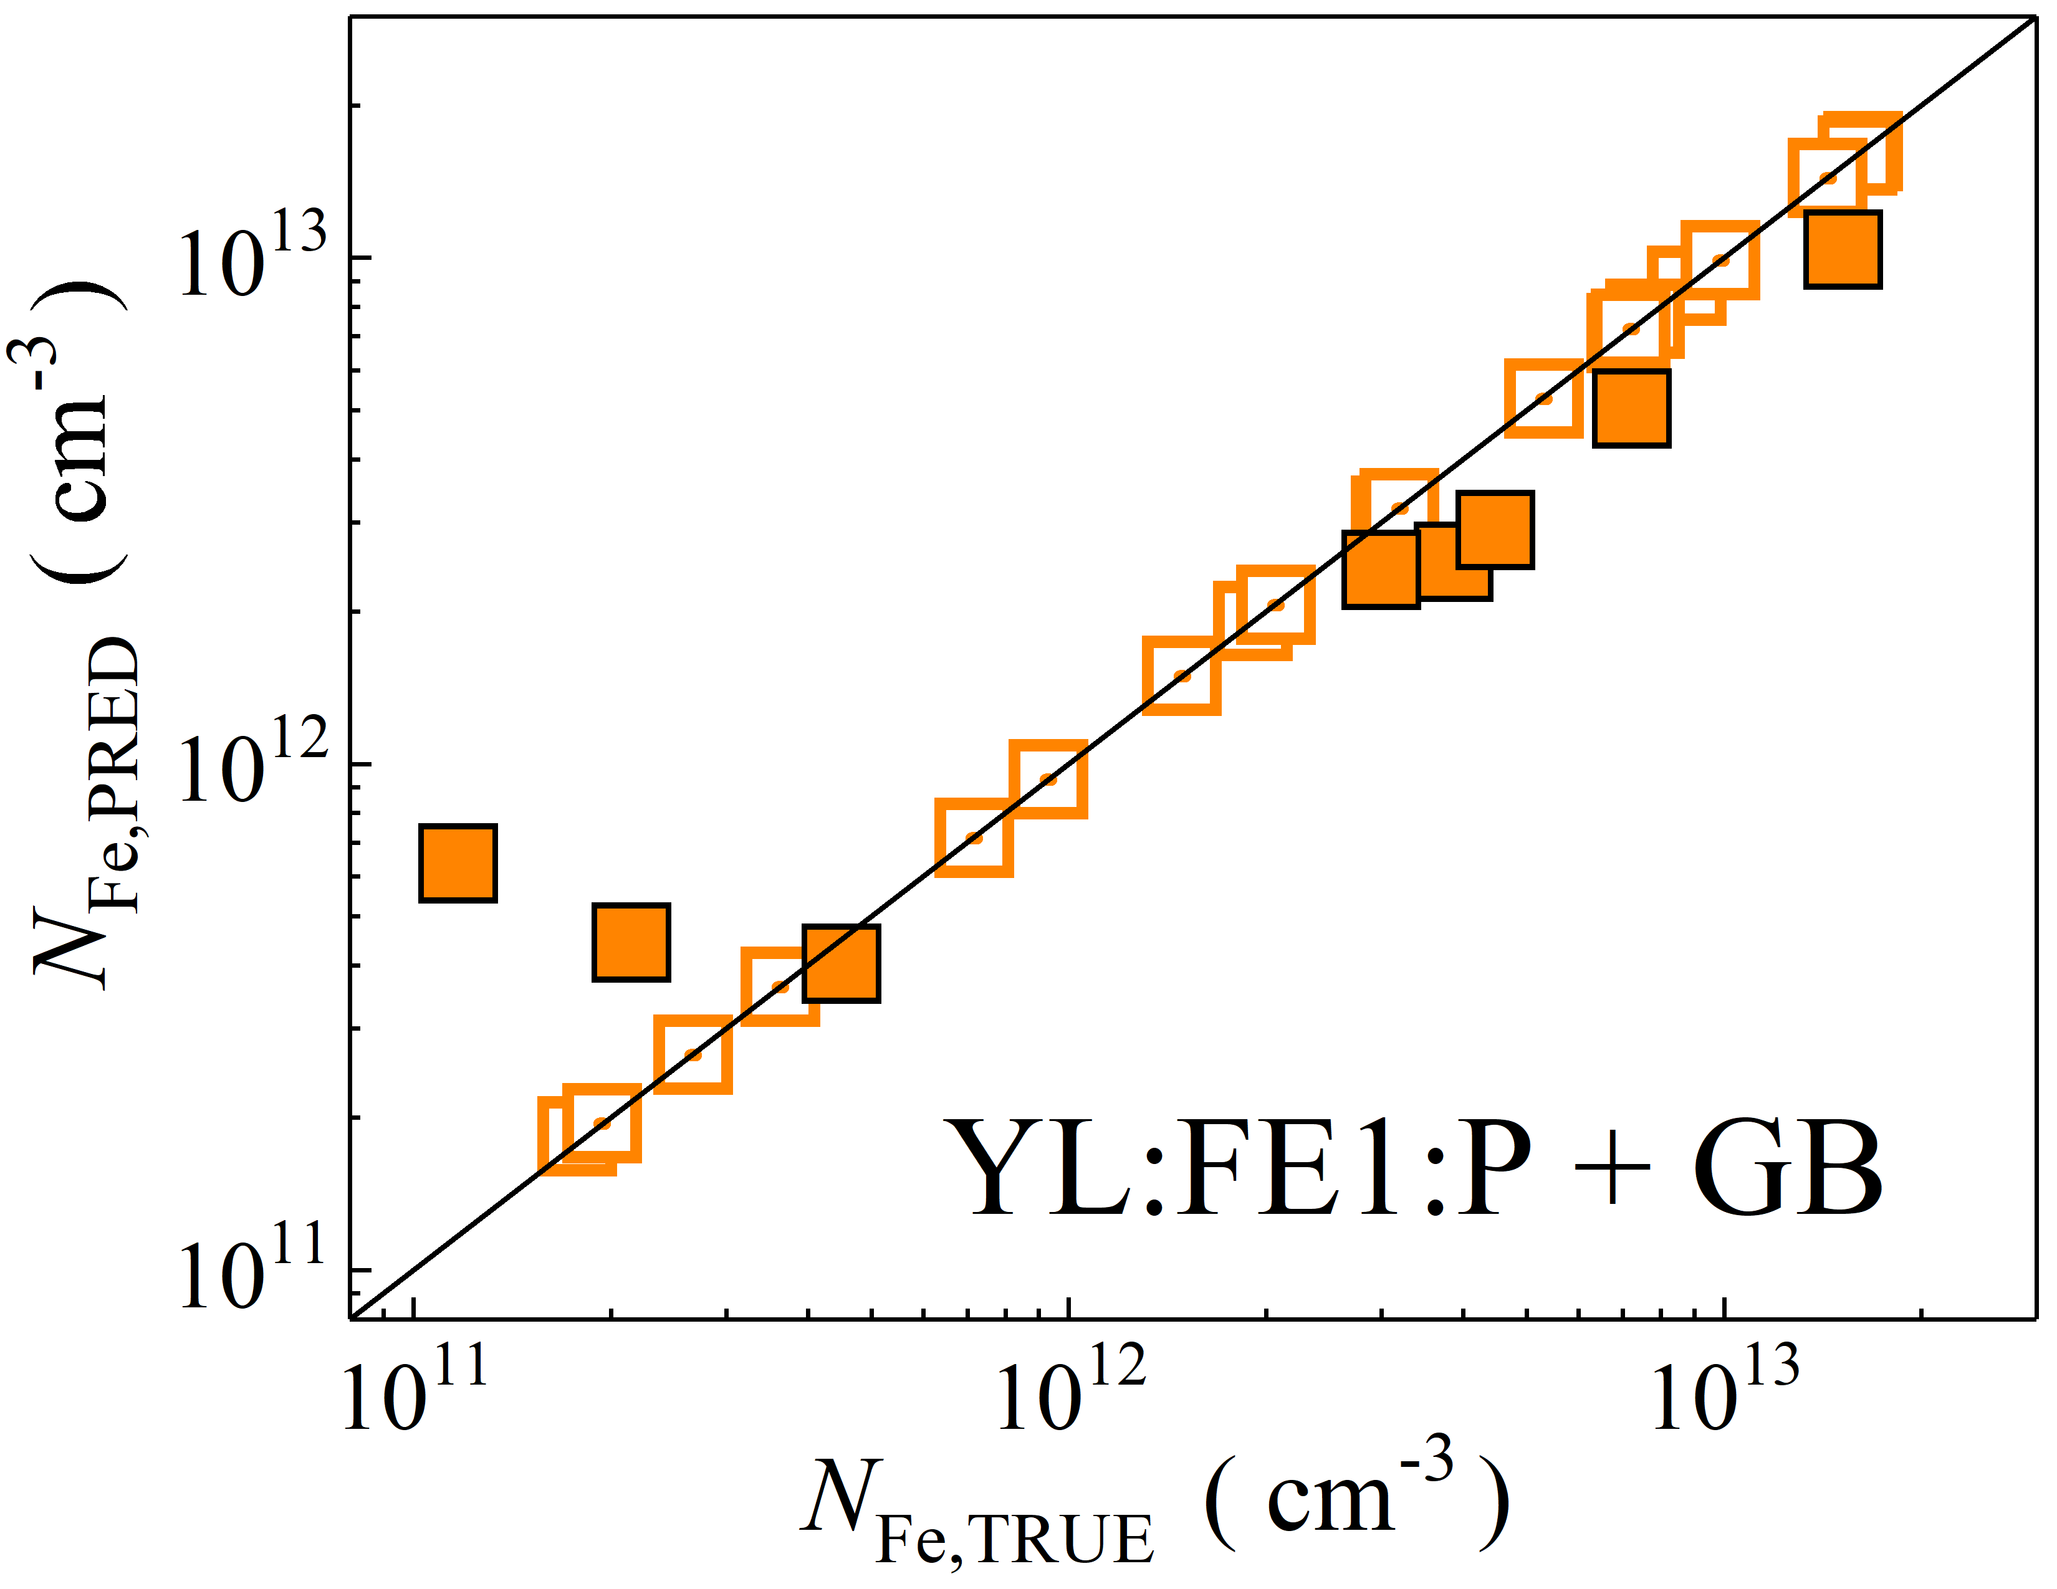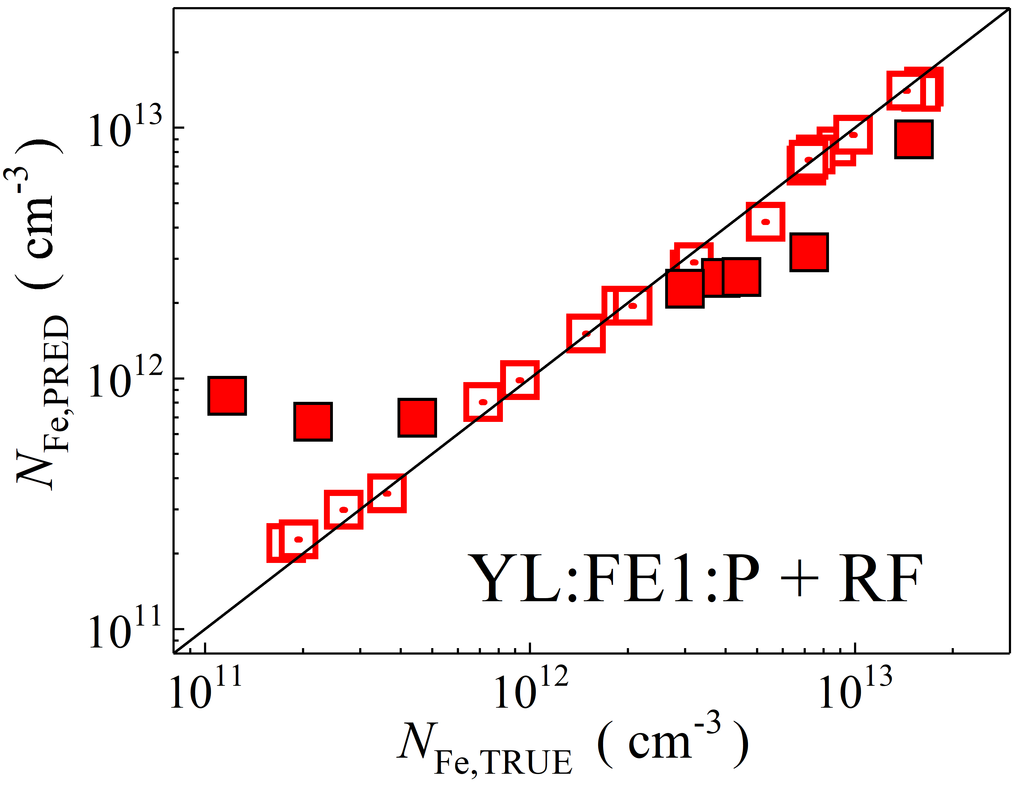

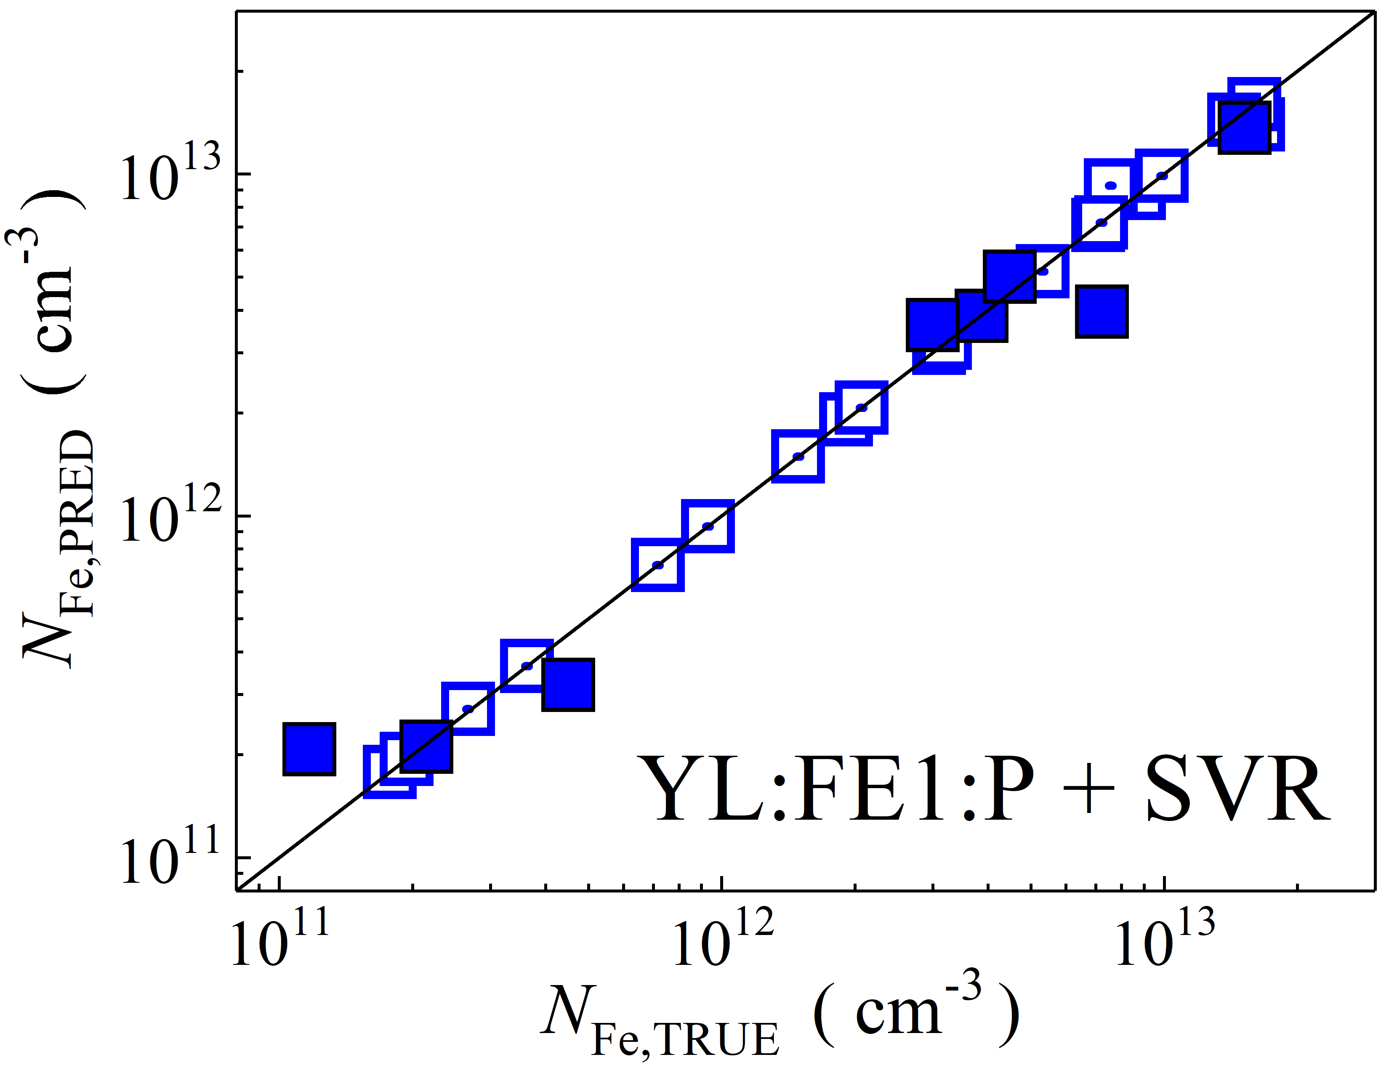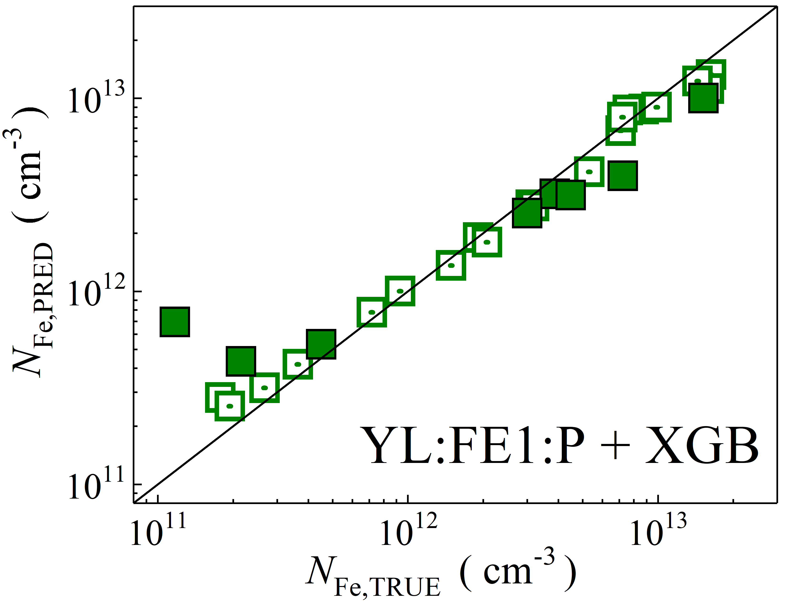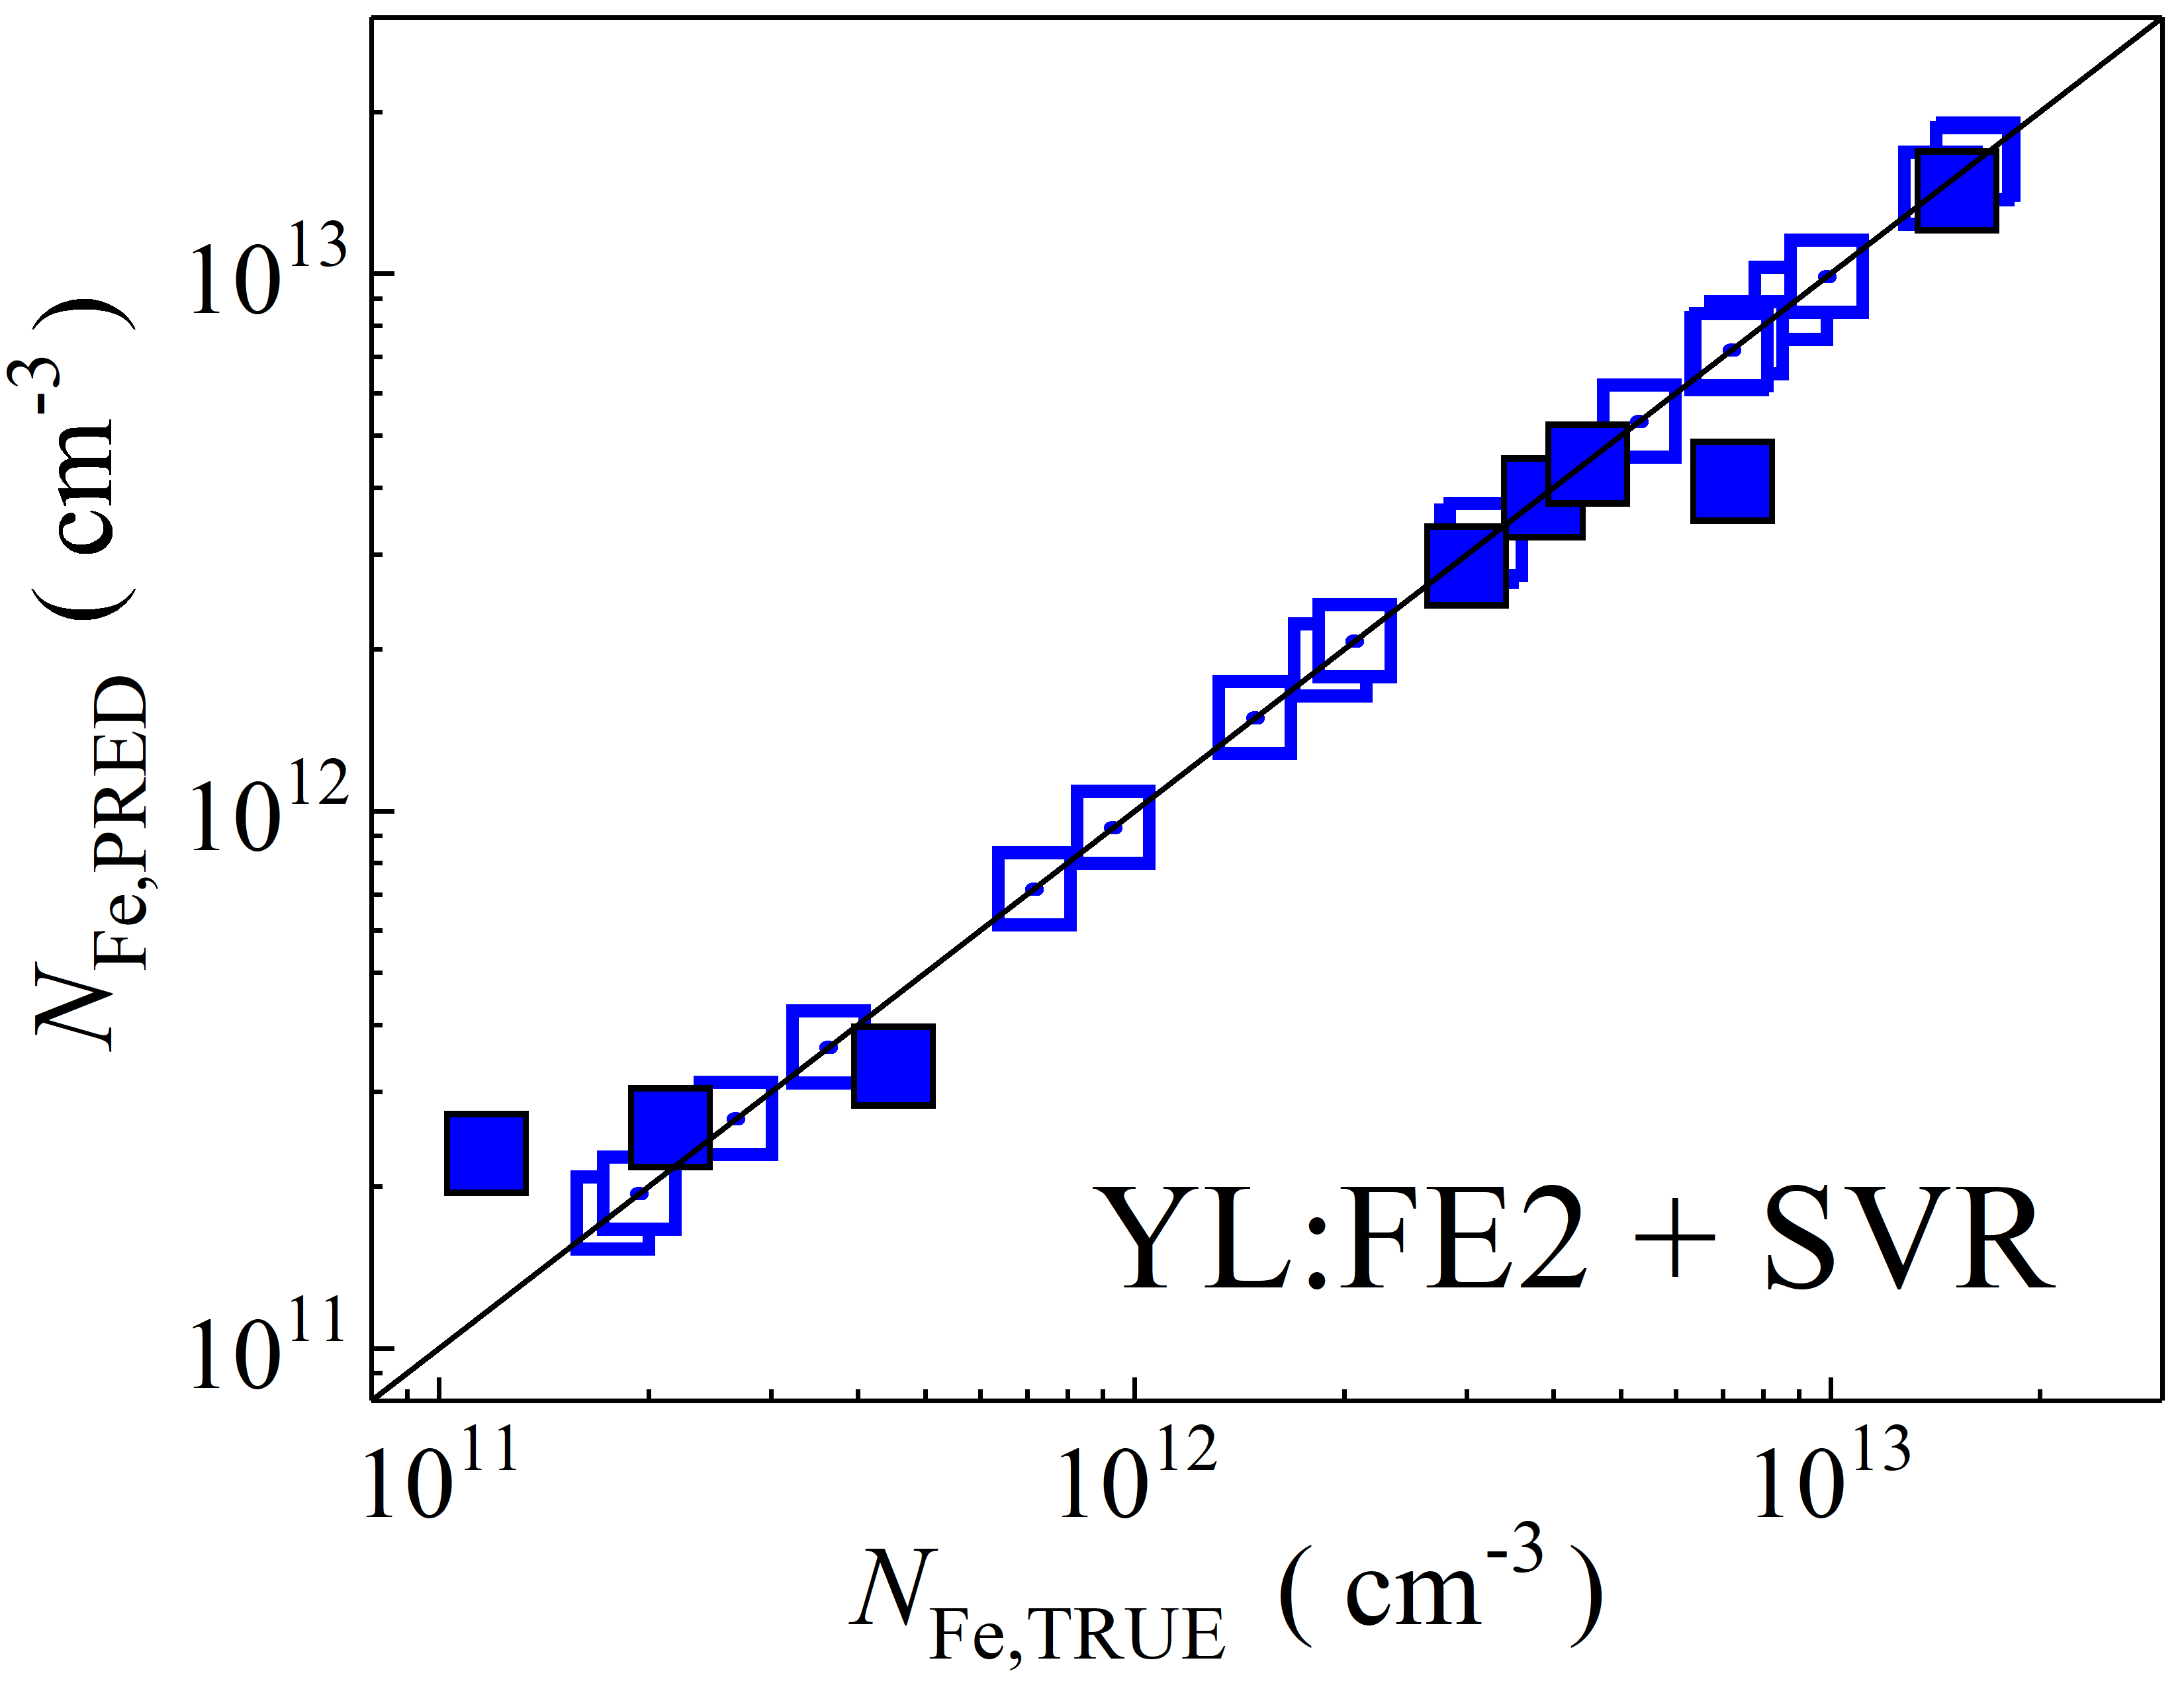

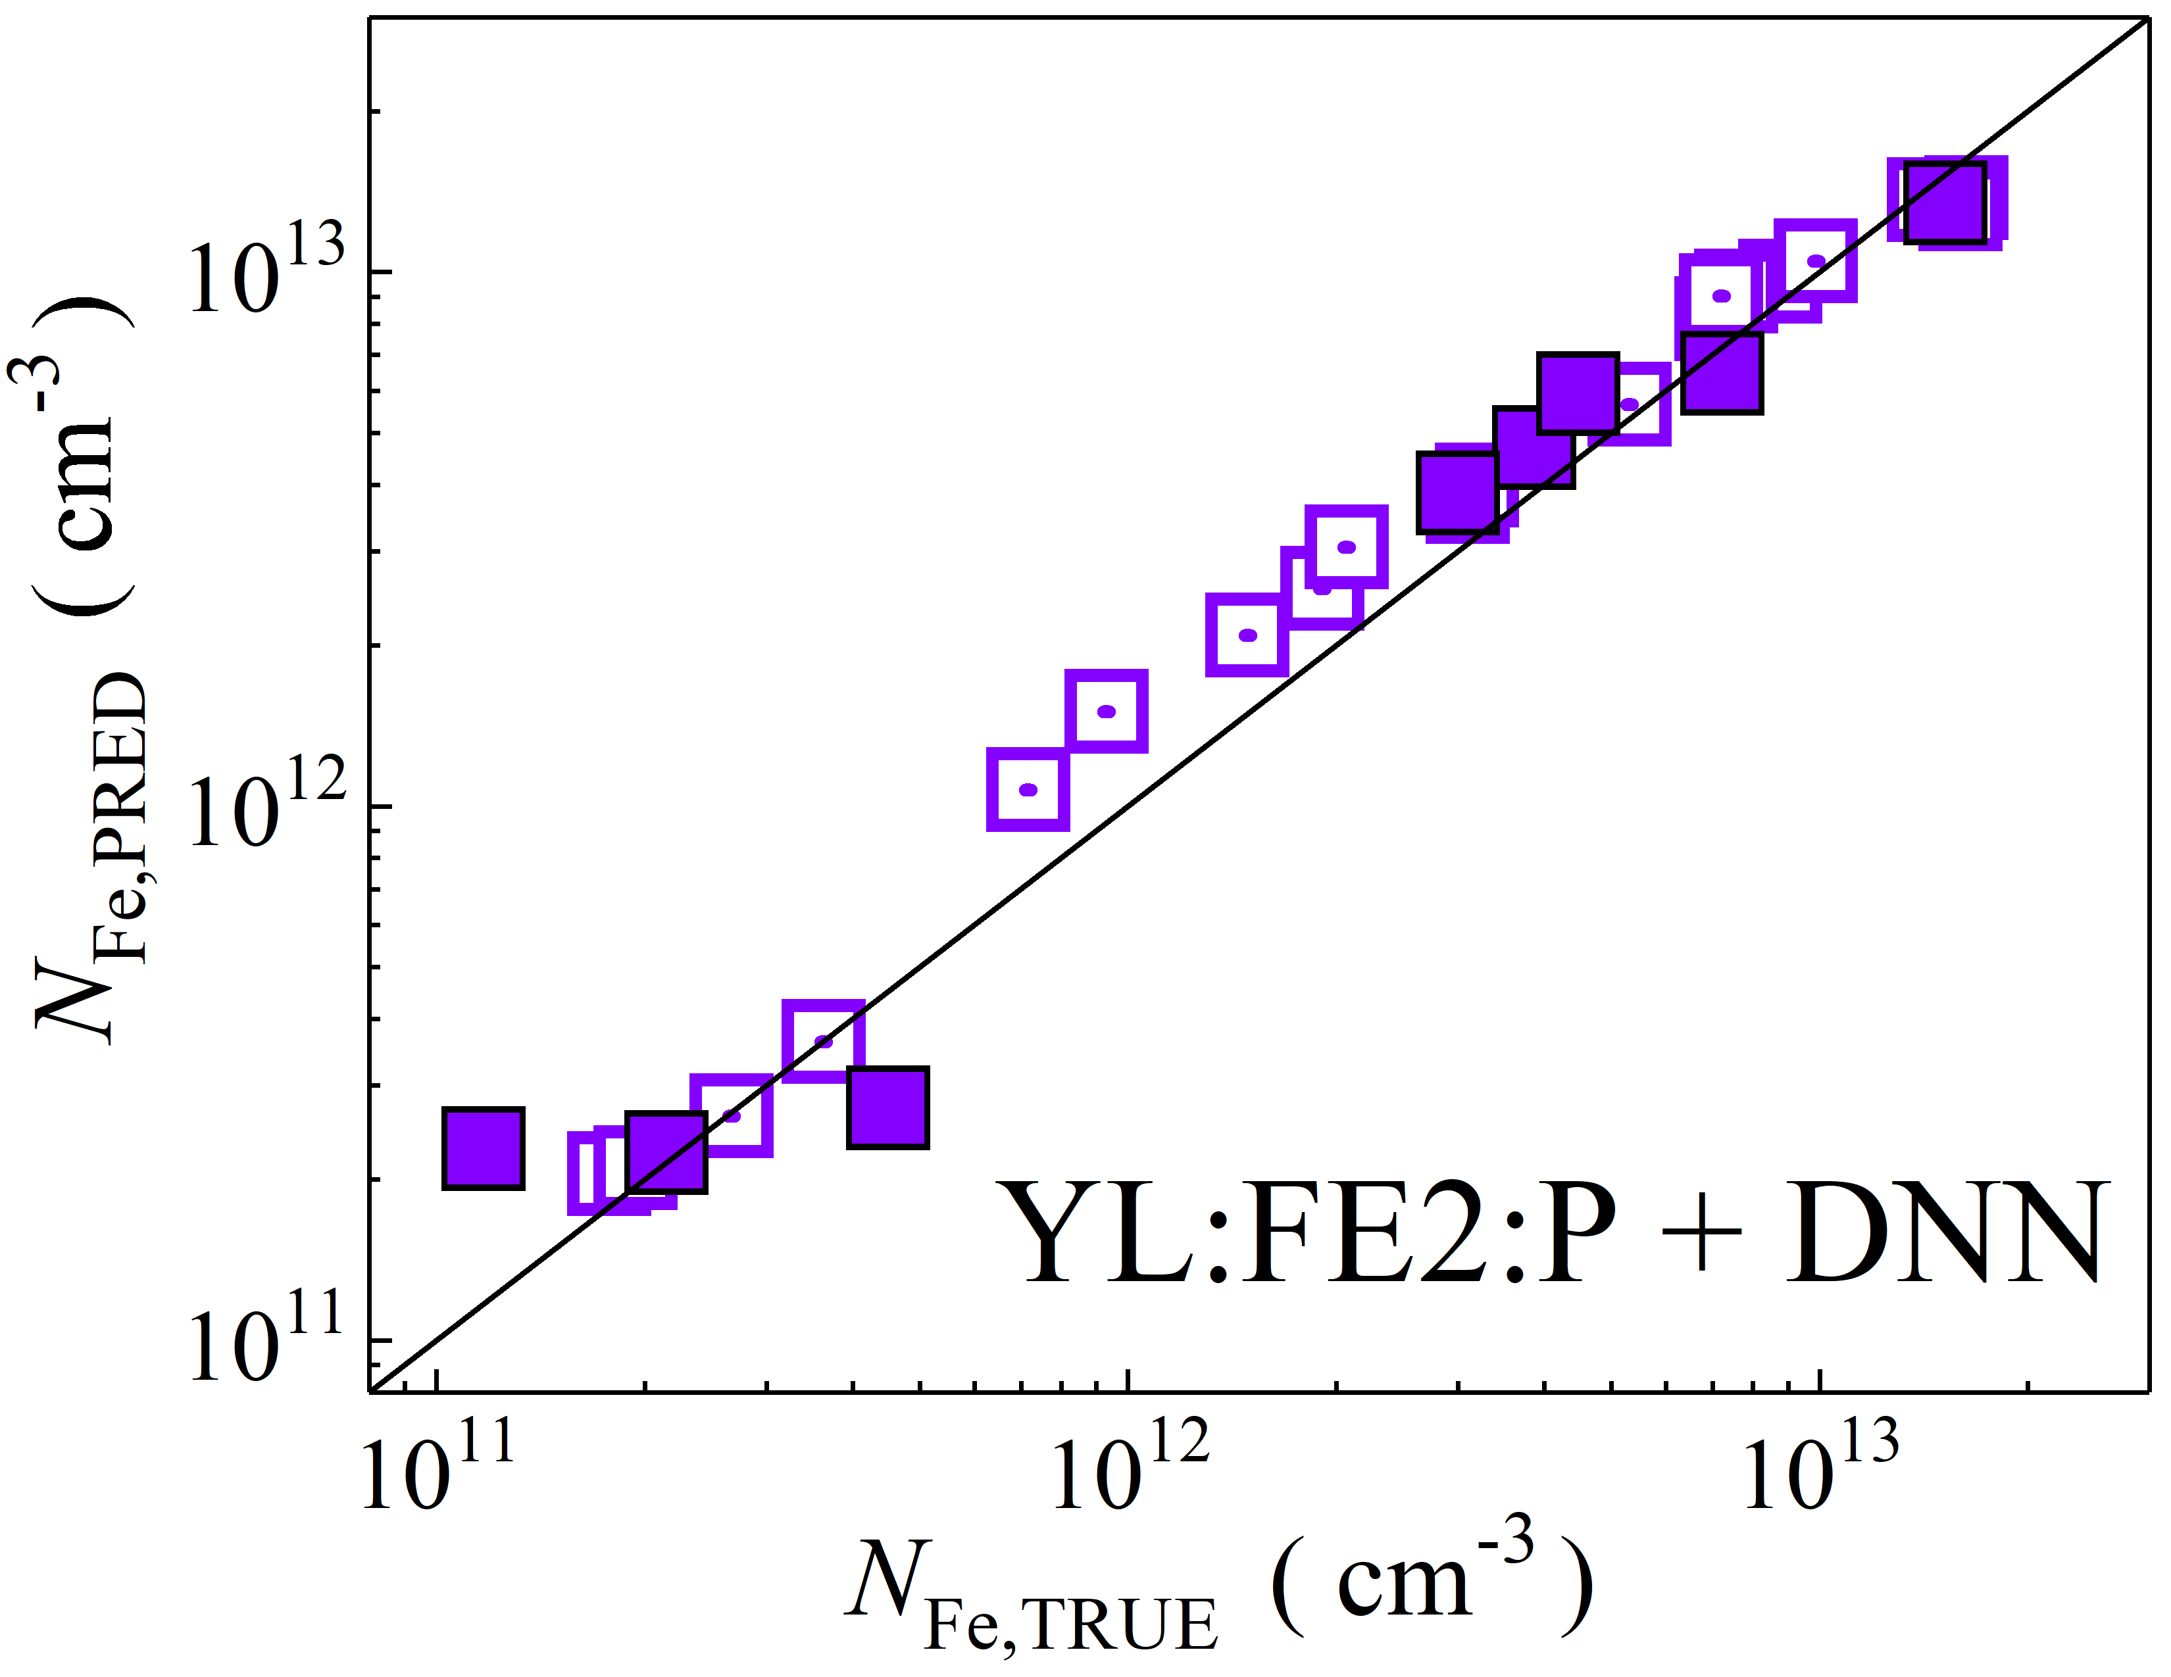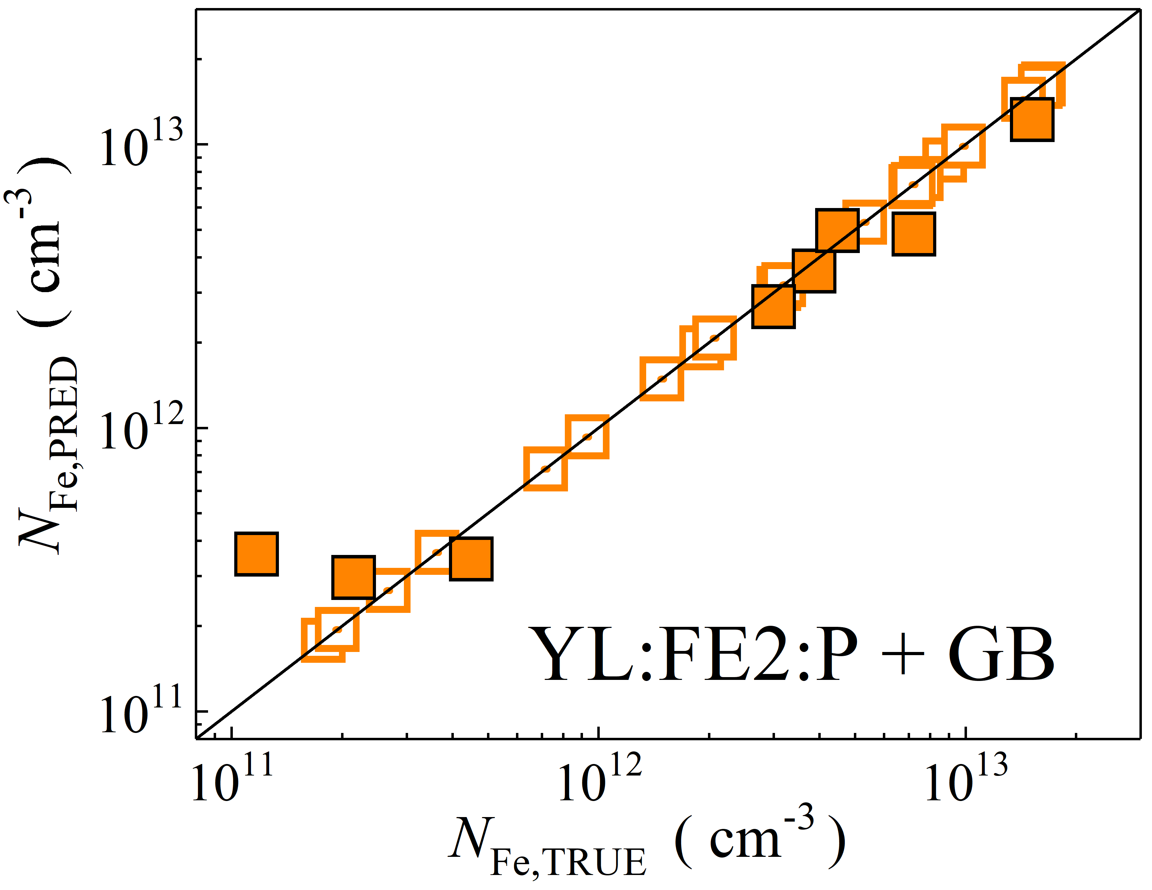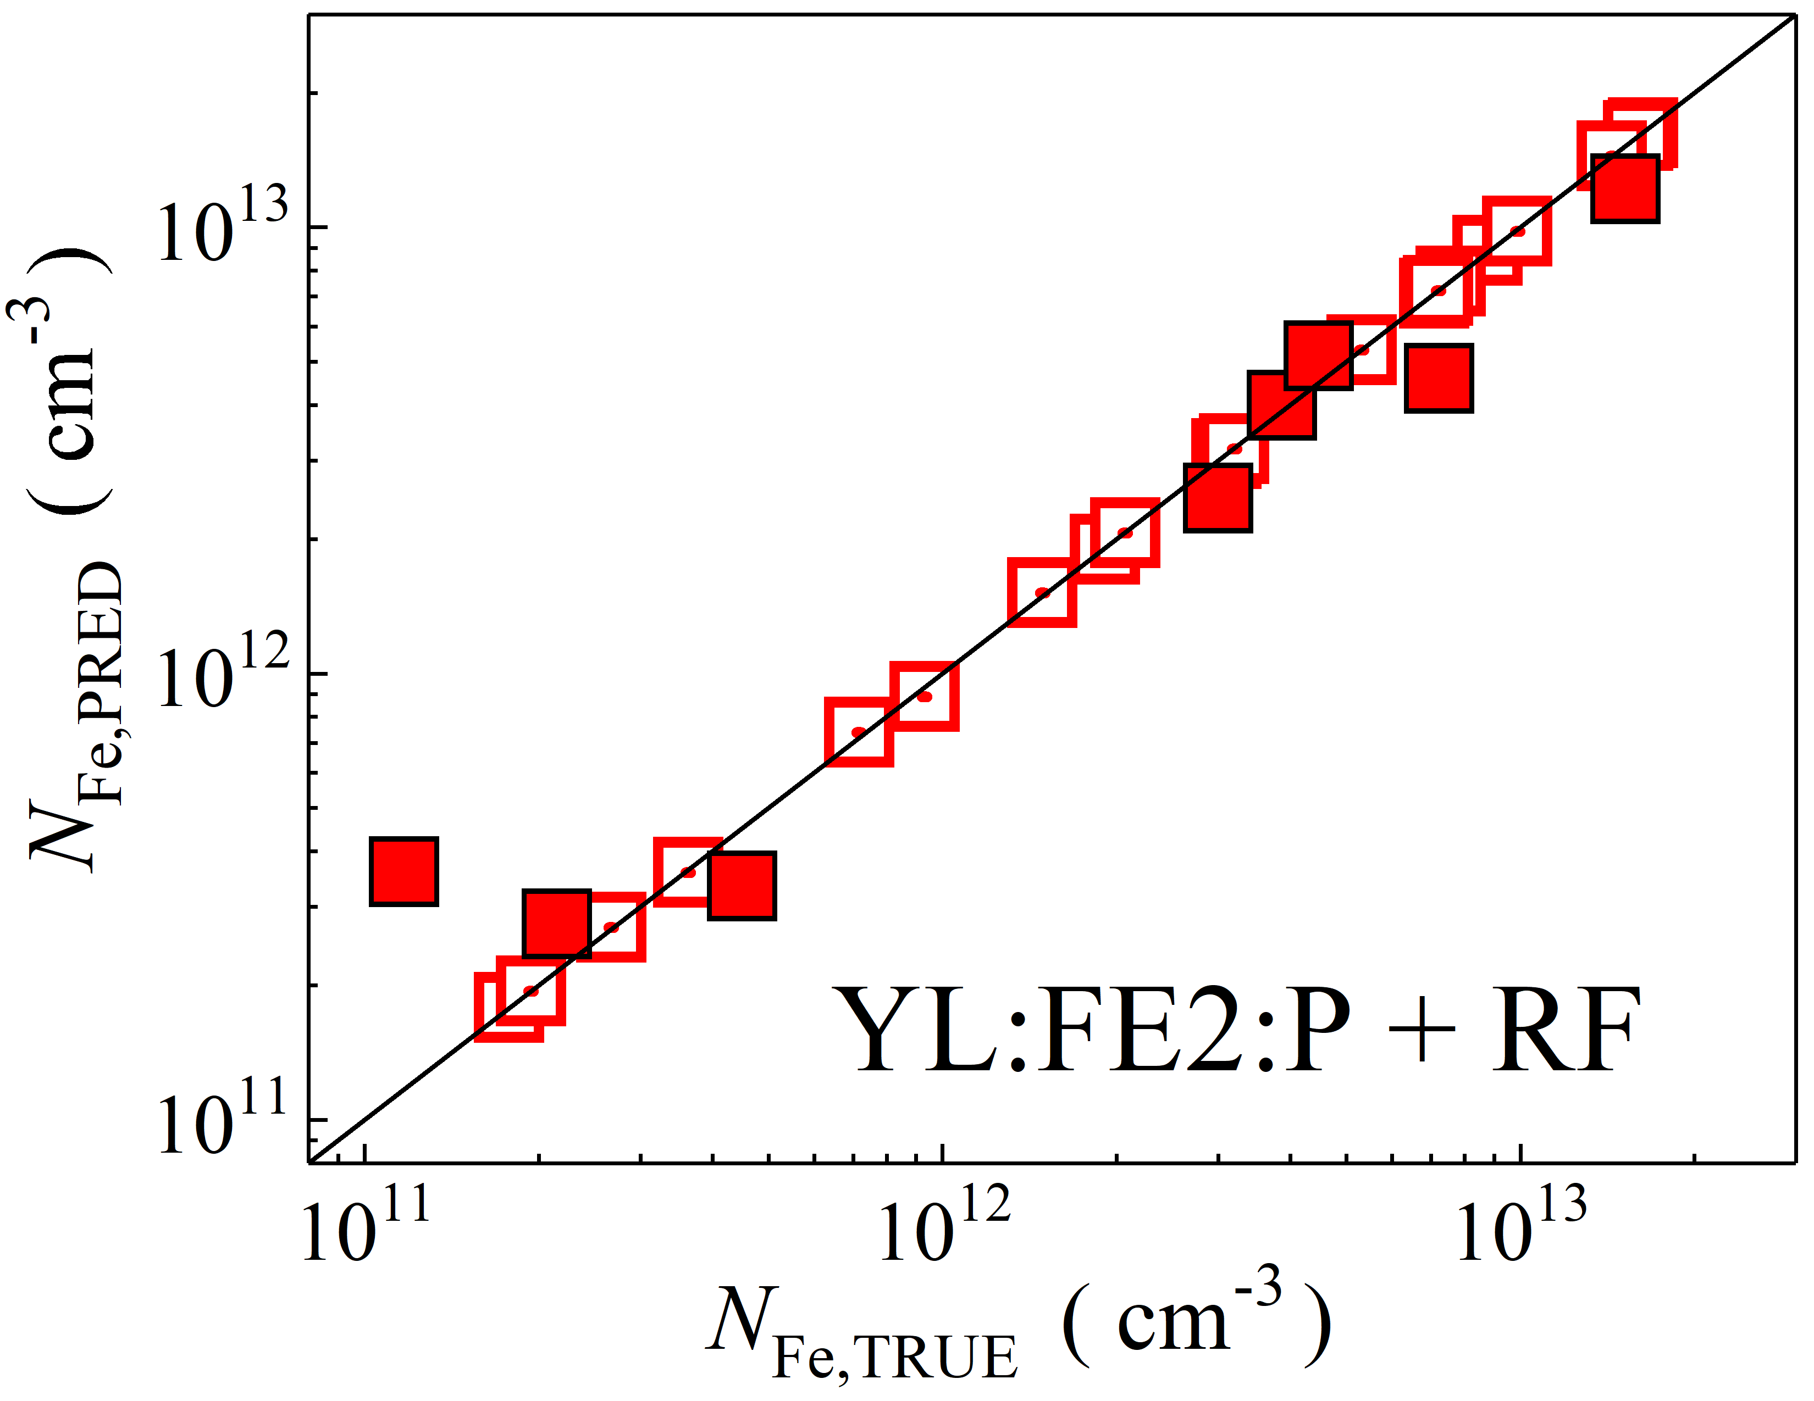

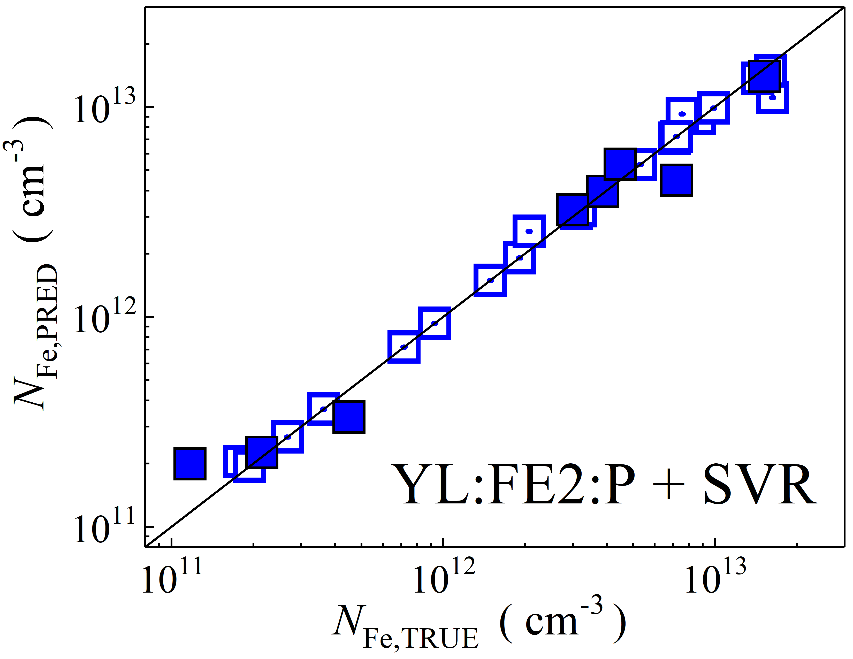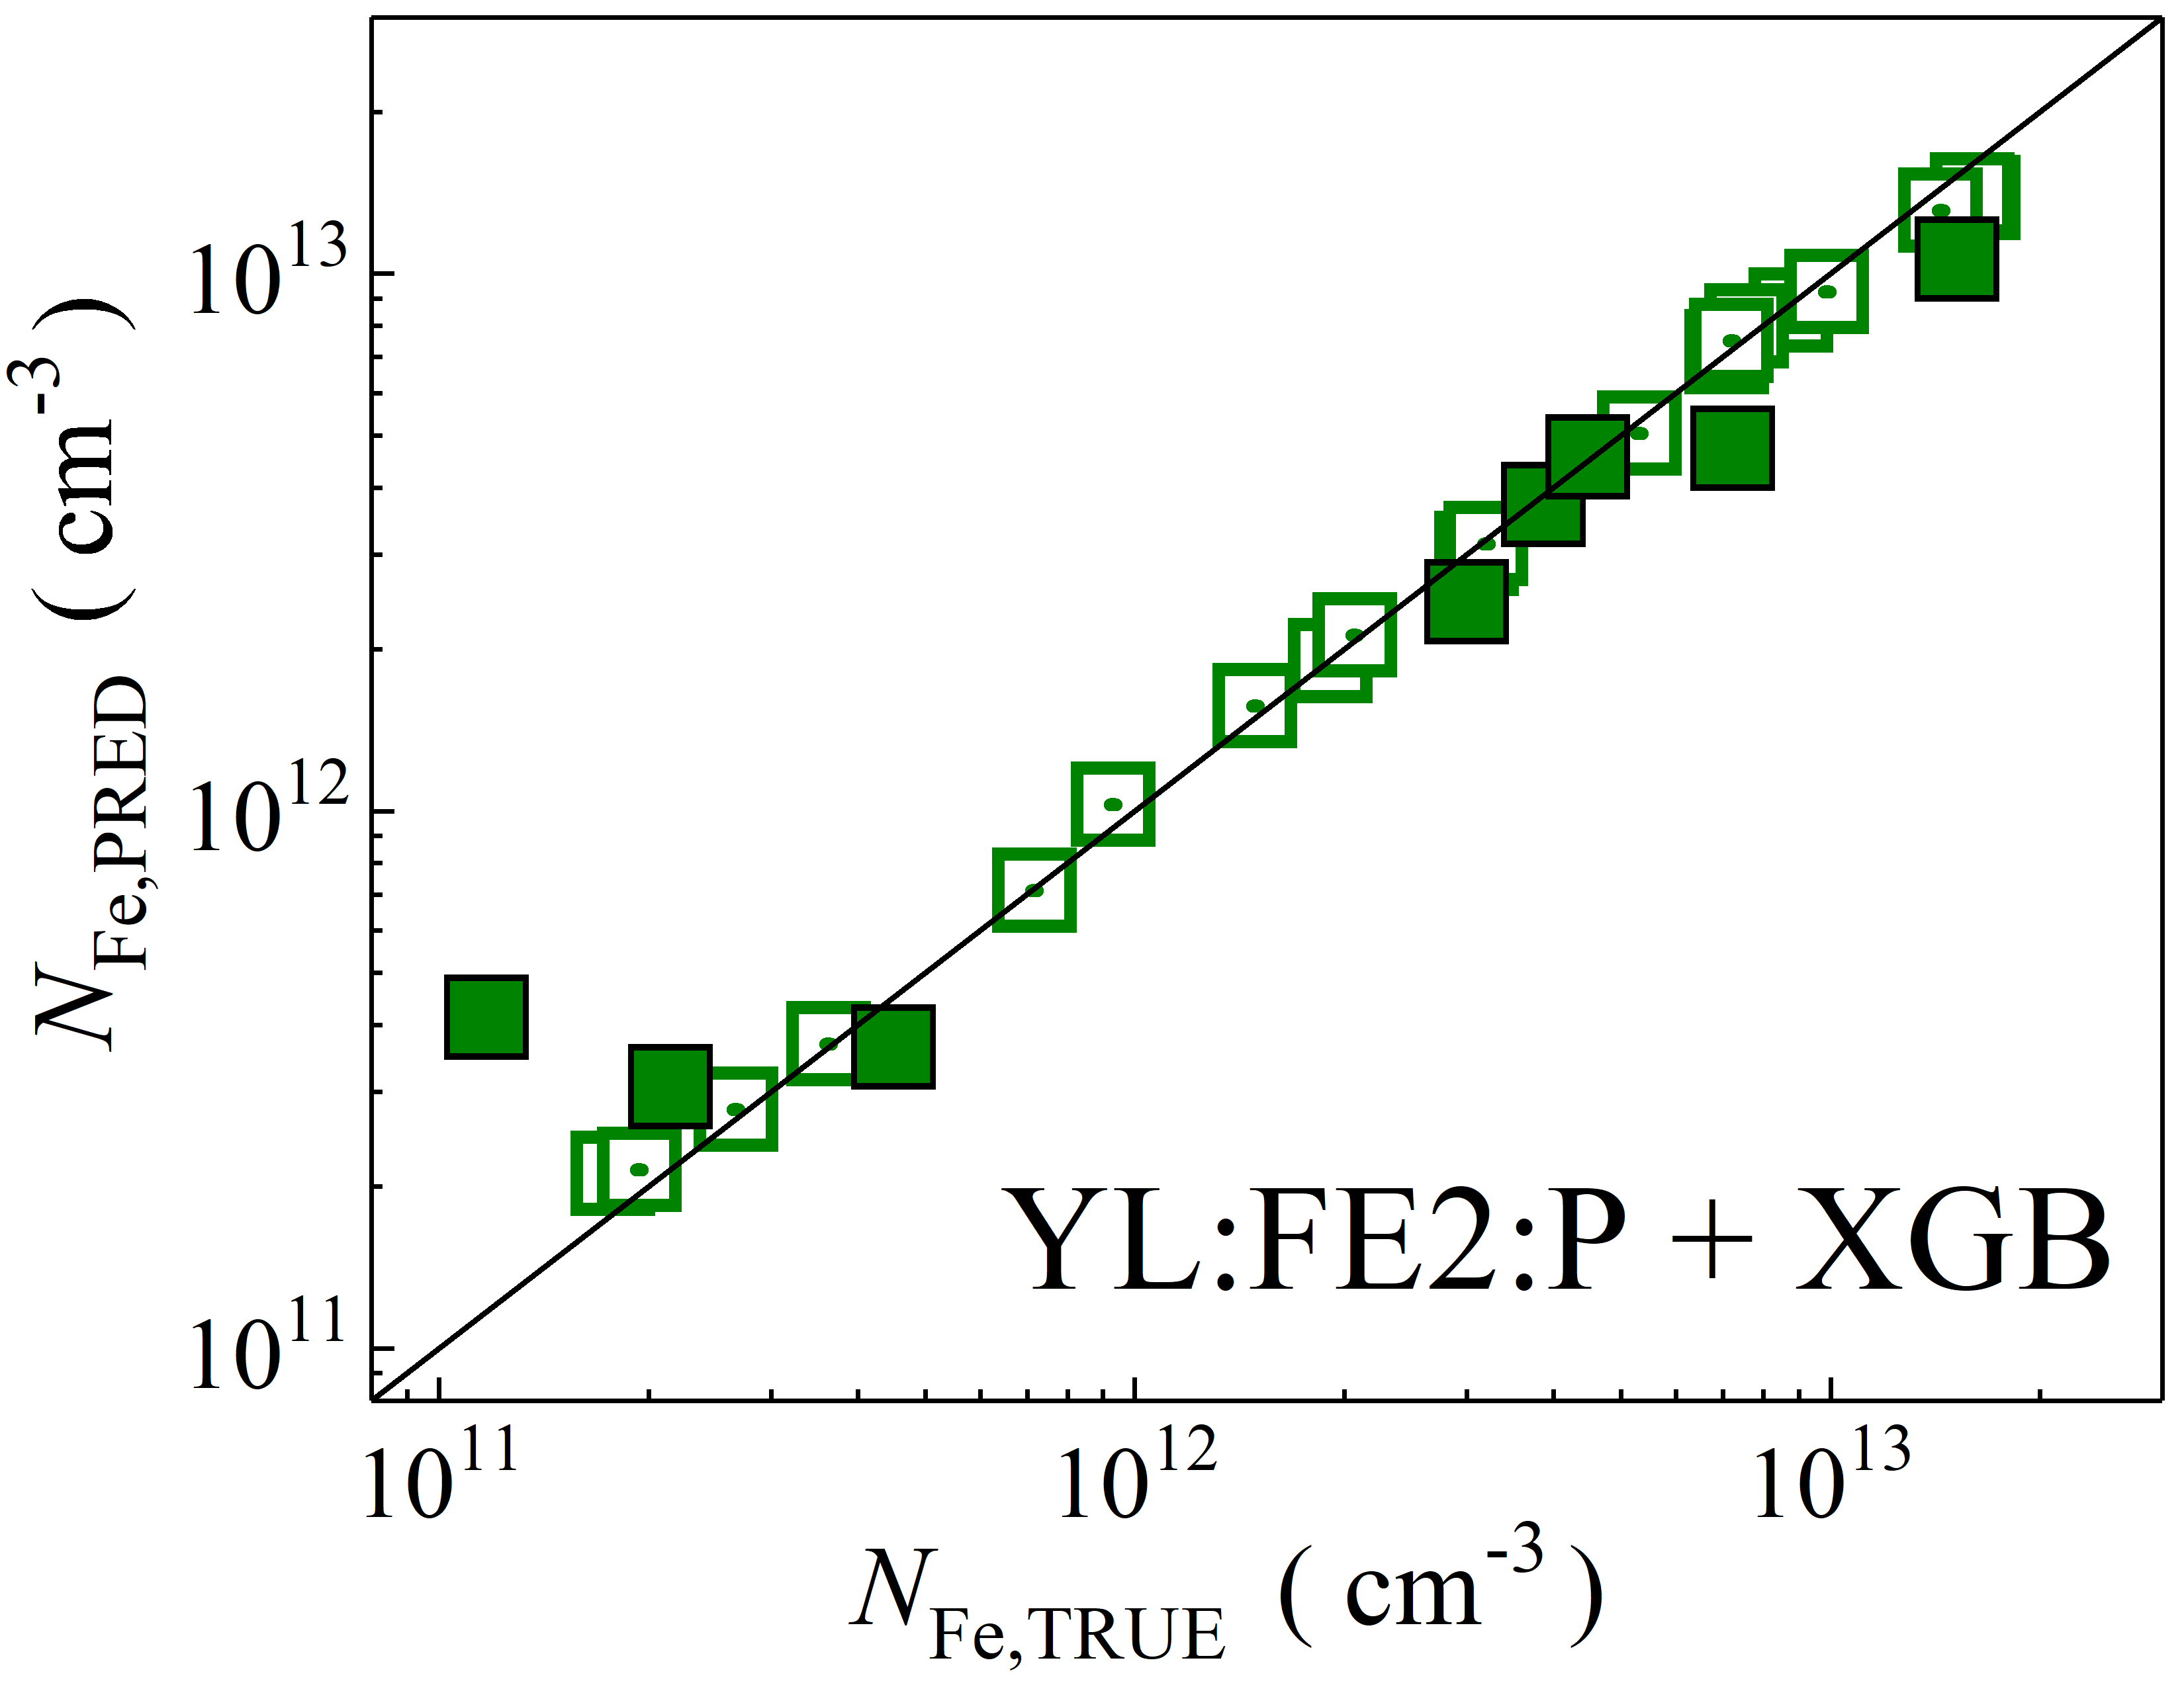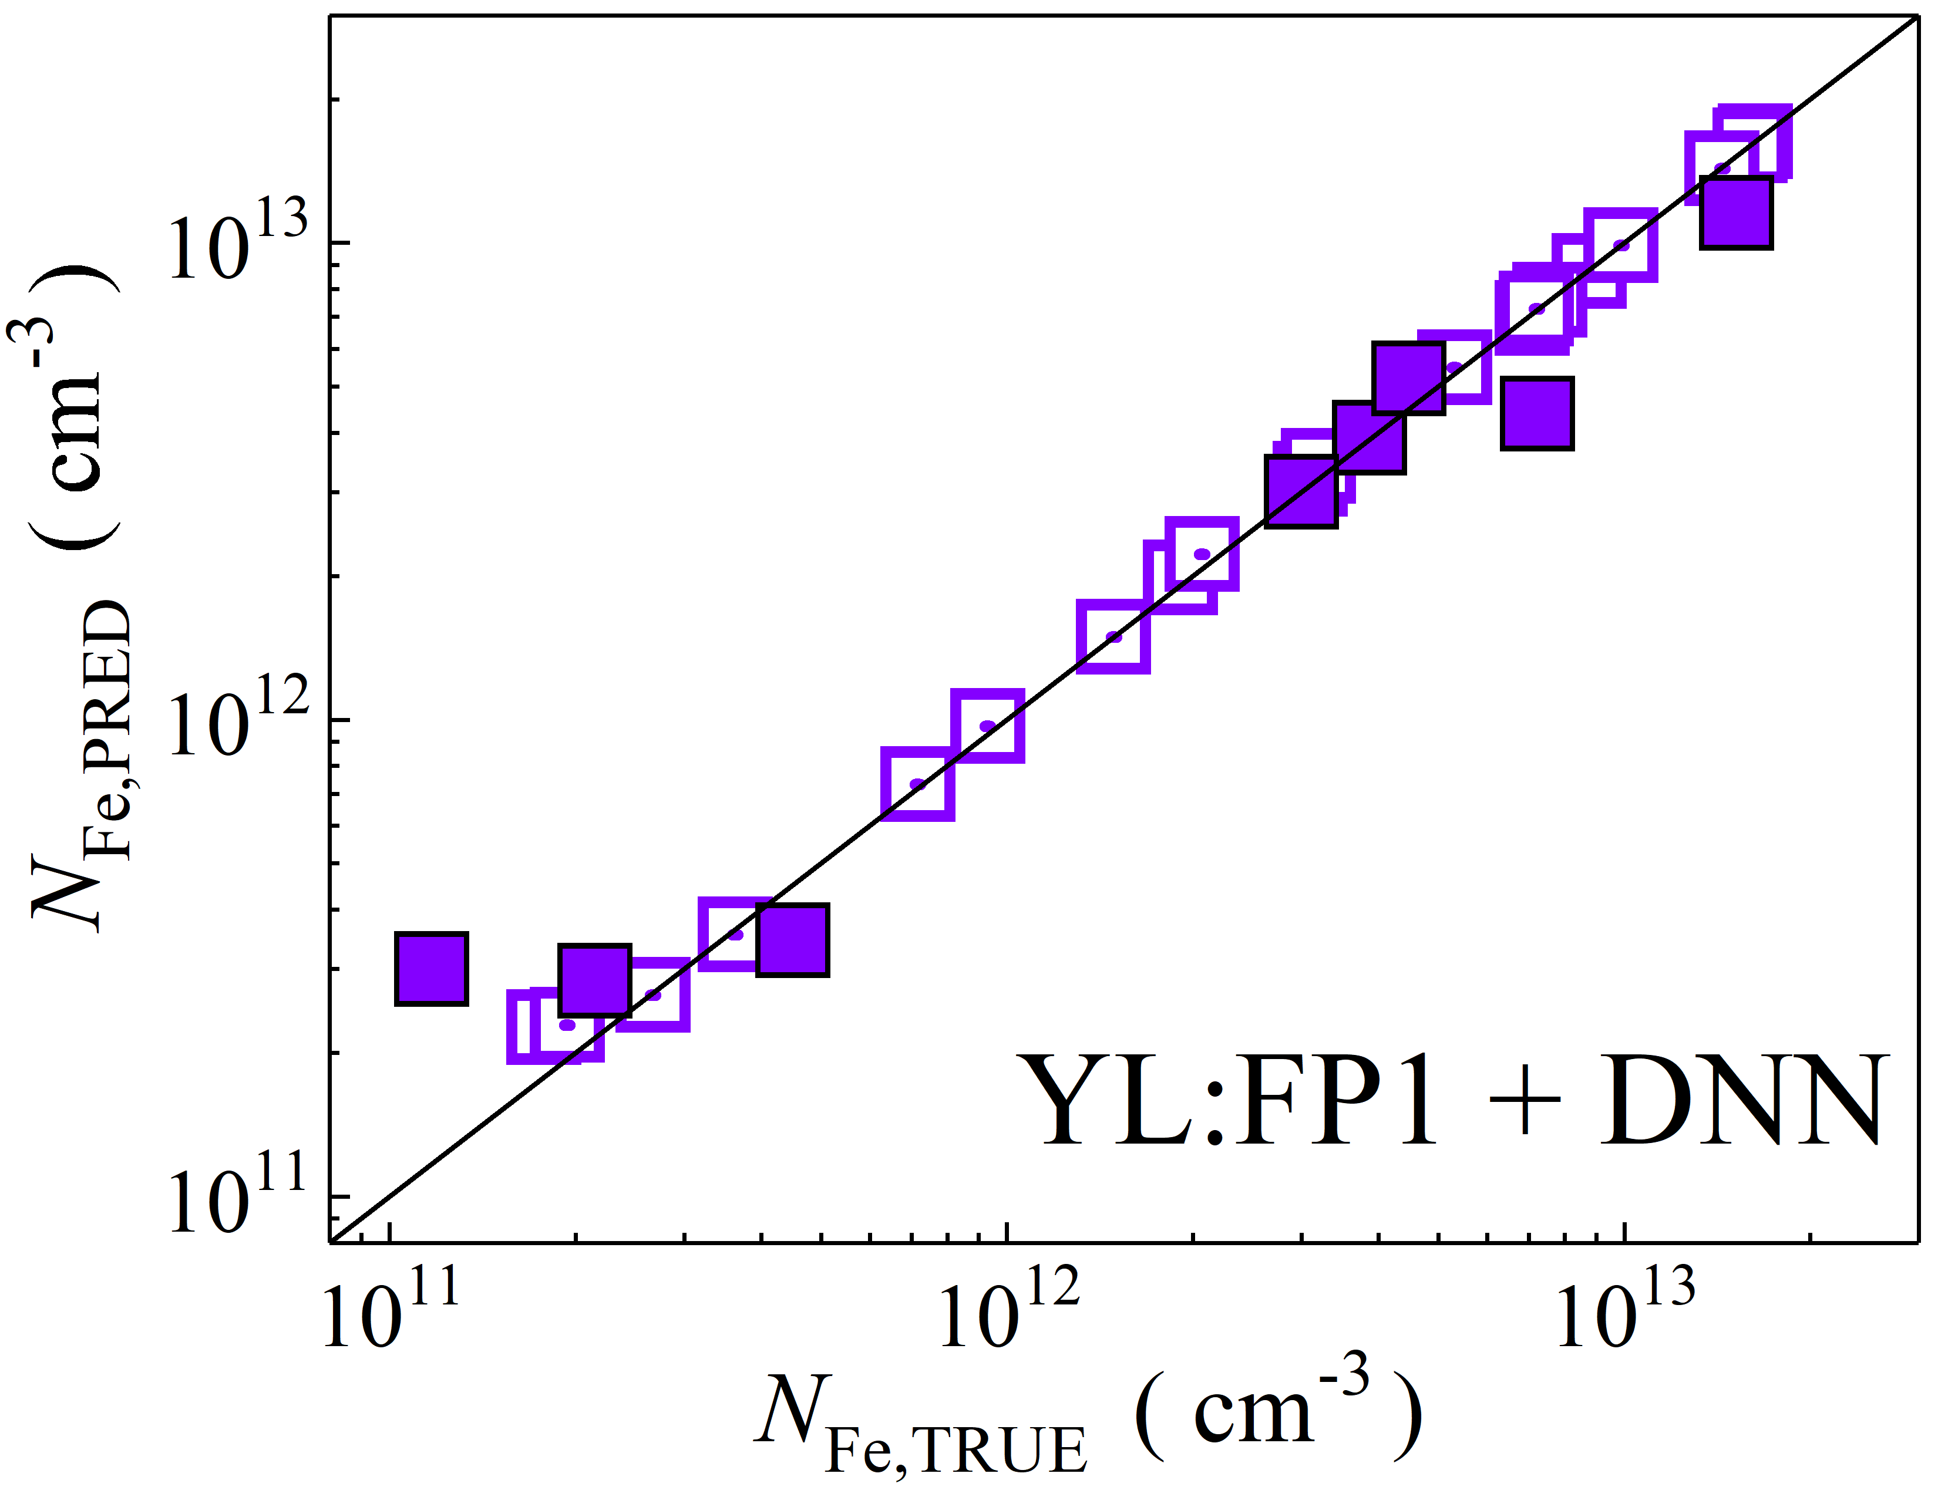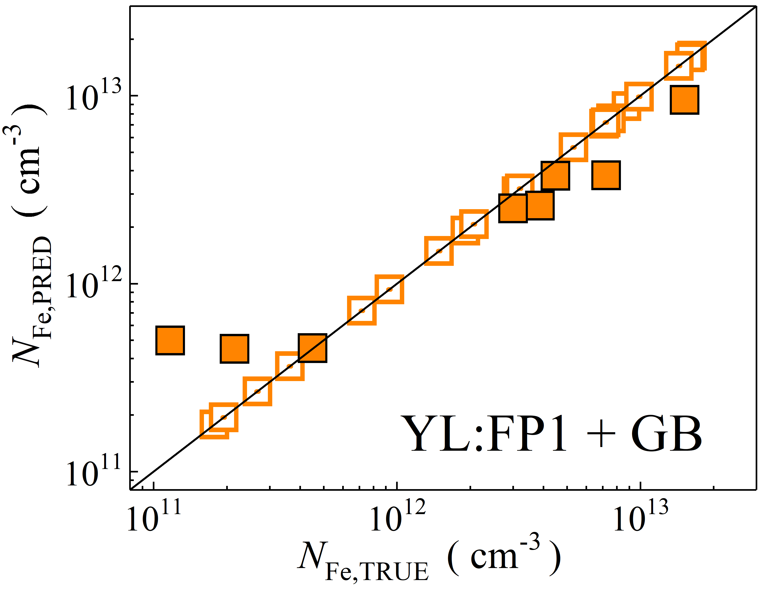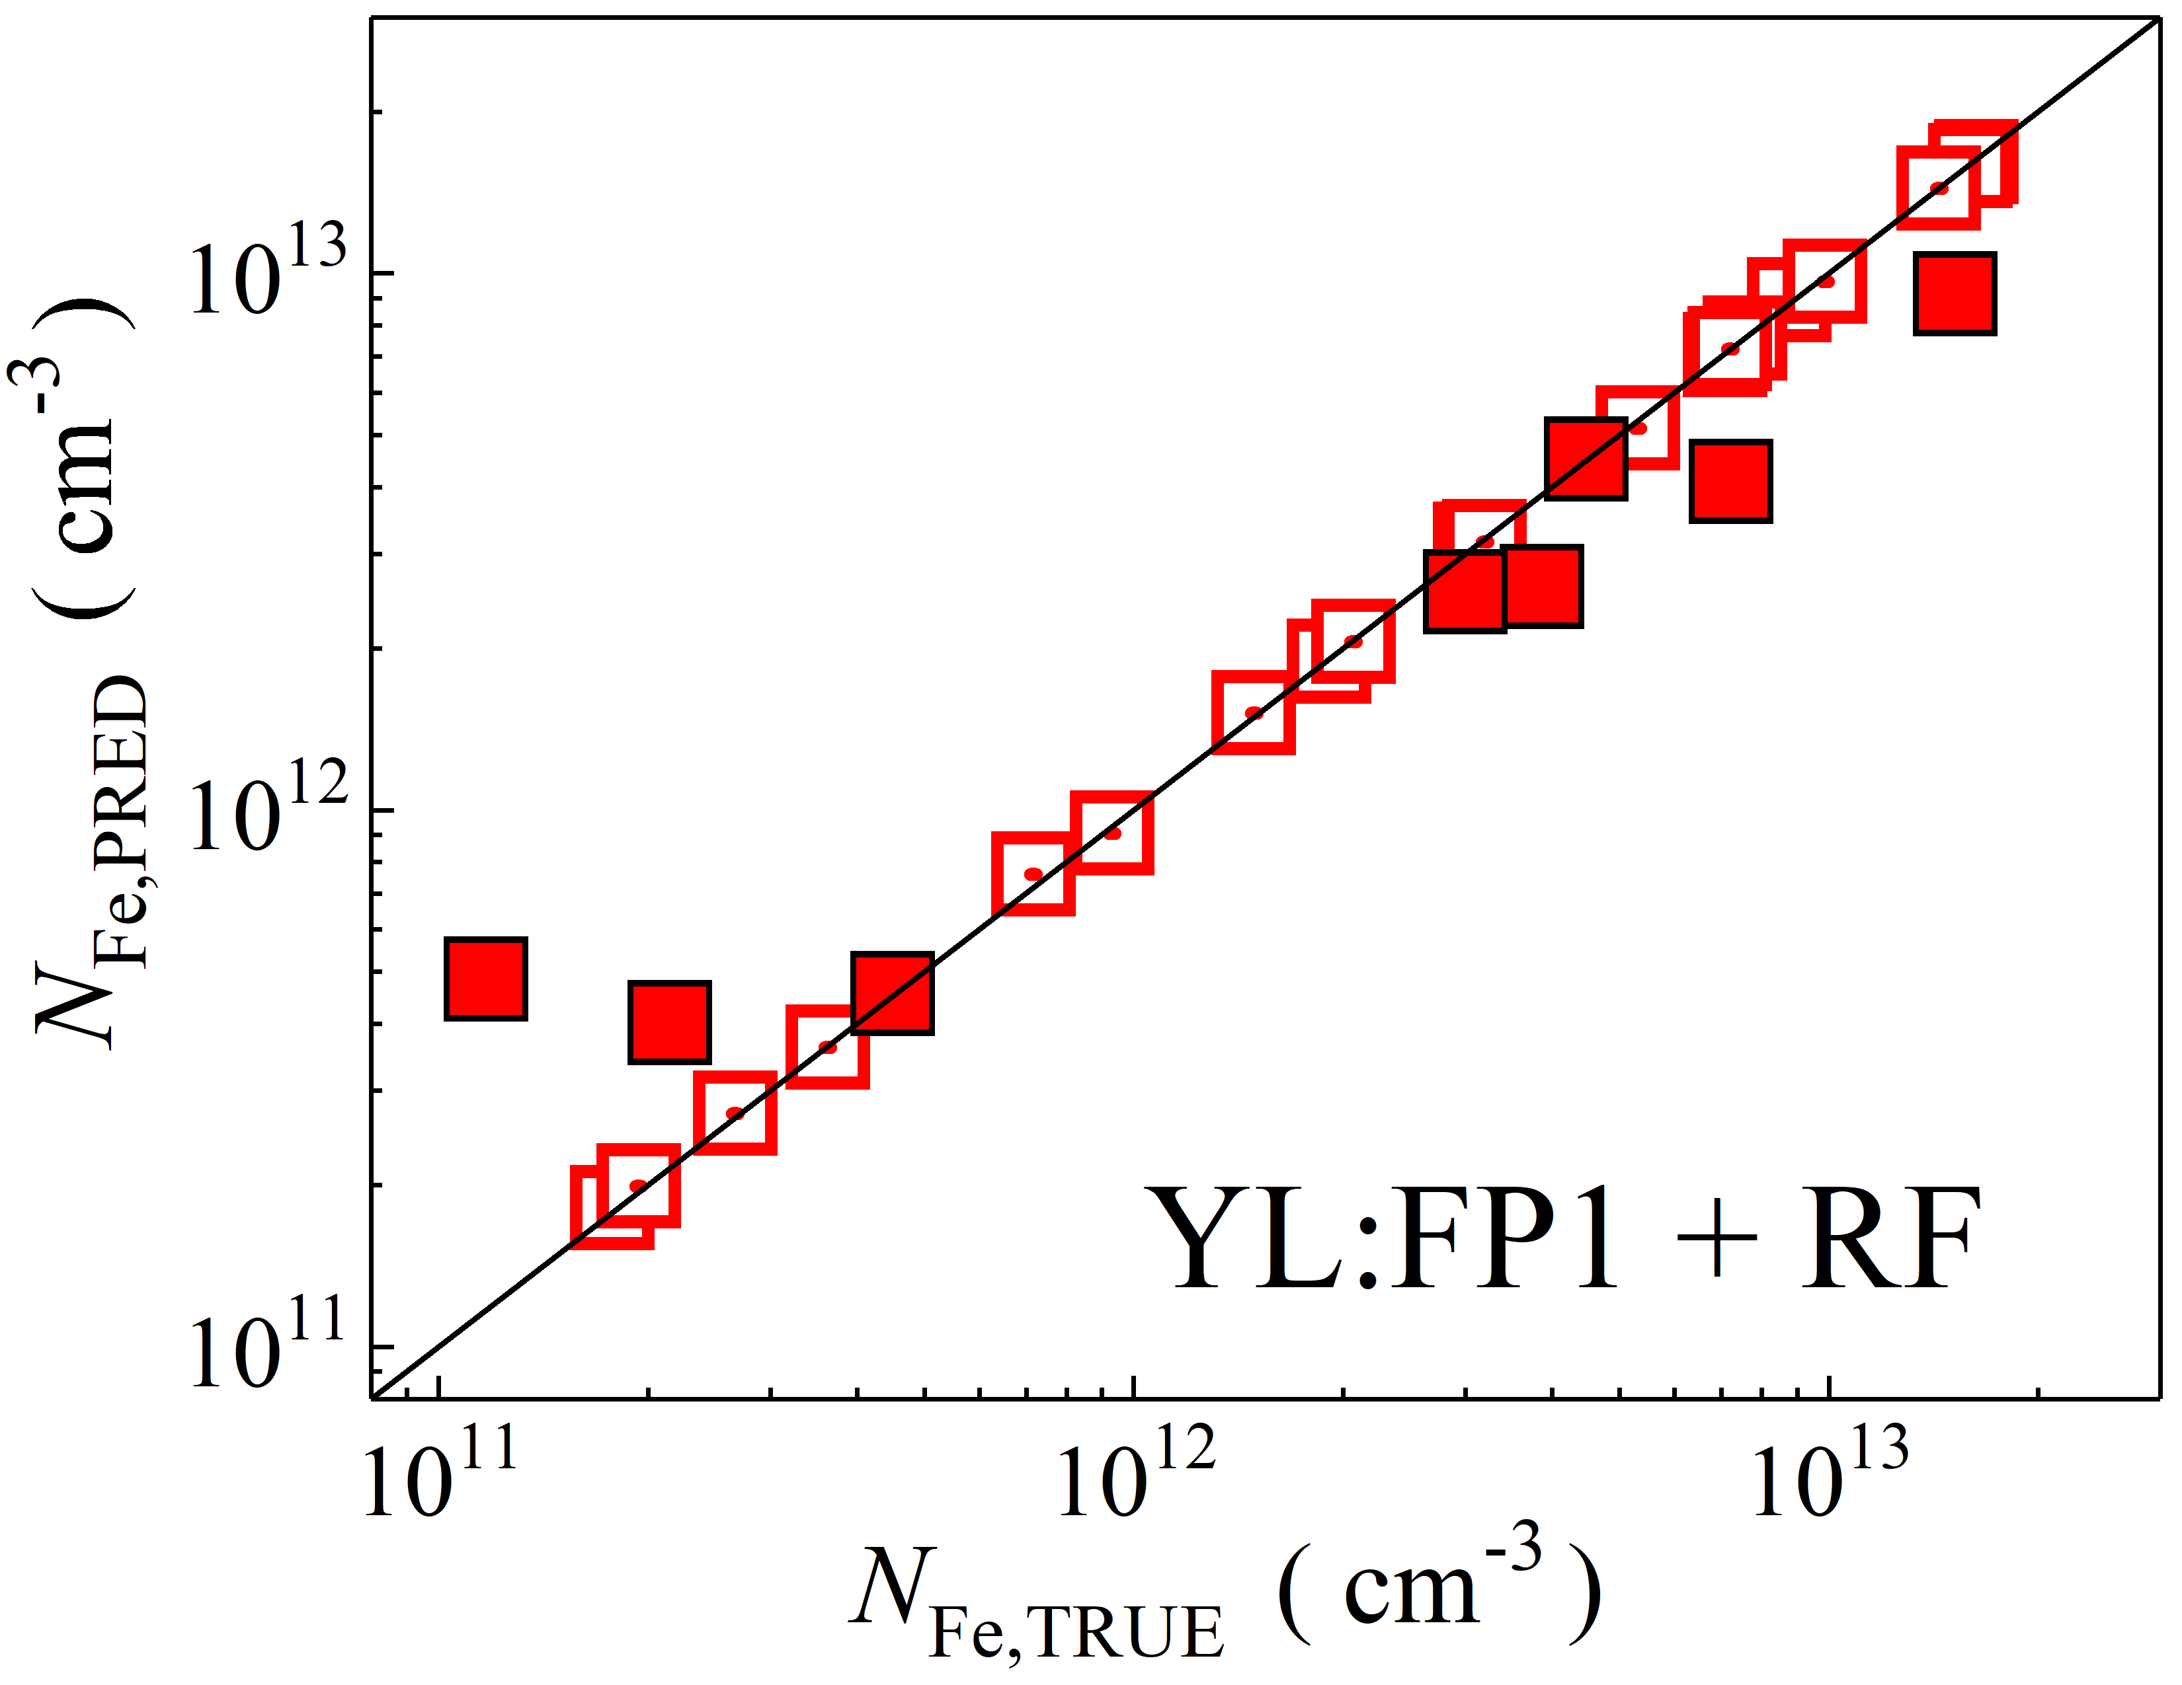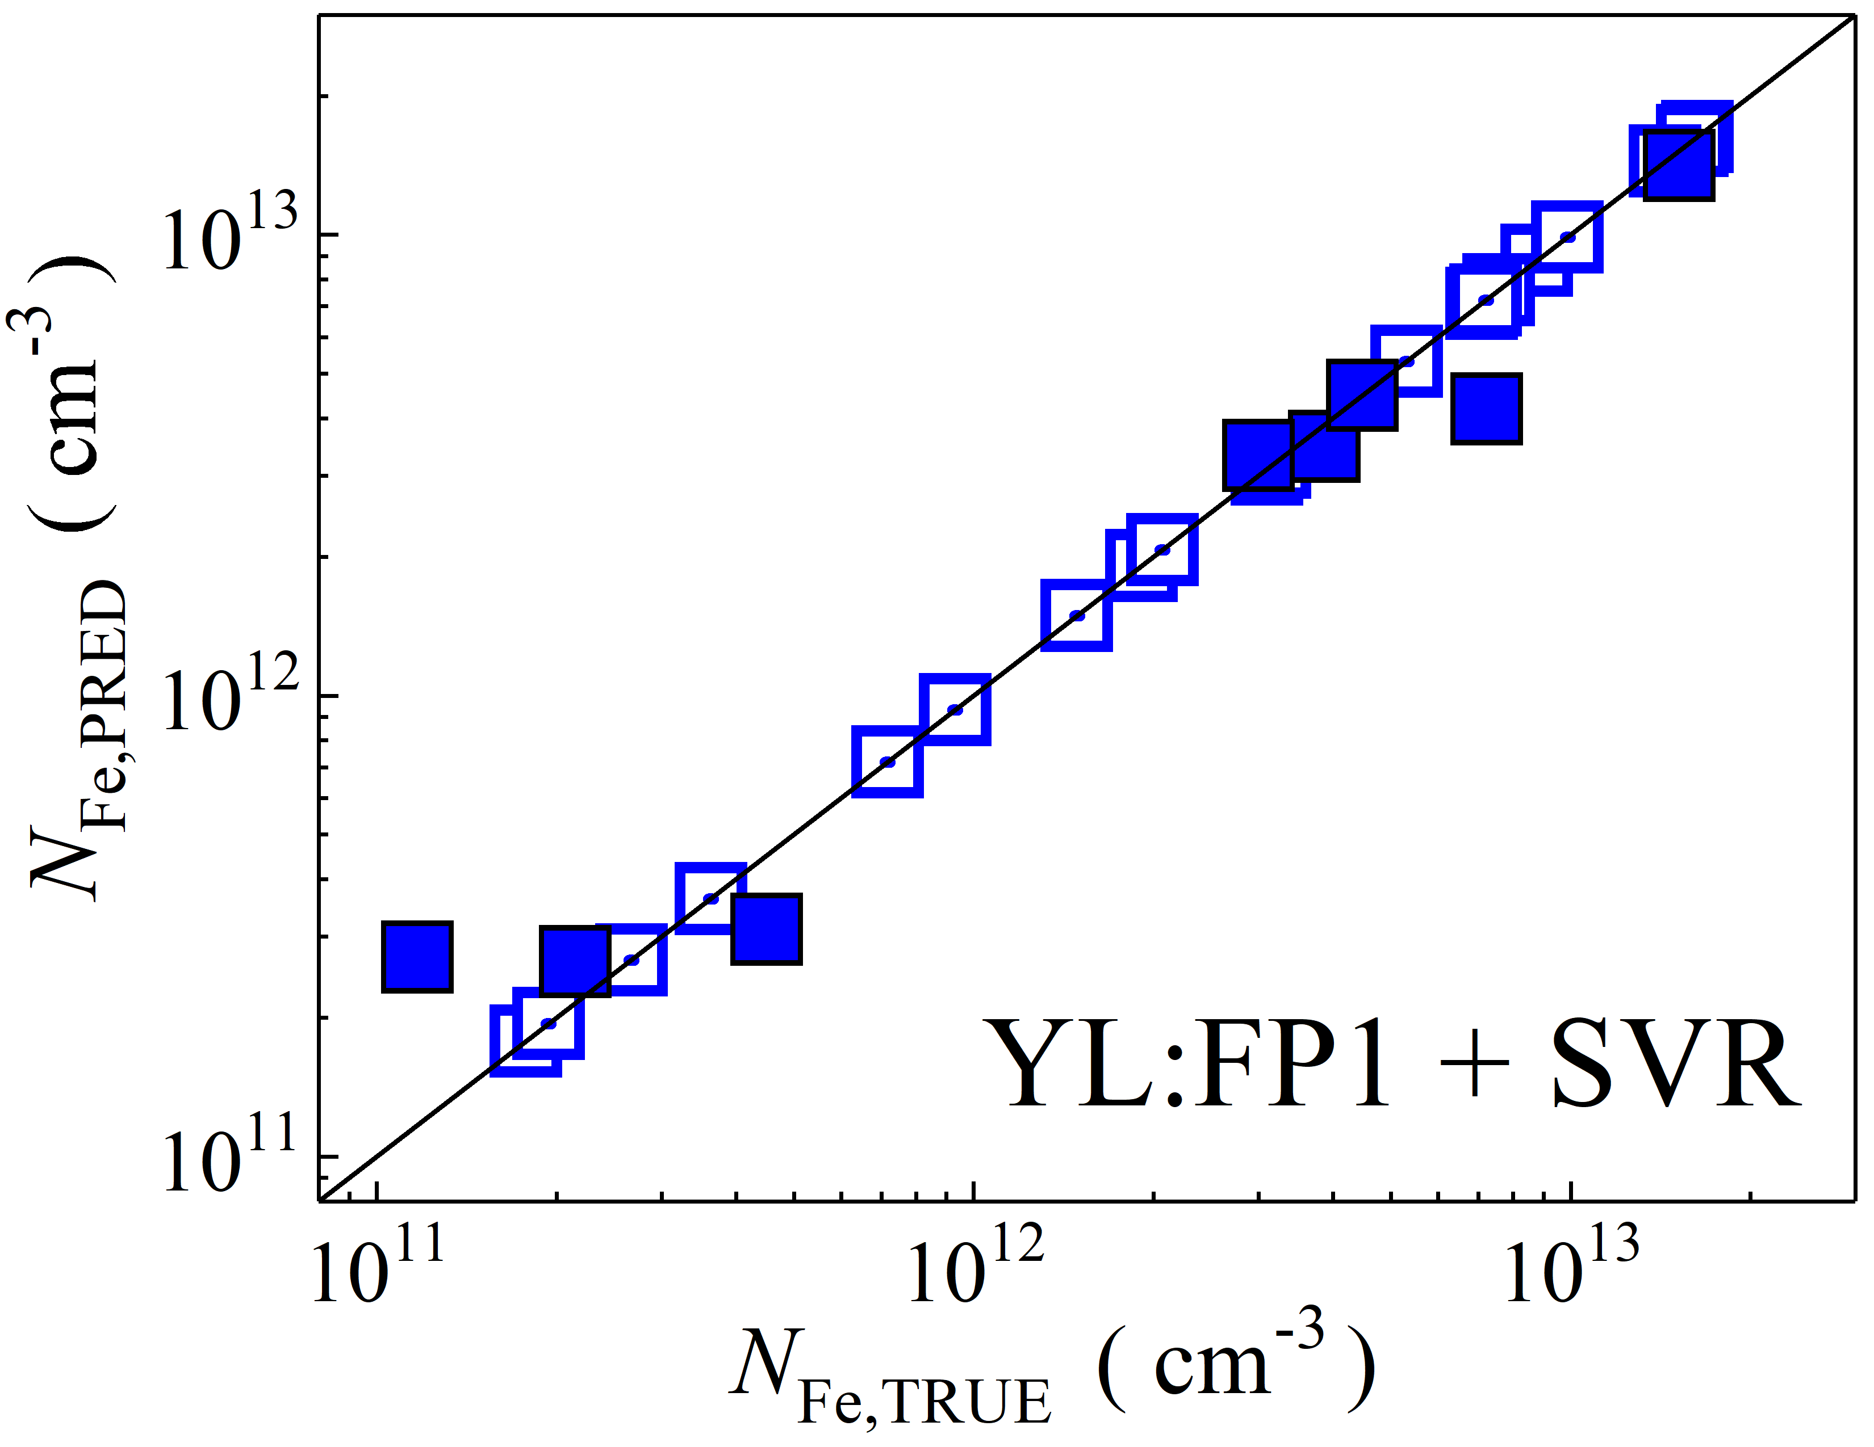

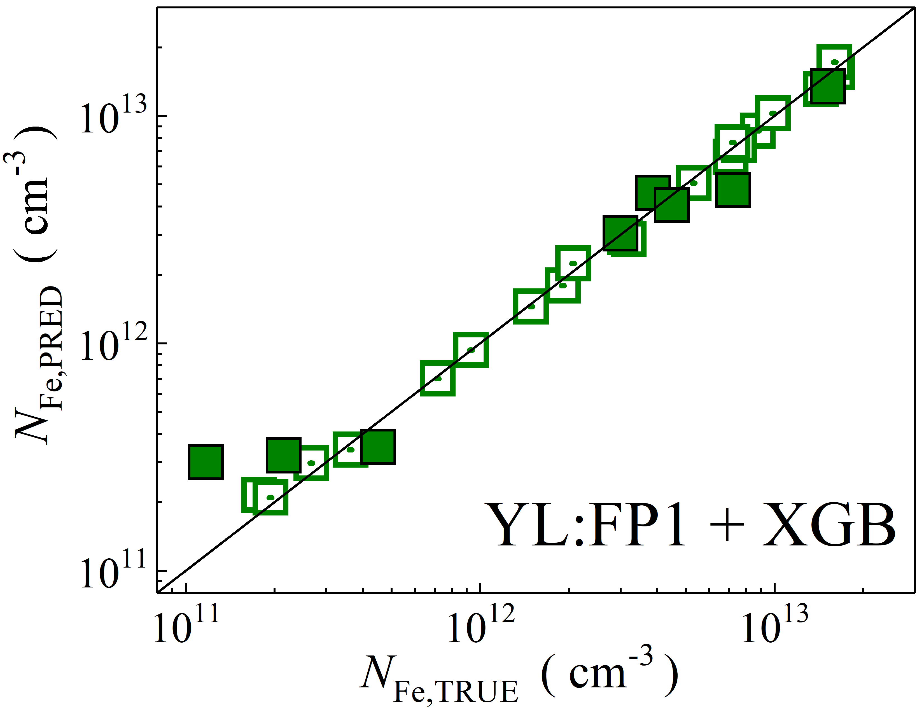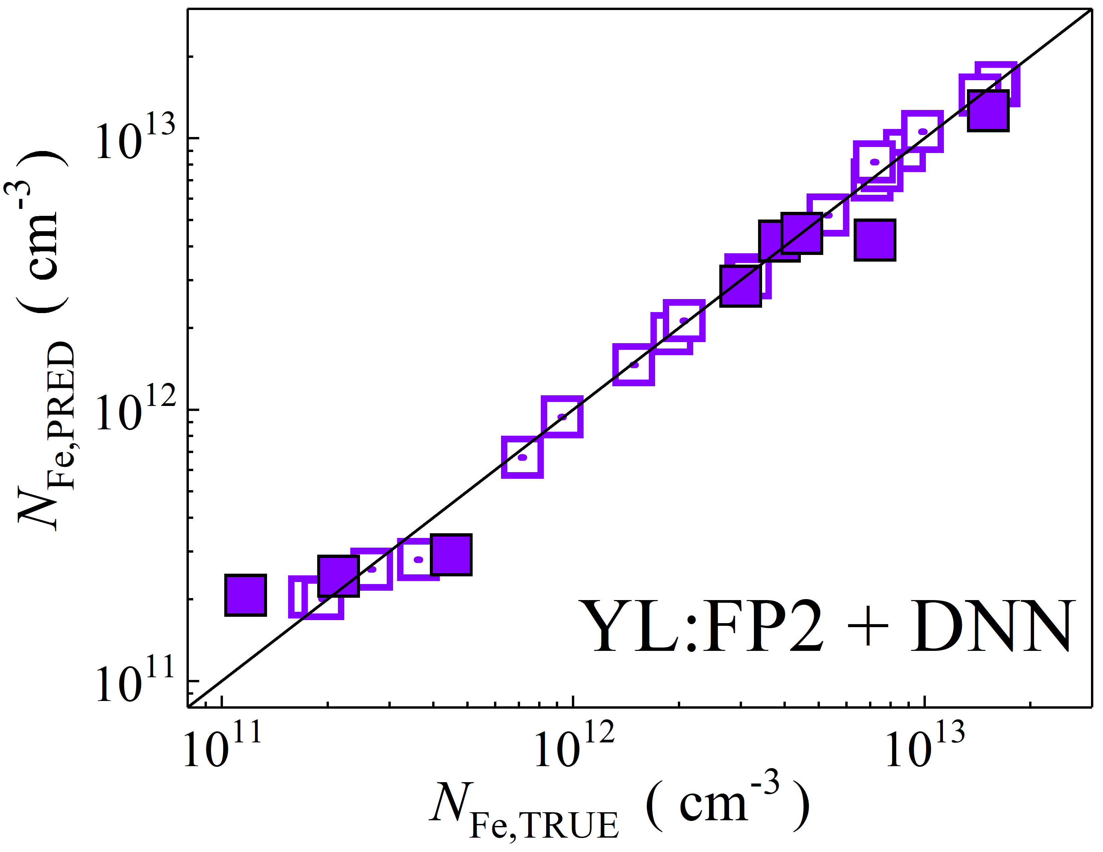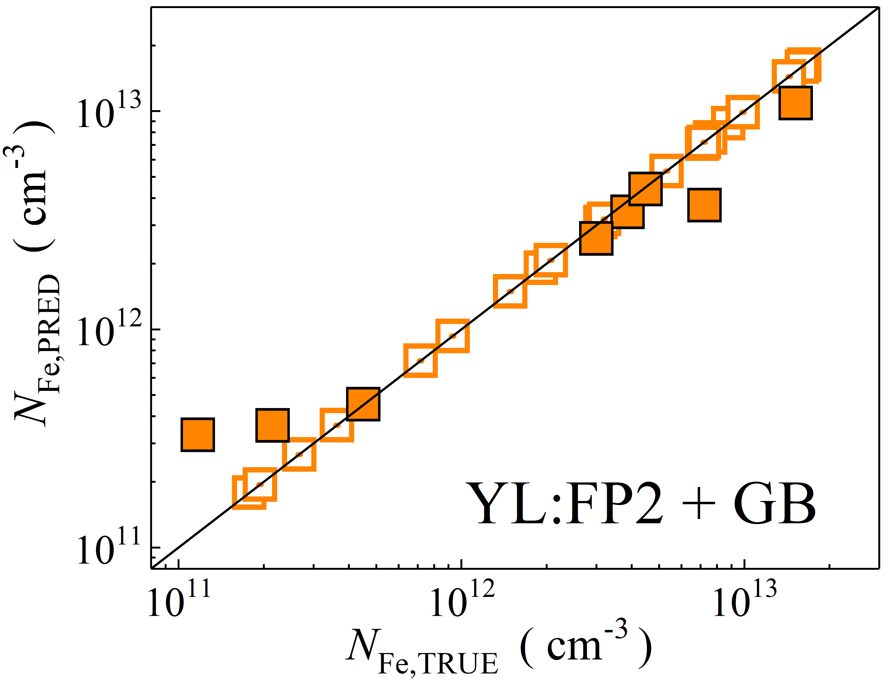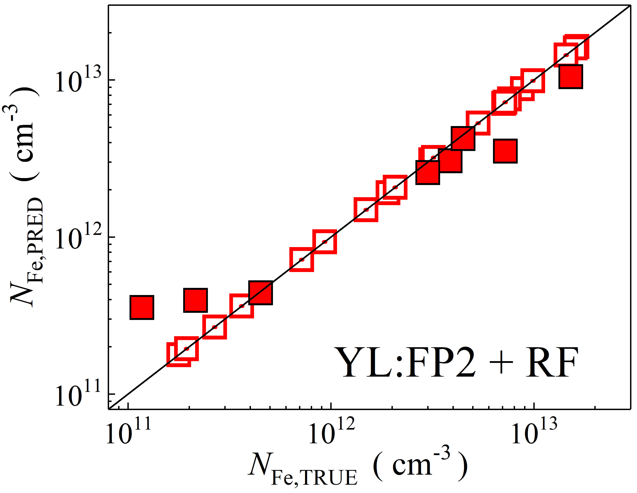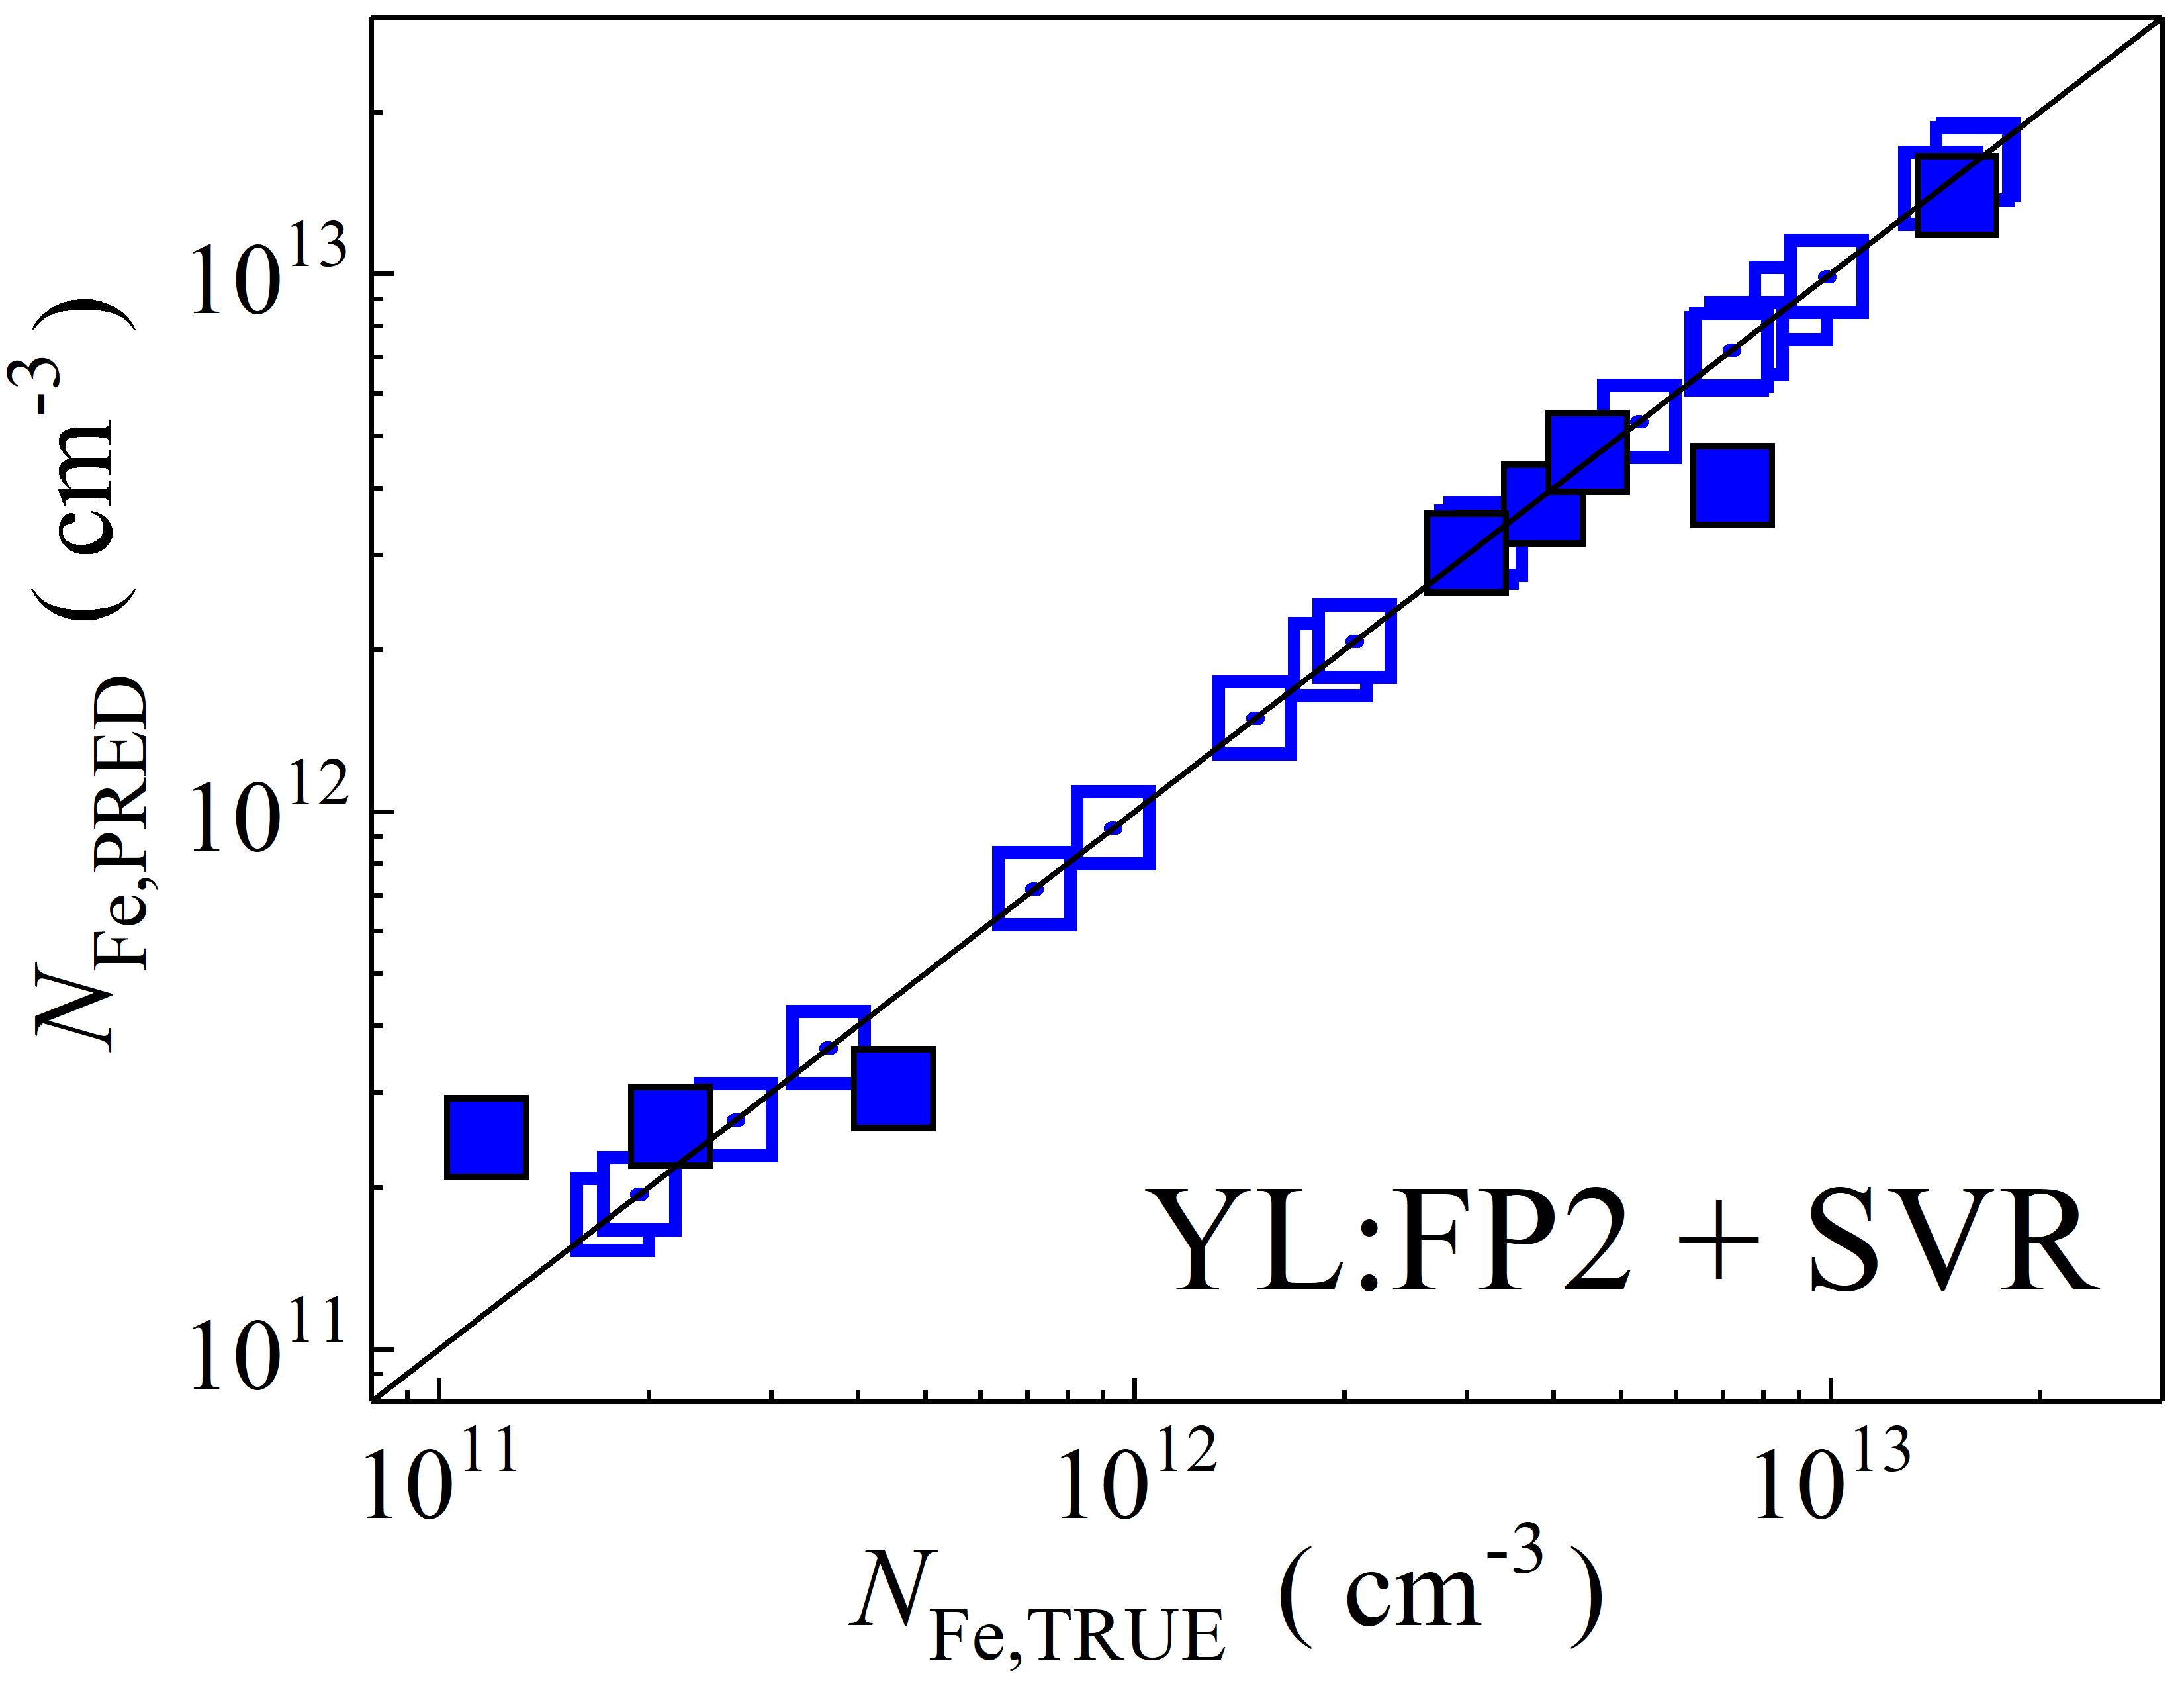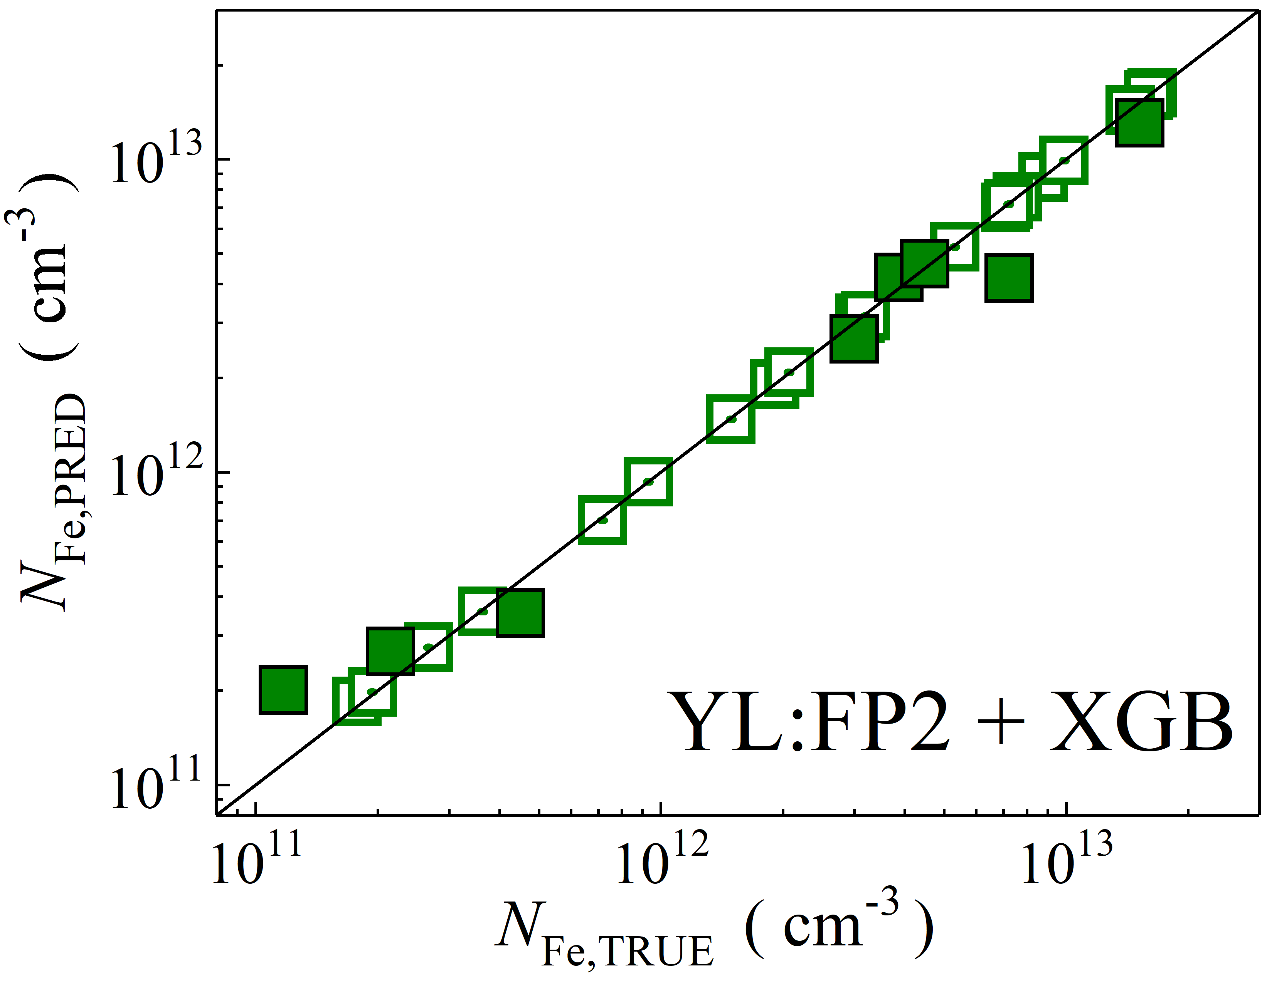

Fig. S2. Scatter plots compare reference iron concentrations $N_{Fe,TRUE}$ with ML-predicted values $N_{Fe,PRED}$ using feature vectors extracted from various computer vision models, including EfficientNetB7, MobileNetV2, NASNet, ResNet152, Xception, and YOLO. The ML algorithms applied are DNN, GB, RF, SVR, and XGB. Symbols represent different datasets: filled squares — test data from experimental measurements, and open squares — train data from experimental measurements. The black lines are the identified lines serving as the references.

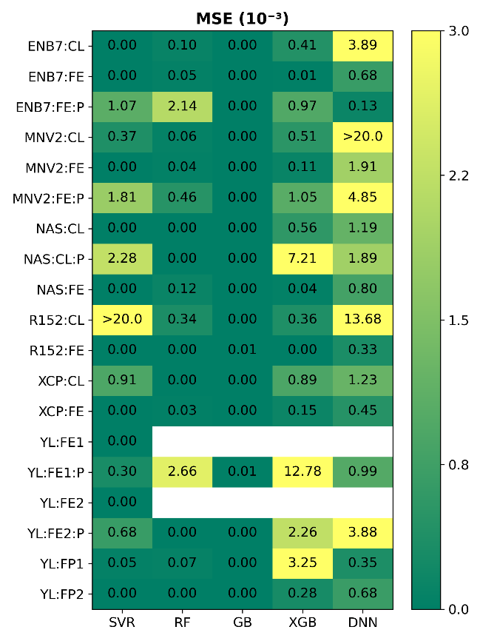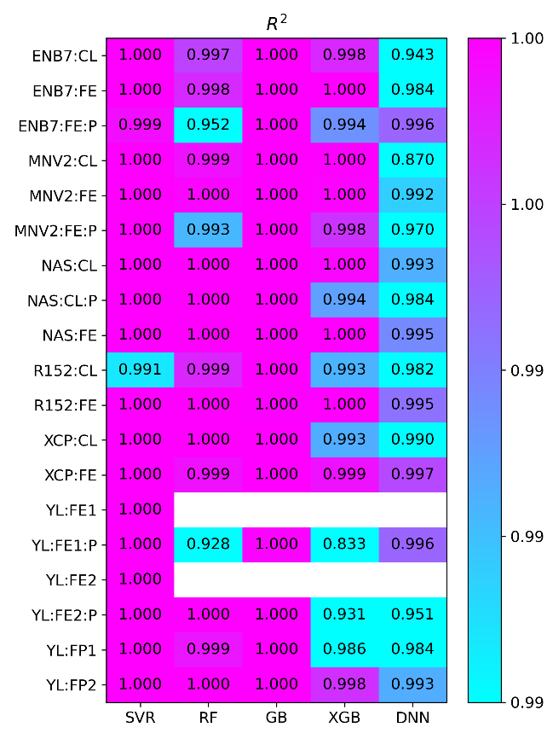

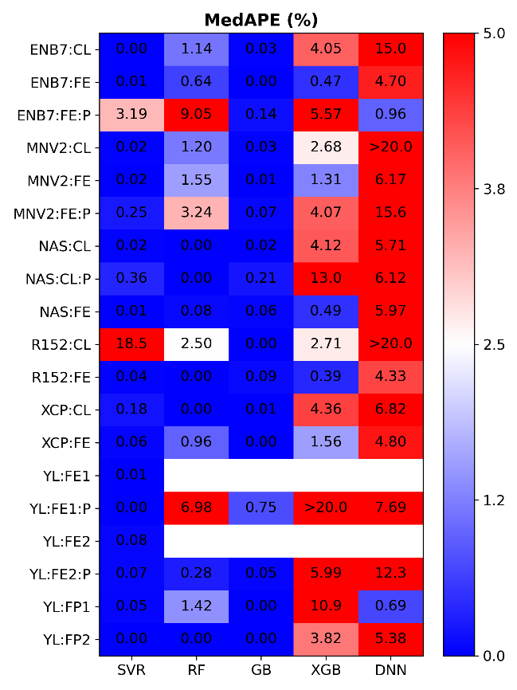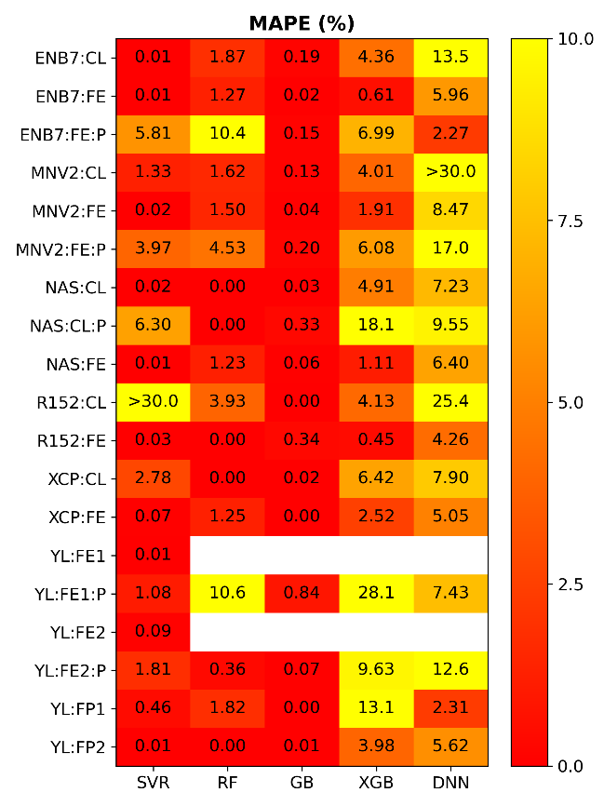

Fig. S3. Heatmaps of mean squared error (MSE, ×10-3), coefficient of determination (R2), median absolute percentage error (MedAPE, %) and mean absolute percentage error (MAPE, %) computed on the training dataset (simulated) for different combinations of computer vision models (vertical axis) and regression models (horizontal axis). [Train]

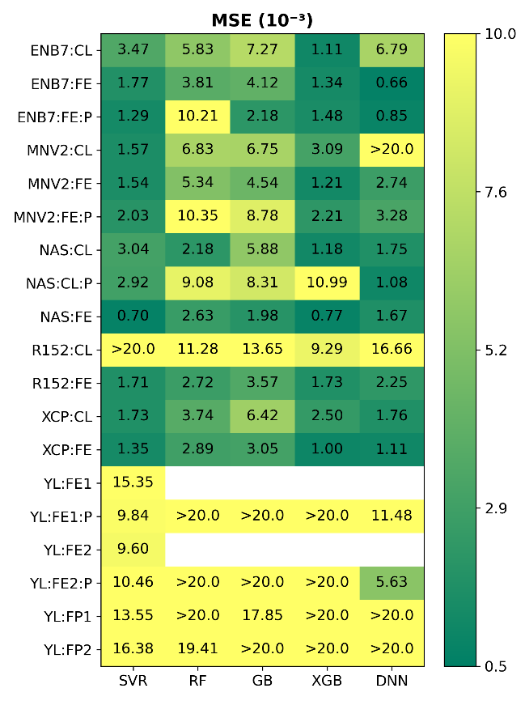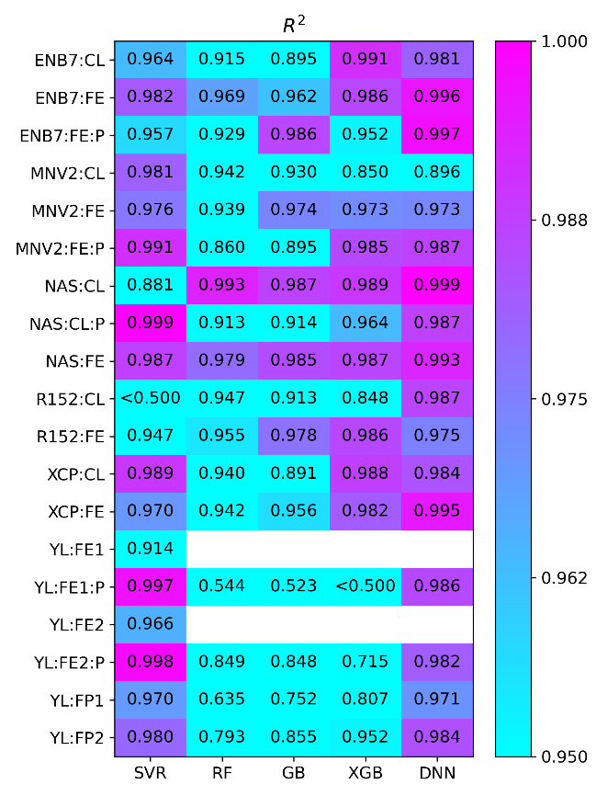

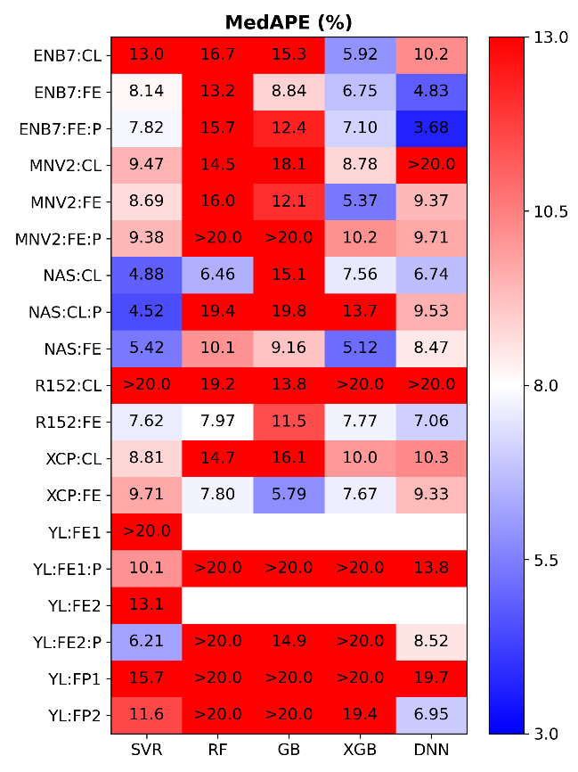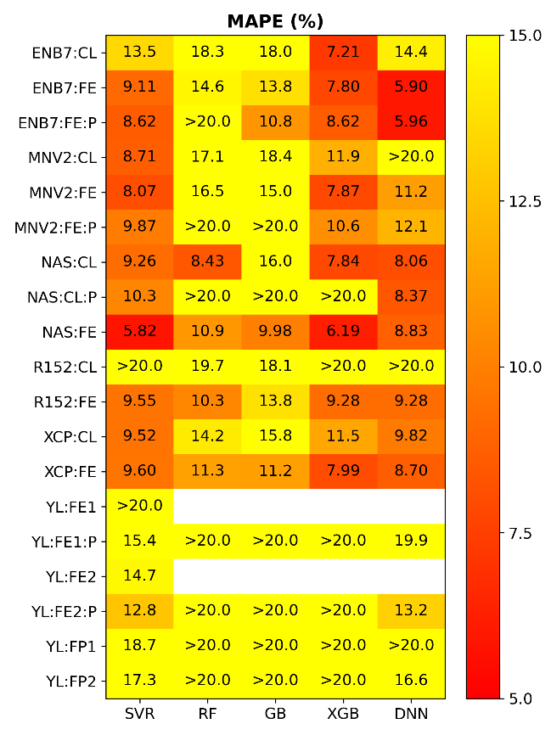

Fig. S4. Heatmaps of mean squared error (MSE, ×10-3), coefficient of determination (R2), median absolute percentage error (MedAPE, %) and mean absolute percentage error (MAPE, %) computed on the test dataset (simulated) for models trained on simulated data for different combinations of computer vision models (vertical axis) and regression models (horizontal axis). [Test]

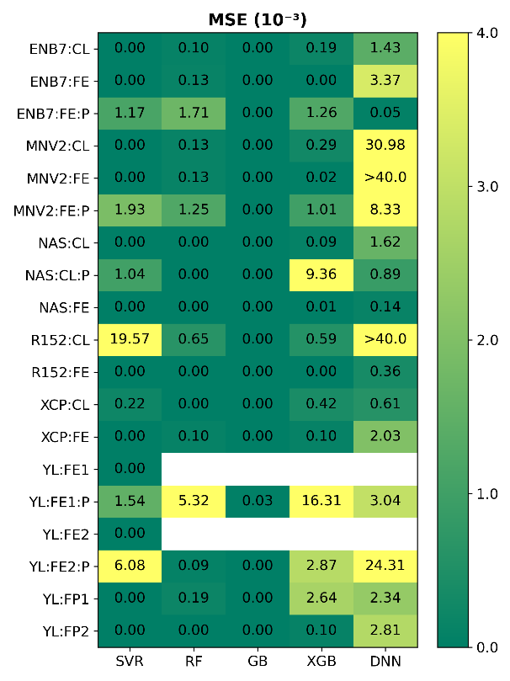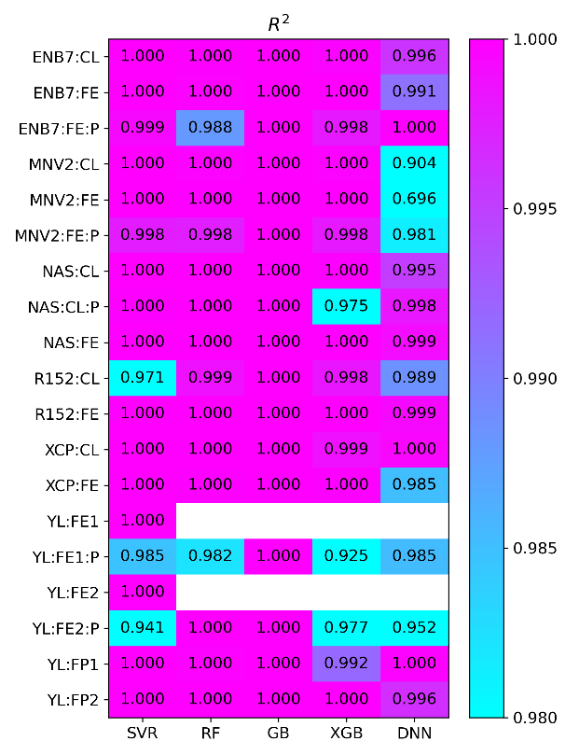

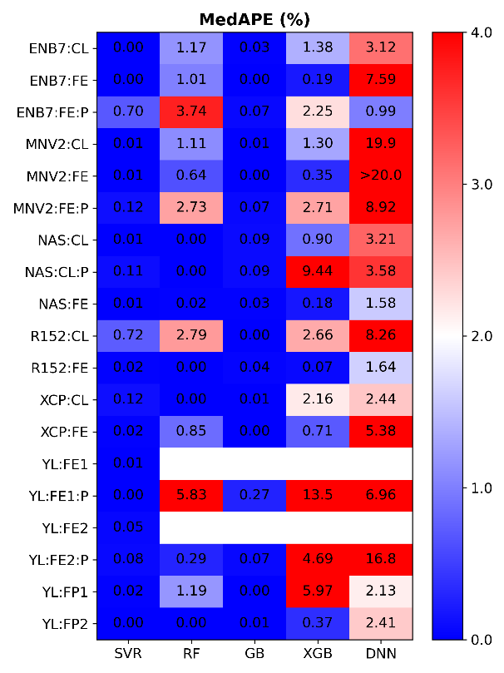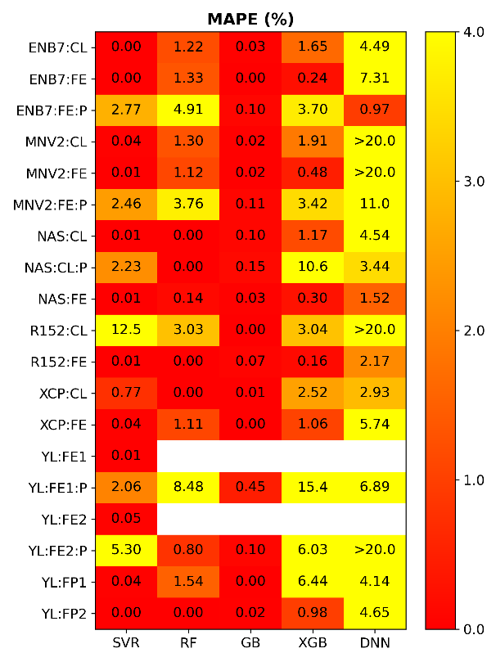

Fig. S5. Heatmaps of mean squared error (MSE, ×10-3), coefficient of determination (R2), median absolute percentage error (MedAPE, %) and mean absolute percentage error (MAPE, %) computed on the training dataset (experimental) for models trained on experimental data for different combinations of computer vision models (vertical axis) and regression models (horizontal axis). [ExpTrain]

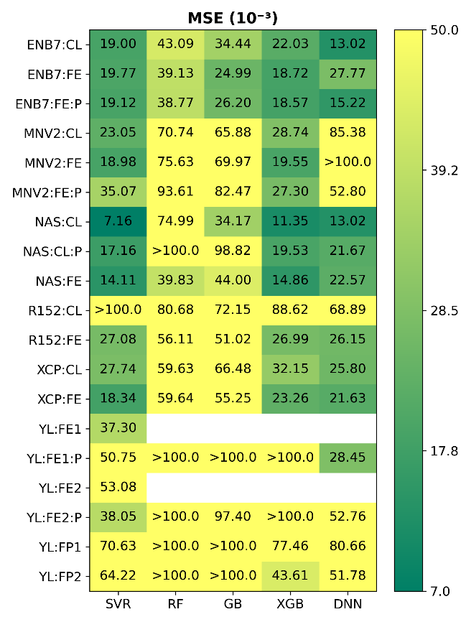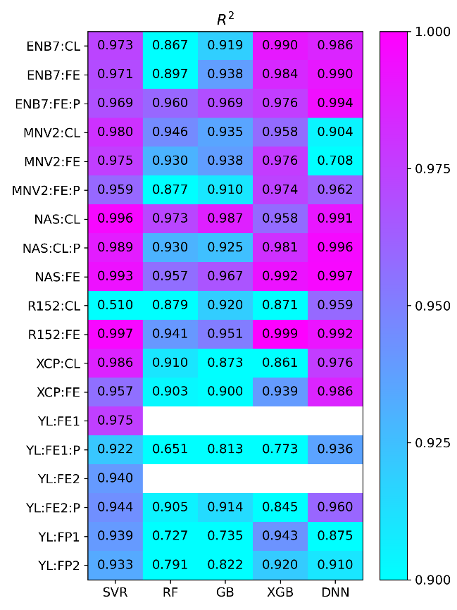

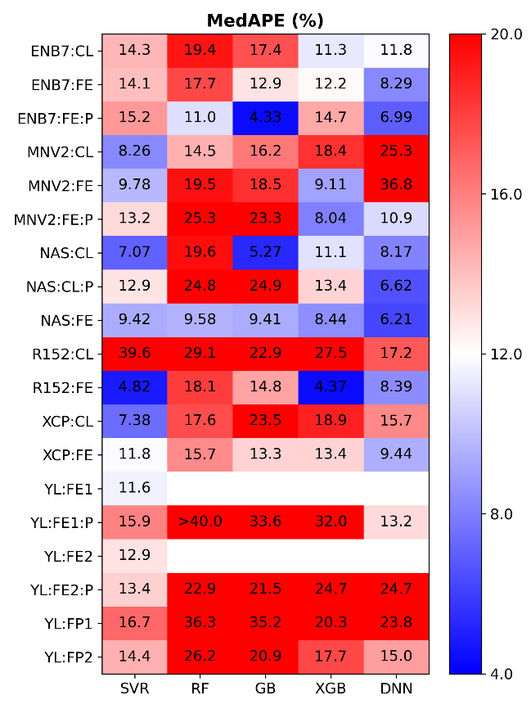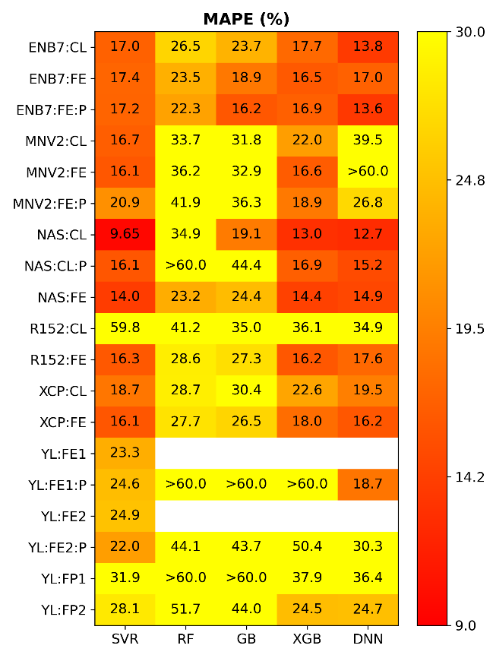

Fig. S6. Heatmaps of mean squared error (MSE, ×10-3), coefficient of determination (R2), median absolute percentage error (MedAPE, %) and mean absolute percentage error (MAPE, %) computed on the test dataset (experimental) for models trained on experimental data for different combinations of computer vision models (vertical axis) and regression models (horizontal axis). [ExpTest]

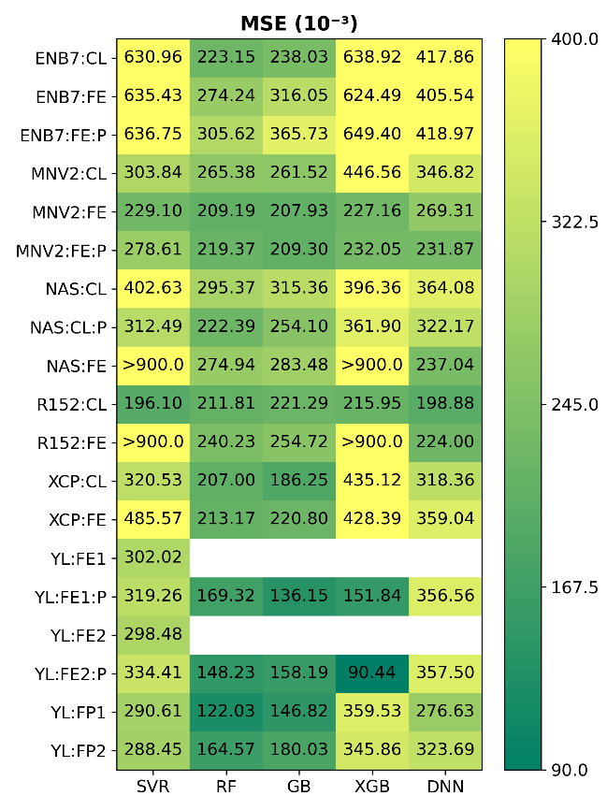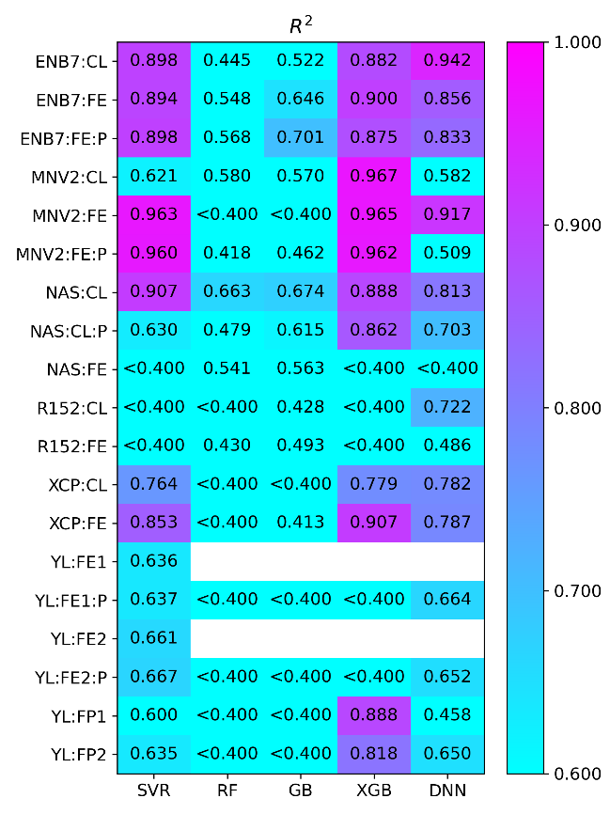

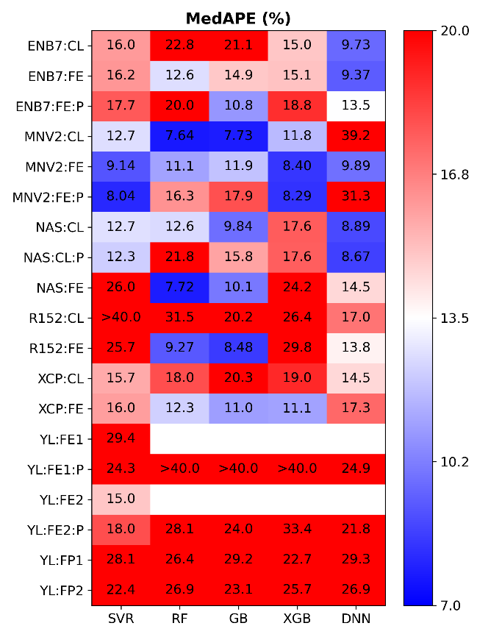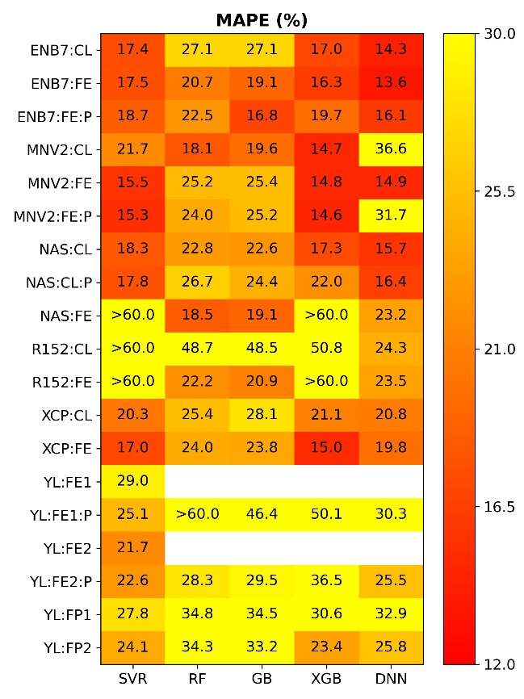

Fig. S7. Heatmaps of mean squared error (MSE, ×10-3), coefficient of determination (R2), median absolute percentage error (MedAPE, %) and mean absolute percentage error (MAPE, %) computed on the experimental dataset (experimental) using models trained on simulated data for different combinations of computer vision models (vertical axis) and regression models (horizontal axis). [Exp]